**MODULE 10 ON ENGLISH FOR PEDAGOGICAL AND HUMAN SCIENCES**

**SECTION 1: GUESSING SKILLS EXERCISE 10**

1. Application of psychological theories and principles to the treatment of problems of abnormal behavior, emotions and thinking.

a) psychological assessment b) psychotherapy

c) psychoanalysis d) psychophysics

2. Student assessment not based on statistics but on holistic and flexible measures and impression.

a) impact assessment b) qualitative assessment

c) quantitative assessment d) eco-adaptive assessment

3. Field of study or special knowledge.

a) discipline b) self-discipline

c) disciple d) disciplinary infraction

4. Ability to plan and do tasks requiring motor skills.

a) regional planning b) administration planning

c) praxis planning d) practicum

5. Losing power of speaking correctly, replacing one word for another, and jumbling words and sentences in such a way as to make speech not understood.

a) epilepsy b) paraphasia

c) prelingual deafness d) predisposition

6. ...................................... may be used to hold back people who are suffering from involuntary physical spasms, to prevent them from hurting themselves.

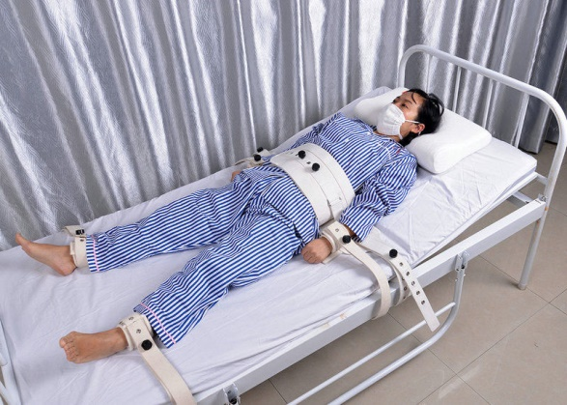

a) Physical impairment

b) Physical therapy

c) Physical restraint

d) Physical matching

7. The smallest unit of meaningful language.

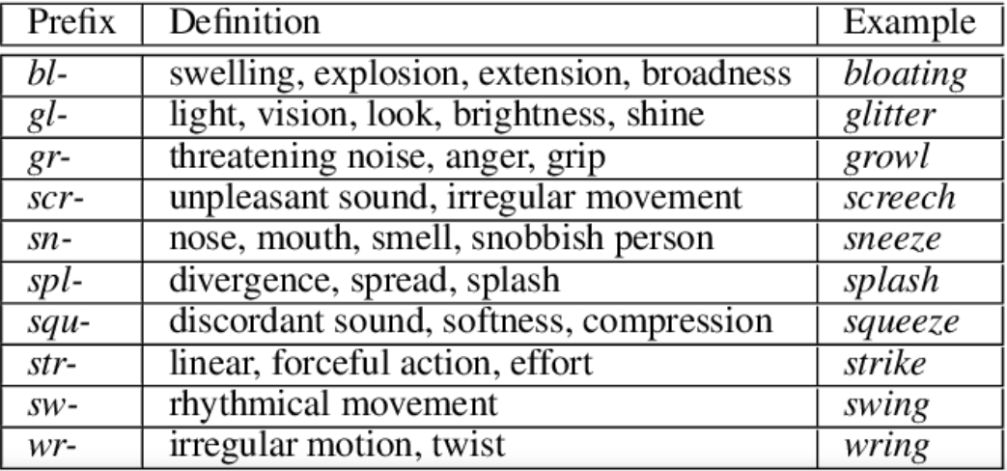a) morpheme /μόρφιμ/ b) phoneme /φόνιμ/

c) phonestheme /φόνεσθιμ/ d) postulation

8. A .......................... is a staff member other than a teacher engaged in education in the classroom in the form of giving secondary help to special students.

a) professional member b) professional adviser

c) paraprofessional d) professional ghostwriter

9. The rhythm of speech that helps give meaning to oral communication.

a) intelligible speech b) acoustic method

c) prosody d) proxemics /προξίμικς/

10. A child behaving inappropriately for a classroom situation.

a) modality b) off-task behavior

c) on-task behavior d) seriation

11. A researcher designs an experiment to test how variables interact to influence how well children learn spelling words. In this case, the main purpose of the study was:

a) Explanation b) Description

c) Influence d) Prediction

12. The philosophical theory that the self is all that you know to exist.

a) verbalism b) animatism

c) atavism d) solipsism /σόλιψίζεμ/

**SECTION 2: AUDIOVISUAL RESOURCES AND TASKS RELATED TO PEDAGOGICAL AND EDUCATIONAL ISSUES**

TASK 1: The following vocabulary is heard in the attached video about epilepsy. To facilitate your understanding of the video, please, study the vocabulary below and then watch the video. The vocabulary is presented in the order heard in the video.

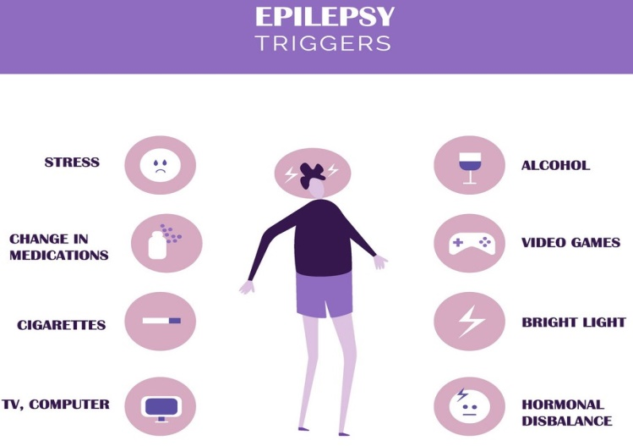

…recurrent seizures = επαναλαμβανόμενες κρίσεις, …outward manifestation = εξωτερική εκδήλωση, …loss of consciousness = απώλεια συνείδησης …head trauma = τραύμα στο κεφάλι …economic implications = οικονομικές συνέπειες …to boil everything down for you = να σας πω τα βασικά …neurons = νευρώνες …action potential = Δυναμικό Ενέργειας …fire off = εκτοξεύουν …ions such as calcium, potassium, sodium = ιόντα όπως ασβέστιο, κάλιο, νάτριο …glutamate = ο νευροδιαβιβαστής γλουταμάτη …NMDA receptor = υποδοχέας Ν-µεθυλο-D-ασπαραγινικού (=N-Methyl-D-Aspartate) …causes the cell to depolarize = προκαλεί την εκπόλωση του κυττάρου …You can liken = μπορείτε να παρομοιώσετε …erroneous signals = λανθασμένα σήματα …propagation = η εξάπλωση …jerking = τρέμουλο …stiffness = ακαμψία, δυσκαμψία, σκληρότητα …loses muscle tone = χάνει τον μυϊκό τόνο …drops like a limp rag = πέφτει σαν ένα χαλαρό κουρέλι …has muscle rigidity = έχει μυϊκή ακαμψία …loss of bladder and bowel control = απώλεια ούρων και κοπράνων …enters a state of recovery = μπαίνει σε φάση ανάνηψης …they feel drowsy = νιώθουν υπνηλία …postictal period = μετεπιληπτική περίοδος …massive expenditure of energy = τεράστια δαπάνη ενέργειας …if not addressed immediately = αν δεν αντιμετωπιστεί άμεσα

TASK 2: The following vocabulary is heard in the attached video about schizophrenia (a mental disease characterized by unnatural social behavior and inability to understand reality). To facilitate your understanding of the video, please, study the vocabulary below and then watch the video. The vocabulary is presented in the order heard in the video.

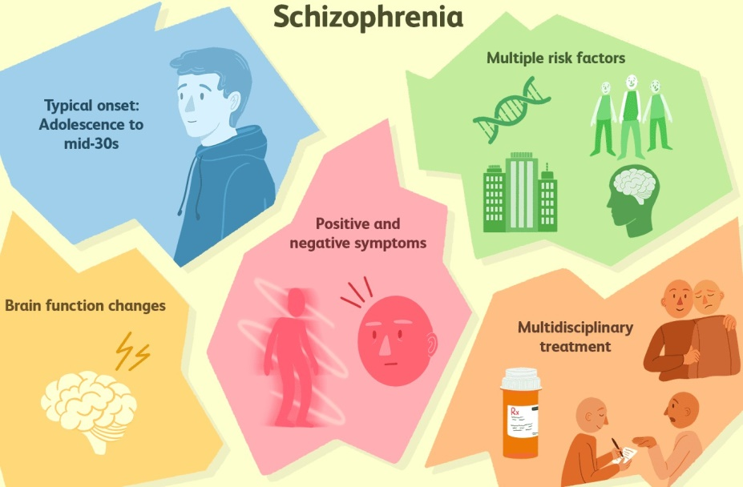

…are plotting against them = μηχανορραφούν εναντίον τους, …withdrawal = απομόνωση, απόσυρση, …extreme agitation = υπερβολική ταραχή, …can be traced = μπορεί κανείς να βρει στοιχεία της, …coined the term = επινόησε τον όρο, …blunted affect /μπλάν-τιντ άφεκτ/ = απρόσφορο ή περιεσφιγμένο συναίσθημα ή επίπεδο συναίσθημα ή συναισθηματική επιπέδωση (στην ουσία πρόκειται για έλλειψη συναισθηματικής αντίδρασης), …loosening of associations = ταχύτατη εκφορά σκέψεων χωρίς ειρμό, …preoccupation = "μονομανία", "ψύχωση", …hallucinations = παραισθήσεις, …delusions = εσφαλμένες αντιλήψεις, ψευδαισθήσεις, …tend to emerge = τείνουν να εμφανίζονται, …symptoms surface = τα συμπτώματα παρουσιάζονται, …puberty = εφηβική ηλικία.

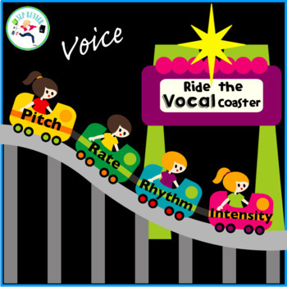

TASK 3: Watch the attached short video about Prosody and discuss it with your teacher and classmates. What is the importance of prosody in teaching and learning? Do teachers in your country appreciate the importance of Prosody?

TASK 3: Your teacher will present you a 100-minute film about Asperger syndrome, or Asperger's, which is a previously used diagnosis on the autism spectrum. Before you watch it, (a) the teacher will give you a handout and ask you to take a look at some information about Asperger disorder to facilitate your understanding the film, and (b) your teacher will divide you into four groups with each group focusing their attention on one of the four main characters of the film: Adam (the 1st main character), Beth (the 2nd main character), Marty (Beth’s father), and Harlan (Adam’s friend). Your task is to put yourself in their shoes, as far as this is possible. This will make it easier to discuss the ﬁlm after you have watched it. It is advisable that you take notes while watching, if it is not hard for you. Some ideas about what to focus on are also provided:



a) Target information about Asperger’s:

Asperger syndrome (AS), also known as Asperger's, is a developmental disorder characterised by significant difficulties in social interaction and nonverbal communication, along with restricted and repetitive patterns of behavior and interests. As a milder autism spectrum disorder (ASD), it differs from other ASDs by relatively normal language and intelligence. Although not required for diagnosis, physical clumsiness and unusual use of language are common. Signs usually begin before two years of age and typically last for a person's entire life.

The exact cause of Asperger's is unknown. While it is largely inherited, the underlying genetics have not been determined conclusively. Environmental factors are also believed to play a role. Brain imaging has not identified a common underlying condition. In 2013, the diagnosis of Asperger's was removed from the Diagnostic and Statistical Manual of Mental Disorders (DSM-5), and people with these symptoms are now included within the autism spectrum disorder along with autism and pervasive developmental disorder not otherwise specified (PDD-NOS). It remains within the International Classification of Diseases (ICD-11) as of 2019 as a subtype of autism spectrum disorder.

There is no single treatment, and the effectiveness of particular interventions is supported by only limited data. Treatment is aimed at lowering obsessive or repetitive routines, and improving communication skills and physical clumsiness. Interventions may include social skills training, cognitive behavioral therapy, physical therapy, speech therapy, parent training, and medications for associated problems, such as mood or anxiety. Most children improve as they grow up, but social and communication difficulties usually persist. Some researchers and people on the autism spectrum have advocated a shift in attitudes toward the view that autism spectrum disorder is a difference rather than a disease that must be treated or cured.

b) Ideas about what to focus on while watching:



1. Being Adam

* It is difﬁcult for anyone to know what it is like having Asperger’s (or being in the autism spectrum) when they do not, but it’s important to at least try to develop an empathetic understanding of how life is for Adam. Explain when he seems to be calm and happy and when he seems to be upset and embarrassed.
* What activities give him pleasure and a sense of achievement or progress?
* What situations does he ﬁnd especially difﬁcult to respond to without becoming distressed?
* How does he feel towards Beth and how does he feel towards her father?
* What is the etiology of Adam’s difficulty in adapting to crowded places?
* Who are those who understand that Adam is always going to behave in ways that are not regarded as ‘normal’ because of his issue and who are those who do not understand that?
* Adam says: “I have been talking too much, so …” What does he mean and why does he say so?



2. Being Beth

* Explain how some of the things she does affect her relationship with Adam in the film.
* What can we say about Beth’s character in the film?
* How do we know how Beth is feeling?
* Beth decides not to move house with Adam in the end. Why has she taken that decision? How do you explain her attitude on that occasion?
* Towards the end of the film, Beth says: “We'll never have a moment where we look into each other's eyes ... and know exactly ...” What does she mean and why does she say so?



3. Being Marty

* How would you describe Marty’s personality?
* How are his feelings for Beth expressed in the ﬁlm?
* How would you describe his relationship to Adam?
* How would you describe his relationship to his wife?
* Marty says: “One more thing, about Adam. He's not for you. It's not his fault …” What does he mean and why does he say so?



4. Being Harlan

* How would you describe Harlan’s character as a whole in the film?
* What are his feelings towards Adam?
* How does he encourage him to go on with his life?
* At the park scene, Harlan says to Adam: “Lunchtime is for guy talk. Two guys talking about women, the weather and such. You got it?” What does he mean and why does he say so?

**SECTION 3: VOCABULARY ANALYSIS IN PEDAGOGICAL TEXT**

TASK 1. The text below is about Attention Deficit (Hyperactivity) Disorder. While reading it, please, focus on particular words, phrases and/or collocations and match them to the following synonyms, images, and Greek meanings.

Some children have more trouble paying attention in class and completing academic assignments than others. It is estimated that from 3 to 10 percent of the population has a condition known as Attention Deficit Disorder (ADD) or Attention Deficit Hyperactivity Disorder (ADHD). This disorder is said to be found present more often in boys than girls (3:1). Not every student having trouble completing assignments or who is squirmy and disruptive to the class has Attention Deficit Disorder. This is particularly true in the lower grades where many of the students have not reached a level of maturity sufficient to meet the demands of the classroom. Some studies have found that a first grade teacher may rate as many as 50% of the boys in the class as having Attention Deficit Disorder using common clinical questionnaires. Thus, educators may mislabel behavior as being abnormal when it actually may be within the low end of normal development.

Shortage: ………………… enough: ……………… moving: …………………

Παρεξηγώ, ‘βαφτίζω’: ……………… Διασπαστικός: …………………….

Actually, normal attention span seems to develop in three stages. First, the child’s attention is said to be overly exclusive. This is a term used by psychologists to describe attention that is focused on a single object for a long period of time while tuning out all other stimuli. An example of this would be a baby who focuses totally on a button or a pin on the clothing of the person holding him. A child whose attention becomes stuck at this stage of development might be diagnosed as having autism. Second, a child’s attention develops to where it is overly inclusive. This refers to a very wide span of attention that is constantly and rapidly changing from one object to another such as a toddler who is running from one toy to the next never able to stay with any one toy for any period of time. A child who is stuck at the second stage of attention span development might be diagnosed as having attention deficit disorder. Third, the child develops selective attention where he is able to shift focus at will from being inclusive to being very exclusive. This is a mature pattern of attention and concentration that is required to be successful in a classroom learning environment.

 Duration of concentration: ……………………….

Υπερβολικά: ……………………..

Bound, clung: ………………………

Exclusive: ………………………….

Sure-fire: …………………………

……………………..

There are a variety of causes for poor attention, concentration and impulse control. A partial list would include the following:

* Immaturity and slow psychological development
* Learning disabilities such as dyslexia
* Anxiety and depression
* Low thyroid and low motivation
* Lack of sufficient sleep and poor nutrition
* Boredom due to lack of challenge

If your child has had the symptoms of poor attention, concentration and/or poor impulse control for some time, you should have your child examined by his physician. In addition to a physical exam and appropriate lab tests, the physician may have the parents and teachers complete questionnaires about the child’s behavior. He may also refer you to a school psychologist or a mental health professional for further assessment. Depending on the outcome of the entire evaluation, one or several specific medical, educational or psychological recommendations may be given.

Tedium: ………………. Bodily: ……………… Demeanor: ………………..

Appraisal: …………………thorough: ……………..

The symptoms of Attention Deficit Disorder are caused by a neurological dysfunction within the brain. Several studies using PET scans have confirmed that there is a definite difference in brain functioning between a group of individuals diagnosed with Attention Deficit Disorder and those without it. The underlying physiological mechanism which causes Attention Deficit Disorder is still not thoroughly understood and remains under scientific study. It is presumed that brain chemistry is out of balance and that specific chemicals called neurotransmitters may be lacking in individuals with Attention Deficit Disorder. In two research studies, when the Attention Deficit Disorder subjects were given their medication and rescanned, their brain activity appeared to be much more like that of the normal group. Another interesting finding of these studies is that the areas of the brain in the Attention Deficit Disorder group where brain activity was lower than in the normal group are known to be associated with such functions as attention and concentration as well as planning and organization. These are the very functions that are impaired in persons with Attention Deficit Disorder. PET scans are considered to be very invasive because they involve the injection of radioactive material into the individual and therefore are not appropriate for diagnostic purposes. To date only two studies of Attention Deficit Disorder using PET scans have been conducted.

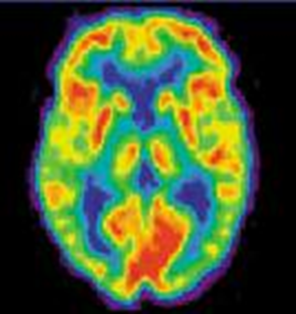 Νευροδιαβιβαστής: …………………………

Spoil: ……………………..

Παρεμβατικός: ……………………

Shot: ……………………….

Perform: ………………….

……………………

Attention Deficit Disorder may be either inherited or acquired. Recent research in genetics has definitely shown that Attention Deficit Disorder runs in families. The specific chromosomes that are involved have not been fully identified though more clues are being discovered as research progresses. Like many other disorders, a child may have the symptoms while his parents may not. Usually there are aunts, uncles, grandparents or cousins with the disorder. Attention Deficit Disorder may be acquired through various conditions that cause insult (damage) to the brain. During pregnancy and delivery these include the use of drugs during pregnancy, toxaemia, infectious diseases, overexposure to radiation, prematurity, complicated delivery. After birth these include meningitis, encephalitis, seizures from fever, head injury and lead toxicity. Excessive use of sweets does not cause Attention Deficit Disorder though it may make the symptoms worse for some individuals who already have the condition.

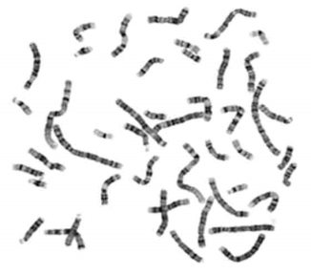 Come into: …………………. Τοκετός:……………. Τοξικότητα μολύβδου: ……………………. Ακτινοβολία: ………………………… Move on: ………………………. Key out: …………………………..

………………

Since many children with Attention Deficit Disorder appear to "outgrow" the condition it can also be looked at as a developmental disorder. Some children seem to develop the ability to pay attention and concentrate later than others just as there is a wide range to timing for developing the ability to walk, talk or be potty trained. In the past, children with Attention Deficit Disorder and other learning disabilities were labeled as "underachievers" in their younger years and then reclassified as "late bloomers" when their development in this area finally caught up with their peers. Today, many adults look back and realize they had a learning disability or Attention Deficit Disorder as a child which they may or may not have been able to overcome. Some people with Attention Deficit Disorder become very successful. However, others continue to have significant symptoms as adults. Some were not able to adapt or compensate on their own and did not receive any help from teachers, parents or professionals. These individuals often dropped out of school and may today be social drop outs of one kind or another. It is for this last reason that children who exhibit signs of Attention Deficit Disorder or learning disabilities should receive all the help necessary and available to spare them the frustration and anguish often associated with these conditions.

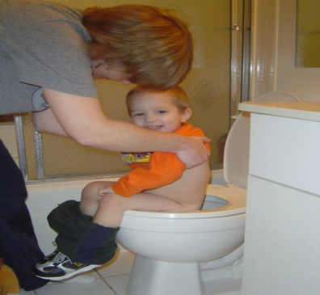Get over: ……………………….

Skip: ………………………

Pain: ………………………

Απαλάσσω: ……………………….

Obtain: ………………………………..

Even off: …………………………

……………………….

SECTION 4: WRITING SKILLS DEVELOPMENT

TASK: According to the instructions provided in Module 1 Section 4, write an essay about the following topic. The vocabulary below may help you to develop your essay.

ESSAY TOPIC 10

*Would you prefer to live in a traditional house or in a modem apartment building? Use specific reasons and details to support your choice.*

Potentially useful vocabulary:

* ***(all the) mod cons***: technology at home that makes jobs easier such as a washing machine, dishwasher etc.
* ***apartment block***: a large building made up of smaller units of apartments
* ***back garden***: a garden at the rear of the house
* ***detached house***: a house that is not physically connected to another property
* ***to do up a property***: to repair an old building
* ***dream home***: a home you regard as perfect
* ***first-time buyer***: someone buying a property for the first time, especially when taking out a loan (mortgage)
* ***fully-furnished***: a rented property with all furniture included
* ***to get on the property ladder***: to buy a property with the aim of buying another bigger or more expensive one later in life
* ***hall of residence***: a college or university building where students live
* ***home comforts***: things that make a home feel comfortable to live in
* ***house-hunting***: looking for a property to live in
* ***house-warming party***: a party to celebrate moving into a new home
* ***ideal home***: a perfect home
* ***to live on campus***: to live on the university or college grounds
* ***mobile home***: a home that can be moved by a vehicle or one that has its own engine
* ***to move into***: to begin to live in a property
* ***to own your own home***: to have bought the property you live in
* ***to pay rent in advance***: weekly or monthly rent paid at the beginning of the week or month
* ***permanent address***: a fixed address
* ***property market***: the buying and selling of land or buildings
* ***to put down a deposit***: to pay an amount of money as the first in a series of future payments
* ***rented accommodation***: property owned by someone else and for which a person pays a fixed amount to live in
* ***single room***: a room for one person
* ***spacious room***: a large room
* ***student digs***: student accommodation
* ***the suburbs***: a residential area on the edge of towns or cities
* ***to take out a mortgage***: to borrow a large amount of money, paid back over several years, in order to buy a house
* ***terraced house***: a house connected on both sides by other properties

KEY-WORD-IN-CONTEXT ACTIVITY. In pairs or individually, study the following concordance lines and find out the meaning of the common collocation (‘National Formulary’) that they have in the middle. Then report it to your teacher orally or in written form.

