Frequently Asked Questions

The WiMAX Forum

Founded in June 2001, the WiMAX Forum is an industry-led, not-for-profit organization formed to certify and promote WiMAX products based upon the harmonized IEEE 802.16/ETSI HiperMAN standard. Focused on global adoption of WiMAX, the WiMAX Forum was chartered to establish certification processes that achieve interoperability, publish technical specifications based on recognized standards, promote the technology, and pursue a favorable regulatory environment.

1. What is WiMAX technology?

WiMAX™ is based upon the IEEE 802.16 standard enabling the delivery of wireless broadband services anytime, anywhere. WiMAX products can accommodate fixed and mobile usage models. The IEEE 802.16 standard was developed to deliver non-line-of-sight (LoS) connectivity between a subscriber station and base station, with typical cell radius of three to ten kilometers. All base and subscriber stations claiming to be WiMAX compliant must go through a rigorous WiMAX Forum Certified™ testing process.

The name "WiMAX" was created by the WiMAX Forum to promote conformity and interoperability of the standard. WiMAX Forum certification allows vendors to sell fixed or mobile products as WiMAX certified, thus ensuring a level of interoperability with other certified products, as long as they fit the same profile.

2. What are the advantages of WiMAX?
There are a number of advantages on use WiMAX; moreover the most important is the combination of low cost and flexibility. WiMAX broadband networks can be quickly built at relatively low cost by installing few wireless base stations providing coverage to the surrounding area with multifunctional application: high-speed Internet, telephone service, voice and data transfer, and video applications.
WiMAX enables high-speed voice and data transfer over long distances in remote and scarcely populated areas, as well as in densely populated areas. The wireless connectivity is not affected by weather conditions, and does not need direct line in order to work; it allows real access to end users through its own infrastructure.
WiMAX products benefit service providers using their existing infrastructure investments as WiMAX has the ability to interoperate across various network types. WiMAX offers potential for development, new applications and opportunities. WiMAX is the technology of choice that supports both fixed and mobile applications.

3. What are the WiMAX applications?
The maturing of the WiMAX technology has made possible a number of new applications beyond data communications. The bandwidth and range makes WiMAX suitable for the following applications:
- Mobile broadband connectivity across cities and countries through a wide variety of devices.
- Fixed wireless broadband
- Wireless alternative to cable and digital subscriber line (DSL) for broadband access
- Data, telecommunications (VoIP) and IPTV services
- Internet connectivity
- Smart Grid and metering
- Smart Cities
- Public Safety
- Aviation
- Oil & Gas

4. What are the key elements of WiMAX technology?

A key element for WiMAX is the interoperability of WiMAX Forum Certified equipment, resulting in mass volume economy of scale and assurance for service providers that, when buying equipment from more than one company, the technologies are interoperable. The WiMAX Forum has assembled an alliance of leaders in the communications and computing industries to drive a common platform for the global deployment of IP-based broadband wireless services. Other key elements include cost, coverage, capacity, and standards for all wireless usage models.

5. How will WiMAX Forum Certified products benefit enterprises and residential users?
• Enterprises: The ease of deployment for WiMAX Forum Certified systems can benefit enterprises by bringing new competition into the marketplace and lowering prices, as well as reaching out to locations not served by wireline Internet access. This is especially relevant for industries like gas, mining, agriculture, transportation, construction and others that operate in remote locations.
• Residential users: For residential customers in suburban and rural areas (where DSL or cable modem service is not available), WiMAX technology can provide the ability to finally have the broadband access they need. This is particularly true in developing countries where traditional telecom infrastructure is not readily accessible.

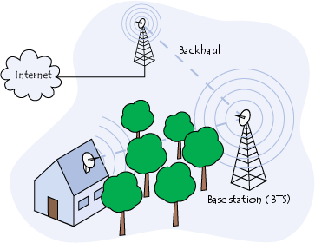
A typical residential WiMax topology. Source: ccm.net

6. What is the data transfer speed of WiMAX technology for end users?

Users can expect to have broadband access speeds ranging from 1-5 Mbps depending on the service provider offering. There is a range difference because it depends on a number of factors, including which frequency is being used, distance of the user from the base station or node, whether there is line of site (or NLoS), to the base station, and the number of users. When the WiMAX Forum refers to 40 Mbps, it is for single channel in wireless frequency (as part of the network) that is likely shared among multiple users.

Individual users will have access to that amount of capacity, but the likelihood is they will have the ability to achieve downlink speeds of 1-5 Mbps, which is similar to the cable experience. There is the potential for higher speeds, but that would depend on the operator's plans.

Several telecom operators (ISPs) also offer 3G and 4G networks with considerable speeds. Availability of 4G networks means large bandwidth, compatibility with IP-based networks, and the development of ultra mobile broadband at a later stage. The latter is expected to operate at speeds close to WiMax technology.

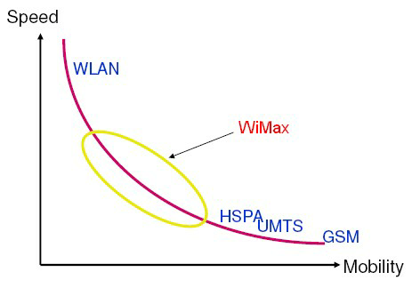
Comparison of wireless technologies. Source: wikipedia.org

7. How does WiMAX technology compare to Wi-Fi technology?

WiMAX and Wi-Fi are complementary. It is important to note that since chipsets that use Wi-Fi are similar to WiMAX chipsets, both can be embedded into one chip. This means that devices utilizing Wi-Fi, including call phones and laptops, will easily be able to incorporate WiMAX technology on the same chipset at minimal additional cost. In the future any device that could potentially benefit from connectivity can become a WiMAX enabled device. This includes devices duch as digital cameras, digital music players, and even your home security system.

______________________________________________________________________________

