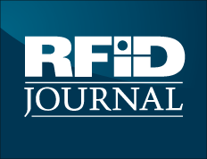

What is RFID?

Here’s a plain-English explanation of what radio frequency identification is and why it’s become an important technology.

Radio frequency identification (RFID) is a generic term that is used to describe a system that transmits the identity (in the form of a unique serial number) of an object or person wirelessly by using radio waves. It’s grouped under the broad category of automatic identification technologies.

Auto-ID technologies include bar codes, optical character readers and some biometric technologies, such as retinal scans. The auto-ID technologies have been used to reduce the amount of time and labor needed to input data manually and to improve data accuracy.
Some auto-ID technologies, such as bar code systems, often require a person to manually scan a label or tag to capture the data. RFID is designed to enable readers to capture data on tags and transmit it to a computer system—without needing a person to be involved.

An RFID tag consists of a microchip attached to a radio antenna mounted on a substrate. The chip can store about 2 kilobytes of data. For example, information about a product or shipment—date of manufacture, destination and sell-by date—can be written to a tag.

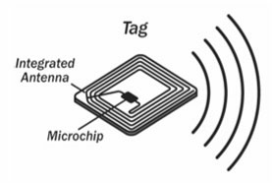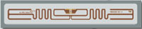
Examples of RFID tags each consisting of a chipset and an antenna.
Source: barcodesinc.com

Then, to retrieve the data stored on a tag, you need a reader. A typical reader is a device that has one or more antennas that emit radio waves and receive signals back from the tag. The reader then passes the information in digital form to a computer system.

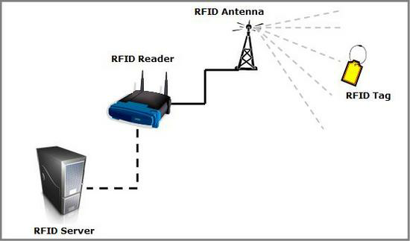

A typical RFID network topology. Source: divilabs.com

RFID technology has been used by thousands of companies for a decade or more. So why is it taking off now? Until recently the cost of RFID has limited its use. For many common applications such as tracking parts for just-in-time manufacturing, companies could justify the cost of tags—a dollar or more per tag—by the savings an RFID system could generate.
When RFID technology is used to track assets or reusable containers within a company’s own walls, the tags could be reused. But for tracking goods in open supply chains, where RFID tags are put on cases and pallets of products by one company and read by another, cost has been a major obstacle to adoption. Tags must in effect be disposable because the company putting them on cannot recycle them. They get thrown out with the box.

The Auto-ID Center

In 1999, U.S. government authorities teamed with Gillette and Procter & Gamble to fund the Auto-ID Center at the Massachusetts Institute of Technology (MIT). The center changed the equation by working with private industry to develop an RFID tag that would be very low cost (the goal was five cents) when manufactured in high volumes. That way, companies could put tags on everything they own and then connect them to the Internet. The center eventual gained the backing of the U.S. Department of Defense and some 100 global companies, including Kimberly-Clark, Metro, Target, Tesco, Unilever, Wal-Mart. These companies were attracted to RFID because it held out the potential of offering perfect supply chain visibility—the ability to know the precise location of any product anywhere in the supply chain at any time.

The Auto-ID Center handed off its technology to a non-profit organization — EPCglobal, which has created a second-generation air interface protocol and the network infrastructure to enable companies to share data in real time. When Company A ships a pallet full of soft drink, the tags on the cases and pallet are scanned as the shipment leaves, and software is used to automatically let Company B know the shipment has left the warehouse. Company B can look up data associated with the serial numbers on the shipment and learn what's coming, when it will arrive and so on. When Company B receives the shipment, it scans the tags automatically, and a message can be immediately sent to Company A to let it know the shipment arrived.

The potential efficiencies created by this visibility are enormous. Companies would be able to reduce inventories while ensuring product is always in the right place at the right time. And because no humans would have to scan the tags, labor costs and errors would also be greatly reduced. It's not clear if this vision can ever be fully achieved. The biggest obstacle today is the cost of the tags. The Auto-ID Center did research suggesting the price of tags could fall to the initial goal of 5 cents when 30 billion tags are consumed annually. But 30 billion tags will never be consumed if the tags cost 25 cents or more. So the industry faces a chicken-and-egg problem—tags won't get cheap until a lot of people use them, but a lot of people won't use them until they get cheap.

Wal-Mart was the first retailer to require suppliers to put tags on cases and pallets. One reason Wal-Mart chose this approach was to solve the chicken-and-egg problem. If the giant retailer's top suppliers began buying tags, that would begin to drive the price down. Lower prices would enable more companies to use the technology. Then volumes would increase and prices would fall further.

RFID Business Applications

Radio frequency identification can be used in many different ways to create value.
Here are the most common ways businesses are using RFID today.

1. Supply Chain Management. RFID technology has been used in supply chains or to automate parts of the chain within a company for years. For example, a Procter & Gamble distribution facility in Spain used a system to increase throughput, reduce shipping errors and cut production costs.

2. Retailing. Retailers such as Metro, Target, Tesco and Wal-Mart are in the forefront of RFID adoption. These retailers are currently focused on improving supply chain efficiency and making sure product is on the shelf when customers want to buy it.

3. Asset Tracking. Companies can put RFID tags on assets that are lost or stolen often, that are under-utilized or that are just hard to locate at the time they are needed.

4. Manufacturing. RFID has been used in manufacturing plants for more than a decade.
It is used to track parts and work in process and also to reduce defects of products.

5. Payment Systems. RFID is also catching on as a payment mechanism. One of the most popular uses of RFID today is to pay for road tolls without stopping the owner’s car.

6. Security and Access Control. RFID has long been used as an electronic key to control who has access to office buildings or areas within office buildings.

7. Other Applications. There are many other innovative uses for RFID. One system uses tags in a bracelet to locate children at parks.

______________________________________________________________________________

