**Is growth in the financial sector good for the economy?**



09 Jul 2015

1. [**Enisse Kharroubi**](https://www.weforum.org/agenda/authors/enisse-kharroubi)Senior Economist, Bank for International Settlements

Global Risks Report 2020

[](https://www.weforum.org/global-risks/reports)

[**Read the report**](https://www.weforum.org/global-risks/reports)

Most Popular

[[](https://www.weforum.org/agenda/2020/02/coronavirus-chinese-companies-response/)](https://www.weforum.org/agenda/2020/02/coronavirus-chinese-companies-response/)

**[Five ways Chinese companies are responding to coronavirus](https://www.weforum.org/agenda/2020/02/coronavirus-chinese-companies-response/)**

**[David Aikman and Alan Chan](https://www.weforum.org/agenda/2020/02/coronavirus-chinese-companies-response/)**[20 Feb 2020](https://www.weforum.org/agenda/2020/02/coronavirus-chinese-companies-response/)

[[](https://www.weforum.org/agenda/2020/02/15-fastest-growing-cities-world-africa-populations-shift/)](https://www.weforum.org/agenda/2020/02/15-fastest-growing-cities-world-africa-populations-shift/)

**[These are the 15 fastest-growing cities in the world](https://www.weforum.org/agenda/2020/02/15-fastest-growing-cities-world-africa-populations-shift/)**

**[Madison Hoff · Business Insider](https://www.weforum.org/agenda/2020/02/15-fastest-growing-cities-world-africa-populations-shift/)**[20 Feb 2020](https://www.weforum.org/agenda/2020/02/15-fastest-growing-cities-world-africa-populations-shift/)

[[](https://www.weforum.org/agenda/2020/02/epidemic-handwashing-hygiene/)](https://www.weforum.org/agenda/2020/02/epidemic-handwashing-hygiene/)

**[Slowing an epidemic starts with you](https://www.weforum.org/agenda/2020/02/epidemic-handwashing-hygiene/)**

**[David L. Chandler · MIT News](https://www.weforum.org/agenda/2020/02/epidemic-handwashing-hygiene/)**[19 Feb 2020](https://www.weforum.org/agenda/2020/02/epidemic-handwashing-hygiene/)

[**More on the agenda**](https://www.weforum.org/agenda/archive)

Forum in focus

**World is 100 years away from gender parity but these countries are speeding things up**

[](https://www.weforum.org/our-impact/gender-gap-accelerators)

[**Read more about this project**](https://www.weforum.org/our-impact/gender-gap-accelerators)

Explore context

Future of Economic Progress

[](https://intelligence.weforum.org/topics/a1Gb0000001hXcwEAE?tab=publications)

[**Explore the latest strategic trends, research and analysis**](https://intelligence.weforum.org/topics/a1Gb0000001hXcwEAE?tab=publications)

Finance and growth are intimately connected. For at least two decades, we have known that for economies to thrive, they need deep and broad financial systems (Levine 1997). But what is true for emerging market economies may not be true in the advanced world. That is, finance could very well be a two-edged sword. When credit is relatively low, or the financial sector’s share of employment modest, higher levels of debt add to growth. But there is a threshold beyond which it becomes a drag. There is now considerable evidence that productivity grows more slowly when a country’s government, corporate or household debt exceed 100% of GDP (see Reinhart and Rogoff 2010, Cecchetti et al. 2011, and Cecchetti and Kharroubi 2012).

**The link between financial growth and real growth**

In a recent paper (Cecchetti and Kharroubi 2015) we broaden the focus to the study of the relationship between financial growth and real growth. Or, more specifically, the effect of changes in the size of the financial system on total factor productivity growth. And, unlike the level relationship – where finance is good for a while – in this case the result is unambiguous. The faster the financial sector grows, the worse it is for total factor productivity growth. Using panel 20 countries over 30 years, we establish that there is a robust, economically meaningful, negative correlation between productivity and financial sector growth. We also find that causality likely runs from financial sector growth to real economic growth.

Graph 1 plots growth in real GDP per person employed on the vertical axis against two measures of financial sector growth on the horizontal: growth in private credit to GDP (left-hand panel) and growth in the share of total employment that is in financial intermediation (right-hand). We use data on 20 advanced economies from 1980 to 2010. In every case, data are averaged over five year periods and measured as deviations from the country mean. The figure shows a clear negative relationship between financial sector growth and productivity growth. The line running through the scatter plot has a negative slope with a coefficient that is significantly less than zero at the 1% level in both cases.

To ensure that the impression from the graph is in fact an accurate reflection of the relationship in the data, we estimate a simple growth regression that both examines a variety of measures for financial sector growth and controls for things like initial conditions, inflation, the size of government, trade openness, population growth, investment to GDP and the occurrence of financial crises. Our conclusion is quite robust – there is a clear negative relationship between financial sector growth and real growth.

**Graph 1**. Financial sector growth and productivity growth

[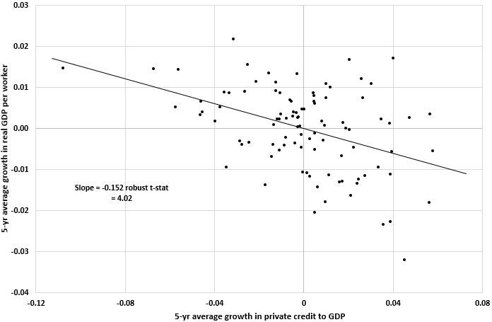](https://assets.weforum.org/wp-content/uploads/2015/07/150708-finance-sector-growth-voxeu-chart.png)

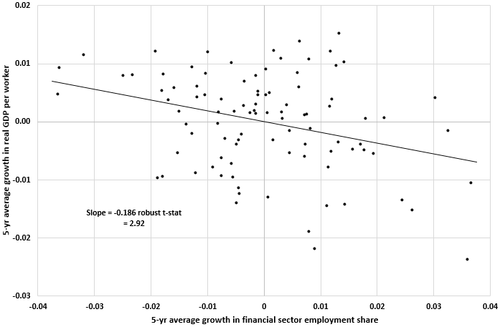

Graphs plot non-overlapping five year averages rates of deviation from country means for Australia, Austria, Belgium, Canada, Switzerland, Germany, Denmark, Spain, Finland, France, the United Kingdom, Greece, Ireland, Italy, Japan, the Netherlands, Norway, Portugal, Sweden and United States over the period from 1980 to 2010. The right hand panel controls for beginning-of-period real GDP per worker.

We can get a sense of the size of the effect by looking at some specific examples. Consider the cases of Ireland and Spain. Starting with Ireland, from 2005 to 2010 the ratio of Irish private credit to GDP more than doubled, growing 16.9% per year. By contrast, over the five years from 1995 to 2000, it grew at a more modest average annual rate of 7.7%. Our estimates (not reported here) imply that this 9.2 percentage point difference has resulted in a productivity slow-down over 2005-2010 of 0.8 percentage points per year compared to the period 1995-2000. This accounts for around 30% of the 2.9 percentage point drop in productivity growth (from 3.3% a.r. to 0.4% a.r.) that occurred over this period.

Turning to Spain, from 1990 to 1995, credit to GDP was almost constant (-0.22% per year) while Spanish productivity was growing 1.7% per year. Fifteen years later, from 2005 to 2010, credit to GDP grew 8.1% a year but productivity grew only 1% a year. Our estimates suggest that, if credit to GDP had been constant instead of rising by 8.1 percentage points, then productivity growth in Spain over 2005-2010 would have the same as it was in 1990-1995 (1.7% per year).

**Why finance is doing harm**

What is behind this empirical regularity? What is the mechanism by which finance, something we know to be fundamental to the operation of the economy, is doing harm? Our hypothesis is that it arises because finance tends to favour relatively low productivity industries as such industries usually own assets that are relatively easy to pledge as collateral. So as finance grows, the sectoral composition of the economy changes in a way that drives aggregate total factor productivity down. The intuition for this comes from the observation that it is easier to obtain external finance for projects that are based either use tangible capital in their production or produce more tangible outputs. The more tangible a firm’s assets or output, the easier it is to pledge them as collateral for a loan.

We take this prediction to the data and study 33 manufacturing industries in 15 advanced economies. The key to figuring out which sectors are most likely to be damaged from financial sector growth requires that we look for the sectors where pledging of either assets or output is difficult. On the asset side, we can measure this directly from information on asset tangibility. For output, we use research and development  intensity as a proxy.

Our results are unambiguous. When the financial sector grows more quickly, productivity tends to grow disproportionately slower in industries with lower asset tangibility, or in industries with higher research and development intensity.

As for the quantitative implications of these estimates, we find that productivity of an industry with high asset tangibility located in a country experiencing a financial boom tends to grow 2.5-3% a year more quickly than an industry with low asset tangibility located in a country not experiencing such a boom. This is quite a large effect, especially when compared with the unconditional sample mean and volatility of labour productivity growth of 2.1% and 4.3%, respectively.

Financial booms are not, in general, growth-enhancing. And, the distributional nature of the impact is disturbing, as credit booms harm what we normally think of as the engines for growth – those industries that have either lower asset tangibility or high research and development intensity. This evidence, together with recent experience during the financial crisis, leads us to conclude that there is a pressing need to reassess the relationship of finance and real growth in modern economic systems.

Disclaimer: Views expressed are those of the author and not necessarily those of the BIS.

**References**

Cecchetti, S and E Kharroubi (2012): “Reassessing the impact of finance on growth”, BIS Working Papers, no 381.

Cecchetti, S and E Kharroubi (2015): “[Why does financial sector growth crowd out real economic growth?](http://www.cepr.org/active/publications/discussion_papers/dp.php?dpno=10642)”, CEPR Discussion Paper 10642.

Cecchetti, S, M Mohanty and F Zampolli (2011), “The Real Effects of Debt’ in Achieving Maximum Long-Run Growth”, proceedings of the Federal Reserve Bank of Kansas City’s Jackson Hole Symposium: 145-196.

Levine, R (1997), “Financial development and economic growth: views and agenda”, *Journal of Economic Literature* 35: 688–726.

Reinhart, C and K Rogoff (2010), “Growth in time of debt”, *American Economic Review Papers & Proceedings* 100: 573–8.

*This article is published in collaboration with [VoxEU](http://www.voxeu.org/article/why-growth-finance-drag-real-economy" \t "_blank). Publication does not imply endorsement of views by the World Economic Forum.*

*To keep up with the Agenda*[*subscribe to our weekly newsletter*](http://weforum.us3.list-manage.com/subscribe?u=79c86265202b9840297f805ad&id=7361259375)*.*

*Authors:*[*Stephen Cecchetti*](http://www.voxeu.org/person/stephen-cecchetti)*is a Professor of International Economics at the Brandeis International Business School. [Enisse Kharroubi](http://www.voxeu.org/person/enisse-kharroubi) is a Senior Economist in the Monetary Policy Division in the Monetary and Economic Department, Bank for International Settlements.*

*Image: A man walks past buildings at the central business district of Singapore February 14, 2007. REUTERS/Nicky Loh.*

**Share**