|  |
| --- |
|  |
|  |
| Languages in Education and Training: Final Country Comparative Analysis  DG EAC  2 January 2014 |

|  |
| --- |
| Languages in Education and Training: Final Country Comparative Analysis  DG EAC |
| A report submitted by ICF GHK  Date: 2 January 2014  Job Number J9241 |
| Shane Beadle  ICF GHK  2nd Floor, Clerkenwell House 67 Clerkenwell Road London EC1R 5BL  T +44 (0)20 7611 1102 F +44 (0)20 3368 6960  www.ghkint.com |

Document Control

|  |  |
| --- | --- |
| Document Title | Languages in Education and Training: Final Country Comparative Analysis |
| Job number | 9241 |
| Prepared by | Shane Beadle and David Scott |
| Checked by | Naomi Williamson |
| Date | 2 January 2014 |

ICF GHK is the brand name of GHK Consulting Ltd and the other subsidiaries of GHK Holdings Ltd. In February 2012 GHK Holdings and its subsidiaries were acquired by ICF International.

Contents

Executive Summary i

Context i

Approach and method i

Key findings i

Conclusions and next steps iv

1 Introduction 1

1.1 Context 1

1.2 Method 2

1.3 Structure of report 3

2 Synthesis of country data 4

2.1 Language diversity in countries 4

2.2 Policy context of foreign language learning 4

2.3 National requirements for language learning 13

2.4 Quantity of language learning in compulsory education 19

2.5 Outcomes and results of language learning 23

2.6 Relationships between learning available, ambitions and achievement in languages 26

2.7 Key findings and observations 35

3 Relationships between policies and outcomes in language learning 36

3.1 Research evidence 36

3.2 National data 36

3.3 Key findings and observations 38

4 Scale and nature of challenges 39

4.1 Challenges 39

4.2 Challenge clusters 43

4.3 Overcoming challenges 44

4.4 Key findings and observations 44

5 Conclusions 46

Annex 1 Country fiche 48

Executive Summary

Context

The Commission’s Staff Working Document on Language competences for employability, mobility and growth,[1] highlights the contribution language skills can make to increasing economic growth. Poor language skills and a narrow range of language skills among the workforce are a serious barrier. The first European Survey of Language Competences found that at present only four in ten students assessed reached an independent user level at the age of 15 in the first foreign language they learn[2]. English is increasingly the first foreign language being learnt which is reducing the range and extent of competences in other foreign languages being acquired by young people.

The Thematic Working Group (TWG) on Languages in Education and Training is tasked with assisting the Commission by providing up to date information on the state of language learning in their educational systems through the completion, consolidation and validation of country specific fiches to build on the evidence collected on languages by the Commission and other agencies with more contextual national information, in order to provide a more in depth analysis of the position within the European Union (EU) and associate and candidate countries.

Approach and method

The country fiches have enabled in this report:

a review of the differences and similarities in the context of language learning and the policy direction of countries to improve language learning covering 25 countries;

a comparative study that shows the differences and similarities between 30 countries in a range of characteristics of language learning in compulsory education (duration, ages, learning time, competency expected and achieved, languages learnt).[3] This is set out to show differences and similarities in relation to the inputs to language learning (duration, curriculum time), ambitions (competency levels expected, qualifications), and outcomes (competencies achieved, number/range of languages learnt) and the relationships between these at national level;

an assessment of the degree to which challenges are faced by countries in improving language learning to meet the proposed European benchmark and address needs set out in the Staff Working Document on Language competences; and

an assessment of the relationships between policies and practices and progress towards overcoming these challenges.

At this point the analysis is constrained by the fact that not all countries have provided data on some of the characteristics of language learning in schools; only about half of the Member States participated in the ESLC and there is no comparable source for the language competences of young people in other countries nor any longitudinal data; and relatively few countries have provided any evaluative information of their policies’ and programmes’ impact over time in their fiches. This limits the analysis of the relationships between policies and programmes to increase language learning in the curriculum and the results achieved and of how challenges can be overcome to improve language learning competences.

Key findings

Policies, programmes and initiatives

Many countries (at least 14) have recently and continue to be actively engaged in policy and programme developments to increase language learning in schools. This is mainly introducing the first foreign language in earlier stages of primary/ISCED 1 and extending the duration of learning the second foreign language. These have driven up the availability of foreign language learning and opportunities to learn foreign languages, although in some countries the extensions are pilots and voluntary initiatives which schools choose to take up. As a consequence, the proportions of students participating in language learning have increased.

In at least 11 countries the focus on language learning is part of recent or ongoing wider national curriculum reforms. Considerably more countries as a consequence have linked their foreign language curriculums to levels in the Common European Reference Framework (CEFR) for language competences (at least 23 currently).

Some countries have or have recently had active programmes to support their policies to increase the availability of language learning. These have included financial assistance to schools to start language learning earlier; teacher training to increase competences; ICT aids to learning languages; and the extension of content and language integrated learning (CLIL) with one programme (in Italy) to embed it in the last year of all secondary education by 2015. There appears to be a greater emphasis in programmes and initiatives on learners in ISCED 1 and 2 than ISCED 3.

There is clearly a widespread recognition that growing the availability of language learning has to be underpinned by sufficient trained teachers, resources and new approaches to teaching and learning. A few countries have also addressed increasing opportunities for language learning outside the classroom through non-formal and informal language learning as well as motivating teachers and learners through testing and assessment, entry requirements for progression to further and higher education and school performance systems. In the main however, there are fewer programmes and policy initiatives to improve the effectiveness of teaching and learning, introduce new more effective pedagogies, and embed language learning more generally through CLIL or other approaches.

Relatively few countries have given attention to recognising and improving the home language competences of migrant children so that they can gain writing and reading skills in these foreign languages as well as the listening and speaking skills gained at home.

Comparative differences in countries’ availability and participation in language learning

There are considerable differences in the availability of and opportunities for language learning (duration, teaching/learning time, starting ages, and range of foreign languages) both for the first and the second foreign language. For example, the duration of compulsory learning of a first foreign language ranges from no years to 15 years with 17 countries requiring 11 years or more. For the second foreign language, there is a wider spread (four countries with nine or more years, 13 with five or less) and more countries where it is not compulsory. Recommended annual teaching hours also vary; for example at ISCED 2 these range from under 100 hours in nine countries to over 175 in five countries. Quite significant differences exist in ISCED 3 where only seven countries and Belgium (nl) have nearly all students in general education learning two languages (nine with fewer than 50%) and there are large differences between the proportions learning languages in general education and vocational education.

However, changes over the last five years have increased the availability of language learning at all ISCED levels. Some countries’ plans will reduce this variation a little further with the earlier introduction of either first or second foreign language learning (DK, UK England and Scotland, Switzerland).

Comparative differences in countries’ ambitions for language learning

There are also considerable differences in the ambitions set for language learning. Among those which have specified a CEFR level for the end of ISCED 2 in the first foreign language, for example, 11 and Belgium (nl) have set it at level A2, ten and Belgium (de) at B1, and two at B2 (Greece and Luxembourg). This might be expected to reflect durations and intensity of language learning but these ambitions are not closely related to recommended teaching time up to the end of ISCED 2. For example, countries expecting level A2 to be achieved have from under 400 hours to over 700 recommended curriculum hours, broadly the same range as countries expecting level B1. A few countries, such as Greece and Lithuania, have raised their ambitions in line with policy changes to improve language learning.

For the first foreign language all countries except for Greece require or recommend teaching hours which are greater than the estimated range of guided learning hours required to achieve the CEFR level ambitions they have set. For the second foreign language it is all countries except Latvia and Portugal. As a consequence they should be sufficient without further increasing teaching time.

Comparative differences in countries’ language learning outcomes

Only 14 countries participated in the ESLC survey testing the competency of a sample of students aged 15.[4] The results show considerable variation in the results achieved by students. For example, in the first foreign language learnt over 80% in Malta and Sweden (both in English) achieved CEFR level B1 or better while it was less than 15% in France (for English) and UK England (for French). In four countries, over 60% achieved level B1 or better (EE, MT, NL, SE) while in seven this was under 33% (BE-fr, BE-nl, FR, PT, PL, ES, UK England). For the second foreign language[5] learnt, the proportion achieving the level below (A2 or better), ranged from three countries with more than 60% achieving this (BE-de, BE-nl, NL) to seven with under 33% achieving this (BG, FR, HR, PL, PT, SE, UK England). There were large differences in some countries between the proportions achieving B1 or better in the first and second language (BE –de, BE –nl, EL, ES, and SE).

It might be expected that in countries with languages learnt over a longer period or with relatively larger amounts of required teaching and learning the competences achieved would be higher on average. When these variables are compared, however, there is no close relationship between the duration of learning or teaching time and the competences achieved by students. For example among the countries with 400-600 recommend hours of learning a first foreign language up to the end of ISCED 2, the proportion achieving level B1 or better ranges from under 30% to over 80%, while several countries with higher recommended hours have relatively low levels of achievement. Even when the likely duration of learning available to those tested is used to compare with the competences achieved, there continues to be no close relationship.

Challenges

While the data is insufficient to indicate the degree of challenges facing all countries, it appears that few countries are doing well against all the challenges to improve language learning or have no challenges. For example:

in relation to the proposed European benchmark, five have a significant challenge on the competence in the first foreign language and six countries have a significant challenge on the proportion learning a second foreign language;

more countries have a challenge with the competence in the second foreign language;

in relation to increasing language learning in ISCED 3, 15 countries (and Belgium–fr) have a significant challenge with a relatively high proportion of students not learning two foreign languages; relatively few have no challenge; none have no challenge in relation to vocational learning pathways (21 countries have a significant challenge); and

in relation to the curriculum time available for language learning, very few countries have insufficient hours to achieve the competences they have set, but some have a significant challenge to improve the effectiveness of learning in the time allocated.

As a consequence the analysis suggests that fewer countries have challenges about the availability of language learning at ISCED 1 and 2 than language learning at ISCED 3, especially for vocational learning pathways although it remains a challenge for some to increase the availability of and participation in a second foreign language. Achieving competency levels to be of value in mobility and employment are a widespread challenge, not just in a second foreign language throughout compulsory education. The challenge is not necessarily about increasing curriculum time but increasing the effectiveness of teaching and learning.

The analysis also shows that groups of countries have similar challenges and indicates the challenges that should be reflected in their policies. Four clusters emerge from the analysis:

* Group A: relatively low levels of competency being achieved but with lower than needed teaching and learning of languages available, because language learning is not compulsory or given sufficient curriculum time. These countries probably have challenges about the quantity of learning (start ages, curriculum time) at all ISCED level; effectiveness of teaching and learning; and learning outside school;
* Group B: relatively good levels of competency are being achieved in the first foreign language which is not replicated with the second possibly because it is not given sufficient learning time or it is not learnt as effectively. These countries probably have challenges about the quantity of second language learning, the effectiveness of second language teaching, and learning the second language outside school;
* Group C: adequate if not better than needed teaching and learning of languages but with relatively poor levels of competency being achieved which may be because reforms have yet to work through but maybe owing to teaching and learning not being as effective as elsewhere. These countries probably have challenges about the effectiveness of teaching and learning at all ISCED levels and learning outside school;
* Group D: relatively good competency levels being achieved in foreign languages but not necessarily being sustained through to the end of ISCED 3 or taught or learnt as effectively as they might be. These countries probably have challenges about the quantity of vocational upper secondary language learning and raising ambitions.

Conclusions and next steps

The relationship analysis between inputs, ambitions and outcomes suggests that higher competences in language learning should be achievable within the curriculum time allocated in most countries. Some countries could set higher ambitions for students by the end of ISCED 2 and ISCED 3. This in turn suggests there are considerable differences in the effectiveness and quality of teaching and learning foreign languages and in the motivation of learners.

Further competency improvement may be helped by increases in the availability of and the opportunity to learn languages in the curriculum since these have increased over the last ten years. But, it may be more likely to come in most countries in future from improving the effectiveness of teaching and learning and the opportunities for non-formal and informal language learning.

While many countries with these challenges have policies and programmes which have addressed or are continuing to address the availability of language learning (especially the second foreign language) and the competences being achieved by the end of ISCED 2, other challenges have had less attention. These include: attrition in learning languages in ISCED 3, language learning in vocational pathways, the more efficient learning of languages within the curriculum time available, and raising ambitions without increasing curriculum time.

As yet there is little evidence supplied by countries completing the fiches that the programmes and initiatives that they have invested in to overcome challenges in relation to improving competences have achieved these. This requires supporting longitudinal data and evaluation evidence. The evidence from programmes and initiatives needs to be explored further. However, it is evident that some countries’ approaches to learning languages are relatively more efficient and effective than others and these may be sources of learning as well.

As a consequence the key challenges for countries appear to be:

achieving higher competency levels which will be of value in mobility and employment;

maintaining and building language competences in ISCED 3 when language learning is less likely to be compulsory and an optional choice for students;

increasing the levels of achievement in languages within the teaching and learning time available which in most cases should be adequate; and

monitoring and assessing improvement in language competences in response to policies and practices being implemented.

# Introduction

This report is a comparative analysis of countries’ education and training in languages to the end of upper secondary education. It covers all Member States and two associate/candidate countries who are members of the Languages in Education and Training Thematic Working Group.[6] It draws on published data, which covers most but not necessarily all of the countries, and a systematic exercise to collect national information on policies and practices to improve language learning. While the published data has been used by the Commission to understand differences and shape policy guidance including the proposed benchmark on languages, it has not been drawn together in this way before to understand better the similar challenges faced by countries and what policies and practices have underpinned improvements to language learning.

## Context

The Commission Staff Working Document on Language competences for employability, mobility and growth,[7] draws out the contribution language skills can make to achieve the EU goal of increasing growth through enabling mobility, employability and business development. Poor language skills are a serious barrier. At present:

only four in ten students reach an independent user level at the age of 15 in the first foreign language they learn[8];

there are significant differences between Member States in the duration, amount of teaching, and motivation to learn foreign languages; and

English is increasingly the first foreign language being learnt which is reducing the range of other languages that are being learnt by young people.

The first European Survey of Language Competences (ESLC) which has informed the analysis strengthens the evidence base and lays the foundation for establishing a benchmark on foreign language competences which the European Council requested the Commission to develop in 2009. The proposal for this benchmark was submitted with the Communication “Rethinking Education”, in November 2012.

The Thematic Working Group (TWG) on Languages in Education and Training is tasked with assisting the Commission by providing up to date information on the state of language learning in their educational systems through the completion, consolidation and validation of country specific fiches to build on the evidence collected on languages with more contextual national information, and to provide a more in depth analysis of the position within the EU.

The country comparative analysis on language learning set out in this report will complement the Commission’s work on the benchmark, bring together quantitative and qualitative information about language learning in Member States (and the other countries participating in the TWG), and provide analysis to draw out where challenges in improving the effectiveness of language learning have been successfully addressed. This will help to develop the final outputs of the TWG and define the priorities for further action, possibly including a peer learning activity within the mandate of the current TWG.

In support of the benchmark proposal, the Commission will prepare a paper to be presented to the Education Committee containing:

methodological considerations around the issues raised by Member States in connection with the benchmark proposal;

an analysis of the different challenges faced by certain countries to improve language learning and of the ways in which other countries have made progress; and

proposals to achieve progress in addressing key challenges and to improve levels of language competences in compulsory education.

## Method

The country comparative analysis is based on a fiche capturing data and narrative information in published sources about languages in education and training within Europe for each Member State and the associate and candidate countries who are also members of the TWG. An example can be found in Annex 1.[9] Most delegates checked these and have added national information to enable further analysis of the reasons for differences and the policies that have enabled improvement[10].

The analysis carried out in this report is:

a review of the differences and similarities in the context of language learning and the policy direction of countries to improve language learning;

a comparative study that shows the differences and similarities between countries in a range of characteristics of language learning in compulsory education (duration, ages, learning time, competency expected and achieved, languages learnt).[11] This is set out to show differences and similarities in relation to the inputs to language learning (duration, curriculum time), ambitions (competency levels expected, qualifications), and outcomes (competencies achieved, number/range of languages learnt) and the relationships between these at national level. It should be noted that the data used is generally from Eurostat data and Eurydice publications for the most recent year available;[12]

an assessment of the degree to which challenges are faced by countries in improving language learning. This is based on the data analysis and a classification of challenges based on current policies agreed by Member States to improve language skills. The challenges identified are set out in the Box below; and

an assessment of the relationships between policies and practices and progress towards overcoming these challenges.

|  |
| --- |
| * + - * 1. Challenges for language learning in education   The challenges drawn out in relation to the proposed European benchmark are:  how to increase the numbers of young people achieving a competence (independent user level) in a firstforeign language (B1); along with increasing the proportion reaching at least a lower basic level of competence (A2 advanced basic user); **so that the European benchmark can be achieved;**  how to increase the numbers of young people learning a second foreign language in lower secondary education; **so that the European benchmark can be achieved.**  The Commission Staff Working Document, Language Competences for Employability, Mobility and Growth draws out the following challenges within the EU to address the needs for higher language competences. These are:  how to increase the numbers achieving a competence (independent user level B1) in a secondforeign language; and how to increase the proportions reaching at least a lower basic level of competence to progress towards this (A2 advanced basic user);  how to assess and recognise competence in foreign languages against the Common European Framework of Reference for Languages (CEFR);  how to increase the number of guided hours of learning languages to achieve higher standards of competence;  how to increase the numbers of learners continuing to learn languages after compulsory education (reduce attrition) through upper secondary, vocational and tertiary;  how to improve and maintain the language competency of young people once they have ended formal learning;  how to increase the range of first, second and third foreign languages being taught in general education and through to tertiary education;  how to improve the level of achievement of learners without increasing the amount of teaching or curriculum time;  how to increase the assessment and recognition of competence in ‘home’ languages; and  how to increase the availability and range of foreign language teachers in schools, vocational learning and tertiary education to enable more young people to learn languages. |

There are some limitations to the analysis possible from the material brought together for this study. These are:

not all countries have provided data on some of the characteristics of language learning in schools;

only about half of the Member States participated in the ESLC and there is no comparable source for other countries’ language competences nor any longitudinal data;

countries have contributed details of policies and programmes but relatively few have provided any evaluative information of their impact over time. This also largely relates to the numbers studying foreign languages not the competences acheived; and

some of the challenges cannot be assessed because there is no published international data that can be drawn on. This is the case with improving the competency of young people once they have ended formal learning, the availability and range of foreign language teachers, and increasing the assessment and recognition of competence in home languages. Consideration is also constrained by the limited range of countries for which there is data in some instances.

## Structure of report

Chapter 2 describes the differences between countries in relation to their language policies and programmes, characteristics of language diversity, language learning, teaching, and language competences in compulsory education. Chapter 3 examines the relationship between policies and outcomes for language learning. Chapter 4 presents the challenges faced by different countries and groups countries which have similar challenges in relation to language learning. In Chapter 5 some emerging conclusions are drawn to shape the further work of the Commission and the TWG.

# Synthesis of country data

In this chapter we describe the differences and similarities between countries in relation to their language diversity and policies on language learning in compulsory education. We then describe in turn differences and similarities in language learning and teaching, the ambitions for learners, the language competences achieved in compulsory education and the relationships between these.[13]

## Language diversity in countries

Some countries have more than one recognised official state language (e.g. BE, CH, CY, FI, IE, LU, MT, SI, UK Scotland and UK Wales). These countries generally recognise regional or foreign languages which are spoken by a significant part of the population.

Many other countries have significant parts of their population speaking minority languages. These include regional languages as well as foreign languages spoken by migrants. They are sometimes difficult to distinguish since regional languages often include languages spoken in neighbouring countries and foreign languages include other European languages as well as languages spoken in other parts of the world.

A considerable proportion of learners in compulsory education speak a first language (regional or foreign) that is different from the language of instruction. The average figure among 33 countries is 9.2% (6.7% if LU is excluded where very few children have French or German as their first language).[14] This is in excess of 10% in Belgium (de and fr), Spain and Bulgaria where there are large numbers speaking a regional language with relatively large proportions also in countries such as Austria, Germany and UK England[15] where there are many migrants’ children in schools. In Switzerland, for example, 25% of learners in compulsory education have a first language which is different from the language of instruction.

In some countries, such as Croatia, national minorities are guaranteed the right to education in their language and script.

## Policy context of foreign language learning

### Policies, strategies and action plans to improve the availability, quality and efficiency of foreign language learning

Over the last ten years most countries have taken some steps to improve the availability of foreign language learning. Some examples include:

lowering the compulsory starting age for learning a first foreign language, such as the Czech Republic, Lithuania, Greece, Denmark, Slovakia and Croatia;

lowering the starting age for learning a second foreign language, such as Italy, Poland and Slovakia;

making a second language compulsory (such as Czech Republic and Denmark);

encouraging schools to provide foreign language teaching at earlier ages in ISCED 1, such as UK England and Austria, or in more foreign languages, such as Lithuania, Croatia and Greece.

Several countries have implemented or are currently implementing specific action plans and strategies to improve the availability, and to some extent the quality of, foreign language learning. These include:

in Estonia the Foreign Languages Strategy 2009-2015 focusing on the learning of foreign languages in general;

in Belgium (nl) an action plan for integrating languages in education;

in Slovenia, a Resolution on the National Programme for Language Policy 2014-2018 was adopted in July 2013[16] to support language diversity and functional multilingualism; and

in Slovakia a series of measures to improve language teaching.

Three of the wide ranging strategies are described in the box[17] below.

|  |
| --- |
| In **France**, the Loi d’orientation et de programmation pour la réfondation de l’École de la République of 8 July 2013 introduced a policy for the gradual development of foreign language learning by:   * teaching a foreign language from the first year of compulsory education; * strengthening the continuity of foreign language learning between primary and secondary school; * promoting linguistic diversity; * encouraging the use of foreign language materials in educational activities during school hours as well as after-school and during extracurricular activities; * developing new avenues for foreign language learning through digital technologies; * encouraging partnerships with schools in third countries; * enhancing the teaching of regional languages and cultures; * developing bilingual courses, and bi-national and international sections.   From the 2013 session of the Baccalauréat, foreign languages will be assessed in all of the general and technical streams (excluding STAV – Science and Technology of Agronomy, TDM - Dance and Music, and Hospitality).  In **Belgium (nl)**, a 2011 concept paper on languages in Flemish education (‘Samen taalgrenzen verleggen’[18]) set out an integrated approach on languages in education, to include the following dimensions:   * before school, stimulating the development of language competencies in childcare; * outside of school, extracurricular activities for the development of the instruction language and foreign languages; * support for schools in the design of a language policy; * language competencies in teacher training.   These initiatives were approved and integrated in an action plan which is being taken forward.  In **Slovakia** Action Plan EK 2004/2006 contained a drive to improve foreign language teaching, particularly in relation to primary schools by creating conditions to improve the quality of teaching of foreign languages for each cycle, to ensure that there were enough teachers qualified to teach foreign languages, and to teach foreign languages other than English (French, German, Russian, Italian and Spanish). Key features of this and subsequent actions were;   * the introduction in 2004-05 of a new examination system based on written, oral and grammatical components for the Baccalaureate level for assessing English, German, Russian, French, Spanish, and Italian; * the National Institute of Professional Development designing a programme to develop the teaching of ICT skills for language learning, linked to each level of schooling; * the National Institute for Education developing and implementing a model for the learning of languages at primary and secondary levels so that all students will learn a first foreign language to B1/B2 level, and a second foreign language to A2/B1 level; * the National Curriculum for foreign languages (English, German, Russian, French, Spanish and Italian) linked to CEFR levels A1, A2, B1, B2 implemented from 2008; * one compulsory foreign language being taught in primary education, two compulsory foreign languages in lower and upper secondary education (gymnázium), from school year 2013/2014 one compulsory foreign language in VET, a second foreign language as an optional subject in VET (in some VET schools two compulsory foreign languages); * English as the key option followed by German, Russian, French, Spanish and Italian. English as the compulsory first foreign language from school year 2010/2011, a choice from German, Russian, Spanish and Italian as the second foreign language. |

In other countries foreign language learning and teaching have undergone or are undergoing change as part of broader educational reforms. For example:

in Greece, the ‘New School’ reform in 2009 included an objective to increase foreign language learning;

in Finland, the Development Plan for Education and Research 2011-2016 pays attention to the need for a National Language Strategy and an enlarged range of language competences, and language instruction in integrated education;

in Malta, a national plan is underway to take stock and improve skills in mathematics, English and Maltese;

in Spain, the Organic Education Act of 3 May 2006 aims for students to be able to communicate in the Spanish, the co-official language in the Autonomous Regions where it exists, and one or more foreign languages;

in UK Scotland, the Curriculum for Excellence reforms include a languages commitment;

the on-going reform of upper secondary school curricula (ISCED 3) in Italy is currently in its fourth year of implementation (to be completed in 2015). From ages 14 to 19, only one foreign language is compulsory for all students, although they may choose educational pathways/types of schools where they have to study up to three foreign languages until they are aged 19;

in The Netherlands, the Visualisation of Success, Quality agenda for secondary education 2008-2011 ("Success in Beeld, Kwaliteitsagenda voortgezet onderwijs 2008-11") has focused on improving schools’ performance in language and mathematics, among other things. In 2011, this was succeeded by an action plan, Better Performance (“Actieplan Beter Presteren”);

in the Czech Republic a new strategy for 2015-2020 will place emphasis on a second language and language education in vocational schools; and

* in Croatia, the new draft Strategy of Education, Science and Technology (currently in public discussion) outlines the importance of introducing classes in foreign languages, especially in tertiary education. It is envisaged that by 2020 all faculties are to implement at least one study programme in English. In addition to that, national curricula for compulsory education are to be developed. One of the principles to be taken into account when developing new curricula is acquisition of knowledge of foreign languages.

Some of these reforms and initiatives are described in the box below.

|  |
| --- |
| In **Greece** the government identified the following problems with foreign language learning: lack of continuity between grades and educational material; too few hours devoted in secondary schools; lack of study programmes for students at different levels of language skills; lack of appropriate teacher training; and lack and therefore use of IT labs in primary schools where languages are taught through new media and technologies. The reform aimed to address these issues by developing a unified programme of studies for foreign languages across all educational levels using the CEFR, implementing a National Foreign Language Exam System (KPG) (so that language skills attained inside or outside school can be certified), and providing training for teachers. The New School is an all-day school (ending at 5pm) which allows more hours to be devoted to language learning. It also allows for learning English in years 1 and 2 (ages 6 and 7). The reform aims for graduation from primary school (ISCED 1) to be linked to achievement of A1 or A2 level in English and for level B2 on completion of lower secondary school (ISCED 2).  In **Sweden**, to increase quality and equity in teaching, the syllabuses for foreign languages were revised in 2000 and in 2011 as part of general curricular reforms. A system has been created with a clear progression and seven defined levels. The levels can be applied to the learning and teaching of languages irrespective of age and stage of school. The seven levels (also called steps) allow students to study modern languages at a higher level than before 2000. If a student at ISCED 3 level chooses a study programme that allows room for several language courses they can now reach the same level in modern languages as in English (level 7, a higher level than before 2000). In 2011, English was included in the same step model as modern languages. Level 1–4 of English (L1) are taught in ISCED 1 and 2. Levels 5–7 are taught in ISCED 3 depending on the students’ choice of pathway in upper secondary school. Level 5 is mandatory in all general and vocational programmes. In the 2011 national curriculum, a core content for English years 1-3 is defined. This is compulsory for all schools and secures an early start nationwide. As to a second foreign language (L2), level 1–2 can be taught in ISCED 1–2 and levels 1–7 can be taught in upper secondary school. Depending on the choice of pathway in upper secondary school and the choice of language in ISCED 1–2, the students reach different levels. A second foreign language is not mandatory in ISCED 1–2. In ISCED 2, if the school so offers, pupils may however also choose to take a third foreign language (L3) if they wish, although this is unusual. In ISCED 3, a modern language besides English is mandatory in some general programmes. Where a modern language is compulsory in the structure of an upper secondary programme, it can be replaced by the student’s mother tongue or by sign language (as a foreign language). |

#### Availability and participation

Most of the policies and initiatives have focused upon increasing participation in the learning of foreign languages during compulsory education.

**Pilot initiatives to make foreign languages available as part of the curriculum when they are not compulsory**. In Greece, a pilot project introduced French or German as a second foreign language in the top two grades of primary education. This pilot was extended to 3,650 schools the following year. In Ireland, pilots have introduced a first foreign language to primary education where it is not a compulsory subject. In UK Scotland, the government is implementing policies to ensure that every child learns two foreign languages by the end of ISCED 2 with the introduction of the first foreign language at the start of primary education and the second at the age of 8.

**Pilot initiatives lowering the age of learning a foreign language.** In Austria, projects have introduced foreign language teaching from the age of three in kindergartens and the use of home languages alongside German. In Portugal pilot projects have also enabled some schools to start teaching a second language to students at the age of 10, rather than at age 12, which is the normal age for introducing the second language as a compulsory subject. Also, in Portugal, primary schools have been able to introduce foreign language education from the age of seven on a voluntary basis with a recommendation that they offer lessons in English. By 2008, over 99% of schools had implemented this with over 50% teaching English from year one (age 7).

**Measures for foreign languages to be compulsory at an earlier age.** In the 2009/10 academic year Poland introduced compulsory language education at the first stage of primary education (age 7), and lowered the age for compulsory learning of the second foreign language from 16 to 13. In Greece, English was introduced as a compulsory foreign language to 8 year olds during the 2005/06 academic year. As part of the educational reform in Turkey, foreign language learning has been introduced at the second grade in primary school, bringing down the start age from 10 to 8. In the Czech Republic, in September 2013 a second foreign language became compulsory from 13 years old onwards. In France, a second foreign language became compulsory in the VET professional baccalaureate pathway in 2009.

This trend is continuing. In Denmark, in 2014 the reforms of primary and lower secondary school “The School of the Future” will be implemented. One of the goals in this is to strengthen language capabilities. Therefore, from the school year 2014/2015 the compulsory starting age for English will be lowered from 9 to 6 years. A second foreign language will also be made compulsory from the age of 11 (French or German). In the seventh grade (age 13), students can choose not to learn the second foreign language (this should happen after agreement between the pupil, teacher and perhaps a youth counsellor) or choose to learn a third foreign language (German, French, Spanish or a language that the school offers). In UK Scotland a new language policy will ensure that every child has the opportunity to learn two languages in addition to their mother tongue by age 15. Pupils will be introduced to their first foreign language during their first year of primary school (aged 4-5) and the second foreign language will be introduced no later than the age of 8-9. In UK England, the requirement to teach a foreign or ancient language in the second stage of ISCED 1 (key stage 2) national curriculum will be introduced in 2014/15 although it is likely that most schools will still dedicate only a small amount of time (20-25 hours a year) which many do already voluntarily. In Switzerland, the implementation of the Intercantonal Agreement on Harmonisation of Compulsory Education (HarmoS Agreement) means that a first foreign language is now taught from grade three (age six) at the latest, and a second from grade five (age eight) at the latest. These are a second national language and English (from the 5th and 7th grades if two years of compulsory pre-school are also counted). In both languages comparable aptitudes are to be achieved by the end of compulsory education.

**Increasing the range of foreign languages on offer to pupils**. As a result of theNational Plan for Foreign Language Education in the Czech Republic there is support for less widely taught languages, defined as languages other than English and German. In Slovakia, a new programme has been introduced where choices of six foreign languages can be studied in all grades. In Poland, new external examinations were introduced at ISCED 2 towards the end of the 2004/05 academic year which increased the range of possible languages available to pupils. Pilot projects have been implemented in Denmark, Finland, Netherlands and Portugal with the aim of encouraging the learning of languages other than English.

**Measures for continuing foreign language learning in upper secondary education.** In the Netherlands, as a result of the policy ‘Focus on professional skills’ (2008) and a subsequent change in the act on Vocational and Adult Education, English became compulsory for all courses on VET level 4(the high end of ISCED 3 and ISCED 4) in August 2012.

**Encouraging language learning where it is not compulsory**. In some countries schools are enabled by regulation to offer more intensive or earlier language learning. For example in Hungary, a second foreign language can be introduced to the curriculum at the age of 12-13 (two years ahead) and schools may offer a year of intensive language learning. In Croatia, more than 70 % of children aged 4 to 6 study one foreign language (French, English, German, Spanish or Italian),) within the regular kindergarten programme or as a shorter programme outside the regular one.

In countries where schools have more flexibility over the curriculum provided to students incentives have encouraged the take up of language learning. In UK England, the Government has encouraged schools to prioritise languages by introducing, the ‘English Baccalaureate’ in 2011 as a performance measure for schools based on the number of students who obtain good passes in five key subjects including a language. This has already led to a small increase in the numbers taking language examinations at the end of ISCED 2 – from 40% of the cohort to 44%. In the Netherlands, primary schools wanting to introduce early language learning (in grades 1-4, of English, German, French or Spanish) may ask for a start-up grant.

**Establishing targets and entry standards for progression**. In a few countries it is apparent that entry requirements to further and higher education like performance standards for schools and students have an effect on behaviours. In Ireland language learning fell in ISCED 3 when a foreign language was dropped as a requirement for university entry. In countries, such as Estonia, an entry level requirement in English has to be met. Lithuania will raise the requirement for university entry from level B1 in 2015 to level B2 in 2016 for a first foreign language.

#### Quality of teaching and standards

There appear to be fewer countries with policies and initiatives to increase the quality or effectiveness of teaching and learning. In some this has focused on the **teaching workforce.** For most the main driver of this appears to be increasing the availability of language learning.

France and the Netherlands have had the most wide ranging initiatives. The French Plan de Rénovation de l’enseignement des langues (2005) was designed to increase learning effectiveness as well as improving foreign language learning among students. The Visualisation of Success, Quality agenda for secondary education 2008-2011 ("Success in Beeld, Kwaliteitsgenda voortgezet onderwijs 2008-11") in the Netherlands has focused on improving schools’ performance in language and mathematics among other things.

Some national strategies have incorporated actions to improve the quality of teacher training and continuing professional development (BG, CZ, EE, HE, NL and SK). In Estonia, the Ministry of Education and Research launched a re-qualification programme for practising unqualified teachers of English in 2005, which authorises graduates to teach English up to the end of compulsory education (year 9). In 2006, the Ministry began to offer free places to upper secondary school English teachers on the MA programme. In the Netherlands plans are being made to address concerns about the supply of foreign language teachers. Steps have been taken to increase cooperation with teacher-training courses.

With the recent reform of Initial Teacher Education in Italy, all prospective non-language teachers are required to attain a B2 level of competence in a foreign language, while C1 is required for CLIL teachers. An in-service training scheme is in place to upgrade prospective CLIL teachers’ competence in a foreign language.

In Greece, as part of the suite of policies aimed at language learning (Unified Language Programme, New School and KPG), CPD activities have included:

* training for primary school teachers (Grades 1, 2, and 3) on the implementation of the new programme for earlier language learning;
* development of e-learning materials for primary school teachers: <http://rcel.enl.uoa.gr/peap/training/ilektroniko-programma-epimorfosis>
* guide and Tools for All Educators on implementing the Unified Language Programme ;
* an e-school for teachers and assessors of the KPG examination.

Spain has bilateral agreements in place to support teachers’ transnational learning. Different teacher mobility schemes are organised at central or regional level: most of them consist of language immersion programmes offering teachers courses in English, French and German-speaking countries, or a combination of some training hours in Spain and some of them in the language area. There are also language courses for teachers in all the educational levels, including training in current teaching practices in foreign languages, development of oral competences, and methodological innovations.

In other countries quality improvement has focused on the **curriculum and the competency levels** to be attained by learners (AT, BG, CH, EE, ES, FR, HE, IT, NL, PT, SE, SK). In 2011 Switzerland released the first national education objectives in foreign languages. These describe the basic competences which pupils ought to have acquired by the end of grades 4, 8 and 11. In Bulgaria a correspondence is being established between language training provided at different stages and levels of school education and the levels defined within the EQF. In Estonia, revised national curricula for primary and secondary schools have been implemented from academic year (2011/2012). Learning outcomes for Estonian as the second language and for foreign languages are assessed in accordance with the CEFR. In France, the Loi d’orientation et de programme pour l’avenir de l’école of 23 April 2005 established a common basis of knowledge and competence; all pupils must attain level B1 of the CEFR in at least one foreign language by the end of compulsory education. In German speaking cantons in Switzerland, ‘lingualevel’ test packages have been made available to schools to facilitate assessment.

|  |
| --- |
| In **Luxembourg**, reform of secondary education (réforme du lycée) is on-going in 2013 and includes the introduction of fixed language levels to be attained on the CEFR for Languages. In vocational secondary schools, from 15 to 19 years old, German and French are taught at two levels, C1 and B2. The student is free to choose which one of the two languages will be his/her main language. English is taught at level B2. In secondary school – general branch, from 16 to 19 years old, German and French are taught at level C1, English is taught at level B2+. According to the performances of the student in the two main languages, a different weight/coefficient is attributed to each language. |

In several countries changes have been made to the **assessment** of foreign languages. In the 2006/2007 school year in Denmark, compulsory national tests in primary and lower secondary (folkeskole) were introduced. At the end of nine years of compulsory schooling, ten compulsory national tests are conducted one of which is in English. Similarly in Austria, the introduction of educational standards in 2009 for German, English and mathematics has led to national tests every three years in English for all students aged 14 against the standard expected (broadly A2).

In Hungary in 2005, foreign language examinations were introduced as being one of four compulsory subjects for the new school-leaving assessments which are used for entry into higher education. In Greece, the ‘National Foreign Language Examination System’ (KPG) was introduced for examinations in English, French, Italian and German in 2003/04 and a parallel initiative, the ‘System of Examining and Certifying Language Learning (SAPIG)’ was started in 2007. In Austria, standard school leaving examinations will be introduced in 2014/15 which will reflect the learning outcomes specified for foreign languages.

|  |
| --- |
| In **Lithuania**, the General Curriculum Framework sets ambitions for achievement in foreign languages which correspond to the CEFR. To develop systematic validated language testing, EU Structural Funds are being used. At the end of lower secondary education (Form 10) students take an optional national foreign language test to assess the level achieved in three language skills (listening, reading and writing) at levels A2-B1. The tests and grading criteria are centrally managed but assessment is local. Speaking is not included. At the end of upper secondary education (Form 12) students take an external examination at levels B1-B2. Tests are piloted and validated to the CEFR in consultation with the Cambridge Assessment experts. Speaking tasks are also being developed by the National Examinations Centre, but assessed locally as a credit. Speaking will be included in the exam and its assessment centralised in 2015. |

#### Number and quality of new entrants to teaching

A few countries have faced up to the need to increase and actively manage the training of new foreign language teachers to ensure an adequate supply which matches needs in schools.

Sweden has had a lack of qualified language teachers. In ISCED 1, 2 and 3, only about half of the workforce is fully qualified in English and for other languages there are fewer. At the same time there has been a fall off in take up of teacher education in languages, except for English. For example, this year, 814 students were accepted to initial teacher training in English for ISCED 2 and 3, whereas only 11 students were accepted to initial teacher training in German. The government has put in place a number of measures to improve the attractiveness of the teaching profession as well as the working conditions for teachers. A new and reformed teacher education programme was introduced in 2011. People with professional experience outside teaching can enter the teaching profession following a supplementary teacher education programme leading to a degree in a subject. A special supplementary educational programme enabling people with foreign teaching qualifications to qualify for employment in the Swedish school system is also offered.

In Slovakia a shortage of fully qualified teachers was addressed within the national programme to improve foreign language learning by increasing the number of fully qualified foreign language teachers for primary education, in English, German, Russian, Italian, French, and Spanish. This was a one year programme for qualified foreign language teachers of lower-secondary education; a two or four year programme for teachers of primary education.

Bulgaria has bilateral agreements with a number of other countries to bring native speakers into high schools to teach foreign languages. The Bulgarian-American Fullbright Commission supports English natives for example.

#### Teaching support and materials

Some countries have supported policies to extend language learning with national programmes to develop learning materials to aid language teachers and learners:

in Cyprus, distance learning is being piloted to assist language learning in small remote primary schools;

in Greece, this includes the development of the KPG e-school which provides self-guided learning tools for language learners – as well as tools and information for parents, teachers, educators and examiners[19];

in Spain, the new unified language learning programme includes the development of interactive tools for learning which require the use of ICT;

the Italian Ministry of Education has promoted two projects, “E-English” to encourage language learning through digital devices and E-CLIL to foster the use of ICT in CLIL teaching. Divertinglese is a multi-modal project sponsored by the Ministry to promote English learning. It consists of a TV channel broadcasting programmes in English and a website addressed to students of all school levels;

in Latvia, ICT tools are used in language teaching as many materials and on-line resources are offered both as part of textbooks and also as additional materials for the acquisition of some specific language skills. Teachers are encouraged to use ICT in in-service training courses which offer programmes for work with interactive white boards, voting systems, tablet PCs, internet materials etc;

Slovenia has had a big national ICT project, E-Education, from 2009-2013, partly financed by ESF;

Croatia is preparing a comprehensive project titled ‘E-schools’ which will be co-funded from Structural funds and implemented from 2015-2020. The project encompasses development of new e-services for teaching and learning; and

Austria has been working with the European Centre for Modern Languages to develop language teachers’ competences through on-line learning.

#### Content and language integrated learning (CLIL)

CLIL has been widely encouraged to increase language competences by establishing such choices for students, offering incentives to schools to offer CLIL, and enabling non-language teachers to teach in a foreign language (BG, ES, FR, HU, NL, LT, SI). These countries recognise that CLIL improves the language competences of students.

In one instance, Italy, CLIL is becoming a compulsory element of education.

|  |
| --- |
| In Italy, CLIL provision has become mandatory in the last year of upper secondary for all general education and technical vocational tracks. Once the 2010 upper secondary school reform has been fully rolled out (this will take place in 2015), all students in the last year of upper secondary education will be obliged to learn one non-language subject through a foreign language. Those on the 'language' pathway must do so from the age of 16 (grade 11). At the age of 17 (grade 12), students are taught a second non-language subject through the medium of a second foreign language from the three they are already learning. In addition following a bi-national agreement, Esabac (a final examination which allows students to obtain a double diploma certifying the results of the Italian State Exam and the French Baccalauréat at the end of the course of studies of upper secondary) has been in place since 2010. Consequently, the curriculum is integrated with the study of French literature and History through the medium of French. Italian-Spanish and Italian German sections allow students who obtain the final diploma to enrol in higher education institutions under the same conditions as Spanish and German native speakers. |

Other examples of developments of CLIL are set out below.

|  |
| --- |
| In **France**, there are specific routes which allow pupils to be taught all or part of the programme in their first foreign language and to deepen learning of a second foreign language. At upper secondary level, there are three bi-national sections: Franco-German (Abibac), France-Spanish (Bachibac) and Franco-Italian (Esabac). Their purpose is the simultaneous award of two end-of-secondary diplomas. *“The training provided in the bi-national section relates to the acquisition and deepening of the ability to communicate in the language of the section, and the acquisition and deepening of the knowledge of the civilization of the partner country.”* (Article D. 421-143-2 of the Code of Education). International sections exist in primary, lower and upper secondary level as part of general education. They are open to French nationals and foreign pupils. International sections are available in 15 foreign languages including Arabic, Chinese, Danish, Spanish, Italian, Japanese, Polish, Portuguese, Russian, and Swedish. In these, pupils in lower secondary receive instruction in the relevant foreign language for at least two hours each week and four hours of teaching literature. Teaching mathematics or history and geography in the foreign language is introduced.  In **Belgium**, the French community has enabled (and financed) all schools since 1998 to offer CLIL (Dutch/German/English) to teach certain subjects. Since 2007, it has been possible for the vocational sectors of secondary schools to do so as well. The Dutch community has provided a legal framework for CLIL which will take effect from 1 September 2014. Schools can then use CLIL (French, English and German) for teaching 20% of their non-language subjects. Schools will be required to adhere to a quality standard for CLIL teaching.  In **Slovenia,** several pilot CLIL projects (e.g. European Classes Project, Communication of Foreign Languages, Enriched Foreign Language Learning Project) aimed at mainstream education have been launched since 2004/05, primarily in upper secondary schools. The long term aim of these projects is to integrate CLIL into the mainstream curriculum through interdisciplinary team teaching (tandems), consisting of a Slovene teacher of a non-language (i.e. content) subject and a foreign language teacher, either a Slovene one (i.e. the non-native speaker of the target FL) or a foreign national, i.e. the native speaker of the target language (English, German, French, Spanish & Italian). |

It is quite common where regional or minority languages are spoken although it is more often described as bilingual teaching of non-language subjects (HU, IE, SI, SZ, UK Wales).

|  |
| --- |
| In **Hungary**, bilingual education has a long tradition. At present there are 83 bilingual (not minority) kindergartens, 136 bilingual primary schools, 73 secondary general schools and 59 secondary vocational schools. In the case of regional and/or minority languages any available subject (with the exception of Hungarian and foreign languages) can be taught in the minority language. Types of programmes for teaching minorities are:   * instruction in the minority language (mother tongue – every subject is taught in the minority language except for Hungarian and foreign languages) – the Serbian minority learns in this type of instruction; * minority bilingual education (at least three subjects are taught in the minority language) – German, Slovak, Croat, Romanian, Slovene, Serb, Greek minorities; * language teaching (Hungarian as the language of instruction with minority language taught as a foreign language) - most minority schools work in this way – Roma, Bulgarian, Polish, Ruthenian minorities. |

#### Embedding languages as a transversal skill in other parts of the curriculum

A few countries have taken steps to embed language learning in the same way that literacy and numeracy and other transversal skills are embedded in a wide range of learning (both formal and non-formal) during compulsory education (CH, HE, IE, SI).

In Ireland, all language curricula include the learning of other transversal skills while the New Junior Cycle Framework is built around eight key skills embedded in all subjects including languages (to be introduced on a phased basis from 2014). CLIL is used to teach all subjects and skills in Irish medium schools. From ISCED level 4 and beyond there are many programmes offering a subject specialisation with a language.

Language learning in Slovenia, be it mother tongue or foreign languages, is also linked to the development of transversal skills, such as learning to learn, information and computer literacy, social skills, intercultural skills, organisational skills etc., at both cross-curricular and discipline/subject level since the last systemic revision of school curricula. The new language (and other subject) syllabuses specifically list transversal skills as objectives to be addressed within single subject teaching and learning as well as with a cross-curricular approach to teaching and learning, based on collaborative intra- and inter-disciplinary teaching.

In Croatia, the new draft Strategy of Education, Science and Technology (currently in public discussion) outlines the need to revise contents and learning outcomes in study programmes as well as the need to ensure a higher level of integration of transversal competences in study programmes.

### Policies, strategies or action plans to improve the availability, quality and efficiency of minority indigenous and foreign language learning

Several countries have focused policies on the learning of languages which are regional languages. This is particularly the case in countries with a history of bilingualism by minority language speakers, such as Bulgaria, Hungary, Ireland, Italy, Spain, Switzerland, and the United Kingdom (Wales). As indicated above, CLIL is a significant way in which bilingual learning is provided.

There are a few examples of countries with initiatives to improve the learning of the home foreign languages of migrants’ children and the recognition of their competences in reading and writing as well as speaking and listening. In France, there is a programme for teaching the language and culture of origin (ELCO) for Algeria, Croatia, Spain, Italy, Morocco, Portugal, Serbia, Tunisia and Turkey. In UK Wales, an ESF programme has supported schools to enable the children of migrants who are learning English to prepare for and undertake examinations at the end of lower and upper secondary education in a language they have learnt at home. In Ireland, the Post-Primary Languages Initiative, funds some additional language classes in lesser taught languages outside the regular school curriculum to enable students to study additional languages and take examinations. In Bulgaria, there is scope for students to learn native languages, such as Turkish, Hebrew, and the language of the Sinti and Roma.

## National requirements for language learning

All countries except Ireland and UK Scotland have specified some minimum requirements for the learning of foreign languages in compulsory education. In Ireland there are requirements for learning an indigenous minority language. All countries have specified ages of learning for at least one foreign language; some also cover the hours of teaching, the number of languages, and the languages to be learnt.

### Minimum annual teaching time for foreign languages as compulsory subjects[20]

The average recommended minimum annual taught time for foreign languages as compulsory subjects at ISCED 1 is 66 hours.[21] Differences among countries are big, going from Luxembourg with 425 hours to Belgium (fr) with 20 hours. Six countries (BE-de, EE, EL, IT, LU, MT) have more than 65 hours of taught time at ISCED 1 (about 1.5-2 hours a week).

At ISCED 2 there is a similar situation with a big range (see Figure 2.1). The highest is again Luxembourg (417 hours) and the lowest is Sweden (53 hours). Eleven countries (BE-de, DE, EE, FR, IT, LT, LU, LV, MT, PT, RO) have teaching time above the average of 138 hours (over three hours a week). Most of these countries also had relatively high levels for ISCED 1, but there are some notable cases where the teaching time at ISCED 2 is much higher than for ISCED 1: Germany recommends 21 hours at ISCED 1 and 245 hours at ISCED 2; Romania recommends 30 hours at ISCED 1 and 188 at ISCED 2.

There is a large range in teaching time at ISCED 2 (Data source: Eurydice 2010/2011, Key Data on Teaching Languages at School in Europe, 2012)

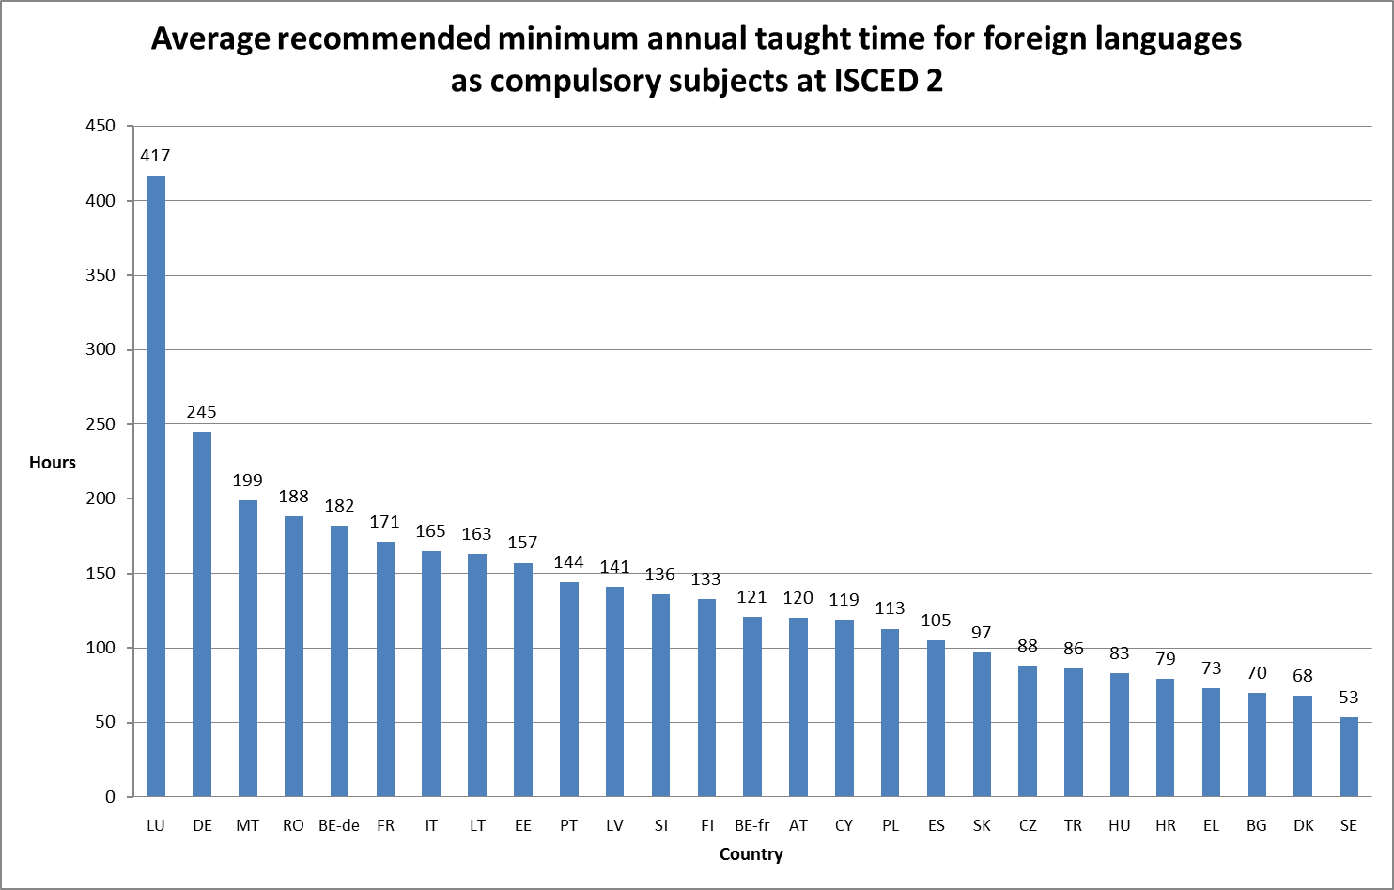

Only twelve countries have minimum hours at ISCED 3. Average teaching time at this level is 119 hours (about three hours a week); five countries have levels above this (CY, FR, HU, LT, RO).In around a quarter of countries, schools can decide the number of hours of foreign language learning. In six countries (EE, FI, IS, NO, PL, SE) schools can decide on how nationally set hours can be distributed across grades. In Ireland and the different parts of the UK, time for foreign language teaching is decided by the school and is often provided at ISCED 1 and 3 even though it is not compulsory.

Looking at recommended minimum taught hours for the **first foreign language** as a compulsory subject across ISCED 1 and 2 (see Figure 2.2), we can see that there is a very large range, with 1,778 hours for Luxembourg and 379 for Cyprus.

The median number of hours is 560 (average, 692) with over 800 in seven countries (BE-de, DE, ES, LI, LT, LU, MT) and under 500 in 11 countries (BE-fr, CY, EE, EL, FI, IS, LV, SE, SI, SK, TR).

For the second foreign language there is again a large range between the highest (1,346 for Luxembourg) and lowest (54 for Bulgaria) recommended minimum taught hours. The median number of hours here is 277 (average, 330), which is significantly lower than for the first foreign language. For the second foreign language, the minimum taught hours are shorter with only two countries having over 500 hours (LU, RO) and eight countries under 250 (BE-de, BG, CY, FI, FR, LV, PL, SI).

There is wide variation in the taught hours for the first foreign language (Data source: Eurydice 2010/2011, Key Data on Teaching Languages at School in Europe, 2012)[22]

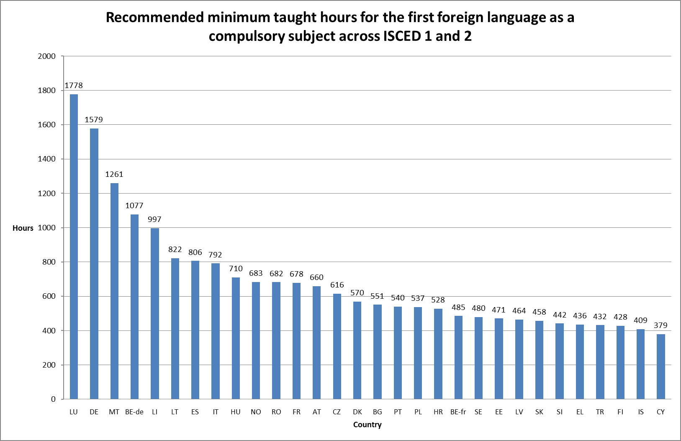

### Ages and durations of learning languages as compulsory subjects up to the end of ISCED2[23]

The average age for starting the **first foreign language** as a compulsory subject is 7.7 years old. Belgium (de) starts at three years old; two countries start at five years old (CY, MT); ten countries at six years old (AT, EE, ES, HR, IT, LI, LU, NO, PT, SK[24]); three countries at seven years old (FR, PL, SE); five countries at eight years old (CZ, DE, EL, LT, RO); nine countries at nine years old (BG, CH, DK, FI[25], HU, IS, LV, SI, TR); three countries at ten years old (BE-fr, BE-nl, NL); and three countries at 11 years old (UK-ENG, UK-NI, UK-WLS).

The average duration of the first foreign language as a compulsory subject for all students up to the end of ISCED 2 is 7.3 years. At the lower scale this is three years in UK England, Wales and Northern Ireland and four years in Belgium (fr and nl). At the higher end of the scale, Belgium (de), Cyprus, Estonia, Norway, and Spain (see Figure 2.3) have 10 or more years. The remaining 26 countries where a foreign language is compulsory are closer to the average and have durations of between 5 and 9 years covering most but not all of the time children are expected to be in education. For the Netherlands, the duration varies between 6 and 8 years depending on the educational pathway: prevocational education (6 years), senior general education (7 years), or pre-university education (8 years).

There is wide variation in the duration of learning a first foreign language (Data source: Eurydice 2010/2011, Key Data on Teaching Languages at School in Europe, 2012)

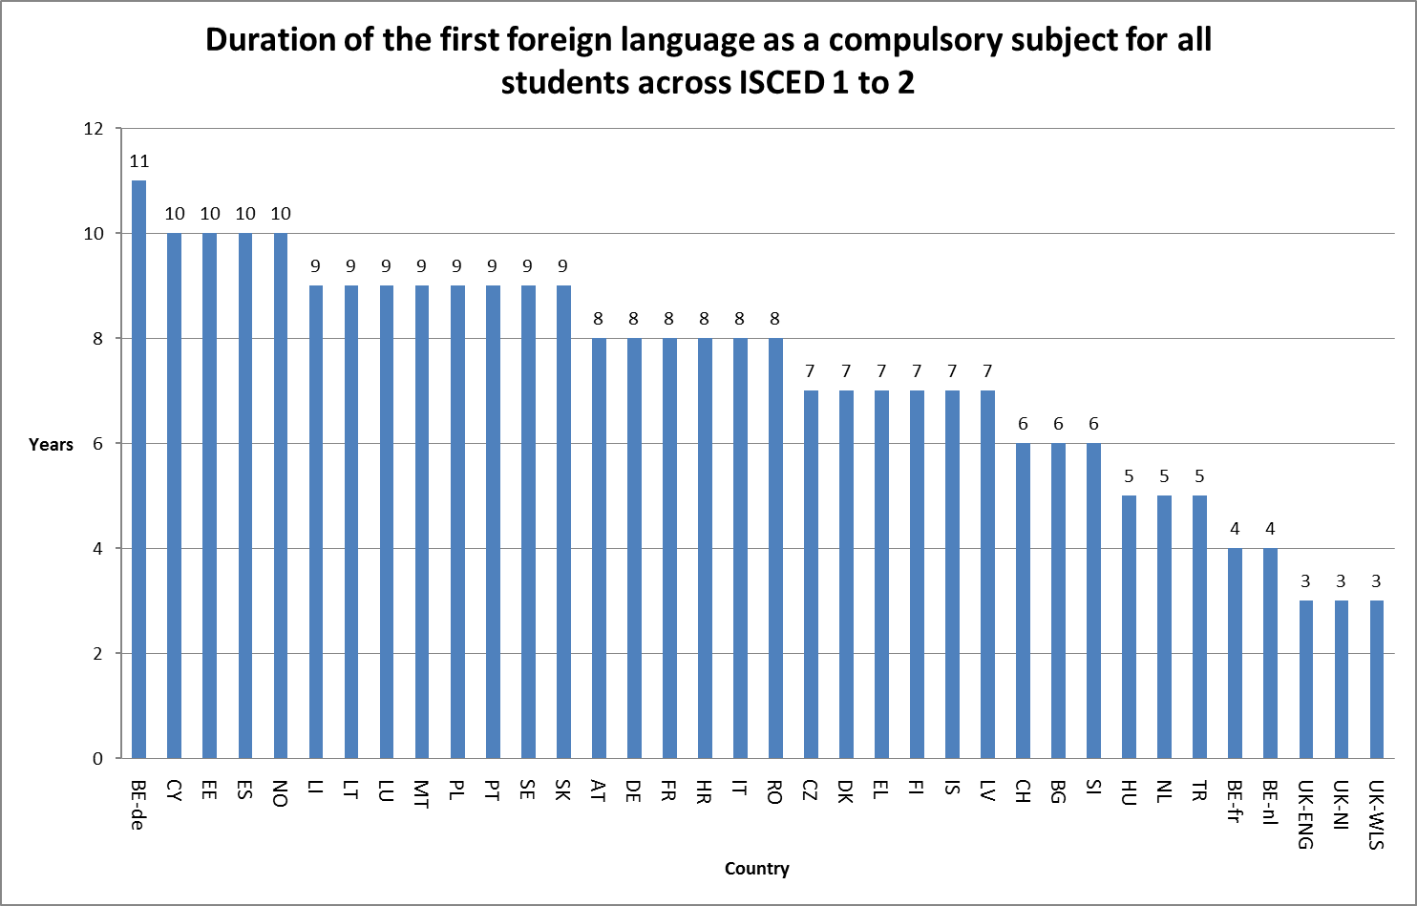

In 26 countries a **second foreign language** is compulsory. Where this is the case, the average age for starting the second foreign language as a compulsory subject is 12 years old. About 70% of countries (BE-de, BE-nl, CH, CY, EE, EL, FI, FR, IS, IT, LT, LV, MT, NL, PL, PT, RO, SI, SK[26]) have starting ages between 10 and 13 years old. Luxembourg starts the earliest at seven years old. Six countries have relatively older starting ages of 14 years old or above (AT, BG, CZ, HU, LI, NO). The average duration of the second foreign language as a compulsory subject up to the end of ISCED 2 is 3 years. Four countries have relatively long durations of six years and over (EE, IS, LU, RO). Two countries have relatively short durations of one year (BE-de, BE-nl). Six countries begin teaching after ISCED 2 (AT, BG, CZ, HU, LI, NO). See Figure 2.4 below. For the Netherlands, the duration varies between 0 and 3 years depending on the educational pathway: the basic vocational track in prevocational education (0 years), prevocational education (2 years), senior general education (3 years), or pre-university education (3 years).

There is wide variation in the duration of learning a second foreign language (Data source: Eurydice 2010/2011, Key Data on Teaching Languages at School in Europe, 2012)

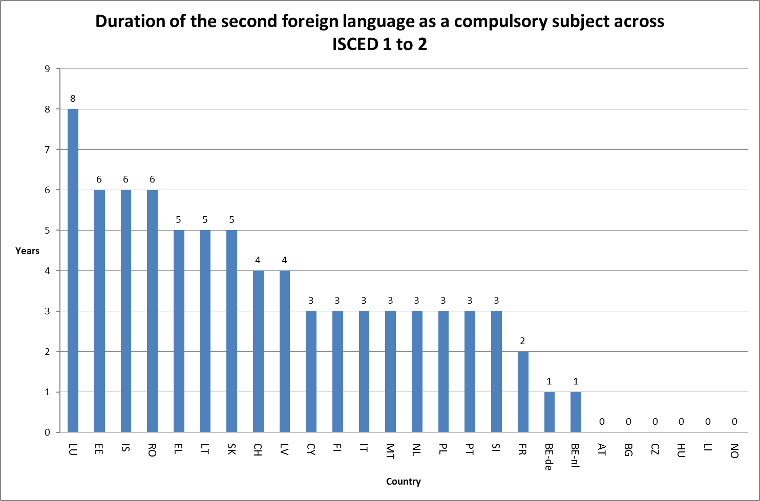

Over the last five or so years, there has been a tendency to start learning a first or second foreign language at an earlier age. Changes have occurred in, for example, Italy, Lithuania, Poland, and Portugal (first foreign language), Slovakia (first and second foreign language) and Romania (second foreign language).

There has been no significant change in the ages at which language learning is no longer compulsory.

### Foreign languages specified by central education authorities to be taught in compulsory education

In a little less than half of the countries, foreign languages are not specified by central education authorities in compulsory education. Where it is specified in all but one of these (Finland)[27] English is either one of the specified languages or the specified language. In nine cases English is the single specified language (DE, DK, EL, IT, MT, NL[28], NO, PT, SK). In five countries English is one of two languages, with the other one being French (BE-de, BE-nl, CY and LI), and Danish (IS). In Switzerland, English must be taught with one second national language, which is decided at the regional level. Luxembourg and Lithuania have three specified languages (English, French and German). In addition to English as a mandatory language, Swedish schools must offer at least two languages from French, Spanish and German during compulsory education, and all three languages at upper secondary education in addition to English.

### Entitlement to learning two foreign languages in the curriculum but outside compulsory foreign language learning

In countries where either a first (UK-SCT) or second language is not compulsory (BE-fr, DE, DK, ES, HR, UK-ENG, UK-NI, SE,) there is generally an expectation that foreign languages are taught as core curriculum options in ISCED 2 or 3. Ten countries (NO, PT, EL, MT, LI, CY, AT, LT, CZ, SI) also have provision for other foreign languages as core curriculum options in addition to having two foreign languages as compulsory components.

### Competence levels to be achieved

Many countries have CEFR based national guidelines for the minimum competence level in foreign languages in their curriculum assessments. These are set out in Figure 2.5[29].

Over half of the 26 countries that have guidelines at ISCED 2 for a first compulsory foreign language (AT, BE-nl, CH, CY, CZ, FI, HR, HU, IT, LI, PL, RO, SI, SK, UK-SCT) specify competency at level A2 of the CEFR (see Figure 2.5). Nearly all the rest specify level B1 (BE-de, DE, DK, EE, FR, LT, LV, PT, SE). Only Luxembourg and Greece have a minimum attainment level of B2.

For a second foreign language, most of the countries specifying competency at level A2 for a first foreign language specify A1 for the second (CY, CZ, FI, HR, RO, SK). Only Belgium (BE-nl) and Austria have the same level for the first foreign language as for the second (A2). Of the countries which specify level B1 for the first foreign language, three (DE, EE, PT) set the same level for the second foreign language, and five (DK, FR, LT, LV SE) specify the level below (which is A2). For those specifying B2, Luxembourg has B1 for the second while Greece has A2.

At ISCED 3, in more than two-thirds of countries the minimum attainment of competence for the first foreign language is B2 (AT, BE-de, CY, CZ, DE, EE, FR, IT, LT, LV, RO, SI, SK). Seven (BE-nl, ES, FI, HR, HU, PL, SE) specify B1 and only LU specifies C1. For the second foreign language at ISCED 3, most countries set the level below that for the first. The level for the first and second foreign language is the same for five countries (BE-nl, DE, EE, FI, LV).

Countries specify a range of competency levels (Data source: Eurydice 2012, Key Data on Teaching Languages at School in Europe, 2012)

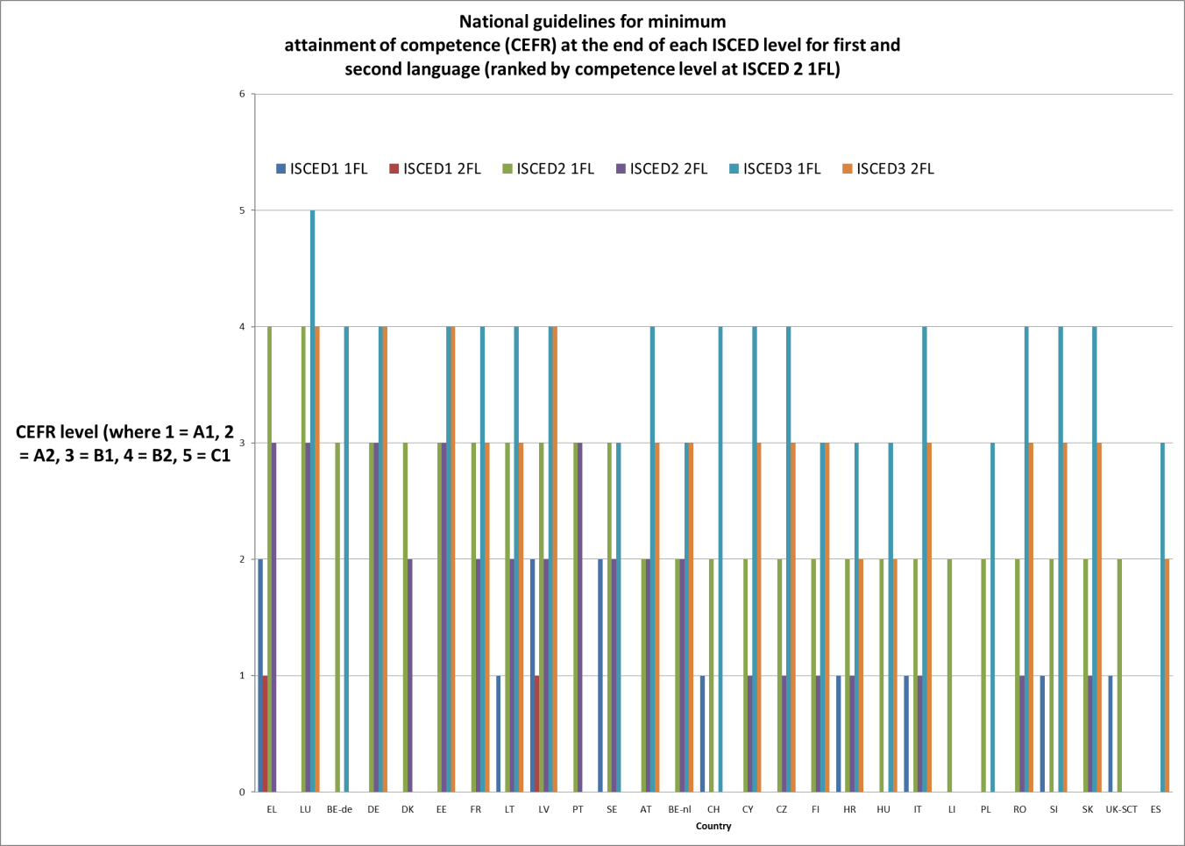

In some instances higher competence levels have been set often when policies have been introduced to increase the duration of language learning. This includes Greece and Lithuania.

### External assessment of language learning competences[30]

Four countries have external assessments at ISCED 1 (CZ, EE, MT, SI). Eleven countries have external assessments at ISCED 2 (CZ, BG, DK, EE, FR, IT, LV, MT, NL[31], PL, SK). Seventeen countries have external assessments at ISCED 3 (AT, CZ, DE, DK, EE, EL, FI, FR, HU, IT, LV, NL, PL, RO, SE, SI, SK).

It is not known how many of these are based on CEFR levels[32].

## Quantity of language learning in compulsory education

Where minimum hours for learning foreign languages and the duration of compulsory language learning are specified, the amount of time for learning can be estimated. This varies hugely between countries particularly between those with early ages for compulsory language learning and two compulsory languages and those with one compulsory language starting at a later age.

National assessment data is available for some of these countries (DK, EE, HU, SK, UK) and the results in some cases can be related to the CEFR. For example:

in Latvia 27% reached at least B2 in English at the end of ISCED 3 (72% at least B1);

in Sweden 96% passed B1 in English at the end of ISCED 2.

To use these results will require matching grades and passes to CEFR levels.

### Proportions of total curriculum time (all foreign languages)

At ISCED 1 the average percentage of the total curriculum time spent on languages is 8% (30 countries). Two countries, Luxembourg (41%) and Malta (15%), have relatively high levels. The lowest level is 2% in Austria.

At ISCED 2 the proportion of total time in the curriculum for all foreign languages rises to an average of 16%. Three countries (DE, FR, LU, MT) have relatively high levels of 20% or higher and four countries (CZ, DK, ES) have relatively low levels of 10% or lower. The remaining 22 countries are closer to the average and are between 11% and 19%. While Luxembourg and Malta have the highest proportions at both levels, for other countries overall there is no relationship between the proportions at ISCED 1 and ISCED 2.

### Changes in the number of hours devoted to the learning of foreign languages

Data is available on changes in the recommended minimum number of hours of compulsory foreign language learning during a notional year in primary and full-time compulsory general secondary education between 2006/07 and 2010/11.

At ISCED 1, 12 countries (CZ, ES, FR, HU, IS, LI, LT, LU, NO, PL, RO, TR) have seen increases; three countries have seen decreases (DK, EL, MT) and 12 countries have not changed (AT, BE-de, BE-fr, BG, DE, EE, FI, IT, LV, PT, SI, SE).

At ISCED 2, 10 countries (BE-de, CZ, HU, IS, LT, NO, PL, RO, SI, SK) have seen increases; five countries have seen decreases (BG, ES, LU, MT, PT)[33] and 10 countries have not changed (AT, BE-fr, DK, EE, EL, FI, FR, LV, TR, SE).

### Proportions of students not learning languages[34]

At ISCED 1 the average percentage of students **not** learning a foreign language is 27%. The proportions vary greatly between countries with the lowest level being 0% and the highest being 95%. In the bottom quartile (AT, ES, HR, IT, LI, LU, MT, NO) the proportions are very small (ranging from 0% to 1.1%). Fifteen countries are in the two middle quartiles (BG, CZ, DK, EL, FI, FR, IS, LT, LV, PL, RO, SE, SK, TR, UK) where there is a range of between 2.7% and 41%. The group of eight countries in the upper quartile (BE-fr, BE-nl, CY, IE, NL, PT, SI, HU) have percentages of over 43%, the highest being Ireland at 95%.

At ISCED 2, the average percentage of students learning no foreign languages is just 1.8%. Seven countries (BE-nl, HU, IE, LT, PL, PT, UK) have proportions in excess of the average, ranging up to 16.9%. Thirteen countries (CY, DK, EL, FR, HR, IT, LI, LU, MT, NL, RO, SE, SI) have very low proportions of 0.2% and below.

### Proportions of students learning one or more languages

At ISCED 1 65% of students are on average learning one foreign language. Eight countries (AT, ES, FR, IT, LI, MT, NO, PL) have percentages between 83% and 100% (the top quartile). Eight countries (BE-nl, CY, EL, IE, LU, PT, NL, SI) have percentages between 4.6% and 50% (the bottom quartile).

This is partly explained by the percentage of students learning two foreign languages at ISCED 1, which is on average only 8.7%. See Figure 2.6 below. Here, eight countries (EL, FI, HR, IS, LU, LV, PL, SE) have percentages between 12% and 84% (the top quartile) (see Figure 2.6). Seven countries in the bottom quartile have virtually none (DK, LI, MT, NL, NO, TR, UK).

There is wide variance in the percentage of students learning two foreign languages at ISCED 1 (Data source: Eurostat, 2011)

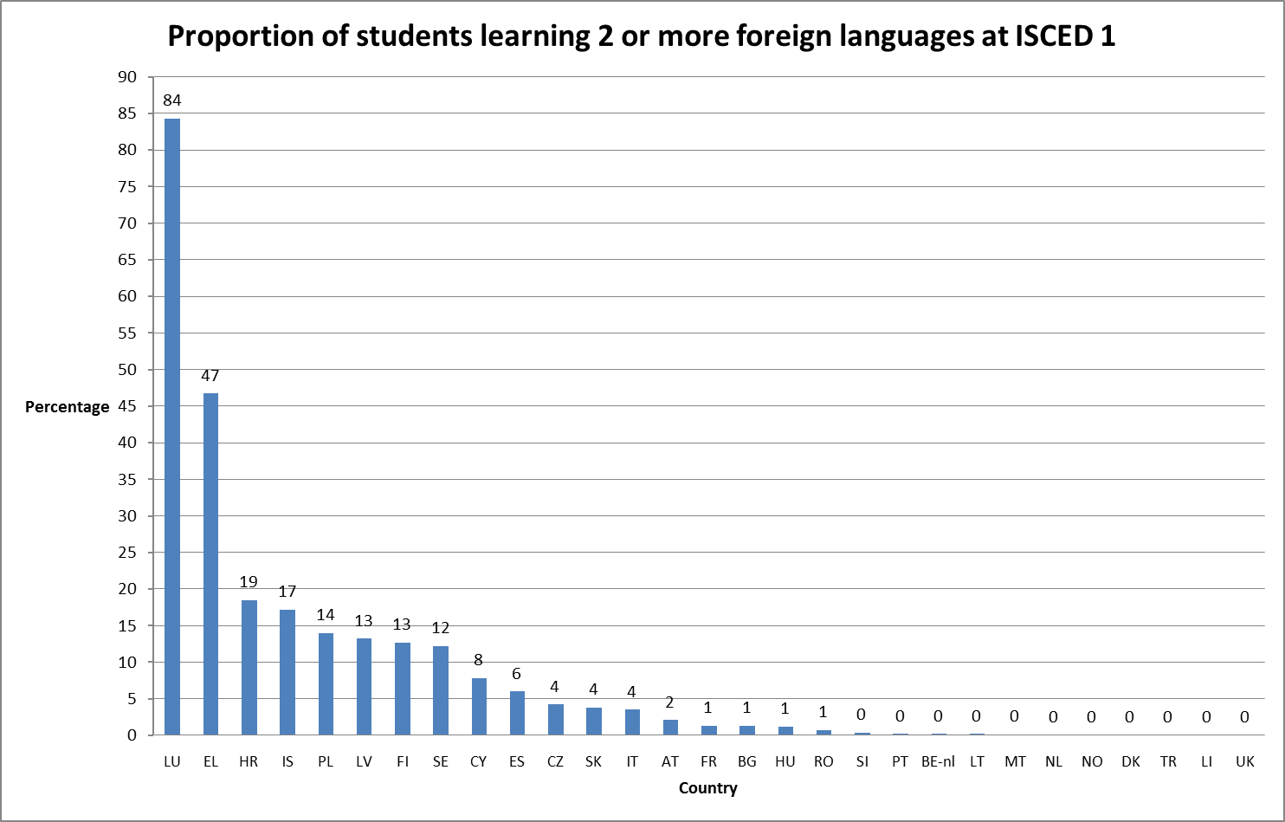

At **ISCED 2** on average 37% of students are learning one foreign language. Eight countries (AT, BE-fr, BG, CZ, ES, HU, IE, UK) have percentages between 59% and 99% (the top quartile). Fourteen countries (BE-nl, DK, FR, HR, LT, LV, MT, NL, NO, PL, PT, SE, SI, SK) have percentages between 10% and 50% (the inter-quartile range). Eight countries (CY, EL, FI, IS, IT, LI, LU, RO) have percentages between 0% and 7.5% (the bottom quartile).

Most of these countries have very high proportions learning two languages (CY, EL, FI, IS, IT, LI, LU, RO, have between 92% and 100%). The average percentage of students learning two foreign languages at ISCED 2 is 64%. Seven countries (AT, BG, CZ, ES, HU, IE, UK[35]) have percentages between 0% and 40% (the bottom quartile) (see Figure 2.7).

Several countries where a second foreign language is not compulsory during or throughout ISCED 2 have relatively high proportions of students learning two languages. This is particularly the case in Sweden (76%, not compulsory) and Belgium (nl) (49%, compulsory for one year).

There is wide variance in the percentage of students learning two foreign languages at ISCED 2 (Data source: Eurostat, 2011)

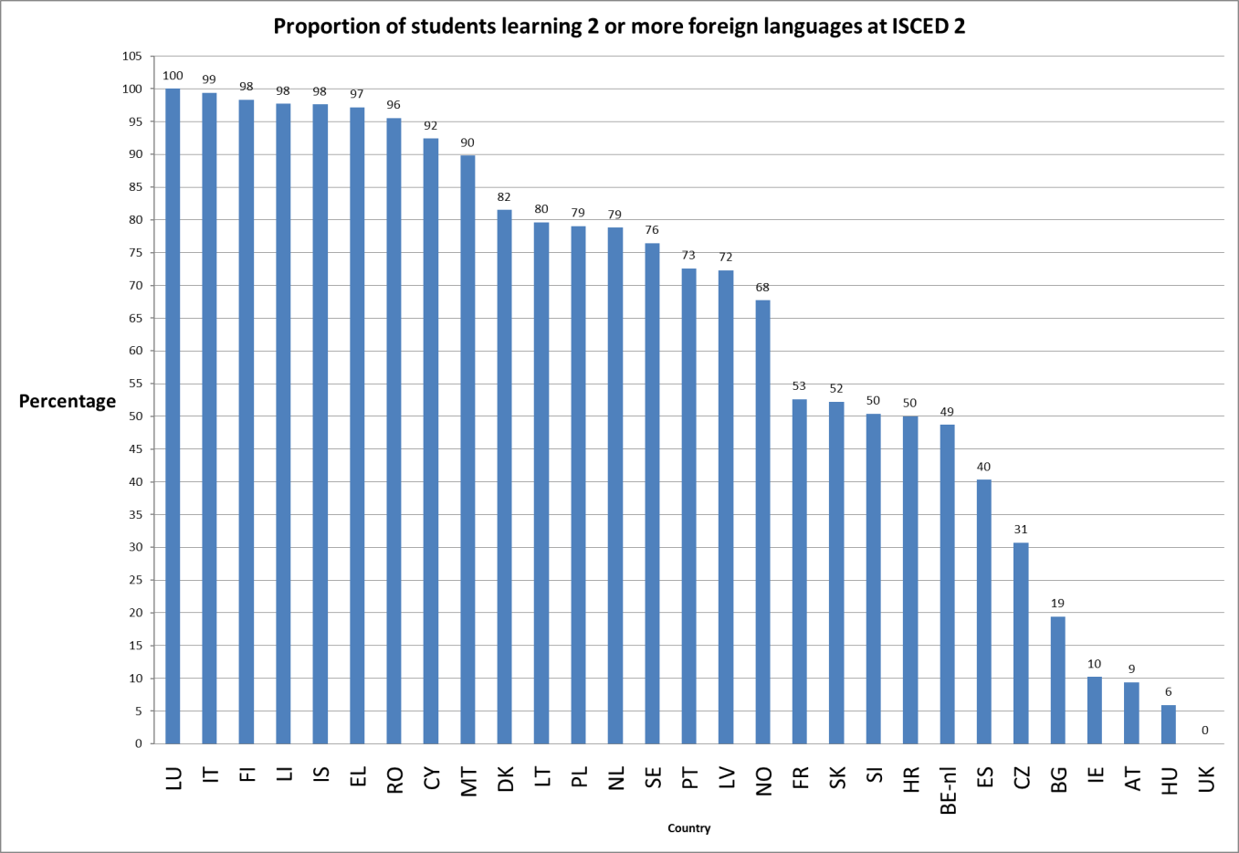

At **ISCED 3 (general education),** the average percentage of students learning one foreign language is 29% and two foreign languages is 66%. Eight countries (EL, ES, HU, IE, IT, LT, MT, PT) have percentages of between 50% and 93% students learning one language (the top quartile), and eight other countries (BE-nl, CZ, FI, LI, LU, RO, SK, SI), have nearly all their students learning two languages (the top quartile - 99% to 100%). Eight countries (EL, ES, IE, IT, LT, MT, PT, UK) have relatively few learning two languages (between 5% and 43%, the bottom quartile).

At **ISCED 3 (vocational),** the average percentage of students learning one foreign language is 58% and two foreign languages is 30%. Six countries (AT, DK, HU, IE, MT, SE) have percentages of between 76% and 100% (the top quartile) learning one language and six different countries (BE-nl, BG, LU, PL, RO, SK) have percentages between 47% and 90% learning two.[36]

Figure 2.8 compares the proportions of students learning two or more foreign languages in general and vocational education. While in nearly all cases the proportion in vocational pathways is lower, those with high proportions in general education do not necessarily have the highest proportions in vocational education.

The pattern in ISCED 3 general is not matched by that of ISCED 3 vocational (Data source: Eurostat, 2011)

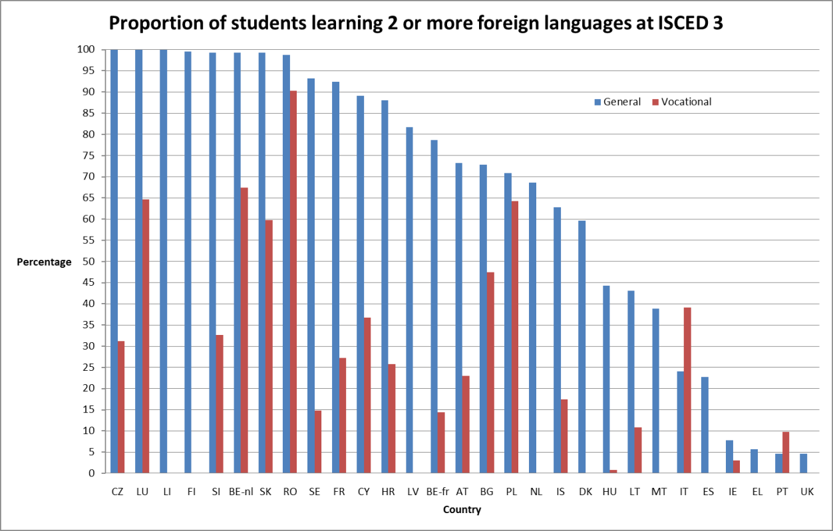

The average number of languages learned in upper secondary general (1.7) is higher than the average number for upper secondary vocational (1.1). For general education, nine countries (BE-nl, CZ, FI, FR, RO, SE, SI SK,) have two or more languages learned, whereas for vocational education and training (VET) there is only one country with this amount (LU). Most other countries (AT, BE-fr, BG, CY, DE, DK, EL, ES, HR, HU, IS, IT, PL, LT, LV, MT, NL, NO) have on average between one and two languages being learnt in upper secondary general. This is also true for upper secondary vocational where 17 countries have between one and two languages being learnt (AT, BE-nl, BG, CY, CZ, FR, HR, IE, IT, LT, LV, MT PL, RO, SI, SK, SE). In general upper secondary education, just four countries (IE, PT, TR, UK) have on average less than one language learnt. The figure for vocational is nine (BE-fr, DE, DK, EL, HU, IS, NO, PT, TR).

## Outcomes and results of language learning

Only 14 countries participated in the ESLC survey testing the competency of a sample of students aged 15.[37]

The results show that in the first foreign language learnt on average 42% achieved an independent user level or better (B1 or above on the CEFR). This ranges from over 80% in Malta and Sweden (both in English) to less than 15% in France (for English) and UK England (for French). In four countries, over 60% achieved level B1 or better (EE, MT, NL, SE) while in seven this was under 33% (BE-fr, BE-nl, FR, PT, PL, ES, UK England). This also means that large proportions of learners tested achieved only level A1 or below, more than half in ES, FR, PL, PT, UK England.

For the second foreign language[38] learnt, on average 26% achieved an independent user level or better. Taking the proportion achieving the level below (A2), this ranges from three countries with more than 60% achieving this (BE-de, BE-nl, NL) to seven with under 33% achieving this (BG, FR, HR, PL, PT, SE, UK England). This also means that in only one country more than half of the learners tested achieved B1 or better (BE- de and nl) and in 11 countries more than half achieved only A1 or below.

Figure 2.9 below shows that countries do not necessarily have similar proportions achieving these competency levels in the first and second language. There are large differences in BE –de, BE –nl, EL, ES, and SE.

Proportions of learners achieving competencies are variable (Data source: ESLC, 2011)

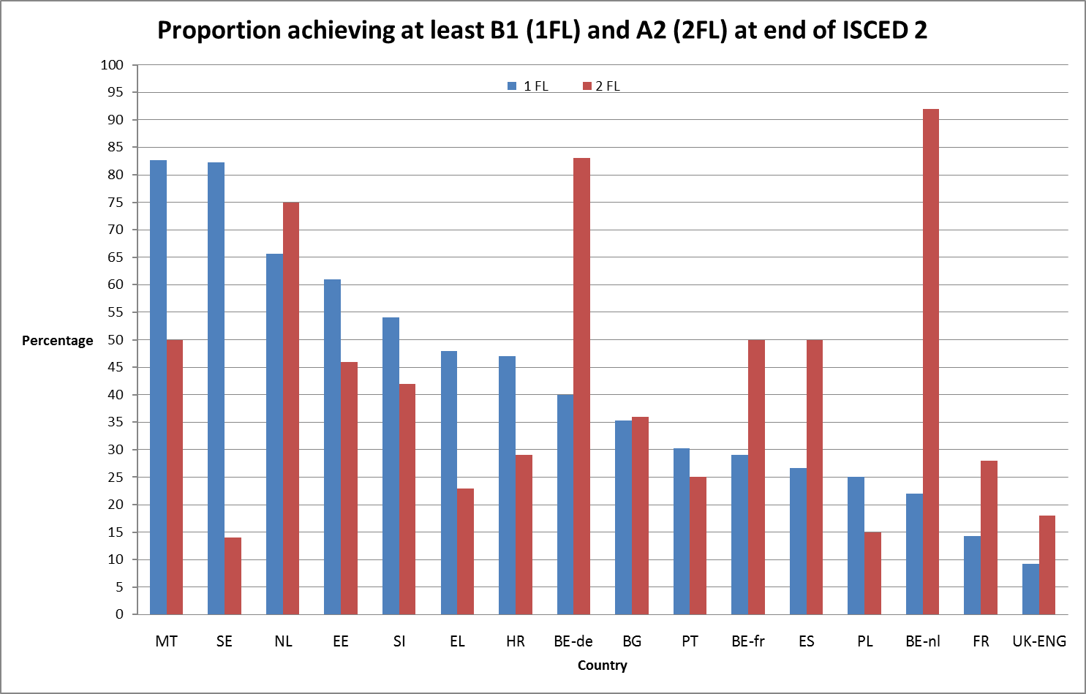

Figures 2.10 and 2.11 show the considerable variation in the range of competency levels achieved by the participating countries.

Proportions of students achieving different competency levels (Data source: ESLC, 2011)

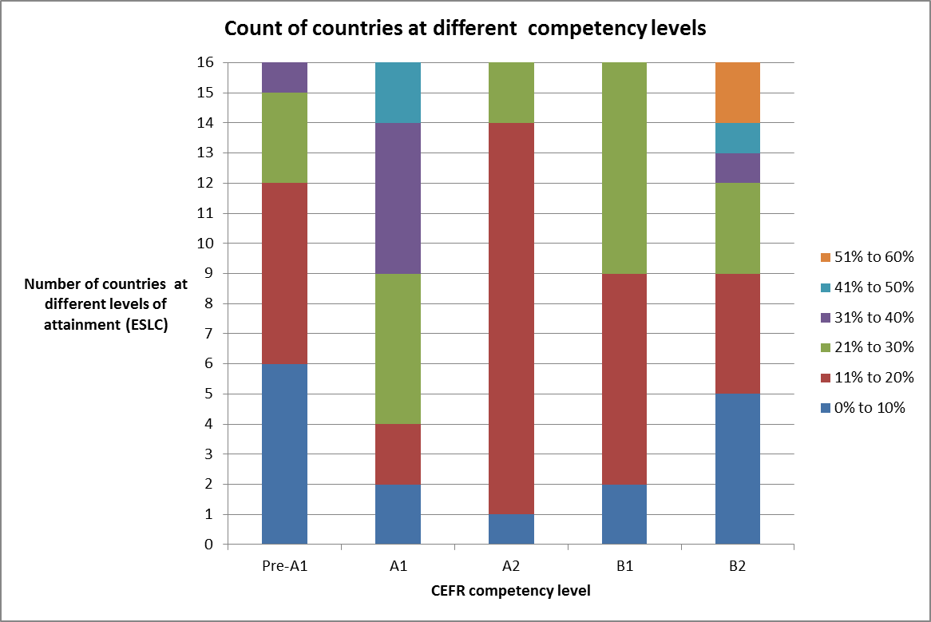

Competency level distribution in the participating countries (Data source: ESLC, 2011)

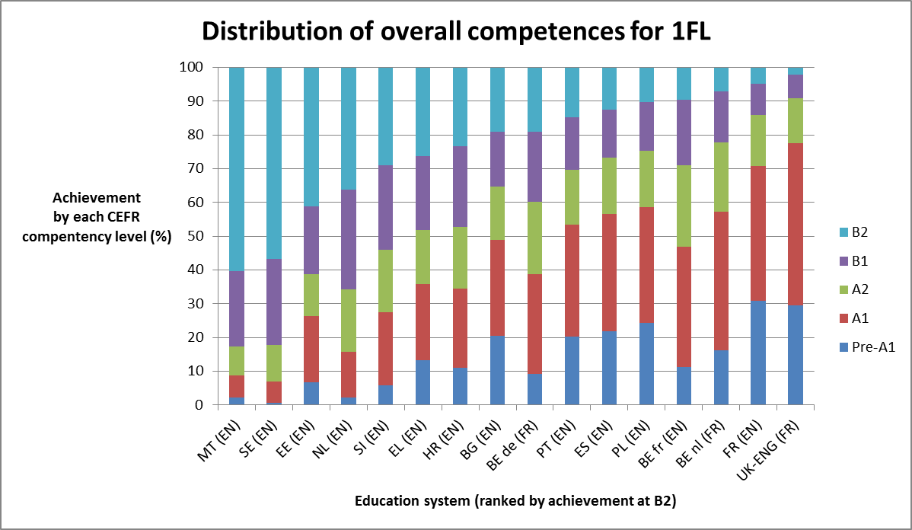

## Relationships between learning available, ambitions and achievement in languages

### Hours of learning and competency levels expected

In the main the hours of learning provided by countries up to the end of ISCED 2 for a first foreign language are well in excess of the rough estimates of guided learning hours recommended for the levels of competence specified which are 180-200 hours for level A2 and 350-400 hours for level B1 (see Table 2.1).[39] The exceptions are Estonia and Latvia. Only Greece, which aims for B2, has hours that are lower than the guideline hours (see Figure 2.12)

Nearly all countries have recommended minimum taught hours in excess of recommended guideline hours (Data source: Eurydice 2012, Key Data on Teaching Languages at School in Europe, 2012)[40]

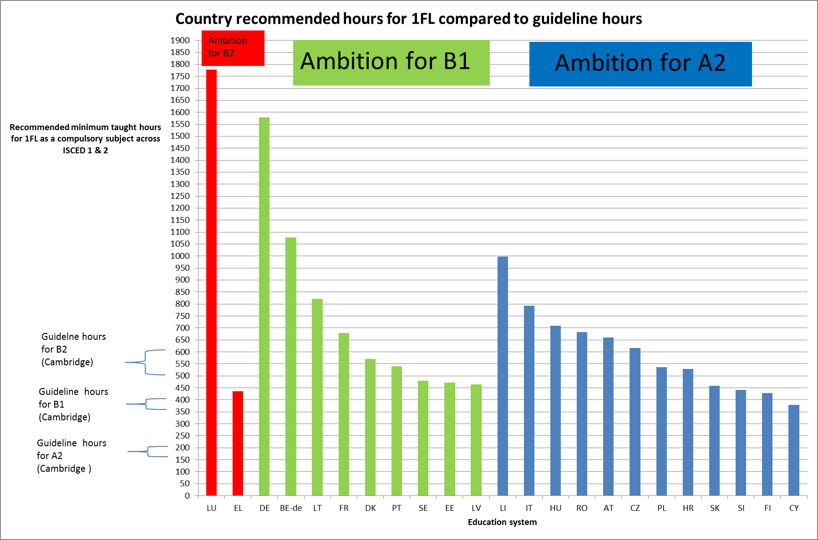

On the second foreign language most are also in excess though there are more exceptions around or below the recommended guided learning hours (PT, LV). This can be seen in Table 2.2 below (from column 1).

For the first foreign language there is not a clear relationship between the minimum number of guided learning hours recommended and the competence level to be reached (comparing column 1 and column 2 in Table 2.1 below). While some countries which provide over 600 hours of learning specify level B1 or B2 (BE-de, DE, FR, HU, IT, LU) to be achieved; others specify A2 (AT, CZ, RO). Equally two countries with fewer than 500 hours of learning up to the end of ISCED 2 specify B1 (EE, LV) or B2 (EL). For the second foreign language level B1 is specified with hours ranging from 270 (PT) to over 1000 (LU) and A1 from under 150 (CY) to over 500 (RO).

Ranking of countries by number of recommended minimum taught hours for a first foreign language (1FL) as a compulsory subject across ISCED 1 & 2 (Data source: Eurydice, Key Data on Teaching Languages at School in Europe, 2012)

| Country | Total recommended minimum taught hours for 1FL as a compulsory subject across ISCED 1 & 2[41] (2010/2011) | National guidelines for minimum attainment of competence at end of ISCED2 (2012) | % attaining B1 in  1FL at end of ISCED2 (ESLC, 2011) |
| --- | --- | --- | --- |
| LU | 1778 | B2 |  |
| DE | 1579 | B1 |  |
| MT | 1261 |  | 83% |
| BE-de | 1077 | B1 | 40% |
| LI | 997 | A2 |  |
| LT | 822 | B1 |  |
| ES | 806 |  | 27% |
| IT | 792 | A2 |  |
| HU | 710 | A2 |  |
| NO | 683 |  |  |
| RO | 682 | A2 |  |
| FR | 678 | B1 | 14% |
| AT | 660 | A2 |  |
| CZ | 616 | A2 |  |
| DK | 570 | B1 |  |
| BG | 551 |  | 35% |
| PT | 540 | B1 | 30% |
| PL | 537 | A2 | 25% |
| HR | 528 | A2 | 47% |
| BE-fr | 485 |  | 29% |
| SE | 480 | B1 | 82% |
| EE | 471 | B1 | 61% |
| LV | 464 | B1 |  |
| SK | 458 | A2 |  |
| SI | 442 | A2 | 54% |
| EL | 436 | B2 | 48% |
| TR | 432 |  |  |
| FI | 428 | A2 |  |
| IS | 409 |  |  |
| CY | 379 | A2 |  |
| IE | No compulsory FL |  |  |
| UK-SCT | No compulsory FL | A2 |  |
| BE-nl | Flexible | A2 | 22% |
| NL | Flexible |  | 66% |
| UK-ENG | Flexible |  | 9% |
| UK-NI | Flexible |  |  |
| UK-WLS | Flexible |  |  |

The variability is clearer in Figure 2.13 below. For example, Latvia has 464 hours for level B1 while Hungary has 710 hours for level A2; France and Austria have similar curriculum hours but Austria expects A2 while France expects B1.

Individual countries recommended minimum taught hours do not appear to be associated with whether the national guideline for minimum attainment of competence is A2 or B1 (Data source: Eurydice, Key Data on Teaching Languages at School in Europe, 2012)

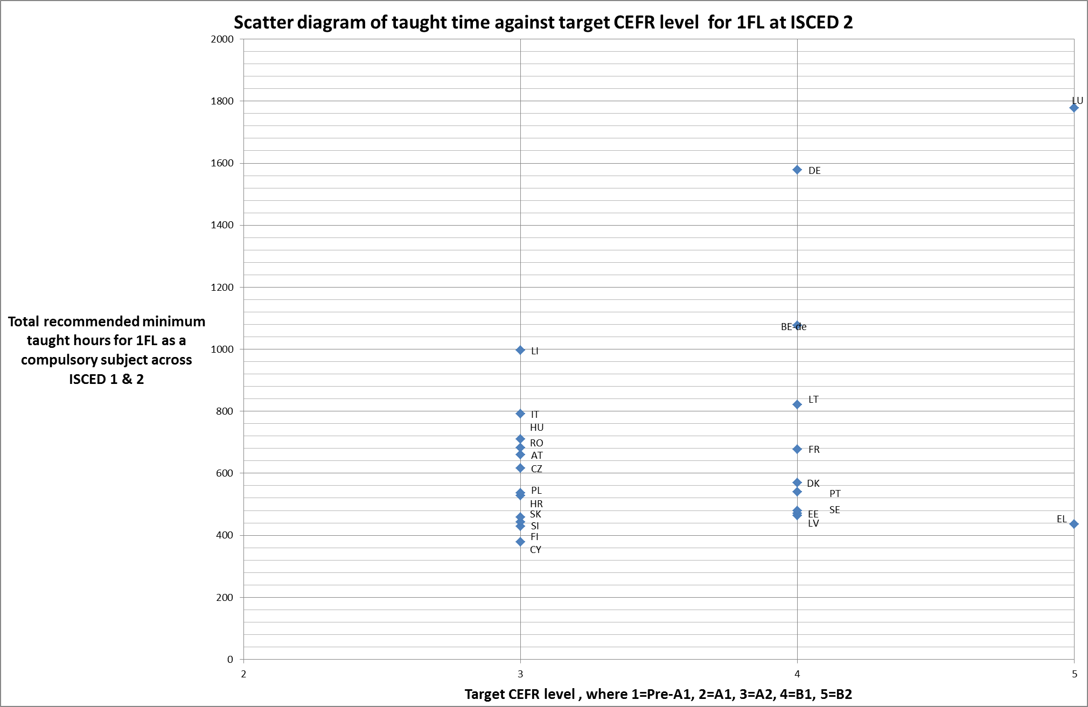

There is similar variability in the recommended minimum guided learning hours for the **second foreign language** as a compulsory subject across ISCED 1 & 2 and the competency levels expected. Table 2.2 shows that there is a very wide range of curriculum hours from under 150 to over 500 and no clear relationship with the competency levels expected. However, in contrast to the first foreign language, some countries have recommended hours that fall below the recommended hours for levels A2 and B1 (LV and PT), although most are in excess.[42]

Ranking of countries by number of recommended minimum taught hours for a second foreign language (2FL) as a compulsory subject across ISCED 1 & 2 (Data source: Eurydice, Key Data on Teaching Languages at School in Europe, 2012)

| Country | Total recommended minimum taught hours for 2FL as a compulsory subject across ISCED 1 & 2[43] (2010/2011) | National guidelines for minimum attainment of competence at end of ISCED2 (2012) | % attaining A2 or higher in 2FL at end of ISCED2 (ESLC, 2011) |
| --- | --- | --- | --- |
| LU | 1346 | B1 |  |
| RO | 564 | A1 |  |
| MT | 498 |  | 50% |
| IS | 400 |  |  |
| EE | 393 | B1 | 46% |
| LT | 350 | A2 |  |
| IT | 297 | A1 |  |
| HU | 295 | A2 |  |
| SK | 286 | A1 |  |
| EL | 278 | A2 | 23% |
| PT | 270 | B1 | 25% |
| FR | 210 | A2 | 28% |
| SI | 205 |  | 42% |
| FI | 200 | A1 |  |
| BE-de | 197 |  | 83% |
| PL | 169 |  | 15% |
| LV | 142 | A2[44] |  |
| CY | 122 | A1 |  |
| BG | 54 |  | 36% |
| AT | None specified in data | A2 |  |
| CZ | None specified in data | A1 |  |
| LI | None specified in data |  |  |
| NO | None specified in data |  |  |
| DE | No compulsory FL | B1 |  |
| BE-fr | No compulsory FL |  | 50% |
| ES | No compulsory FL |  | 50% |
| TR | No compulsory FL |  |  |
| HR | No compulsory FL | A1 | 29% |
| DK | No compulsory FL | A2 |  |
| SE | No compulsory FL | A2 | 14% |
| IE | No compulsory FL |  |  |
| UK-SCT | No compulsory FL |  |  |
| BE-nl | Flexible | A2 | 92% |
| NL | Flexible |  | 75% |
| UK-ENG | Flexible |  | 18% |
| UK-NI | Flexible |  |  |
| UK-WLS | Flexible |  |  |

### Hours of learning and competency levels achieved

The rationale for increasing hours of teaching and guided learning is that starting language learning at an earlier age and having more guided learning will increase language competence. As a consequence we might expect that there should be an identifiable correlation between the amount of teaching available and the competencies achieved. Figure 2.14 shows no strong relationship between teaching time for the first foreign language and achievement. Although Malta has a high level of achievement and a large amount of teaching while Poland has a lower level of achievement and far fewer hours, there are many countries with similar amounts of teaching but very different results.

Achievement is not correlated with taught time for the 1FL (Data source: Eurydice 2010/2011, Key Data on Teaching Languages at School in Europe, 2012 / ESLC, 2011)

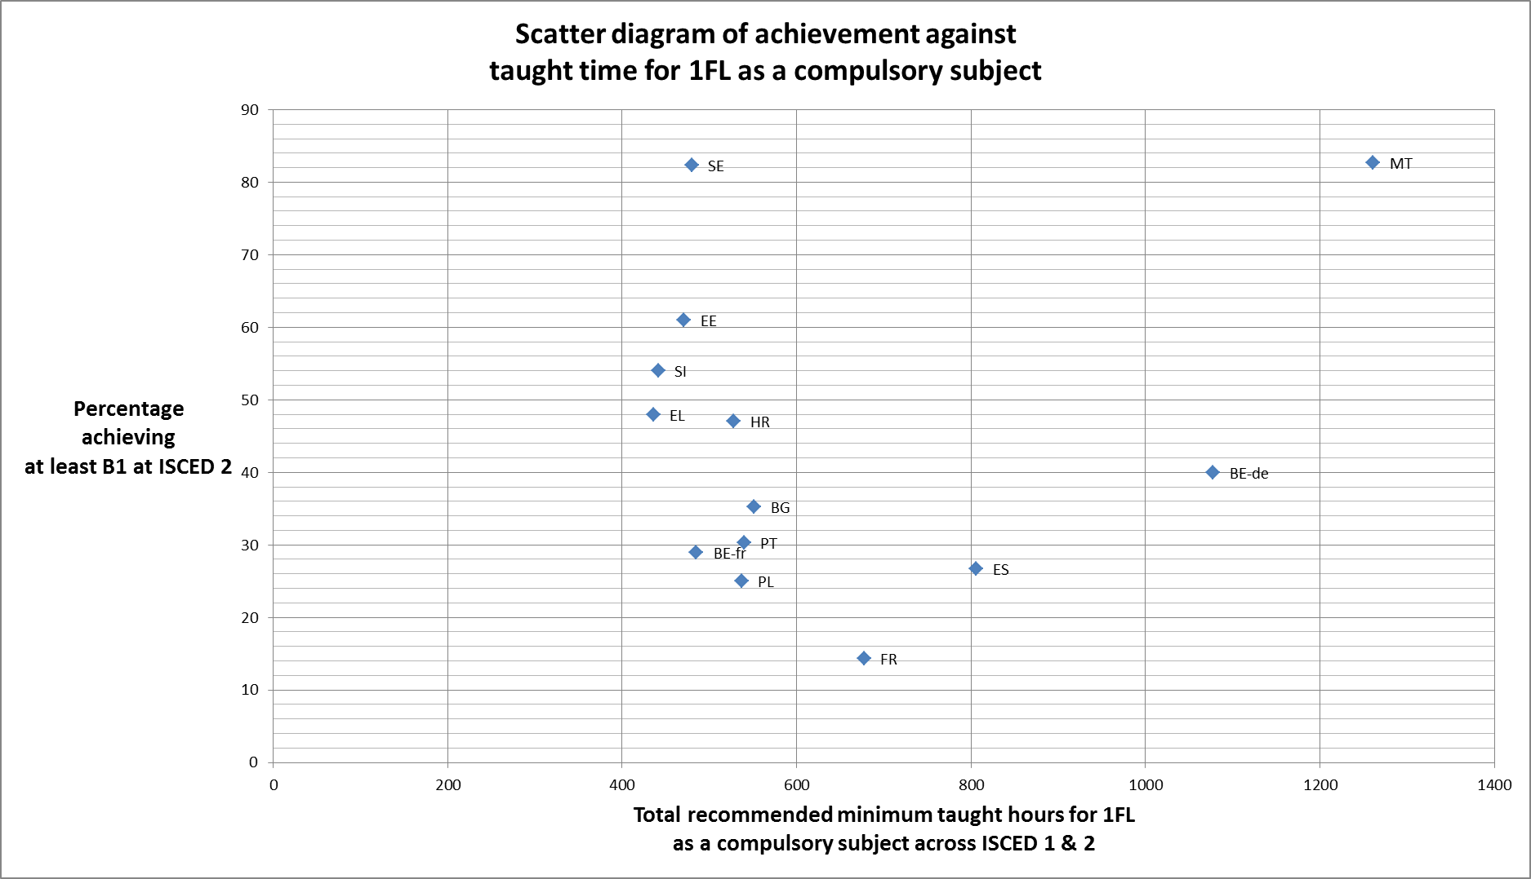

There is a little closer relationship for the second foreign language but much variability. Figure 2.15 shows similar levels of achievement are obtained from under 200 hours of learning as over 450 hours, and very different results from 200-300 hours of teaching.

Achievement is not correlated with taught time for the 2FL (Data source: Eurydice 2010/2011, Key Data on Teaching Languages at School in Europe, 2012 / ESLC, 2011)

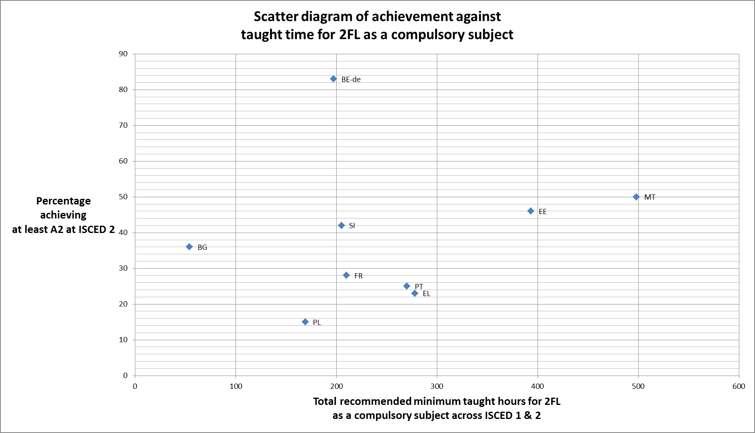

The same is true when looking at the correlation between achievement and durations of learning first and second languages. The scatter diagrams in Figure 2.16 and 0 show no clear association between the two sets of data.

Achievement is not correlated with duration of the 1FL (Data source: Eurydice 2010/2011, Key Data on Teaching Languages at School in Europe, 2012 / ESLC, 2011)

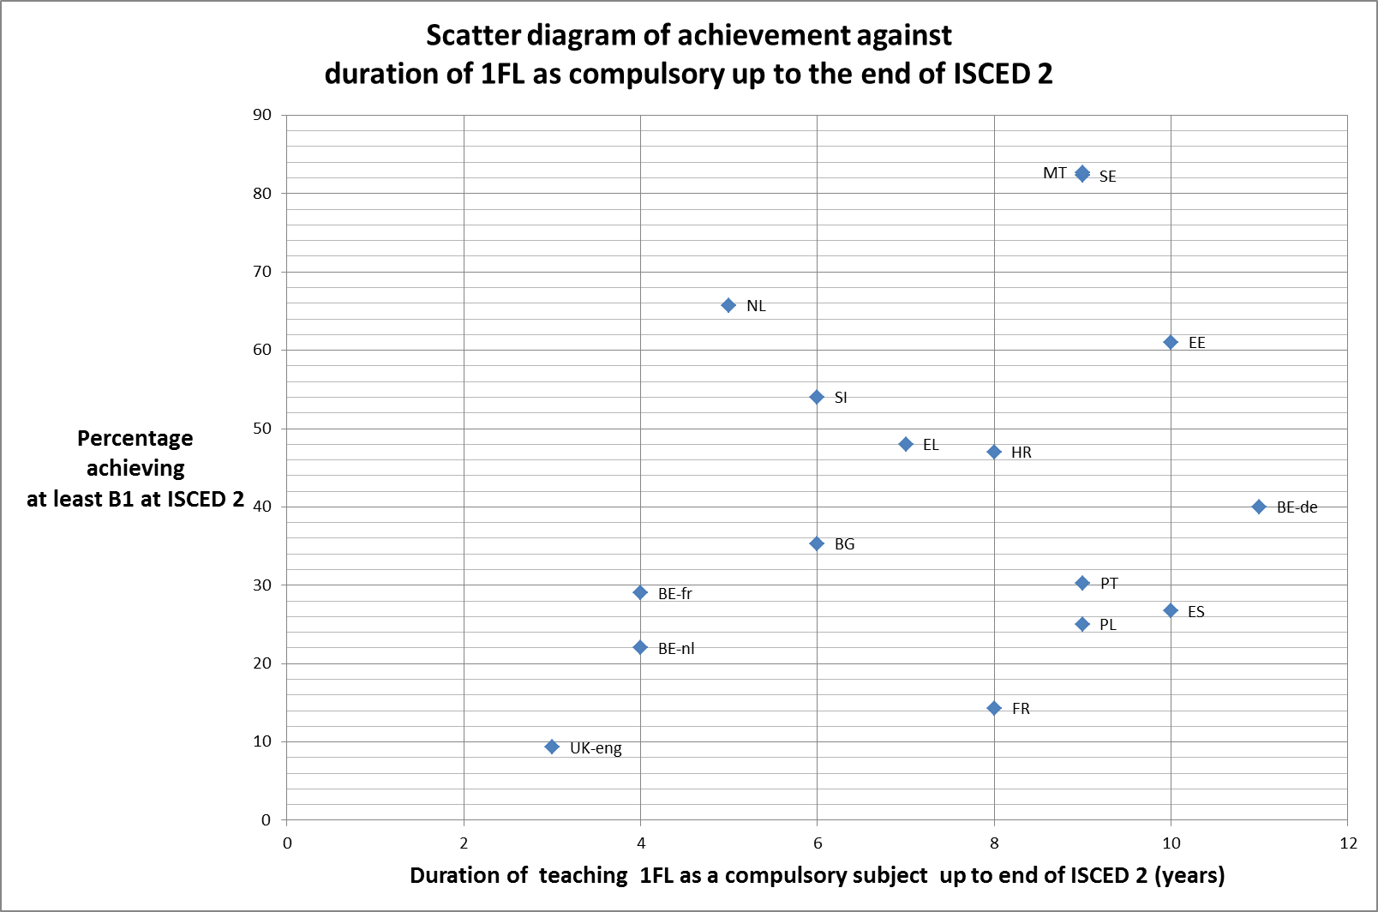

Achievement is not correlated with duration of the 2FL (Data source: Eurydice 2010/2011, Key Data on Teaching Languages at School in Europe, 2012 / ESLC, 2011)

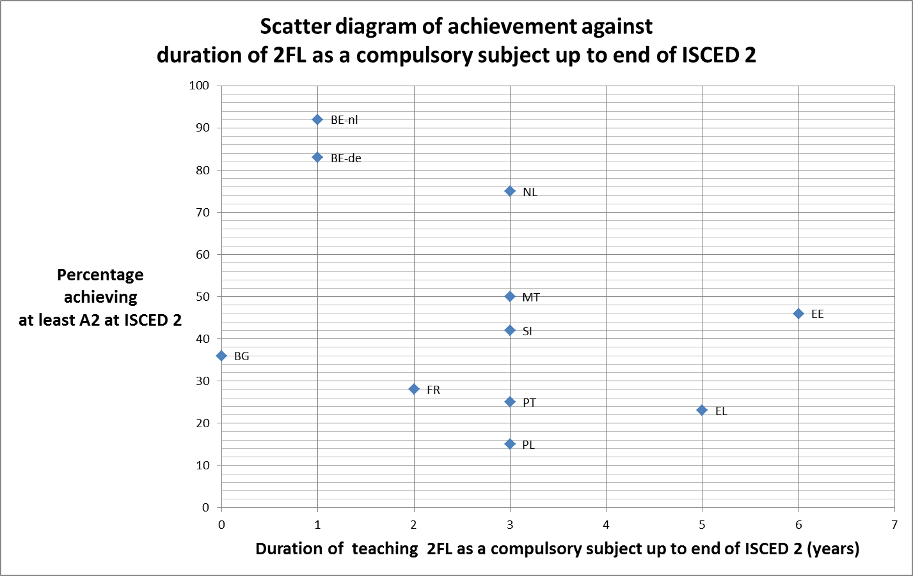

We might expect a time lag between policies to increase the duration of learning and curriculum time and improved competencies being achieved since this may take five or more years to have an effect on those reaching the end of ISCED 2, for example. Figure 2.18 plots the percentage achieving BI in 2011 against the duration/hours in place in 2007. This shows a slightly closer relationship than in Figure 2.16 but a considerable spread of achievement for similar amounts of guided learning time.

Achievement is not closely correlated with duration of learning the 1FL in 2007 (Data source: Eurydice / ESLC, 2011)

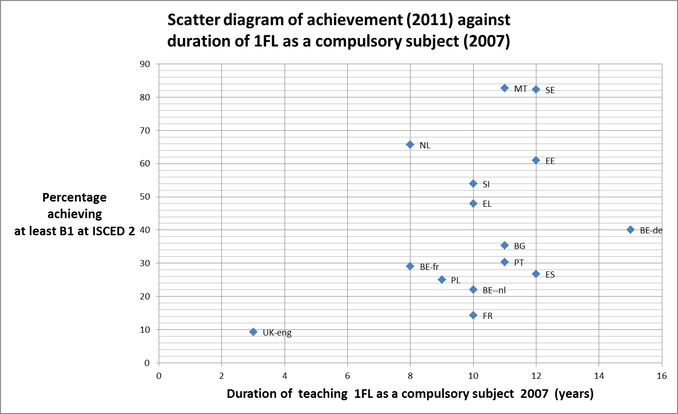

The same data provides a measure of effectiveness in teaching languages if we convert the competencies achieved by learners tested to an average score and compare this as a ratio to the curriculum hours recommended for teaching. A higher ratio suggests greater effectiveness. Table 2.3 below shows a large variation in the ratio and differences arising because similar levels are achieved from different levels of teaching.

For example, Sweden achieves an average score of 4.3 with 480 hours whereas Malta achieves the same level with 1,261 hours. Indeed, most of the countries with an average score above 3 have around 450-500 taught hours while countries with lower scores have more curriculum hours.

Competency against amount of compulsory learning for the first target language (Data source: Eurydice 2010/2011, Key Data on Teaching Languages at School in Europe, 2012 / ESLC, 2011)

| Country[45] | Average CEFR score, where pre-A1 = 1 and B2 = 5) (ESLC, 2011) | Total recommended minimum taught hours for 1FL as a compulsory subject across ISCED 1 & 2[46] | Ratio of score to time (representing competency score per 100 hours of learning) |
| --- | --- | --- | --- |
| SE (EN) | 4.3 | 480 | 0.9 |
| SI (EN) | 3.5 | 442 | 0.8 |
| EE (EN) | 3.7 | 471 | 0.8 |
| EL (EN) | 3.3 | 436 | 0.7 |
| HR (EN) | 3.3 | 528 | 0.6 |
| BE fr (EN) | 2.8 | 485 | 0.6 |
| BG (EN) | 2.8 | 551 | 0.5 |
| PT (EN) | 2.7 | 540 | 0.5 |
| PL (EN) | 2.5 | 537 | 0.5 |
| MT (EN) | 4.3 | 1261 | 0.3 |
| ES (EN) | 2.6 | 806 | 0.3 |
| FR (EN) | 2.2 | 678 | 0.3 |
| BE de (FR) | 3.1 | 1077 | 0.3 |

For the second foreign language (Table 2.4) the ratio is higher in many cases but the differences are again considerable. For example, Bulgaria achieves an average score of 1.4 with 54 hours whereas Portugal achieves less than this with 270 hours. For the second foreign language for BE-fr, ES, HR, and SE average scores range from 0.8 to 1.8.

Competency against amount of compulsory learning for the second target language (Data source: Eurydice 2010/2011, Key Data on Teaching Languages at School in Europe, 2012 / ESLC, 2011)

| Country | Average CEFR score, where pre-A1 = 1 and B2 = 5) (ESLC, 2011) | Total recommended minimum taught hours for 2FL as a compulsory subject across ISCED 1 & 2[47] | Ratio of score to time (representing competency improvement per 100 hours of taught hours, on a scale where pre-A1 = 1 and B2 = 5) |
| --- | --- | --- | --- |
| BG (DE) | 1.4 | 54 | 2.6 |
| BE de (EN) | 2.6 | 197 | 1.3 |
| SI (DE) | 1.6 | 205 | 0.8 |
| FR (ES) | 1.2 | 210 | 0.6 |
| PL (DE) | 0.8 | 169 | 0.5 |
| PT (FR) | 1.1 | 270 | 0.4 |
| EE (DE) | 1.7 | 393 | 0.4 |
| MT (IT) | 1.8 | 498 | 0.4 |
| EL (FR) | 1.0 | 278 | 0.4 |
| ES (FR) | 1.8 | 0 (not compulsory) | NA |
| HR (DE) | 1.2 | 0 (not compulsory) | NA |
| SE (ES) | 0.8 | 0 (not compulsory) | NA |
| BE fr (DE) | 1.8 | 0 (not compulsory) | NA |

## Key findings and observations

### Policy landscape

Linguistic diversity is often a factor which encourages language learning from an early age and bilingual learning in quite a few countries, although it is often a minority or regional language which is learnt. These are not always counted as foreign languages.

Many countries (at least 14) have been and continue to be actively engaged in policy and programme development to increase language learning in schools mainly the first foreign language in earlier stages of primary/ISCED 1 and a second foreign language for a longer duration (at least 14 countries). These have driven up the availability of foreign language learning and opportunities to learn foreign languages, often as part of wider national curriculum reforms (at least 11 countries) although in some countries these extensions are pilots and voluntary initiatives.

Considerably more countries have linked their curriculum content and learning outcomes to levels in the Common European Reference Framework (CEFR) for language competences over the last few years (at least 24 now do so).

Some countries have, or have recently had, active programmes to support these policies to increase the availability of language learning with financial assistance to schools, teacher training, ICT, CLIL, experiments/pilots, and curriculum content changes. There appears to be a greater emphasis in programmes and initiatives on learners in ISCED 1 and 2 than ISCED 3.

There is a widespread recognition that growing the availability of language learning has to be underpinned by sufficient trained teachers and by some that this also includes learning outside the language class, testing and assessment, and school performance systems. In the main however, there are fewer programmes and policy initiatives to improve the effectiveness of teaching and learning, introduce new more effective pedagogies, and embed language learning more generally through CLIL or other approaches. Relatively few countries have active programmes to influence non-formal and informal language learning.

A few countries have had policies which seek to change the behaviour of schools, teachers and students. These have included funding, performance and inspection rating, and entry requirements for progression to further and higher education.

Few countries have given attention to improving the levels of migrant children’s foreign language skills in schools.

### Provision and performance

There are considerable differences in the availability of and opportunities for language learning (duration, teaching/learning time, starting ages, and range of foreign languages) both for the first and the second foreign language. Some countries’ plans will reduce this variation a little with the earlier introduction of either first or second foreign language learning (DK, UK ENG and SCT, CH).

Most countries require or recommend teaching hours which are greater than the estimated guided learning hours required to achieve the CEFR level ambitions they have set so they should be sufficient without further increasing teaching time. Ambitions are variable and not necessarily in line with the duration of learning time and teaching time, nor with other policies to improve quality. Some countries could probably set higher levels to be achieved.

There is no clear relationship between the duration of learning or teaching time and the competences achieved by students. This suggests considerable differences in the effectiveness of teaching and the motivation of learners.

Further competency improvement may be helped by increases in the availability of and the opportunity to learn languages in the curriculum in a few countries but it may be more likely to come in most countries from improving the effectiveness and quality of teaching and opportunities for non-formal and informal language learning.

# Relationships between policies and outcomes in language learning

In this chapter the relationship between the nature and extent of language learning in compulsory education and the competences achieved is explored further from the published analysis of the ESLC and evidence provided by TWG delegates in the country fiches. This chapter would benefit from a more detailed literature review and additional information from national governments about the outcomes of their policies and programmes and trends in achievement.

## Research evidence

The final report on the ESLC indicates that there is a relationship between individuals’ higher scores in the language tests and (among other things relating to teaching and the media):[48]

an early start age in learning a foreign language (with higher scores for reading and listening skills particularly);

more lesson time (three hours a week);

the learning of other foreign or ancient languages in schools; and

the perceived usefulness of languages by students.

It also found that the environment for language learning had a significant effect on motivation and on learning outside the language class. It offered this as an explanation for some of the differences in competencies achieved. For example the higher levels of competency achieved in English in some countries compared to other languages because of the availability of English on the internet and on films/TV in the original version. This has been reported in Lithuania, for example, where competences in English are better than in other languages even when the curriculum time provided is the same.

This is broadly in line with other research which shows that learning in bilingual or CLIL schools (with opportunities to speak/use the language at home or during leisure time) improves language competency because it is embedded in other formal and non-formal learning.[49]

While this suggests that language learning competency should improve with more teaching time there are other factors influencing this as well as the quality of teaching and assessment and the ambitions defined for learners. These are linked to the environment for non-formal and informal learning both in and out of school.

## National data

Countries’ experience of introducing changes in policies and practice could provide evidence of the impact of changes in the starting age, duration, curriculum and amount of learning on improvements in the competencies achieved as well as of programmes to improve the quality of teaching and the approaches to teaching languages.

There is though little evidence from the information provided in the country fiches of outcomes and impact because relatively few provide evidence of what has happened in relation to the level of competences achieved. This requires some longitudinal impact studies, which could use national and school based assessment data, and formal evaluations of programmes and initiatives.

It is evident though that:

when opportunities to increase language learning voluntarily are offered schools take this up and the numbers of learners are increased. This has happened in the Netherlands, Spain and Portugal, for example;

initiatives to raise the take up and standard of second foreign language learning can have positive effects. In Sweden additional merits have been given to students and this has increased both the numbers studying and completing a second foreign language. Students have not received higher grades, but more students have achieved a grade. In the Netherlands the LinQ initiative has stimulated better results in and continued study of a second foreign language;

the attrition in studying foreign languages in upper secondary education when they are often no longer compulsory can be reversed with changes to requirements and rewards for studying a foreign language. In UK England this has worked in lower secondary education where language learning is not compulsory with changes made to the system for monitoring schools’ performance which has seen an increase in the proportion of students completing examinations in one and two foreign languages; and

increasing opportunities for CLIL teaching raises competences without affecting the learning of other subjects. It is reported in the Netherlands, for example, that CLIL schools achieve better results in English than non-CLIL schools.

|  |
| --- |
| **Enabling an earlier start to language learning**  In **Spain:**   * a significant increase in the percentage of children in Pre-Primary Education (ISCED 0) studying a foreign language (from age 3): 36% (2001) – 47.1% (2006) – 74.1% (2011) * a significant increase in the percentage of children in Primary Education (ISCED 1) studying a foreign language (from age 6): 88.2% (2001) – 92.8% (2006) – 99.4% (2011) * a significant increase in the percentage of children in Primary Education (ISCED 1) studying a second foreign language (from age 6): 4.8% (2006) – 6.1% (2011) * 15.2 % of students in Primary Education in different programmes of content and foreign language integrated learning * 9.2 % of students in Secondary Education in different programmes of content and foreign language integrated learning * increase in the level and number of foreign language teachers through immersion programmes, both at Initial Training stage and CPD courses.   In **Portugal**, the extension of foreign language learning to the first cycle of compulsory education started in 2005/2006 (restricted to the 3rd and the 4th grades initially and three years later extended to the 1st and the 2nd grades) led to (from the 2006/2007 school year) nearly 90% of pupils enrolled in the 3rd and 4th grades learning English. The same percentage of pupils was achieved in the 1st and 2nd grades from 2008/2009. |

|  |
| --- |
| **Increasing second foreign language learning where it is not compulsory**  In **Sweden,** one of the most important measures during the last few years to increase interest in studying foreign languages as well as to increase the completion rate has been the introduction of extra merit points for language studies. Since their introduction in 2007 it has proved an efficient way to promote continued studies in languages (as well as in mathematics). Pupils who continue with their second foreign language can benefit from a higher merit rating when applying to higher education. The system also promotes starting with a third language as well as reaching the final level (7) in English. The system has contributed to an increase in the number of pupils studying a second foreign language. From 2009/2010 to 2012/2013 statistics below show an annual increase of about 1 per cent in the number of pupils taking a second foreign language with a greater increase among boys which is slightly narrowing the gap with girls.  Percentage of all grade 9 pupils, the last year of ISCED 2, that were registered to study modern languages in October 2012:   * 2009/10 – 59,0% boys, 72,2% girls * 2010/11 – 61,2% boys, 72,4% girls * 2011/12 – 62,8% boys, 74,0% girls * 2012/13 – 63,7% boys, 75,1% girls   This has also increased the proportions achieving higher grades. From 2009 to 2012, statistics show an increase in the number of students having foreign languages at higher levels in their final grades:   * English level 7: 20,1 % of the students had this grade in 2009 compared to 31,5 % 2012; * Spanish level 4: 6,1% of the students had this grade in 2009 compared to 10,8 % in 2012; * German level 4: 4,6% of the students had this grade in 2009 compared to 5,9% in 2012; * French level 4: 4 % of the students had this grade in 2009 compared to 5,9 % in 2012.   In the **Netherlands**, 70 schools participated in the LinQ project to improve second foreign language learning with better teaching materials (mostly schools teaching both French and German). Results were better use of the target language in classrooms and improvements in speaking and listening skills. More students obtained extra certificates offered by Delf Scolaire or the Goethe Institute and more students chose French and German as an exam subject. |

|  |
| --- |
| **English as a language of instruction**  In **Sweden,** in 2003 the Government allowed municipalities to start pilot schemes where English is used as the language of instruction in primary and lower secondary schooling. Half of the total teaching time can be used for this purpose. A 2010 evaluation showed that grades were higher and pupil satisfaction was higher than the national average in these schools. Since 2011, any schools can apply to the School Inspectorate to use English as the language of instruction but the principle of a maximum of half the teaching time still applies. CLIL may be used in both general and vocational upper secondary education. There are no restrictions on hours of CLIL teaching or subjects. |

There is also evidence reported by TWG delegates that testing and setting target levels on the CEFR has raised competencies achieved (Estonia).

## Key findings and observations

The analysis of the ESLC suggests a relationship between language competences and a range of factors including teaching and learning time, motivation and opportunities to learn in non-formal and informal settings.

There is very limited evidence provided by national TWG delegates in the country fiches which support the effectiveness of policies and programmes to increase the availability of language learning and raise competences. It is clear only that:

measures to increase the availability of language learning and take up where it is optional, such as additional funding and incentives to schools and learners, can be effective in changing behaviours and providing motivations to learn languages in ISCED 1 and 3 (ES, PT, SE, UK - England) and improve the competence levels achieved; and

higher competences should be achieved from initiatives such as CLIL and embedded learning.

# Scale and nature of challenges

In this chapter we analyse the data to indicate what appear to be the scale of challenges for different countries, which countries have similar challenges in relation to language learning, and which countries may provide lessons for overcoming challenges. The classifications of levels of challenge are based on the data described in Chapter 2.

## Challenges

### European benchmark challenges

Table 4.1 sets out to what extent countries face similar challenges and the degrees of challenge in relation to contributing to the achievement of the European benchmark proposed using the data available.

On the first challenge, competence at a first foreign language, for most countries there is no data (19) although a considerable number of these have set CEFR competence levels for ISCED 2 and 3 and have assessment processes which may help in determining the group such countries fall in (AT, CZ, DE, DK, FI, HU, LV, RO, SK). Four which do have data have a significant challenge while five have no challenge although for each of these a higher proportion achieving levels B1 or B2 could be an ambition.

On the second challenge the proportion learning two foreign languages, there is more comparable data. Six countries and BE-fr have a significant challenge; 14 have none but there could be room for improvement. Only one country has a significant challenge on this as well as on competency in a first foreign language (UK) although this may be greater given the absence of data from some countries. More countries have some degree of challenge with both (BE –fr, nl, BG, ES, FR, HR, PT).

Some of the countries with challenges have (or have had recently) policies and programmes which address these challenges. These include:

competency in a first foreign language (EL, ES, FR, PT); and

the availability of a second foreign language (BE-nl, HU, SI, SK).

Country cluster analysis against European benchmark challenges

| Challenge | Indicator | Significant challenge | Some challenge | No challenge | No data |
| --- | --- | --- | --- | --- | --- |
| 1. Increase the numbers achieving a competence (independent user level) in a **first foreign language** | % of students reaching B1 level or higher in the first foreign language at end of ISCED 2 (Source: ESLC) | Less than half of the benchmark  BE-nl, FR, PL, UK-ENG | More than half of the benchmark  BE-de, BE-fr, BG, EL, ES, HR, PT | Above the benchmark of 50%  EE, MT, NL, SE, SI | AT, CH, CY, CZ, DE, DK, FI, HU, IE, IS, IT, LI, LT, LU, LV, NO, RO, SK, TR. |
| 2. Increase the numbers of children and young people learning **a second foreign language** in lower secondary education | % of pupils at ISCED 2 studying at least two foreign languages  (Source: Eurostat 2010/2011) | Less than half of the benchmark  AT, CZ[50], BE-fr, BG, HU, IE, UK | More than half of the benchmark  BE-nl, ES, FR, HR, LV, NO, PT, SI, SK | Above the benchmark of 75%  CY, DK, EL, FI, IS, IT, LI, LT, LU, MT, NL, PL, RO, SE | BE-de, EE, DE, SZ, TR, UK (ENG, NI, SCT, WLS) |

### Other challenges

Table 4.2 sets out to what extent countries face challenges in relation to language learning for employability, mobility and growth where information is available to assess this.

On the challenge to increase competency in a second foreign language fewer countries have no challenge than with the first foreign language; two countries have a significant challenge with both the first and second foreign languages (PL, UK-England) and some have a greater challenge with the second foreign language than the first (EE, EL, MT SE, SI). For Belgium (de, nl), it is the reverse.

Some countries with a challenge have (or have had recently) policies and programmes which address these challenges. These include France, Portugal and Sweden.

On the assessment and recognition of competences in foreign languages against the CEFR, 10 countries and Belgium (fr) do not use this as a benchmark for assessment and examination. Quite a few countries have introduced this in the last few years, most recently Greece.

On increasing language learning in ISCED 3 (often after compulsory education or the compulsory learning of languages) in general and vocational education:

15 countries (and Belgium–fr) have a significant challenge with a relatively high proportion of students not learning two foreign languages;

relatively few have no challenge; none have no challenge in relation to vocational learning pathways (21 countries have a significant challenge); and

many also have a significant challenge in reducing the difference between general and vocational pathways.

Relatively few countries have (or have had recently) policies and programmes which address these challenges around ISCED 3; Italy is one of these.

These differences have probably contributed to the proportion of adults who have reported that they are able to speak at a level in two foreign languages well enough to hold a conversation. Of the eight countries for which this could be described as a significant challenge, seven have a significant challenge in relation to two foreign languages being learnt at ISCED 3.

On increasing the range of languages being taught, nine countries specify a first foreign language. Fourteen countries (and BE-fr) leave the choice to schools. Most countries permit learning in six or more foreign languages.

On improving the return from providing learning in foreign languages six of the 13 countries with data appear to have a significant challenge to raise the effectiveness of learning a first foreign language. All probably have a sufficient amount of curriculum time available. It also suggests that some countries which have relatively shorter durations for language learning are more efficient at achieving better results than others.

Fewer countries appear to be directly tackling the challenge of improving the effectiveness of teaching and learning foreign languages although there are (or have been recently) policies and programmes which could address this. For example, some countries have had initiatives to improve learning materials (EL, ES, IT, LV, SI) and to extend CLIL (BE-fr, FR, IT, SI).

Country cluster analysis against other challenges in Staff Working Document

| **Challenge** | **Indicator** | **Significant challenge** | **Some challenge** | **No challenge** | **No data** |
| --- | --- | --- | --- | --- | --- |
| Increase the numbers achieving a competence (A2) **in a second foreign language** | % of students reaching A2 level or higher in the second foreign language at the end of lower secondary education | Under 25%  EL, PL, SE, UK-ENG | 25% to 50%  BE-fr, BG, EE, ES, FR, HR, MT, PT, SI | Over 50%  BE-de, BE-nl, NL | AT, CH, CY, CZ, DE, DK, FI, HU, IE, IS, IT, LI, LT, LU, LV, NO, RO, SK, TR, UK |
| Assess and recognise competence in foreign languages against the CEFR | Data available on expected minimum levels of attainment based on CEFR for 1FL and 2FL at ISCED 2 & 3 (Source: Key Data on Teaching Languages at School in Europe, Eurydice, 2010/11) | No CEFR standards set  BE-fr, BG, ES, IE, IS, MT, NO, TR,  UK-ENG, NI, WLS | CEFR standards partially available for 1FL and 2FL at ISCED 2 & 3  BE-de, CH, DK, EL, LI, PL, PT, SI, UK SCT | CEFR standards for 1FL and 2FL at ISCED 2 & 3  AT, BE-nl, CY, CZ, DE, EE, FI, FR, HR, HU, IT, LT, LU, LV, NL[51], RO, SE, SK |  |
| Increase the numbers of learners continuing to learn languages after compulsory education (reduce attrition) through upper secondary, vocational and tertiary | a) % of students not learning 2 foreign languages at ISCED 3 (general) (Source: Eurostat 2011)  b) % of students not learning 2 foreign languages at ISCED 3 (vocational) (Source: Eurostat 2011)  c) Percentage point (pp) difference between a and b (General subtracted from Vocational)  d) Proportion of respondents saying that they are able to speak at least two foreign languages well enough to hold a conversation (Eurobarometer, 2011) | Over 20%  AT, BE-fr, BG, DK, EL, ES, HU, IE, IS, IT, LT, MT, NL, PL, PT, UK  Over 20%  AT, BE-fr, BE-nl, BG, CY, CZ, DK, EL, FR, HR, HU, IE, IS, IT, LT, LU, MT, PL, PT, SE, SI, SK  Over 25 pp difference  AT, BE-fr, BE-nl, BG, CY, CZ, DK, FR, HR, HU, IS, LT, LU, MT, SE, SI, SK  Under 20%  BG, EL, ES, FR, HU, IE, PT, UK | 5-20%  CY, FR, HR, LV, SE  5-20%  RO  10-25 pp difference  20% to 50 %  AT, BE, CY, CZ, DE, FI, IT, PL, RO, SE, SK | Under 5%  BE-nl, CZ, FI, LI  LU, RO, SI, SK  Under 5%  Less than 10 pp difference  EL, IE, IT, PL, PT, RO  Over 50%  DK, EE, LT, LU, LV, MT, NL, SI | EE, BE-de, DE, NO, TR, UK-ENG, UK-NI, UK-SCT, UK-WLS  BE-de, DE, EE, ES, FI  LI, LV, NL, NO, TR, UK  BE-de, DE, EE, ES, FI, LI, LV, NL, NO, TR, UK  HR, IS, LI, NO, TR |
| Increase the range of first, second and third foreign languages being taught in general education and through to tertiary education | a) Number of foreign languages schools must provide as core curriculum options in general  secondary (Source: Key Data on Teaching Languages at School in Europe, Eurydice, 2010/11)  b) Number of foreign languages recommended, or required or permitted in the school curriculum across ISCED 1-3 (Source: Key Data on Teaching Languages at School in Europe, Eurydice, 2010/11) | 1 language specified  DE, DK, EL, IT[52], MT, NL[53], NO, PT, SK  Central education authorities do not make any recommendations  BG, LV[54], PL, UK | 2-3 languages specified including English  BE-de, BE-nl, CY, IS, LI, LT, LU, SE, SI  Below the median  BE-de, BE-nl, DE, EE, EL, ES, FI, HR, HU, IS, LI, LT, PT, SE, SK | No languages specified / or English not specified  AT, BE-fr, BG, CZ, EE, ES, FI, FR, HR, HU, LV, PL, RO, TR, UK  The median of 6 or above  AT, BE-fr, CY, CZ, DK, FR, IE, IT, LU, MT, NL, NO, RO, SI, TR |  |
| Improve the level of achievement of learners without increasing the amount of teaching or curriculum time | Ratio of competency score to time (see Table 2.3) | 0.5 and below  BE de, BG, PT, PL, MT, ES, FR, | 0.51-0.79  BE fr, EL, HR | 0.8 and above  EE, SE, SI | AT, BE-nl, CY, CZ, DE, DK, FI, HU, IE, IS, IT, LI, LT, LU, LV, NL, NO, RO, SK, TR, UK |

This analysis also shows that:

only two countries do not have at least one significant challenge: Estonia and Latvia (although this may reflect the data available for this analysis);

all countries have several challenges; and

fewer countries appear to have challenges about the availability of language learning at ISCED 1 and 2 than language learning at ISCED 3.

The biggest challenges appear to be:

achieving competency levels of B2 and above which will be of value in mobility and employment;

maintaining and building language competences in ISCED 3 when language learning is less likely to be compulsory and an optional choice for students; and

increasing the levels of achievement in languages within the teaching and learning time available which is most cases should be adequate.

## Challenge clusters

The analysis suggests that there may be four groups of countries with the following similar characteristics:

relatively low levels of competency being achieved but with lower than needed teaching and learning of languages available, because language learning is not compulsory or given sufficient curriculum time (Group A);

relatively good levels of competency being achieved in the first foreign language which is not replicated with the second possibly because it is not given sufficient learning time or it is not learnt as effectively (Group B);

adequate if not better than needed teaching and learning of languages but with relatively poor levels of competency being achieved which may be because reforms have yet to work through but maybe owing to teaching and learning not being as effective as elsewhere (Group C); and

relatively good competency levels being achieved in foreign languages but not necessarily being sustained through to the end of ISCED 3 or taught or learnt as effectively as they might be (Group D).

Groups A and B have challenges with the opportunity for and availability of language learning, Groups A and C have challenges with the effectiveness of language learning, all the groups have challenges to ensure language learning can be improved and sustained within the resources currently allocated in the curriculum.

At this point we can only make some judgements based on the information available. For some this has to be tentative. The limitations to this are:

there is insufficient data on four countries to make any judgement (CH, DE, RO, TR);

there is no comparable achievement data for all countries; what is available relates to the countries (participating in the ELSC) and their competency at (or about) the age of 15 not the end of general education before progression to higher education or employment;

most countries’ inputs are known where they are compulsory and generally required of all schools; and

given the lack of any clear relationship between results and the curriculum time given to language learning, it is not possible to assume that higher levels of competency will arise from higher levels of curriculum time and longer durations of learning languages.

As a consequence, Table 4.3 suggests an allocation of countries to each group (probable and possible). Supporting information from national assessment data against CEFR levels would assist in confirming the composition of the clusters.

Clusters of countries

| Cluster group | Probable country | Possible country[55] | Challenges |
| --- | --- | --- | --- |
| A | UK | IE | Quantity of learning (start ages, curriculum time) at all ISCED levels  Effectiveness of teaching  Learning outside school |
| B | BE-de, nl, EE, EL, HR, MT, SE, SI | AT, CY, DK, IT, LT, LV, SK | Quantity of second language learning  Effectiveness of second language teaching  Learning second language outside school |
| C | BE-fr, BG, ES, FR, PL, PT | CZ, HU | Effectiveness of teaching at all ISCED levels  Learning outside school |
| D | NL | LU | Quantity of vocational upper secondary language learning  Raising ambitions |
| Not allocated |  | CH, DE, RO, TR |  |

This also suggests that countries are probably at different stages of developing language learning in their education systems. The clusters should change over the next few years as national policies to increase the learning of languages work through provided that they achieve the expected results in terms of improved language competences. For some countries it will be an additional challenge to measure this, since they have not got competence levels or common assessment systems in place to evaluate their impact.

## Overcoming challenges

While the evidence provided here of what works to address the challenges countries face is by far from complete, the analysis of the evidence of relationships between inputs and outcomes and between specific policy interventions and results achieved in Chapters 2 and 3 shows that:

almost all of the challenges have been tackled by at least several countries so there ought to be learning to be shared from strengths and experiences. For example there are countries where language learning is well integrated in vocational learning in ISCED 3, where CLIL or embedded language learning is more commonplace, and where teaching practice and learning materials are being developed to raise students’ competences;

some countries appear to achieve better outcomes with similar or less teaching time than is provided in other countries’ schools; and

many countries have CEFR standards and externally validated assessment of language learning which may enable relationships to be established between policy initiatives and outcomes achieved.

## Key findings and observations

The data is insufficient to indicate the degree of challenges facing all countries. Despite this limitation, it appears that few countries are doing well against all the challenges or have no challenges.

The analysis shows that some countries have to do better in terms of inputs more of which relate to the second language than the first if they are to raise competency in a second foreign language. Most countries have to do more in terms of improving outcomes. This may work through as earlier starts to learning languages affect competences at the end of ISCED 1 and 2, provided that teaching and learning is effective.

The analysis also shows that groups of countries have similar challenges and indicates the challenges that should be reflected in their policies (Table 4.3). The tentative grouping of countries could be confirmed if national assessment data were available.

While many countries have policies and programmes which have addressed or are continuing to address the availability of language learning, other challenges have had less attention: attrition in learning languages in ISCED 3, language learning in vocational pathways, the more efficient learning of languages within the curriculum time available, and raising ambitions without increasing curriculum time. These appear to be key challenges along with the challenge of measuring the impact of policies and initiatives to raise language competences. If this were in place, it might be clearer which policies and practices underpin improvement.

# Conclusions

The analysis takes forward understanding about language learning. It shows that:

there is considerable information to compare the inputs to language learning (age, duration, curriculum time, number of languages learnt) and to see trends over time; less to compare ambitions and results. This is principally because some countries do not set ambitions in relation to the CEFR (or have only recently done so) while not all countries have standard assessments to compare with each other or to discern the impact of their policies and initiatives on language learning;

with the expansion of language learning in the curriculum in most countries over the last ten years and the widespread implementation of curriculum changes which in some instances are backed up by policies and practices to introduce CLIL, increase the supply and quality of language teachers and introduce better learning materials, improvements in language achievement by the end of ISCED 2 and ISCED 3 should be expected because greater proportions of those entering the workforce will have language competences than older adults.

However, the relationship between the level of inputs (duration of learning a foreign language, curriculum time), ambitions (expected level of competence to be achieved by a proportion of learners) and the quality of outcomes (proportions achieving a competency level in reading, writing, listening and speaking) is not strong. More than sufficient (or relatively higher) curriculum hours do not necessarily produce relatively better outcomes at present. The variability in turn suggests that there are improvements to learning languages effectively that could benefit countries widely. Additional curriculum time is not necessarily needed in many countries except at ISCED 3; and higher ambitions could be introduced in some countries without additional guided learning time.

Many countries’ active policies on improving language learning suggest that few, if any, are complacent about the position and recognise that increasing inputs is only part of the process to bring about improvements in language competences. However, more countries will need to incorporate this in their strategies and action plans.

The key challenges for TWG countries appear to be:

achieving higher competency levels in foreign languages which will be of value in mobility and employment;

maintaining and building language competences in ISCED 3 when language learning is less likely to be compulsory and an optional choice for students;

increasing the levels of achievement in languages within the teaching and learning time available which in most cases should be sufficient; and

monitoring and assessing improvement in language competences in response to policies and practices being implemented.

The analysis of policies in place suggests that while most countries have active policies and programmes on language learning, these do not necessarily feature as the priorities within them. This may relate to countries’ position in relation to challenges (cluster group) but equally it may reflect a continuing focus on inputs (such as starting ages and duration) and less on outcomes and effectiveness.

Unfortunately the analysis is not supported by much evidence of the outcomes of the many specific national policies and programmes or pilots and initiatives that have taken place over the last ten years or so or are in train. As a consequence there is not much evidence of whether and how additional hours of learning, an early start to learning, raising the quality of new language teachers or introducing new pedagogies make a difference to results.

It is evident that some policies and practices may be improving outcomes but this is far from comprehensive.

Therefore it is important for the future work of the TWG that the next step is gaining a better understanding of which policies and practices have made or are making a difference in terms of competences achieved by the end of each ISCED level in both learning first and second foreign languages. National programme or pilot analyses would provide clearer evidence of the links between inputs and outcomes (have they worked? how have they worked?) where policy implementation has been evaluated to demonstrate that:

the desired outcomes have been achieved. These could relate to the level of competences reached by learners at different ages or the take up and continuation of learning of languages where they are optional, for example;

the desired outcomes have been achieved more efficiently with few additional teaching resources. These could relate to the use of CLIL approaches, ICT for personal learning, teacher training, transition teaching between stages, or out of school activities and media exposure where there is evidence of positive impacts;

outcomes have been achieved by changing teachers’ and learners’ behaviours such as performance targets, merits and entry requirements for progression; and

wider benefits have been achieved from new approaches to language learning, such as increasing other competences more quickly.

It could also come from understanding what underpins relatively greater success in achieving higher language competencies, such as in the Netherlands for example.

Many countries do not have the national or local systems in place to monitor progress in achieving higher competences in foreign languages and this would help.

1. Country fiche

| # | Type of data / information | Narrative / trend / data | Data location[56] | Responsibility |
| --- | --- | --- | --- | --- |
|  | Headline information | | | |
| 1 | Total population | Data | Eurostat (DGT fiche) | GHK |
| 2 | Population in compulsory education | ISCED 1  ISCED 2  ISCED 3 | Eurostat | GHK |
| 3 | Official state language/s | List | DGT multilingualism fiche | GHK |
| 4 | Recognised minority languages and other foreign languages spoken by large numbers | List | DGT multilingualism fiche | GHK |
| 5 | Learners in compulsory education with a different first language (minority or foreign) than the language of instruction | Data | EAC fiche (% aged 15)  Data by OECD, PISA 2006 database, in: Eurydice, Key data on teaching languages at School in Europe; 2008, p. 20 | GHK |
| 6 | % of 15 year olds attaining level of independent user in first foreign language[57]  *EU: 42%, Benchmark 2020: 50%* | Data | Rethinking Education: Country Analysis  (ESLC data) | GHK |
| 7 | % of pupils in lower secondary education studying at least two foreign languages  *EU: 61%, Benchmark 2020: 75%* | Data | Key Data on Teaching Languages at School in Europe, 2012 (p. 68) – for actuals see Eurostat UOE | GHK |
| 8 | Average number of foreign languages learned per pupil at ISCED 2 | Data | Rethinking Education: Country Analysis (Eurostat UOE) | GHK |
|  | Policy context of foreign language learning | | | |
| 9 | Existence of policies, strategies or action plans to improve availability, quality and efficiency in foreign language learning (addressing national challenges)  Key issues:   * increasing quantity * earlier start * improving competences   (for further issues on quality and methodology, please refer to last section) | Key current policy direction / national targets / action plans addressing supply and demand of language learning at each ISCED level | Rethinking Education: Country Analysis (not likely to be comprehensive)  Key Data on Teaching Languages at School in Europe, 2012 (p. 36)  Language Rich Europe  EAC 2007 The diversity of language teaching in the EU  Language and language education policies in Austria, (2007) Council of Europe | GHK initially/Delegates |
| 10 | Key achievements of policies, strategies and action plans over the last five years | Narrative supported by data | Eurydice; national reviews and analysis including secondary analysis of the European Survey on Language Competences  Language and language education policies in COUNTRY, (2007) Council of Europe | GHK initially/Delegates |
| 11 | National guidelines for foreign language teaching curriculum, minimum attainment of competence at the end of each ISCED level, learning outcomes. | Content and any links to CEFR and EQF levels for:   * ISCED 1 * ISCED 2 * ISCED 3 (general and VET) | EACEA/Eurydice (2012). Key Data on Teaching Languages at School in Europe 2012, pp. 130-131. Also check country specific notes p. 132 | GHK initially/Delegates |
| 12 | National requirements for external assessment of attainment in foreign language learning | Narrative for   * ISCED 1 * ISCED 2 * ISCED 3 (general and VET) * VET * HE | Eurydice  (Assessment in Primary, General Lower Secondary Education, Upper Secondary Education, VET and HE) | GHK initially/Delegates |
|  | Legal context of foreign language learning | | | |
| 13 | Recommended minimum annual teaching time for foreign languages as compulsory subjects in full-time compulsory education (ministerial direction or inspection guidance) | At each grade 1-12  Average number of hours at ISCED levels | Key Data on Teaching Languages at School in Europe, 2012, p.112 (plus Comparative analysis- min taught time.xls) | GHK |
| 14 | School autonomy in deciding amount of hours in foreign language learning | * No * Yes, distribution of hours across years * Yes, no compulsory languages or hours * Yes, no stated number of hours | Key Data on Teaching Languages at School in Europe, 2012 | GHK |
| 15 | Ages for the **first** foreign language as a compulsory subject | * Start age * Duration (years) * Changes | Key Data on Teaching Languages at School in Europe, 2012, pp. 28-31  See Comparative analysis- min taught time.xls Tab 1 | GHK |
| 16 | Ages for the **second** foreign language as a compulsory subject | * Start age * Duration (years) * Changes | Key Data on Teaching Languages at School in Europe, 2012  See Comparative analysis- min taught time.xls Tab 1 | GHK |
| 17 | Ages for the **third** foreign language as a compulsory subject | * Start age * Duration (years) * Changes | Key Data on Teaching Languages at School in Europe, 2012  See Comparative analysis- min taught time.xls Tab 1 | GHK |
| 18 | Where not compulsory, age at which foreign language can be chosen | * Start age * Duration (years) * Changes |  | Delegates |
| 19 | Foreign languages specified by central education authorities (full-time compulsory education) to be taught (single language or options) | 1st, 2nd, 3rd language -  Changes | Key Data on Teaching Languages at School in Europe, 2012, pp 45-48 | GHK |
| 20 | Entitlement to learning two foreign languages in the curriculum but outside compulsory foreign language learning | 1st, 2nd and other languages  Narrative, (e.g. flexibility of schools) | Key Data on Teaching Languages at School in Europe, 2012, p. 32p.35, P.48 | GHK initially/Delegates |
| 21 | Foreign language requirements for entry to HE | Narrative |  | Delegates |
|  | Quantity of foreign language learning in compulsory education | | | |
|  | Time in curriculum | | | |
| 22 | % of total time in curriculum (all foreign languages)  *EU: generally less than 10%* | * ISCED 1 * ISCED 2 * ISCED 3 | Key Data on Teaching Languages at School in Europe, 2012, pp 121-122 | GHK |
| 23 | Description of policies or practices to increase the number of hours devoted to the teaching of foreign languages | e.g. Changes in taught time in the curriculum for foreign languages | Key Data on Teaching Languages at School in Europe, 2012, pp113- | GHK initially/Delegates |
|  | Numbers / proportion of those learning | | | |
| 24 | % of students learning 0 foreign languages | * ISCED 1 * ISCED 2 * ISCED 3 (prevocational and vocational) * VET[58] * HE | Eurostat | GHK (ISCED)  Delegates (VET, HE) |
| 25 | % of students learning 1 foreign language | * ISCED 1 * ISCED 2 * ISCED 3 (prevocational and vocational) * VET[59] * HE | Eurostat | GHK (ISCED)  Delegates (VET, HE) |
| 26 | % of students learning 2 or more foreign languages | * ISCED 1 * ISCED 2 * ISCED 3 (prevocational and vocational) * VET[60] * HE | Eurostat | GHK (ISCED)  Delegates (VET, HE) |
| 27 | Description of differences in numbers of languages learned in upper secondary general and upper secondary VET | Narrative | EACEA/Eurydice (2012). Key Data on Teaching Languages at School in Europe 2012, p.65 and 63/71 | GHK initially/Delegates |
|  | Achievement of competence | | | |
| 28 | % of students reaching A2 level or  higher in the second foreign language at the end of lower secondary education  *EU average: 42%* | Data | European Survey on Language Competences (ESLC) | GHK |
| 29 | National attainment data at all levels (achievements in tests or exams) in foreign languages | Data (age, language)   * ISCED 1 * ISCED 2 * ISCED 3 (general and VET) |  | Delegates |
| 30 | Description of policies and practices around increased opportunities for children and young people to improve foreign language skills outside compulsory education (including non-formal and informal learning) | Narrative | European Survey on Language Competences (ESLC) | GHK initially/Delegates |
|  | Quality of foreign language learning in compulsory education | | | |
| 31 | Description of policies and practices to combine the teaching of languages with the teaching of other subjects (CLIL) | Narrative | Eurydice 2006, Content and Language  Integrated Learning (CLIL)  at School in Europe  Local projects (European language policy and CLIL report) | GHK initially/Delegates |
| 32 | Description of policies and practices to link the learning of languages to the learning of other transversal skills | Narrative | Rethinking Education  Assessment of Key Competences in initial education and training: Policy Guidance | GHK initially/Delegates |
| 33 | Description of policies and practices around increased opportunities for the development of ICT language learning resources | Narrative | Key Data on Teaching Languages at School in Europe, 2012 p.107  Cedefop 2009, European Conference on New Technologies for Language Learning **(CANNOT FIND REPORT)**  Cedefop 2009, ICT as an Instrument for Foreign Language Teaching  **(CANNOT FIND REPORT)** | GHK initially/Delegates |
| 34 | Description of policies and practices in Initial Teacher Education to increase their foreign language teaching competence and the number of available teachers | Narrative | Key Data on Teaching Languages at School in Europe, 2012 p90-91, 69  Key Data on Teachers and School Leaders in Europe, Eurydice 2013 | GHK initially/Delegates |
| 35 | Description of policies and practices in Continuing Professional Development of teachers to increase their foreign language teaching competence and the number of available teachers | Narrative | Key Data on Teaching Languages at School in Europe, 2012, p. 99-101  Key Data on Teachers and School Leaders in Europe, Eurydice 2013, p 66-67 | GHK initially/Delegates |
| 36 | Entry requirements to Initial Teacher Training for teachers of foreign languages | Narrative | Key Data on Teaching Languages at School in Europe, 2012  Key Data on Teachers and School Leaders in Europe, Eurydice 2013 | GHK initially/Delegates |
| 37 | Description of policies and practices to reduce any gender or socio-economic differences in foreign language competence | Narrative | Eurydice, Gender Differences in Educational Outcomes: Study on the Measures Taken and the Current Situation in Europe | GHK initially/Delegates |
| 38 | Description of policies and practices to increase access to language learning in non-compulsory or post-compulsory education (VET and HE) | Narrative | Cedefop 2011, VET in Europe Country reports  Language Rich Europe Trends in Policies and Practices for Multilingualism in Europe | GHK initially/Delegates |

1. SWD(2012) 372 final
2. This is defined as level B1 on the Common European Framework of Reference for Languages.
3. In some instances data is not available for all the countries so the base varies.
4. This covered all three language areas in Belgium separately and only England in the UK.
5. It is acknowledged that the second foreign language tested was not necessarily the most widely taught because tests were provided in only English, French, German, Spanish and Italian.
6. The other non-Member countries are Turkey and Switzerland. This report also includes other associate and candidate countries in analyses where data is available.
7. SWD(2012) 372 final
8. This is defined as level B1 or better on the Common European Framework of Reference for Languages.
9. This also shows the sources for the data in each case.
10. The following countries have not provided any national information to add to the fiches: Germany, Malta, Romania and Turkey.
11. In some instances data is not available for all the countries so the base varies.
12. Some countries have commented on the accuracy of a few of the published figures for their country and some have provided more up to date figures in the fiches. But to enable comparisons the **published** figures are used in this analysis.
13. In the analysis we refer to countries although the analysis for Belgium is in some instances split between the three language areas and for the UK between the four nations (England, Northern Ireland, Scotland and Wales).
14. Here and in all other cases, unless otherwise stated, the mean average is a mean of the country averages.
15. In England the latest school census returns (2012) show that 18% of children in primary schools (ISCED 1) have a first language other than English; in Austria 23% of children in ISCED 1 and 2 (2011/12) have a language other than German.
16. http://zakonodaja.gov.si/rpsi/r01/predpis_RESO91.html
17. Examples selected for boxes reflect the detail provided in the fiches and their relevance to illustrating a specific policy.
18. http://www.ond.vlaanderen.be/nieuws/2011/doc/talennota_2011.pdf
19. <http://rcel.enl.uoa.gr/kpgeschool/index.php>
20. These are generally recommended (in some countries compulsory) so schools may provide more or less. In Spain, for example, it is believed that more teaching hours are provided.
21. Here and in all other cases, unless otherwise stated, the mean average is a mean of the country averages.
22. These are approximate calculations using Eurydice figures for recommended minimum taught time for foreign languages as compulsory subjects for each grade in full-time compulsory general education (2010/11). Figures separating first and second foreign languages have been estimated by adding the hour figures for each individual grade where the respective language is taught. Where both a first and second language (and third where appropriate) are taught in the same grade, the hours for this grade have been equally apportioned between the different languages. Data on starting age and duration of first and second foreign languages as compulsory subjects in pre-primary, primary and/or general secondary education is taken from Eurydice (2010/11). This method has been used in the absence of country data. Only in the case of France is the taught time for a first foreign language known and this is a little different (684 hours rather than the estimated 678 hours).
23. Duration can be variable because of pathways chosen by students; where this is the case the maximum has been used. It is also only calculated where it is compulsory for schools to provide teaching. In some countries, such as UK SCT, foreign language teaching is not compulsory but pupils are ‘entitled’ to learn foreign languages as laid down in the school curriculum.
24. In Slovakia, pupils are obliged to start learning the first foreign language within ISCED 1, i.e. 6 to 8 years old (Grade 1 to 3). It is up to the school to define the grade. There is a possibility for schools to teach the first foreign language from the first grade (6 years old), but the State educational programme defines the start of the first foreign language within ISCED 1 as 8 at the latest.
25. The age varies in Finland. The earliest age is seven, but according to the statistical yearbook of the National Board of Education, the majority (87 % in 2010) of students begin their first compulsory language on the third grade (age of nine).
26. The State educational programme specifies the start of the second foreign language as within ISCED 2, i.e. 10 – 14 years old (Grade 5 – 9). It is up to the school to define the grade.
27. In Finland, the first foreign and the compulsory foreign languages are not the same. Finnish or Swedish are (the only) compulsory languages, but they are generally not the first foreign languages. 90 % of pupils (National Board of Education statistics 2011) take English as their first foreign language; Finnish (5 %) and Swedish (1 %) are the next ones.
28. For the Netherlands, at ISCED 2 all pupils in senior general education and pre-university education (around 50 % of the total number at ISCED 2) have to learn both French and German, but one of these languages may be replaced by another official language. So French and German have a preferential status.
29. In the Netherlands, CEFR levels have not been laid down in legislation, but CEFR levels are specified in documents that help schools to prepare their pupils for the final central examinations and school examinations.
30. This is where competences are tested by examinations which are carried out by external bodies or externally validated.
31. In the Netherlands, final examinations at ISCED 2 and ISCED 3 (general education) are partly central (only some skills) and partly school exams. Each type of exam has a weight of 50% in determining the final mark.
32. A study for the European Parliament, The implementation of the CEFR for Languages in European education systems (2013), found that in six case study countries that the examinations were based on the CEFR in three of the four countries which made explicit links between their ambitions/curricula and the CEFR levels.
33. The decrease in Italy is due to the extension of compulsory general secondary education from three to five years so the annual amount appears to have fallen.
34. In all countries some children with special educational would not be required to be learning languages.
35. Although the UK reports 0%, some students do learn two foreign languages. In UK Scotland examination entries indicate that 4% of students have studied two foreign languages in ISCED 2.
36. Finland reports that it should fall in this category
37. This covered all three language areas in Belgium separately and only England in the UK.
38. It is acknowledged that the second foreign language tested was not necessarily the most widely taught because tests were provided in only English, French, German, Spanish and Italian.
39. Cambridge ESOL estimates quoted in Language Competences for Employability, Mobility and Growth. Countries might expect higher or lower guided learning hours depending on the starting age and prior language learning skills and for some languages different alphabets and grammars but these bands are a useful benchmark.
40. See explanation of calculation in footnote 22 above.
41. See explanation of calculation in footnote 22 above.
42. The ESLC analysis found that at an individual level learners of a second language benefit from learning a first language.
43. See explanation of calculation in footnote 22 above.
44. The level is specified as A2 to B1.
45. BE-nl, NL and UK-ENG are not included because data on taught time is not available.
46. See explanation of calculation in footnote 22 above.
47. See explanation of calculation in footnote 22 above.
48. European Commission (2012) First European Survey on Language Competences: final report
49. This study is not drawing on a systematic literature review although this is widely supported in the evidence base for CLIL.
50. In CZ, a second language became compulsory for 13 year olds in September 2013.
51. In the Netherlands, CEFR levels have not been laid down in legislation, but CEFR levels are specified in documents that help schools to prepare their pupils for the final central examinations and school examinations.
52. In Italy, from 14 to 19, only one foreign language is compulsory for all students; however, they may choose educational pathways/types of schools where they have to study up to three foreign languages until they are 19
53. In the Netherlands, at ISCED 2 all pupils in senior general education and pre-university education (around 50 % of the total number at ISCED 2) have to learn both French and German, but one of these languages may be replaced by another official language. So French and German have a preferential status.
54. In Latvia in schools with a minority language of instruction, a second foreign language is compulsory at ISCED 3.
55. Possible countries are those without outcome and results data where we have assumed they may fall in these clusters because of similar characteristics of language learning.
56. Primary source to be referenced
57. Levels B1 and B2 of the Council of Europe’s Common European Framework of Reference for Languages (CEFR).
58. If this can be disaggregated
59. If this can be disaggregated
60. If this can be disaggregated