The presidency of Calvin Coolidge 1923-29
By the end of the 1920s, nearly half of the American population owned automobiles, radios, and durable consumer goods such as vacuum cleaners and washing machines. Chain stores and mail-order houses proliferated. New product offerings made their debut on the market each year, prompting companies to launch advertising and public-relations campaigns in an effort to stimulate consumption. Widespread electrification helped reduce the manufacturing costs of existing products. Consumer credit enabled many people to make purchases even before they had accumulated enough money to do so.
The Roaring Twenties Main cultural features of the period: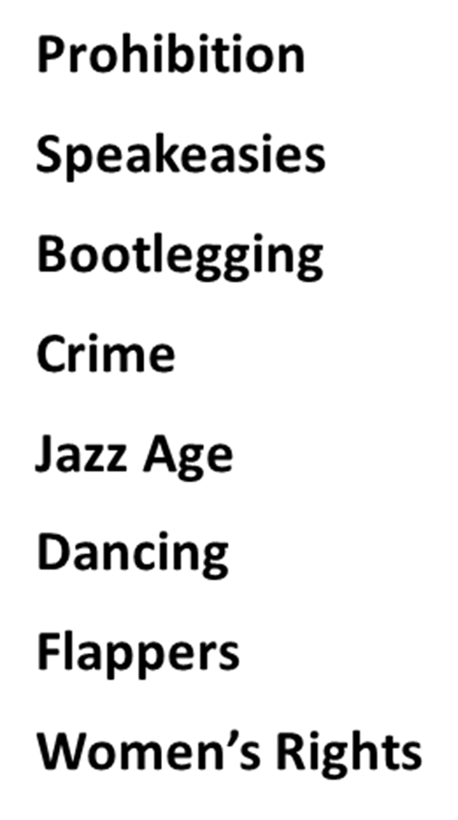
Prohibition of alcohol : The 18th Amendment (1919) to Constitution forbade the manufacture, sale, import or export of intoxicating liquors. The 21st Amendment (1933) repealed the 18th Amendment
Flapper : a term applied to a "new breed“ of young Western women who wore short skirts, bobbed their hair, listened to jazz, and flaunted their disdain for what was then considered acceptable behavior. Flappers were seen as brash for wearing excessive makeup, drinking, treating sex in a casual manner, smoking, driving and flouting social and sexual norms. Zelda was dubbed by her husband as "the first American flapper”
Jazz Age : a period in the 1920s and 1930s in which jazz music and dance styles rapidly gained nationwide popularity in the United States. Originating in New Orleans as a fusion of African and European music, jazz played a significant part in wider cultural changes in this period, often referred to in conjunction with the Roaring Twenties, and in the US it overlapped in significant cross-cultural ways with the Prohibition Era. The movement was largely affected by the introduction of radios nationwide.
F. Scott Fitzgerald is widely credited with coining the term, first using it in his 1922 short story collection titled Tales of the Jazz Age. Became emblems of the Jazz Age, for which they are still celebrated.
Urban car culture : in 1923 Ford started the mass production of the Model T.
the era of the automobile had begun.
it was and still is a kind of status symbol to own the newest and fastest car. By 1925 there was one automobile for every six persons in the country (as compared to one for every one hundred in Great Britain), and by 1930 this had increased to one for every 4.6 people

Al “Scarface” Capone : Top Chicago Gangster: promoted anti-prohibition acts. Broke the law several times for illegal booze creation, distribution, and consumption. Became an idol for liberation on the Prohibition stage
Alcohol sales //Protection business //Gambling //speakeasies

Second KKK, 1915 : Founded as a small organization in Georgia. Starting in 1921, it grew rapidly nationwide at a time of prosperity. Reflecting the social tensions of urban industrialization and vastly increased immigration, its membership grew in cities, and spread to the Midwest and West out of the South. The 2nd KKK preached "One Hundred Percent Americanism" demanded the purification of politics, calling for strict morality and better enforcement of prohibition. Its appeal was directed exclusively at white Protestants. Some local groups took part in attacks on private houses and carried out other violent activities.

Born Sept. 24, 1896 in St. Paul, Minnesota the son of Edward Fitzgerald, owner of a furniture-making company
His alcoholism interfered with his life and work and often required him to be hospitalized.
Suffered a heart attack and a month later he died of a 2nd heart attack in 1940 at movie columnist Shielah Graham’s apartment in Hollywood, California while awaiting his doctor's arrival. He was 44 years of age.
Fell in Love with Zelda Sayre : a tale of a poor writer who wanted to marry a girl from a rich family and somehow willed it to happen. She agreed to marry him once he was a success.
1920 This Side of Paradise. Instant success, Zelda marries him. Fell in Love with Zelda Sayre
a tale of a poor writer who wanted to marry a girl from a rich family and somehow willed it to happen.
She agreed to marry him once he was a success. 1920 This Side of Paradise
Instant success, Zelda marries him Frances -daughter

Zelda Fitzgerald (1900 – 1948)
The immediate success of Scott's first novel This Side of Paradise (1920) brought them into contact with high society, but their marriage was plagued by wild drinking, infidelity and bitter recriminations. Ernest Hemingway, whom Zelda disliked, blamed her for Scott's declining literary output. After being diagnosed with schizophrenia, she was increasingly confined to specialist clinics, and the couple were living apart when Scott died suddenly in 1940. Zelda died 7 years later in a fire at the hospital in Asheville, North Carolina, in which she was a patient.
She made joking reference to the use of her diaries in Scott's work, but the lifted material became a genuine source of resentment:
It seems to me that on one page I recognized a portion of an old diary of mine which mysteriously disappeared shortly after my marriage, and, also, scraps of letters which, though considerably edited, sound to me vaguely familiar. In fact, Mr. Fitzgerald … seems to believe that plagiarism begins at home.
In 1932, while being treated, Zelda had a burst of creativity. Over the course of her first six weeks at the clinic, she wrote an entire novel and sent it to Scott's publisher.
When Scott finally read Zelda's book he was furious. The book was a semi-autobiographical account of the Fitzgeralds' marriage. The failure of Save Me the Waltz, and Scott's scathing criticism of her for having written it—he called her "plagiaristic“ and a "third-rate writer"—crushed her spirits. It was the only novel she ever saw published.

In August 1936, after Fitzgerald had confessed in print the low ebb of his fortunes and mental condition, Esquire published a Hemingway story, "The Snows of Kilimanjaro", containing this passage:
"The rich were dull and they drank too much or they played too much backgammon. They were dull and they were repetitious. He remembered poor Scott Fitzgerald and his romantic awe of them and how he had started a story once that began, 'The rich are different from you and me.' And how someone had said to Scott, Yes, they have more money. But that was not humorous to Scott. He thought they were a special glamorous race and when he found they weren't it wrecked him just as much as any other thing that wrecked him."
Fitzgerald, living at the time in Ashville, North Carolina, was quick to respond, in a letter as gracious as it was blunt:

"Dear Ernest,
Please lay off me in print. If I choose to write de profundis sometimes it doesn't mean I want friends praying aloud over my corpse. No doubt you meant it kindly but it cost me a night's sleep. And when you incorporate it [the story] in a book would you mind cutting my name?" When the story appeared in a Hemingway collection, the name had been changed to Julian.

