Modernism was a movement that revolted against the literature, music, art, and architecture of Western culture. A group of visionaries emerging at the turn of the twentieth century targeted the classical and romantic strains of European tradition as static and passé. Depressed by the militarism and chaos of the Great War, Modernists finally questioned fundamental values such as progress and enlightenment, which had long defined the Western tradition.
Modernism emerged in the visual arts as early as the 1860s, with Édouard Manet. Further developments in the natural and social sciences encouraged a new group of Europeans around the turn of the century. The art of this early modernism was abstract, innovative, and often utopian. The decades to follow saw a proliferation of bold new artists and movements, each challenging those that had come before: Futurism (Boccioni), Dada (Duchamp), Cubism (Braque, Picasso), and Expressionism (Kandinsky).
Literary modernism flourished during the years between the world wars—effectively, the movement’s second generation. Modernist technique in poetry and fiction relied on such devices as shifting perspective, stream-of consciousness narration, non-linear structure, and symbolic fragmentation. In the hands of James Joyce, T. S. Eliot, Gertrude Stein, Virginia Woolf, and William Faulkner, the great legacy of the Enlightenment and nineteenth-century realism crumpled beneath the force of a sustained literary revolt.
The writers of Hemingway’s generation are often termed “Modernists.” Disillusioned by the large number of casualties in World War I, they turned away from the nineteenth-century, Victorian notions of morality and propriety and toward a more existential worldview. Many of the era’s most talented writers congregated in Paris.
World War I (1914–1918) is known by many names: the Great War, “the war of illusions,” the war to end all wars.” When the shooting finally ended, an estimated 10 million people were dead and 20 million were wounded. It was the war that introduced the deadly arsenal of modern weaponry to soldier and civilian alike. After the Great War, combat would never be the same. The trenches were only one aspect of a conflict that saw the deployment of revolutionary and murderous new technology. The machine gun, the airplane, the armored tank, submarines, and poison gas were used in warfare, most of them for the first time—an arsenal that would dominate military strategy and planning for the century to come.
The term Lost Generation was coined in 1920 in Paris by Gertrude Stein who was a member of the expatriate circle in Paris. Initially the term meant nothing at all but gradually acquired meaning. It became a term of identification for U.S. and British expatriates who rejected American and English conventions and readily adopted the more open and appealing life style of Left Bank Paris. Sitting in cafes along the Boulevard Montparnasse, Paris these people would talk, eat and watch crowds milling outside. The Lost Generation could not accept the pre-war belief in love, romanticism and prosperity. The war had destroyed both optimism and hope. Even the Great Boom of the 1920s promising economic prosperity did not attract these people who saw in it corruption and insincerity. Unable to accept pre-war American values, distrusting postwar values, the Lost Generation became spiritually bankrupt and emotionally sterile. In order to escape the spiritual vacuum they sought refuge in pleasures of the body—alcohol and sex. Alcoholism and sexual promiscuity became two rampant diseases amongst bohemian expatriate American writers who reacted strongly against American consumerism. Since they could not believe in love or religion they chose sexual freedom and cynicism or moral indifference. Young people who came of age after World War II also underwent a similar process of disillusionment and reinvention. They were called the Beat Generation.
The Iceberg Theory is the writing style of American writer Ernest Hemingway. Influenced by his journalistic career, Hemingway contended that by omitting superfluous and extraneous matter, writing becomes more interesting. When he became a writer of short stories, he retained this minimalistic style, focusing on surface elements without explicitly discussing the underlying themes. Hemingway believed the true meaning of a piece of writing should not be evident from the surface story, rather, the crux of the story lies below the surface and should be allowed to shine through. Critics claim that his iceberg theory, also known as the theory of omission, in combination with his distinctive clarity of writing, functioned as a means to distance himself from the characters he created.
Hemingway made it clear that this "theory of omission" should not be used as an excuse for a writer not to know the details behind his or her story. As he wrote in "Death in the Afternoon," "A writer who omits things because he does not know them only makes hollow places in his writing."
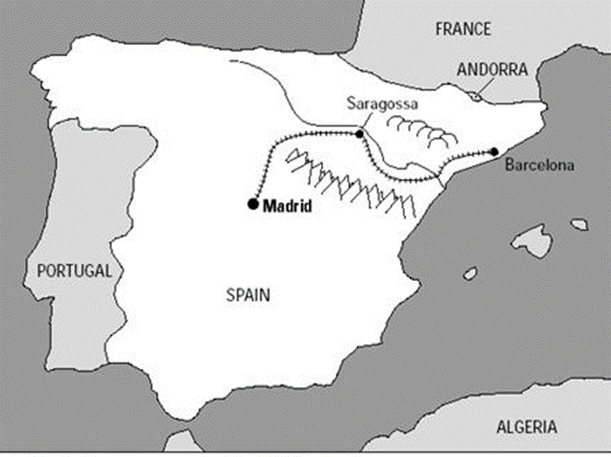

Ernest Hemingway 1899-1961
1954, awarded the Nobel Prize for Literature
plagued by ill health and mental problems, commicommitted suicide, July, 1961

Train station in the Ebro valley in Spain. Dry vs green side. At the crossroads – not the final destination

- To have the abortion and stay together
- To have the abortion and not stay together
- Not to have the abortion and stay together
- Not to have the abortion and not stay together
Hemingway’s Code heroes: to live with dignity, and grace, honesty and the restraint while playing an unwinnable game.
Code: in his novels, life is full of tension and battle; the world is in chaos; man is always fighting desperately a losing battle. However, though life is but a losing battle, man can live in such a way that loss becomes dignity; man can be physically destroyed but never defeated spiritually.
His masculine heroes—the tough men fond of outdoor sports such as bullfighting, hunting and fishing.
Relation to women– seemed to admire women who would play the game well; but, believed men were better off without women and women who wanted “equality” were competitive threats to men.
Married 4 times, all 3 later wives were talented reporters whom he expected to give up their careers.

