Benjamin Franklin

One of the Founding Fathers of the United States. A polymath, he was a leading writer, printer, political philosopher, politician, Freemason, postmaster, scientist, inventor, humorist, civic activist, statesman, and diplomat. As a scientist, he was a major figure in the American Enlightenment and the history of physics for his discoveries and theories regarding electricity. As an inventor, he is known for the lightning rod, bifocals, and the Franklin stove, among other inventions.
Franklin earned the title of "The First American" for his early and indefatigable campaigning for colonial unity, initially as an author and spokesman in London for several colonies. As the first United States ambassador to France, he exemplified the emerging American nation

Poor Richard's Almanack

The Almanack contained the calendar, weather, poems, sayings and astronomical and astrological information that a typical almanac of the period would contain. Franklin also included the occasional mathematical exercise, and the Almanack from 1750 features an early example of demographics. It is chiefly remembered, however, for being a repository of Franklin's aphorisms and proverbs, many of which live on in American English. These maxims typically counsel thrift and courtesy, with a dash of cynicism.
The Almanack was also a reflection of the norms and social mores of his times, rather than a philosophical document setting a path for new-freedoms, as the works of Franklin's contemporaries, Jefferson, Adams, or Paine were. Historian Howard Zinn offers, as an example, the adage "Let thy maidservant be faithful, strong, and homely" as indication of Franklin's belief in the legitimacy of controlling the lives of servants for the economic benefit of their masters.
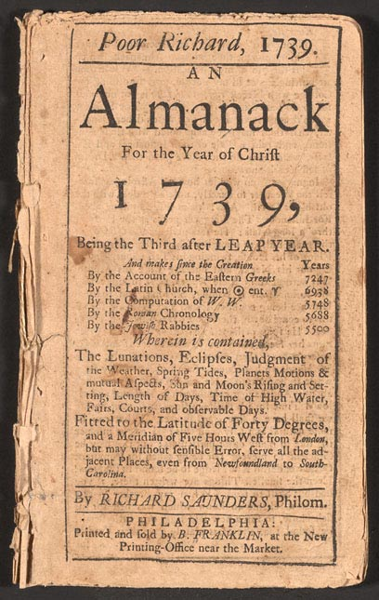

Cultural Impact
Napoleon Bonaparte considered the Almanack significant enough to translate it into Italian, in 1797. The Almanack was also twice translated into French, reprinted in Great Britain several times.

- “Love your Enemies, for they tell you your Faults.”
- “He that falls in love with himself will have no rivals.”
- “There never was a good war or a bad peace.”
- “Better slip with foot than tongue.”
- “Look before, or you’ll find yourself behind.”
- “Don’t throw stones at your neighbors, if your own windows are glass.”
- “Well done is better than well said.”
- “What you seem to be, be really.”
- “A true Friend is the best Possession.”
- “No gains without pains.”
- “Lost Time is never found again.”
- “When you’re good to others, you’re best to yourself.”
- “Glass, China, and Reputation, are easily crack’d, and never well mended.”
- “What more valuable than Gold? Diamonds. Than Diamonds? Virtue.”
- “It is better to take many Injuries than to give one.”
- “Wish not so much to live long as to live well.”

