The True Travels, Adventures and Observations of Captain John Smith in Europe, Asia, Africa and America Published in London, 1630.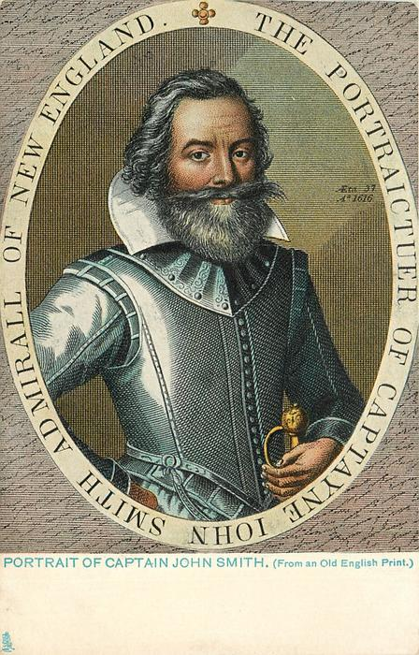ttps://www.winthropsociety.com/doc_johnsmith.php 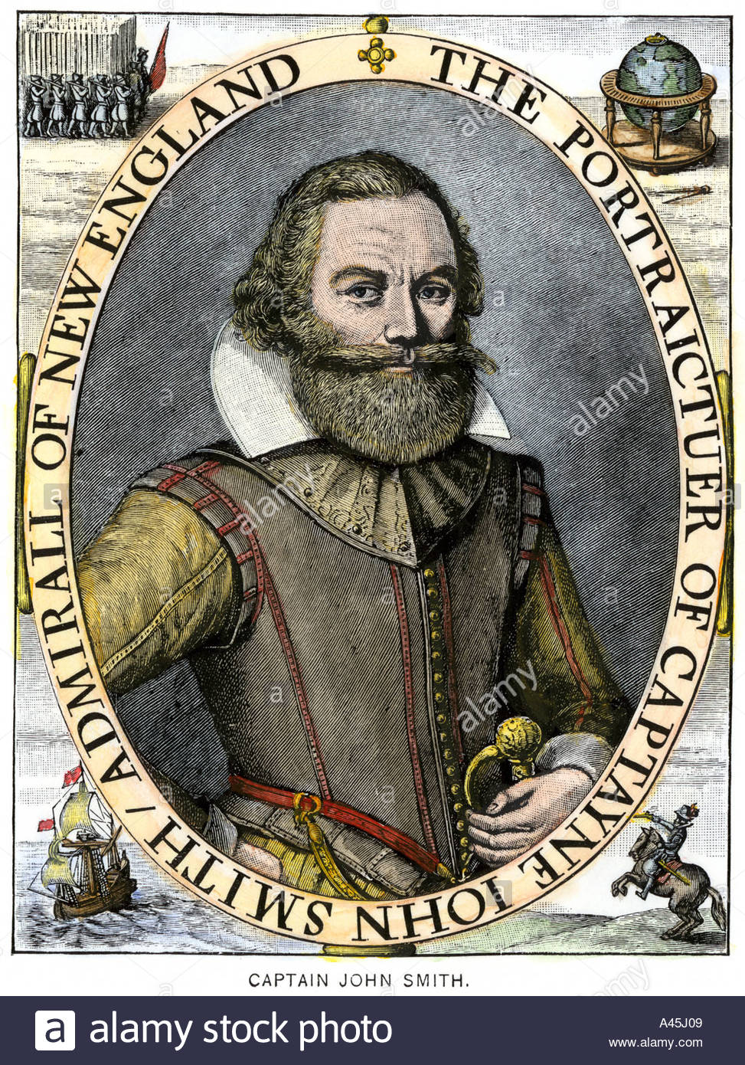

On the cover of the Summer 1996 Quarterly is a portrait of Capt. John Smith (1579 - 1631). He is a legendary figure in Virginia’s history, but few realize that, after he was removed from his captaincy of Virginia in 1609, he devoted the last 20 years of his life in the furtherance of the colonization of New England. He was the first to accurately map the coast. He coined the name of New England, and persuaded the royalty to endorse it. He wrote A Description of New England (1616) and his remarkable General History of Virginia (1624), which are our most accurate pictures of the land and the story of the earliest settlements. He strived all the last years of his life and spent all his resources pursuing his vision of a New England, and died without ever seeing the fruition of his efforts, thinking that perhaps his life's work had been in vain. On the contrary, we will say that John Smith was the first great American.
John Smith was not a Puritan. A simple Christian, certainly, but an English patriot foremost. He was the son of a Lincolnshire farmer, of grammar school education, who gained experience during his epic career as a soldier and sea-captain.
Smith loved America, and foresaw its importance to England.
Smith was a practical yet visionary genius who sympathized with the poorly prepared Mayflower Pilgrims, and abhorred the short-sighted, greedy foolishness of the aristocratic adventurers. There can be little doubt that our Puritan forefathers read and took to heart all of Smith's writings, made the best use of them, and felt indebted to him.

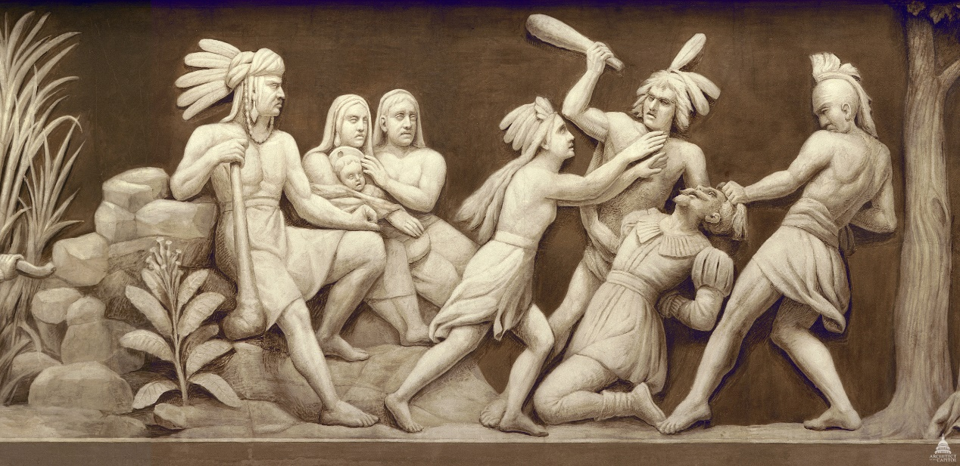
Thomas U. Walter's 1859
Pocahontas saves Captain John Smith, one of the founders of Jamestown, Virginia, from being clubbed to death. Her father, Chief Powhatan, is seated at the left. This scene is the first showing English settlement. (1607)
About the Frieze of American History
The frieze in the Rotunda of the United States Capitol contains a painted panorama depicting significant events in American history.
Pocahontas was born about 1596 and named "Amonute," though she also had a more private name of Matoaka. She was called "Pocahontas" as a nickname, which meant "playful one," because of her frolicsome and curious nature.
https://www.nps.gov/jame/learn/historyculture/pocahontas-her-life-and-legend.htm

Pocahontas: Her Life and Legend
.
John Smith's Map of 1612
Not much is known about this memorable woman. What we do know was written by others, as none of her thoughts or feelings were ever recorded. Specifically, her story has been told through written historical accounts and, most recently, through the sacred oral history of the Mattaponi. Most notably, Pocahontas has left an indelible impression that has endured for more than 400 years. And yet, many people who know her name do not know much about her.
Pocahontas was born about 1596 and named "Amonute," though she also had a more private name of Matoaka. She was called "Pocahontas" as a nickname, which meant "playful one," because of her frolicsome and curious nature. She was the daughter of Chief Powhatan. At height, the Powhatan Chiefdom had a population of about 25,000 and included more than 30 Algonquian speaking tribes.
As the daughter of the paramount chief Powhatan, custom dictated that Pocahontas would have accompanied her mother, who would have gone to live in another village, after her birth. However, nothing is written by the English about Pocahontas' mother. Some historians have theorized that she died during childbirth, so it is possible that Pocahontas did not leave like most of her half-siblings. Either way, Pocahontas would have eventually returned to live with her father Powhatan and her half-siblings once she was weaned. Her mother, if still living, would then have been free to remarry.

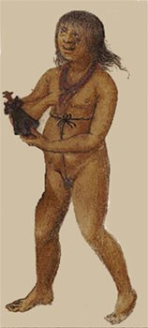How a young Pocahontas might have looked.
Unknown British Museum
As a young girl, Pocahontas would have worn little to no clothing and had her hair shaven except for a small section in the back that was grown out long and usually braided. The shaven parts were probably bristly most of the time as the Powhatan Indians used mussel shells for shaving. In winter, she could have worn a deerskin mantle (not everyone could afford one). As she grew, she would have been taught women's work; even though the favorite daughter of the paramount chief Powhatan afforded her a more privileged lifestyle and more protection, she still needed to know how to be an adult woman.
Women's work was separate from men's work, but both were equally taxing and equally important as both benefited all Powhatan society. As Pocahontas would learn, besides bearing and rearing children, women were responsible for building the houses, which they may have owned. Women did all the farming, (planting and harvesting), the cooking (preparing and serving), collected water needed to cook and drink, gathered firewood for the fires (which women kept going all the time), made mats for houses (inside and out), made baskets, pots, cordage, wooden spoons, platters and mortars. Women were also barbers for the men and would process any meat the men brought home as well as tanning hides to make clothing.
Another important thing Pocahontas had to learn to be an adult woman was how to collect edible plants. As a result, she would need to identify the various kinds of useful plants and have the ability to recognize them in all seasons. All of the skills it took to be an adult woman Pocahontas would have learned by the time she was about thirteen, which was the average age Powhatan women reached puberty.

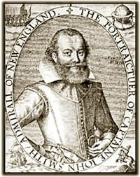Captain John Smith. Unknown Artist
When the English arrived and settled Jamestown in May 1607, Pocahontas was about eleven years old. Pocahontas and her father would not meet any Englishmen until the winter of 1607, when Captain John Smith (who is perhaps as famous as Pocahontas) was captured by Powhatan's brother. Once captured, Smith was displayed at several Powhatan Indian towns before being brought to the capital of the Powhatan Chiefdom, to Chief Powhatan.
What happened next is what has kept the names of Pocahontas and Captain John Smith inextricably linked: the famous rescue of John Smith by Pocahontas. As Smith tells it, he was brought in front of Chief Powhatan, two large stones were placed on the ground, Smith's head was forced upon them, and a warrior raised a club to smash in his brains. Before this could happen, Pocahontas rushed in and placed her head upon his, which stopped the execution. Whether this event actually happened or not has been debated for centuries. One theory posits that what took place was an elaborate adoption ceremony; its adherents believe that Smith's life was never in danger (though, he most likely would not have known that). Afterwards, Powhatan told Smith he was part of the tribe. In return for "two great guns and a grindstone," Powhatan would give Smith Capahowasick (on the York River), and "forever esteem him as his son Nantaquoud." Smith was then allowed to leave the place
Once Smith returned to Jamestown, Chief Powhatan sent gifts of food to the starving English. These envoys were usually accompanied by Pocahontas, as she was a sign of peace to the English. On her visits to the fort, Pocahontas was seen cart-wheeling with the young English boys, living up to her nickname of "playful one."
The English knew Pocahontas was the favorite daughter of the great Powhatan, and was consequently seen as a very important person. On one occasion, she was sent to negotiate for the release of Powhatan prisoners. According to John Smith, it was for and to Pocahontas alone that he finally released them. As time passed, however, relations between the Powhatan Indians and the English began to deteriorate, but Pocahontas's relationship with the newcomers continued ….

