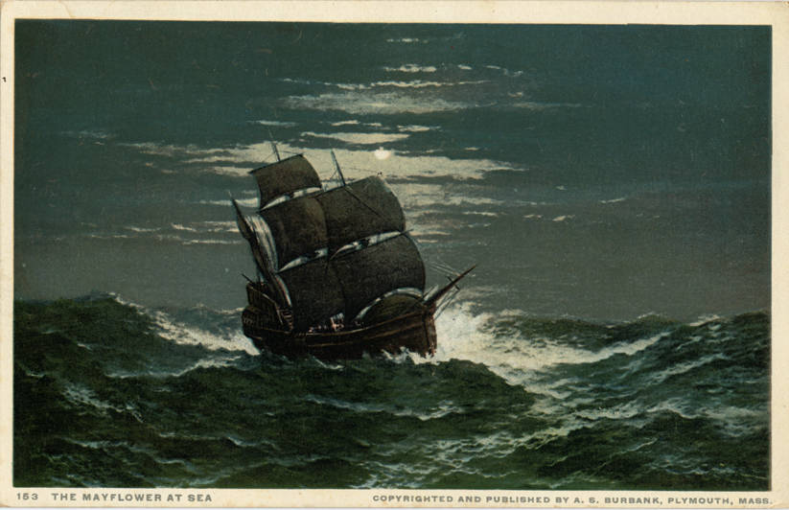
Mayflower was an English ship that transported a group of English families known today as the Pilgrims from England to the New World in 1620. After a grueling 10 weeks at sea, the Mayflower, with 102 passengers and a crew of about 30, reached America, dropping anchor near the tip of Cape Cod, Massachusetts, on November 21, 1620. By 1620, the community determined to cross the Atlantic for America, which they considered a "new Promised Land," where they would establish Plymouth Colony.
The group of 102 passengers who crowded aboard Mayflower for the crossing was not homogenous. Many of the passengers were members of the Leiden congregation, but they were joined by a number of English families or individuals who were hoping to better their life situations, or were seeking financial gain. These two general groups have sometimes been referred to as the "saints" and "strangers".
Although the Leiden congregation had sent its strongest members with various skills for establishing the new colony, nearly half of the passengers died the first winter of the "great sickness". Actually, arriving in November, they had to survive unprepared through a harsh winter. As a result, only half of the original Pilgrims survived the first winter at Plymouth. Without the help of local Indigenous peoples to teach them food gathering and other survival skills, all of the colonists may have perished. The following year, they celebrated the colony's first fall harvest along with the Indigenous people, which centuries later was declared the first Thanksgiving Day.[3]
Anyone who arrived in Plymouth on the Mayflower and survived the initial hardships is now considered a Pilgrim with no distinction being made on the basis of their original purposes for making the voyage.

