What is popularly called Transcendentalism among us, is Idealism. As  thinkers, mankind have ever divided into two sects, Materialists  and Idealists; the 1st class founding on experience, the 2nd on  consciousness; the 1st class beginning to think from the data of the senses,  the 2nd class perceive that the senses are not final, and say, the senses give  us representations of things, but what are the things themselves, they cannot  tell. The materialist insists on facts, on history, on the force of circumstances, and the animal wants of man; the idealist on the power of Thought and of  Will, on inspiration, on miracle, on individual culture. | Ralph Waldo  Emerson | The  Transcendentalist (1841)
So shall we come to look at the world with new eyes. It shall answer the  endless inquiry of the intellect, — What is truth?— What is good? Build, therefore, your own world. As fast as you conform your life to the pure idea  in your mind, that will unfold its great proportions. A correspondent  revolution in things will attend the influx of the spirit. | Ralph Waldo  Emerson | The American  Scholar  (1837)
Writing in an age where America's literary and national voices  were shaped by Emersonian transcendentalism and its faith in  nature, self-reliance and an expansionist philosophy, Poe offered a constant rebuttal by asserting that we inhabit a universe unfavorably disposed toward  humankind, that human nature itself was simply untrustworthy. As the  America of the 1840s looked brightly into a future of limitless possibilities, Poe's work counterpointed the general spirit of American optimism by  revealing the human propensity to seek pain rather than tranquility. |  | 
“The Raven” is written backwards  composing a poem is a mathematical problem  -a piece of work must have a single effect which could be read at one sitting  -Length: 100 Lines/poem, “The Raven” has 108 Lines  -Unity of Effect  -Content=Beauty + Death=the death of a beautiful woman  -Subject and Tone=Melancholy  -no meaning for the narrator: the search, the moral of “Nevermore”  "Mournful and never-ending remembrance." |  | The Philosophy  of Composition  1846
one of Poe’s finest and most representative tales  supreme example of the Gothic horror story.  “art for art’s sake”  a story should be devoid of social, political, or moral teaching  Poe’s aim in his representation of horror in his tales was to create  the sense of terror of the soul and mind. | 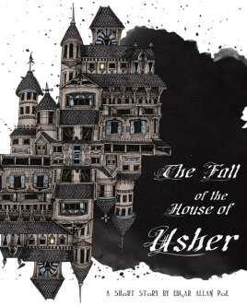 | The Fall of the House of Usher
Better known as a poet, best-known as a magazine editor and critic  Turned to story writing mainly for financial reasons  Critiqued for his gothic sensationalism:  “too fond of the wild—unnatural and horrible”  The Fall of the House of Usher was rejected in 1839. Editor’s belief:  people preferred the more modern, realistic style of Charles Dickens  Readers view Poe’s Gothic tales reflexively as expressions of their author’s tortured state of mind  Griswold published, two days after Poe’s death, an obituary of  him in the New York Tribune. He wrote that few would grieve personally because of the kind of man Poe was. He created the idea of Poe as an artistic genius tormented to madness. | Poe in  His Own  Time
Poe as the Romantic artist. Baudelaire discovered Poe in 1852.  In Histoires extraordinaires (1856) he characterized Poe as the poète maudit (“accursed poet”), who suffered in the materialistic and commercial society of America yet was able to create the finest literature of his age.  In an 1861 introduction to three of Poe’s tales newly translated into Russian, Dostoevsky declared that the “vigor of [Poe’s] imagination,” distinguished him from every other author.  In England, Swinburne, Oscar Wilde, and Dante Gabriel Rossetti lauded Poe. Their praise recast Poe as a forefather of modernist writing.  Yeats described his work “vulgar and commonplace”  In 1923, D. H. Lawrence included an essay on Poe in his very influential book Studies in Classic American Literature  Aldous Huxley said that Poe was “cursed with incorrigible bad taste” | Reception  in Europe | 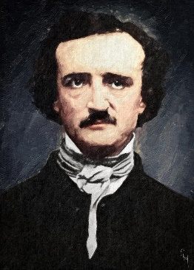
Henry James: “an enthusiasm for Poe is the mark of a decidedly primitive stage of reflection”  T. S. Eliot sneered that Poe had “the intellect of a highly gifted young person before puberty”  In 1925, William Carlos Williams published an essay presenting Poe as a pioneer of serious American literature.  E. L. Doctorow compared “The Raven” to Ravel’s “Bolero” | Reception  in the US
In the 1920s - focus on his presumed psychopathology.  Marie Bonaparte (1933 and in English in 1949) identifies the man with his tales, symbolically depicting his unconscious struggles  Why do readers think that Poe is merely expressing his own feelings, while Hawthorne is exposing a human condition?  Possibly 1st person narration  Or, they trace the disintegration of the human psyche. In Roderick Usher and in the narrator of “Ligeia,” f.ex. Lawrence detected the image of vampires, who in their desire to know their female counterparts suck out their very life. | Psycho-analyzing  Poe
“A poem must not mean / But be.”  Russian Formalists analyze the text in itself / attention to its linguistic properties.  New Criticism (1940, 1950), resembles formalism in its focus on the text itself. New Critics see fiction as self-contained work of art, emphasis on how works of literature convey meanings | New Approaches
“The Question of Poe’s Narrators”: what the stories tell us is quite different from what the narrators are saying.  Tales reveal the blindness of their narrators  Man’s trust in reason is folly. Poe mocks rationalism by exposing his narrators’ incomprehension of what is happening to them. | Surprising Discoveries
Others see irony, parody and hoax  f.ex. “The Fall of the House of Usher” makes fun of “Germanism”  Michael Allen (1969) argues that Poe designed his stories to appeal simultaneously to two different audiences: the unsophisticated “many” and the elite “few.” | Poe as Parodist | 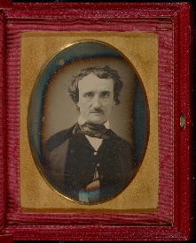
Of Poe’s more than sixty tales, about half are openly comical.  “The Balloon Hoax” tells the story of the first transatlantic balloon crossing. It was published in the New York Sun without any indication that it was fiction.  “The Facts in the Case of M. Valdemar” Was Poe kidding?  It seems incredible that a writer could ridicule a style so mercilessly one month and then employ it in complete seriousness the next.  It is not simply that hoaxing helps explain otherwise confusing features (and presumed faults) in Poe’s work. Poe’s hoaxing seems an essential part of what he is about | Poe  the Humorist
“Look at how stories and poems avoid saying what they mean.”  “The Purloined Letter,” about a piece of writing that is concealed, disguised, turned inside out. “The Purloined Letter” was the subject of an  article by Jacques Lacan, a rejoinder by Jacques Derrida, and a volume of subsequent commentary by others.  “The Man of the Crowd,” about a man who, looking out the window of a coffeehouse, picks a man out of the crowd and determines to know, as it were, the secret of his character. He follows and observes the man all night until dawn the next day, finally concluding that he will never learn what he wants to know. He ends the story (as he began it) with what he says is a comment made about a certain book: “it does not permit itself to be read.” | De  construct-ion | 