Transcendentalism: Context https://adhc.lib.ua.edu/site/literarylandscapes/transcendentalism-context/
Transcendentalism
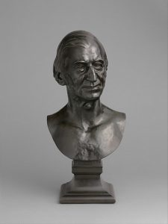Emerson. Source
Crafting a unique, well-defined American identity and an accompanying philosophy was considered an important task for authors in the United States during the 19th century. The most famous and successful of these endeavors is embodied in the works of an eclectic group of intellectuals now called transcendentalists. Their thoughts on a number of topics have helped to create what many conceive as the essential American spirit, especially those regarding nature and the role of the individual in society.
A common topic in transcendentalist literature is the conception of nature as a pathway to intense, spiritual experiences. Transcendentalism is often thought of as a branch of Romanticism due to the romantic nature of this idea. Ralph Waldo Emerson, often credited as the father of the transcendentalist movement, wrote that while standing in nature “all mean egotism vanishes. I become a transparent eyeball. I am nothing. I see all” (Emerson 217). Similar tales of dramatic personal transformation brought about by experiencing nature first-hand are common throughout transcendentalist literature. The idea that engulfing oneself in nature could bring about a deeper understanding of the world, as Emerson describes here, is essential to the transcendentalist conception of nature as a transformative agent.
Another defining feature of transcendentalist thought is the importance given to individualistic ways of thinking and living. In one of the most famous passage of American literature, Thoreau, another definitive transcendentalist writer, claimed that “The mass of men lead lives of quiet desperation” (Thoreau 984) because they think that they have no choice but to live ordinary lives. In contrast to this way of living, transcendentalists typically encouraged people to live lives focused on more than just earning a living but on self-discovery and personal and intellectual growth. What separates this facet of their thought from earlier American conceptions about the value of self-improvement is that most transcendentalists did not value material wealth or material possessions. According to most transcendentalist writers, true meaning cannot be found in outward society but must be derived from the essence of one’s own self.
Both ideas today form an essential part of the American identity. Many in America still revere nature and consider excursions into it to be restorative, meaningful experiences. Additionally, the focus on individual identity as a source of meaning in life and a disdain for the repressive nature of everyday life are popular themes in American literature and media to this day. While few self-identify as transcendentalists today, the movement’s philosophy about life has a wide-reaching impact on contemporary American thought and culture.
Works Consulted
Emerson, Ralph Waldo. “Nature.” The Norton Anthology of
American Literature.. Gen. ed. Nina Baym, Robert Levine.
8th ed. Vol. A. New York:Norton, 2012. 217. Print
Thoreau, Henry David. “Walden.” The Norton Anthology of
American Literature.. Gen. ed. Nina Baym, Robert Levine. 8th
ed. Vol. A. New York: Norton, 2012. 984. Print

Transcendentalism: Key Authors
Ralph Waldo Emerson
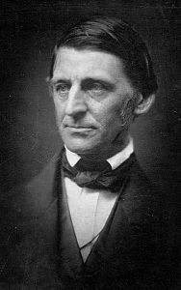American writer Ralph Waldo Emerson, circa 1857.
During the nineteenth century, America continued to establish its own identity separate from Europe. Various reforms took place, including prison improvement, abolitionism, women’s rights, and the Second Great Awakening.
America worked to better itself as a nation and overcome any of its shortcomings. As Americans determined the national rhetoric for the budding country, the notion of individualism characterized the climate of change. Individualism, which falls directly under the umbrella of transcendentalism, stressed that we are each responsible for bettering ourselves and our community. Many leaders of this movement emphasized reliance on ourselves and the environment to answer our questions, instead of God, scripture, or previous philosophers. Ralph Waldo Emerson’s writings pushed for these ideals, asserting his belief that humans contain an innate sense of right and wrong independent from religious views. Ultimately, Emerson’s writings became a key player in helping America create its own distinct literary movement during the nineteenth century.

In his first essay, Nature, which was not widely recognized after publication, Emerson presented numerous philosophical concepts and the foundation of transcendentalism. Although his piece could give advice to any American at the time, it specifically spoke to the hearts of other budding American Transcendentalist writers, encouraging them to invent their own style rather than imitating former creators. Emerson’s most famous essay, “Self-Reliance,” consists of journal entries compiled throughout his lifetime as well as excerpts from multiple lectures he delivered. Because Emerson had gained more of a following by the time of this essay’s publication, he targeted this piece toward his general audience of American readers. He sought to nourish confidence in his reader’s ideas and encourage them to try new things, overall pushing America to form a strong self-identity.
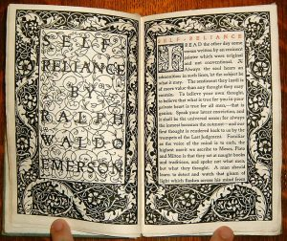“Self-Reliance,” by Ralph Waldo Emerson, originally published in his Essays collection in 1841.
Throughout Emerson’s “Self-Reliance,” he continually focuses on the importance of staying true to oneself and discovering originality. The writer encourages his readers to follow their individual will and not conform to social expectations. He also discusses the need for open-mindedness in order to grow as a person, stating that if you are not changing your opinions and learning new information every so often, then you are not advancing yourself as a person. Furthermore, Emerson disputes organized religion in his writing, instead pointing to the idea of experiencing spirituality through living in the present moment. He also discourages the imitation of former great masters of the arts and sciences; he instead believes that greatness is intrinsic, and not something that can be copied. Overall, Emerson argues that reliance upon one’s self frees individuals to uncover their true identity and achieve ultimate independence.
Emerson’s “Self-Reliance” serves to push the individualist agenda of the nineteenth century. When discussing the importance of open-mindedness, Emerson advises that “A foolish consistency is the hobgoblin of little minds, adored by little statesmen and philosophers and divines.” (Emerson 274). Here, Emerson’s emphasis on being open to different perspectives ties in with the individualism ideology. He believes that people often feel they must be consistent for other people, not for themselves. However, the Transcendentalist Movement stresses perfection of self, which encourages one to not care what other people think. Additionally, Emerson demonstrates his objection to organized religion when he speaks of the “purity of the present moment” (Emerson 277). This quote encourages one to find spirituality through your own experiences, and to trust your own beliefs, rather than archaic ideas of the divine. This is a direct opposition to Protestant and other traditional Christian beliefs of the 19th Century, which demanded you must know God through scripture.
Works Cited
Emerson, Ralph Waldo. “Self–Reliance.” The Norton Anthology: American Literature (Volume B), edited by Nina Baym, W.W. Norton & Company, Inc., 2012, pp. 274-277.
Unknown. “Ralph Waldo Emerson – Self-Reliance.” Genius, 21 Oct. 2016, genius.com/Ralph-waldo-emerson-self-reliance-annotated.
User: Scewing. “Ralph Waldo Emerson.” Wikimedia, 15 Feb. 2013, commons.wikimedia.org/wiki/File:Ralph_Waldo_Emerson_ca1857_retouched.jpg.

https://adhc.lib.ua.edu/site/literarylandscapes/henry-david-thoreau/#more-3473

Henry David Thoreau
Henry David Thoreau was born into the lower economic status, but because of his natural intelligence, his family chose him to attend Harvard University. This is where he met the famous transcendentalist philosopher Ralph Waldo Emerson. It was in 1836 when the two transcendentalists met. Emerson would later become Thoreau’s good friend and mentor. Thoreau, looking up to Emerson, would be inspired by his transcendentalist ideals and would start his own works inspired by Emerson’s original thoughts.
Unlike most writers, including his mentor, Thoreau took to a different genre of writing. Thoreau chose to express his literature through journal writing. Through that form of writing, he was able to express his different philosophies and beliefs. Thoreau’s beliefs consisted of one’s need for constant self-improvement and self-sufficiency. He also took the notion that traveling should never be for self exploration, but should be about learning from different cultures. Thoreau’s slightly more radical beliefs were that slavery went against the entirety of the transcendentalist ideals. Thoreau took this belief as far as not paying his taxes out of an act of protest against the fugitive slave act. These actions put him in jail for a short amount of time. Thoreau’s stance on slavery would issue him into the beginning of the reform era.
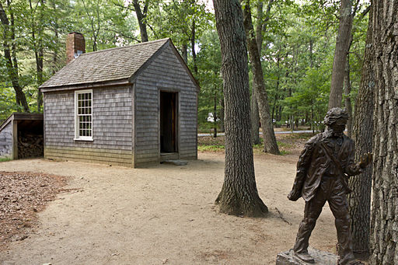This is a replica of the home built by Thoreau. This replica of his home is what Thoreau lived in while writing Walden. This monument is located in Concord, MA and was built by Ronald Wells Robbins.
Thoreau wrote his most famous piece Walden: Life in the Woods in 1852. Walden: Life in the Woods was based on his own life and his decision to live out in the wilderness in the house that he built himself. Thoreau promoted his life choices in Walden, describing it as what should be the norm for everyone to live. His passion in his lifestyle shows that Thoreau’s intended audience was not only for his fellow transcendentalist; but also for the general population. Thoreau used Walden: Life in the Woods to show them how to change the way they are living, consuming, and going into debt over “frivolous” things.
In Walden: Life in the Woods Thoreau throws out complex ideas, that weren’t explained properly on how to execute in life. Thoreau’s complex thinking in Walden can be found when Thoreau explains the value of education in his first chapter Economy. He expresses that going to college is valuable for the experience. Thoreau argues that you actually learn from being around intellectuals and not by going to classes (Thoreau 1006). He especially denounces paying the expenses to live in a dormitory. However, Thoreau never explains to his readers how they should go about learning and valuing their education; without paying or going through a college course. The presenting of ideas without a way to execute it in life was just one issue that was found in Thoreau’s Walden.
Walden was an influential work that was slightly flawed. A major issue within Thoreau’s ideology in Walden was that he wasn’t truly self-sufficient. Thoreau had a lot of assistance and advantages that he didn’t really address in Walden. These advantages allowed for the lifestyle Thoreau spoke of to be more attainable for him but not so much for his audience. Thoreau unlike some was able to receive assistance from his good friend Emerson. Emerson allowed Thoreau to build his house on his land. Another advantage Thoreau had was his ability to obtain a loan. During his time there were many people, mainly minorities who this luxury was completely unattainable. However, Thoreau does not address any of his privilege or advantages in Walden.

Works Consulted
Levine, Robert, and Arnold Krupat. Norton Anthology American Literature.
Edited by Nina Baym, 8th ed., B, W W Norton & Co Inc., 2007.
Thoreau, Henry David. Walden: Life in the Woods. Ticknor and Fields, 1854.

