FICTION
For Teju Cole, Art Is a Lens on a History of Violence
His new novel, “Tremor,” uses images and artifacts to look deeply into trauma, identity and consolation.

• • • 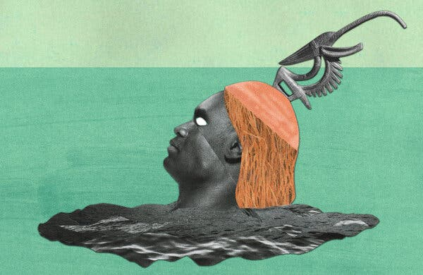
Credit...Trevor Davis/Getty Images
By Brian Dillon
Brian Dillon is the author, most recently, of “Affinities: On Art and Fascination.” He is working on “Ambivalence,” a book about education.
Oct. 17, 2023
When you purchase an independently reviewed book through our site, we earn an affiliate commission.
TREMOR, by Teju Cole

Novelist, essayist, critic, photographer, teacher — most writers or artists are content with one or two of these titles, perhaps blurring the distinctions between main and side pursuits. In his new novel, “Tremor,” all of Teju Cole’s capacities are present: the fiction writer of “Every Day Is for the Thief” (2007) and “Open City” (2011), the adventurous essayist of “Known and Strange Things” (2016), the Harvard professor, the devotee and practitioner of conceptually cool but classical photography.
“Tremor” is the most sundry and vagrant of Cole’s works to date, with abrupt changes in form, perspective and theme. At times it feels familiar, especially in the ease with which Cole moves from the tight focus of his lightly fictionalized protagonist to the wide-angle lens of historical events and forces.
This feature of his work is a lure, a formal and ethical trap for the reader who is at first seduced by Cole’s mastery of anecdote before being immersed in rich, sometimes discomfiting ideas. He has written admiringly about, and frequently been compared to, the German writer W.G. Sebald; they share among other things a capacity to tunnel back from a single image or artifact to scenes of historical barbarism. (I almost wrote that Cole seems like a postcolonial version of Sebald — but Sebald is already the postcolonial Sebald)
“Tremor” opens with the sort of wide-screen dissolve, gliding over centuries and continents, that one sees frequently in Sebald’s 1995 novel “The Rings of Saturn” — except here the starting milieu is academic-bourgeois New England.
A Nigerian American photographer and professor named Tunde is antiquing in Maine with his Japanese wife, Sadako, when they find a West African antelope headdress, or -. A cheap artifact without provenance, it nonetheless starts Tunde thinking about colonial violence on both sides of the Atlantic.
The trade in “authentic” African art, the modern museum as storehouse for imperial loot, narratives of Native American attack and kidnapping as precursors to the “war on terror”: The novelist can invite readers to hold all of this history and more in mind, even (or especially) when it is relayed through a character as faintly outlined as Tunde.
I say relayed “through” and not “by” because Tunde is mostly a third-person figment. For sure, we know things about his life: that he spent his youth in Lagos, that he teaches art history, that at least one previous lover was a man. But as a voice, Tunde is fully present only in his reflections on images and on history. Nowhere is this more true than in a chapter-length lecture on J.M.W. Turner’s 1840 painting “Slave Ship” and stolen artworks in the Museum of Fine Arts, Boston — a talk interrupted by a brief loss of sight in one of Tunde’s eyes. (Cole has suffered the same intermittent condition.)
The lecture, like the novel that surrounds it, is haunted by two questions concerning the fate of faces and bodies seen in art and in other kinds of images, or read about in novels. First, “every image of a human being proposes a question to the viewer: Why am I being shown this?” That is, what interests are served?
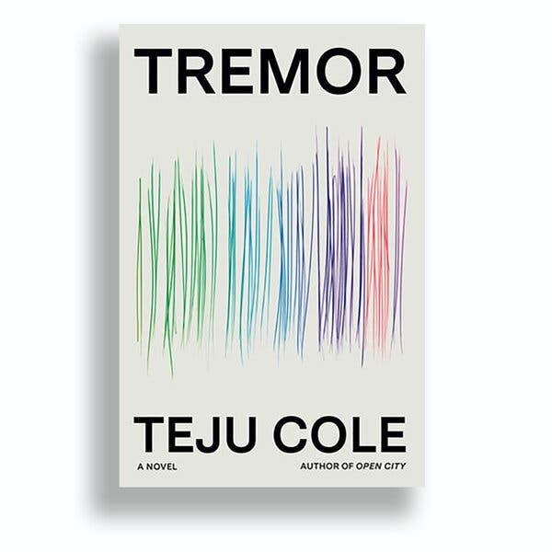
Second, there is always the vexing enigma of those whose images or identities have been erased or only partly shown. In Turner’s painting, and the real event of 1781 that inspired it, almost 150 enslaved people have been thrown into the Atlantic from the British ship Zong. Turner’s original title was “Slavers Throwing Overboard the Dead and Dying, Typhoon Coming On” — a title Tunde prefers because “there’s no one whose essence or true description is ‘slave.’” All that’s visible of the victims are a few chained hands and feet, dwarfed by the raging waves.
What is obscured in Tunde’s own meditations on art and politics, or elided in his recollections of life in Lagos, his travels in Europe and Africa? In one of the novel’s most pointed episodes, Tunde remembers coming out of the Louvre and enraging, by taking his photograph, a Senegalese seller of Eiffel Tower trinkets. Tunde thought such Black traders were his “brothers,” but the man “saw nothing but a class enemy.”
Here both character and novel reach the limits of essayistic self-scrutiny as ethical corrective to one’s own power and privilege. Only invention — of new voices, new forms — will answer adequately. And so, after what had seemed, in Tunde’s lecture, like the peak of autofictional solipsism, Cole presents 24 short monologues from diverse inhabitants of Lagos — all unnamed but indelible. (The city is a character of sorts in “Tremor,” one of the ways Cole pays homage to another influence, Italo Calvino.)
There is the young man who says: “Orgies happen at every level in Lagos. This is not about rich or middle-class people. I’m not rich.” The woman who details an encounter with a man into BDSM: “I guess my inner Yoruba woman came out. Don’t slap me man!” In many or most of these stories, other lives lie submerged or have been silenced in the telling: a mother raped decades ago during a home invasion, a domestic servant raped by her employer’s driver.
The Lagos stories connect to a series of troubling images Tunde analyzes with his students at Harvard. At times, “Tremor” devolves into a near-theoretical disquisition=discussion/essay on regarding the pain of others. Even (is “even” the right word?) the most exquisite or entrancing images are fraught with vicious associations, obscene elements just out of frame.
The stories of sexual assault go unexamined by Tunde, which is apt for a character who is troubled by the ethical quandaries of representing violence but who approaches them with a somewhat distancing, if cultured, eye. In “Open City,” Cole’s aesthete narrator, Julius, appears to have blocked or forgotten the fact he raped a girl while in his early teens. The new novel, leaving Tunde to his bout=spell of temporary blindness, again gives us more insight than its protagonist can: The testimony of the citizens of Lagos exists in a different fictional realm from Tunde’s (unless these characters are passing through his mind).
Ambiguous about the possibility of fully relaying trauma or violence, “Tremor” is also a collection of consolations. Cole the photographer and Cole the essayist are ever-present, casting an eye on evanescent drawings a Lagos artist makes under a bridge, or trying to net in words the nighttime flights of jazz, flamenco and high life. Behind it all is a suspicion that writerly attention to such textures and transports is itself a form of partial sightlessness — but it might also be the best preparation for facing down the worst the light reveals.

TREMOR | By Teju Cole | 239 pp. | Random House | $28

•

