**THE NATIONAL AND KAPODISTRIAN UNIVERSITY OF ATHENS**

**FACULTY OF ENGLISH STUDIES**

**American Poetry**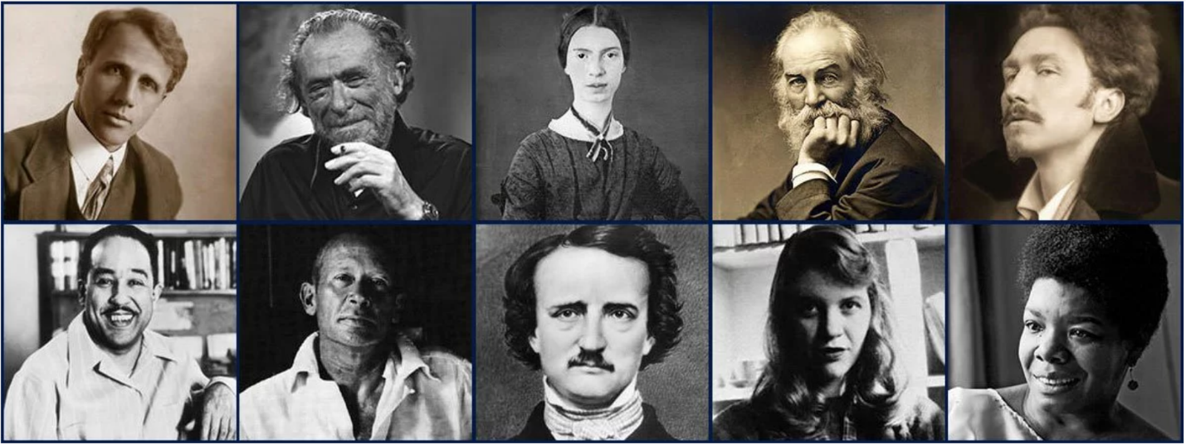

**4th semester 2024-25**

**Dr. Christina Dokou**

**Fridays, 9:00-12:00, Amphitheatre 434**

**E-class:** [**https://eclass.uoa.gr/courses/ENL518/**](https://eclass.uoa.gr/courses/ENL518/)

**Office Hours: Mondays and Fridays, 12:00-13:00, Office 703**

**Aims:** This course is designed as **a general overview of anglophone poetry written in the United States of America, s**tarting with the 17th century onward. The course aims to point at the historical and cultural permutations of form and content in poetry in the U.S., its major representatives, and the way this poetry expresses in itself the cultural markers of the American nation.

Although the instructor will provide introductory and analytical lectures for each item and period, **your strong participation is** **indispensable** to this course. You should come to class each week having read the assigned poems and relevant biographical information so that you are prepared to discuss them.

Evaluation: Your final grade will be determined 100% by your performance in a **final written examination**.

You may also wish to try for a **2-point extra-credit paper**, consisting of a 6-8-page research assignment (2-3000 words) on one of the themes suggested below. Papers should use Times New Roman 12-pt. font, and 1.5 spacing. You must have at least five (5) items of bibliography: only credible sources (articles from JSTOR and Project MUSE, available through the University VPN service; googlebooks; library books; published articles in journals or reprinted in online collections; encyclopedia and Wikipedia listings; reviews from credible poetry and newspaper sites) should be consulted. You MUST also provide, with the final draft, copies of the first pages of all the entries in your “Works Cited” list in a unified PDF. Please follow the Works Cited and in-text citation format of the 9th edition of the *MLA Style Manual* (instructions can be found online at “The Owl at Purdue” website at <https://owl.purdue.edu/owl/research_and_citation/mla_style/mla_formatting_and_style_guide/mla_formatting_and_style_guide.html> ). All stages of the paper-writing process MUST be completed before you hand in the final draft. Papers are due on the day of the final exam. Please note that if your paper is plagiarized, your grade will automatically be zero (0).

Should any problems arise, you are encouraged to contact the instructor immediately.

**Course Text**: The poems are on the “Weekly Poems” file on e-class. Auxiliary material (e.g., for the extra credit paper) is available on my website at <http://users.uoa.gr/~cdokou>. The PowerPoints with the outlines of each class will be uploaded on e-class after each session.

**Course Outline**

|  |  |
| --- | --- |
| **Date** | **Readings Due** |
| February 28 | Introduction--The origins of “American” poetry--major phases |
| March 7 | Bradstreet, “To My Dear and Loving Husband,” “In Memory of...Elizabeth Bradstreet”; Wheatley, “On Being Brought from Africa to America” |
| March 14 | Poe, “The Raven,” “The Bells” |
| March 21 | Whitman, From *Song of Myself,* parts 1-13 |
| March 28 | Dickinson, poems 49, 185, 249, 280, 324, 712 |
| April 4 | Frost, “After Apple Picking”; Sandburg, “Chicago”; EXTRA CREDIT THESIS DUE |
| MAKE UP  CLASS | Stevens, “The Emperor of Ice-Cream”; Williams, “The Red Wheelbarrow,” “This Is Just to Say” |
| May 2 | Pound, “A Pact,” “In a Station of the Metro”; HD, “Helen,” “Oread” |
| May 9 | Eliot, “The Love Song of J. Alfred Prufrock” |
| May 16 | Hughes, “The Negro Speaks of Rivers”; Gwendolyn Brooks, “We Real Cool”; EXTRA CREDIT OUTLINE AND BIBLIOGRAPHY DUE |
| May 23 | Plath, “Daddy”; Ginsberg, “Howl” |
| May 30 | Rich, “Diving into the Wreck”; Momaday, “The Snow Mare” |
| June 6 | Carlson-Wee, “How to”; Smith, “the bullet was a girl” |
| Exam Day | COMPLETE PAPER DUE |

**Possible Extra Credit Themes**:

* Desperate Housewives: Anne Sexton’s “Her Kind” and Adrienne Rich’s “Aunt Jennifer’s Tigers”
* Americanizing European Tradition: Henry Wadsworth Longfellow and Robert Duncan
* Transcendentalism Now: The Relation with American Nature in Gary Snyder and Mary Oliver
* 50 Shades of Black: The Different Voices of Claude McKay, Audre Lorde, Honoree Fanonne Jeffers
* Emily Dickinson and Walt Whitman’s Views on Children and Childhood/ Animals
* The Relation between Picture and Poetry: Cathy Song’s “Beauty and Sadness” and William Carlos Williams’s “Portrait of a Lady”
* Making Poetry out of Myth: “Medusa” by Oliver Herford, Louise Bogan, and Patricia Smith
* Ecocritical Poetics: Gary Snyder and Mary Oliver
* Native American Pow-wowetry: Singing History and Survival
* American Satire: Anne Sexton’s “Her Kind” and Amiri Baraka’s “Dope”
* Dead Presidents: Walt Whitman’s “O Captain! My Captain!” and Wendell Berry’s “November 26, 1963”
* The Face of America: Ginsberg’s “America” versus Angelou’s “On the Pulse of Morning”
* Politically In-verse: 21st Century Protest Poetry (choose two contemporary poets on your own)
* Poetry Retouched: John’ Berryman’s *Homage to Mistress Bradstreet*