AMERICAN POETRY
Dr. Christina Dokou
WEEKLY POEMS

WEEK 2

Anne Bradstreet (ca. 1612-1672)
Biography at http://www.poetryfoundation.org/bio/anne-bradstreet

To my Dear and Loving Husband

If ever two were one, then surely we.
If ever man were lov'd by wife, then thee.
If ever wife was happy in a man,
Compare with me, ye women, if you can.
I prize thy love more than whole Mines of gold
Or all the riches that the East doth hold.
My love is such that Rivers cannot quench,
Nor ought but love from thee give recompence.
Thy love is such I can no way repay.
The heavens reward thee manifold, I pray.
Then while we live, in love let's so persever
That when we live no more, we may live ever.

Notes (by line)
1] we: Anne's husband was Simon Bradstreet (1603-97). They were married in England in 1628.
11] persever: poetically accented on the second syllable.

Original text: Anne Bradstreet, Several Poems, 2nd edn. (Boston: John Foster, 1678). Cf. The Complete Works of Anne Bradstreet, ed. Joseph R. McElrath, Jr., and Allan P. Robb (Boston: Twayne, 1981): 180.

In Memory Of My Dear Grandchild Elizabeth Bradstreet, Who Deceased August, 1665, Being A Year And Half Old
Farewell dear babe, my heart's too much content,
Farewell sweet babe, the pleasure of mine eye,
Farewell fair flower that for a space was lent,
Then ta'en away unto eternity.
Blest babe, why should I once bewail thy fate,
Or sigh thy days so soon were terminate,
Sith thou art settled in an everlasting state.

By nature trees do rot when they are grown,
And plums and apples thoroughly ripe do fall,
And corn and grass are in their season mown,
And time brings down what is both strong and tall.
But plants new set to be eradicate,
And buds new blown to have so short a date,
Is by His hand alone that guides nature and fate.

1678

Phillis Wheatley (1753?-1784)
Biography at: http://www.poetryfoundation.org/bio/phillis-wheatley

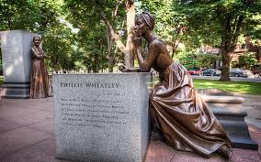

On Being Brought from Africa to America

'Twas mercy brought me from my Pagan land,
Taught my benighted soul to understand
That there's a God, that there's a Saviour too:
Once I redemption neither sought nor knew.
Some view our sable race with scornful eye,
"Their colour is a diabolic die."
Remember, Christians, Negros, black as Cain,
May be refin'd, and join th' angelic train.

Note on lines 6-7: Wheatley is punning on indigo die and sugarcane.
Original text: Phillis Wheatley, Poems on Various Subjects, Religious and Moral (London: by A. Bell, for Cox and Berry, Boston, 1773): 18. Facsimile edition in The Collected Works of Phillis Wheatley, ed. John C. Shields (New York: Oxford University Press, 1988).
WEEK 3

Henry Wadsworth Longfellow (1807-1882
Biography at: https://en.wikipedia.org/wiki/Henry_Wadsworth_Longfellow

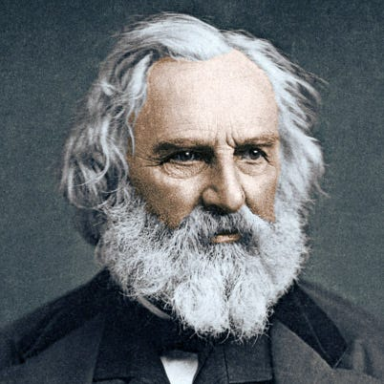
The Slave’s Dream

Beside the ungathered rice he lay,
His sickle in his hand;
His breast was bare, his matted hair
Was buried in the sand.
Again, in the mist and shadow of sleep,
He saw his Native Land.
Wide through the landscape of his dreams
The lordly Niger flowed;
Beneath the palm-trees on the plain
Once more a king he strode;
And heard the tinkling caravans
Descend the mountain-road.
He saw once more his dark-eyed queen
Among her children stand;
They clasped his neck, they kissed his cheeks,
They held him by the hand!—
A tear burst from the sleeper's lids
And fell into the sand.
And then at furious speed he rode
Along the Niger's bank;
His bridle-reins were golden chains,
And, with a martial clank,
At each leap he could feel his scabbard of steel
Smiting his stallion's flank.
Before him, like a blood-red flag,
The bright flamingoes flew;
From morn till night he followed their flight,
O'er plains where the tamarind grew,
Till he saw the roofs of Caffre huts,
And the ocean rose to view.
At night he heard the lion roar,
And the hyena scream,
And the river-horse, as he crushed the reeds
Beside some hidden stream;
And it passed, like a glorious roll of drums,
Through the triumph of his dream.
The forests, with their myriad tongues,
Shouted of liberty;
And the Blast of the Desert cried aloud,
With a voice so wild and free,
That he started in his sleep and smiled
At their tempestuous glee.
He did not feel the driver's whip,
Nor the burning heat of day;
For Death had illumined the Land of Sleep,
And his lifeless body lay
A worn-out fetter, that the soul
Had broken and thrown away!

Edgar Allan Poe (1809-1849)
Biography at: http://en.wikipedia.org/wiki/Edgar_Allan_Poe
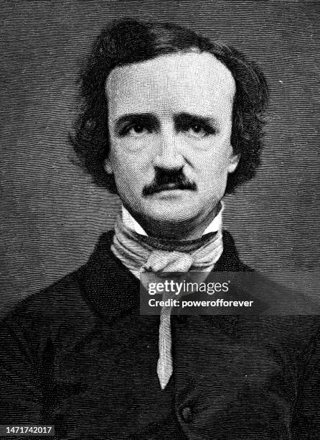
The Raven

Once upon a midnight dreary, while I pondered, weak and weary,
Over many a quaint and curious volume of forgotten lore—
While I nodded, nearly napping, suddenly there came a tapping,
As of some one gently rapping, rapping at my chamber door.
“’Tis some visiter,” I muttered, “tapping at my chamber door—
Only this and nothing more.”
Ah, distinctly I remember it was in the bleak December;
And each separate dying ember wrought its ghost upon the floor.
Eagerly I wished the morrow;—vainly I had sought to borrow
From my books surcease of sorrow—sorrow for the lost Lenore—
For the rare and radiant maiden whom the angels name Lenore—
Nameless here for evermore.

And the silken, sad, uncertain rustling of each purple curtain
Thrilled me—filled me with fantastic terrors never felt before;
So that now, to still the beating of my heart, I stood repeating
“’Tis some visiter entreating entrance at my chamber door—
Some late visiter entreating entrance at my chamber door;—
This it is and nothing more.”

Presently my soul grew stronger; hesitating then no longer,
“Sir,” said I, “or Madam, truly your forgiveness I implore;
But the fact is I was napping, and so gently you came rapping,
And so faintly you came tapping, tapping at my chamber door,
That I scarce was sure I heard you”—here I opened wide the door;—
Darkness there and nothing more.

Deep into that darkness peering, long I stood there wondering, fearing,
Doubting, dreaming dreams no mortal ever dared to dream before;
But the silence was unbroken, and the stillness gave no token,
And the only word there spoken was the whispered word, “Lenore?”
This I whispered, and an echo murmured back the word, “Lenore!”—
Merely this and nothing more.

Back into the chamber turning, all my soul within me burning,
Soon again I heard a tapping somewhat louder than before.
“Surely,” said I, “surely that is something at my window lattice;
Let me see, then, what thereat is, and this mystery explore—
Let my heart be still a moment and this mystery explore;—
’Tis the wind and nothing more!”

Open here I flung the shutter, when, with many a flirt and flutter,
In there stepped a stately Raven of the saintly days of yore;
Not the least obeisance made he; not a minute stopped or stayed he;
But, with mien of lord or lady, perched above my chamber door—
Perched upon a bust of Pallas just above my chamber door—
Perched, and sat, and nothing more.

Then this ebony bird beguiling my sad fancy into smiling,
By the grave and stern decorum of the countenance it wore,
“Though thy crest be shorn and shaven, thou,” I said, “art sure no craven,
Ghastly grim and ancient Raven wandering from the Nightly shore—
Tell me what thy lordly name is on the Night’s Plutonian shore!”
Quoth the Raven “Nevermore.”

Much I marvelled this ungainly fowl to hear discourse so plainly,
Though its answer little meaning—little relevancy bore;
For we cannot help agreeing that no living human being
Ever yet was blessed with seeing bird above his chamber door—
Bird or beast upon the sculptured bust above his chamber door,
With such name as “Nevermore.”

But the Raven, sitting lonely on the placid bust, spoke only
That one word, as if his soul in that one word he did outpour.
Nothing farther then he uttered—not a feather then he fluttered—
Till I scarcely more than muttered “Other friends have flown before—
On the morrow he will leave me, as my Hopes have flown before.”
Then the bird said “Nevermore.”

Startled at the stillness broken by reply so aptly spoken,
“Doubtless,” said I, “what it utters is its only stock and store
Caught from some unhappy master whom unmerciful Disaster
Followed fast and followed faster till his songs one burden bore—
Till the dirges of his Hope that melancholy burden bore
Of ‘Never—nevermore’.”

But the Raven still beguiling all my fancy into smiling,
Straight I wheeled a cushioned seat in front of bird, and bust and door;
Then, upon the velvet sinking, I betook myself to linking
Fancy unto fancy, thinking what this ominous bird of yore—
What this grim, ungainly, ghastly, gaunt, and ominous bird of yore
Meant in croaking “Nevermore.”

This I sat engaged in guessing, but no syllable expressing
To the fowl whose fiery eyes now burned into my bosom’s core;
This and more I sat divining, with my head at ease reclining
On the cushion’s velvet lining that the lamp-light gloated o’er,
But whose velvet-violet lining with the lamp-light gloating o’er,
She shall press, ah, nevermore!

Then, methought, the air grew denser, perfumed from an unseen censer
Swung by Seraphim whose foot-falls tinkled on the tufted floor.
“Wretch,” I cried, “thy God hath lent thee—by these angels he hath sent thee
Respite—respite and nepenthe from thy memories of Lenore;
Quaff, oh quaff this kind nepenthe and forget this lost Lenore!”
Quoth the Raven “Nevermore.”

“Prophet!” said I, “thing of evil!—prophet still, if bird or devil!—
Whether Tempter sent, or whether tempest tossed thee here ashore,
Desolate yet all undaunted, on this desert land enchanted—
On this home by Horror haunted—tell me truly, I implore—
Is there—is there balm in Gilead?—tell me—tell me, I implore!”
Quoth the Raven “Nevermore.”

“Prophet!” said I, “thing of evil!—prophet still, if bird or devil!
By that Heaven that bends above us—by that God we both adore—
Tell this soul with sorrow laden if, within the distant Aidenn,
It shall clasp a sainted maiden whom the angels name Lenore—
Clasp a rare and radiant maiden whom the angels name Lenore.”
Quoth the Raven “Nevermore.”

“Be that word our sign of parting, bird or fiend!” I shrieked, upstarting—
“Get thee back into the tempest and the Night’s Plutonian shore!
Leave no black plume as a token of that lie thy soul hath spoken!
Leave my loneliness unbroken!—quit the bust above my door!
Take thy beak from out my heart, and take thy form from off my door!”
Quoth the Raven “Nevermore.”

And the Raven, never flitting, still is sitting, still is sitting
On the pallid bust of Pallas just above my chamber door;
And his eyes have all the seeming of a demon’s that is dreaming,
And the lamp-light o’er him streaming throws his shadow on the floor;
And my soul from out that shadow that lies floating on the floor
Shall be lifted—nevermore!

WEEK 4

Walt Whitman (1819–1892)
Poet biography at: http://en.wikipedia.org/wiki/Walt_Whitman and http://www.poemhunter.com/walt-whitman/biography/; also a short version at https://www.poets.org/poetsorg/poet/walt-whitman
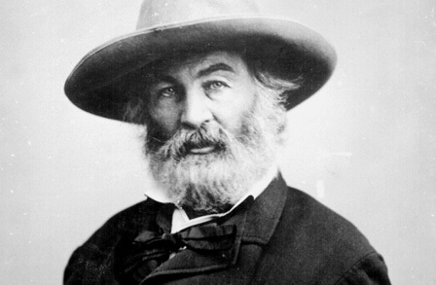
Song of Myself
https://www.poetryfoundation.org/poems/45477/song-of-myself-1892-version
Read only parts 1-13

WEEK 5

Emily Dickinson (1830-1886)
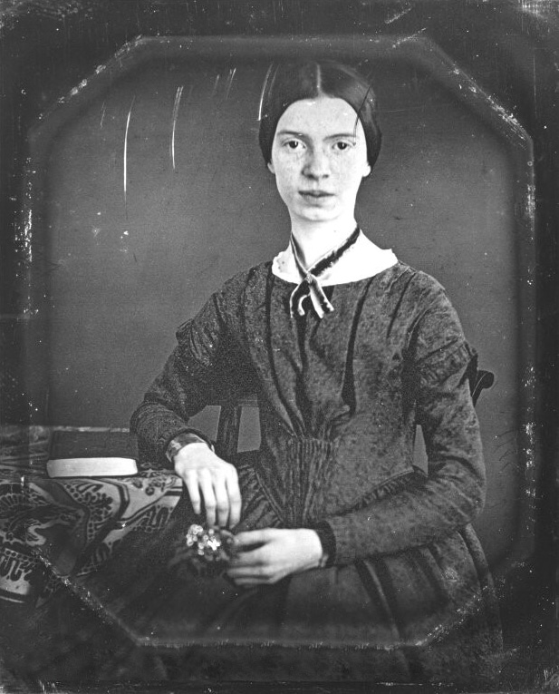

Biography at: http://www.online-literature.com/dickinson/ and
http://en.wikipedia.org/wiki/Emily_Dickinson

Poem 49

I never lost as much but twice,
And that was in the sod.
Twice have I stood a beggar
Before the door of God!
Angels—twice descending
Reimbursed my store—
Burglar! Banker—Father!
I am poor once more!

Poem 185
"Faith" is a fine invention
When Gentlemen can see—
But Microscopes are prudent
In an Emergency.

Poem 249
Wild Nights – Wild Nights!
Were I with thee
Wild Nights should be
Our luxury!
Futile – the Winds –
To a Heart in port –
Done with the Compass –
Done with the Chart!
Rowing in Eden –
Ah, the Sea!
Might I but moor – Tonight –
In Thee!

Poem 280

I felt a Funeral, in my Brain,
And Mourners to and fro
Kept treading – treading – till it seemed
That Sense was breaking through –

And when they all were seated,
A Service, like a Drum –
Kept beating – beating – till I thought
My Mind was going numb –

And then I heard them lift a Box
And creak across my Soul
With those same Boots of Lead, again,
Then Space – began to toll,

As all the Heavens were a Bell,
And Being, but an Ear,
And I, and Silence, some strange Race
Wrecked, solitary, here –

And then a Plank in Reason, broke,
And I dropped down, and down –
And hit a World, at every plunge,
And Finished knowing – then –

Poem 324

Some keep the Sabbath going to Church –
I keep it, staying at Home –
With a Bobolink for a Chorister –
And an Orchard, for a Dome –

Some keep the Sabbath in Surplice –
I, just wear my Wings –
And instead of tolling the Bell, for Church,
Our little Sexton – sings.

God preaches, a noted Clergyman –
And the sermon is never long,
So instead of getting to Heaven, at last –
I’m going, all along.

Poem 712
Because I could not stop for Death--
He kindly stopped for me--
The Carriage held but just Ourselves--
And Immortality.
We slowly drove--He knew no haste
And I had put away
My labor and my leisure too,
For His Civility--
We passed the School, where Children strove
At Recess--in the Ring--
We passed the Fields of Gazing Grain--
We passed the Setting Sun--
Or rather--He passed us--
The Dews drew quivering and chill--
For only Gossamer, my Gown--
My Tippet--only Tulle--
We paused before a House that seemed
A Swelling of the Ground--
The Roof was scarcely visible--
The Cornice--in the Ground--
Since then--'tis Centuries--and yet
Feels shorter than the Day
I first surmised the Horses' Heads
Were toward Eternity—

WEEK 6
Robert Frost (1874-1963)

After Apple-Picking
My long two-pointed ladder's sticking through a tree
Toward heaven still,
And there's a barrel that I didn't fill
Beside it, and there may be two or three
Apples I didn't pick upon some bough.
But I am done with apple-picking now.
Essence of winter sleep is on the night,
The scent of apples: I am drowsing off.
I cannot rub the strangeness from my sight
I got from looking through a pane of glass
I skimmed this morning from the drinking trough
And held against the world of hoary grass.
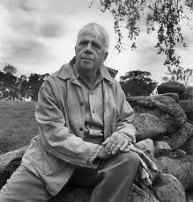
It melted, and I let it fall and break.
But I was well
Upon my way to sleep before it fell,
And I could tell
What form my dreaming was about to take.
Magnified apples appear and disappear,
Stem end and blossom end,
And every fleck of russet showing clear.
My instep arch not only keeps the ache,
It keeps the pressure of a ladder-round.
I feel the ladder sway as the boughs bend.
And I keep hearing from the cellar bin
The rumbling sound
Of load on load of apples coming in.
For I have had too much
Of apple-picking: I am overtired
Of the great harvest I myself desired.
There were ten thousand thousand fruit to touch,
Cherish in hand, lift down, and not let fall.
For all
That struck the earth,
No matter if not bruised or spiked with stubble,
Went surely to the cider-apple heap
As of no worth.
One can see what will trouble
This sleep of mine, whatever sleep it is.
Were he not gone,
The woodchuck could say whether it's like his
Long sleep, as I describe its coming on,
Or just some human sleep.

Source: Collected Poems, Prose, & Plays (Library of America, 1995)

Wallace Stevens, 1879 – 1955
Biography at http://en.wikipedia.org/wiki/Wallace_Stevens

The Emperor of Ice-Cream
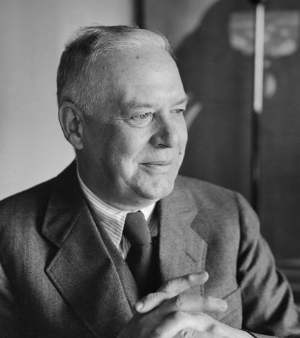
Call the roller of big cigars,
The muscular one, and bid him whip
In kitchen cups concupiscent curds.
Let the wenches dawdle in such dress
As they are used to wear, and let the boys
Bring flowers in last month's newspapers.
Let be be finale of seem.
The only emperor is the emperor of ice-cream.

Take from the dresser of deal,
Lacking the three glass knobs, that sheet
On which she embroidered fantails once
And spread it so as to cover her face.
If her horny feet protrude, they come
To show how cold she is, and dumb.
Let the lamp affix its beam.
The only emperor is the emperor of ice-cream.

From The Collected Poems of Wallace Stevens. Copyright 1954 by Wallace Stevens. Reprinted with the permission of Alfred A. Knopf, a division of Random House, Inc.
_________________________________________________________________

William Carlos Williams

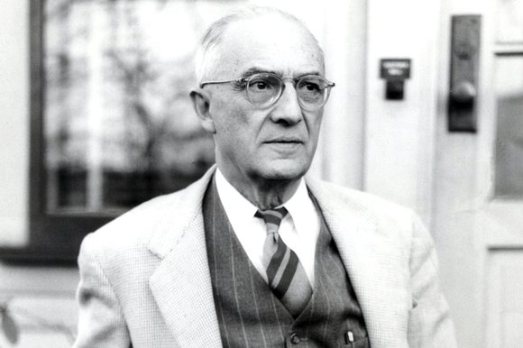
The Red Wheelbarrow

so much depends
upon

a red wheel
barrow

glazed with rain
water

beside the white
chickens
William Carlos Williams, “So much depends” from The Collected Poems of William Carlos Williams, Volume I, 1909-1939, edited by Christopher MacGowan, 1938
WEEK 7

Ezra Pound (1885–1972)
Biography at http://en.wikipedia.org/wiki/Ezra_Pound

In a Station of the Metro

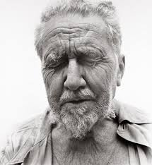
THE apparition of these faces in the crowd;
Petals on a wet, black bough.

Source: Modern American Poetry: An Introduction. Ed. Louis Untermeyer, New York: Harcourt, Brace and Howe, 1919.

A Pact
I make a pact with you, Walt Whitman -
I have detested you long enough.
I come to you as a grown child
Who has had a pig-headed father;
I am old enough now to make friends.
It was you that broke the new wood,
Now is a time for carving.
We have one sap and one root -
Let there be commerce between us.

H.D. (Hilda Doolittle) (1886-1961)
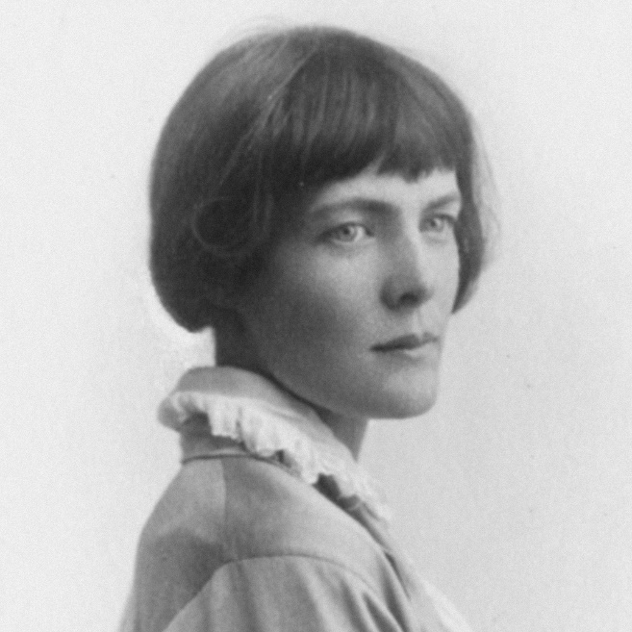
Biography at http://en.wikipedia.org/wiki/Hilda_Doolittle and H. D.

Oread
Whirl up, sea—
whirl your pointed pines,
splash your great pines
on our rocks,
hurl your green over us,
cover us with your pools of fir.

Helen

All Greece hates
the still eyes in the white face,
the lustre as of olives
where she stands,
and the white hands.

All Greece reviles
the wan face when she smiles,
hating it deeper still
when it grows wan and white,
remembering past enchantments
and past ills.

Greece sees unmoved,
God’s daughter, born of love,
the beauty of cool feet
and slenderest knees,
could love indeed the maid,
only if she were laid,
white ash amid funereal cypresses.

From: Collected Poems 1912-1944. Copyright © 1982 by The Estate of Hilda Doolittle. Reprinted with the permission of New Directions Publishing Corporation.

WEEK 8

T.S. Eliot (1888-1965)
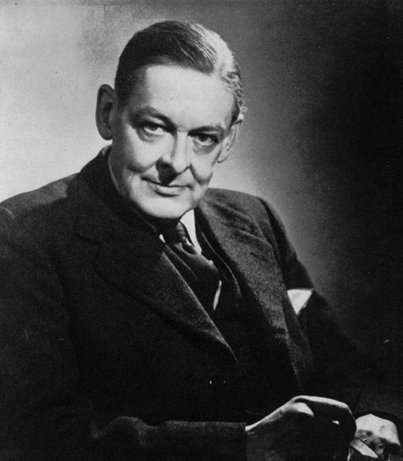

Biography at T. S. Eliot - Wikipedia and T. S. Eliot | Poetry Foundation

The Love Song of J. Alfred Prufrock

S’io credesse che mia risposta fosse
A persona che mai tornasse al mondo,
Questa fiamma staria senza piu scosse.
Ma percioche giammai di questo fondo
Non torno vivo alcun, s’i’odo il vero,
Senza tema d’infamia ti rispondo.

Let us go then, you and I,
When the evening is spread out against the sky
Like a patient etherized upon a table;
Let us go, through certain half-deserted streets,
The muttering retreats
Of restless nights in one-night cheap hotels
And sawdust restaurants with oyster-shells:
Streets that follow like a tedious argument
Of insidious intent
To lead you to an overwhelming question ...
Oh, do not ask, “What is it?”
Let us go and make our visit.

In the room the women come and go
Talking of Michelangelo.

The yellow fog that rubs its back upon the window-panes,
The yellow smoke that rubs its muzzle on the window-panes,
Licked its tongue into the corners of the evening,
Lingered upon the pools that stand in drains,
Let fall upon its back the soot that falls from chimneys,
Slipped by the terrace, made a sudden leap,
And seeing that it was a soft October night,
Curled once about the house, and fell asleep.

And indeed there will be time
For the yellow smoke that slides along the street,
Rubbing its back upon the window-panes;
There will be time, there will be time
To prepare a face to meet the faces that you meet;
There will be time to murder and create,
And time for all the works and days of hands
That lift and drop a question on your plate;
Time for you and time for me,
And time yet for a hundred indecisions,
And for a hundred visions and revisions,
Before the taking of a toast and tea.

In the room the women come and go
Talking of Michelangelo.

And indeed there will be time
To wonder, “Do I dare?” and, “Do I dare?”
Time to turn back and descend the stair,
With a bald spot in the middle of my hair —
(They will say: “How his hair is growing thin!”)
My morning coat, my collar mounting firmly to the chin,
My necktie rich and modest, but asserted by a simple pin —
(They will say: “But how his arms and legs are thin!”)
Do I dare
Disturb the universe?
In a minute there is time
For decisions and revisions which a minute will reverse.

For I have known them all already, known them all:
Have known the evenings, mornings, afternoons,
I have measured out my life with coffee spoons;
I know the voices dying with a dying fall
Beneath the music from a farther room.
So how should I presume?

And I have known the eyes already, known them all—
The eyes that fix you in a formulated phrase,
And when I am formulated, sprawling on a pin,
When I am pinned and wriggling on the wall,
Then how should I begin
To spit out all the butt-ends of my days and ways?
And how should I presume?

And I have known the arms already, known them all—
Arms that are braceleted and white and bare
(But in the lamplight, downed with light brown hair!)
Is it perfume from a dress
That makes me so digress?
Arms that lie along a table, or wrap about a shawl.
And should I then presume?
And how should I begin?

Shall I say, I have gone at dusk through narrow streets
And watched the smoke that rises from the pipes
Of lonely men in shirt-sleeves, leaning out of windows? ...

I should have been a pair of ragged claws
Scuttling across the floors of silent seas.

And the afternoon, the evening, sleeps so peacefully!
Smoothed by long fingers,
Asleep ... tired ... or it malingers,
Stretched on the floor, here beside you and me.
Should I, after tea and cakes and ices,
Have the strength to force the moment to its crisis?
But though I have wept and fasted, wept and prayed,
Though I have seen my head (grown slightly bald) brought in upon a platter,
I am no prophet — and here’s no great matter;
I have seen the moment of my greatness flicker,
And I have seen the eternal Footman hold my coat, and snicker,
And in short, I was afraid.

And would it have been worth it, after all,
After the cups, the marmalade, the tea,
Among the porcelain, among some talk of you and me,
Would it have been worth while,
To have bitten off the matter with a smile,
To have squeezed the universe into a ball
To roll it towards some overwhelming question,
To say: “I am Lazarus, come from the dead,
Come back to tell you all, I shall tell you all”—
If one, settling a pillow by her head
Should say: “That is not what I meant at all;
That is not it, at all.”

And would it have been worth it, after all,
Would it have been worth while,
After the sunsets and the dooryards and the sprinkled streets,
After the novels, after the teacups, after the skirts that trail along the floor—
And this, and so much more?—
It is impossible to say just what I mean!
But as if a magic lantern threw the nerves in patterns on a screen:
Would it have been worth while
If one, settling a pillow or throwing off a shawl,
And turning toward the window, should say:
“That is not it at all,
That is not what I meant, at all.”

No! I am not Prince Hamlet, nor was meant to be;
Am an attendant lord, one that will do
To swell a progress, start a scene or two,
Advise the prince; no doubt, an easy tool,
Deferential, glad to be of use,
Politic, cautious, and meticulous;
Full of high sentence, but a bit obtuse;
At times, indeed, almost ridiculous—
Almost, at times, the Fool.

I grow old ... I grow old ...
I shall wear the bottoms of my trousers rolled.

Shall I part my hair behind? Do I dare to eat a peach?
I shall wear white flannel trousers, and walk upon the beach.
I have heard the mermaids singing, each to each.

I do not think that they will sing to me.

I have seen them riding seaward on the waves
Combing the white hair of the waves blown back
When the wind blows the water white and black.
We have lingered in the chambers of the sea
By sea-girls wreathed with seaweed red and brown
Till human voices wake us, and we drown.

Source: Collected Poems 1909-1962 (1963)

WEEK 9

Langston Hughes (1901-67)
Biography at: http://en.wikipedia.org/wiki/Langston_Hughes

“The Negro Speaks of Rivers”

I’ve known rivers:
I’ve known rivers ancient as the world and older than the
flow of human blood in human veins.

My soul has grown deep like the rivers.

I bathed in the Euphrates when dawns were young.
I built my hut near the Congo and it lulled me to sleep.
I looked upon the Nile and raised the pyramids above it.
I heard the singing of the Mississippi when Abe Lincoln
went down to New Orleans, and I’ve seen its muddy
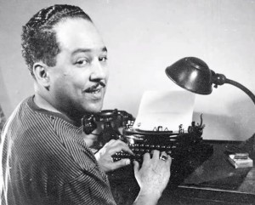
bosom turn all golden in the sunset.

I’ve known rivers:
Ancient, dusky rivers.

My soul has grown deep like the rivers.

Gwendolyn Brooks (1917-2000)
Biography at: http://www.poetryfoundation.org/bio/gwendolyn-brooks

“We Real Cool”

THE POOL PLAYERS.
SEVEN AT THE GOLDEN SHOVEL.
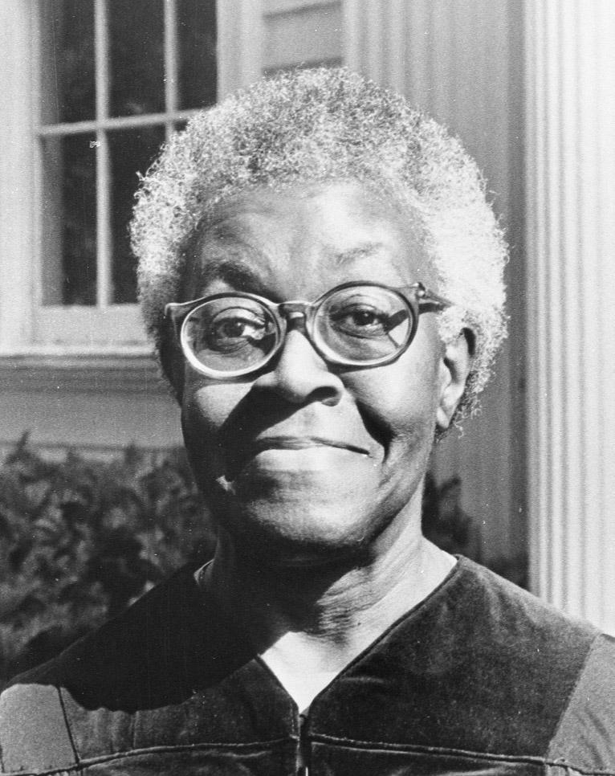

We real cool. We
Left school. We

Lurk late. We
Strike straight. We

Sing sin. We
Thin gin. We

Jazz June. We
Die soon.

Copyright © 1963 by Gwendolyn Brooks. Reprinted with the permission of the Estate of Gwendolyn Brooks. Source: Poetry (September 1959).

WEEK 10
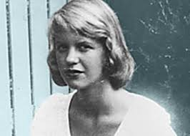

Sylvia Plath (1932-63)

Biography at: http://en.wikipedia.org/wiki/Sylvia_Plath

Daddy

You do not do, you do not do
Any more, black shoe
In which I have lived like a foot
For thirty years, poor and white,
Barely daring to breathe or Achoo.

Daddy, I have had to kill you.
You died before I had time——
Marble-heavy, a bag full of God,
Ghastly statue with one gray toe
Big as a Frisco seal

And a head in the freakish Atlantic
Where it pours bean green over blue
In the waters off beautiful Nauset.
I used to pray to recover you.
Ach, du.

In the German tongue, in the Polish town
Scraped flat by the roller
Of wars, wars, wars.
But the name of the town is common.
My Polack friend

Says there are a dozen or two.
So I never could tell where you
Put your foot, your root,
I never could talk to you.
The tongue stuck in my jaw.

It stuck in a barb wire snare.
Ich, ich, ich, ich,
I could hardly speak.
I thought every German was you.
And the language obscene

An engine, an engine
Chuffing me off like a Jew.
A Jew to Dachau, Auschwitz, Belsen.
I began to talk like a Jew.
I think I may well be a Jew.

The snows of the Tyrol, the clear beer of Vienna
Are not very pure or true.
With my gipsy ancestress and my weird luck
And my Taroc pack and my Taroc pack
I may be a bit of a Jew.

I have always been scared of you,
With your Luftwaffe, your gobbledygoo.
And your neat mustache
And your Aryan eye, bright blue.
Panzer-man, panzer-man, O You——

Not God but a swastika
So black no sky could squeak through.
Every woman adores a Fascist,
The boot in the face, the brute
Brute heart of a brute like you.

You stand at the blackboard, daddy,
In the picture I have of you,
A cleft in your chin instead of your foot
But no less a devil for that, no not
Any less the black man who

Bit my pretty red heart in two.
I was ten when they buried you.
At twenty I tried to die
And get back, back, back to you.
I thought even the bones would do.

But they pulled me out of the sack,
And they stuck me together with glue.
And then I knew what to do.
I made a model of you,
A man in black with a Meinkampf look

And a love of the rack and the screw.
And I said I do, I do.
So daddy, I’m finally through.
The black telephone’s off at the root,
The voices just can’t worm through.

If I’ve killed one man, I’ve killed two——
The vampire who said he was you
And drank my blood for a year,
Seven years, if you want to know.
Daddy, you can lie back now.

There’s a stake in your fat black heart
And the villagers never liked you.
They are dancing and stamping on you.
They always knew it was you.
Daddy, daddy, you bastard, I’m through.

First published in Ariel, 1965. Reprinted in The Collected Poems, 1981.
Copyright Credit: Sylvia Plath, “Daddy” from Collected Poems. Copyright © 1960, 1965, 1971, 1981 by the Estate of Sylvia Plath. Editorial matter copyright © 1981 by Ted Hughes. Used by permission of HarperCollins Publishers.

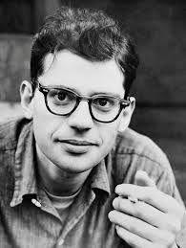
Allen Ginsberg (1926-97)
Biography at: http://en.wikipedia.org/wiki/Allen_Ginsberg

“Howl”
(complete text at https://www.poetryfoundation.org/poems/49303/howl)

WEEK 11

Adrienne Rich (1929-2012)
Biography at: http://en.wikipedia.org/wiki/Adrienne_Rich

Diving into the Wreck

First having read the book of myths,
and loaded the camera,
and checked the edge of the knife-blade,
I put on
the body-armor of black rubber
the absurd flippers
the grave and awkward mask.
I am having to do this
not like Cousteau with his
assiduous team
aboard the sun-flooded schooner
but here alone.
There is a ladder.
The ladder is always there
hanging innocently
close to the side of the schooner.
We know what it is for,
we who have used it.
Otherwise
it is a piece of maritime floss
some sundry equipment.
I go down.
Rung after rung and still
the oxygen immerses me
the blue light
the clear atoms
of our human air.
I go down.
My flippers cripple me,
I crawl like an insect down the ladder
and there is no one
to tell me when the ocean
will begin.
First the air is blue and then
it is bluer and then green and then
black I am blacking out and yet
my mask is powerful
it pumps my blood with power
the sea is another story
the sea is not a question of power
I have to learn alone
to turn my body without force
in the deep element.
And now: it is easy to forget
what I came for
among so many who have always
lived here
swaying their crenellated fans
between the reefs
and besides
you breathe differently down here.
I came to explore the wreck.
The words are purposes.
The words are maps.
I came to see the damage that was done
and the treasures that prevail.
I stroke the beam of my lamp
slowly along the flank
of something more permanent
than fish or weed
the thing I came for:
the wreck and not the story of the wreck
the thing itself and not the myth
the drowned face always staring
toward the sun
the evidence of damage
worn by salt and sway into this threadbare beauty
the ribs of the disaster
curving their assertion
among the tentative haunters.
This is the place.
And I am here, the mermaid whose dark hair
streams black, the merman in his armored body.
We circle silently
about the wreck
we dive into the hold.
I am she: I am he
whose drowned face sleeps with open eyes
whose breasts still bear the stress
whose silver, copper, vermeil cargo lies
obscurely inside barrels
half-wedged and left to rot
we are the half-destroyed instruments
that once held to a course
the water-eaten log
the fouled compass
We are, I am, you are
by cowardice or courage
the one who find our way
back to this scene
carrying a knife, a camera
a book of myths
in which
our names do not appear.
From Diving into the Wreck: Poems 1971-1972 by Adrienne Rich. Copyright © 1973 by W. W. Norton & Company, Inc. Reprinted by permission of the author and W. W. Norton & Company, Inc. Copyright 1973 by Adrienne Rich.

N. Scott Momaday (1934-2024)
Biography at: https://www.britannica.com/biography/N-Scott-Momaday


The Snow Mare
In my dream, a blue mare loping,
Pewter on a porcelain field, away.
There are bursts of soft commotion
Where her hooves drive in the drifts,
And as dusk ebbs on the plane of night,
She shears the web of winter,
And on the far, blind side
She is no more. I behold nothing,
Wherein the mare dissolves in memory,
Beyond the burden of being.
Source: Poets.org

WEEK 12

Anders Carlson-Wee

Biography at: https://www.anderscarlsonwee.com/about

“How To”
If you got hiv, say aids. If you a girl,
say you’re pregnant––nobody gonna lower
themselves to listen for the kick. People
passing fast. Splay your legs, cock a knee
funny. It’s the littlest shames they’re likely
to comprehend. Don’t say homeless, they know
you is. What they don’t know is what opens
a wallet, what stops em from counting
what they drop. If you’re young say younger.
Old say older. If you’re crippled don’t
flaunt it. Let em think they’re good enough
Christians to notice. Don’t say you pray,
say you sin. It’s about who they believe
they is. You hardly even there.

https://www.jehsmith.com/1/2018/07/how-to-by-anders-carlson-wee.html


Danez Smith

Biography at Danez Smith | Poetry Foundation

“the bullet was a girl”

the bullet is his whole life.
his mother named him & the bullet
was on its way. in another life
the bullet was a girl & his skin
was a boy with a sad laugh.
they say he asked for it—
must I define they? They are not
monsters, or hooded or hands black
with cross smoke.
they teachers, they pay tithes
they like rap, they police—good folks
gather around a boy’s body
to take a picture, share a prayer.
oh da horror, oh what a shame
why’d he do that to himself?
they really should stop
getting themselves killed

Copyright © 2015 by Danez Smith. Originally published in Poem-a-Day on September 3, 2015, by the Academy of American Poets

