MEDIEVAL LITERATURE

JOURNAL HALL OF FAME

2024-25

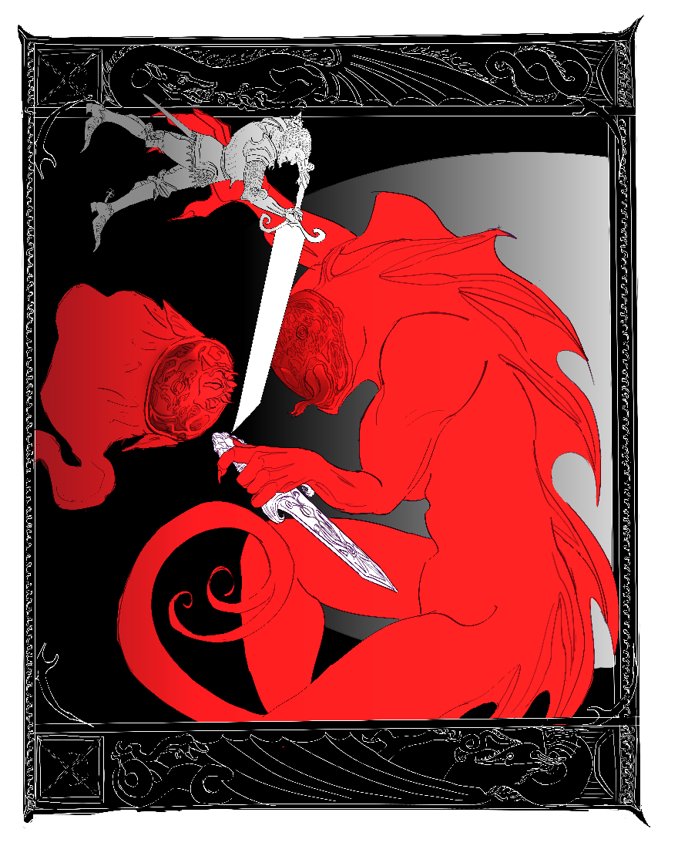

**Irene Dritsa (1563202100059)**

**Beowulf vs. Grendel’s Mother**

**Maria ‘Marietta’ Brintziki (1563202100149)**

***Beowulf*, Part II**

In the second third of *Beowulf* (ll. 1063-2196), we encounter, amongst other things, women of different class, position, even of different nature altogether. We see women as peace-weavers, women as political figures, women as commodities, women as protectors, even a woman as an avenger. Oftentimes, these women will act as ‘mirrors’ or as foils to one another, either by having similar storylines or by being ‘fillers’ in the story in order to bring out another woman’s traits. As these roles interweave and interact in complex ways, this journal will attempt to establish connections between the female characters of *Beowulf* mentioned in the aforementioned lines and examine them from a critical angle by attempting to dispel prejudices and preconceived images often shared and projected in the work by the male characters.

The first role I am going to examine is that of the *freothuwebbe* or peace-weaver. These were women who were married to a member of an enemy tribe in order to establish peace and end all animosity. In this second third of *Beowulf*, two women are noted to have this role: Hildeburh and Freawaru. Hildeburh is a character in a poem sung by Hrothgar’s scop; a woman who is married off to king Finn of Frisia in order to settle a feud between two tribes. Her role as peace-weaver however, is ultimately unsuccessful: Hildenburh not only lives to see and mourn her brother’s, Hnæf, and her son’s death, but also her husband’s, and is in the end carried away back to her native tribe. Similar to Hildenburh is the story of Freawaru, the ‘young, gold-laden’ (l. 2020) maiden, promised to Ingeld, son of king Froda, in order to settle a feud. Young Freawaru’s grim future is foretold both by the narrator and Beowulf, who vividly imagines that some conflict will spark again in the future between the warriors of the two tribes. In both cases, we see two women whose lives are spoiled and wasted, who are condemned to see loved ones be murdered, and who are themselves condemned to be passed from one tribe to another as a mere commodity, a useful tool.

The second role I will examine, is that of the woman as protector, as examined in the character of Wealhtheow, wife of Hrothgar. Wealhtheow is much more than a wife to the king; her speech to Beowulf perfectly encapsulates how politically astute and tactful she is – even if she is restrained to a speech or two of lesser importance (at least when compared to those of other male characters in the poem). However, what makes her character so admirable, is her ability to sense danger and use the available means to prevent it. Wealhtheow notably asks of Beowulf to act as a protector to her sons, perhaps sensing Hrothulf’s future treachery. If that is the case, Wealhtheow not only manages to affectively deflect danger (as Beowulf will take his role of protector very seriously later in the poem), but also senses it, unlike her husband Hrothgar, thus making her more perceptive and cunning than a male figure of power.

The third, and perhaps most notable role, is that of the woman-avenger, as seen in Grendel’s mother. Before I analyze Grendel’s mother as a character, I want to point out the significance of rendering her nameless in a story in which she clearly plays a not so minor role. As it is said in lines 1351-1352, “In earlier days the people of the region / named him Grendel”. Grendel as a ‘monster’ without logos or moral principles is unable to name himself, so this task is taken up by people who are capable of naming – and also marginalizing – him. The detail of naming the male monster, but completely omitting to do so to his female counterpart should not be dismissed or downplayed, especially in a story in which characters’ names can determine their reception by others. Even a far more minor character to Grendel’s mother is named (Æschere, elder brother of Yrmenlaf) and is even eulogized by Hrothgar, whilst Grendel’s mother remains nameless and is referred to as “a restless corpse-spirit” (l. 1327). As a character, Grendel’s mother is seen through the same lens of ‘otherness’ like her son before her. Disconsolate and bereft, Grendel’s mother acts in the exact same way as the ‘civilized’ men of the poem: she seeks revenge for her son’s death, in which she finds in the killing of Æschere. The killing of one, instead of many thanes/warriors, is downplayed by the men of the story as a personal failure of Grendel’s mother. Upon a more careful reading however, Grendel’s mother can quickly transform from a failed avenger, to a fair one. Æschere is not just any man; he is Hrothgar’s chief adviser. By killing -even unbeknownst to her- a man who is almost like a son to the king of the Danes, she is taking ‘an eye for an eye’ without any further unnecessary bloodshed. Despite the fact that Grendel’s mother is seen as a creature who lacks reason and acts on the baser instincts of one’s soul, it is the ‘civilized’ and ‘proper’ humans who hang the severed arm of Grendel as a trophy to Heorot’s wall, thus sending the already mourning mother in a grief-driven frenzy. Grendel’s mother’s acts are no different to the actions of honor-driven men of the poem and this is reflected not only through her revenge, but also by her similar act of hanging a severed member of her victim in display (this time being Æschere’s head).

Lastly, I want to briefly mention a set of two women which work as each other’s foils: Hygd and Modthrytho. Hygd is portrayed as the obedient, “very young, / wise, and courteous” (ll. 1922-1923) wife of Hygelac, whereas Modthrytho is the very opposite of her. She is reputed to have such a violent temper that every man who might as much as look at her in the eyes, he meets his end (ll. 1931-1936). Her ways are only changed upon her marriage to king Offa, wherein she becomes a great queen, reputed for her good deeds. As the story provides very little information on both women, it is hard to tell much about Modthrytho’s character. Nevertheless, it is worth mentioning that Modthrytho is a stereotypical portrayal of a Xanthippean, menacing woman, who needs to be ‘reformed’ by a husband, thereby becoming yet another literary ‘shrew’ that needs to be ‘tamed’.

Albeit being seen as a minority of lesser significance, women make up the most diverse set of characters in *Beowulf*. The female characters of *Beowulf* take the roles of mothers, daughters, sisters and wives, protectors, peace-weavers, political advisors and avengers. By assuming different kinds of roles in multiple contexts, the women of *Beowulf* offer the reader a glimpse into the life of fantastical medieval femininities in a male-dominated world, where women can range from misread, gluttonous monsters and shrews, to clever, caring mothers and political figures.

**Nikoleta Gardiki (1563202100041)**

**Grendel’s Mother**

While reading the episode of Grendel’s mother, I couldn’t help but notice the resemblance between Grendel’s mother and the Lady in the Lake from the modern horror series the *Haunting of Bly Manor*. I actually found it difficult to not picture the snatching of Aeschere without imagining the Lady’s snatching of Peter Quint. Particularly the lines 1289-1292 describe Grendel’s mother’s sudden appearance in Heorot in an almost jumpscare-like way: she left the hall as soon as she entered, snatching one of Hrothgar’s trusted advisors. A similar scene can be seen in *Bly Manor* in episode 5, when the Lady in the Lake suddenly emerges from the shadows and wraps her fingers around Peter’s throat, dragging him into the lake with her after suffocating him. The Lady in the Lake, Viola, follows the same cycle ever since her ghost was trapped inside her chest of jewels that was tossed inside the lake after her husband and daughter decided to leave the Manor. Once Viola awakes, the cycle begins. She enters the Manor looking for her daughter and, instinctively, kills whoever disrupts her path by blocking her way. As for Grendel’s mother, there is no implication in the text that she could have known who Aeschere was or his position to Hrothgar, and even if she did, he wasn’t the one she was looking for, so we can assume that she only snatched Aeschere because he was the closest man to her path in order to lure Beowulf.

Hrothgar also calls Grendel’s mother ‘a restless corpse-spirit’ in line 1327. Viola is another restless ghost that was cursed to haunt the Manor and perform the same cycle. The reasons for their restlessness are quite similar as well: their children. While Grendel’s mother is looking to avenge her son’s death at the hands of Beowulf, Viola is looking for her daughter – when she forgets that she is specifically looking for her own daughter, she is well aware that she is supposed to be searching for a child, which is why she tenderly wraps her arms around the child sleeping on her daughter’s former bed years later and takes the child along with her in the lake. Finally both Grendel’s mother and Viola live underwater and their victims are found near bodies of water, although Viola drags her prey deep inside the lake. Grendel’s mother’s approach to that is slightly different since Aeschere’s head was found beside the water and Beowulf willingly entered her own habitat to fight. Whether or not Mike Flanagan, the director and screenwriter of *Bly Manor*, was familiar with Grendel’s mother, I think this comparison proves that a Beowulf horror adaptation wouldn’t be so far-fetched. Why not even a cliche early 2000s slasher – Grendel starts murdering a group of teenagers who disturb his peace in an isolated cabin in the woods in Denmark. In the middle of the movie, the teenagers manage to kill Grendel only to realize that the real threat was Grendel’s mother who avenges her son until she is beheaded by the only survivor, Beowulf (Netflix, let me write your next movie).

And if *Beowulf* does become a slasher film, maybe we should add Beowulf’s name to the final girls list.

**George Karavas (1563202100081)**

**Beowulf and Grendel**

An attempt at writing a poem from a perspective where Grendel and his mother represent primal tribes and their native lands respectively. Thus, Beowulf’s killing of Grendel is the slaughtering of native people and the killing of Grendel’s mother is the invading of said people’s lands in an effort to exterminate them and expand in their territory.

On stories of man and monster

“From motherland to motherland, to new-found-lands and glory, men!  
Onwards! Marching on; through swamps, through plains, through caves, through rain, through thunder!  
Stepping, trembling, thudding lands. Τhe cloud-dark heavens grumbling!  
Against mighty wailing winds, against the abyss-howling of night.  
Across the cliffs, across the mountains lie foes to be beheaded!  
To be dismembered, dissected ornaments for our glorious halls!   
The sun shall rise and shine upon you, rinse your sweet sweat; silence all!  
In battlefront your fair fame waits, like fine crops to be reaped, then cherished!”  
But, as all hell broke loose, the uproars silenced beautifications.  
Perspiration was drawn from men as dew is drawn from full-drenched leaves.  
Chain-mails against chain-mails crashing, sword against sword came down clashing.  
Clanging, clinging onto dear life! Though they no longer longed for her…  
Bloodstained were from battle, the warriors' world-observers.  
As on blood were flowers warmly bathed, grounds rewritten arose anew;  
and on them a faint, fading distant past withdrew as blood dried up.  
A cursed whisper of what’s passed, a damned layer of palimpsest!  
To be engulfed in flames, to be turned into ashes, debris, dust.  
Time ticks by and epochs fly but still mothers weep and children cry  
for all that steel, for all that iron took from them, so far away.  
Picking buds to pluck, then offer purge of pain that first was absent;  
The grace of god is only as good as mercy in a battlefront.  
“What religion, what lord must I worship to remain well-alive?  
Peoples disposed of, fertile lands in fires; Chaos over peace!”,  
Begged a worn-out weary woman, before her head was slashed and tossed.  
It met the ground with a thump, and blood gushed out of where once it hung.  
“Good thinking, but the rest will be thought after to rest you’ve been put.  
At last! All that is left are fields; no fiends, no fierceness. Look, rejoice!  
There's only good and what it takes!” (for it to be transmogrified…).  
Growling, soaring over the white skies, roaring proudly of glory-  
Rowing oars, grunting voices of returning sea-ravaged wave-men;  
slowly lost in mist, figures merged with haze, even shadows vanished;   
And as time took its toll, all left alive were some sounds and some song;  
The thudding turned to panting, the trembling turned to quiet rustling.  
The clashing turned to hushing, the crashing smelt to air’s breeze passing.  
The hissing winds once howling bliss; all flora floored by fiery steps.  
The hissing winds now brushing weeds; standing so mighty tall and proud!  
And in ‘em live the sound and contents travelling through lands and times;  
From afar melodies echo beyond the temporality,  
beyond the still lying of presence; from a distant glorious past.  
Forgotten is the wailing, the woe of women; wasted womb-work.  
As such are told the lasting tales of monster and of monstrous man.

**Vasiliki-Antonia “Silia” Antoniou (1563202100014)**

***Beowulf* Part II**

After reading the second part of *Beowulf*, what stood out to me the most was the fact that Grendel’s mother had no name. Despite being the terrifying ogre’s parent and possessing equal amounts of power, her presence is simply not as important as her son’s. She is referenced to as a ‘monster-woman’, a sinner or simply as Grendel’s relative, but she has no identity other than that. We see that she doesn’t terrorize or kill humans until they attack Grendel and that sends her into a violent rage and need to avenge her fallen child. It’s interesting that both Beowulf and the mother fight to protect those who they consider family, Beowulf protecting his Lord, Hrothgar and avenging his comrades and fellow thanes, while the mother seeks revenge on behalf of her monstrous offspring. They are both not afraid to die or spill their blood in battle and that proves that Beowulf, the hero of the story, is not entirely different than the monstrous ogre woman in terms of their motives and strength of character. Of course, he ends up winning the fight (thanks to plot armor, may I add), but underwater the mother actually poses a bigger threat than her son, giving Beowulf a run for his money (literally and figurately). Even when Beowulf manages to kill the mother with his newly-acquired blade, he completely abandons her severed head (almost served on a plate for him) and chooses to decapitate Grendel, completely ignoring the woman in his way. It is pretty obvious to me at this point that she is the Other, even among monsters and demons. Perhaps Beowulf felt like Grendel symbolized a more notorious enemy for the Danish people or even ‘spared’ the mother’s head due to her gender or maternal role, but it’s still strange how he disregards this scary snake-demon and leaves her behind in the underwater cave, as if she died unnoticed, in an insignificant way. The female is overshadowed by the male, even in the case of death, probably because of medieval misogynistic conventions. I believe that she also subverts the ‘damsel in distress’ trope because instead of being described as having a flawless appearance and passive behavior, she is presented as an ‘evil’ monster and sinner, a dangerous creature to be dealt with, therefore taking a more traditionally masculine role. Had the point of view been different or had she been an ordinary human being, maybe the readers would have empathized with her more due to her grief and personal loss, as well as commended her on her bravery in avenging Grendel despite her heartbreak. Ultimately, she is a mother who lost her child, despite their circumstances. To me, she symbolizes bravery and she doesn’t search for glory or fame, only means to mend her pain and show her anger through blood, the only way she knows. Despite her efforts and ferocity, however, she is left in the dark once again.

**Panagiotis Niarchos (1563202100152)**

**Blood-soaked fairytales; how heroes are made in the epic poem “Beowulf” and Hidetaka Miyazaki’s “Dark Souls”**

When Beowulf’s fight with the monstrous Grendel ends, we are left with a ferocious scene. King Hrothgar’s hall is in ruin, its floors lined with the splinters of the broken down door and other furniture, and drenched in the viscera of Beowulf’s mangled companion as well as the blood of the dismembered beast, whose screams would grow quieter as it fled back into the safety of the night and away from the hero who had given it its first ever taste of fear. It is difficult, however, to not feel a certain degree of dread towards the victorious Beowulf; a human warrior who managed to match the strength of a monster and defeat it with ease. The question, therefore, is, where does Beowulf end and Grendel begins?

The arbitrary barrier between monster-slayer and monster is a theme that is heavily explored in Hidetaka Miyazaki’s 2011 video game “Dark Souls”. In the game’s expansive mythology, one of the most revered and legendary figures is the knight Sir Artorias. In an age long past, Sir Artorias was sent on a knightly quest on behalf of his lord, to seal away a great darkness that threatened to consume the land. He fought the great ancient beast Manus, and upon its defeat, Sir Artorias succeeded in keeping the darkness at bay, but unfortunately perished in the attempt. Ages later, in the game’s present, Sir Artorias is hailed as the greatest of all knights and a true legend of unparalleled virtue. However, thanks to a little time-travel, the player can witness the truth of the myth of Sir Artorias first-hand.

The reality is that Sir Artorias failed in his mission. It was the player who managed to defeat the ancient horror Manus and it was the player who sealed away its darkness. In their journey to the past, the player will encounter Sir Artorias, and it is in this encounter that his legend fully unravels. The knight failed to stop the beast and its darkness, and was left with a broken arm and fully corrupted by the abyss he was sent to contain. The knight is no more than a maddened husk of his former self, hopelessly fighting the abyss that consumed him, only for the player to finally put him to rest. It is in this brief encounter with the knight that we realize that the legend of Sir Artorias was merely a fabrication. Not only did he fail in his legendary quest, but he succumbed to the very evil he was sent to contain, becoming no more than another monster in the army that Manus was hoping to raise.

The tragedy of Sir Artorias and the birth of the myth of Beowulf, in my opinion, share a lot in the way they are explored. Sir Artorias’ legend was a lie, with the reality being that the proud knight met his end half-crazed and no different than the monster he was tasked with slaying. Beowulf, however, has the luxury of a warning. He is told that monstrous strength may allow him to battle beasts like Grendel, but it is precisely this strength that made Grendel the plague that he was. In essence, a hero is praised for virtues which allows them to face the supernatural, the darkness that the rest of the community shudders to confront, but in doing so the hero has to elevate themselves, shed their humanity in hope of meeting the measure of the inhuman task. It is in this gamble that the hero might lose themselves, and it is precisely this corruption that comes despite their best efforts, the most tragic and human characteristic of all.

**Elena Kodrou (202000246)**

**A Hill to Die On**

As far as battles go, vis-a-vis one choosing theirs carefully, there is no reality in which I do not defend Grendel’s Mother to the death. She had chosen a solitary life, or maybe it had chosen her, being a so-called “monster”, her son the only creature not alienating her and yet she could not find peace. Even after she had made her home in a cave in the depths of a monster-infested lake, because surely that would discourage any potential visitors (pests), she was not allowed to live, well, at all.

After finding her son bleeding out amongst the trees under which she had once felt safe, it follows of course that Grendel’s Mother thirsts for revenge. Revenge on the savages that had invaded her home and disrupted her quietude, revenge on the heathens that ripped her son apart and kept his arm as a trophy. Truthfully, their crimes against her called for much more than the death of one measly human, no matter his position, and yet the filthy humans refused to let this be the end of a twelve-year long vendetta. They chose to attack a still-grieving mother in her own home, steal from her and defile her son’s corpse.

So, yes, I will defend the right of a mother to take justice in her own hands, against her land’s invaders, her son’s murderers. This is the battle I choose. Grendel’s Mother did nothing wrong, and I will make this my hill to die on.

Also for your consideration:

*Beowulf*, ll. 1063-2195 a summary in memes:

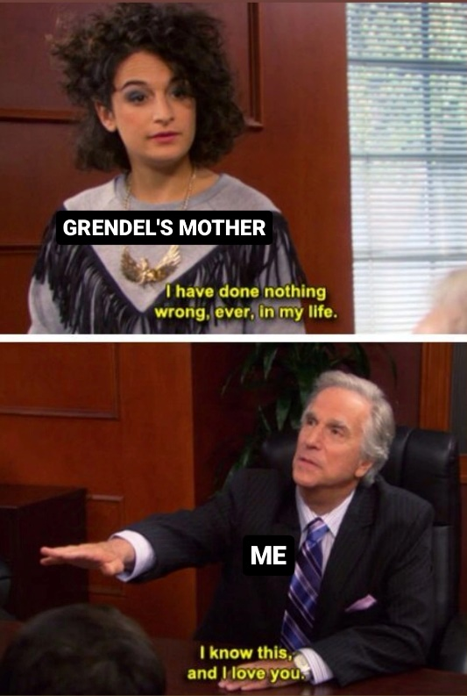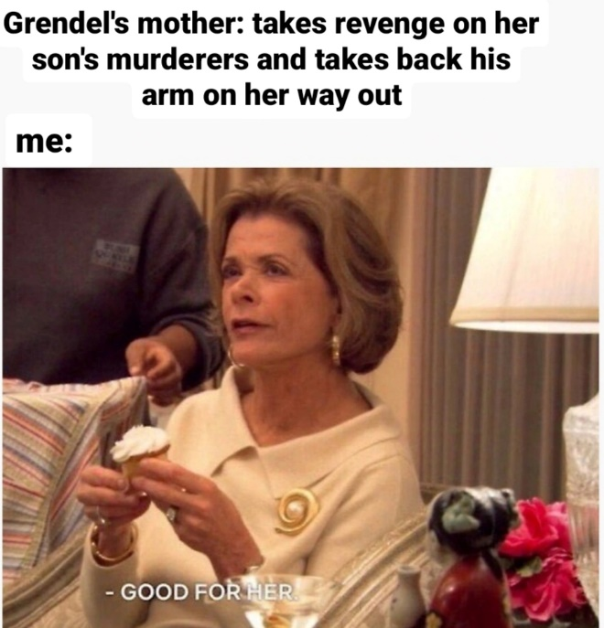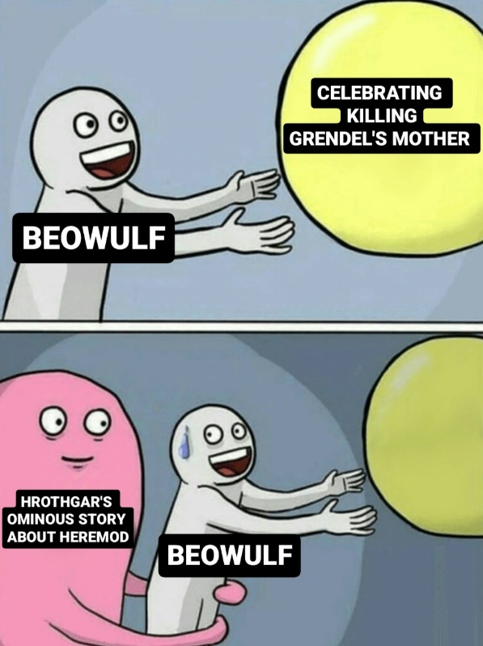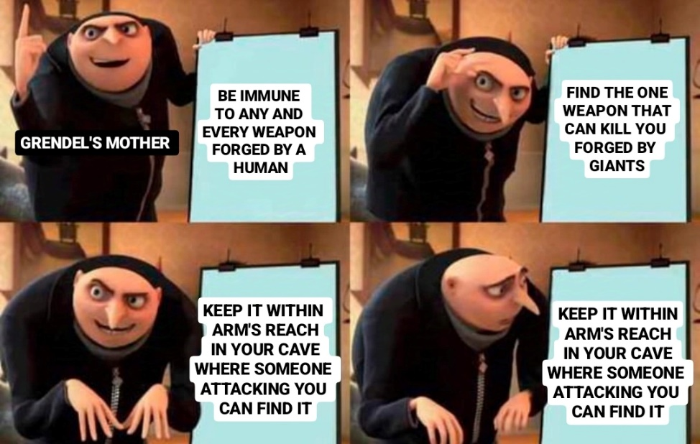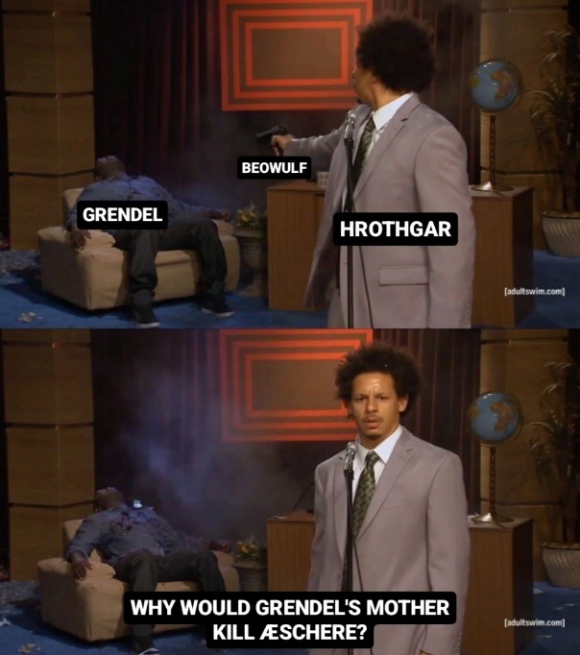



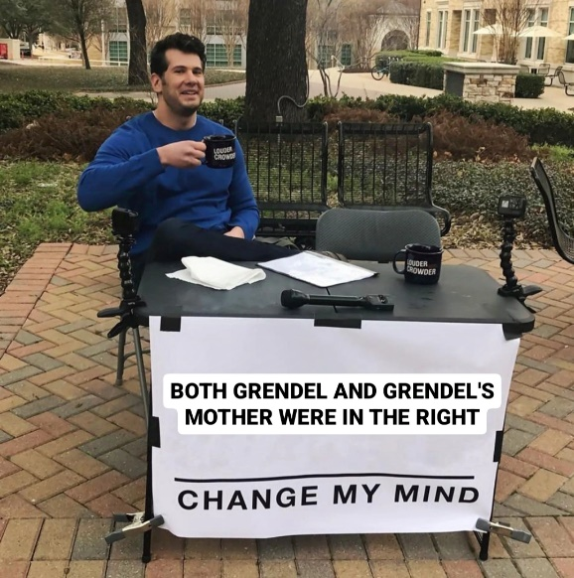

**Kyriaki Englezou (1563202100060)**

***Beowulf,* Part II**

In the epic poem ‘*Beowulf’*, Grendel and his mother are two creatures that can take on many different meanings. On of these is to see them as symbolic representations of native tribes and their culture and, therefore, the whole poem can be viewed from the perspective of invasion and conflict.

The two monsters’ lair is one with nature, away from any form of human life. This close relation to the wilderness and the clear antithesis to the Lord’s Hall symbolises the way indigenous people were viewed by the conquerors and the explorers: as untamed beasts who are too far removed from civilisation to be even considered human. Using this as a rationalisation, the invaders were free to show their cruel side to the old inhabitants of the land and forcefully remove or eliminate them. Depicting them as threats and spreading this message through the arts gave them the opportunity to attack and steal, while wiping out the old way of thinking and living in the process. Those ‘unruly’ and ‘untamed’ people became their target, as they contrasted greatly with the civilisation the invaders were attempting to establish at the time, symbolised by the great hall Heorot.

The mother’s actions can be seen as a last form of resistance from a tribe which is slowly but steadily losing its culture, traditions and lands. After Grendel’s death, his mother does not go after his killer right away. Instead, her first move is to remove her son’s hand, which has been treated disgracefully and has been hanged as a trophy for all to see in the Great Hall. This action can be interpreted as the native people trying peacefully to honour their dead, which have been mistreated in the hands of the enemy. Having done nothing wrong, those long existing tribes could, possibly, not be able to understand why someone could act so cruelly against them and harm their people and their beloved land. If the mother in the story stands symbolically for those natives, then her prioritisation of her son’s dignity shows the real face of the land’s first inhabitants; they are not cruel and uncivilised but have their own moral compasses and values.

Even the death and abduction of one of the Lord’s men can be justified as an equal counterattack performed by the mother. After making sure her son’s body can be whole again, the monstress attacks and kills Æschere and drags his corpse back to her lair. Continuing on the assumption that the mother represents the old, native way of thinking, this could be an indication of the natives’ character who chose to retaliate but not to spill blood unnecessarily. Their plan would not be revenge, as Beowulf the killer himself was not targeted, but rather an attempt to even the scale and to avoid any further conflict. We see that in the end it is the humans who returned to the lair to attack once more and not the other way around. Having nothing to gain, the native tribes would not risk the lives of their people to rid the land of the invaders, but they would have to defend themselves if they were under attack, just as the mother was forced to do when Beowulf returned for her head.

Grendel’s mother is a figure in this epic that could either be seen as a bloodthirsty monster or as a means to represent a whole other way of life. If viewed as a symbol for the native tribes, she becomes a misjudged character who did everything in her power to defend her home and its people from the unknown.

**Irene Dritsa (1563202100059)**

**Beowulf’s Final Battle**

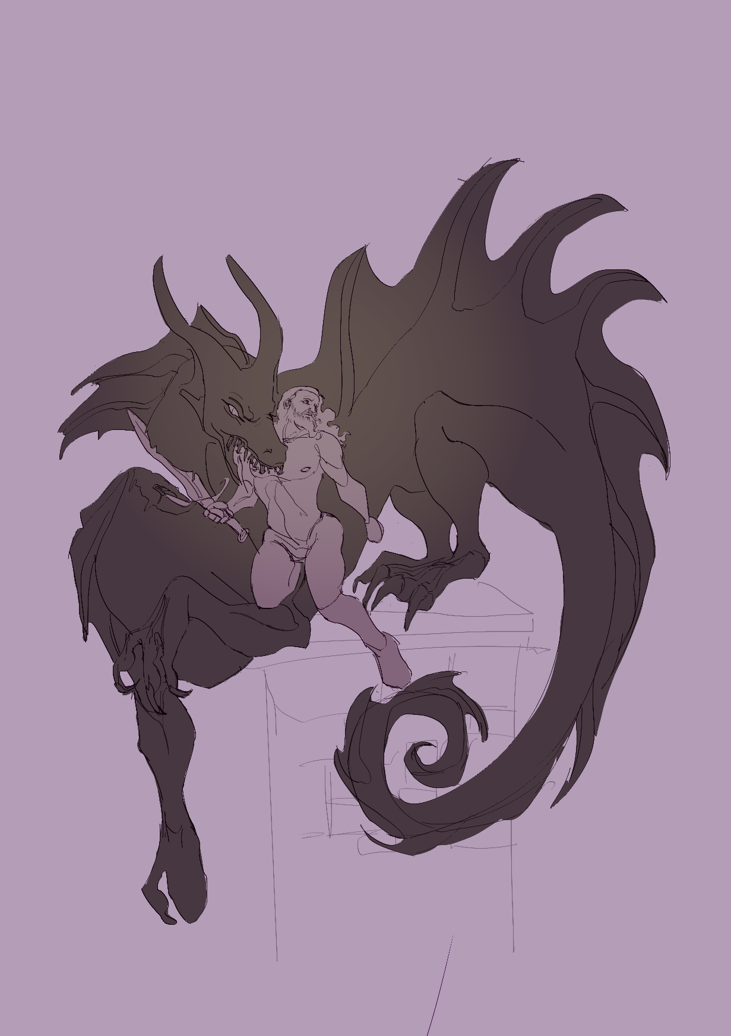

**Alexandros Tzartzas (1563202100250)**

***Sir Gawain and the Green Knight***

One of the interesting aspects of *Sir Gawain and the Green Knight* is the use of the myth of Troy, or more specifically, that of Aeneas. In the first canto, the latter is alluded to directly. According to the myth, Aeneas left Troy to establish Rome, whilst his descendants would go on to become the supposed rulers of western European civilization. One example of that is Romulus and Remus, founders of Rome. In that vein, though one would expect Aeneas to be revered unreservedly, given his status as the supposed forefather of England, it’s interesting to note how he’s characterized by the Gawain poet as “being famed for his falsehood, the foulest on earth” (l. 4). Yet, this may not be so surprising after all. The above represents Aeneas’ ambivalence as a mythological figure: he is at once noble and cowardly, an epic figure and a human with flaws.

In a similar fashion, Gawain is also ambivalent. Indeed, he’s represented as this chivalrous knight, who is valorous, and behaves with civility both towards the lord of the castle and his wife. And yet, Gawain also seemingly oversteps bounds when brutally decapitating the Green Knight (though, unsurpisingly, the Green Knight survives unscathed, perhaps because of his magical status) or, more crucially, when he deceitfully keeps the sash a secret from the lord of the castle, despite his agreement to share things in a reciprocal fashion with him.

Nonetheless, this all harks back to Aeneas, and there is possibly a direct comparison made between Gawain and the legendary Trojan figure. Like Aeneas, Gawain is a liminal hero, responsible both for imperfections and (comical?) indiscretions, as well as acts of courtoisie, of noble chivalry. As we said in class, maybe it’s this liminality that makes Gawain a hero.

Another interesting aspect of the poem is the ‘other’ castle that Gawain encounters on his journey. Its “battlements” (l. 290), which are of the “best style”, as well as its aesthetic splendor reminds one of *The Pearl*, and the fortified city described there in beautiful terms. After all, the same poet wrote both, so he does seem to be fond of luxuriously opulent castles and courts, or at least describing them. This could be an interesting and significant motif in the medieval texts that we study. Likewise, Gawain’s voyage through the dreary forests of Wirral and the bleak landscapes of western England remind one of “The Wanderer”and the protagonist’s own trying exile there.

**Paraskevi Angelopoulou (1563202100001)**

# ***Sir Gawain and the Green Knight***

The story of *Sir Gawain and the Green Knight* closely resembles the tale of a Celtic mythical hero named Cú Chulainn. Cú Chulainn is an Irish hero who takes part in a "beheading game" with a giant. This myth is most likely the source of inspiration for the Gawain poet. In Arthurian, Christianized England, it was common to adapt old pagan stories to fit the Christian worldview and the ideals that accompanied it.

Even though the main plot of *Sir Gawain and the Green Knight* is based on a pagan myth, there are numerous elements inspired by biblical stories and Christian symbolism. For instance, the motif of the number three (the three axe blows, the three hunts, and the three seduction attempts) is linked to the Judeo-Christian triadic concept of God (Father, Son, and Holy Spirit) and the three temptations of Christ. Moreover, the pentangle on Gawain’s shield, which features the Virgin Mary at its center, at first glance symbolizes the five virtues of a knight (courtesy, generosity, chastity, fellowship, and piety). However, on closer analysis, it connects to King Solomon’s endless knot, the five wounds of Christ.

When analyzing Gawain’s ethos, two significant differences emerge between him and the typical pagan hero. The first concerns Gawain’s discipline in matters of sexuality which is opposite to Cú Chulainn’s womanizing behavior. In the story, Gawain stays as a guest in a castle, where the queen attempts to seduce him three times. Each time, Gawain skillfully and subtly rejects her advances. This part of the story reminds me of two biblical narratives that likely influenced Gawain’s response to temptation.

One such story is that of Samson, a man of great strength who met his downfall because he trusted a foreign woman and succumbed to her seduction. Gawain, familiar with this cautionary tale (as shown by his final rant when Bertilak exposes him), understands that yielding to seduction is both dangerous and against the law of God. Similarly, his manner of rejecting the queen is guided by the story of Joseph in Genesis 39:6-23. Joseph resists the seduction of his master’s wife, adhering to his faith and moral principles. Unlike Gawain, however, Joseph suffers imprisonment after being falsely accused of attempted rape. Gawain, knowing the story of Joseph, manages to “reject” the queen’s offer with care and tact, allowing the queen just enough affection so as to avoid having her or her husband offended.

The second point in the poem where Gawain differs from the classic pagan hero is symbolized by the girdle he accepts from the queen to help him survive the beheading game with the Green Knight. Although the Green Knight is aware of the belt, he does not criticize Gawain harshly for this act of self-preservation. Instead, he praises Gawain for his knightly virtues and forgives his minor failing. This reflects the Christian concept of divine judgment, which acknowledges human flaws and sins but offers forgiveness to those who strive to live piously and with good intentions—even though, ironically, this Christian charity is exercised by the agent of a Celtic pagan goddess. The girdle symbolizes fallen human nature. Unlike the perfect, godlike heroes or those of divine descent (such as Cú Chulainn) in pagan mythology, Arthurian legends present heroes who are distinctly human, with visible flaws. These heroes are not worshipped for their supernatural strength and courage but are admired for their great deeds and strong religious morality and courtesy.

The way this Arthurian legend turns a pagan story into a Christian tale full of symbolic elements and powerful meanings makes it a worthwhile read.

# THE END

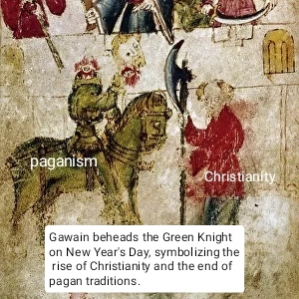

**George Karavas (1563202100081)**

**The Three Kisses**

Oh, brilliant solstice, how you but rebut the armistice

Of bleak December’s festive feast.

How seamlessly pale and perky pallets

fiercely, boldly battle for the surface.

How man imposes color and consent

οn ashen canvases, decaying and deceased.

Ah! Τhat which cannot be grasped, or clasped,

how dearly we dare and try and retain.

And all that leaves and all that flees,

how foolishly we strive and fight to keep.

The torrents of the torments that tear us apart

and the charm of challenges to man unknown,

bring about the apparition of what’s inside;

Whether withered, whether worth

a soul;

I recount a cursed kiss.

a gift so foul; I howl.

I crossed with cursed decease;

The buss of death I found.

The dance I found of lovely life

once to life I felt unbound.

And on I wandered and so, I wondered;

Over ponds I pondered; if ponderous

it be to be rebuilt, rebound.

For, if perfection to infection is susceptible,

perhaps content a man may be

perceptively contemptible, deceitfully elated;

for elevated values, though not vile, are so volatile.

And he who soars the heights of skies,

is one who woven firstly was

to a womb where one will lastly wear.

And ravenous ravens shall rive one apart.

On the lake’s reflection I reflect; they appeared,

I crumbled.

They coax and caw of terror-

two the kisses I received;

I quaff, oh, quaff on error,

trapped in spiteful deceit.

In spite of it spiting me, I spawn a spine;

I spare myself the pointless pity,

I scream and shout, I form two fists-

I punch and punch the pond’s mirage,

but once the liquid calms, serenely

it forms me morose, sere with remorse,

and with eyes of somebody certain that possesses

the silent, sorrow’s sorry seeming;

And they speak, despite doom’s deeming,

of a tormented, laden soul with lament.

But though you be chthonic, beastly fiend,

I am human; and courage is autochthonous to me.

I am human; and oases and crises won’t frighten me.

I am human; through and through. I’m free

and unappropriated.

Shut I squeeze my eyes,

perhaps I’ll lie perfected.

I quench on third a kiss,

but am effectively unaffected.

PS: FUN FACT!!!

Legend has it that Sir Ga(y)wain returned to the castle (in the middle of nowhere!) after the end of the story. There, he spent a fierce, fiery, last night with the Queen. Certain queer- and not queen- sources inform us that it was a favor which he returned to the king afterwards (email me for intricate details). Thing is; he changed into the King’s trousers and not his own after the whole ordeal was over, leaving his own back. The king found, in the left pocket of Gawain’s trousers, a piece of writing with a four-lined stanza scribbled on it. Those lines could be roughly translated into something along these lines:

“I greet, my King, the treats,

but not that Morgan’s tricks.

Thou see, methought it was Christmas,

and not fucking Halloween!”

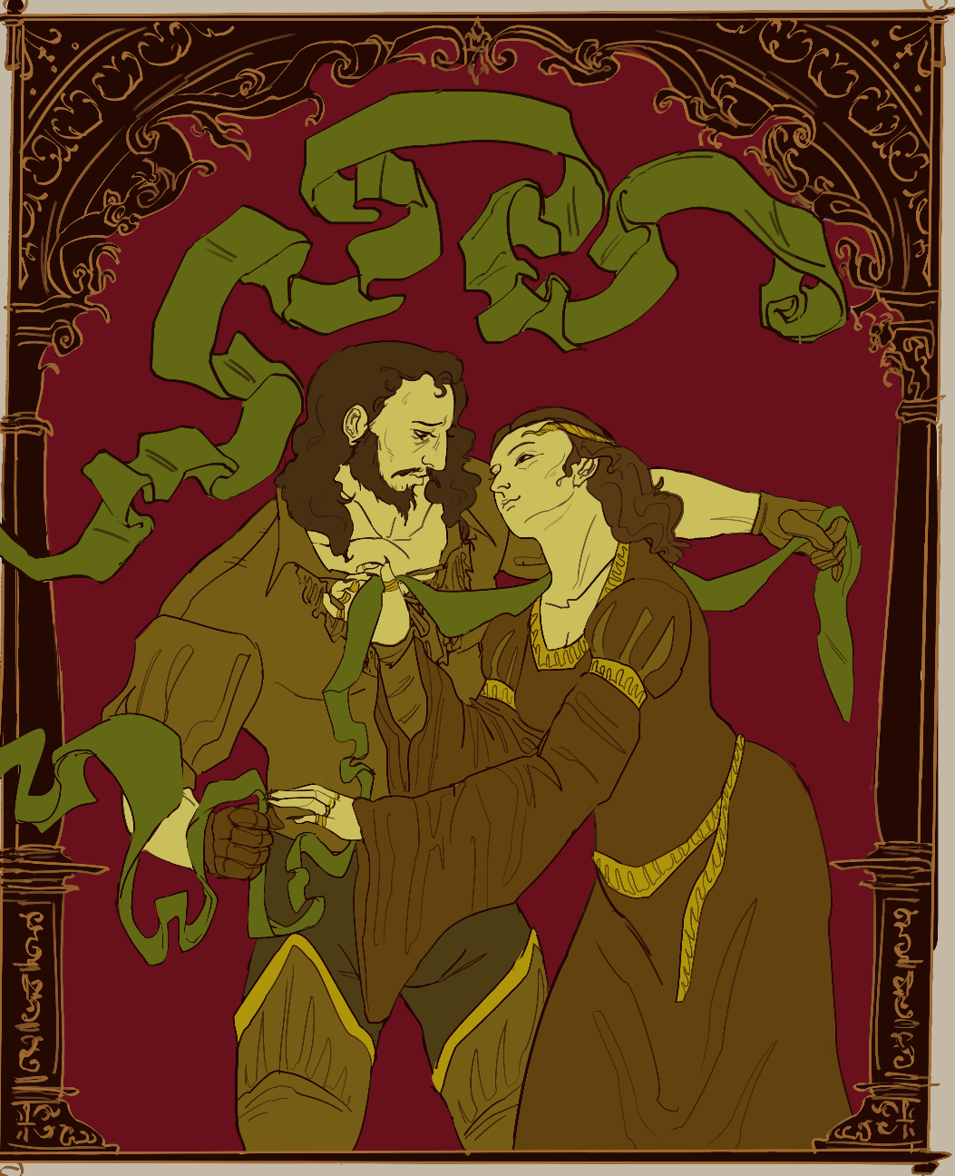

**Irene Dritsa (1563202100059)**

**Sir Gawain and Lady Bertilak**

**Elena Kodrou (202000246)**

**Heads Will Roll!**

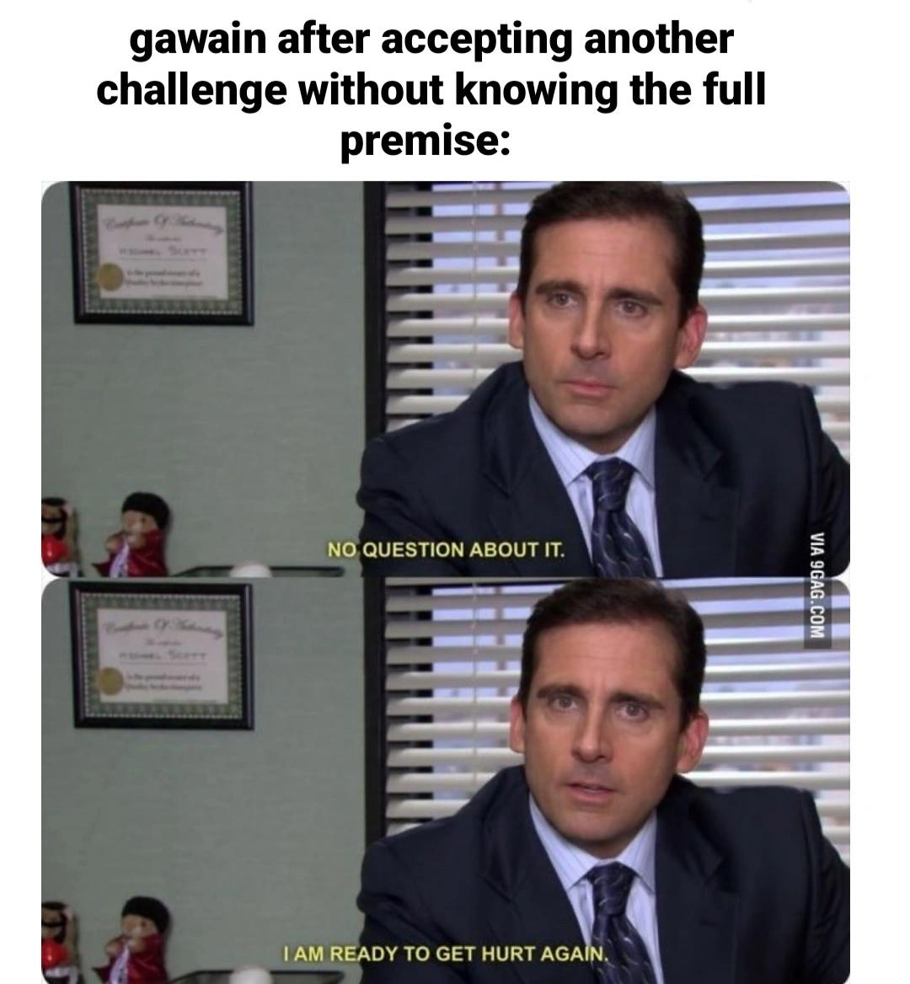

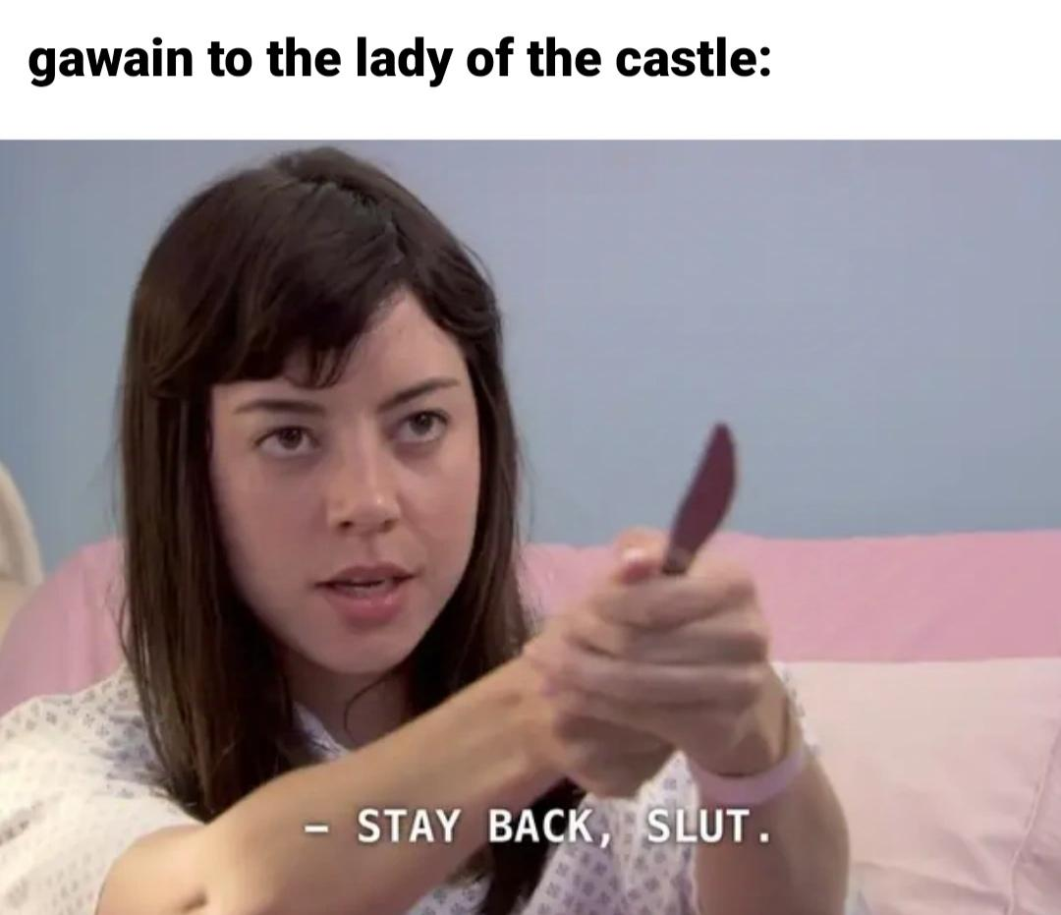



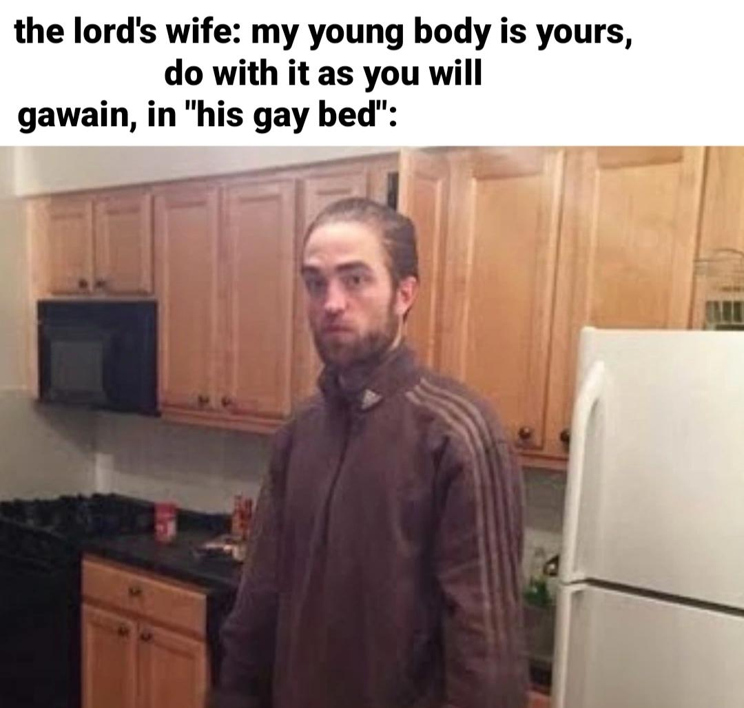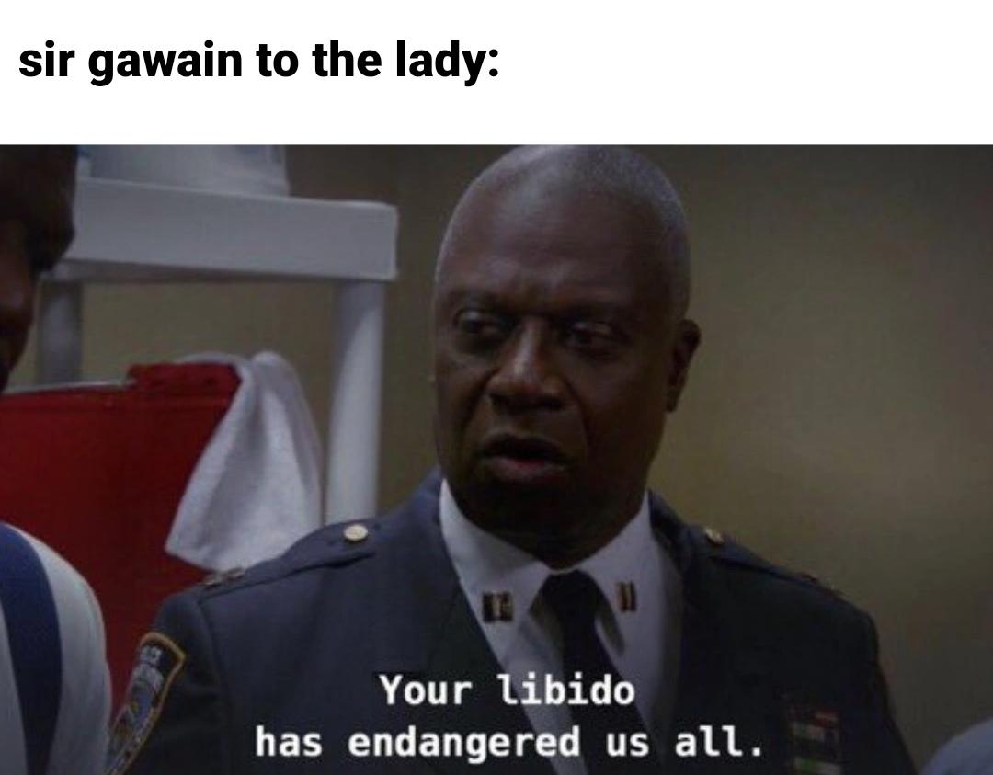

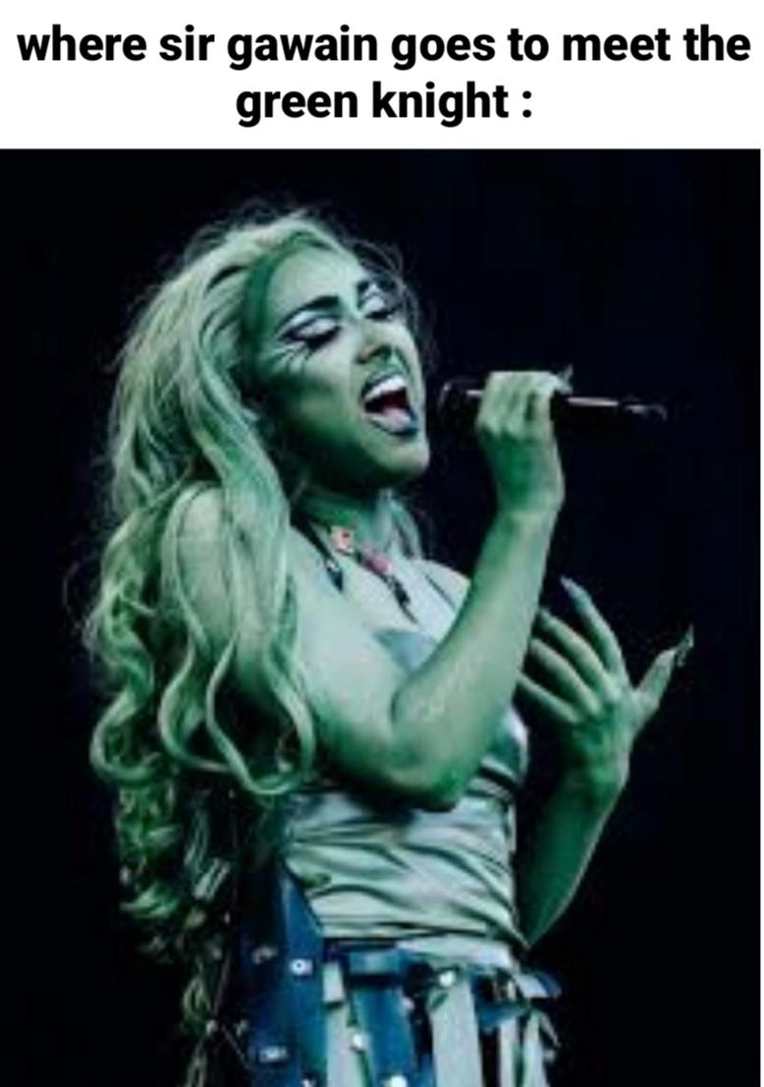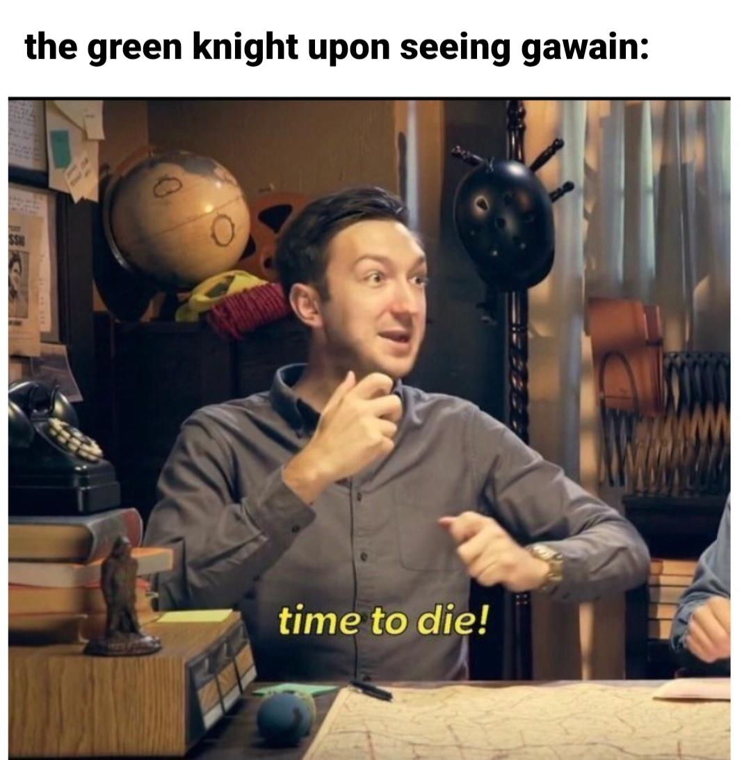



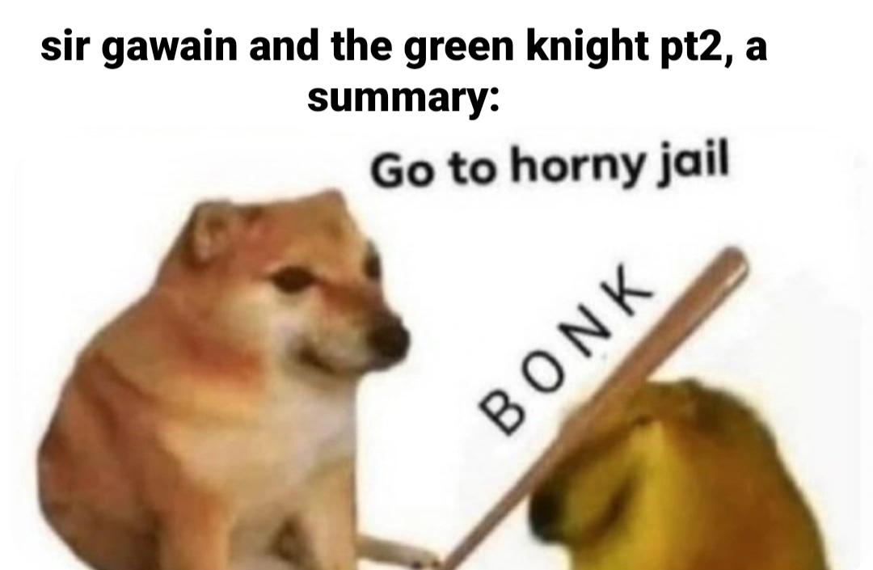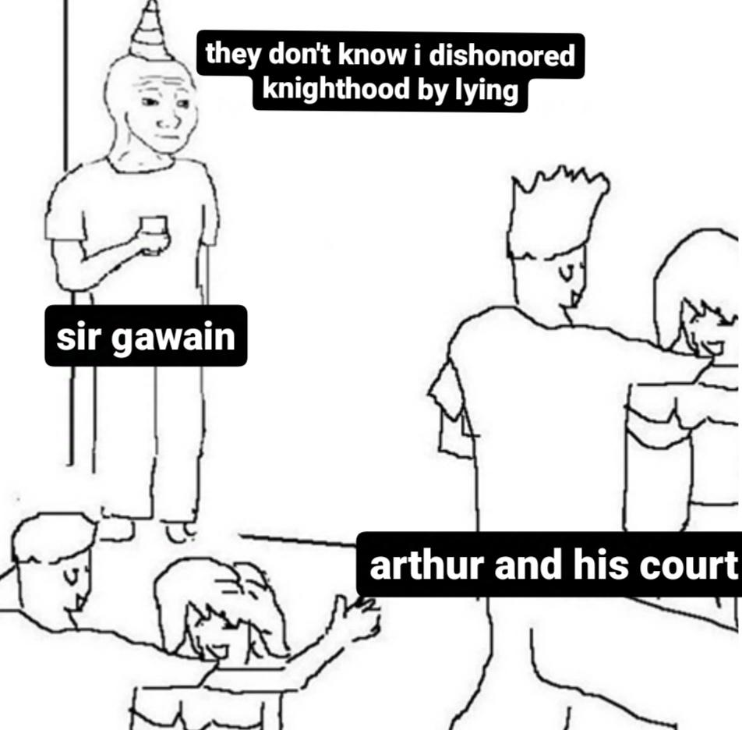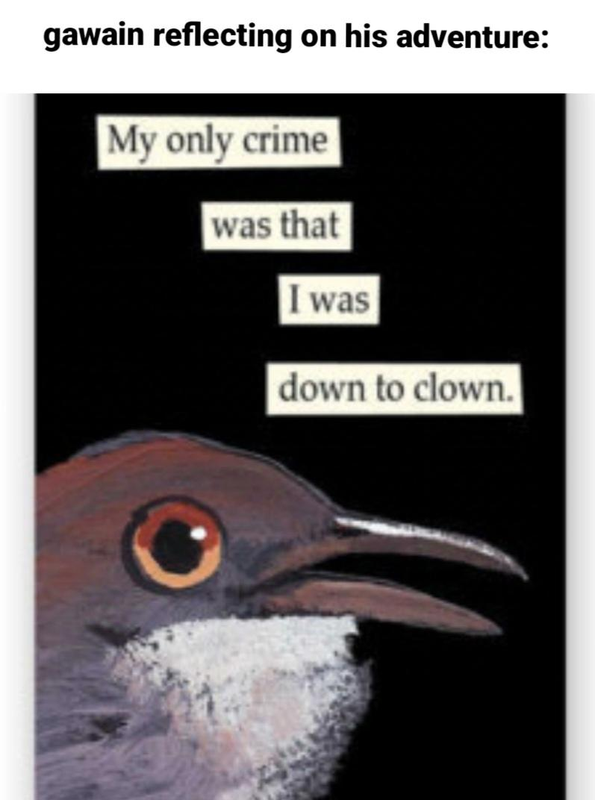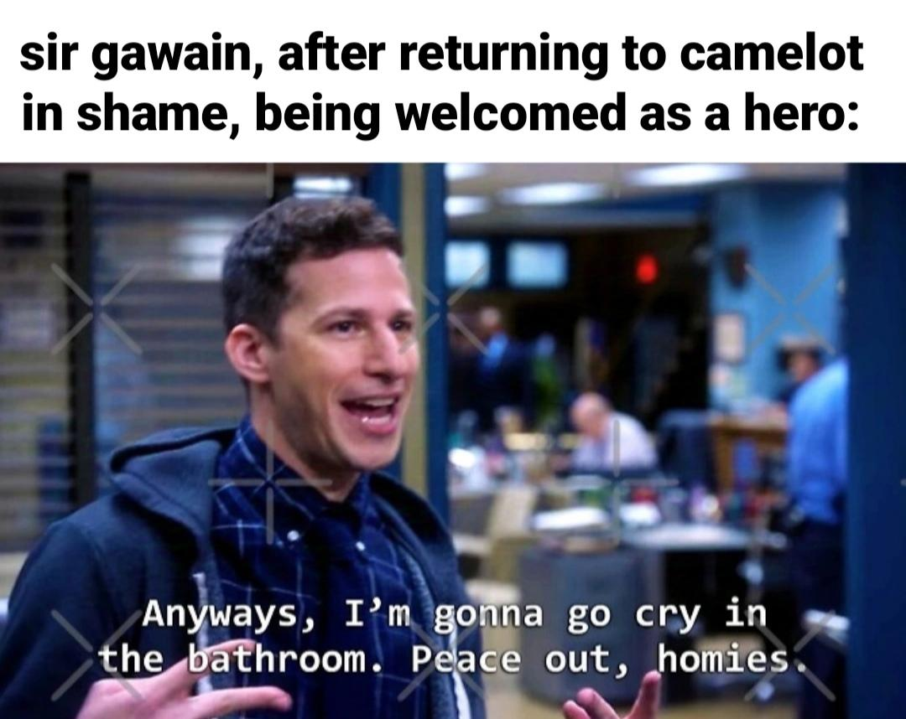

**Nikoleta Gardiki (1563202100041)**

**It Was Morgan All Along!**

When the Green Knight revealed to Gawain that the knight’s challenge had been a trick by Morgan le Fay as a way to shake Arthur’s court and scare Guinevere to death, I was admittedly surprised. Upon rereading the revelation, I wondered why I was so taken aback by that plot twist when it was just natural that Morgan le Fay, the eternal Arthurian scapegoat, would have been behind Gawain’s adventures. The poet spends more than twenty lines (946-969) describing the appearance of the old lady, who we later find out is Morgan residing at Bertilak’s castle, that accompanies the castle’s fair lady and the Gawain poet certainly does not hold back: Morgan is an older woman that is so hideous to look at, she is almost transformed into Medusa - her petrifying gaze might not be literal, but her ugliness sure is. And indeed, the poet chooses to emphasize Morgan’s disgusting exterior to account for her internal wickedness - how could she not be evil, how could she not devise such a plan when she is so ugly? Even before the revelation of Morgan, Gawain himself does not seem to be surprised or angered by the fact that the lady of the castle that had attempted to seduce him was Bertilak’s wife and excuses his ignorance by comparing himself to Biblical men who had been fooled by their deceitful women (2425-2428). When Bertilak tries to persuade Gawain into returning to his castle so he could meet with Morgan, Gawain of course refuses to do so but he does not comment on the revelation nor does he blame Bertilak for falling for Morgan’s tricks. Bertilak’s actions are forgiven through Gawain’s previous lines about untrustworthy Biblical women.

It is interesting that despite the continuous praise of the beauty and youthfulness of Bertilak’s wife (RIP Gawain poet, you would have loved *The Substance* with Demi Moore), she is still a seductress whose sole purpose is to make Gawain sin and forsake his knightly virtues - exactly what the wicked Biblical women did. The poet makes sure to describe her minimal clothing, her gracious movements and the sweet words she uses to seduce Gawain, going even further as to make the lady frustrated at Gawain’s refusal, saying that it is shameful for him to not appreciate and love a woman like her who is openly offering herself to him. The women in the poem exist to justify sin and evil, whether they are old or young, beautiful or ugly. In simpler terms, no woman can be trusted as they are inherently wicked.

I would not be surprised if the phantom of Morgan le Fay was shaking her head in disapproval when the Gawain poet decided to include her as the Trickster. She has had so many different interpretations by various authors that I am sure even she must be confused as to what her actual personality is. If a song could summarize Morgan’s feelings about her representation in *Sir Gawain and the Green Knight*, it would be *My Chemical Romance*’s ‘I’m Not Okay’.

**Georgia Theodosia Marini (1563202100123)**

**Sending hate mail to martyrdom: a critique of the knightly and Christian values of “noble” sacrifice in *Sir Gawain and the Green Knight***

Upon reading the entirety of *Sir Gawain and the Green Knight*, I find myself in a situation that is not uncommon in my interactions with literature. That is to say, as I sit down to critically discuss a beautifully written and, at times, very amusing story, I am also met with feelings of irritation. It is difficult to overlook how a substantial part f it is essentially a man being glorified for choosing to walk straight to his own death. Thus, the theme I would wish to discuss in this journal is the glorification of subjugation. The values of the Patriarchy and Christianity become even more entwined than they already were to give birth to this new code of values, which fall under the umbrella of chivalry and knighthood. The culmination of these values leads to what is, to me, a terrifying masculinist narrative that confines people’s way of existence and self-expression in only two ways it deems appropriate: the subjugator and the subjugated, the dominator and the docile, the servant and the lord. A knight holds a unique position within this binary, given that they’re expected to embody a sort of hybrid identity. In particular, they are, in typical patriarchy fashion, expected to reach self-actualisation through committing acts of great violence, they are deemed heroic in such manner. However, unlike other types of heroes it is not enough for the knight to be a subjugator, they must also be subjugated themselves, and they must be a willing participant in both. To bring this to the actual text, Gawain starts the story as a knight completely subjugated to Arthur, the king, his lord, the personification of authority. As the Green Knight enters the fray and demands a participant in his strange game, someone has to appease him. But who will be the one to do it? Could it be, the king himself? No. Of course not. Perish at the thought. Gawain stands up and says I will do it my lord, and not only will I do it, I will perform this task willingly and with great excitement because I am hardly the most useful knight at the end of the day, and my offering myself up to this task is actually the perfect outcome since otherwise I would’ve been worthless all my life and if I die in the process, your royal highness, then it is really not that serious. (I admit this is not word for word how he says it… But honestly, he could have fooled me). He volunteers himself for this task and essentially plainly says that the validation of the king (and God, let us not forget about God) is the only thing that fuels and legitimises his personhood. If he does this and lives, or if he does this and perishes in the process, both will have the desired outcome: fulfilling his service to authority. He exhibits utter docility to the king. In the celebrations prior to his departure, they essentially dress him up as a pig for slaughter and send him to his death, yet he does not falter or ever dare question both the authority figure, and the code of ethics that confine him in that position. It is a deeply dehumanising path.

Sir Gawain firmly believes that he must not abandon this pursuit, he made a promise, gave his word, on his honour as a knight he must die. But what is this honour really? What does it entail? In truth this honour is null and void, it is but the symbol of the knightly armour, with no body to be found within it. It bears no connection to genuine kindness and desire to protect. All it truly contains is two things: the aforementioned total devotion to authority, and secondly, the capacity to commit violent acts specifically at the behest of that authority. Here we approach the second type present in this binary, from the subjugated we move to the subjugator. Sir Gawain, like all knights are expected to, is willing to draw blood for his king. He attempts to decapitate the green knight in Arthurs’ stead. His code of knightly ethics is not at all concerned with concepts such as murder and taking a life. Authority is the basis of ethics. The moral dimension of an action is determined by its proximity to authority. In that way the knight is different than the image of the American gunslinger, for example. He does not simply fall under the masculine patriarchal narrative of pure domination; he is not taught that he must dominate all others on his way to self-actualisation. Much more specifically, he must dominate whoever the kings asks him. This is performed, once again, for the sake of the king not the knight himself, and he must do it in a way that is in accordance with his code of honour. As for who reigns over that honour? The Christian god. In truth, it sounds like mortifying way to exist. This constant self-imposed docility, as well as the internalised sense of dread that comes with it, are reflected in the story. Sir Gawain enacts upon the green knight an act of violence, in the name of the king. Subsequently, he is forced to experience the same act of violence himself. And he is expected to do so unflinchingly. The green knight complains when Gawain flinches, it is cowardly, unseemly, and of course Sir Gawain tries to conform. The sheep is supposed to like the slaughter house, after all the butcher fed it as it was growing, did he not? Wouldn’t want to seem ungrateful and make a bad impression, after all this is all that exists to its life’s purpose. Overall, it seems to cultivate a sense that there are only two ways to exist, the subjugated and the subjugator, but concerning the figure of the knight, one role has to fall into the other. It is very limiting and affords no chances of liberation or agency of any kind. In a way, it is a narrative that castrates any form of rebellion and radicalism, it is built to perpetuate a status quo of unflinching and stifling authority, be it earthly or “divine” in nature.

The Christian element makes its appearance, it is fundamental to knightly values which truly shine through here. In the Old Testament God asks of Abraham to slay his son for him, to prove his faith. Abraham is willing to go through with it, and this is the example the faithful are supposed to follow. So, when the god that asked you to murder your son, after all, decides to let you be, (as a reward for your utter devotion to him), you fashion him merciful and think yourself justified in agreeing to kill your child over it in the first place. Your faith in his benevolence was not unfounded! Acts of violence performed at the behest of authority gain a positive moral component. When colonialism arrives in a place, the people with swords or guns come through first and those missionaries with bibles and crosses follow after. Those that are sanctified within Christianity are mostly martyrs. It seems to me that what truly constitutes the sanctification of a martyr is not their kind deeds in service of God, it is the fact that they were willing to die for him. It is rooted in the desire for docility in the face of divine authority, not actual change. Jesus himself, the one viewed as the son of God also embodies this. He is more celebrated by the faith for dying for humanity’s sins, than he is for the actual good he could’ve done, “Our Dear Lord for our doom to die was born”. The most prominent symbol in Christianity is the cross he died torturously upon. In most depictions, Saint Jeanne D’Arc is looking up piously, a sword in her hands facing downwards. The sword affords her no agency, it is there to remind you that she used it at Gods command, that was her purpose. She died for him too, after she was done killing for him. Sir Gawain wishes to make this noble sacrifice for no actual reason other than validation. The only difference between his journey and suicide is that the king, and his homosocial patriarchal society, would attribute value to him now, even if that were to be post mortem. Even when he survives this trial, he is overtaken by shame for not honouring his deal with the lord and deciding to keep the belt instead. The code of knighthood is such a one, that even when you walk to your executioner and stand so incredibly still, after having rejected offers of sex out of wedlock three times in the days leading up to your impending doom, you still cannot fully win, it will never be enough.

There is however some resistance to this narrative that can be seen within the text itself, in my view. There is merit to be found in the fact that Sir Gawain, no matter how focused he is on his great quest, refusing to dishonour his promise (even when outright offered alternatives), still does not wish to die. He is not a textbook perfect victim. Despite his devotion to the king, he experiences human emotion and dreads the encounter that he thinks will most likely mean his end. He might be willingly walking to his possible demise, but he’s not entirely impassive about it. He is terrified and flinches in the actual trial. After he survives and is no longer bound by his code, he blatantly tells the green knight that he will take no other blows. He is eager to fight for his life and defend himself after that brush with death. This is also found in his decision to don the protective belt and not offer it to the lord, going against their agreement. Despite it all, he wishes to live and that is evident. It points to the fact that this utter devotion is not something inherent or an element of human nature, the text itself suggests there might be a better way to live. This is strengthened by the fact that Sir Gawain survives this trial instead of actually being sacrificed (this version of such narratives is not without flaw however, as seen in the tale of Abraham reference stated earlier). Lastly another element I enjoyed is Sir Gawain’s commentary on consent, where he claims that a gift not offered freely is no gift and violence is frowned upon where he dwells, when the Lady suggest that he could force himself on women who refuse him. A show of genuine concern for not causing harm onto others, in what we would usually expect to be a purely superficial puritanical attitude towards the ethics of sex, with no regard for the woman’s personhood.

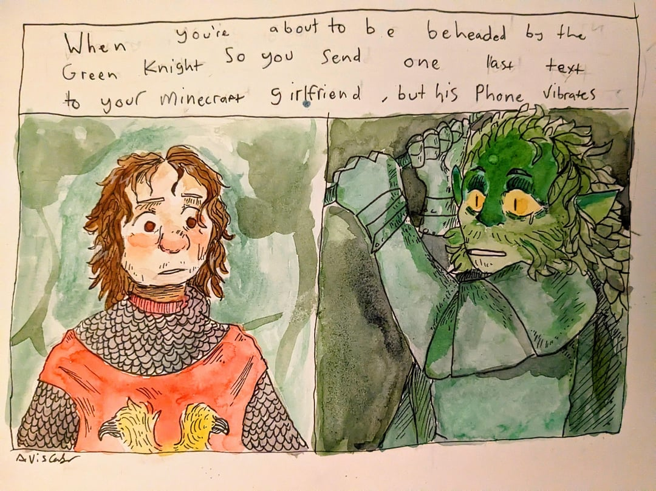

**Panagiotis Niarchos (1563202100152)**

**To dream of castles and swords; the uncanny horror of gender and manhood in David Lowery’s film adaptation of ‘*Sir Gawain and the Green Knight’***

‘*Tell me a tale of yourself, so I might know thee.’* are the first words spoken to the young Gawain by his aging uncle, the great king Arthur. The young Gawain is too stunned to speak, surrounded by the legendary men he has admired all his life. Inside the Round Table of the greatest of all kings, he feels insignificant, as his short life has yet to be graced with an epic tale of chivalric romance. Then suddenly, the doors of the great hall spring open, and the otherworldly horror that is the Green Knight issues his challenge— the grotesque pagan challenges the orderly Christian:

‘*Let whichever of your knights is boldest of blood and wildest of heart step forth, take up arms, and try with honor to land a blow against me[…] but, thy champ must bind himself to this; should he land a blow, then one year and Yuletide hence, must seek me out yonder to the Green Chapel six days to the north[…] and let me strike him in return[…] I will return what was given to me.’*

The young Gawain has no choice but to accept. By dishonorably beheading the challenger in this hall of honor, Gawain earns himself his tale, but also the impending doom that is sure to follow.

In David Lowery’s interpretation of the medieval poem, Gawain is a young soon-to-be knight in the service of his uncle, King Arthur. While the trailers and the well-established Arthurian legend promises us that this will be an epic fantasy movie of great knights braving the horrors of the world, steel phallus in hand, the movie makes it abundantly clear that this will not be the case this time. David Lowery’s ‘*The Green Knight’* is not a story of the ‘chosen-one’ overcoming great odds to become the most important man in the world, but of a boy who struggles to understand the enormity of the world he is thrown into and which, ultimately, is too big to care.

Throughout the movie, the audience can’t help but feel a sense of uncanny horror in the face of both the surreal scenery and psychedelic sequences that occur through Gawain’s journey, but of the essence of the journey itself. The justification of Gawain’s quest is constantly called into question, with even the protagonist offering vague and unconvincing reasons as to why he is compelled to do this, almost as if driven by an outside force well beyond his control. And in the end, in Gawain’s final confrontation with the towering Knight, the ending feels unsatisfactory. We are offered a glimpse into a future where Gawain flees the Green Chapel and lives out the rest of his days as the king of the realm, but spends those days in constant dread of the fate that looms over his head. And even in the canonical ending, where Gawain accepts to honor the terms of the challenge, and assumes the steady stare and calm demeanor of a man changed by his journey, the Green Knight spares him and lets him go with the words: ‘*Now, off with your head.’* Even in the ending in which Gawain lives and completes his quest as honor dictates, the audience is unable to shake off this gnawing feeling of uncanny dread— something is still wrong, even though the credits are rolling.

The root of the problem lies in Arthur’s first words to the young Gawain ‘*Tell me a tale of yourself, so I might know thee.’* Gawain was raised in a hall where every name and every man was attached to legend, where the king himself claimed ancestry from the greatest men to ever walk the earth. Yet these honorable men refused to meet the Green Knight’s challenge, and cheered as the boy took advantage of his challenger’s courtesy by trying to end the game short by cutting off his head. He looks up to his uncle, the king, who is an ailing old man proud of a kingdom he spent a lifetime building. But once Gawain leaves the walls of Camelot, he witnesses the splendor of his uncle’s kingdom firsthand; death, decay, war, decadence, and the signs of a realm in its deathbed; a realm ready to be swallowed by the green. And in this lonely journey, the various characters he meets offer him the opportunity to act honorably, which he does without a second thought, without a hint of refusal, all in an effort to reach the Green Chapel and solemnly put his neck below the Knight’s axe.

This seeming acceptance of doom directly correlates to the main issue at hand, the core of Gawain’s character as told by David Lowery; the conflict between the myth and the reality of manhood. In a twisted and perverse way, ‘*The Green Knight’* is a coming of age story, of a boy who wishes to be a man and sets off into the world to make a legend for his own, even though for the legend to come true he literally has to have his head chopped off. He is influenced by men whose stories are nothing but aesthetics, with no real honor attached to them and, in all likelihood, no truth either. But when facing all these men, he is forced to perform, despite his reluctance and his fear, he has to put on a deeper voice, speak in verse, and brandish a sword with which to behead an innocent man. And even in the absence of those men, when faced with the other denizens of the greater world around him, he is still performing for that crowd sitting around the cold stone of the decaying Round Table.

*‘Is this… Really all there is?’* he exclaims when he finally reaches the Green Chapel and the Knight is preparing his swing, and in an act of righteousness, removes the magical sash that would defend him from it, ready to face whatever the Green Knight has in store for him. Even in the most private moment of the film, when Gawain is alone with his executioner, he is still putting on a performance. His mind wonders and imagines a future where he is lord of the castle, because his uncle told him so, he takes a docile princess to be his queen, because duty told him so, he makes war with his enemies, because his knights told him so. Even as he is seemingly about to lose his life, he imagines a future where he gets to live out his masculine fantasy, but in his dream lies the threat of vulnerability, the knowledge that all to come is possible from a single act of cowardice. Never once does Gawain refuse anyone, he needs other to tell him what honor is, and even as the Green Knight puts his hand on his cheek and says *‘Well done, my brave knight.’* seemingly having beat the game and achieved honor, he is still putting on a performance for this new fatherly figure of the Green Knight. Gender remains uncanny.

In the end, it is this uncanniness that permeates *‘The Green Knight’*, the root of Gawain’s uncertainty; the uncanny feeling that there’s something wrong with the man the world wants him to become. His performance is something superficially imposed upon him, not a testament to his actual character, but an expression of how the world around him- and more specifically other men- want him to be. It is as if a foreign force is responsible for his future and not himself and his desires.

*‘Why greatness? Is goodness not enough?’* asks Essel to Gawain in a tender moment between two lovers, seemingly perplexed as to why would someone decide to embark on a quest that is, by definition, going to end in their demise. Essel is a sex worker who shares a deep romantic relationship with Gawain in the film, and is admittedly the only source of stability for him in his life. It is very interesting how the women in *‘The Green Knight’* interact with Gawain. They are there to remind him of how there is a life beyond the suicidal pursuit of honor, as expressed by Essel, to remind him how poorly he has internalized the values of the patriarchal structure he seeks to join in his encounter with the Lady of the Castle, and how the Green Knight himself was wrought from magic by his mother to test him. The women in Gawain’s life remind him how his only key to happiness and self-actualization is through the pursuit of personal desire, so in essence, women know more about how a good man is ought to be than the men in King Arthur’s court.

*‘Tell me a tale of yourself, so I might know thee.’* In search of the affirmation from the patriarch of Camelot, Gawain embarks on a reckless quest, completes chores without question for the people he meets along the way, and ultimately meets with the Green Knight, a meeting which bore him no consequence. Throughout the entirety of his story, Gawain performs masculinity in front of an omnipresent audience of lying dishonest men who push him to become this image of the divine masculine, even though that is a far cry from what would bring anyone actual happiness. ‘*Why greatness? Is goodness not enough?’* Eventually, Gawain completes his quest without a second thought, and as the credits roll and the off-putting feeling remains, the audience understands the source of the uncanny horror; Gawain never once made a decision for himself and learned nothing from his journey— even in his most private moments he was still performing. Gender remains uncanny.

**Panagiotis Niarchos (1563202100152)**

**The Lord that was promised; the influence of Sir Thomas Malory’s ‘*Le Morte d’Arthur’* in Hidetaka Miyazaki’s fantasy video-game epic *Elden Ring***

‘You are never going to kill storytelling, because it’s built into the human plan. We come with it’

Margaret Atwood (1939 - )

Storytelling and the making of legends is an intrinsic characteristic of the human race, one which has withstood the test of time and has remained a part of us throughout our evolution. It is through the use of shared narratives that people maintain communities, create connections, and forge shared identities. It is also often the case that these stories become such an intimate part of a people’s identity, that it is almost impossible to trace their precise origin, or be certain which aspects of the story refer to real historical figures and which aspects don’t.

Perhaps the legend which adheres to this principle the most, in regards to the western literary canon, is the legend of King Arthur and the Knights of the Roundtable. The Arthurian legends define the meaning of the word ‘chivalry’, and spanning a vast collection of stories, folklore, and poems, tell the complete tale of Arthur’s rise and fall. This legend’s significance does not limit itself to literature, but is a cornerstone of the British national identity as a whole, remaining relevant both during the early conceptions of a unified Britain, and still holding weight today in the era of the United Kingdom. So it is that we see Arthur’s tale transcend mere literature, and enter the sphere of the political. Given its significance to the birth of the notion of a unified British nation, it is impossible to differentiate the Arthurian tales from their political context. One might go as far as to say that the story of the chivalrous utopia of Camelot and its sovereign are meant to be perceived as a sort of propaganda piece— an impossible standard which the people of the British Isles aspire to reach, fail, but reach greatness nonetheless.

This kind of political agenda is something quite common in world literature both of the past and the present, with the influence of the Arthurian legends themselves being prominent in modern popular culture. A very strong example of this is found within the vast mythology of Hidetaka Miyazaki’s epic fantasy video-game masterpiece *Elden Ring.* Perhaps one of the most important figures in the in-game world of *Elden Ring* is the character of Godfrey, First Elden Lord. He was husband to the God-Queen Marika, and through his wars of conquest, pacified the world and build a shining empire known as the Golden Order. He ruled from his castle in the capital city of Leyndell and through his union with Queen Marika, became patriarch to a line of demigods; the Golden Linage. In the end, when Godfrey had vanquished his Queen’s last enemies and had brought the entire continent to heel, he and his armies were banished across the sea, only to be called back by the God-Queen once the world had need of its lord once more.

Godfrey and Arthur’s stories are almost purposefully put in direct parallel to one another. Before his ascension to lordship, Godfrey was a simple pagan chieftain of a warrior clan, but through his union with the Goddess Marika, he assumed the new title of First Elden Lord, and promised to conduct himself as such. As his Queen was to be the figurehead of a new faith, through their marriage, he symbolized the connection of the new regime with the old pagan world, and it is through countless wars that he made the unification of these two seemingly opposing worlds a reality. In the end, as Queen Marika’s new age was slowly succumbing to the fate of all empires, Lord Godfrey was replaced by Second Elden Lord Radagon, but was honorably exiled from the lands of his empire with the promise of his eventual return looming large over the minds of his people.

In the same way, Arthur was at first a pagan chieftain of a warrior clan, who through attaining kingship, became ‘civilized’. His connection to the witches and warlocks of the old primitive pagan and his devout faith in the new Christian made him a unifying figure in the face of the coming post-roman age. And it is though the affair of his queen with sir Launcelot, and the subsequent decline of his brilliant kingdom, that Arthur was forced into exile, to one day return when his realm needed him again.

Even though these stories are written centuries and continents apart, it is very interesting to note their similarities, not in the sense of genre but their context. Both in real life and in the world of *Elden Ring*the stories of these legendary rulers are used for the same purpose and with a similar political agenda. Both Arthur and Godfrey were figureheads of a new age that promised an end to strife and division, of an entire people unified under the guidance of a ruler who embodied past, present, and future, and who, in the end, honorably departed the mortal world but not forever and without wavering. Both the legendary Arthur and Godfrey, First Elden Lord, embody the enduring characteristic of the human race; to tell stories of unity and hope in a better tomorrow.

‘Alas, I am returned to be granted audience once more. Upon my name as Godfrey, the First Elden Lord.’

**Nina Vannieuwenhuyse (280832048329)**

**The Lost Tale**

For this journal, I have tried to imagine what it would be like if Chaucer had

forgotten to include a tale in his final work. To do this, I used the same rhythm

he does (iambic pentameter) and a rhyming scheme of couplets. I also made it

similar to his works in themes and motifs, such as the natureingang. It is a little

silly, and I could not resort to only using Chaucerian words, since I’m not

familiar enough with them, but I hope you enjoy.

Words by Chaucer

There was a tale I forgot to include

Which, so do I admit, was rather rude

Towards the person this is all about

A beautiful lady, not quite devout.

I am talking about Elwin the witch

Who we all knew to be quite the b****

She herself said she was an apothecary

But if you asked too much she got rather weary

And not seldom did she throw a slipper

At the one being a bit too chipper.

As did the others, she told quite a tale

When we were jointly walking through a dale.

The tale was about a client of hers,

She once treated – without using a curse.

Godfrey was his name, to the witch he came

Not even on account of being lame,

Although it was a bother, but in pain

About his hair, for he was very vain.

The Witch’s tale

When the winter had passed and the spring come

The air was alive with the sound of drum,

The birds mated, colourful flowers bloomed

Yet Godfrey had the feeling he was doomed.

He was not feeling under the weather,

But far from feeling light as a feather.

Problem was that his hair had fallen out

The question as to why only raised doubt.

Many suspected his wife without proof,

For she acted – unlike herself- aloof.

His shiny hair had been his sole strong suit

Apart from that he was not very cute.

His squat posture and rough demeanour

Made even scare crows look a lot cleaner.

“Would you look at me” he wailed, “It’s not fair,

I beg your help, please get back my lush hair.”

The man was miserable to the bone,

His whining I truly could not condone.

So I went to work, grinding and cutting

The herbs, some green earth and a sparrow’s wing.

When the concoction was prepared, I smeared

It on his head and saw how well he fared.

“It burns so!”, he yelped, jumping to and fro

He did not care it would make his hair grow.

The strong man brought down by a small malaise,

Just like the great Samson back in his days.

Now as to why his hair was missing

I could only resume with my guessing,

Until the shepherd came by, looking well

Herding the sheep he was going to sell.

It was plain to see that his hair was lush,

Normally he had no need for a brush.

You see, he used to be bald, or nearly,

A miracle must have happened, clearly.

For such volume isn’t acquired overnight,

No matter the prayers you would recite.

By use of my excellent marksmanship,

I say so myself, not biting my lip,

My own shoe guided him nearer for sure,

confronting him about his new coiffure.

With some pressure and a foul-smelling drink

I got him to speak, before he could blink

And he confessed he was wearing a wig,

Of real human hair, the surprise was big.

Godfrey’s wife adored him, it was her gift

Understandably, this caused a big rift.

Godfrey yelled: “What about my naked head?”,

He was not the sharpest tool in the shed.

After more pressure, out came the story

Shimmering in all its twisted glory,

About Godfrey’s wife and the bald shepherd

And some of the details were quite peppered.

She liked all parts of him, except his baldness

And this one big flaw made her reassess.

To be fair, unless I stand corrected,

It resembled an egg and reflected.

A brilliant plan was formed when she saw

She could get her husband’s hair in her claw.

So, under the dark cover of the night,

After having gathered her wits and might,

She snuck out from under the warm cover

And shaved his head, thinking of her lover.

She made him a wig, completing her dream,

A handsome man as outcome of this scheme.

Godfrey has his hair back, but lost his wife,

Who could have known hair could cause such strife!

**Stelios Alevyzakis (1563202000003)**

**“The Miller’s Tale”**

I found the story really interesting and funny to be honest , I loved how it made fun of the tradition that a young girl is “forced” to marry someone significantly older in order to have a good life and although Alison is no saint, I was secretly on her side as it’s not very common for a girl to have so much fun and enjoy herself or make the best of the situation she’s in in stories like this .I also loved how she rejected Absalon every single time despite his incessant whining and pleading ,it gave her a sense of integrity that I felt was needed to support her decisions and actions ,it made the illicit affair with Nicholas seem like real love and not just a fling that would be done by next week .

Furthermore I thoroughly enjoyed how playful both lovers were regarding the way they tried to send away Absalon and in my opinion it gave their characters an edge that I didn’t see coming at first .I also really liked how the story  teaches the time old lesson that marrying outside of your age by a long shot will make you pay the price no matter the provisions you think you’ve taken, just like in the case of John who kept Alison in a cage in order to keep an eye on her at all times .

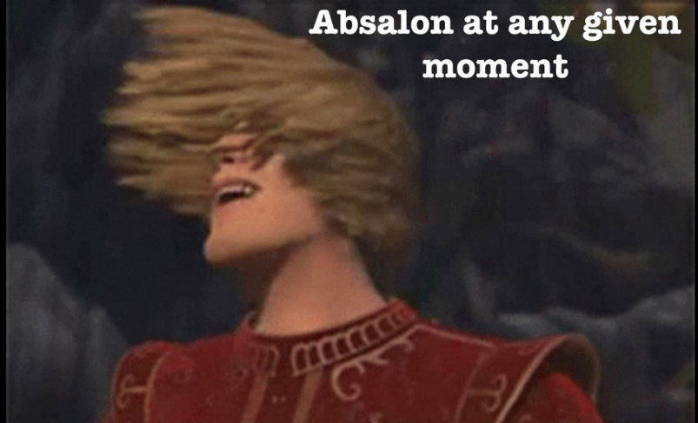In conclusion, the way the Miller talked about social conventions such as marriage,adultery and the importance of not gossiping about another’s man marriage made me relate to him as I too am a gossip girl of some sort and his willingness to put everything out there in the open shows an open mindedness that I think people of that time lacked .

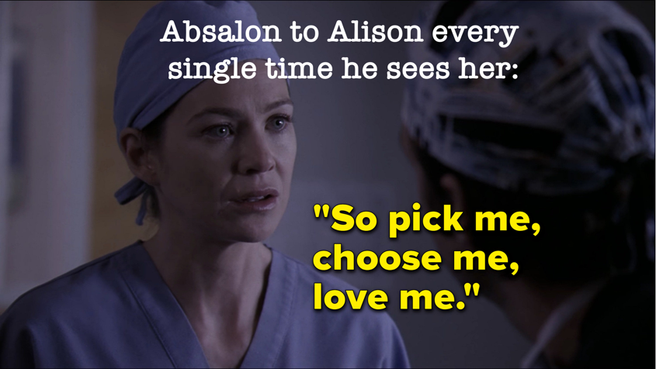

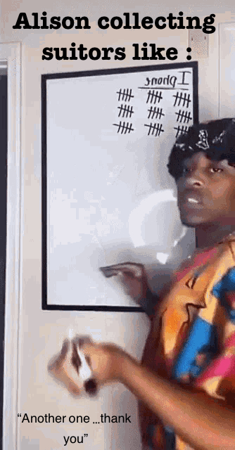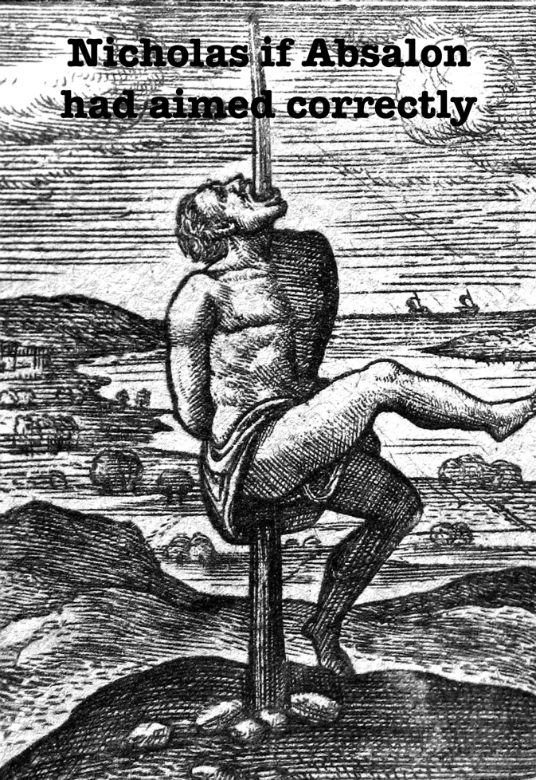



**Nikoleta Gardiki (1563202100041**)

First of all, if you had told my pre-Chaucer self that Geoffrey Chaucer, the father of English literature, wrote a whole tale that eventually led to a fart joke, I would have thought you were insane.

I felt so sorry for Alison while reading the tale - not only was she married to a man twice her age that “kept her in the cage, for he was old and she was wild and young” because of envy, not only was she assaulted by Nicholas and denied his advances (though their later affair is the focus of the tale), but she was also chased by Absalon who would not take ‘no’ for an answer. She was the three men’s object of desire, only acknowledging her youthfulness and beauty which is why I believe Alison making Absalon kiss her butt is a sign of empowerment! And to be honest, he had it coming. Alison combats the “pure woman” medieval stereotype by actively embracing her sexuality and a vulgar action (that of making Absalon kiss her butt), thus opposing the dominant image of a dutiful wife.

Here is a playlist with medieval takes on modern songs that I believe Alison would listen to while fooling men (also available on Spotify!).

**Alison Did Nothing Wrong**

|  |
| --- |
| Candy Shop - Medieval Bardcore Version |
| Hips Don’t Lie - Medieval Style |
| Sexyback - Medieval Bardcore Version |
| How You Like That - Medieval Style |
| Smells Like Teen Spirit - Medieval Style |
| I Put a Spell on You - Medieval Bardcore Version |
| Somebody Told Me - Medieval Style |
| Bad Guy - Medieval Version |
| Bad Romance - Hildegard von Blingin’ |
| Holding Out for A Hero - Hildegard von Blingin’, Whitney Avalon |
| Boulevard Of Broken Dreams - Medieval Style |
| Hey Ya! - Medieval Bardcore Version |
| Smooth Criminal - Medieval Style |

And a meme!

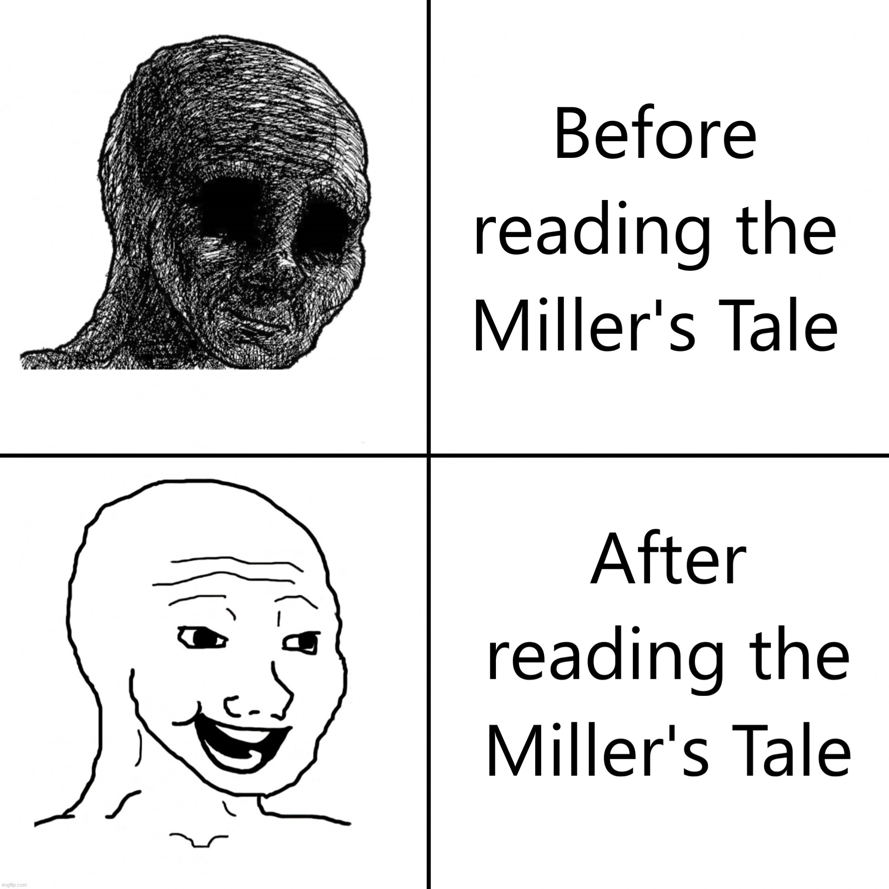

**Alexandros Tzartzas (1563202100250)**

***The Canterbury Tales:* “The Miller’s Tale”**

In “The Miller’s Tale”, Alison, a young and beautiful woman, marries an older carpenter, John. However, Nicholas, a young scholar, comes along, and the two decide to have an amorous tryst, even though Alison is married. In itself, this storyline reminds one that Chaucer distrusted the notion that wives could be faithful, a notion possibly informed by his own experiences (as we see in the translator’s introduction).

In “The Miller’s Tale”of *The Canterbury Tales*, Alison, the young wife of John, (a carpenter) notices Nicholas, a university student who lodges at their house, and agrees to have an amorous tryst with him. Chaucer does a good job characterizing her and describing her seemingly inordinate beauty. But perhaps he succeeds precisely because he leaves behind lacunae in his description of her (i.e. rather than describing explicitly her every single attribute, he limits himself to writing that ‘The wisest man you met would have to wrench/His fancy to imagine such a wench’), thereby amplifying her comeliness. Her ‘complexion being brighter than a florin’, her fairness, and her (milky) white apron reminds one of the description of the daughter in *The Pearl*, which perhaps repeats certain conceptions of beauty standards. After all, she does have a ‘purse of leather’ that is ‘pearled’. More interestingly still, her beauty (as characterized by Chaucer) also rests on her youth; and not merely on her youth, but on her being like a young girl (‘And she would skip or play some game or other/Like any kid or calf behind its mother’). Uh oh. That might serve to make the contrast between her and the carpenter even greater, but there is something interesting about her girlishness, and how that epitomizes her beauty (for Nicholas and the carpenter), rather than her being, say, more mature and wiser.

Interestingly, the ‘Alison’ of “The Miller’s Tale” reminds one of the ‘Alison’ in “Jolly Jankin”, which we explored in the first week of class. They are, after all, not only namesakes, but do also share similarities more broadly. The Alison of “Jolly Jankin”lusts after a young Jankin, and seemingly has no reservations about romantically admiring him in church, during what is supposed to be a pious liturgy (or, for that matter, sleeping with him, and bearing his child). Likewise, the Alison of “The Miller’s Tale” decides to put her youth and beauty to better use by sleeping with the handsome Nicholas, perhaps a better match for her – at least carnally, but perhaps also emotionally – than her older carpenter husband. And she also decides to fulfil her desires in her own house, being as forward and cheeky as ‘Jankin’s’ Alison. Interestingly, moreover, in “Jolly Jankin” the name Alison is a rhyming pun on kýrie eléison. In that regard, there is this sense that religious piety is being mocked and turned on its head. It makes me think of what was said on that first week, that “Jolly Jankin”formed part of a carnivalesque tradition, where the dominant order was temporarily upended. In a similar vein, if the kyrieeleison pun of “Jolly Jankin”is to be extended to “The Miller’s Tale”, then there may perhaps be something satirical about Alison, too. I wonder whether “Jolly Jankin”was influenced in any way by “The Miller’s Tale”, since it was written circa 1450, so around fifty years after Chaucer’s death in 1400.

A similar example is the mockery of notions having to do with the chivalric/aristocratic/feudal order, whereby Absalon, the parish clerk, ‘swore to be page and servant to his doxy’ Alison. Thus, Absalon would be willing to be the page of his desired ‘doxy’ Alison, ironically elevating her to noble rank. It could be said that the cultural conceptions of the day are being twisted around.

Finally, it’s interesting to note how the religious element is used by Nicholas to dupe the carpenter, thus showing how such ‘sciences’ – or arts – can be used as a means to an end, as a convenient instrument to achieve other goals, rather than being appreciated as areas of study in-themselves. It is funny – and sad, potentially even mad – thinking about how far Nicholas is willing to go to dupe the carpenter, and ultimately have his amorous tryst with Alison. To that end, Nicholas even puts on a whole show to trick the carpenter into thinking that he has divined the coming of the Second Flood, thereby misleading John. I feel sorry, above all, for the carpenter who has been cuckolded. Beyond that, though, we also see the entwinement of academia and scholarship (in that era) with tricks, especially of a bawdy sort.

**Ilektra Maria Ntoufa (1563202100159)**

“The Miller's Tale” by Geoffrey Chaucer is hands down one of the weirdest and funniest stories I've read in a while. First, it started off very mildly. We have this very beautiful description of Nicholas as this handsome, sweet and intelligent man ‘He himself was sweeter than the root of liquorice or any fragrant herb’.What I found very different though, was that the description of Alison, one of the main characters, focused solely on her appearance and clothing. In my opinion, and putting humorous elements aside, Alison was objectified through the entirety of the play. The comical elements might blur our vision and let us think differently, almost hiding this more serious aspect of the story, but her objectification is very clear. One reference from the text that can justify this idea is: ‘She was a daisy, O a lollipop for any noble man to take to bed, or some good man of yeoman stock to wed’. Also, the way Alison was treated in the beginning of the play was very disturbing, as she was basically grabbed and forced into being with Nicholas. While she was screaming and begging for him to let her go, I couldn’t help but be sorry for the poor girl and the things she had to go through. First, being in a marriage with a person much older than her, showing a very acute contradiction between old and young age ‘Youth and old age are often in debate’, and now being completely helpless in the arms of Nicholas. This objectification of women is again being implied even with the humorous atmosphere the play tries to portray. It's almost as if it represents the mocking of this treatment by society, marking it as something indifferent. That especially stuck with me, when she obeyed and fell in love with him. I really question whether she really loved him or not throughout the story. Did she give up because she actually wanted him or something entirely deeper and darker? I also thought the same thing when reading Absolon’s part and the confession of his feelings to Alison, because even though he said ‘Looking at her would make a happy life’, he also said ‘If she had been a mouse, and he a cat, she’d have been pounced upon’, and then went on and tried to provoke her by using money.

Nevertheless, the humor elements and storyline are fascinating and intelligent. The plot of Nicholas against the carpenter was clever and well made, as well as the revenge of Absolon, which was the funniest part of the play. I also found some parts very interesting, like the one where Nicholas used his astrology knowledge to his own benefit and specifically told the carpenter ‘ go save your lives for us’ . This phrase can be interpreted in different ways. For the carpenter, it meant to protect himself, and his wife, but for Nicholas, it meant creating a new life for him and Alison, meaning one that they could be together. Nicholas is one of those characters that I can’t distinguish if he is necessarily ‘good’ or ‘bad’ in a conventional way. I despised the way he treated Alison in the beginning, but then he went out of his way and plotted against the carpenter for her. I might be reading too much into the play, but like I mentioned, I still am not sure about Alison’s true intentions and why she suddenly fell in love with him. The last part I would like to mention is how Absolon was so honest about his feelings for Alison, even though he showed it in an unconventional way. When Alison refused his kiss, he said ‘true love is always mocked and girded at’, which honestly may be the most romantic sentence of the entire story.

**Georgia Theodosia Marini (1563202100123)**

**Chaucer’s “The Wife of Bath Prologue” and “The Wife of Bath’s Tale”**

While reading the prologue to wife of Barth something that struck me as interesting is that I am not at all certain on whether the text is intended to be read as empowering to women or not. It seems to me to be toeing the line between female empowerment and the confirmation of the very caricatures that it sometimes attempts to criticise. It can also be registered as a genuine attempt at broaching female liberation in regards to challenging puritanical ideals, but Chaucer does not seem able to liberate his writing from other misogynistic and often bio essentialist harmful narratives in his portrayal of women. Narratives which also, in part, have their roots in other aspects of Christianity, he seems to ignore. Or maybe it is not ignorance, but merely we reach the limits of his progressive views of women.

More specifically, as one starts going through the text, they do witness an unabashed display of sexuality from the wife. She claims that it is right for her to take many husbands and uses the Christian dogma to support her arguments, claiming that God sees marriage as a blessing. In doing so she compares herself to male biblical figures who had multiple wives, such as king Solomon, and regards their existence as virtuous under the eyes of the lord, stating that she’d love to follow in their footsteps. This is obviously quite a radical argument on the woman’s (and possibly Chaucer’s) end, both in terms of the patriarchy and Christian religion. Christianity is a dogma whose core beliefs often seem to revolve around shame and guilt. Particularly, inherent shame for experiencing sexuality, for occupying a human body, for existing as a human. The story of creation itself portrays humanity’s time on earth as a punishment and suggests that one should dedicate their whole life repenting for sins committed eons before their conception. We are brought into this world owing a debt, expected to go through the motions of existence in a perpetual state of self-loathing, forever chasing ideals of purity that are unattainable and a salvation that can only come after death. This is also a famously gendered narrative. In institutionalised religion, and Christianity in particular, women are often seen as adjacent to the devil, their minds inherently conniving and their bodies are synonymous to temptation, not personhood. A woman’s sexuality is sinful, she should never derive any enjoyment from her desires, the only path not reprehensible is submission to men, purely for purposes of procreation. The entire exile of human kind from the gardens of heaven is a result of humans making a choice for the first time, and Eve does it first, she “manipulates” Adam into following. The message is clear, a woman’s nature is to lure men away from the path of God, their choices doomed us all, they should not be allowed to make any more of them. As such, it is a very bold statement for a woman to not only be so unashamed in her own sexuality, but to use religion to justify this attitude, by comparing hirself to men considered blessed from God, in fact. Additionally, her admittance that, although she applauds virginity and purity in others, it is not a lifestyle that she herself is built for (“He spoke to those that would live perfectly, and by your leave my lords that’s not for me”) is a profoundly self-realised and radical statement in this context. As mentioned earlier, Catholicism teaches you to chase perfection, and be permanently miserable and ashamed of yourself for not achieving it, frantically trying to rid yourself of your own racing blood and the breath that you draw. Afterall, God only seems to like you once you’re dead, so why not spend your life trying to make the rot set in quicker. This woman however is content with this “imperfection” (In quotations because I wish to clear up that I do not in fact think that there are any inherent ethical connotations to deciding to have sex or not). She is not torn up over it, she says, we all have our place under God and mine lies elsewhere. She also does not share Christianity’s aversion to the physical body at all, and views the sexual act as something that ought to be enjoyable for both parties, displaying a clear affinity for sex that the Christian religion would customarily condemn a woman for expressing. Furthermore, the social construct of virginity is also something that is imposed on the female form, and yet she makes reference to Jesus himself being a virgin. She seems to be tearing down time and again these double standards that exist within religion. There are also references to Venus, Mars and the stars, on her end. This combination of the old and new religion might represent the same one which exists within the very notion of a “Christian woman” (What with women being often connected to nature and paganism).

As the story progresses however, certain problems begin to arise, in my view. First of all, there is a problematic comment on consent, “If I turn difficult, God give me sorrow.” Admittedly, when female empowerments appear only rooted in the sexual, it is bound to start having issues. Moving forward in the story one notices an annoying contradiction. As the woman narrates how she manipulates and fools her husband she criticises him for having certain negative assumptions on women, that she herself is written to be embodying. She chastises him for thinking of her as conniving and deceptive, that she is easily tempted, unfaithful and governed only by her desires. These are all actual harmful stereotypes regarding women and the character is right for criticising him, but subsequently she essentially admits to all of them being true. Are the men who agree with the wife’s preaching actually supposed to be supportive of women, or are they sitting comfortably in hearing their biases confirmed? I am not denying the element of empowerment in a woman being able to outsmart a man the way the wife does her husband(s), since it could presuppose a certain intellectual superiority, but for every step forward, the narrative takes three back. It is a long enduring stereotype for women to exhibit intellect only in manner that is deceptive. Nature of woman as evil is something perpetuated by religion, so it is interesting how in his effort to criticise one aspect of it, Chaucer is found guilty of others. This narrative does not only imply that all intellectual thinking done by women must have negative connotations, but also that women are not people who are capable of rational thought independently. All their efforts must be carried out towards manipulation, dominance and even metaphorical castration of men. Instances of female solidarity are also vilified, implying all women are conspirators in this endeavour (The maid covering for the wife). Dominance as the end goal of existence is a very patriarchal ideal, while this narrative of women all being secretly evil, living a double life as they rub their hands and twirl their moustache nefariously, starting to laugh at your stupidity the moment you leave the house, is often used by misogynists as a way to justify their bigotry and violence.

I would like to further expand on this on two fronts. Firstly, women’s behaviours mainly revolving around moving men like chess pieces, cuts off their link to direct action and limits the agency they’re afforded. This is a pattern that is still very present today in literature. In *Game of Thrones* Cersei says “Tears aren’t a woman’s only weapon, the best one is between your legs”, in Frank Herbert’s *Dune* the Bene Gesserit are a shadow government organisation, with magical powers that allow them to command anyone, who perpetuate their order through assigning concubines and performing controlled breeding. The female mind is a constant manipulator, and her physical body is always vital as a means to that end. Secondly, this pattern of women ultimately desiring nothing more than mastery of men, is recurring throughout the story. For this, one must refer to the actual tale of the wife, where it is literally what all women are said to ultimately desire. It is very much a man’s view on what women want, very patriarchal, at first glance. I will say however, it is partially redeemed by the fact that the interpretation of this in the tale itself, does not hold the negative connotations of the prologue. Allowing women mastery over men seems, to mean, respecting a woman’s wishes, which will result in happiness for all. The climactic scene is the one where the knight allows the woman to make the choice on what she thinks is right between the two options she gives him, which opens a secret third option where everyone is happy. Thus, what allowing mastery seems to be in truth, is respecting women as people and trusting their judgement. It is good that the message is: this behaviour can “save your life”. Also, the knight often experiences predicaments where he does not have the luxury of choice, not even in regards to his own body, something his victim also went through. It also follows the tradition of Arthurian legend promoting peaceful coexistence with women, and by extension nature and the old pagan religion, as opposed to men being more tied to Catholicism (Mentions of fey creatures living in the forest now being replaced by a friar who can take your maidenhead, the knight meeting a circle of dancing women and an old woman with magical powers in the woods). I will say on an entirely personal note, a rapist ending a story happily married to a beautiful woman because he “learned his lesson now” instead of being found dead in some ditch, does seem to me disappointing. I do recognise however that the story is written this way specifically to be didactic, I am just bitter.

My final gripe with this story, is that for all the pains the tale seems to take to portray showing respect to women as the intended path, the prologue once again has a really contradictory part. The wife’s last husband is a perfect example of how the villainization of women leads to violence. When recounting various biblical and mythological stories that depict women as evil doers, he internalises that hatred towards his wife and beats her. The wife’s claims of that being the husband she loved most, not only despite, but even because, he was the one that abused her, built a very misogynistic image. It perpetuates the idea that women want what they cannot have and subconsciously wish to be “put in their place”. This contradicts the point about their desire for “mastery over men”, which really just ends with men and women living harmoniously. It is possible however, that my issues with this are misguided and it is supposed to be a parallel to the Arthurian legend presented. Particularly, the husband apologising to her and her hitting him back, both of them making up after, could be the scene implying that they solved their differences and he learned the error in his ways and never put his hands on her again? As a contemporary reader however, this does not seem to me as a satisfying or articulate enough resolution to domestic violence.