Study of the paleogeographical evolution of southern Evoikos Gulf during Pleistocene – Holocene transition

Introduction
Greece has the longest coastline in the Mediterranean. Consequently, sea-level changes are of great importance for the geographical evolution of the coastal areas.
Southern Evoikos Gulf is a shallow tectonic epicontinental basin, which separates Attica from Southern Evia and it is divided into two sub-basins: a northern shallow one where water depths range from 20 to 70m, the coastal zone is steep and the sea floor is flat, and a southern deeper basin with a maximum depth of 162m. Our study focuses on the northern basin.
Furthermore, southern Evoikos is characterized as an area of low seismicity, due to low tectonic activity.
The hydrographic network of the area is characterized by Asopos river and some other ephemeral streams.
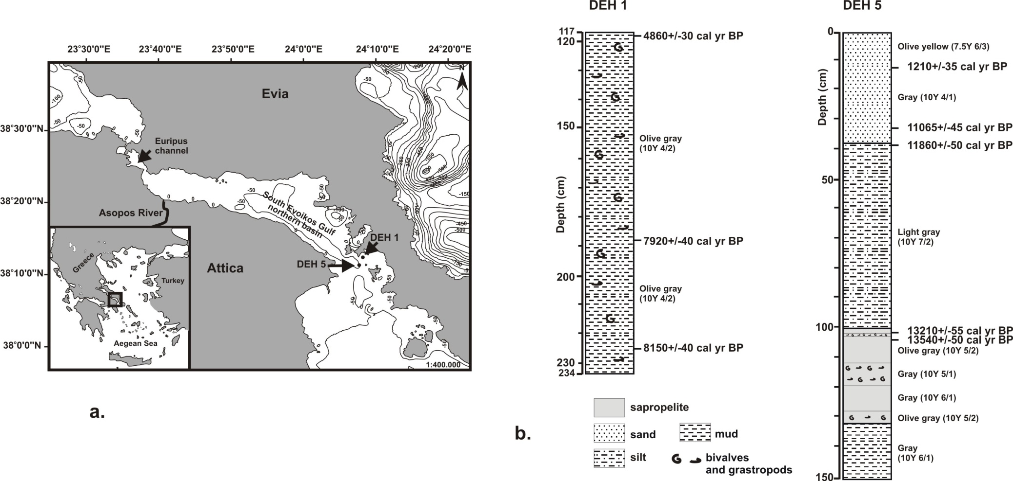
Purpose of this study is to identify the environmental changes that occurred in the southern Evoikos Gulf during the Upper Pleistocene-Holocene transition using fossil microfaunas.
Materials and methods
A sediment core is selected for the purposes of the current study: DEH 5 (N38°11' 19.3992", E24°7' 46.9488") with a total length of 150cm. It was recovered with a benthos gravity corer from 75.5m water depth.
Five radiocarbon dates were carried out by AMS method for DEH 5 on the layers:
12-13 cm: 1210 cal. yr B.P.
38-39 cm: 11860 cal. yr B.P.
102-103 cm: 13210 cal. yr B.P.
103-104 cm: 13540 cal. yr B.P.

Results – The ostracod fauna
A total of 88 samples were studied. All ostracods were collected, counted and identified from each sample. 52 species were identified and the participation rates of each species in every sample were calculated. Furthermore, diversity index Shannon-Wiener (H’) and Dominance (D) index were calculated.
The ecological/paleoecological data collected from the literature for the identified species allowed the distinction:
- of index species (highly adapted to a particular kind of environment and consequently its presence is indicative of this environment)
- characteristic assemblages (ostracod associations indicative of certain environmental conditions)
In particular, the following ecological data were collected:
Acanthocythereis hystrix: Species found in open marine environments, up to 70m depth and fine grained sandy substrate.
Candona neglecta: It is a freshwater species and occurs in temporary and permanent water bodies but it is also reported from inland and coastal oligohaline brackish waters.
Callistocythere crispata: It occurs in open marine environments, up to 70m depth and fine grained sandy substrate.
Carinocythereis carinata: Species found in shallow coastal marine environments, up to 50m depth and fine grained sandy substrates.
Cyprideis torosa: It is a species that presents large populations in all the transitional environments between freshwater, brackish and marine environments. It is an euryhaline species.
It lives in shallow (<30m) usually restricted and of low energy environments (such as lagoons and water bodies near estuaries) and it is an euryhaline species.
It dominates (it is by far the most abundant species) all the ostracod assemblages in brackish environments (mainly lagoons) when salinity ranges 2-17‰.
It is therefore a species that can coexist both with oligohaline species (when salinity ranges from 2 to 5‰), and mesohaline species (when salinity ranges from 5 to 17‰). WE HAVE TO CHECK THE ACCOMPANYING SPECIES
Cytherella spp.: Species found in open marine environments, up to 70m depth and fine grained sandy substrates.
Cytheromorpha fuscata: It is a mesohaline species, but tolerates also oligohaline conditions.
Limnocythere inopinata Inhabits mainly shallow, freshwater bodies like ponds, swamps, lakes, streams, and rivers, but it is also found in oligohaline inland coastal waters.
Leptocythere spp.: Species which prefer shallow marine to brackish mesohaline environments of low energy.
Palmoconcha agilis: Species which prefers shallow, up to 50m depth, coastal marine environments, rich in subaquatic vegetation/algae and/or fine grained sandy substrates.
Xestoleberis spp. Species that occur in shallow, up to 50m depth, coastal marine environments, usually rich in subaquatic vegetation/algae. Some species of this genus can also tolerate brackish conditions.

Additional data
Characteristic species assemblage: A group of species/taxa that have similar ecological preferences and indicate certain environmental setting.
euryhaline species: species that tolerate a high range of salinity fluctuations
marine species: 30-40‰ salinity
mesohaline species: 5-18‰ salinity
oligohaline species: 0,5-5‰ salinity
freshwater species: 0-0,5‰ salinity

Try to answer the following issues
1. Which assemblages could be distinguished based on the species ecological characteristics?
2. How these assemblages are distributed along the sediment core?
3. Could you create and interpret the distribution charts of Shannon-Wiener (H’) diversity index and Dominance (D’) index?
4. Which are the environmental changes that took place during Late Pleistocene – Holocene in the studied basin of southern Evoikos gulf? What caused these changes?

