

Mathematics Education
Summer School
Nαύπλιο, Greece
21 – 27 August 2003
MATHEMATICIANS AS EDUCATIONAL CO-RESEARCHERS:
Reflections on Learning Mathematics at University Level
Elena Nardi

Session 2

Dataset 1*

*based on a study conducted by
Elena Nardi and Paola Iannone, at the University of East Anglia
and managed by Chris Sangwin, University of Birmingham
Proposed outline for Session 2

In Sessions 2 and 3 we will discuss samples of data from Cycle 3 (the theme for this Cycle was Mediating Mathematical Meaning: Symbols and Graphs) of the study introduced in Session 1.

In Session 2 we will discuss samples of Year 1/2 mathematics undergraduates’ written responses to problems from courses in Analysis, and Group Theory.

The contents of this booklet, which we will go through during the session are as follows:

- On pages 3-5 we exemplify the Theme with Example 1. This is a short piece of data (transcript of a one to one tutorial with a Year 1 student) and commentary from Elena Nardi’s doctorate (the research that initiated the series of studies which form the basis for the current project).

- Examples 2 (Analysis) and 3 (Group Theory) originate in data gathered by Elena Nardi and Paola Iannone for a series of studies on undergraduates’ mathematical writing (pages 6-9). These data consist of Year 1/2 students’ written responses to problems handed out to them in fortnightly problem sheets. For each example we have included:

- A question from the Pure Mathematics courses taught during Years 1/2, Semester I;
- The recommended answer provided by the lecturer of the course;
- Examples of students’ written responses to the question;
- A short list of issues we believe the examples raise.

- On pages 10 and 11 we offer a brief account of relevant literature which aims to provide a glimpse into the extensive work in the area and on page 12 an indicative bibliography on the Theme.

Example 1
Bestowing Meaning On the Concept of Coset
Through Ambivalent Uses of Geometric Images*

*from (Nardi 2000) and based in material from (Nardi 1996)

As addressed in Harel and Kaput's work on Object-Valued Operators (1991), students often construct concept images of cosets in Group Theory via familiar geometric figures. The students' intensive need to resort to this familiarity originates largely, not to the 'fairly simple' relationships between certain mathematical objects (Leron and Dubinsky 1995) that characterise theorems such as the Homomorphism Theorems or Lagrange's Theorem (their consistently problematic conceptualisation by students is reported in (Hazzan and Leron 1996)) but to the abstract nature of the mathematical objects involved. For example, Lagrange's Theorem is about 'easy' things such as 'one number dividing the other, two sets having the same cardinality or being disjoint, etc.'. 'The students' difficulty', they conclude, 'may be largely due to their confusion about the nature of cosets', to not 'seeing these cosets as objects to be measured, counted and compared'. These observations on the students' conceptualising processes resonate with the evidence presented in this Episode.

Background to the Episode. In the beginning of the tutorial student Camille declares her confusion with the notion of equivalent classes defined by ‘a~b when f(a)=f(b) where G is a group and f: G → G’ (Note: in more accurate terms Camille ought to have said 'if and only if' instead of 'when' and also specify what f is: a homomorphism from G to G or an injection as suggested in the Episode). The tutor draws

Equivalence Class of b Equivalence Class of b'

fig.1

to illustrate that 'if b and b' are in different equivalence classes then f (b)and f (b') are different'. In the subsequent discussion (C1-C5 and T1-T3 lines of transcript, omitted here) Camille appears puzzled with fig.1 ('Why are they all straight lines?', she enquires). Because these lines 'do not mean anything', the tutor replaces fig.1 with fig.2, one with 'squigges' as the equivalence classes :
fig. 2

Fig.1 is the tutor's image of equivalence classes where an element a of the domain is a dot and its equivalence class (defined as the set of elements in the domain that are mapped on the same value as a) is a line segment. The metaphorical elements of this image however seem to escape Camille who interprets fig.1 literally. In the Episode below she offers analogous interpretations with regard to the notion of coset.

The Episode. Subsequently the discussion of the correspondence between the elements of a group and their equivalence classes evokes in Camille a query on another correspondence: 'the 1-1 correspondence between the conjugates of x and x'. Remarkably Camille demonstrates precise knowledge of the relevant definitions (centraliser, conjugate) as well as a relation between the two concepts (unlike most of the students who were incapable of reproducing definitions of even simpler group-theoretical constructs mentioned in the lectures). The tutor initiates a discussion of the 1-1 relation between cosets of the centraliser and conjugates of x but Camille is quiet and looks sceptical. Then she asks:

C6: What are cosets materially? | T4: What do you mean by that?
C7: If we have a group G and a subgroup H why do we bother to find the cosets? | T5: Because of results like this. They turn up naturally.
C8: Cosets are a group multiplied by an element in the big group. | T6: [hesitantly] Yes...it's a set...
C9: Cosets are just a moving... | T7: That's right. That's one way... you can look at it as translates of a subgroup... sort of multiplying g with everything in H and it shifts it...
C10: [after a pause] So if we have a square of size one and then the group G is like this...  fig. 3 | T8: You have to be slightly careful... It is slightly... don't think about in... you're not thinking of applying it on squares, are you?
C11: So then it would have four cosets? | T9: Mmm... if the subgroup was a quarter of the size of the whole thing, yes... it would have four cosets... that's right.
C12: And the cosets are always the same size as the original. | T10: That's right. As we know they partition the group.

Camille, in her above mentioned demonstration of knowledge, has not used the term coset at all. The term occurs for the first time in the tutor's words and captures Camille's attention. Subsequently, and in the rest of the Episode, it seems that the notion of coset constitutes a large part of her preoccupation : C6-C12 seem to be persistent, multiple attempts to imbue it with some meaning. C6 comes through as a surprisingly philosophical and abstract question which raises a very fundamental existential issue with regard to the notion of coset: what is surprising about C6 is that it comes in the middle of the tutor's describing a quite sophisticated construction (establishing a correspondence between the cosets of the centraliser and the conjugates of an element x in a group) and shifts the conversation from the strictly and specifically mathematical (represented by the tutor) to the metamathematical. Camille has been attentively listening to the tutor's demonstration of the construction and has given the very strong impression that, throughout, she has been processing the dense information provided by the tutor. C6 however illustrates that this processing must have been motivated mostly by the desire to construct an image of coset — visual, 'material' — than consume the tutor's argument. From then on, as said earlier, C6-C12 is a series of successive attempts at interpreting the concept of coset.

C6 is a nearly platonistic enquiry on the nature of cosets as objects, as entities. Camille's entities in C6 do not necessarily act or interact. In C7 the questioning of the nature of these objects takes the form of an exploration of their raison-d'-être. C8 is a dissection of a coset that equates a coset with how it comes into existence. I note that so far T4-T6 do not seem to have a direct impact on Camille's generating of ideas of what a coset is. C9 is a geometric interpretation of C8 derived from the notion (and notation for) transformations, and in particular translations. The tutor carefully tunes in, using 'translates', a classical description (T7), but Camille accelerates her tentative condensation of her conception of coset in a geometric image in an unusual way. C10 (in parallel with her 'straight lines' in the Background) illustrate the thin line between a metaphorical and a literal interpretation of a picture. It is perhaps reasonable to assume here that Camille operates under the strong visual impact of the four-sided figures used by the tutor earlier in the tutorial (fig.1 and fig.2). The tutor is surprised and alarmed (T8) by Camille's intention to 'apply [this idea] on squares'. C11 is evidence that Camille is too preoccupied with her image construction to be influenced by T8 and she furthers the interpretation of her fig.3 in a less controversial but highly ambivalent way. T9 is one more effort on the tutor's side to tune in and transform the student's images from within. Surprisingly then Camille turns in a shift to a more abstract property of cosets in which however the geometric/numerical jargon ('size' in C12) is maintained. The tutor (T10) has completely adopted Camille's metaphor and contributes another observation on cosets.

Finally Camille ceases the effort to interpret further the notion of coset once she acquires an image of cosets that is satisfying and clear to her. That Camille is content with what she has acquired can be assumed on the basis of the evidence, given during the study, that this student does not bring a conversation to an end until she acquires a satisfactory (to her) understanding. The issue that C6-C12 raise is whether the quality of the acquired perception of a coset — via these visual images — justifies Camille's eventual sense of content. Given that the tutor cautiously surrenders in adopting Camille's image but does not cross-check whether the intended (by the tutor) and the acquired (by Camille) image of a coset coincide, the questions raised by this issue ought to remain open.

In sum, in the above, a student, who exhibits a remarkable memory of the definitions of the concepts involved in the discussion, is engaging in a meaning bestowing process with regard to the notion of coset. The student asks the tutor about the raison-d'-être of the concept and her efforts are characterised by a tendency to use images of familiar regular geometric shapes in order to construct a mental image of new concepts (equivalence classes as parallel straight lines, cosets as squares). Evidence was given that these geometric images are interpreted literally by the student. This raises the issue of a potential cognitive danger built in their use — despite their undeniable, and widely acknowledged in the literature, pedagogical value .

From a teaching point of view, the tutor has demonstrated a certain degree of flexibility in thinking in the terms of the student's images (actually it is the tutor who sparks off the use of geometric images in this tutorial) but, in the end, there doesn't seem to exist any guarantee that the particular use of these images has resulted in the tutor's intended concept image of the notion of coset. The student's plea may have been for concrete illustrations ('materially'?) of the utility of the new concept of coset but this plea here seems to have remained unresponded to.

Example 2

From: Week 4, Question 3

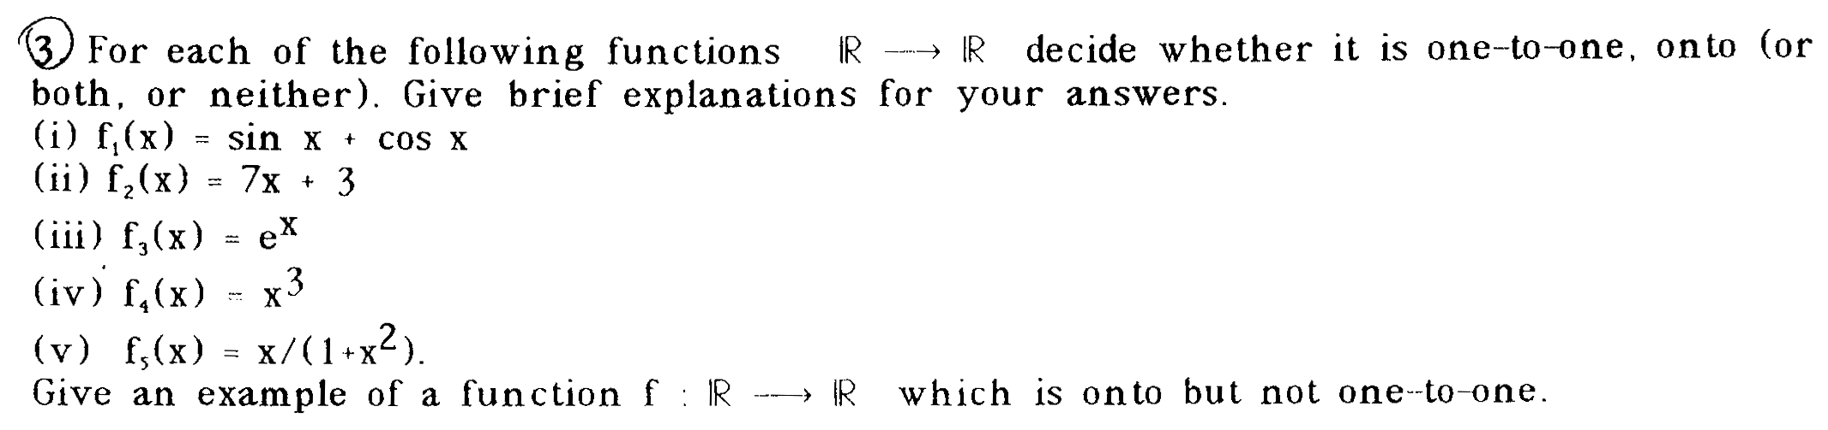

Lecturer’s suggested response:

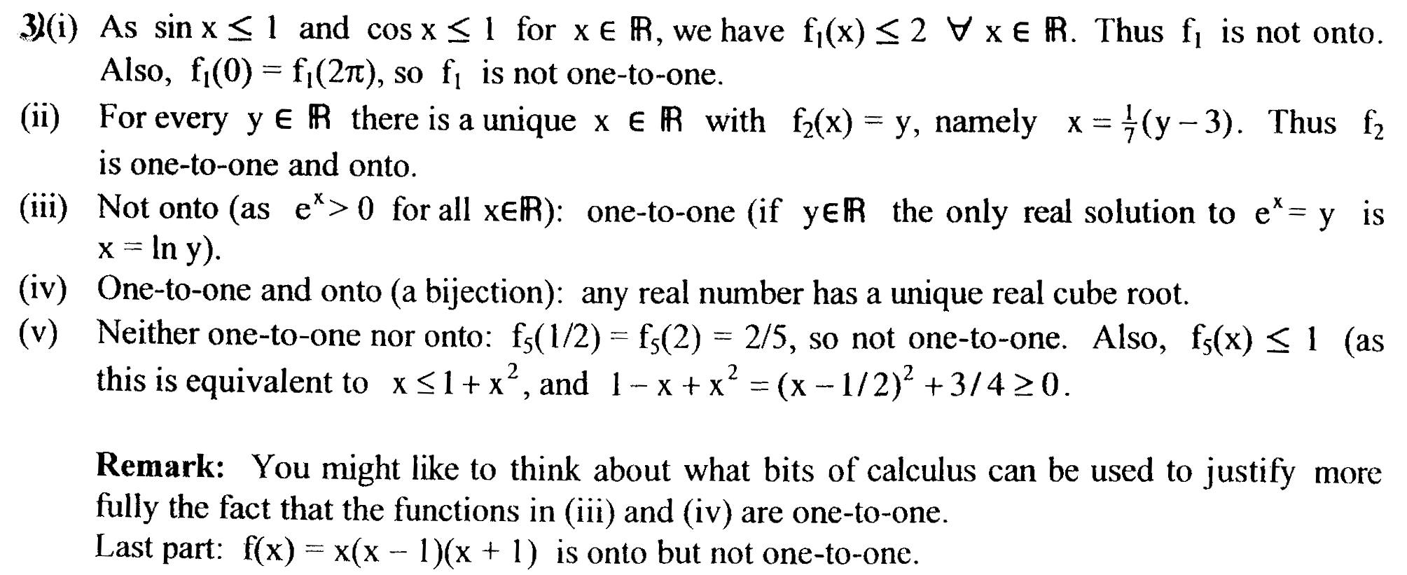

Student WD

Student LW

Examples of issues to consider:

- Student WD’s response relies completely on the observation of the graph of the function. (see points a and b on a parallel to the x-axis). His answers are correct but lack formal justification. What is the implication then of relying on the diagram for the students’ acquisition of formal reasoning skills?
- Student LW’s response, where the graph is inaccurate, represents the potential risks within the practice of relying exclusively on the diagrams. There seem to be a shift here from relying on (potentially misleading) visual evidence to employing visual evidence as a tool that supports understanding. How can teaching facilitate this shift?

Example 3

From: Week 2-Group Theory, Question 5

Q1.5: Write down all group tables for a group of four elements. Hence show that there are two essentially different such groups, both commutative. (Consider group tables obtained by merely renaming elements as essentially the same). How are they best distinguished? For each make a list of all the subgroups.

Lecturer’s suggested response:

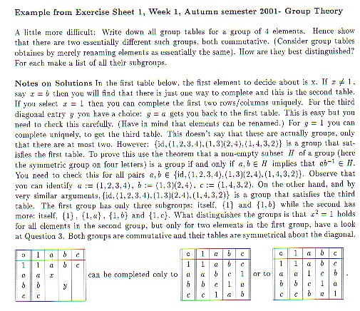

Student W

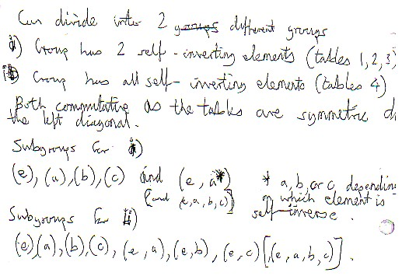

Student H

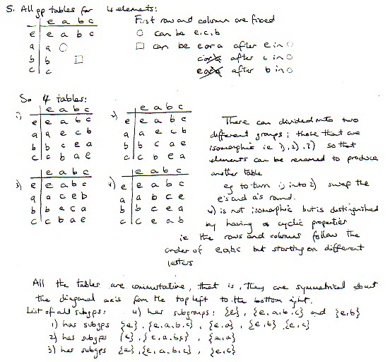

Examples of issues to consider:

- In student H’s response, we can see an efficient “step by step” construction of the tables of the group of four elements. However, there is no hint here that a table does not necessarily give a group. Student H seems to miss the notion that the binary operation defined on the set induces naturally an inner structure of the group (its subgroup lattice) and therefore does not seem to see any contradiction in the claim that two groups are isomorphic but have different subgroups.
- Student H’s actions, typical in the written responses we have examined, appear to be heavily table-based. Her understanding of the notion of isomorphism seems to involve processes she calls ‘swapping’ and ‘turning into’. Could we suggest that this firm adherence to/dependence on table-based actions, while facilitating the construction of the groups with four elements (and the checking of properties such as commutativity), at the same time places an obstacle in the students’ constructing an image of the group’s inner structure (as well as perhaps distracting them from checking associativity which requires operating upon three, not two, elements)? That this student’s notion of isomorphism is problematic is suggested also by the grammar/syntax she uses when she talks about isomorphic groups: she doesn’t talk explicitly about, e.g., 1 as isomorphic to 2 but she writes ‘4 is isomorphic’ (to what?).
Mediating Mathematical Meaning:
Language, Symbols and Graphs
A brief literature review

Mathematical culture is strongly characterised by its forms of expression — mathematics is often described as the activity of constructing metaphors that reveal the answers to extraordinary questions relating to abstraction which in turn is a form of imagination (Bullock 1994). So since language is traditionally seen as an expression of imagination, mathematics can be seen as the language of abstraction. Moreover language is also often seen as a major determinant of communication: whether it is ordinary language, or the formal syntax and notation of mathematics, or visualisation, language is the architecture of thought as well as its carrier. Here we briefly review some current research on the communicational aspects of advanced mathematical thinking.

Laborde (1990) notes that oral mathematical discourse has not been extensively researched even though there is evidence that suggests its importance as far as the learner's cognition is concerned. She contends that the rarity of research in the field

reflects the practical and theoretical difficulties of research on oral language: the transcription of spoken language needs time to be done very accurately, and the analysis of such transcripts is generally complex because the degree of implicitness of oral discourse is greater than in a written communication and elements of the context constituting the enunciative situation play a more important role. These constraints prevent the analysis of long pieces of dialogues.
(Laborde 1990, p.60)

Also in our work what Laborde calls the enunciative situation has been a serious consideration in the sense that the students' cognition is explored, not in spite of the different contextual situations in which this cognition is expressed, but exactly as a transition from one form of expression to another. Clement et al (1981), Ghosh and Giri (1987) and Burton (1988) discuss the novices' difficulties in translating from ordinary language into mathematics and suggest evidence that students express differently on the blackboard, in their writing and in an exam. In our work we use these various contexts as sources of illumination with regard to students’ cognition.

Like Clements et al, interference from everyday logic and language (student-professor problem) is also mentioned by other researchers such as Janvier (1987) and Bjorkqvist (1993) who studied the students' personal conceptions of logical necessity and possibility and found influence from everyday conceptions and a partial dependence on key elements in the structure of the sentence; particularly relevant here are his findings on double modalities, the categorical form of propositions that contain two negations. Students were found to be deeply confused with these linguistic structures. By implication, when confronted with similar structures, that in addition are embedded as syntactic and semantic content of mathematical expressions, students are expected to be equally or possibly more confused. The influential role of content and form in mathematical cognition and the need to introduce it explicitly to the novice has been discussed also in (Byers & Erlwanger 1984; Abkemeier & Bell 1976 and Davis & McKnight 1984).

In the above the communicational aspects of advanced mathematical cognition have been discussed in terms of the learners' discursive practices and in particular their linguistic practices. This should not suggest however a lesser emphasis on visualisation (e.g. in our work in the context of Linear Algebra and the persistently repeated metaphor of the plane and, more generally the cases where visual representations are used by the students as part of their intuitive access to some new concepts). I note here that one important point made in the literature on visualisation (Bishop 1989; Davis 1989; Janvier 1987 and Presmeg 1986) is that while there is a strong visual element in mathematical cognition at all levels, when the students find difficulty in connecting different representations (for instance formal definitions and visual representations), they often abandon visual representations — which tend to be personal and idiosyncratic — for other more socially acceptable tentative ones.

Finally there is some work on the understanding of mathematical texts (e.g. problem sheets, lecture notes). Furinghetti and Paola (1991) have discussed the understanding of mathematical texts in relation to the students' difficulties with formal proof. Other researchers have explored particular aspects of the students' responses to written mathematical text: so for instance Dee Lucas and Larkin (1991) found that proofs written in a verbal, ordinary language produced better performance than equation-based proofs on problems related to both equation and nonequational proof content. They also explain that equations cause students to shift attention away from non equational content and learners have more difficulty processing equations than verbal statements of the same content. Similarly MacGregor (1990) noticed that writing sentences helps students write correct equations and contrary to expectations the most successful students were those who used common idiomatic forms of English that could not be directly translated into mathematical notation.
Bibliography

Abkemeier, M. K. & Bell, F. H. 1976. 'Relationships between variables in learning and modes of presenting mathematical concepts.', International Journal of Mathematics Education in Science and Technology, 7(3), 257-270
Bishop, A. J. 1989. 'Review of visualization in mathematics education.', Focus on Learning Problems in Mathematics, 11(1), 7-16
Bjorkqvist, O. 1993. Interpretations of double modalities. PME19, Tsukuba, Vol.1, 107-114)
Bullock, J. O. 1994. 'Literacy in the Language of Mathematics', American Mathematical Monthly, 101(8), 735-743
Burton, M. B. 1988. 'A Linguistic Basis for Student Difficulties with Algebra', For the Learning of Mathematics, 8(1), 2-7
Byers, V. & Erlwanger, S. 1984. 'Content and form in mathematics.', Educational Studies in Mathematics15, 259-275
Clement, J., Lochhead, J. & Monk, G. S. 1981. 'Translation difficulties in learning mathematics.', American Mathematical Monthly (April), 286-290
Davis, R. B. 1989. Learning Mathematics: The Cognitive Science Approach to Mathematics Education, London and New York: Routledge
Davis, R. B. & McKnight, C. 1984. 'The influence of semantic content on algorithmic behaviour.', The Journal of Mathematical Behaviour, 3(1), 39-87
Dee-Lucas, D. & Larkin, J. H. 1991. 'Equations in Scientific Proofs: Effects on Comprehension', American Educational Research Journal, 28(3), 661-682
Furinghetti, F. & Paola, D. 1991. On some obstacles in understanding mathematical texts. PME15, Assisi, Vol.2, 56-63
Gray, Eddie M. Tall, David O. 1994, Duality, Ambiguity, and Flexibility: A "Proceptual" View of Simple Arithmetic.Journal for Research in Mathematics Education. v25 n2 p116-40 Mar 1994.
Ghosh, S. & Giri, S. 1987. 'Understanding secondary mathematics: analysis of linguistic difficulties vis-a-vis errors.', International Journal of Mathematics Education in Science and Technology, 18(4), 573-579
Harel, G. & Kaput, J. 1991. 'The Role of Conceptual Entities and their Symbols in Building Advanced Mathematical Concepts', in D. Tall (ed.) Advanced Mathematical Thinking, Dordrecht / Boston / London: Kluwer Academic Publishers, 82-94
Hazzan, O. & Leron, U. 1996, 'Students' use and misuse of mathematical theorems: the case of Lagrange's Theorem', For the Learning of Mathematics 16, 23-26.
Janvier, C. 1987. Problems of Representation in the Teaching And Learning of Mathematics, Hillsdale, NJ: Erlbaum
Laborde, C. 1990. 'Language and Mathematics', in J. Kilpatrick and P. Nesher (ed.) Mathematics and Cognition: A Research Synthesis by the International Group for the Psychology of Mathematics Education, Cambridge: Cambridge University Press, 53-69
Leron, U. & Dubinsky, E. 1995, 'An abstract algebra story', American Mathematical Monthly, 102(3), 227-242.
Macgregor, M. 1990. 'Writing in Natural Language Helps Students Construct Algebraic Equations', Mathematics Education Research Journal, 2(2), 1-11
Nardi, E. 1996, The Novice Mathematician's Encounter With Mathematical Abstraction: Tensions in Concept-Image Construction and Formalisation, Doctoral Thesis, University of Oxford.
Nardi, E. 2000, ‘Mathematics Undergraduates' Responses to Semantic Abbreviations, 'Geometric' Images and Multi-Level Abstractions in Group Theory’ Educational Studies in Mathematics 43, 169-189
Presmeg, N. 1986. 'Visualisation and mathematical giftedness.', Educational Studies in Mathematics, 17, 297-311
Schoenfeld, A. H. 1987. 'Confessions of an accidental theorist.', For the Learning of Mathematics, 7(1), 30-38
Tall, D 1995, The Psychology of Symbols & Symbol Manipulators: What are we doing right?, Proceedings of the Seventh Annual International Conference on Technology in College Mathematics Teaching, Addison-Wesley, 453-457.

