**02 ΜΑΘΗΜΑ ΔΕΥΤΕΡΑ 13-03-2023,**

Webex meeting recording: 02 INM-20230313 1030-1

Password: Wp93kk3h

Recording link: <https://uoa.webex.com/uoa/ldr.php?RCID=ac28e7fa533c0b539c54d6c605c0f2db>,

ΠΡΟΚΑΤΑΡΚΤΙΚΑ

### ΕΥΚΟΛΟ η ΔΥΣΚΟΛΟ ΜΑΘΗΜΑ, ?

### ΔΙΔΑΚΤΙΚΑ ΒΟΗΘΗΜΑΤΑ

#### Victor J. Katz. A History of MATHEMATICS, An Introduction, Third Edition.

Copyright © 2009 by Pearson Education, Inc.

Συντομογραφια KATZ.

Cover photo:

Tycho Brahe and Others with Astronomical Instruments, 1587, “Le Quadrant Mural”

1663. Blaeu, Joan (1596–1673 Dutch). Newberry Library, Chicago, Illinois, USA © Newberry

Library/SuperStock. Many of the designations us

MURAL= τοιχογραφια, mur (French)=τοιχος

Tycho Brahe And Others With Astronomical Instruments, 1587. "Le Quadran Mural" 1663 Blaeu, Joan(1596-1673 Dutch) Newberry Library, Chicago, Illinois, USA

<https://www.superstock.com/asset/tycho-brahe-others-astronomical-instruments-le-quadran-mural-blaeu-joan/1095-418>,

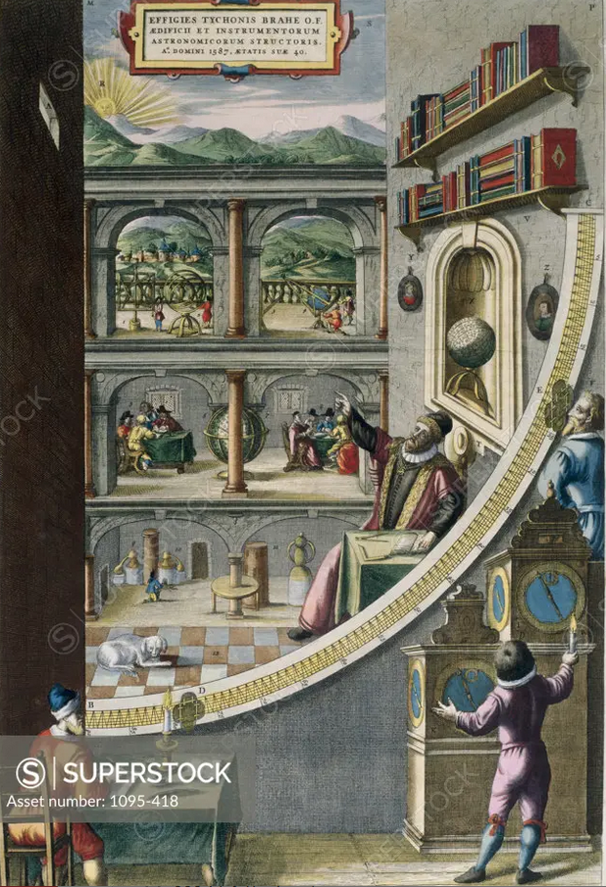

Superstock offers millions of photos, videos, and stock assets to creatives around the world. This image of Tycho Brahe And Others With Astronomical Instruments, 1587. "Le Quadran Mural" 1663 Blaeu, Joan(1596-1673 Dutch) Newberry Library, Chicago, Illinois, USA by Newberry Library is available for licensing today.

#### The Quadrant, ΤΕΤΑΡΤΗΜΟΡΙΟ,

<https://www.cartahistorica.com/our-catalogue/curiosities/quadrant/>,

The quadrant would have already been described by Ptolemeus. It is a navigation tool in the form of a wooden or bronze quarter of a circle. There were multiple types of quadrants. They helped to calculate a celestial body position, to determine the time and to record the latitude. In the thirteenth century it was rewritten by John the Sacrobosco in Paris and Jacob ben Machir ibn Tibbon (also called Profatius) in Montpellier. The disadvantage of the quadrant is its instability in case of a moving ship, so the use of this instrument at sea was not so practical. The bigger the instrument, the more accurate its calculations will be. The illustrated apparatus has been built by Brahe in 1588, and measured 194 cm

Original title: Quadrans Magnus Chalibeus in quadrato etiam comprehensus, unaque Azimuthalis

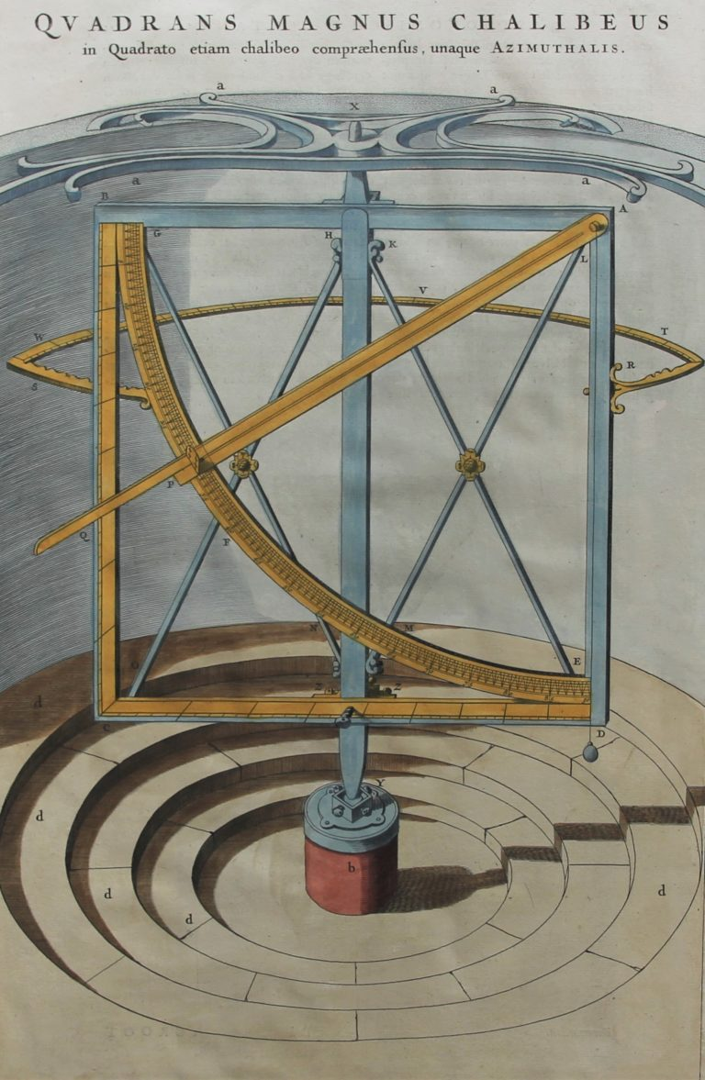

#### Ptolemy Astrology 1564.jpg,

<https://en.wikipedia.org/wiki/Quadrant_(instrument)>,

<https://en.wikipedia.org/wiki/File:Ptolemy_Astrology_1564.jpg>,

English: Ptolemy from "CLAVDIO TOLOMEO PRINCIPE DE GLI ASTROLOGI, ET DE GEOGRAFI" published by Giordano Ziletti, 1654,

<http://www.er.uqam.ca/nobel/r14310/Ptolemy/Ziletti.html>,

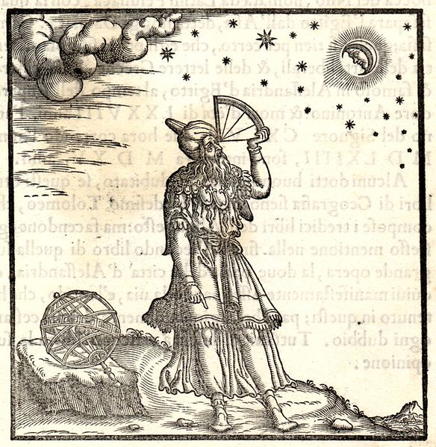

#### H. Edwards, Jr. The Historical Development of the Calculus

1979 by Springer-Verlag New York, Inc.

Συντομογραφια EDWARDS.

#### Joshua Cole and Carol Symes. Western civilizations : their history & their culture / Joshua Cole and Carol Symes. —Eighteenth edition.

W. W. Norton & Company, Inc., 500 Fifth Avenue, New York, N. Y. 10110

wwnorton.com

Συντομογραφια ColeSymes.

##### The School of Athens, (Italian: Scuola di Atene),

<https://en.wikipedia.org/wiki/The_School_of_Athens>,

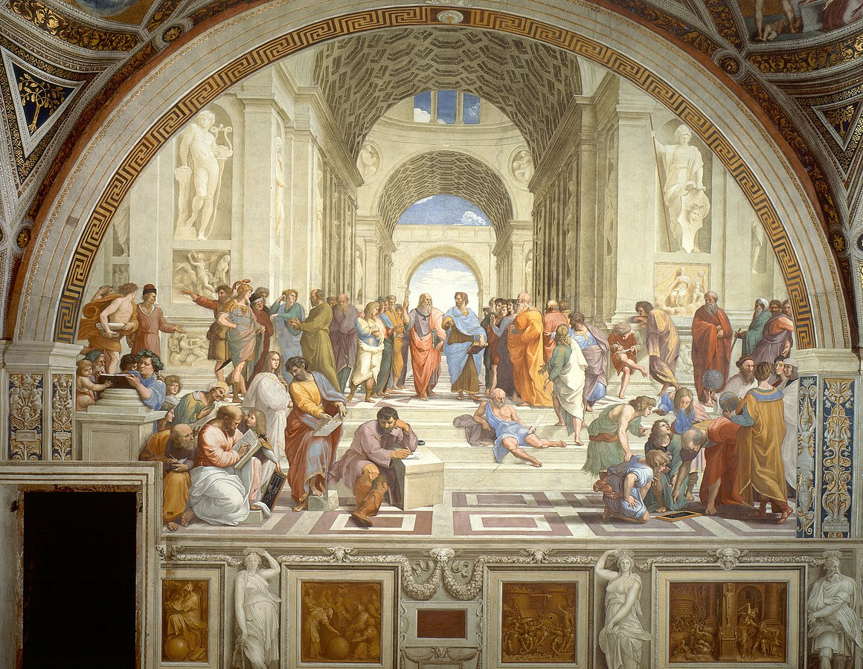

##### Perspective: Central Vanishing Point

<https://gogeometry.com/geometric_art/school_athens_perspective.html>,

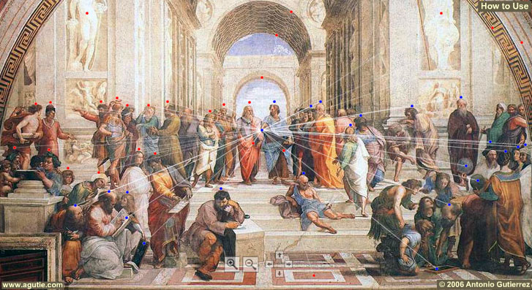

##### PERSPECTIVE, Vanishing line,

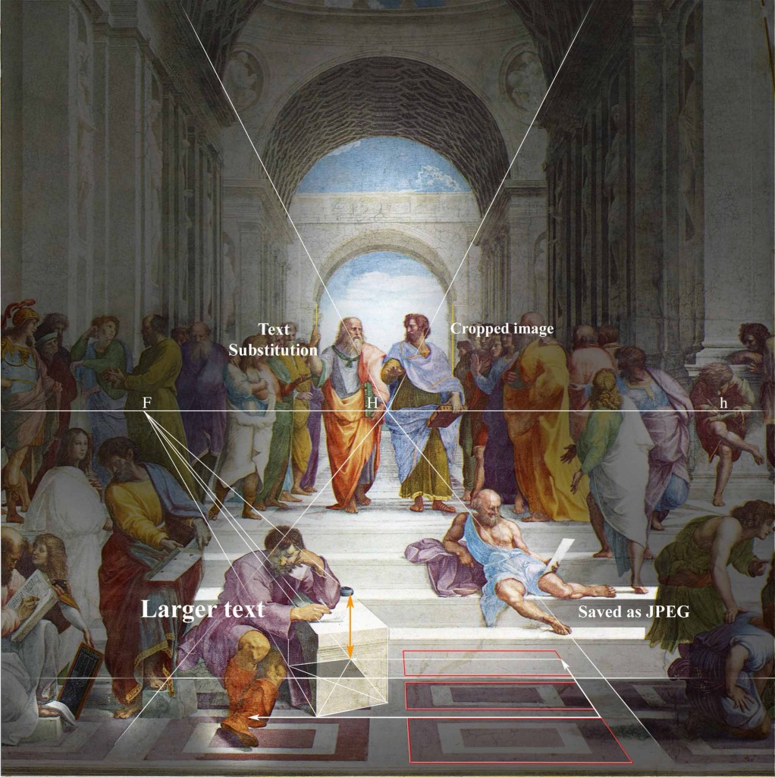

<https://en.wikipedia.org/wiki/The_School_of_Athens>,

The School of Athens (Italian: Scuola di Atene) is a fresco by the Italian Renaissance artist Raphael. The fresco was painted between **1509 and 1511** as a part of Raphael's commission, ( by Pope Julius II). to decorate the rooms now known as the Stanze di Raffaello, in the Apostolic Palace in the Vatican. It depicts a congregation of philosophers, mathematicians, and scientists from Ancient Greece, including Plato, Aristotle, Pythagoras, Archimedes, and Heraclitus. The Italian artists Leonardo da Vinci and Michelangelo are also featured in the painting, shown as Plato and Heraclitus respectively.

The painting notably features accurate perspective projection, a defining characteristic of the Renaissance era. **Raphael learned perspective from Leonardo**, whose role as Plato is central in the painting. The themes of the painting, such as the rebirth of Ancient Greek philosophy and culture in Europe (along with Raphael's work) were inspired by Leonardo's individual pursuits in theatre, engineering, optics, geometry, physiology, anatomy, history, architecture and art.[1]

The School of Athens is regarded as one of Raphael's best known works, and has been described as "Raphael's masterpiece and the perfect embodiment of the classical spirit of the Renaissance".[2]

##### An elder Plato walks alongside a younger Aristotle,

<https://en.wikipedia.org/wiki/The_School_of_Athens>,

<https://en.wikipedia.org/wiki/File:Sanzio_01_Plato_Aristotle.jpg>,

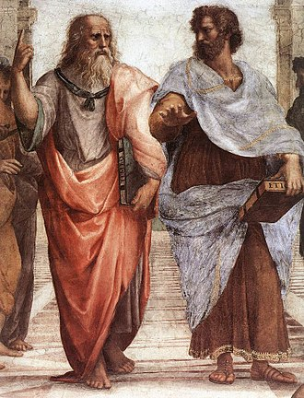

Plato (427 - 347 BC) holds a copy of his Timaeus, and gestures upward to the aetherial realm of his eternal forms. This Plato is probably a portrait of Leonardo da Vinci. This Aristotle is probably a portrait of Giulliano del Sagallo .

Aristotle of Stagira (384 - 322 BC) (according to Dante Alighieri "**The Master of those who know**") stretches his hand. He holds a copy of his Nichomachean Ethics -- and he indicates with his gesture the worldliness, the concreteness, of his contributions to philosophy. Nicomachus was the father of Aristotle but also his son was called Nicomachus (the mother some say was Herpyllis a concubine of Aristotle which he married after the death of his wife Pythias).

Does his brown and blue colored clothes represent the two elements water and earth (probably to show that his philosophy is grounded, material), whereas Plato's two colors represent fire and air?

##### Bramante as Euclid, ?

<https://en.wikipedia.org/wiki/The_School_of_Athens>,

<https://en.wikipedia.org/wiki/File:Scuola_di_atene_23.jpg>,

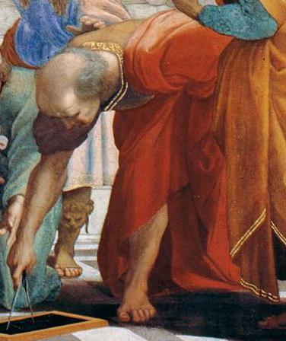

##### Zoroaster, Ptolemy, Raphael as Apelles and Perugino, Il Sodoma or Timoteo Viti as Protogenes,

<https://en.wikipedia.org/wiki/The_School_of_Athens>,

<https://en.wikipedia.org/wiki/File:Raffael_071.jpg>,

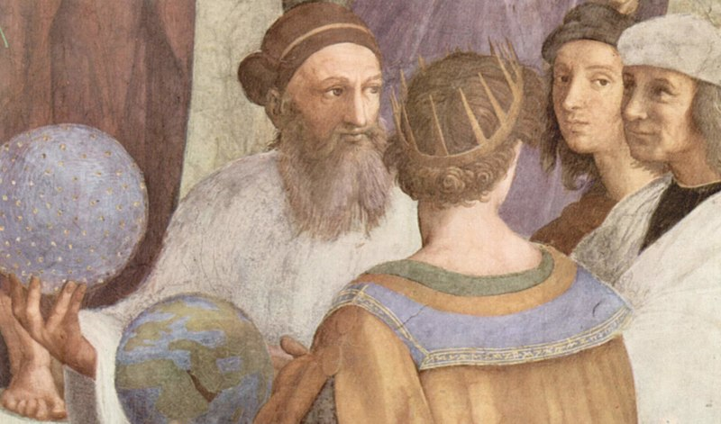

Raffaello Sanzio da Urbino[a] (Italian: [raffaˈɛllo ˈsantsjo da urˈbiːno]; March 28 or April 6, 1483 – April 6, 1520),[2][b] better known as **Raphael (**UK: /ˈræfeɪəl/ RAF-ay-əl, US: /ˈræfiəl, ˈreɪf-, ˌrɑːfaɪˈɛl/ RA(Y)F-ee-əl, RAH-fy-EL),[4] was an Italian painter and architect of the High Renaissance. Together with Leonardo da Vinci and Michelangelo, he forms the traditional trinity of great masters of that period.[6]

Raphael as Apelles,

Back view of **Ptolemy** holding earth sphere, facing Strabo (or Zoroaster, represented as an astrologer), holding a celestial sphere.

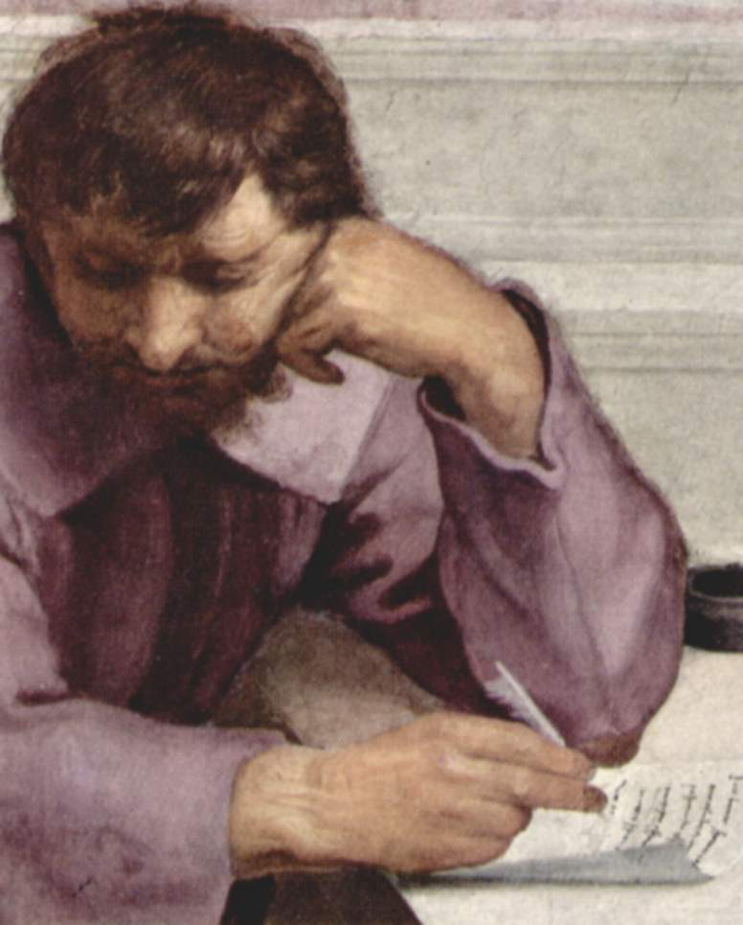

Michelangelo as Heraclitus