102 μαθημα, τεταρτη, 26-04-2023,

Webex meeting recording: 102 WEDNESDAY INM-20230426 0922-1

Password: fBEjyP5S

Recording link: <https://uoa.webex.com/uoa/ldr.php?RCID=97876672d9deea429beb7b5f6472566c>,

102AnagennhshErg22.docx,

ΠΡΟΚΑΤΑΡΚΤΙΚΑ,

Εργασιες 22, 23, . μονο η 22 εγινε,

Συνοψη προηγουμενων

#### ΥΣΤΕΡΟΣ ΜΕΣΑΙΩΝΑΣ, LATE MIDDLE AGES, 1300-1500,

##### Black Death, ΠΑΝΩΛΗΣ,

<https://en.wikipedia.org/wiki/Black_Death>,

The **Black Death** (also known as the Pestilence, the Great Mortality or the **Plague**)[a] was a bubonic plague pandemic occurring in **Western Eurasia and North Africa from 1346 to 1353.** It is the most fatal pandemic recorded in human history, causing the deaths of 75–200 million people,[1] peaking in Europe from **1347 to 1351**.[2][3] Bubonic plague is caused by the bacterium Yersinia pestis spread by fleas, but during the Black Death it probably also took a secondary form, spread by person-to-person contact via aerosols, causing **pneumonic plague.**[4][5]

##### <https://www.google.com/search?client=firefox-b-d&q=deaths+by+black+death>,

How many died from Black Death?

The Black Death was so extreme that it's surprising even to scientists who are familiar with the general details. The epidemic **killed 30 to 50 percent of the entire population of Europe. B**etween 75 and 200 million people died in a few years' time, starting in 1348 when the plague reached London.

ΣΥΝΕΠΙΕΣ,

ΑΥΞΗΣΗ ΜΙΣΘΩΝ ΕΡΓΑΖΟΜΕΝΩΝ,

Slaves, > surfs, > ανεξαρτητοι εργαζομενοι,

ΑΙΣΘΗΣΗ ΑΝΑΓΚΗΣ ΑΛΛΑΓΗΣ

Εδώ ξεκιναει η ΑΝΑΓΕΝΝΗΣΗ στην ΙΤΑΛΙΑ.

ΚΕΝΤΡΙΚΗ ΙΔΕΑ, ΚΕΝΤΡΙΚΗ ΑΠΟΚΛΙΣΗ ΑΠΟ ΜΕΣΑΙΩΝΑ,

Η παρουσα ζωη εχει αξια, μπορει να γινει καλη με κοσμικα μεσα,

Pandemics and inequality,

<https://warwick.ac.uk/fac/soc/economics/research/centres/cage/news/03-12-20-pandemics_and_inequality/>,

Thursday 3 Dec 2020

Pandemics of the past have had major consequences for inequality, not all of them positive. What lessons can we learn about the potential redistributive effects of COVID-19? Guido Alfani explores the impact of plague and influenza on inequality, and asks how infection spread and mortality rates affect wealth and income redistribution.

The Black Death and subsequent plagues

The Black Death, which struck Europe and the Mediterranean **during 1347–52 killing about half the population of the area, caused a significant and long-lasting reduction in wealth and income inequality**. This is clearly visible in Italy (Fig.1), which is the area for which we currently have the best information. In the aftermath of the Black Death, the richest 10% of the population lost their grip on between 15 and 20% of their **overall wealth, and pre-plague levels were not reached again before the second half of the seventeenth century**.

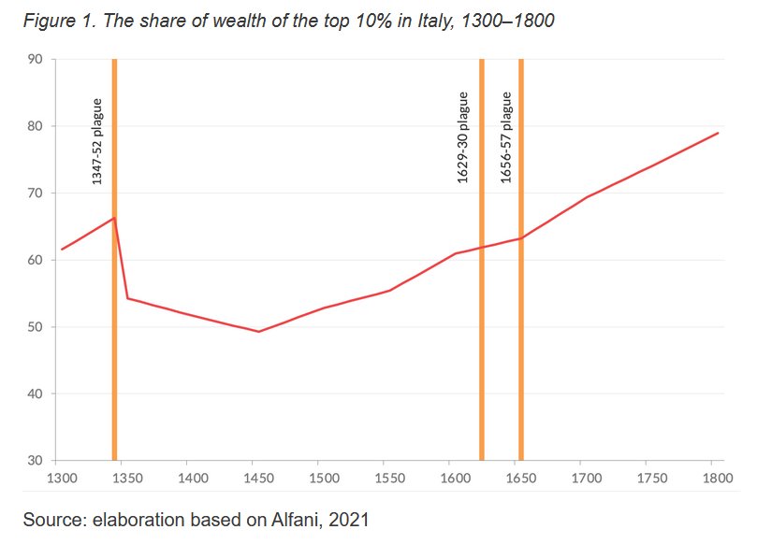

###### Περαιτερω πληροφοριες

Historical effects of shocks on inequality: the great leveler revisited.

<https://www.nature.com/articles/s41599-021-00763-4#Sec1>,

## ΑΝΑΓΕΝΝΗΣΙΣ, RENNAISANCE, rinascita (Italian), ? 1350-?1800,

<https://en.wikipedia.org/wiki/Renaissance>,

This article is about the European Renaissance of the 15th and 16th centuries. For the earlier European Renaissance, see Renaissance of the 12th century. For other uses, see Renaissance (disambiguation).

Renaissance

"The School of Athens" by Raffaello Sanzio da Urbino.jpg

The School of Athens (1509–11) by Raphael

### Rinascita,

<https://en.wikipedia.org/wiki/Renaissance>,

The term **rinascita** ('rebirth') first appeared in Giorgio Vasari's Lives of the Artists (c. 1550), **anglicized as the Renaissance in the 1830s**.[19] The word has also been extended to other historical and cultural movements, such as the Carolingian Renaissance (8th and 9th centuries), Ottonian Renaissance (10th and 11th century), and the Renaissance of the 12th century.[20]

### OVERVIEW,

**In all, the Renaissance could be viewed as an attempt by intellectuals to study and improve the secular and worldly, both through the revival of ideas from antiquity, and through novel approaches to thought.** Some scholars, such as Rodney Stark,[24] play down the Renaissance in favor of the earlier innovations of the Italian city-states in the High Middle Ages, which married responsive government, Christianity and the birth of capitalism. This analysis argues that, whereas the great European states (France and Spain) were absolute monarchies, and others were under direct Church control, the independent city-republics of Italy took over the principles of capitalism invented on monastic estates and set off a vast unprecedented Commercial Revolution that preceded and financed the Renaissance.

ΑΙΣΘΗΣΗ ΑΝΑΓΚΗΣ ΑΛΛΑΓΗΣ

Εδώ ξεκιναει η ΑΝΑΓΕΝΝΗΣΗ στην ΙΤΑΛΙΑ.

ΚΕΝΤΡΙΚΗ ΙΔΕΑ, ΚΕΝΤΡΙΚΗ ΑΠΟΚΛΙΣΗ ΑΠΟ ΜΕΣΑΙΩΝΑ, ΚΟΣΜΙΚΟΤΗΣ,

### ΘΡΗΣΚΕΥΤΙΚΟΙ ΠΟΛΕΜΟΙ, ΜΕΤΑΡΥΘΜΙΣΗ, REFORMATION, RELIGIOUS WARS,

European wars of religion

<https://en.wikipedia.org/wiki/European_wars_of_religion>,

**The European wars of religion were a series of wars waged in Europe during the 16th, 17th** and early 18th centuries.[1][2] **Fought after the Protestant Reformation began in 1517,** the wars disrupted the religious and political order in the Catholic countries of Europe, or Christendom. **Other motives during the wars involved revolt, territorial ambitions and great power conflicts**. **By the end of the Thirty Years' War (1618–1648), Catholic France (δυναστια ΒΟΥΡΒΩΝΩΝ), had allied with the Protestant forces against the Catholic Habsburg monarchy.[3]** The wars were largely ended by the Peace of Westphalia (1648), which established a new political order that is now known as Westphalian sovereignty.

Ninety-five Theses,

<https://en.wikipedia.org/wiki/Ninety-five_Theses#cite_note-FOOTNOTEBrecht1985199%E2%80%93200-34>,

Luther sent the Theses enclosed with a letter **to Albert of Brandenburg, Archbishop of Mainz, on 31 October 1517**, a date now considered the start of the Reformation and commemorated annually as Reformation Day. **Luther may have also posted the Ninety-five Theses on the door of All Saints'** Church and other churches in Wittenberg—in accordance with University custom—on 31 October or in mid-November. The Theses were quickly reprinted and translated, and distributed throughout Germany and Europe.

### ΕΝΙΣΧΥΣΗ ΚΕΝΤΡΙΚΗΣ ΕΞΟΥΣΙΑΣ,

ΣΥΝΘΗΚΗ ΒΕΣΤΦΑΛΙΑΣ, (1648)

### ΟΘΩΜΑΝΙΚΗ ΑΠΕΙΛΗ

#### Siege of Vienna (1529)

<https://en.wikipedia.org/wiki/Siege_of_Vienna_(1529)>,

The siege of Vienna, in 1529, was the first attempt by the Ottoman Empire to capture the capital city of Vienna, Austria, Holy Roman Empire. Suleiman the Magnificent, sultan of the Ottomans, attacked the city with over 100,000 men, while the defenders, led by Niklas Graf Salm, numbered no more than 21,000. Nevertheless, Vienna was able to survive the siege, which ultimately lasted just over two weeks**, from 27 September to 15 October, 1529.**

#### Battle of Vienna,

<https://en.wikipedia.org/wiki/Battle_of_Vienna>,

The Battle of Vienna[a] took place at Kahlenberg Mountain near Vienna on 12 September 1683[2] after the imperial city had been besieged by the Ottoman Empire for two months. The battle was fought by the **Holy Roman Empire (led by the Habsburg monarchy and the Polish–Lithuanian Commonwealth, both under the command of King John III Sobieski)** against the Ottomans and their vassal and tributary states. The battle marked the first time the Commonwealth and the Holy Roman Empire had cooperated militarily against the Ottomans, and it is often seen as **a turning point in history, after which "the Ottoman Turks ceased to be a menace to the Christian world".[21][Note 3]** In the ensuing war that lasted until 1699, the Ottomans lost almost all of Hungary to the Holy Roman Emperor Leopold I.[21]

### German Peasants' War (1524–1525)