104 ΜΑΘΗΜΑ, ΔΕΥΤΕΡΑ, 08-05-2023,

Webex meeting recording: 104 MONDAY INM-20230508 0912-1

Password: Myb2mBEx

Recording link: <https://uoa.webex.com/uoa/ldr.php?RCID=bd4645e08a7115f0a7b51651eac59290>,

104AbaxFibonAlgAnagen.docx

**ΣΧΕΔΙΑΣΜΟΣ,**

Ανεβηκε το 103 μαθημα.

Συζητηση για crescent,

ΕΡΓΑΣΙΕΣ 24, 25, tis exoyme dei sto 103 μα

ΠΕΡΙΛΗΨΗ ΠΡΟΗΓΟΥΜΕΝΩΝ,

Εισοδος εε, Fibonacci,

Υπενθυμιση 19.2.5 ΕΞΕΡΕΥΝΗΣΕΙΣ,

### ΑΒΑΞ, ABACUS ital., ABACI eng,

#### ΑΒΑΞ, ABACUS ital., ABACI eng,

GOOGLE, Η λέξη άβακας είναι η ελληνική λέξη **άβαξ** που σύμφωνα με τρία αρχαία λεξικά σημαίνει μια πινακίδα, μια σανίδα, κάτι που δεν έχει βάση Ἄβαξ· κυρίως ? ὁ μὴ ἔχων βάσιν, καταχρηστικῶς δὲ καὶ ἐπὶ οἵουδήποτε σανιδίου. **Δηλαδή αρχικά δεν σημαίνει αριθμητήριο.**

[**https://el.wiktionary.org/wiki/%E1%BC%84%CE%B2%CE%B1%CE%BE**](https://el.wiktionary.org/wiki/%E1%BC%84%CE%B2%CE%B1%CE%BE)**,**

**η**

**<https://el.wiktionary.org/wiki/%E1%BC%84%CE%B2%CE%B1%CE%BE>,**

σανίδα ή πλάκα για την καταμέτρηση ψήφων

※ 4ος αιώνας πκε ⌘ Αριστοτέλης, Ἀθηναίων πολιτεία Arist.Ath.69.1@perseus.tufts.edu

πάντες δ᾽ ἐπειδὰν ὦσι διεψηφισμένοι, λαβόντες οἱ ὑπηρέται τὸν ἀμφορέα τὸν κύριον, ἐξερῶσι ἐπὶ ἄβακα τρυπήματα ἔχοντα ὅσαιπερ εἰσὶν αἱ ψῆφοι, ἵν᾽ αὗται φανεραὶ προκείμεναι καὶ εὐαρίθμητοι ὦσιν, καὶ τὰ τρυπητὰ καὶ τὰ πλήρη δῆλα τοῖς ἀντιδίκοις. οἱ δὲ ἐπὶ τὰς ψήφους εἰληχότες διαριθμοῦσιν αὐτὰς ἐπὶ τοῦ ἄβακος, χωρὶς μὲν τὰς πλήρεις, χωρὶς δὲ τὰς τετρυπημένας. καὶ ἀναγορεύει ὁ κήρυξ τὸν ἀριθμὸν τῶν ψήφων, τοῦ μὲν διώκοντος τὰς τετρυπημένας, τοῦ δὲ φεύγοντος τὰς πλήρεις: ὁποτέρῳ δ᾽ ἂν πλείων γένηται, οὗτος νικᾷ, ἂν δὲ ἴσαι, ὁ φεύγων.

ABACUS,

GOOGLE. Etymology. The word abacus dates to at least AD 1387 when a Middle English work borrowed the word from Latin that described a sandboard abacus. The Latin word is derived from ancient Greek ἄβαξ (abax) which means something without a base, and colloquially, any piece of rectangular material.

ο άβαξ (πλάκα) της Σαλαμίνος

<https://el.wiktionary.org/wiki/%CE%AC%CE%B2%CE%B1%CE%BA%CE%B1%CF%82#%CE%95%CF%84%CF%85%CE%BC%CE%BF%CE%BB%CE%BF%CE%B3%CE%AF%CE%B1>,

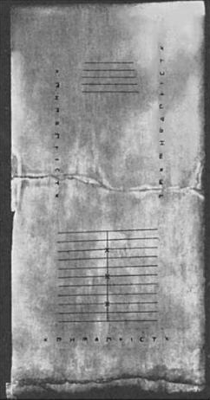

Salamis Tablet: oldest abacus from 300 BC found 1846 at the island of Salamis, Greece

<https://el.wiktionary.org/wiki/%CE%91%CF%81%CF%87%CE%B5%CE%AF%CE%BF:Salaminische_Tafel_Salamis_Tablet_nach_Wilhelm_Kubitschek_Numismatische_Zeitschrift_Bd_31_Wien_1899_p._394_ff.jpg>,

#### ROMAN NUMERALS,

<https://gr.pinterest.com/pin/9359111718602986/>,

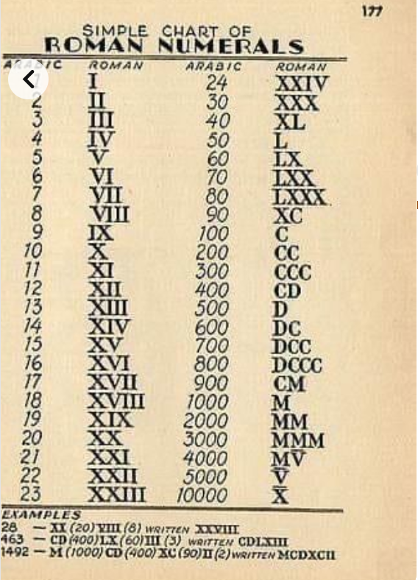

#### Hindu–Arabic numeral system

The Hindu–Arabic numeral system or Indo-Arabic numeral system[1] (also called the Hindu numeral system or Arabic numeral system)[2][note 1] is a positional decimal numeral system, and is the most common system for the symbolic representation of numbers in the world.

**It was invented between the 1st and 4th centuries by Indian mathematicians. The** system **was adopted in Arabic mathematics by the 9th century.** It became more widely known through the writings of the Persian mathematician Al-Khwārizmī[3] (**On the Calculation with Hindu Numerals, c. 825)** and Arab mathematician Al-Kindi (On the Use of the Hindu Numerals, c. 830). The system had spread to medieval Europe by the High Middle Ages.

#### Arabic numerals, Adoption and spread,

<https://en.wikipedia.org/wiki/Arabic_numerals>,

Adoption and spread,

**The first Arabic numerals in the West** appeared in the Codex Albeldensis in Spain. The Codex Vigilanus or Codex Albeldensis (Spanish: Códice Vigilano or Albeldense. Updated 976).

The first mentions of the numerals from 1 to 9 in the West are found in the Codex Vigilanus of 976, an illuminated collection of various historical documents covering a period from antiquity to the 10th century in Hispania.[12] Other texts show that numbers from 1 to 9 were occasionally supplemented by a placeholder known as sipos, represented as a circle or wheel, reminiscent of the eventual symbol for zero. The Arabic term for zero is sifr (صفر), transliterated into Latin as cifra, and the origin of the English word cipher.

**From the 980s, Gerbert of Aurillac** (later, Pope Sylvester II ((life c. 946 – 12 May 1003), **(Pope (999-1203**)), ) used his position to spread knowledge of the numerals in Europe. Gerbert studied in Barcelona in his youth. He was known to have requested mathematical treatises concerning the astrolabe from Lupitus of Barcelona after he had returned to France.[12]

The reception of Arabic numerals in the West was gradual and lukewarm, as other numeral systems circulated in addition to the older Roman numbers. As a discipline, the first to adopt Arabic numerals as part of their own writings were **astronomers and astrologists,** evidenced from manuscripts surviving from mid-12th-century Bavaria. Reinher of Paderborn (1140–1190) used the numerals in his calendrical tables to calculate the dates of Easter more easily in his text Compotus emendatus.[13]

Adjective, Sylvester

silvestris (neuter silvestre); third-declension two-termination adjective

Of or pertaining to a forest or wood

forested, wooded, overgrown with trees

rural, wild, living in forests

COMMENT.

<https://www.reddit.com/r/AskHistorians/comments/49z4d6/why_did_florence_ban_hinduarabic_numerals_in_1299/>,

GOOGLE. In Florence, for example, people argued that Arabic numerals were easier to falsify than Roman ones. The poor legibility of the figures in merchants' ledgers was also criticised. In 1299, the city banned the use of Arabic numerals in contracts and official documents.

COMMENT.

SOCIAL INERTIA, another example

#### Dispute between abacists and algorists,

<https://library.ethz.ch/en/locations-and-media/platforms/virtual-exhibitions/fibonacci-un-ponte-sul-mediterraneo/fibonaccis-significance-for-the-present-day/dispute-between-abacists-and-algorists.html>,

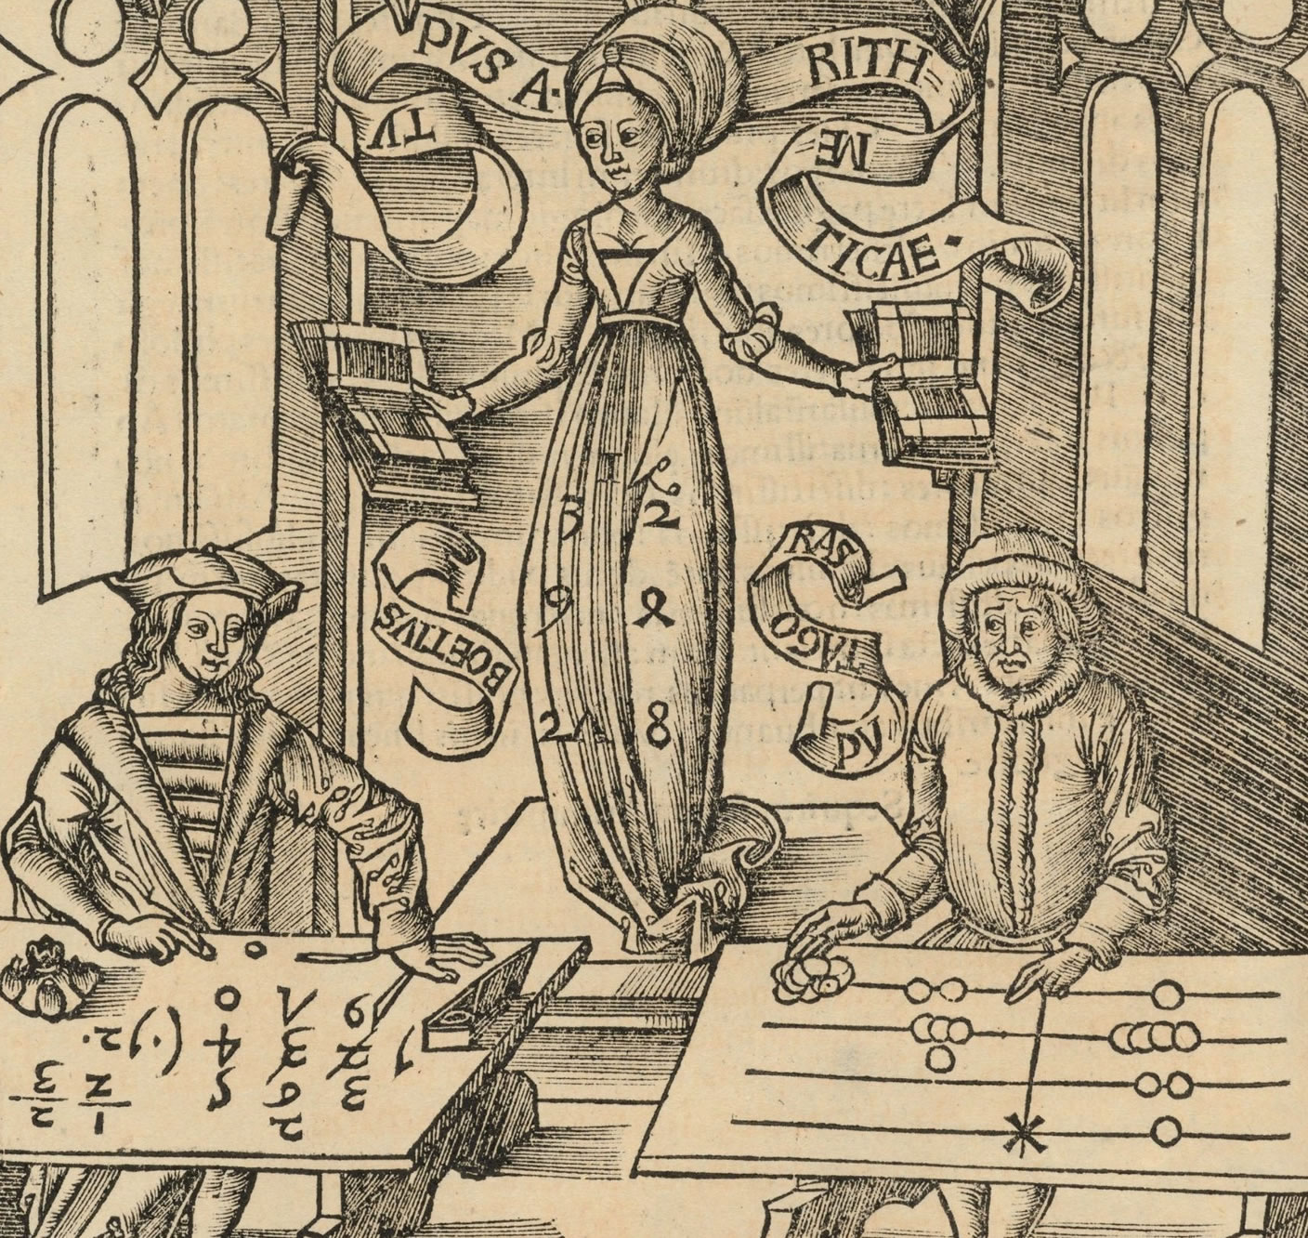

Extract from "Margarita philosophica nova" by Gregor Reisch

(1512 edition),

Man has always striven to simplify life by using technical aids. And this was also the case with counting and calculating. So the abacus was used in different forms for centuries. Even today the abacus is used in East Asia, India and Russia.

**In the thirteenth century the system of calculation with written numerals in use in the Arab world was introduced into the Western world first via the Arabs and then by Leonardo of Pisa,** known as Fibonacci. Fibonacci above all sought in his "Liber abaci", the "Book of arithmetic", to persuade merchants of the great benefit of Indo-​Arabic arithmetic.

Ideological conflict until the French Revolution

However, the authorities and the church were set against the widespread introduction of calculation with numerals. So even as late as 1300 there was a ban in various Italian cities on using Indo-​Arabic numerals in contracts and official documents. An ideological conflict lasting centuries then began between the abacists, who stuck to calculating with the abacus and continued to use Roman numerals, and the algorists, the adherents of written calculation with Indo-​Arabic numerals and place-​value writing. **It was only in the course of the 1789 French Revolution, when the abacus was banned from schools and administration, that Indo-​Arabic numerals could finally be imposed throughout Europe.**

**The anachronistic picture from "Margarita philosophica nova" shows on the right the ancient Greek scholar Pythagoras as representative of the abacists with an abacus.** On the left can be seen the late Roman philosopher Boethius, who is already calculating with the new Indo-​Arabic numerals and represents the algorists. In the middle is Arithmetica, who has decided the dispute between abacists and algorists in favour of the algorists.

##### Boethius, ΒΟΗΘΙΟΣ,

Wikipedia, Anicius Manlius Severinus Boethius,[6][note 1] commonly known as Boethius (/boʊˈiːθiəs/; Latin: Boetius; c. 480–524 AD), was a Roman senator, consul, magister officiorum, historian, and philosopher of the Early Middle Ages. He was a central figure in the translation of the Greek classics into Latin, a precursor to the Scholastic movement, and, along with Cassiodorus**, one of the two leading Christian scholars of the 6th century.** The local cult of Boethius in the Diocese of Pavia was sanctioned by the Sacred Congregation of Rites in 1883, confirming the diocese's custom of honouring him on the 23 October.[9]

##### Gregor Reisch, wikipedia

Gregor Reisch (c. 1467 – 9 May 1525) was a German **Carthusian monk and humanist scholar.** He is best known for **his compilation Margarita Philosophica, one of the earliest printed encyclopedias** of general knowledge.[1]

##### Carthusians

The Carthusians, also known as the Order of Carthusians (Latin: Ordo Cartusiensis), are a Latin enclosed religious order of the Catholic Church. The order was founded by Bruno of Cologne **in 1084 and includes both monks and nuns**.

COMMENT

## ΑΛΓΕΒΡΑ ΣΤΗΝ ΑΝΑΓΕΝΝΗΣΗ,

See KATZ, p. 383, Ch.12 Algebra in the Renaissance

### Algebraic Symbolism and Techniques (ΑΝΑΓΕΝΝHΣΗ),

KatzHistoryOfMathematics3rdS, 12.1.1. p.386

**Algebraic Symbolism and Techniques**

Recall that Islamic algebra was entirely rhetorical. There were no symbols for the unknown or

its powers nor for the operations performed on these quantities. **Everything was written out in words**.

The same was generally true in the works of the early abacists and in the earlier Italian work of **Leonardo of Pisa (Fibonacci**)..

Early in the fifteenth century, however, some of the abacists (Arabic numerals), began to substitute abbreviations for unknowns. For example, in place of the standard words ***cosa* (thing),** *censo* (square, απογραφη), *cubo* (cube), and *radice* (root), some authors used the abbreviations *c*, *ce*, *cu*, and *R*. Combinations of these abbreviations were used for higher powers.

Thus,

***ce di ce* or *ce ce* stood for *censo di censo* or fourth power (*x*2*x*2);**

*ce cu* or *cu ce*, designating ***censo di cubo* and *cubo di censo (x3 )*, respectively, ce di cu stood for fifth power (*x*2*x*3);** And

***cu cu*, designating *cubo di cubo*, stood for sixth power (*x*3*x*3**).

**Η επαναληψη δηλωνε γινομενο**.

By the **end of the fifteenth century, however**, the naming scheme for higher powers had changed, and authors used

*ce cu* or ***censo di cubo* to designate the sixth power (*(x*3*)*2)** and *cu cu* or *cubo di cubo* to represent the ninth power

(*(x*3*)*3).

**Η επαναληψη δηλωνε «δυναμη εις την δυναμη»**.

The fifth power was then designated as *p.r.* or *primo relato* and the seventh power as *s.r.* or *secondo relato*..

RELATO, σχετιζομενος, συγγενης,

***Coss*** was simply the German form of

the Italian **cosa,** or thing, the name usually given to the unknown in an algebraic equation.

Two of the most important **Cossists** in the first half of the sixteenth century were Christoff

Rudolff (sixteenth century) and Michael Stifel (1487–1567).

**Piu, πλεον,**

The most important (and obvious) meaning of più is as an adjective meaning “more”

**Più bella cosa**, (πιο όμορφο πράγμα), Eros Ramazzotti

“to pio ομορφο plasma”

<https://lyricstranslate.com/el/piu-bella-cosa-pio-omorfo-pragma.html>,

**Meno, less,**

SGP, koinonikh adraneia,

#### Luca Pacioli (1445–1517).

See KATZ, p, 389,

Pacioli, one of the last of the abacists, was ordained as a Franciscan friar in the 1470s

and taught mathematics at various places in Italy during the remainder of his career. He

became so famous as a teacher that there is a painting of him by Jacopo di Barbari now

hanging in the Naples Museum, which shows him teaching geometry to a young man

tentatively identified as Guidobaldo, the son of his patron, the Duke of Urbino (Fig. 12.1).

As part of his teaching, Pacioli composed three different abacus texts for his students. He

regretted what he believed to be the low ebb to which teaching had fallen. Because he

felt that one of the problems was the scarcity of available subject material, he gathered

mathematical materials for some twenty years and in **1494 completed the most comprehensive**

mathematics text of the time, and one of the earliest mathematics texts to be printed. This

was the ***Summa de arithmetica, geometrica, proportioni et proportionalita*, a 600-page work**

written in the Tuscan dialect rather than in Latin. It contained not only practical arithmetic but also much of the algebra already discussed, the first published **treatment of double entry**

bookkeeping, and a section on practical geometry. There was little that was original

in this work. In fact, a large number of the algebra problems are taken directly from della

Francesco’s treatise, while the practical geometry is very similar to that of Leonardo of Pisa.

Nevertheless, its comprehensiveness and the fact that it was the first such work to be printed

made it into a widely circulated and influential text, extensively studied by sixteenth-century

Italian mathematicians. It became the common base from which these men were able to

extend the range of algebra. Before considering these advances, however, we first turn to

contemporaneous developments elsewhere in Europe. It is not only from Italy that our algebra

comes.

See <https://en.wikipedia.org/wiki/Luca_Pacioli>,

Fra Luca Bartolomeo de Pacioli (sometimes Paccioli or Paciolo; c. 1447 – 19 June 1517)[3] was an Italian mathematician, Franciscan friar, collaborator with Leonardo da Vinci, and an early contributor to the field now known as accounting. **He is referred to as the father of accounting and bookkeeping and he was the first person to publish a work on the double-entry system of book-keeping on the continent**.[4][a] He was also called Luca di Borgo after his birthplace, Borgo Sansepolcro, Tuscany.

##### WORKS

Tractatus mathematicus ad discipulos perusinos

(Ms. Vatican Library, Lat. 3129), a nearly 600-page textbook dedicated to his students at the University of Perugia where Pacioli taught from 1477 to 1480.

Summa de arithmetica, geometria.

Proportioni et proportionalita (Venice 1494), a textbook for use in the schools of Northern Italy. It was a synthesis of the mathematical knowledge of his time and contained the first printed work on algebra written in the vernacular (i.e., the spoken language of the day). It is also notable for including one of the first published descriptions of the bookkeeping method that Venetian merchants used during the Italian Renaissance, known as the double-entry accounting system. The system he published included most of the accounting cycle as we know it today. He described the use of journals and ledgers and warned that a person should not go to sleep at night until the debits equalled the credits. His ledger had accounts for assets (including receivables and inventories), liabilities, capital, income, and expenses – the account categories that are reported on an organization's balance sheet and income statement, respectively. He demonstrated year-end closing entries and proposed that a trial balance be used to prove a balanced ledger. Additionally, his treatise touches on a wide range of related topics from accounting ethics to cost accounting. He introduced the Rule of 72, using an approximation of 100*ln 2 more than 100 years before Napier and Briggs.[9] Its exercises were largely copied without credit from Piero della Francesca's earlier book, Trattato d'abaco.[10]

#### Elimination of second term,

Katz p. 388,