106 ΜΑΘΗΜΑ, ΔΕΥΤΕΡΑ, 15-05-2023,

ArsMagnaLysh3bathmias

Webex meeting recording: 106 MONDAY INM-20230515 0914-1

Password: yPRtppq8

Recording link: <https://uoa.webex.com/uoa/ldr.php?RCID=4ae1a03c572ba7ec90933c7dee5f5380>,

**ΠΡΟΚΑΤΑΡΚTΙΚΑ,**

Biblia apeirostikoy, αναλυτικης γεωμ

Εργασιες 28, 31, 32,

Εμφαση στο 28.

###### SGP. <https://plato.stanford.edu/entries/cardano/>,

This tragic event represented a turning point in Cardano’s life and intellectual career. In 1562, he decided to leave Pavia, whose academic environment had become increasingly hostile, to teach medicine in Bologna. As a result of mounting suspicions that he was actively spreading heretical views, he was arrested on 6 October 1570 and remained in prison until 22 December of the same year. In February 1571, before the Sacred Congregation led by Antonio Baldinucci, **Cardano was required to acknowledge and reject his serious crimes against the faith (abiura de vehementi), having been declared “vehemently suspect of heresy.”** **He solemnly swore that he would no longer teach and publish books until his death**. **In 1571 he went to Rome to serve as personal physician to Pope Pius V and then Pope Gregory XIII.** After having been admitted to the College of Physicians in 1575, he died in Rome, **on 20 September 1576**, devoting his last energies (from September 1575 to May 1576) to write his autobiography, De vita propria, published posthumously by Gabriel Naudé in 1643.

**He moved to Rome, where he received a lifetime annuity from Pope Gregory XIII** (after first having been rejected by Pope Pius V, who died in 1572) and finished his autobiography. He was accepted in the Royal College of Physicians, and as well as practising medicine he continued his philosophical studies until his death in 1576.?????[citation needed] SEE <http://galileo.rice.edu/Catalog/NewFiles/cardano.html>,

SGP. Sto VITA PROPRIA den to anaferei.

### ΔΙΑΦΟΡΑ,

## ARS MAGNA,

**Οσα περιεχονται ΔΕΝ ηταν ο πρωτος που τα απεδειξε,**

**Εξισωση 3ου , 4ου βαθμου,**

**p. 8**

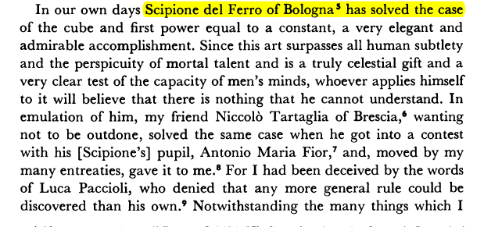

p. 26. ARS MAGNA, αφιερωση στον ANDREA OSIANDER

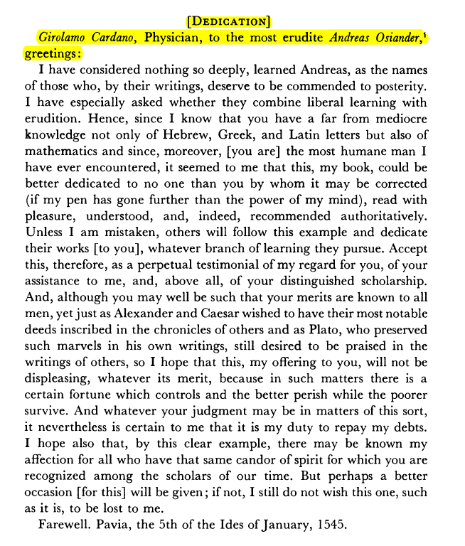

Ο ANDREA OSIANDER htan epifanhs προτεσταντης.

p. 285. ΕΠΙΛΟΓΟΣ,

WRITTEN IN FIVE YEARS,

MAY IT LAST AS MANY THOUSANDS

THE END OF THE GREAT ART

ON THE RULES OF ALGEBRA

BY GIROLAMO CARDANO 22

Printed in Nilrnberg by Joh. Petreius in the year 1545 21

21 1570 and 1663 omit.

p. 31, ars magna, This **art** originated with **Mahomet the son of Moses the Arab.**' Leonardo of Pisa is a trustworthy source for this statement.~ There

SGP. “art” η λυση εξισωσεων.

### Muḥammad ibn Mūsā al-Khwārizmī,

<https://en.wikipedia.org/wiki/Muhammad_ibn_Musa_al-Khwarizmi>,

ARS MAGNA p. 31

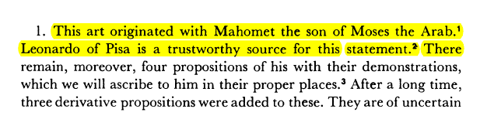

**Muḥammad ibn Mūsā al-Khwārizmī**[note 1] (Arabic: محمد بن موسى الخوارزمي, romanized: Muḥammad ibn Musā al-Khwārazmi; c. 780 – c. 850), or al-Khwarizmi, was a Persian polymath from Khwarazm,[6][7][8][9][10][11] who produced vastly influential works in mathematics, astronomy, and geography. Around 820 CE, he was appointed as the astronomer and head of the library of the House of Wisdom in Baghdad.[12]: 14

**al-Kitāb al-Mukhtaṣar fī Ḥisāb al-Jabr wal-Muqābalah,** The Compendious Book on Calculation by Completion and Balancing,

Compendious, συνοψη,

Mukhtaṣar (Arabic: المختصر), in Islamic law, refers to a concise handbook of legal treatises, characterized by neatness and clarity.

Hisaab, in English is Register,

Algebrista, χειροπρακτησ.

Al jabr, 'reunion of broken parts, bonesetting')

Muqabalah means "**putting face to face, confronting, equation**," and. the question arises as to the reason for giving to it the meaning of the special operation of removing the equal positive members.

**Al-Khwarizmi's popularizing treatise on algebra (The Compendious Book on Calculation by Completion and Balancing, c. 813–833 CE[13]: 171 )** presented the first systematic solution of linear and quadratic equations. One of his principal achievements in algebra was his demonstration of how to solve quadratic equations by completing the square, for which he provided geometric justifications.[12]: 14  Because he was the first to treat algebra as an independent discipline **and introduced the methods of "reduction" and "balancing**" (the transposition of subtracted terms to the other side of an equation, that is, the cancellation of like terms on opposite sides of the equation),[14] he has been described as the father[6][15][16] or founder[17][18] of algebra. The term algebra itself comes from the title of his book (the word al-jabr meaning "completion" or "rejoining").[19] His name gave rise to the terms algorism and algorithm,[20][21] as well as Spanish, Italian and Portuguese terms algoritmo, and Spanish guarismo[22] and Portuguese algarismo meaning "digit".

In the 12th century, Latin translations of his textbook on arithmetic (Algorithmo de Numero Indorum) which codified the various Indian numerals, introduced the decimal positional number system to the Western world.[23] The Compendious Book on Calculation by Completion and Balancing, translated into Latin by Robert of Chester in 1145, was used until the sixteenth century as the principal mathematical text-book of European universities.[24][25][26][27]

In addition to his best-known works, he revised Ptolemy's Geography, listing the longitudes and latitudes of various cities and localities.[28]: 9  He further produced a set of astronomical tables and wrote about calendaric works, as well as the astrolabe and the sundial.[29] He also made important contributions to trigonometry, producing accurate sine and cosine tables, and the first table of tangents.

### ΤΙ ΑΛΓΕΒΡΑ ΗΞΕΡΕ Ο ΚΑΡΔΑΝΟΣ

Οι συντελεστες και το x ησαν ΑΡΙΘΜΟΙ, γενικως (ασχετα με το τι μετρανε).

ΠΡΟΣΟΧΗ. Πλην του x, (ηταν συνηθως ο «αγνωστος»), οι λοιποι αριθμοι ησαν «συγκεκριμενοι» (όχι παραμετροι).

Ισχυαν οι γνωστοι νομοι των πραξεων

Π.χ. τα αβ υπαρχει, ισως δεν ξερουμε τι είναι, όμως «θεωρουμε» ότι αβ=βα

“ΥΠΗΡΧΑΝ” αρνητικοι αριθμοι, «περιπου»,

ΔΕΝ υπηρχαν γραμματα για παραμετρους.

Το “x” το ειχε από τους αραβες, (δεν ηξερε τον ΔΙΟΦΑΝΤΟ)

ΔΕΝ υπηρχα «μεταβλητες πλην ΜΙΑΣ. (i.e. oxi x, y, z, )

ΔΕΝ υπηρχαν παραμετροι

### ΚΕΝΤΡΙΚΗ ΙΔΕΑ ΤΗΣ ΛΥΣΗΣ,

Απόδειξη μέσω στερεομετρίας, του

(s+t)3 -3st(s+t) –(s3 +t3) =0

. ΓΕΩΜΕΤΡΙΚΗ ΑΠΟΔΕΙΞΗ, Αραβικη επιρροη. ΔΕΝ εγnωριζε τον ΔΙΟΦΑΝΤΟ.

GEOMETRIC PROOF,

<https://www.pinterest.com/pin/299489443969463718/>,

Cubic equation, <https://en.wikipedia.org/wiki/Cubic_equation>,

ΣΥΝΕΧΙΖΟΥΜΕ

Εξισωση x3 +px +q =0

Ταυτοτητα (s+t)3 -3st(s+t) –(s3 +t3) =0

Αν βρω s, t τετοια ωστε

-3st=p και –(s3 +t3)=q,

tote EXΩ την λυση x=s+t !!!

ΟΜΩΣ, τοτε τα s, t, ικανοποιουν

st=-p/3 και s3 +t3 =-q, η

s3t3=-(p/3)3 και s3 +t3 =-q,

δηλ. για τα s3 , t3,είναι λυσεις 2-βαθμιου εξισωσεως ! που ξερω πώς να την λυσω.

Αφου βρω τα s3 , t3,θα εξαγαγω τις κυβικες ριζες, οποτε βρισκω τα s, t και το (s+t) είναι η ζητουμενη ριζα !

ΠΝΕΥΜΑ ΑΝΤΙΛΟΓΙΑΣ: Μια στιγμη. Αν η ως ανω 2-βαθμια εξισωση ΔΕΝ εχει (πραγματικες) ριζες, τοτε «τινος» «θα εξαγαγω τις κυβικες ριζες» ?

ΠΝΕΥΜΑ ΑΙΣΙΟΔΟΞΙΑΣ: Ελα μωρε τωρα, λεπτομερια, κατι θα βρεθει !.

### ΤΥΠΟΙ ΤΩΝ ΛΥΣΕΩΝ της x3 + px+q=0,

Με p, q είναι πραγματικοι, .

Βλ. SGP3kai4bathm σελ. 85, στον ΥΠΟΦΑΚΕΛΟ ΒΙΒΛΙΟΓΡΑΦΙΑ του φακελου ΕΓΓΡΑΦΑ. Εκει υπαρχουν ολες οι αποδειξεις.

Κατωτερω καταγραφουμε τα αποτελεσματα.

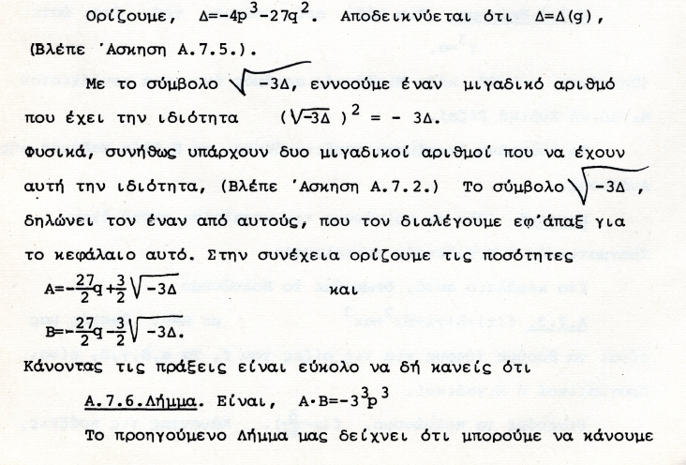

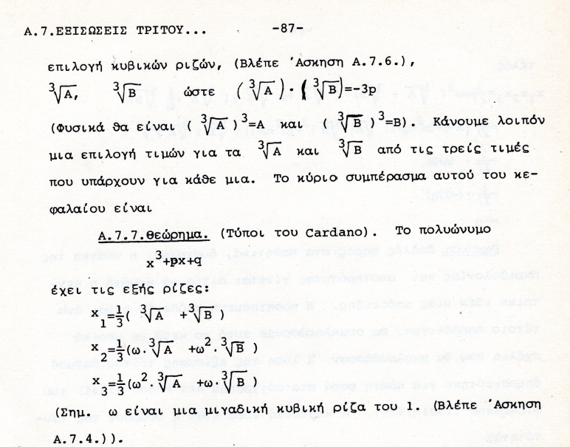

Π.χ, επιλεγουμε ω=(-1+(31/2 )i )/2

### ΣΥΓΚΕΚΡΙΜΕΝΑ ΠΑΡΑΔΕΙΓΜΑΤΑ,

#### x3 + 6x=20,

Η εξισωση αυτή εχει την πραρματικη ριζα 2

Αλλα οι τυποι του CARDANO δινουν



ΣΧΟΛΙΟ. Το «8» είναι υποσημειωση.

Επισης ο «ασαφης» σταυρος είναι -.

ΕΡΕΥΝΑ.

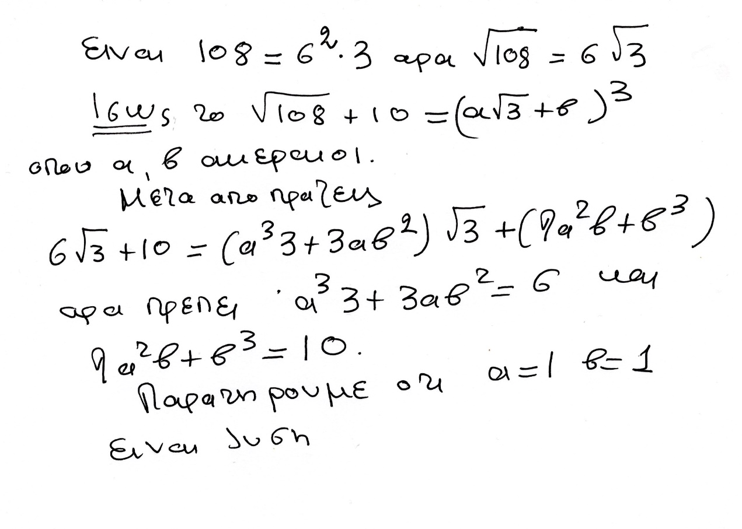

Αντι για «πρεπει», ας «ελπισουμε»

ΑΡΑ

(1+31/2 )3 = 1081/2 +10,

και αναλογως -(1-31/2 )3 = 1081/2 -10,

Αρα



= (1+31/2 ) – (-(1-31/2 )) =2 !

ΣΧΟΛΙΑΣΤΕ !!!

Ας βρουμε και τις άλλες 2 ριζεσ

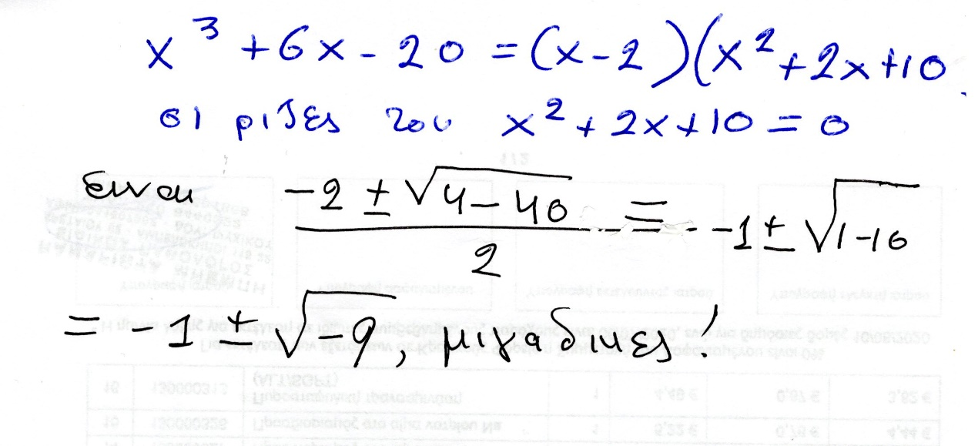

#### x3 -7x+6=0

Θεωρουμε την ως ανω εξισωση. Την φτιαξαμε από το γινομενο

(x-1)(x-2)(x+3)= x3 -7x+6, ριζες 1, 2, -3.

Κατά την ως ανω μεθοδο του CARDANO, οι ριζες περιγραφονται ως κατωτερω.

Οριζουμε

Α=-81+30(31/2 )i, Β==-81-30(31/2 )i,

ω=(1+(31/2 )i)/2.

H πορεια του CARDANO (με μεταγενεστερες βελτιωσεις), δινει τις τρεις ριζες

ρ1 =(1/3)(Α1/3 +Β1/3 )

ρ2 =(1/3)(ωΑ1/3 +ω2Β1/3 )

ρ3 =(1/3)( ω2Α1/3 +ωΒ1/3 )

Κανοντας απλα τις πραξεις, όπως καταλαβαινουμε τους μιγαδικους σημερα, διαπιστωνουμε τις ισοτητες

((3+ 2(31/2)i)3 =A kai ((3- 2(31/2)i)3 =B

ρ1 =(1/3)( ((3+ 2(3 1/2)i+ ((3- 2(3 1/2)i )=2

ρ2 =(1/3)(ωΑ1/3 +ω2Β1/3 )=1

ρ3 =(1/3)( ω2Α1/3 +ωΒ1/3 )=-3

πως όμως «μαντεψαμε» το ((3+ 2(31/2)i) και ((3- 2(31/2)i) ?