107 μαθημα, τεταρτη, 17-05-2023,

107SxoliaGia3bathmiaBombelliBio

Webex meeting recording: 107 WEDNESDAY INM-20230517 0919-1

Password: KbMZrF6K

Recording link: https://uoa.webex.com/uoa/ldr.php?RCID=920e47160acc1164254646fae5ed69b7

ΠΡΟΚΑΤΑΡΚΤΙΚΑ,

Την δευτερα 22-05-2023, λογω εκλογων δεν εχουμε μαθημα.

Επαναληψη των τυπων CARDANO

Ας δουμε πως βρισκουμε την «κυβικη» ριζα του Α=-81+30(31/2 )i,

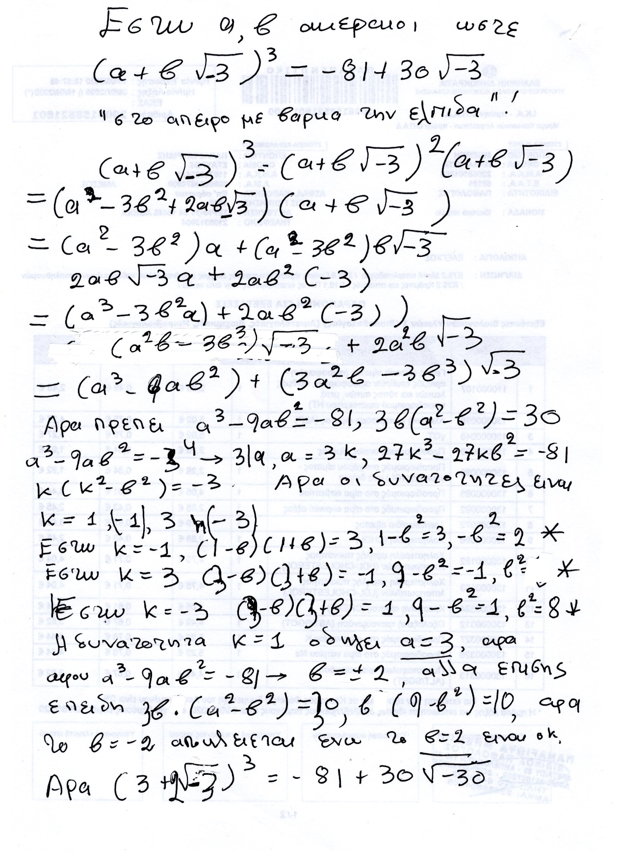

Τα παραπανω λιγο-πολύ με poly δισταγμο ηταν το στυλ του BOMBELLI (όχι του CARDANO)

Παρεμφερει υπολογισμους κανει και ο ΚΑΤΖ p. 406.

### ΚΑΠΟΙΑ ΣΧΟΛΙΑ,

Κατωτερω παραθετουμε, ποιοι είναι οι τυποι του CARDANO, poy briskontai kai parapano.

Βλ. SGP3kai4bathm σελ. 85, στον ΥΠΟΦΑΚΕΛΟ ΒΙΒΛΙΟΓΡΑΦΙΑ του φακελου ΕΓΓΡΑΦΑ. Εκει υπαρχουν ολες οι αποδειξεις.

H arxikh ejisvsh einai

x3 +px + q=0

Κατωτερω καταγραφουμε τα αποτελεσματα.

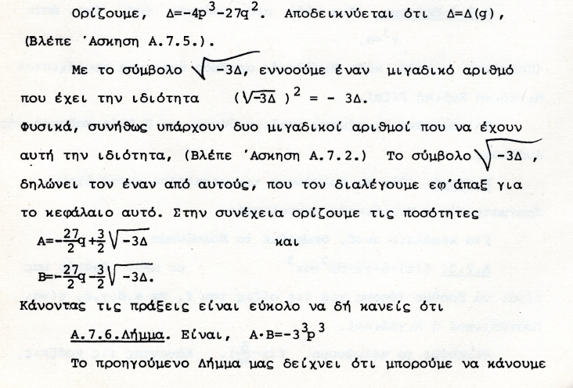

Το Δ λεγεται **ΔΙΑΚΡΙΝΟΥΣΑ (DISCRIMINANT),** .

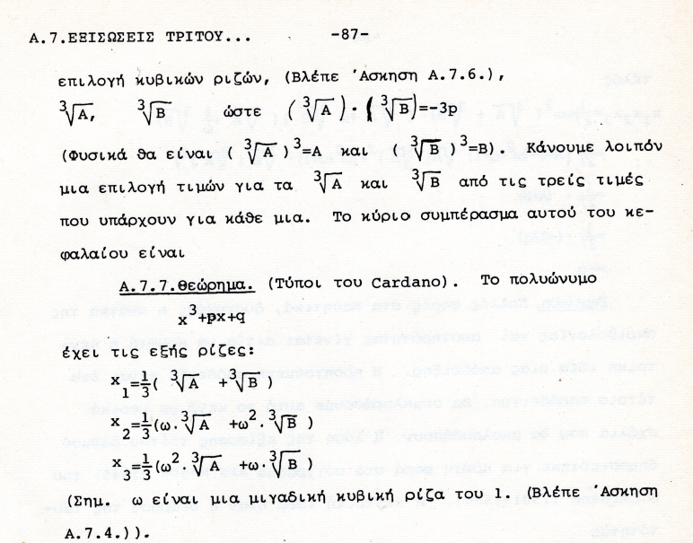

ΠΡΟΤΑΣΗ.

Α) αν Δ>0, τοτε οι τρεις ως ανω ριζες είναι ΠΡΑΓΜΑΤΙΚΕΣ !

Β) αν Δ<0, τοτε οι τρεις ως ριζες είναι ΜΙΑ ΠΡΑΓΜΑΤΙΚΗ και οι δυο ΜΙΓΑΔΙΚΕΣ συζυγεις,

#### casus irreducibilis,

##### ΕΡΩΤΗΜΑ.

Αν εξισωση 3ου βαθμου εχει 3 ριζες πραγματικες, είναι δυνατον να υπαρξουν τυποι που να δινουν τις 3 ριζες με πραξεις που εχουν ΜΟΝΟΝ τα συμβολα +, επι, δια, ριζικα. ?

<https://en.wikipedia.org/wiki/Pierre_Wantzel>,

Wantzel was also the first person who proved, in 1843,[6] that when a cubic polynomial with rational coefficients has three **real roots but it is irreducible in Q[x]** (the so-called casus (περιπτωση) irreducibilis), then the roots cannot be expressed from the coefficients using real radicals alone (ΣΓΠ. i.e. radicals Επι πραγματικων αριθμων), that is, complex non-real numbers must be involved if one expresses the roots from the coefficients using radicals. This theorem would be rediscovered decades later by (and sometimes attributed to) Vincenzo Mollame and Otto Hölder.

##### ΣΥΓΚΡΙΣΗ με δευτεροβαθμιες.

Για να βρουμε τις 3 πραγματικες ριζες, εχουμε αναγκη την **υπαρξη ενοσ ευρυτερου σωματος περαν των πραγματικων.**

##### ΜΑΘΗΜΑΤΙΚΑ Γ΄ Τάξης Γενικού Λυκείου

Ομάδας Προσανατολισμού Θετικών Σπουδών

και Σπουδών Οικονομίας & Πληροφορικής

Β´ ΜΈΡΟΣ

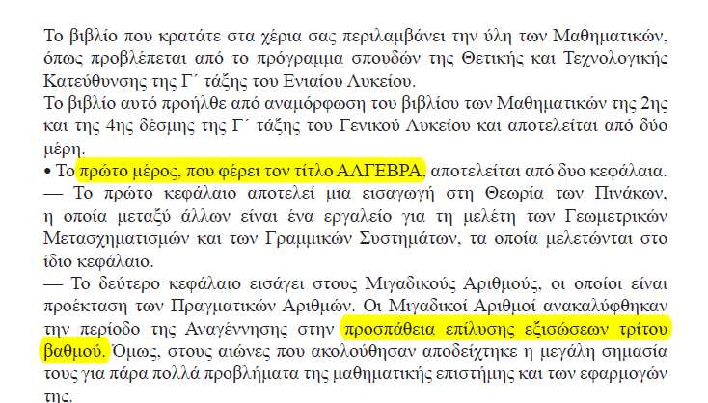

#### ΤΙ ΕΚΑΝΕ ΤΗΝ ΔΙΑΦΟΡΑ,

«περισσοτερη «αλγεβρικοτης»»

ΔΕΝ υπηρχε καποιο νέο εργαλειο. Πιο επιδεξια χρηση των παλαιων.

Oxi 2023

## ΣΥΜΠΛΗΞΡΩΜΑΤΑ,

### ΣΥΓΚΡΙΣΗ ΕΥΚΛΕΙΔΗ και ΚΑΡΔΑΝΟΥ,

ΓΕΩΜΕΤΡΙΑ και ΔΙΑΣΤΑΣΕΙΣ μεχρι 3 εναντι ΑΡΙΘΜΩΝ,

ΑΠΑΙΤΗΣΕΙΣ ΑΥΣΤΗΡΟΤΗΤΑΣ

ΚΑΝΟΝΑΣ και ΔΙΑΒΗΤΗΣ.

ΑΓΝΩΣΤΟΣ x, Praξeis metajy ekfraseωn poy τον περιεχουν.

ΠΡΩΤΗ ΠΑΡΑΤΗΡΗΣΗ, x = 2a3

x3 +px +q =0

(s+t)3 -3st(s+t) –(s3 +t3) =0

Αν βρω s, t τετοια ωστε

-3st=p και –(s3 +t3)=q,

tote EXΩ την λυση x=s+t !!!

Για τον ΕΥΚΛΕΙΔΗ υποθετουμε ότι το p δηλωνει εμβαδο, και το q δηλωνει ογκο, και το ζητουμενο x είναι ευθυγραμμο τμημα.

ΟΜΩΣ, τοτε τα s, t, ικανοποιουν

st=-p/3 και s3 +t3 =-q, η

s3t3=-(p/3)3 και s3 +t3 =-q,

Τι σημανει, (κατά τον ΕΥΚΛΕΙΔΗ),

s3t3=-(p/3)3

οπου τα s, t είναι μηκη ?

ΔΙΑΦΟΡΑ

σχετικα με την συζητηση με το ειδος των <<εξισωσεων>> που

λυνονται στα Στοιχεια

Περιεχονται στις προτασεις VI, 27, 28, 29. Υπαρχει περιορισμος για να

υπαρχει λυση , και δινει μονον την μια ριζα! Στην 30 λυνει με <<εξισωση>>

το μεσο και ακρο λογο!

### TARTAGLIA NICCOLO,

Kk TARTAGLIA NICOLO,

#### WIKIPEDIA

<https://en.wikipedia.org/wiki/Niccol%C3%B2_Fontana_Tartaglia#cite_ref-5>,

#### TARTAGLIA (ALSO TARTALEA OR TARTALIA). NICCOLO,

<https://www.encyclopedia.com/science/dictionaries-thesauruses-pictures-and-press-releases/tartaglia-also-tartalea-or-tartaia-niccolo>,

Tartaglia’s father, Michele, a postal courier, died about 1506, leaving his widow and children in poverty. Six years later, during the sack of Brescia, Niccolò, while taking shelter in the cathedral, received five serious head wounds. It was only through the loving care of his mother that he recovered. At the age of about fourteen, he went to a Master Francesco to learn to write the alphabet; but by the time he reached “k,” he was no longer able to pay the teacher. “From that day,” he later wrote in a moving autobiographical sketch, “I never returned to a tutor, but continued to labor by myself over the works of dead men, accompanied only by the daughter of poverty that is called industry” (Quesiti, bk. VI , question 8).

Apo wiki, Masotti, Arnoldo, Niccolò Tartaglia in the Dictionary of Scientific Biography.

#### <https://en.wikipedia.org/wiki/Cubic_function>,

In 1530, [Niccolò Tartaglia](https://en.wikipedia.org/wiki/Niccol%C3%B2_Tartaglia) (1500–1557) received two problems in cubic equations from [Zuanne da Coi](https://en.wikipedia.org/w/index.php?title=Zuanne_da_Coi&action=edit&redlink=1) and announced that he could solve them. He was soon challenged by Fiore, which led to a famous contest between the two. Each contestant had to put up a certain amount of money and to propose a number of problems for his rival to solve. Whoever solved more problems within 30 days would get all the money. Tartaglia received questions in the form *x*3 + *mx* = *n*, for which he had worked out a general method. Fiore received questions in the form *x*3 + *mx*2 = *n*, which proved to be too difficult for him to solve, and Tartaglia won the contest.

#### McTutor,

<https://mathshistory.st-andrews.ac.uk/Biographies/Tartaglia/>,

# ΟΙ ΜΙΓΑΔΙΚΟΙ, ΑΛΓΕΒΡΙΚΟΣ ΣΥΜΒΟΛΙΣΜΟΣ,

## RAFAEL BOMBELLI BIO,

### <https://mathshistory.st-andrews.ac.uk/Biographies/Bombelli/>,

MacTutor logo MacTutor

Rafael Bombelli

Born January 1526, Bologna, Papal States (now Italy)

Died 1572, (probably) Rome, Papal States (now Italy)

Summary

Rafael Bombelli was an Italian mathematician who wrote an influential algebra text and made free use of both negative numbers and complex numbers.

Biography

**Rafael Bombelli**'s father was **Antonio Mazzoli** but he changed his name from **Mazzoli to Bombelli**. It is perhaps worth giving a little family background. The Bentivoglio family ruled over Bologna from 1443. **Sante Bentivoglio** was "signore" (meaning lord) of Bologna from 1443 and he was succeeded by Giovanni II Bentivoglio who improved the city of Bologna, in particular developing its waterways. **The Mazzoli family were supporters of the Bentivoglio family but their fortunes changed when Pope Julius II took control of Bologna in 1506, driving the Bentivoglio family into exile**. An attempt to regain control in 1508 was defeated and Antonio Mazzoli's grandfather, like several other supporters of the failed Bentivoglio coup, were executed. The Mazzoli family suffered for many years by having their property confiscated, but the property was returned to Antonio Mazzoli, Rafael Bombelli's father. Antonio Mazzoli was able to return to live in Bologna. There he carried on his trade as **a wool merchant and married Diamante Scudieri, a tailor's daughter.** Rafael Bombelli was their eldest son, and he was one of a family of six children. Rafael **received no university education**. He was taught by an engineer- architect **Pier Francesco Clementi** so it is perhaps not too surprising that Bombelli himself should turn to that occupation. **Bombelli found himself a patron in Alessandro Rufini who was a Roman noble**, later to become the Bishop of Melfi.

It is unclear exactly how Bombelli learnt of the leading mathematical works of the day, but of course he lived in the right part of Italy to be involved in the major events surrounding the solution of [cubic](https://mathshistory.st-andrews.ac.uk/Glossary/#cubic_equation) and [quartic equations](https://mathshistory.st-andrews.ac.uk/Glossary/#quartic_equation). [Scipione del Ferro](https://mathshistory.st-andrews.ac.uk/Biographies/Ferro/), the first to solve the cubic equation was the professor at Bologna, Bombelli's home town, but del [Ferro](https://mathshistory.st-andrews.ac.uk/Biographies/Ferro/) died the year that Bombelli was born. The contest between Fior and [Tartaglia](https://mathshistory.st-andrews.ac.uk/Biographies/Tartaglia/) (see [Tartaglia](https://mathshistory.st-andrews.ac.uk/Biographies/Tartaglia/)'s biography) took place in 1535 when Bombelli was nine years old, and [Cardan](https://mathshistory.st-andrews.ac.uk/Biographies/Cardan/)'s major work on the topic *Ars Magna* Ⓣ was published in 1545. **Clearly Bombelli had studied** [**Cardan**](https://mathshistory.st-andrews.ac.uk/Biographies/Cardan/)**'s work and he** also followed closely the very public arguments between [Cardan](https://mathshistory.st-andrews.ac.uk/Biographies/Cardan/), [Ferrari](https://mathshistory.st-andrews.ac.uk/Biographies/Ferrari/) and [Tartaglia](https://mathshistory.st-andrews.ac.uk/Biographies/Tartaglia/) which culminated in the contest between [Ferrari](https://mathshistory.st-andrews.ac.uk/Biographies/Ferrari/) and [Tartaglia](https://mathshistory.st-andrews.ac.uk/Biographies/Tartaglia/) in Milan in 1548 (see [Ferrari](https://mathshistory.st-andrews.ac.uk/Biographies/Ferrari/)'s biography for details).

From about 1548 Pier Francesco Clementi, Bombelli's teacher, worked for the Apostolic Camera, a specialised department of the papacy in Rome set up to deal with legal and financial matters. The Apostolic Camera employed Clementi to reclaim marshes near Foligno on the Topino River, southeast of Perugia in central Italy. This region had became part of the Papal States in 1439. It is probable that Bombelli assisted his teacher Clementi with this project, but we have no direct evidence that this was the case. We certainly know that around 1549 Bombelli became interested in another reclamation project in a neighbouring region.

It was in 1549 that Alessandro Rufini, Bombelli's patron, acquired the rights to reclaim that part of the marshes of the

**Val di Chiana** which belonged to the Papal States. The Val di Chiana is a fairly central region in the Tuscan Apennines which was not well drained either by the Arno river which runs north west going through Florence and Pisa to the sea, or by the Tiber which runs south through Rome. By 1551 Bombelli was in the Val di Chiana recording the boundaries to the land that was to be reclaimed. **He worked on this project until 1555 when there was an interruption to the reclamation work.**

**While Bombelli was waiting for the Val di Chiana project to recommence, he decided to write an algebra book**. He had felt that the reason for the many arguments between leading mathematicians was the **lack of a careful exposition of the subject.** Only [Cardan](https://mathshistory.st-andrews.ac.uk/Biographies/Cardan/) had, in Bombelli's opinion, explored the topic in depth and his great masterpiece was not accessible to people without a thorough grasp of mathematics. Bombelli felt that a self-contained text which could be read by those without a high level of mathematical training would be beneficial. He wrote in the preface of his book [[2](https://mathshistory.st-andrews.ac.uk/Biographies/Bombelli/#reference-2)] (see also [[3](https://mathshistory.st-andrews.ac.uk/Biographies/Bombelli/#reference-3)]):-

I began by reviewing the majority of those authors who have written on [algebra] up to the present, in order to be able to serve instead of them on the matter, since there are a great many of them.

By 1557, the work at Val di Chiana still being suspended, Bombelli had begun writing his algebra text. We will study in detail the contents of the work below. Suffice to say for the **moment that, in 1560 when work at Val di Chiana recommenced, Bombelli had not completed his algebra book**.

Work at the Val di Chiana marshes could not have been far from completion when it had been suspended, for it was completed before the end of 1560. The scheme was a great success and through the project Bombelli gained a high reputation as an hydraulic engineer. In 1561 Bombelli went to Rome but **failed in an attempt to repair the Santa Maria bridge** over the Tiber. However, with reputation still high, Bombelli was taken on as a consultant for a project to drain the Pontine Marshes. These marshes in the Lazio region of south-central Italy had been an area where malaria had been a health hazard since the period of the Roman Republic. Several emperors and popes made unsuccessful attempts to reclaim the area but all, including the one which Bombelli acted as consultant on for Pope Pius IV, came to nothing. [It was not until 1928 that the Pontine Marshes were finally drained.]

On one of Bombelli's visits to Rome he made an exciting mathematical discovery. Antonio Maria Pazzi, who taught mathematics at the University of Rome, showed Bombelli a manuscript of [Diophantus](https://mathshistory.st-andrews.ac.uk/Biographies/Diophantus/)'s *Arithmetica* and, after Bombelli had examined it, the two men decided to make a translation. Bombelli wrote in [[2](https://mathshistory.st-andrews.ac.uk/Biographies/Bombelli/#reference-2)] (see also [[3](https://mathshistory.st-andrews.ac.uk/Biographies/Bombelli/#reference-3)]):-

... [we], **in order to enrich the world with a work so finely made, decided to translate it and we have translated five of the books (there being seven in all); the remainder we were not able to finish because of pressure of work on one or other.**

Despite never completing the task, Bombelli began to revise his algebra text in the light of what he had discovered in [Diophantus](https://mathshistory.st-andrews.ac.uk/Biographies/Diophantus/). In particular, 143 of the 272 problems which Bombelli gives in Book III are taken from [Diophantus](https://mathshistory.st-andrews.ac.uk/Biographies/Diophantus/). Bombelli does not identify which problems are his own and which are due to [Diophantus](https://mathshistory.st-andrews.ac.uk/Biographies/Diophantus/), but he does give full credit to [Diophantus](https://mathshistory.st-andrews.ac.uk/Biographies/Diophantus/) acknowledging that he has borrowed many of the problems given in his text from the *Arithmetica*.

Bombelli's *Algebra* was intended to be in five books. The first three were published in 1572 and at the end of the third book he wrote that [[1](https://mathshistory.st-andrews.ac.uk/Biographies/Bombelli/#reference-1)]:-

... the geometrical part, **Books IV and V**, is not yet ready for the publisher, but its publication will follow shortly.

Unfortunately Bombelli **was never able to complete these last two volumes for he died shortly after the publication of the first three volumes.** In 1923, however, Bombelli's manuscript was discovered in a library in Bologna by Bortolotti. As well as a manuscript version of the three published books, there was the unfinished manuscript of the other two books. Bortolotti published the incomplete geometrical part of Bombelli's work in 1929. Some results from Bombelli's incomplete Book IV are also described in [[17](https://mathshistory.st-andrews.ac.uk/Biographies/Bombelli/#reference-17)] where author remarks that Bombelli's methods are related to the geometrical procedures of [Omar Khayyam](https://mathshistory.st-andrews.ac.uk/Biographies/Khayyam/).