108 ΜΑ, ΔΕΥΤΕΡΑ, 22-05-2023,

108BombelliAlgebraMigadikoiDynaneis,

Webex meeting recording: 108 MONDAY INM-20230522 0915-1

Password: Dxumuy73

Recording link: <https://uoa.webex.com/uoa/ldr.php?RCID=f0988ef90c1555aee319f4b8b17cf174>,

**ΠΡΟΚΑΤΑΡΚΤΙΚΑ,**

Αλλαγη μαθηματος 29-05-2023,

Ανεβηκαν στα ΕΓΓΡΑΦΑ/ΒΙΒΛΙΟΓΡΑΦΙΑ :

MathhmatikaCLykeiouBMMigadikoiAnalysh.pdf

EukleideiaGeometriaA_LykBM

EukleideiaGeometriaB_LykBM.pdf

MathBLykeiouBMAnalytGeom.pdf,

Την ΤΕΤΑΡΤΗ να δουμε ΑΝΑΛΥΤΙΚΗ

Συντομη επαναληψη του 107 μα,

## Bombelli's *Algebra*

### ΜΙΓΑΔΙΚΟΙ,

#### (-)(-)= +

<https://mathshistory.st-andrews.ac.uk/Biographies/Bombelli/>,

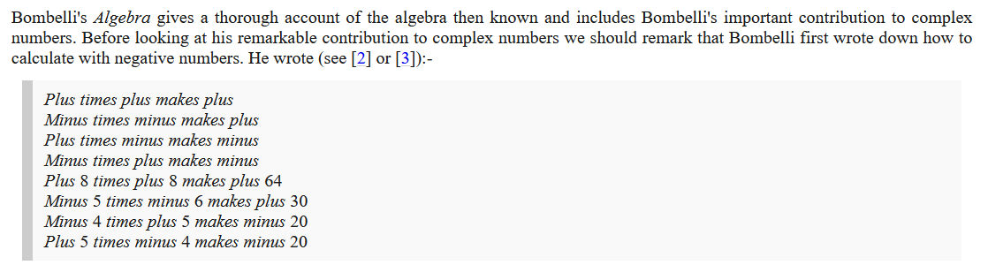

SGP. “first in Europe”. Η πρωτη εμφανιση των κανονων οφειλεται στον Brahmagupta (c. 598 – c. 668 CE) to 628.

#### ΠΡΑΞΕΙΣ ΜΙΓΑΔΙΚΩΝ,

<https://mathshistory.st-andrews.ac.uk/Biographies/Bombelli/>,

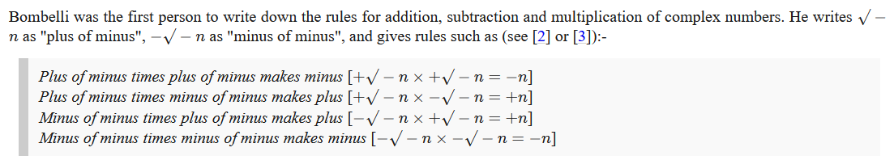

Θα μπορουσε να το δει κανεις:

ixi=-1, ix(-i)=1, (-i)x(i)=1, (-i)(-i)=-1

Bombelli, himself, did not find working with complex numbers easy at first, writing in [[2](https://mathshistory.st-andrews.ac.uk/Biographies/Bombelli/#reference-2)] (see also [[3](https://mathshistory.st-andrews.ac.uk/Biographies/Bombelli/#reference-3)]):-

«And although to many this will appear an extravagant thing, **because even I held this opinion some time ago,** since it **appeared to me more sophistic than true**, nevertheless **I searched hard and found the demonstration**, which will be noted below. ... But let the reader apply all his strength of mind, for [otherwise] even he will find himself deceived.»

##### “I searched hard and found the demonstration”,

Όχι, δεν την βρηκε ακριβως, καλα-καλα ουτε τον ορισμο ηξερε.

###### Christiaan Huygens,

**WIKIPEDIA,** Christiaan Huygens, Lord of Zeelhem, FRS (/ˈhaɪɡənz/ HY-gənz,[4] US: /ˈhɔɪɡənz/ HOY-gənz,[5] Dutch: [ˈkrɪstijaːn ˈɦœyɣə(n)s] (listen); also spelled Huyghens; Latin: Hugenius; 14 April 1629 – 8 July 1695) was a Dutch mathematician, physicist, engineer, astronomer, and inventor who is regarded as a key figure in the Scientific Revolution.[6][7] In physics, Huygens made seminal contributions to optics and mechanics, while as an astronomer he studied the rings of Saturn and discovered its largest moon, Titan. As an engineer and inventor, he improved the design of telescopes and invented the pendulum clock, the most accurate timekeeper for almost 300 years. A talented mathematician and physicist, his works contain the first idealization of a physical problem by a set of mathematical parameters,[8] and the first mathematical and mechanistic explanation of an unobservable physical phenomenon.[9]

In order to achieve the confidence of the experts it **is not of great interest**

whether we give an absolute demonstration or such a foundation of it that

after having seen it they do not doubt that a perfect demonstration can be given.

**I am willing to concede that it should appear in a clear, elegant,**

**and ingenious fonn, as in all works of Archimedes**. But the first and most

important thing is the **mode of discovery itself,** which men of learning

delight in knowing. Hence it seems that we must above all follow that

**method by which this can be understood and presented most concisely** (free from all elaboration and superfluous detail. a concise report. a concise definition. concisely adverb.), **and clearly.**

We then save ourselves the labor of writing, and others that

of reading-those others who have no time to take notice of the enonnous

quantity of **geometrical** inventions which increase from day to day and in

this learned century seem to grow beyond bounds if they must use the

**prolix** (using more words than necessary to express thought) and perfect method of the Ancients. (Struik [II], p. 189).

##### SOPHIST, sophisticated, etc

###### Sophisticated,

having, revealing, or involving a great deal of worldly experience and knowledge of fashion and culture.

###### Sophistry

the use of clever but false arguments, especially with the intention of deceiving.

###### SOPHIST,

WIKIPEDIA, A sophist (Greek: σοφιστής, romanized: sophistes) was a teacher in ancient Greece in the fifth and fourth centuries BC. Sophists specialized in one or more subject areas, such as philosophy, rhetoric, music, athletics, and mathematics. They taught arete – "virtue" or "excellence" – predominantly to young statesmen and nobility.

In the present day, however, a sophist refers to someone who deliberately argues using fallacious arguments or reasoning, in order to mislead; see the section § Modern usage below.

Π.χ. ΠΡΩΤΑΓΟΡΑΣ, (όχι ΚΡΙΤΙΑΣ που ηταν εις των 30 τυρανων). ),

WIKIPEDIA, Protagoras

Article

Talk

Read

Edit

View history

Tools

From Wikipedia, the free encyclopedia

For other uses, see Protagoras (disambiguation).

Not to be confused with Pythagoras.

Protagoras

Salvator Rosa - Démocrite et Protagoras.jpg

Democritus (center) and Protagoras (right)

17th-century painting by Salvator Rosa

in Hermitage Museum

Born c. 490 BC[1][2]

Abdera

Died c. 420 BC (aged c. 70)[2]

Era Pre-Socratic philosophy

Region Western philosophy

School Sophistic movement

Main interests

language, semantics, relativism, rhetoric, agnosticism, ethics

Notable ideas

'Sophist' as teacher for hire, man–measure doctrine ('Man is the measure of all things')

Influences

Influenced

Protagoras (/prəʊˈtæɡəˌræs/; Greek: Πρωταγόρας; c. 490 BC – c. 420 BC)[1] was a pre-Socratic Greek philosopher and rhetorical theorist. He is numbered as one of the sophists by Plato. **In his dialogue Protagoras**, Plato credits him with inventing the role of the professional sophist.

Protagoras also is believed to have created a major controversy during ancient times through his statement that, "**Man is the measure of all things**," interpreted (possibly wrongly, since he disagreed) by **Plato to mean that there is no objective truth;** Protagoras seems to have meant that each person's own personal history, experiences and expectations, developed over their lifetime, determine their judgments, opinions, and statements regarding "truth" (which is the title of the book in which Protagoras made this statement). When a person makes a judgment about a certain thing—good or bad or beautiful or unjust—that person will differ from other people's judgments because their experience has been different.[3]

##### KATZ p. 405,

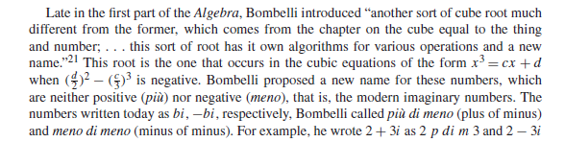

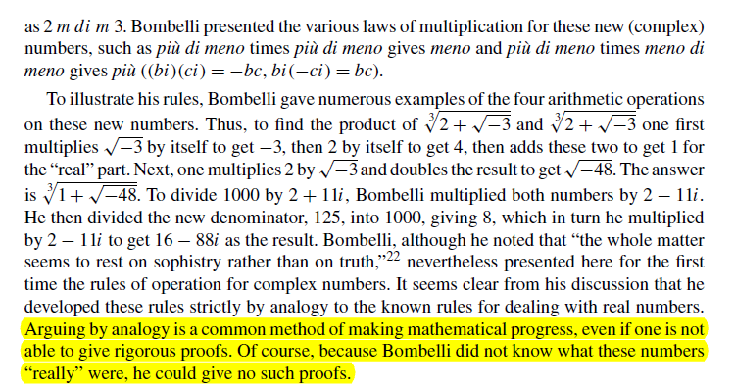

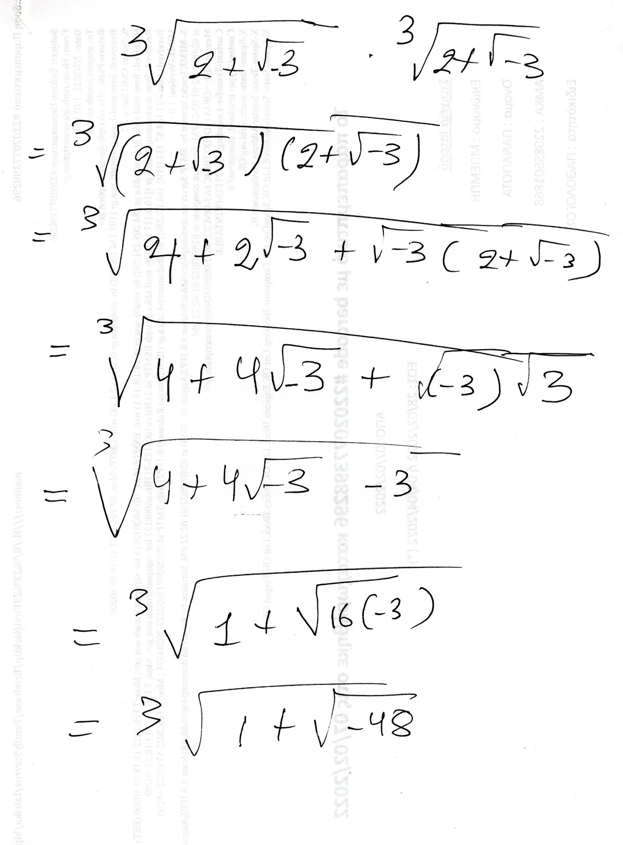

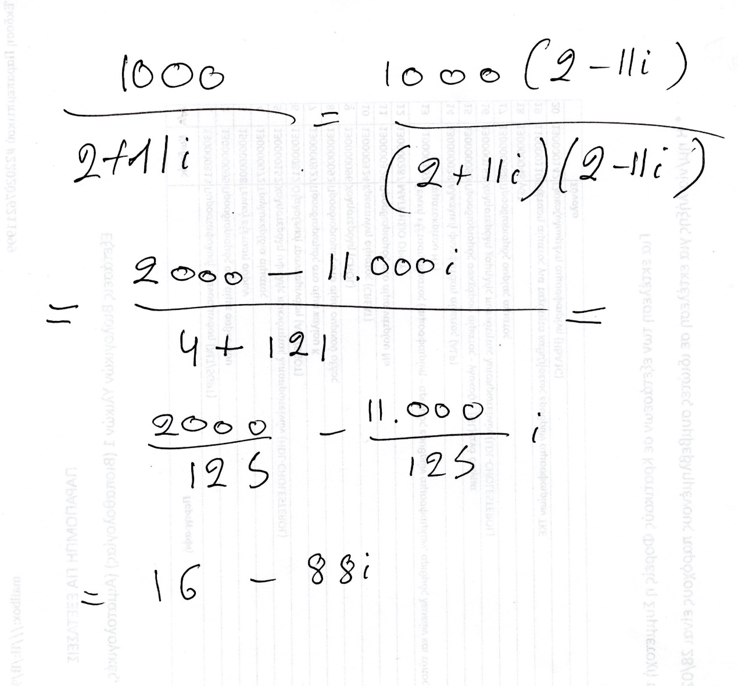

###### Πολλαπλασιασμος ριζικων εχει προβλημα

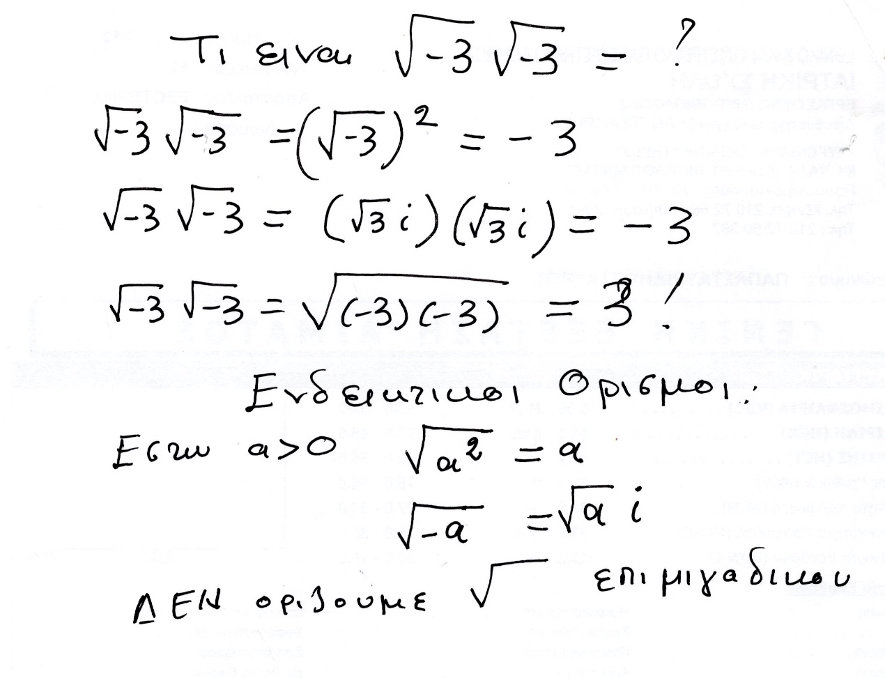

### ΣΥΜΒΟΛΑ,

#### ΠΑΛΑΙΟΤΕΡΗ ΓΡΑΦΗ ΔΥΝΑΜΕΩΝ,

KatzHistoryOfMathematics3rdS, 12.1.1. p.386

Algebraic Symbolism and Techniques (ΑΝΑΓΕΝΝHΣΗ),

**Algebraic Symbolism and Techniques**

Recall that Islamic algebra was entirely rhetorical. There were no symbols for the unknown or

its powers nor for the operations performed on these quantities. **Everything was written out in words**.

The same was generally true in the works of the early abacists and in the earlier Italian work of **Leonardo of Pisa (Fibonacci**)..

Early in the fifteenth century, however, some of the abacists (Arabic numerals), began to substitute abbreviations for unknowns. For example, in place of the standard words ***cosa* (thing),** *censo* (square, απογραφη), *cubo* (cube), and *radice* (root), some authors used the abbreviations *c*, *ce*, *cu*, and *R*. Combinations of these abbreviations were used for higher powers.

Thus,

***ce di ce* or *ce ce* stood for *censo di censo* or fourth power (*x*2*x*2);**

***ce cu* or *cu ce***, designating ***censo di cubo* and *cubo di censo*, respectively, ce di cu stood for fifth power (*x*2*x*3);** And

***cu cu*, designating *cubo di cubo*, stood for sixth power (*x*3*x*3**).

**Η επαναληψη δηλωνε γινομενο**.

By the **end of the fifteenth century, however**, the naming scheme for higher powers had changed, and authors used

***ce cu***or ***censo di cubo* to designate the sixth power (*(x*3*)*2)** and ***cu cu* or *cubo di cubo***to represent the ninth power

(*(x*3*)*3).

**Η επαναληψη δηλωνε «δυναμη εις την δυναμη»**.

The fifth power was then designated as *p.r.* or *primo relato* and the seventh power as *s.r.* or *secondo relato*..

RELATO, σχετιζομενος, συγγενης,

***Coss*** was simply the German form of

the Italian **cosa,** or thing, the name usually given to the unknown in an algebraic equation.

Two of the most important **Cossists** in the first half of the sixteenth century were Christoff

Rudolff (sixteenth century) and Michael Stifel (1487–1567).

**Piu, πλεον,**

The most important (and obvious) meaning of più is as an adjective meaning “more”

**Più bella cosa**, (πιο όμορφο πράγμα), Eros Ramazzotti

“to pio ομορφο plasma”

<https://lyricstranslate.com/el/piu-bella-cosa-pio-omorfo-pragma.html>,

**Meno, less,**

SGP, koinonikh adraneia,

#### MCTUTOR

