109 ΜΑ, τεταρτη, 24-05-2023,

109109Ergas204142NeaAlgebra.docx

Webex meeting recording: 109 WEDNESDAY INM-20230524 0910-1

Password: nMDEfm7Y

Recording link: <https://uoa.webex.com/uoa/ldr.php?RCID=7d5cb99e26b15d565eb27a1f0c95b226>,

ΠΡΟΚΑΤΑΡΚΤΙΚΑ,

Θα λυσουμε ΕΡΓΑΣΙΕΣ 29, 41, 42,

Σε ένα σημειο παμε σε ΑΝΑΛΥΤΙΚΗ ΓΕΩΜΕΤΡΙΑ,

#### KATZ p. 405

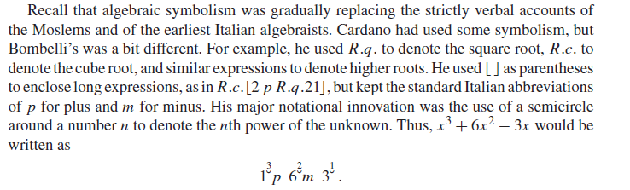

#### ΕΡΩΤΗΜΑ: ΠΟΙΑ η ΑΞΙΑ του ΑΝΩΤΕΡΩ.

Ax xAy =Ax+y , (Ax )y =Ax y,

### ΣΥΜΠΛΗΡΩΜΑΤΑ,

#### Wikipedia,

Bombelli's Algebra Algebra, 1572

In the book that was published in 1572, entitled Algebra, Bombelli gave a comprehensive account of the algebra known at the time. He was the first **European to write down the way of performing computations with negative numbers**. The following is an excerpt from the text:

"Plus times plus makes plus

Minus times minus makes plus

Plus times minus makes minus

Minus times plus makes minus

Plus 8 times plus 8 makes plus 64

Minus 5 times minus 6 makes plus 30

Minus 4 times plus 5 makes minus 20

Plus 5 times minus 4 makes minus 20"

As was intended, Bombelli used simple language as can be seen above so that anybody could understand it. But at the same time, he was thorough.

### REFERENCES,

<https://web.archive.org/web/20031119121820/http://www.gavagai.de/philosoph/HHP78.htm>,

<https://fermatslasttheorem.blogspot.com/2006/11/rafael-bombelli.html>,

<https://www.wikiwand.com/en/Rafael_Bombelli>,

<https://mathshistory.st-andrews.ac.uk/Extras/Bombelli_algebra/>,

# ΝΕΑ ALGEBRA του 16ου αιωνα,

## Η ΑΛΓΕΒΡΑ ΤΟΥ ΓΥΜΝΑΣΙΟΥ σημερα,

Κάθε ΜΕΓΕΘΟΣ μπορει να χαρακτηρισθει με συμβολα x, y, a, b, c, …που δηλωνουν αριθμους

Μπορουμε να γραφουμε ΕΚΦΡΑΣΕΙΣ a+x, ax, xa, a(b+c), (ab)c, a(bc), klp . **ΔΕΝ δινουμε αναγκαστικα ερμηνεια.**

ΙΣΧΥΕΙ ax=xa, a(b+c)=ab+ac, (ab)c= a(bc), κλπ,

(δηλαδη ισχυουν τα αξιωματα του ΔΑΚΤΥΛΙΟΥ, η μπορουμε τα πουμε ισχυουν οι «νομοι» των πραξεων). (Σημερα κωδικοποιουνται με τα αξιωματα ΔΑΚΤΥΛΙΟΥ).

Εχουμε πολλες ΜΕΤΑΒΛΗΤΕΣ και ΠΑΡΑΜΕΤΡΟΥΣ,

KATZ,

p. 407 Vi`ete, Algebraic Symbolism, and Analysis .

*The Analytic Art,* KATZ, p. 408, 12.4.1 Fran¸cois Vi`ete and The Analytic Art

Endiaferoyses parathrhseis

## FRANCOIS VIETE, VIETE FRANCOIS, BIO,

### WIKIPEDIA

<https://en.wikipedia.org/wiki/Fran%C3%A7ois_Vi%C3%A8te>,

François Viète

François Viète, Seigneur (αφέντης ουσ αρσ, άρχοντας ουσ αρσ), de la Bigotière (Latin: Franciscus Vieta; 1540 – 23 February 1603), commonly known by his mononym, Vieta, was a French mathematician whose work on new algebra was **an important step towards modern algebra**, due to its **innovative use of letters as parameters in equations**. He was a lawyer by trade, and served as a **privy councillor** to both Henry III and Henry IV of France.

Biography

#### Early life and education

Viète was born at Fontenay-le-Comte in present-day Vendée. His grandfather was a merchant from La Rochelle. His father, Etienne Viète, **was an attorney in Fontenay-le-Comte and a notary in Le Busseau**. His mother was the aunt of Barnabé Brisson, a magistrate and the first president of parliament during the ascendancy of the **Catholic League of France**.

Viète went to a **Franciscan school** and in 1558 studied law at Poitiers, graduating as a **Bachelor of Laws in 1559.** A year later, he began his career as an attorney in his native town.[3] From the outset, he was entrusted with some major cases, including the settlement of rent in Poitou for the widow of King Francis I of France and looking after the interests of Mary, Queen of Scots.

#### Serving Parthenay

In 1564, Viète entered the service of Antoinette d’Aubeterre, Lady Soubise, wife of **Jean V de Parthenay-Soubise**, one of the **main Huguenot military leaders** and accompanied him to Lyon to collect documents about his heroic defence of that city against the troops of Jacques of Savoy, 2nd Duke of Nemours just the year before.

The same year, at Parc-Soubise, in the commune of Mouchamps in present-day Vendée, Viète became the tutor of **Catherine de Parthenay,** Soubise's twelve-year-old daughter. He taught her science and mathematics and wrote for her numerous treatises on astronomy and trigonometry, some of which have survived. In these treatises, **Viète used decimal numbers (twenty years before Stevin's paper) and he also noted the elliptic orbit of the planets,[4] forty years before Kepler and twenty years before Giordano Bruno's death**.

John V de Parthenay presented him to King Charles IX of France. Viète wrote a genealogy of the Parthenay family and following the death of Jean V de Parthenay-Soubise in 1566 his biography.

In 1568, Antoinette, Lady Soubise, married her daughter Catherine to **Baron Charles de Quellenec** and Viète went with Lady Soubise to La Rochelle, where he mixed with the highest Calvinist aristocracy, leaders like Coligny and Condé and Queen Jeanne d’Albret of Navarre and her son, Henry of Navarre, the future Henry IV of France.

In 1570, he refused to represent the Soubise ladies in their infamous lawsuit against **the Baron De Quellenec, where they claimed the Baron was unable (or unwilling) to provide** an heir.

#### First steps in Paris

In 1571, he enrolled as an attorney in Paris, and continued to **visit his student Catherine**. He regularly lived in Fontenay-le-Comte, where he took on some municipal functions. He began publishing his Universalium inspectionum ad Canonem mathematicum liber singularis and **wrote new mathematical research by night or during periods of leisure**. He was known to dwell on any one question for up to three days, his elbow on the desk, feeding himself without changing position (according to his friend, Jacques de Thou).[5]

**In 1572, Viète was in Paris during the St. Bartholomew's Day** massacre. That night, Baron De Quellenec was killed after having tried to save Admiral Coligny the previous night. The same year, Viète met Françoise de Rohan, Lady of Garnache, **and became her adviser against Jacques, Duke of Nemours**.

In 1573, he became a councillor of the Parliament of Brittany, at Rennes, and two years later, he obtained the agreement of Antoinette d'Aubeterre for **the marriage of Catherine of Parthenay to Duke René de Rohan, Françoise's brother**.

In 1576, **Henri, duc de Rohan** took him under his special protection, recommending him in 1580 as "maître des requêtes" (ΕΦΕΤΕΙΟΝ). . In 1579, Viète finished the printing of his Universalium inspectionum (Mettayer publisher), published as an appendix to a book of two trigonometric tables (Canon mathematicus, seu ad triangula, the "canon" referred to by the title of his Universalium inspectionum, and Canonion triangulorum laterum rationalium). A year later, he was appointed maître des requêtes to the parliament of Paris, committed to serving the king. **That same year, his success in the trial between the Duke of Nemours and Françoise de Rohan, to the benefit of the latter, earned him the resentment of the tenacious Catholic League.**

**Catholic League**

ΓΟΟΓΛΕ. Holy League, French **La Sainte Ligue**, association of Roman Catholics during the French Wars of Religion of the late 16th century; it was first organized in 1576 under the leadership of Henri I de Lorraine, 3e duc de Guise, to oppose concessions granted to the Protestants (Huguenots) by King Henry III.

#### Exile in Fontenay

**Between 1583 and 1585, the League persuaded Henry III to release Viète, Viète having been accused of sympathy with the Protestant cause.** Henry of Navarre, at Rohan's instigation, addressed two letters to King Henry III of France on March 3 and April 26, 1585, in an attempt to obtain Viète's restoration to his former office, but he failed.[3]

Viète retired to Fontenay and Beauvoir-sur-Mer, with François de Rohan. He spent four years devoted to mathematics, writing his New Algebra (1591).

#### Code-breaker to two kings

In 1589, Henry III took refuge in Blois. He commanded the royal officials to be at Tours before 15 April 1589. Viète was one of the first who came back to Tours. He **deciphered the secret letters of the Catholic League and other enemies of the king.** Later, he had arguments with the classical scholar [Joseph Juste Scaliger](https://en.wikipedia.org/wiki/Joseph_Juste_Scaliger). Viète triumphed against him in 1590.

After the death of Henry III, Viète became a privy councillor to Henry of Navarre, now Henry IV.[[6]](https://en.wikipedia.org/wiki/Fran%C3%A7ois_Vi%C3%A8te#cite_note-6): 75–77 He was appreciated by the king, who admired his mathematical talents. Viète was given the position of councillor of the *parlement* at [Tours](https://en.wikipedia.org/wiki/Tours). In 1590, Viète discovered the key to a [Spanish](https://en.wikipedia.org/wiki/Spanish_language) [cipher](https://en.wikipedia.org/wiki/Cipher), consisting of more than 500 characters, and this meant that all dispatches in that language which fell into the hands of the French could be easily read.[[7]](https://en.wikipedia.org/wiki/Fran%C3%A7ois_Vi%C3%A8te#cite_note-FOOTNOTECantor191158-7)

Henry IV published a letter from Commander Moreo to the King of Spain. The contents of this letter, read by Viète, revealed that the head of the League in France, [Charles, Duke of Mayenne](https://en.wikipedia.org/wiki/Charles,_Duke_of_Mayenne), planned to become king in place of Henry IV. This publication led to the settlement of the [Wars of Religion](https://en.wikipedia.org/wiki/French_Wars_of_Religion). **The King of Spain accused Viète of having used magical powers.** In 1593, Viète published his arguments against Scaliger. **Beginning in 1594, he was appointed exclusively deciphering the enemy's secret codes**.

#### Work and thought

Ενδιαφερον κειμενο, όχι πολλεσ αναφορεσ,

<https://mathshistory.st-andrews.ac.uk/Biographies/Viete/>,

H L L Busard, Biography in Dictionary of Scientific Biography (New York 1970-1990).

<https://www.encyclopedia.com/people/science-and-technology/mathematics-biographies/francois-viete>,

Viète himself, published his answer to Roomen's problem in 1595, stating in the introduction [1]:-

I, who do not profess to be a mathematician, but who, **whenever there is leisure, delight in mathematical studies** ...

###### Viète's symbolic algebra

Firstly, Viète gave algebra a foundation as strong as that of geometry. He then ended the **algebra of procedures** (al-Jabr and al-Muqabala), creating the **first symbolic algebra,** and claiming that with it, all problems could be solved (nullum non problema solvere).[12][13]

In his dedication of the Isagoge to Catherine de Parthenay, Viète wrote:

"These things which are new are wont in the beginning to be set forth rudely and formlessly and must then be polished and perfected in succeeding centuries. Behold, the art which I present is new, but in truth so old, so spoiled and defiled by the **barbarians**, that I considered it necessary, in order to introduce an entirely new form into it, to think out and publish a new vocabulary, having gotten rid of all its pseudo-technical terms..."[14]

#### Adriaan van Roomen's problem

xxxxxxxx

#### Religious and political beliefs

Viète was accused of Protestantism by the Catholic League, but he was not a Huguenot**. His father was,** according **to Dhombres.[**19] Indifferent in religious matters, he did not adopt the Calvinist faith of Parthenay, nor that of his other protectors, the Rohan family. His call to the parliament of Rennes proved the opposite. **At the reception as a member of the court of Brittany, on 6 April 1574, he read in public a statement of Catholic faith**.[19]

Nevertheless, **Viète defended and protected Protestants his whole life**, and suffered, in turn, the wrath of the League. It seems that for him**, the stability of the state was to be preserved** and that under this requirement, the King's religion did not matter. At that time, such people were called "Politicals."

**Furthermore, at his death, he did not want to confess his sins**. A friend had to convince him that **his own daughter would not find a husband,** were he to refuse the sacraments of the Catholic Church. Whether Viète was an atheist or not is a matter of debate.[19]

## The Analytic Art,

The Analytic Art

Nine Studies in Algebra, Geometry

and Trigonometry from the Opus Restitutae (ανακαινισμένο)

Mathematicae Analyseos, seu (τα δικα σου), Algebra Nova

Francois Viete

Translatedby

T. Richard Witmer

Dover Publications Inc.

Mineola,

### ANALYSIS SYNTHESIS,

Viete Francois, trns WITMER, The Analytic Art, p. 11,

There is a certain way of searching for the truth in mathematics that

**Plato is said first to have discovered**. **Theon called it analysis**, which he

defined as assuming that which is sought as if it were admitted [and

working] through the consequences [of that assumption] to what is

admittedly true, as opposed to synthesis, which is assuming what is

[already] admitted [and working] through the consequences [of that

assumption] to arrive at and to understand that which is sought.2

Although the ancients propounded only [two kinds of]

SELECTIONS ILLUSTRATING THE HISTORY OF GREEK MATHEMATICS WITH AN ENGLISH TRANSLATION BY

IVOR THOMAS

FORMERLY SCHOLAR OF ST. JOHN'S AND Sf.NIOR DEMY OF MAGDALEN COLLEGE, OXFORD

IN TWO VOLUMES II FROM ARISTARCHUS TO PAPPUS

VOL. p. 596.

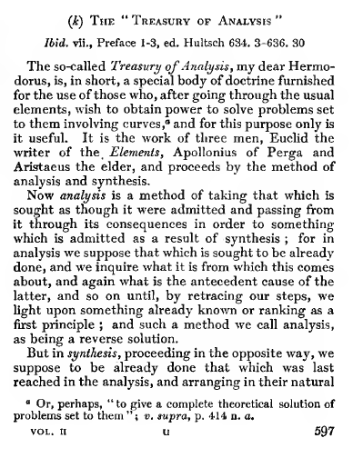

### ΣΥΜΒΟΛΑ του VIETE,

KATZ p. 410

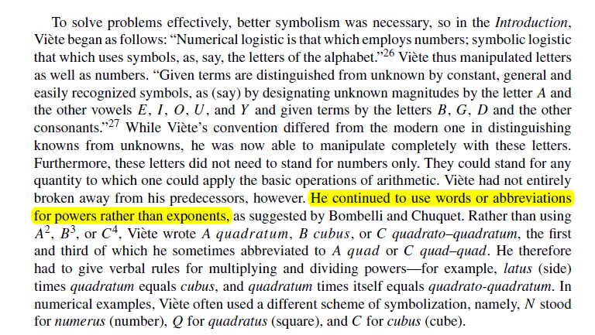

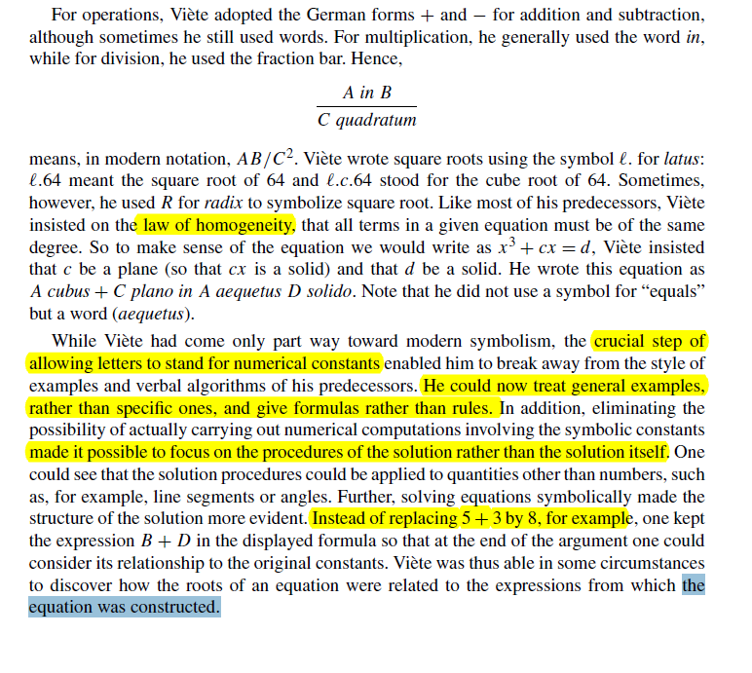

### ΤΑΥΤΟΤΗΤΕΣ,

KATZ, p.411,

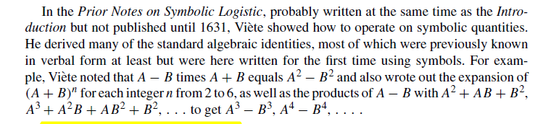

### VIETE s FORMULAE, ΤΥΠΟΙ ΤΟΥ VIETE,

KATZ, p. 414,

