**01 ΜΑΘΗΜΑ ΤΕΤΑΡΤΗ 14-02-2024,**

**ΩΡΕΣ ΜΑΘΗΜΑΤΟΣ, 2024,**

**ΤΕΤΑΡΤΗ 11.00-14.00, Σαβατο 12.00-13.00,**

**Στο WEBEX ζηταω, 10.00-15.00μμ, και 11.00-14.00 antistoixos,**

**ΤΕΤΑΡΤΗ, 11.00-14.00,**

**https://uoa.webex.com/uoa/j.php?MTID=maa67bbd45944ec818692492c15d85d45,**

**ΣΑΒΒΑΤΟ, 12.00-13.00,**

**https://uoa.webex.com/uoa/j.php?MTID=ma7845f8931bb6438227c75ffcc4d0fa4,**

**sto webex zhtao 11.00-14.00,**

**LINK RECORDING,**

**Webex meeting recording: 01 INM 2024 tetarth, 11.00-14.00-20240214 0920-1**

**Password: 2TyjB5FV**

**Recording link: https://uoa.webex.com/uoa/ldr.php?RCID=a8b088ce5b6a250daab54f3bc14c900f**

# ΧΡΗΣΙΜΕΣ ΠΛΗΡΟΦΟΡΙΕΣ ΓΙΑ ΤΟΥΣ ΦΟΙΤΗΤΕΣ/ΙΕΣ,

## ΕΠΙΚΟΙΝΩΝΙΑ

ΑΝΑΓΚΗ ΟΜΟΙΟΓΕΝΙΑΣ του ΟΛΟΥ ΜΑΘΗΜΑΤΟΣ

**ΣΤΟΙΧΕΙΑ ΚΑΘΗΓΗΤΟΥ,**

**ΣΤΑΥΡΟΣ Γ ΠΑΠΑΣΤΑΥΡΙΔΗΣ,** [**spapast@math.uoa.gr**](mailto:spapast@math.uoa.gr)**,**

**Σε τυχουσα επικοινωνια σας, παρακαλεισθε να συμπεριλαβετε και ένα κινητον.**

**~~ΠΑΡΑΚΑΛΟΥΝΤΑΙ ΟΣΟΙ~~** ~~επιθυμούν να παρακολουθήσουν το μάθημα, το~~ **~~ταχύτερο~~** ~~να στειλουν στην διεύθυνση~~ [**~~spapast@math.uoa.gr~~**](mailto:spapast@math.uoa.gr)**~~, :~~**

**~~ΟΝΟΜΑΤΕΠΩΝΥΜΟ, ΗΛΕΚΤΡΟΝΙΚΟ ΤΑΧΥΔΡΟΜΕΙΟ, ΚΙΝΗΤΟ ΤΗΛΕΦΩΝΟ, ΦΩΤΟΓΡΑΦΙΑ~~**~~. (Το αρχείο της φωτογραφίας να εχει σαν όνομα το όνομα του εικονιζομένου, π.χ. “παπασταυριδης σταυρος.jpg~~” ,

~~Παρακαλούνται να δηλώσουν αν είναι «ΕΛΕΥΘΕΡΟΙ ΑΚΡΟΑΤΕΣ» η ΦΟΙΤΗΤΕΣ του ΜΤΠΧ~~.

**ΠΑΡΑΚΑΛΟΥΝΤΑΙ ΟΣΟΙ** επιθυμούν να παρακολουθήσουν το μάθημα ΙΝΜ~~,~~

Να εγγραφουν και να παρακολουθουν την eclass του μαθήματος ΙΝΜ,

<http://eclass.uoa.gr/>, **το ταχύτερο δυνατόν** .

Ιδιαιτερα συνισταται να παρακολουθουν τον φακελλο

[Αρχικός κατάλογος](https://eclass.uoa.gr/modules/document/index.php?course=MATH417&openDir=/) >

Εγγραφα>2023-24, Bibliografia, Ανακοινώσεις, Εργασιες,

ΠΡΟΣ ΩΡΑΣ, το μαθημα είναι ανοικτό με εγγραφή Ελεύθερη Πρόσβαση (με εγγραφή) σε **όσους διαθέτουν λογαριασμό στην πλατφόρμα**

Σε χρονο που θα ανακοινωθει, Πρόσβαση στο μάθημα έχουν μόνο όσοι βρίσκονται Εγγεγραμμενοι στο μαθημα,

#### ΚΑΤ ΕΥΘΕΙΑΝ ΜΕΤΑΒΑΣΗΣ σε eclass ΧΩΡΙΣ ΕΓΓΡΑΦΗ,

<http://eclass.uoa.gr/courses/MATH417/>, η

GOOGLE eclas uoa ιστορια νεωτερων μαθηματικων> η-Τάξη ΕΚΠΑ | ΙΣΤΟΡΙΑ ΝΕΩΤΕΡΩΝ ΜΑΘΗΜΑΤΙΚΩΝ

ΔΙΑΔΙΚΑΣΙΑ ΜΕΤΑΒΑΣΗ σε eclass.

GOOGLE>eclass, uoa >η-Τάξη ΕΚΠΑ (<http://eclass.uoa.gr/>), >ΚΑΤΑΛΟΓΟΣ ΜΑΘΗΜΑΤΩΝ (αριστερη στηλη))> ΜΑΘΗΜΑΤΙΚΩΝ>Σχολή - Τμήμα: ΕΚΠΑ » Μαθηματικών » Μεταπτυχιακό πρόγραμμα σπουδών > Μάθημα (Κωδικός) ΙΣΤΟΡΙΑ ΝΕΩΤΕΡΩΝ ΜΑΘΗΜΑΤΙΚΩΝ (Δ15. ΙΣΤΟΡΙΑ ΤΩΝ ΝΕΩ)

## ΩΡΕΣ ΤΟΥ ΜΑΘΗΜΑΤΟΣ, ΙΔΡΥΜΑΤΙΚΟΙ ΛΟΓΑΡΙΑΣΜΟΙ, eclass, κλπ

ΤΕΤΑΡΤΗ 11.00-14.00,

ΣΑΒΒΑΤΟΝ, 12.00-13.00,

**ΠΑΡΑΚΑΛΕΙΣΘΕ όπως η προσελευση στο εξ αποστασεως μαθημα να γινεται μεσω ΙΔΡΥΜΑΤΙΚΩΝ ΛΟΓΑΡΙΑΣΜΩΝ**. ?

## ΔΙΑΔΙΚΑΣΙΑ ΑΞΙΟΛΟΓΗΣΗΣ του ΦΟΙΤΗΤΗ,

Κατ αρχας, στο ΜΤΠΧ ΔΙΔΑΚΤΙΚΗΣ απαιτειται παρουσια, ιδιαιτερα στην ΙΝΜ η παρουσια γινεται μεσω WEBEX, (πλην εξαιρεσεων).

Περαιρερω η συνολική αξιολόγηση του φοιτητή βασίζεται σε τρία πυλώνες:

**ΔΡΑΣΤΗΡΙΟΤΗΤΑ ΣΤΗΝ ΤΑΞΗ, ΕΡΓΑΣΙΕΣ, ΤΕΛΙΚΗ ΕΞΕΤΑΣΗ**. .

### ΕΡΓΑΣΙΕΣ,

Κατά καιρούς θα αποστέλλονται στους φοιτητές του μαθήματος “ΕΡΓΑΣΙΕΣ” προς λύση-απαντηση.

Το αρχείο με τις ΕΡΓΑΣΙΕΣ θα είναι αρχείο .doc (η ενιοτε .pdf κλπ στην eclass, στο Εργαλειο ΕΡΓΑΣΙΕΣ. .

Το αρχείο θα έχει όνομα π.χ. 1004TritoBathm.docx ~~η xTritoBathm.jpg~~, η ~~xTritoBathm.pdf~~ κλπ οπου x θα είναι αύξων αριθμός.

Οι φοιτητές αναμένεται στην αναγραφόμενη προθεσμία να ανεβασουν την λύση στο εργαλειο ΕΡΓΑΣΙΕΣ ως αρχείο π.χ. **1004ΟνομαΦοιτητηTritoBathm.docx**.

Προσοχή να αναγραφεί το όνομα του φοιτητή ~~και να τηρείται η προθεσμία~~.

Η λύση του ΕΡΓΑΣΙΕΣ θα πρέπει να περιέχει και την εκφώνηση.

ΠΑΡΑΔΕΙΓΜΑ.

1009TeleutaiaSynenteukshTouEinstein, 1009MitropoulosTeleutaiaSynenteukshTouEinstein,

### ΔΡΑΣΤΗΡΙΟΤΗΤΑ ΣΤΗΝ ΤΑΞΗ.

Συμμετοχη στην συζητηση, κλπ

ΠΑΡΑΔΕΙΓΜΑ. ΟΙ ΟΡΟΙ του ανωτερω ΤΙΤΛΟΥ

### ΕΞΕΤΑΣΙΣ ΕΙΣ ΤΟ ΤΕΛΟΣ του ΕΞΑΜΗΝΟΥ.

Με ΦΥΣΙΚΗ ΠΑΡΟΥΣΙΑ.

### ΕΥΚΟΛΟ η ΔΥΣΚΟΛΟ ΜΑΘΗΜΑ, ?

ΣΤΟΧΟΣ, η Αληθεια.

### ΣΥΜΒΟΥΛΕΣ ΠΡΟΣ ΤΟΥΣ ΦΟΙΤΗΤΕΣ,

ΔΙΑΦΟΡΑ ΑΠΟ ΠΡΟΠΤΥΧΙΑΚΑ,

ΔΕΝ ΤΑ ΑΦΗΝΟΥΜΕ ΟΛΑ … για τις ΕΞΕΤΑΣΕΙΣ,

e.g. κ. ΔΕΣΠΟΙΝΑ ΒΑΝΔΗ,

ΑΓΓΛΙΚΑ,

ΣΥΜΒΟΥΛΕΣ από παλαιοτερουσς φοιτητες,

## ΔΙΔΑΚΤΙΚΑ ΒΟΗΘΗΜΑΤΑ

### Victor J. Katz. A History of MATHEMATICS, An Introduction, 3th Edition.

Copyright © 2009 by Pearson Education, Inc.

Συντομογραφια KATZ.

Victor J Katz, A History of Mathematics (3rd Edition) Hardcover]

Product Details

Hardcover: 992 pages

Publisher: Pearson; 3 edition (July 12, 2008)

Language: English

ISBN-10: 0321387007

ISBN-13: 978-0321387004

Product Dimensions: 8.2 x 1.5 x 9.4 inches

Shipping Weight: 3.9 pounds (View shipping rates and policies)

Average Customer Review: 4.2 out of 5 stars See all reviews (4 customer reviews)

Amazon Best Sellers Rank: #62,474 in Books (See Top 100 in Books)

Buy New, $120.97 & FREE Shipping. Details

ΕΛΛΗΝΙΚΗ ΜΕΤΑΦΡΑΣΗ

KATZ J. VICTOR ΙΣΤΟΡΙΑ ΤΩΝ ΜΑΘΗΜΑΤΙΚΩΝ

ΠΑΝΕΠΙΣΤΗΜΙΑΚΕΣ ΕΚΔΟΣΕΙΣ ΚΡΗΤΗΣ,

Μετάφραση: Κώστας Χατζηκυριάκου

Επιμέλεια: Γιάννης Χριστιανίδης

ISBN-13: 978-960-524-334-0

Κωδικός στον Εύδοξο: 12388495

Χαρακτηριστικά: 21 x 29 εκ., 1016 σελ., σκληρόδετο

Έτος έκδοσης: 2013

Τρέχουσα έκδοση: 2013

Τίτλος πρωτοτύπου: "A History of Mathematics. An introduction", Addison-Wesley Longman Inc., 2nd edition, 1998

Λιανική τιμή: €60,00

Έκπτωση: 10%

Τιμή αγοράς: €54,00

????ΚΑΤΕΒΑΙΝΕΙ από DOS BOOKS,

#### Cover photo ΚΑΤΖ, :

Tycho Brahe and Others with Astronomical Instruments, 1587, “Le Quadrant Mural”

1663. **Blaeu, Joan** (1596–1673 Dutch). Newberry Library, Chicago, Illinois, USA © Newberry

Library/SuperStock. Many of the designations us

MURAL= τοιχογραφια, mur (French)=τοιχος,

What is fresco mean in art?

A fresco is a type of wall painting. The term comes from the Italian word for fresh because plaster is applied to the walls while still wet. There are two methods of carrying out fresco painting: buon fresco and fresco a secco.

Tycho Brahe And Others With Astronomical Instruments, 1587. "Le Quadran Mural" 1663 Blaeu, Joan(1596-1673 Dutch) Newberry Library, Chicago, Illinois, USA

<https://www.superstock.com/asset/tycho-brahe-others-astronomical-instruments-le-quadran-mural-blaeu-joan/1095-418>,

Joan Blaeu (Dutch pronunciation: [ˈjoːɑn ˈblʌu]; 23 September 1596 – 21 December 1673; also called Johannes Blaeu) was a Dutch cartographer born in Alkmaar, the son of cartographer Willem Blaeu.

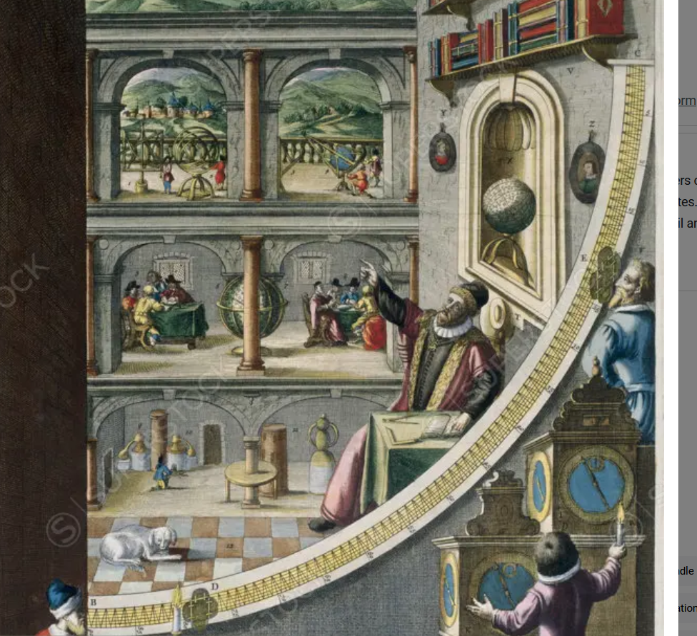

Superstock offers millions of photos, videos, and stock assets to creatives around the world. This image of Tycho Brahe And Others With Astronomical Instruments, 1587. "Le Quadran Mural" 1663 Blaeu, Joan(1596-1673 Dutch) Newberry Library, Chicago, Illinois, USA by Newberry Library is available for licensing today.

#### The Quadrant, ΤΕΤΑΡΤΗΜΟΡΙΟ,

<https://www.cartahistorica.com/our-catalogue/curiosities/quadrant/>,

The quadrant would have already been described by **Claudius Ptolemeus**. It is a navigation tool in the form of a wooden or bronze quarter of a circle. There were multiple types of quadrants. They helped to calculate a celestial body position, to determine the time and to record the latitude. In the thirteenth century it was rewritten by John the Sacrobosco in Paris and Jacob ben Machir ibn Tibbon (also called Profatius) in Montpellier. The disadvantage of the quadrant is its instability in case of a moving ship, so the use of this instrument at sea was not so practical. The bigger the instrument, the more accurate its calculations will be. The illustrated apparatus has been built by Brahe in 1588, and measured 194 cm

Original title: Quadrans Magnus Chalibeus in quadrato etiam comprehensus, unaque Azimuthalis

### C. Henry Edwards Jr. The Historical Development of the Calculus

1979 by Springer-Verlag New York, Inc.

Συντομογραφια EDWARDS. Professor Emeritus, Years at UGA: 1963-1999,

### Joshua Cole and Carol Symes. Western civilizations : their history & their culture / Joshua Cole and Carol Symes. —18th edition.

W. W. Norton & Company, Inc., 500 Fifth Avenue, New York, N. Y. 10110

wwnorton.com

Συντομογραφια ColeSymes.

#### The School of Athens, (Italian: Scuola di Atene),

<https://en.wikipedia.org/wiki/The_School_of_Athens>,

Joshua Cole and Carol Symes. Western civilizations : their history & their culture, p.iii, πρωτο εσωτερικο εξωφυλλο

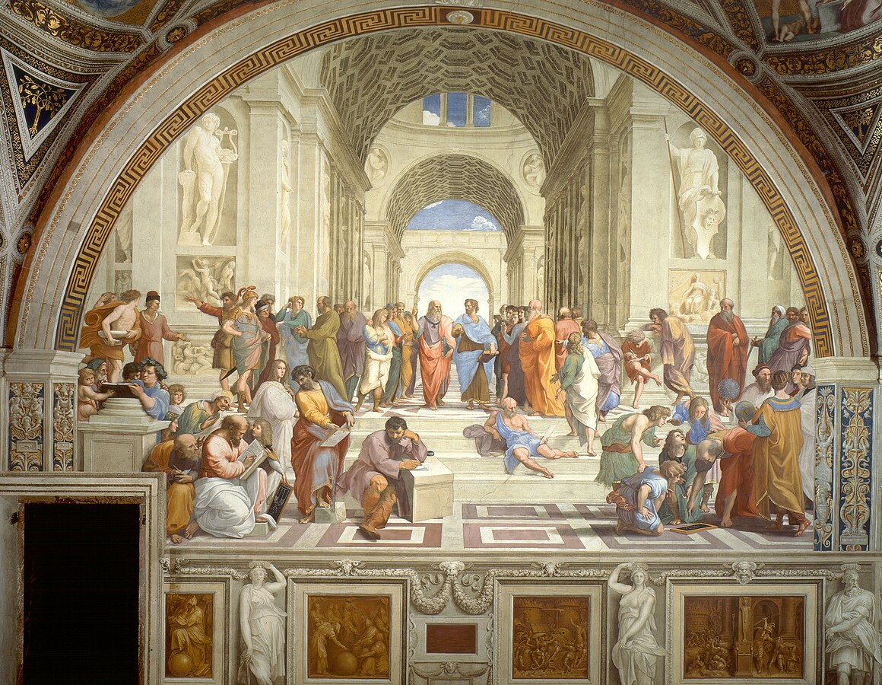

Artist Raphael SANTI,

Year 1509–1511

Type Fresco

Dimensions 500 cm × 770 cm (200 in × 300 in)

Location Apostolic Palace, Vatican City

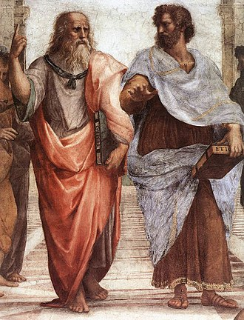

An elder Plato walks alongside a younger Aristotle.

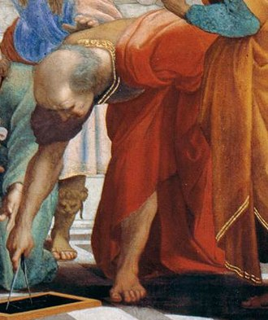

? Bramante as Euclid

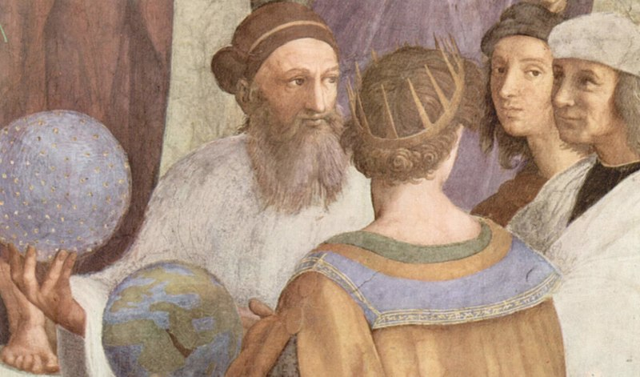

Zoroaster, Ptolemy, **Raphael** as Apelles and Perugino and Raphael !, Il Sodoma or Timoteo Viti as Protogenes

Zoroaster,

<https://en.wikipedia.org/wiki/Zoroaster>,

Zoroaster,[a] also known as Zarathustra,[b] was a religious reformer and the spiritual founder of Zoroastrianism. He founded the first documented monotheistic religion in the world and also had an impact on Plato, Pythagoras, and the **Abrahamic religions**, including Judaism, Christianity, and Islam.[9][10][11] …

Date

There is no consensus on the dating of Zoroaster. The Avesta gives no direct information about it, while historical sources are conflicting. Some scholars base their date reconstruction on the Proto-Indo-Iranian language and Proto-Indo-Iranian religion, while others use internal evidence.[14] **While many scholars today consider a date around 1000 BC to be the most likely,[7][8] others still consider a range of dates between 1500 and 500 BC to be possible**.[2][3][4][5][6]

##### Πτολεμαιοσ, Ptolemy, Claudius Ptolemy Claudius Ptolemaeus,

<https://en.wikipedia.org/wiki/Ptolemy>,

Claudius Ptolemy (/ˈtɒləmi/; Greek: Πτολεμαιοσ, Ptolemaios; Latin: Claudius Ptolemaeus; c. 100 – c. 170 AD)[1] was an Alexandrian mathematician, astronomer, astrologer, geographer, and music theorist,[2] who wrote about a dozen scientific treatises, three of which were of importance to later Byzantine, Islamic, and Western European science. The first is the astronomical treatise now known as the **Almagest,** although it was originally entitled the **Mathēmatikē Syntaxis** or Mathematical Treatise, and later known as The Greatest Treatise. The second is the Geography, which is a thorough discussion on maps and the geographic knowledge of the Greco-Roman world. The third is the astrological treatise in which he attempted to adapt horoscopic astrology to the Aristotelian natural philosophy of his day. This is sometimes known as the **Apotelesmatika** (lit. "On the Effects") but more commonly known as the Tetrábiblos, from the Koine Greek meaning "Four Books", or by its Latin equivalent Quadripartite.

Unlike most Greek mathematicians, Ptolemy's writings (foremost the Almagest) never ceased to be copied or commented upon, both in Late Antiquity and in the Middle Ages.[3] **However, it is likely that only a few truly mastered the mathematics necessary to understand his works,** as evidenced particularly by the many abridged **and watered-down** introductions to Ptolemy's astronomy that **were popular among the Arabs and Byzantines.**[4][5]

##### Perspective: Central Vanishing Point

<https://en.wikipedia.org/wiki/Vanishing_point>,

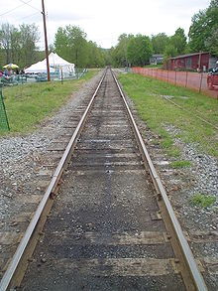

A photo demonstrating a vanishing point at the end of the railroad.

<https://en.wikipedia.org/wiki/Vanishing_point>,

###### Raphael: The School of Athens, 1509. Perspective: Central Vanishing Point

<https://gogeometry.com/geometric_art/school_athens_perspective.html>,

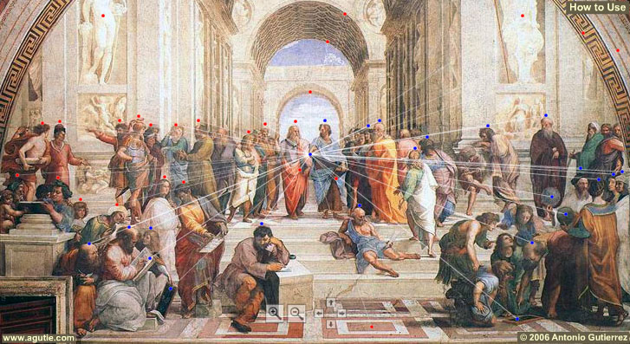

###### Leon Battista Alberti, Euclid,

**Perspective: Central Vanishing Point**

<https://en.wikipedia.org/wiki/Vanishing_point>,

italian humanist polymath and architect Leon Battista Alberti **first introduced the concept in his treatise on perspective in art, (**De picture), written in 1435.[2]

SGP, no mention of EUCLID

**Leon Battista Alberti**

<https://en.wikipedia.org/wiki/Leon_Battista_Alberti>,

no mention of EUCLID,

EUCLID, OPTICS,

Leon Battista Alberti (Italian: [leˈom batˈtist‿alˈbɛrti]; 14 February 1404 – 25 April 1472) was an Italian Renaissance humanist author, artist, architect, poet, priest, linguist, philosopher, and cryptographer; he epitomised the nature of those identified now as polymaths. He is considered the founder of Western cryptography, a claim he shares with Johannes Trithemius.[1][2],

Leon Battista Alberti and Euclid

Albertiana, 9 (2008), 165-249

Branko Mitrovic

More Info: The paper co-authored with Paola Massalin. It presents an analysis and a transcription of Leon Battista Alberti's annotations on the manuscript of Euclid's Elements that belonged to him.

Publication Name: Albertiana, 9 (2008), 165-249

<https://www.academia.edu/4540841/Leon_Battista_Alberti_and_Euclid>,

Apart from Piero della Francesca, no artist viewed life more exhaustively in

mathematical terms than Leon Battista Alberti, for whom mathematics supplied a

certainty and contentment lacking in the arbitrary vexatiousness of human

affairs.2

**Elements and Optics (ΣΓΠ. ΣΤΟΙΧΕΙΑ και ΟΠΤΙΚΑ), (of EUCLID), contain all the mathematical knowledge necessary for the geometrical construction of perspective**.5

**Alberti’s Elementa picturæ in fact attempt to emulate Euclid’s writing.** His studies of Euclid are well documented: a manuscript copy of **Campanus of Novara**’s translation of Euclid’s Elements, **annotated by Alberti himself**, **is still preserved in the library of St. Mark in Venice.6** The Appendix of this paper presents transcription of these annotations by Paola Massalin. The intention of the article is to analyse their content in the context of contemporary debates about of art and architecture.

contentmen, a state of happiness and satisfaction.

vexatiousness, in a way that is annoying or difficult to deal with

**Branko Mitrovic** is a Serbian-Norwegian architectural historian and theorist who has backgrounds in both philosophy and architecture. Currently, he teaches history and theory of architecture at the Department of Architecture and Technology in the Norwegian University of Science and Technology. Wikipedia

PhD (Architecture) University of Pennsylvania, USA, 1996. Dissertation: Theory of Proportions in Daniele Barbaro's Commentary on Vitruvius' De architectura.

Catching the Light, Arthur Zajonc

Oxford University Press, 1995.

p. 25-26, .

The visual ray of Euclid is different in important ways, however,

from the luminous and ethereal emanation (εκπομπη) of Plato and

Empedocles. In Euclid’s hands, the eye’s fiery emanation has

become a straight line, a visual ray, susceptible to deductive

logic and geometric proof. His extensive mathematical studies

yielded many fruits and became the basis for later Arab investigations

and for laying the foundation for the discovery of linear

perspective by **Brunelleschi, Alberti, and Diirer centuries later**.

But mathematization came at a price. It distanced man from the

earlier and more immediate experience reflected in the Platonic

understanding of vision.

**The significance of mathematization should not be underestimated.**

**Without abstraction, science as we know it cannot exist.**

Yet in order to analyze one must stop experiencing and go on

to represent the object of study with thoughts of crystalline

clarity, for example, with mathematical concepts. Euclid did

just this. Plato’s somewhat elusive (difficult to find, catch, or achieve), immaterial bridge of light

between object and eye, became through Euclid a geometry of

visual rays, cones, and angular measurement. Everything

needed for the study of geometrical optics was developed, but

in the process one can detect an important distancing from the

subjective human experience of seeing. Euclid’s meticulous

mathematical style of argumentation has replaced the more poetic

treatment of Empedocles or Plato. As every physicist knows,

the elegant forms of mathematics can easily outshine the dull

stirrings of experience, and eventually come to replace the phenomena

they originally were invented to describe. Euclid’s handling

of light foreshadows the growing separation of sight as

lived experience from sight as a formal object of investigation.

The history of light has turned a comer, and with it the mystery

of sight entered a new phase, one that blossomed first in Arab

lands, to culminate finally in the work of another great geometer

and mathematician, Rene Descartes.