05 ΔΙΑΛΕΞΗ,

Δεν υπαρχει βιντεο,

**ΠΡΟΚΑΤΑΡΚΤΙΚΑ,**

Eric Temple Bell, Men of Mathematics,

Grattan-Guinness. Perhaps the **most widely read modern book on the history of mathematics**. **As it is also one of the worst, it can be said to have done a considerable disservice to the professio**n

Family (ΟΙΚΟΓΕΝΕΙΑ), Hominidae (ΑΝΘΡΩΠΙΔΑΙ η ΜΕΓΑΛΟΙ ΠΙΘΗΚΟΙ)

Π.χ. άνθρωπο, χιμπατζίδες, γορίλες και ουρακοτάγκους.

GENUS(ΓΕΝΟΣ), HOMO (ΑΝΘΡΩΠΟΣ

(SPECIES) ΕΙΔΗ

Homo Sapiens (ανθρωπος ο σοφος η ο εμφρων)

Ιt is likely that Homo sapiens (anatomically modern humans) has been the only extant species of genus Homo.

ΧΡΟΝΙΚΗ ΕΞΕΛΙΞΗ,

Αρχη του ΣΥΜΠΑΝΤΟΣ.

Προ c. 14 δις. ετη.

Δημιουργια ΓΗΣ.

c. 4.5 billions ετη.

Εμφανισης ΖΩΗΣ στην ΓΗ

Προ c. 4 δις. ετη.

ΓΕΝΟΣ ΑΝΘΡΩΠΟΣ,

Προ 1.7 millions ετη, στην ΑΦΡΙΚΗ.

HOMO SAPIENS,

**Homo sapiens,** οσον αφορα **σωματικα χαρακτηριστικα,**  **most likely** developed in the HORN of Africa **between 300,000 and 200,000 years ago,.**

HOMO SAPIENS, **Behavioral modernity**,

**Behavioral modernity**, involving the development of **language, figurative art (describes artwork particularly paintings and sculptures that is clearly derived from real object), and early forms of religion (etc.)** is taken to have arisen **before 40,000 years ago**,

### The Concept of CIVILIZATION,

ΣΓΠ. Προηγουνται, HUNTERS GATHERERS, (ΚΥΝΗΓΟΙ, Τροφοσυλεκτες),

#### Cole Symes p.4

Cities, however, became possible only as a result of innovations that began around the end of the last Ice Age, about 13,000 years ago, (**11,000 b.c.),** e.g. **settlement, agriculture**, . Whereas, e.g. writing, DIVISION OF LABOR, stratification, armies, etc came to fruition in Mesopotamia 8,000 years later (3,000 b.c.).

The history of civilization is therefore a short one. Within the study of humanity, which reaches back to **the genus Homo (ΑΝΘΡΩΠΟΣ), in Africa, some 1.7 million years** ago, it is merely a blip on the radar screen.

~~Homo is the~~ **~~genus that emerged in the genus Australopithecus~~** ~~that encompasses the extant species Homo sapiens, plus several extinct species classified as either ancestral to or closely related to modern humans, most notably H. erectus~~ **~~and H. neanderthalensis~~.**

**Even within the history of the species Homo sapiens, the subspecie (OR species), to which we all belong and which evolved about 40,000 years ago, civilization is a very recent development.**

(REMARK. ΠΟΛΙΤΙΣΜΟΣ.).

The study of early civilizations is both fascinating

and challenging. **Historians still do not understand why**

**the first-known cities should have developed in the region**

**between the Tigris and the Euphrates Rivers**, in what is

now Iraq. Once developed, however, the basic patterns of

urban life quickly spread to other parts of the Near East,

both **by imitation and by conquest.** A network of trading

connections linked these early cities, but intense competition

for resources made alliances among them fragile.

Then, **around the middle of the second millennium B.C.E.** (1000-2000 π.Χ.),

emerging powers began to

shape these **fiercely independent cities into empires**. How

this happened—and how we know that it happened—is

the subject of Chapter 1.

(REMARK SGP. Εξηγησεις για π.Χ., μ.Χ., B.C., A.D.,

(BCE means “Before the Common Era,” equivalent to the Christian dating

system B.C., “Before Christ”),

π.χ. παραδειγματος χαριν,

μ. Χ. μετα ΧΡΙΣΤΟΝ, . Προ Χριστου. AD Anno Domini,

**BCE, Before Common Era. CE Common Era, CE.)**

## Civilization, Wiki,

Καπως διαφορετικη οπτικη της εννοιας ΠΟΛΙΤΙΣΜΟΣ,

<https://en.wikipedia.org/wiki/Civilization#History>,

**A civilization or civilisation** (see English spelling differences) is any complex society characterized by **urban development**, **social stratification** imposed by a cultural (SGP, economic) elite, symbolic systems of communication (for example, **writing systems**), and a perceived **separation from and domination over the natural environment.**[1][2][3][4][5][6][7][8]

Civilizations are intimately associated with and often further defined by other socio-politico-economic characteristics, including centralization, the domestication of both humans and other organisms, specialization of labour, culturally ingrained ideologies of progress and supremacism, monumental architecture, taxation, societal dependence upon farming and expansionism.[2][3][4][6][7][8] Historically, civilization has often been understood as a larger and "more advanced" culture, in contrast to smaller, supposedly primitive cultures.[1][3][4][9] Similarly, some scholars have described civilization as being necessarily multicultural.[10] ~~In this broad sense, a civilization contrasts with non-centralized tribal societies, including the cultures of nomadic pastoralists, Neolithic societies or hunter-gatherers, but it also contrasts with the cultures found within civilizations themselves~~. As an uncountable noun, "civilization" also refers to the process of a society developing into a centralized, urbanized, stratified structure. Civilizations are organized in densely populated settlements divided into hierarchical social classes with a ruling elite and subordinate urban and rural populations, which engage in intensive agriculture, mining, small-scale manufacture and trade. Civilization concentrates power, extending human control over the rest of nature, including over other human beings.[11]

Civilization, as its etymology (below) suggests, is a concept originally linked to towns and cities. The earliest emergence of civilizations is generally associated with the final stages of the Neolithic Revolution, culminating in the relatively rapid process of urban revolution and state formation, a political development associated with the appearance of a governing elite.

### Neolithic Revolution, Agricultural Revolution,(ΑΓΡΟΤΙΚΗ ΕΠΑΝΑΣΤΑΣΗ),

[**https://en.wikipedia.org/wiki/Neolithic_Revolution#In_the_Fertile_Crescent**](https://en.wikipedia.org/wiki/Neolithic_Revolution#In_the_Fertile_Crescent),

Neolithic Revolution around 12,500 years ago (10.500 π.χ. )

The Neolithic Revolution, Neolithic Demographic Transition, Agricultural Revolution, or First Agricultural Revolution was the wide-scale transition of many human cultures during the Neolithic period from a lifestyle of Hunting and Gathering (ΚΥΝΗΓΟΙ ΚΑΙ ΤΡΟΦΟΣΥΛΛΕΚΤΕΣ), to **one of agriculture and settlement, making an increasingly larger population possible**.[1] These settled communities permitted humans to observe and experiment with plants to learn how they grew and developed.[2] This new knowledge led to the domestication of plants.[2][3]

Archaeological data indicates that the domestication of various types of plants and animals happened in separate locations worldwide, starting in the geological epoch of the Holocene[4]

**The Holocene is** (Ολόκαινος εποχή ) the current geological epoch. It began approximately 11,650 cal years Before Present ( c. 9701 BCE), after the Last Glacial Period, ...

**Neolithic Revolution around 12,500 years ago (10.500 π.χ. )**

.[5] It was the world's first historically verifiable revolution in agriculture. The Neolithic Revolution greatly narrowed the diversity of foods available, resulting in a downturn in the quality of human nutrition.[6]

The Neolithic Revolution involved far more than the adoption of a limited set of food-producing techniques. During the next millennia it would transform the small and mobile groups of hunter-gatherers that had hitherto dominated human pre-history into sedentary (non-nomadic) societies based in built-up villages and towns. These societies radically modified their natural environment by means of specialized food-crop cultivation, with activities such as irrigation and deforestation which allowed the production of surplus food. Other developments found very widely are the domestication of animals, pottery, polished stone tools, and rectangular houses.

These developments, sometimes called the **Neolithic package**, provided the basis for centralized administrations and political structures, hierarchical ideologies, depersonalized systems of knowledge (e.g. writing), densely populated settlements, specialization and division of labour, more trade, the development of non-portable art and architecture, and property ownership.

The relationship of the above-mentioned Neolithic characteristics to the onset of agriculture, their sequence of emergence, and empirical relation to each other at various Neolithic sites remains the subject of academic debate, and varies from place to place, rather than being the outcome of universal laws of social evolution.[8][9] The Levant saw the earliest developments of the Neolithic Revolution from around 10,000 BCE, followed by sites in the wider Fertile Crescent.

**The earliest known civilization developed in Sumer in southern Mesopotamia (c.** 6,500 before present**, η 4500 π.χ.); its emergence also heralded the beginning of the Bronze Age**.[7]

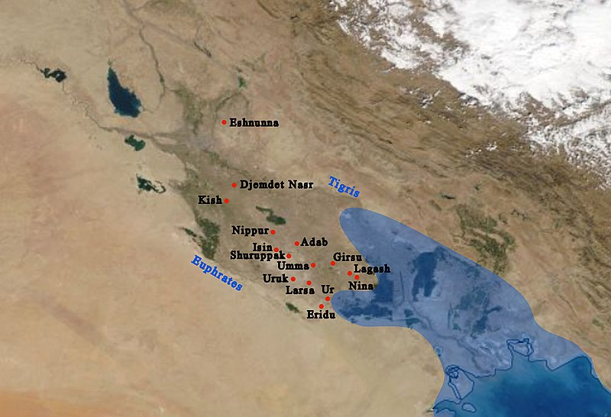

The general location on a modern map, and main cities of Sumer with ancient coastline. **The coastline nearly reached Ur in ancient times**.

A Sumerian harvester's sickle, dated to 3,000 BC

<https://en.m.wikipedia.org/wiki/File:ClaySumerianSickle.jpg>,

