06 ΔΙΑΛΕΞΗ,

09-03-2024, ΣΑΒΒΑΤΟΝ,

Στο βιντεο εκ λαθους αναφερεται 05 ΔΙΑΛΕΞΗ,

Webex meeting recording: 06 Dialeksis INM 2024, SATURDAY 12.00-13.00-20240309 1022-1

Password: cJhixKD6

Recording link: <https://uoa.webex.com/uoa/ldr.php?RCID=fae4f7ef1f0b45bfcbcae91d9eaee583>,

ΠΡΟΚΑΤΑΡΚΤΙΚΑ,

RECORDING,

ΟΝΟΜΑΤΕΠΩΝΥΜΟΝ, klp

ΦΩΤΟΓΡΑΦΙΑ,

2001_ΒΑΣΙΛΕΙΟΥ_ΑΝΤΩΝΙΑ_EureshPhlikouYpoloipou (2)

Να γινει 2001Basileiou_EureshPhlikouYpoloipou (2)

2001_MALAFEKAS_IWANNIS.rar

**ΠΟΛΙΤΙΣΜΟΣ,**

<https://en.wikipedia.org/wiki/Civilization#History>,

A civilization or civilisation (see English spelling differences) is any complex society characterized by urban development, social stratification imposed by a cultural (SGP, economic) elite, symbolic systems of communication (for example, writing systems), and a perceived separation from and domination over the natural environment.[1][2][3][4][5][6][7][8]

Civilizations are intimately associated with and often further defined by other socio-politico-economic characteristics, including centralization, the domestication of both humans and other organisms, specialization of labour, culturally ingrained ideologies of progress and supremacism, monumental architecture, taxation, societal dependence upon farming and expansionism.[2][3][4][6][7][8] Historically, civilization has often been understood as a larger and "more advanced" culture, in contrast to smaller, supposedly primitive cultures.[1][3][4][9] Similarly, some scholars have described civilization as being necessarily multicultural.[10] In this broad sense, a civilization contrasts with non-centralized tribal societies, including the cultures of nomadic pastoralists, Neolithic societies or hunter-gatherers, but it also contrasts with the cultures found within civilizations themselves. ~~As an uncountable noun, "civilization" also refers to the process of a society developing into a centralized, urbanized, stratified structure~~. Civilizations are organized in densely populated settlements divided into hierarchical social classes with a ruling elite and subordinate urban and rural populations, which engage in intensive agriculture, mining, small-scale manufacture and trade. Civilization concentrates power, extending human control over the rest of nature, including over other human beings.[11]

Civilization, as its etymology (below) suggests, is a concept originally linked to towns and cities. **The earliest emergence of civilizations is generally associated with the final stages of the Neolithic Revolution**, culminating in the relatively rapid process of urban revolution and state formation, a political development associated with the appearance of a governing elite.

<https://en.wikipedia.org/wiki/Civilization#History>,

**A civilization or civilisation** (see English spelling differences) is any complex society characterized by **urban development**, **social stratification** imposed by a cultural (SGP, economic) elite, symbolic systems of communication (for example, **writing systems**), and a perceived **separation from and domination over the natural environment.**[1][2][3][4][5][6][7][8]

Civilizations are intimately associated with and often further defined by other socio-politico-economic characteristics, including centralization, the domestication of both humans and other organisms, specialization of labour, culturally ingrained ideologies of progress and supremacism, monumental architecture, taxation, societal dependence upon farming and expansionism.[2][3][4][6][7][8] Historically, civilization has often been understood as a larger and "more advanced" culture, in contrast to smaller, supposedly primitive cultures.[1][3][4][9] Similarly, some scholars have described civilization as being necessarily multicultural.[10] ~~In this broad sense, a civilization contrasts with non-centralized tribal societies, including the cultures of nomadic pastoralists, Neolithic societies or hunter-gatherers, but it also contrasts with the cultures found within civilizations themselves~~. As an uncountable noun, "civilization" also refers to the process of a society developing into a centralized, urbanized, stratified structure. Civilizations are organized in densely populated settlements divided into hierarchical social classes with a ruling elite and subordinate urban and rural populations, which engage in intensive agriculture, mining, small-scale manufacture and trade. Civilization concentrates power, extending human control over the rest of nature, including over other human beings.[11]

Civilization, as its etymology (below) suggests, is a concept originally linked to towns and cities. The earliest emergence of civilizations is generally associated with the final stages of the Neolithic Revolution, culminating in the relatively rapid process of urban revolution and state formation, a political development associated with the appearance of a governing elite.

**The earliest known civilization developed in Sumer in southern Mesopotamia (c.** 6,500 before present**, η 4500 π.χ.); its emergence also heralded the beginning of the Bronze Age**.[7]

**Neolithic Revolution, Agricultural Revolution,(ΑΓΡΟΤΙΚΗ ΕΠΑΝΑΣΤΑΣΗ),**

[**https://en.wikipedia.org/wiki/Neolithic_Revolution#In_the_Fertile_Crescent**](https://en.wikipedia.org/wiki/Neolithic_Revolution#In_the_Fertile_Crescent),

Neolithic Revolution around 12,500 years ago (10.500 π.χ. )

The Neolithic Revolution, Neolithic Demographic Transition, Agricultural Revolution, or First Agricultural Revolution was the wide-scale transition of many human cultures during the Neolithic period from a lifestyle of Hunting and Gathering (ΚΥΝΗΓΟΙ ΚΑΙ ΤΡΟΦΟΣΥΛΛΕΚΤΕΣ), to **one of agriculture and settlement, making an increasingly larger population possible**.[1] These settled communities permitted humans to observe and experiment with plants to learn how they grew and developed.[2] This new knowledge led to the domestication of plants.[2][3]

Archaeological data indicates that the domestication of various types of plants and animals happened in separate locations worldwide, starting in the geological epoch of the Holocene[4]

**The Holocene is** (Ολόκαινος εποχή ) the current geological epoch. It began approximately 11,650 cal years Before Present ( c. 9701 BCE), after the Last Glacial Period, ...

**Neolithic Revolution around 12,500 years ago (10.500 π.χ. )**

.[5] It was the world's first historically verifiable revolution in agriculture. The Neolithic Revolution greatly narrowed the diversity of foods available, resulting in a downturn in the quality of human nutrition.[6]

The Neolithic Revolution involved far more than the adoption of a limited set of food-producing techniques. During the next millennia it would transform the small and mobile groups of hunter-gatherers that had hitherto dominated human pre-history into sedentary (non-nomadic) societies based in built-up villages and towns. These societies radically modified their natural environment by means of specialized food-crop cultivation, with activities such as irrigation and deforestation which allowed the production of surplus food. Other developments found very widely are the domestication of animals, pottery, polished stone tools, and rectangular houses.

These developments, sometimes called the **Neolithic package**, provided the basis for centralized administrations and political structures, hierarchical ideologies, depersonalized systems of knowledge (e.g. writing), densely populated settlements, specialization and division of labour, more trade, the development of non-portable art and architecture, and property ownership.

The relationship of the above-mentioned Neolithic characteristics to the onset of agriculture, their sequence of emergence, and empirical relation to each other at various Neolithic sites remains the subject of academic debate, and varies from place to place, rather than being the outcome of universal laws of social evolution.[8][9] The Levant saw the earliest developments of the Neolithic Revolution from around 10,000 BCE, followed by sites in the wider Fertile Crescent.

**The earliest known civilization developed in Sumer in southern Mesopotamia (c.** 6,500 before present**, η 4500 π.χ.); its emergence also heralded the beginning of the Bronze Age**.[7]

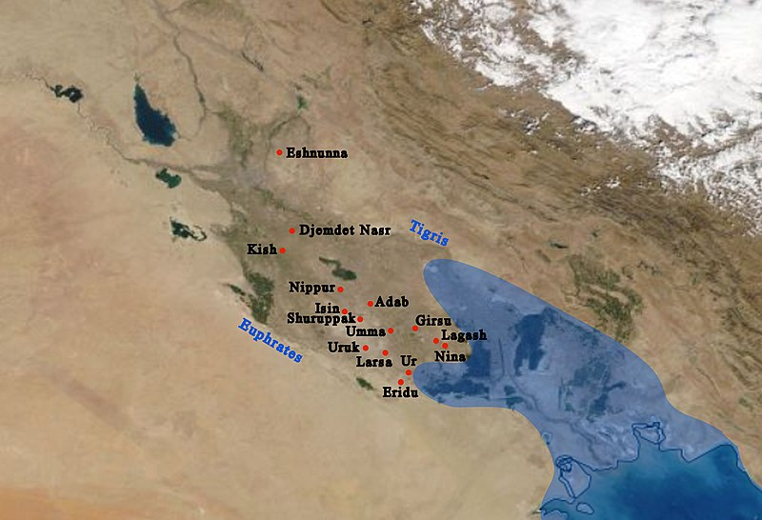

The general location on a modern map, and main cities of Sumer with ancient coastline. **The coastline nearly reached Ur in ancient times**.

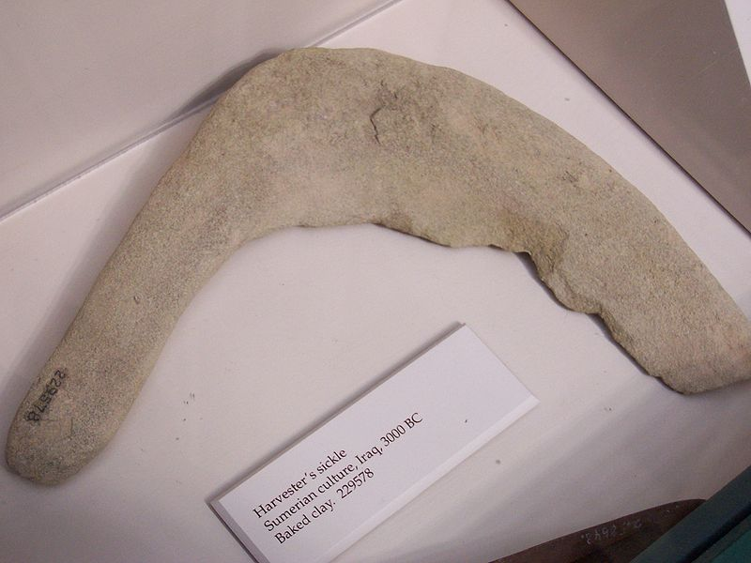

A Sumerian harvester's sickle, dated to 3,000 BC

<https://en.m.wikipedia.org/wiki/File:ClaySumerianSickle.jpg>,

### BRONZE, ΟΡΕΙΧΑΛΚΟΣ, ΜΠΡΟΥΝΤΖΟΣ, (~3500 BCE),

#### Bronze, wiki,

**Bronze is an alloy (κραμα), consisting primarily of copper (χαλκος), commonly with about 12–12.5% tin** (κασσιτερος, ), and often with the addition of other metals **(including aluminium, manganese, nickel, or zinc (**ψευδαργυρος, ΤΣΙΓΚΟΣ) and sometimes non-metals, such as phosphorus, or metalloids such as arsenic or silicon. These additions produce a range of alloys (ΚΡΑΜΑ), that may be harder than copper alone, or have other useful properties, such as strength, ductility, or machinability.

The archaeological period in which bronze was the hardest metal in widespread use is known as the **Bronze Age**. **The beginning of the Bronze Age in western Eurasia and India is conventionally dated to the mid-4th millennium BCE (~3500 BCE),** and to the early 2nd millennium BCE in China;[1] elsewhere it gradually spread across regions.

Οι ηρωες του ΟΜΗΡΟΥ ειχαν οπλα από ΟΡΕΙΧΑΛΚΟ (BRONZE)

The Bronze Age was followed by the **Iron Age** starting from about **1300 BCE and reaching most of Eurasia by about 500 BCE**, although bronze continued to be much more widely used than it is in modern times.

Because historical artworks were often made of brasses (copper and zinc (Ψευδάργυρος) ) and bronzes with different compositions, modern museum and scholarly descriptions of older artworks increasingly use the generalized term "copper alloy"(ΚΡΑΜΑ ΧΑΛΚΟΥ), instead.[2],