**10 ΔΙΑΛΕΞΗ,**

ΣΑΒΒΑΤΟΝ, 23-03-2024,

Webex meeting recording: 10 DIALEKSIS INM 2024, SATURDAY 12.00-13.00-20240323 1021-1

Password: JxPnq2Mh

Recording link: https://uoa.webex.com/uoa/ldr.php?RCID=a2fb3b6b0da4fb99154420d6173baee4

**ΠΡΟΚΑΤΑΡΚΤΙΚΑ,**

Ισως εργασια 2003, εγινε

Ξεκιναμε με την εργασια 2003, .

### The Empire of Hammurabi,

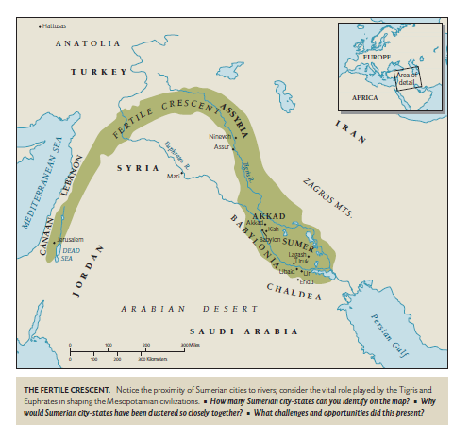

ColeSymes p. 11.

ColeSymes, p. 18

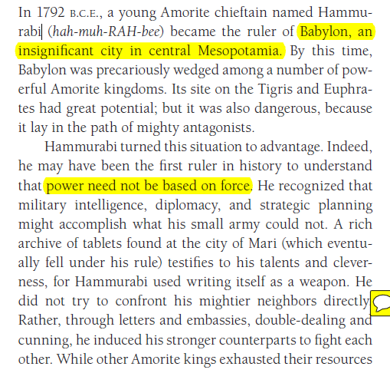

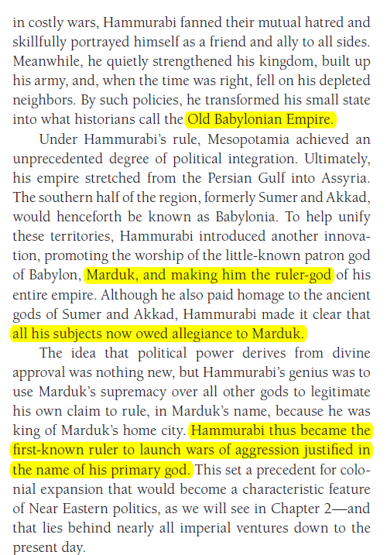

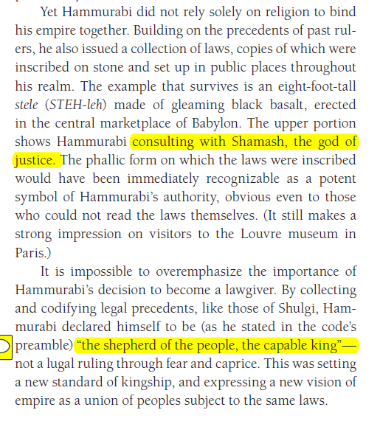

### CODE OF HAMMURABI

<https://en.wikipedia.org/wiki/Code_of_Hammurabi>,

The Code of Hammurabi is a well-preserved Babylonian code of law of ancient Mesopotamia, dated back to about 1754 BCE (Middle Chronology). It is one of the oldest deciphered writings of significant length in the world. The sixth Babylonian king, Hammurabi, enacted the code. A partial copy exists on a 2.25 metre (7.5 ft) stone stele. It consists of 282 laws, with scaled punishments, adjusting "**an eye for an eye, a tooth for a tooth**" (lex talionis)[1] (talionis, retaliation ), as graded depending on social status, of slave versus free, man or woman.[2]

<https://en.wikipedia.org/wiki/Hammurabi>,

Hammurabi is best known for having issued the Code of Hammurabi, which he claimed to have received **from Shamash, the Babylonian god of justice**. Unlike earlier Sumerian law codes, such as the Code of Ur-Nammu, which had focused on compensating the victim of the crime, the Law of Hammurabi was one of the first law codes **to place greater emphasis on the physical punishment of the perpetrator.** It prescribed specific penalties for each crime **and is among the first codes to establish the presumption of innocence.** They were intended to limit what a wronged person was permitted to do in retribution. **The Code of Hammurabi and the Law of Moses in the Torah contain numerous similarities**.

#### A Mathematician’s Apology, G. H. Hardy,

**p. 11,**

If intellectual curiosity, professional pride, and ambition are the dominant incentives **to research**, then assuredly no one has a fairer chance of satisfying them than a mathematician. His subject is the most curious of all—there is none in which **truth plays such odd pranks**. It has the most elaborate and the most fascinating technique, and gives unrivalled openings for the display of sheer professional skill. Finally, as history proves abundantly, mathematical achievement, **whatever its intrinsic worth**, **is the most enduring** of all. We can see this even in semi-historic civilizations. The Babylonian and Assyrian civilizations have perished; Hammurabi, Sargon, and Nebuchadnezzar are empty names; yet Babylonian mathematics is still interesting, and the Babylonian scale of 60 is still used in astronomy. But of course the crucial case is that of the Greeks.

The Greeks were the first mathematicians who are still ‘real’ to us to-day. Oriental mathematics may be an interesting curiosity, but Greek mathematics is the real thing. The Greeks first spoke a language which modern mathematicians can understand: as Littlewood said to me once, they are not clever schoolboys or ‘scholarship candidates’, but ‘Fellows of another college’. So Greek mathematics is ‘permanent’, more permanent even than Greek literature. **Archimedes** will be remembered when **Aeschylus** is forgotten, because languages die and mathematical ideas do not. ‘Immortality’ may be a silly word, but probably a mathematician

has the best chance of whatever it may mean.

3 best british mathematicians, HARDY, LITTLEWOOD and HARDY, LITTLEWOOD,