11 ΔΙΑΛΕΞΗ,

ΤΕΤΑΡΤΗ 27-03-2024, 11.00-02.00,

Webex meeting recording: 11 DIALEKSIS INM 2024 tetarth, 11.00-14.00-20240327 0931-1

Password: 53vMmWJM

Recording link: <https://uoa.webex.com/uoa/ldr.php?RCID=1b76e8b6504270ee00535534806d0b4d>,

**ΠΡΟΚΑΤΑΡΚΤΙΚΑ**

ΑΝΑΠΛΗΡΩΣΗ ΩΡΩΝ,

Σαββατο 30-03,

ΣΥΖΗΤΗΣΗ επι των ΕΡΓΑΣΙΩΝ, 3001, 3002,

### ΑΣΤΡΟΝΟΜΙΑ ΒΑΒΥΛΩΝΙΩΝ

ΜΟΙΡΕΣ, ΛΕΠΤΑ, ΔΕΥΤΕΡΟΛΕΠΤΑ, κλπ

??? ΠΡΟΒΛΕΨΕΙΣ ΕΚΛΗΨΕΩΝ ΣΕΛΗΝΗΣ,

Journal for the History of Astronomy

Lunar Eclipse Times Predicted by the Babylonians

J. M. Steele, F. R. Stephenson

First Published May 1, 1997 Research Article

<https://en.wikipedia.org/wiki/History_of_astronomy#cite_ref-dp1998_17-0>, History of astronomy

Astronomy is the oldest of the natural sciences, dating back to antiquity, **with its origins in the religious, mythological, cosmological, calendrical, and astrological beliefs and practices of prehistory**: vestiges of these are still found in astrology, a discipline long interwoven with public and governmental astronomy, and not completely disentangled from **it until a few centuries ago in the Western World** (see astrology and astronomy). In some cultures, astronomical data was used for astrological prognostication.

**Ancient astronomers were able to differentiate between stars and planets, as stars remain relatively fixed over the centuries while planets will move an appreciable amount during a comparatively short time**.

**The origins of Western astronomy can be found in Mesopotamia, the "land between the rivers" Tigris and Euphrates, where the ancient kingdoms of Sumer, Assyria, and Babylonia were located.**

**A form of writing known as cuneiform (ΣΦΗΝΟΕΙΔΗΣ), emerged among the Sumerians around 3500–3000 BC**. Our knowledge of Sumerian astronomy is indirect, via the earliest Babylonian star catalogues dating from about 1200 BC. The fact that many star names appear in Sumerian suggests a continuity reaching into the Early Bronze Age. Astral theology, which gave planetary gods an important role in Mesopotamian mythology and religion, began with the Sumerians. **They also used a sexagesimal (base 60) place-value number system,** which simplified the task of recording very large and very small numbers. **The modern practice of dividing a circle into 360 degrees, of 60 minutes each, began with the Sumerians**. For more information, see the articles on Babylonian numerals and mathematics.

**Babylonian astronomy was the basis for much of what was done in Greek and Hellenistic astronomy, in classical Indian astronomy, in Sassanian Iran, in Byzantium, in Syria, in Islamic astronomy, in Central Asia, and in Western Europe**.( Pingree, David (1998), "Legacies in Astronomy and Celestial Omens", in Dalley, Stephanie, The Legacy of Mesopotamia, Oxford University Press, pp. 125–137, ISBN 0-19-814946-8.)

### ΑΡΙΘΜΟΙ,

#### INFO

**Cuneus (ΣΦΗΝΑ),** comprises the Latin root of cuneiform, which means wedge (ΣΦΗΝΑ). A triangular reed (ΚΑΛΑΜΟΣ) or stylus was used to form cuneiform signs in wet clay. Clay tablets were then dried in the sun to permanently fix the writing (Fairbank, 1970). **Sumerian cuneiform existed as the first written language.**

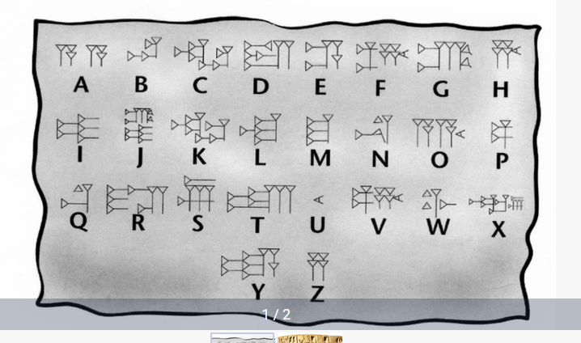

Cuneiform script - world’s first ever writing system,

<https://azertag.az/en/xeber/Cuneiform_script___worlds_first_ever_writing_system-2106473>,

#### Cuneiform script,

Go BURTON p. 20

BURTON, p. 24,

#### ΒΑΒΥΛΩΝΙΑΚΟΙ ΑΡΙΘΜΟΙ,

##### Babylonian numerals

<https://mathshistory.st-andrews.ac.uk/HistTopics/Babylonian_numerals/>,

The Babylonian civilisation in Mesopotamia replaced the Sumerian civilisation and the Akkadian civilisation. We give a little historical background to these events in our article Babylonian mathematics. Certainly in terms of their number system the Babylonians inherited ideas from the Sumerians and from the Akkadians. From the number systems of these earlier peoples came the base of 60, that is the sexagesimal system. Yet neither the Sumerian nor the Akkadian system was a **positional system** and this advance by the Babylonians was undoubtedly their greatest achievement in terms of developing the number system. **Some would argue that it was their biggest achievement in mathematics**.

Often when told that the Babylonian number system was base 60 people's first reaction is: what a lot of special number symbols they must have had to learn. Now of course this comment is based on knowledge of our own decimal system which is a positional system with nine special symbols and a zero symbol to denote an empty place. However, rather than have to learn 10 symbols as we do to use our decimal numbers**, the Babylonians only had to learn two symbols** to produce their base 60 positional system.

Now although the Babylonian system was a positional base 60 system, it had some vestiges of a base 10 system within it. This is because the 59 numbers, which go into one of the places of the system, were built from a 'unit' symbol and a 'ten' symbol.

Here are the 59 symbols built from these two symbols

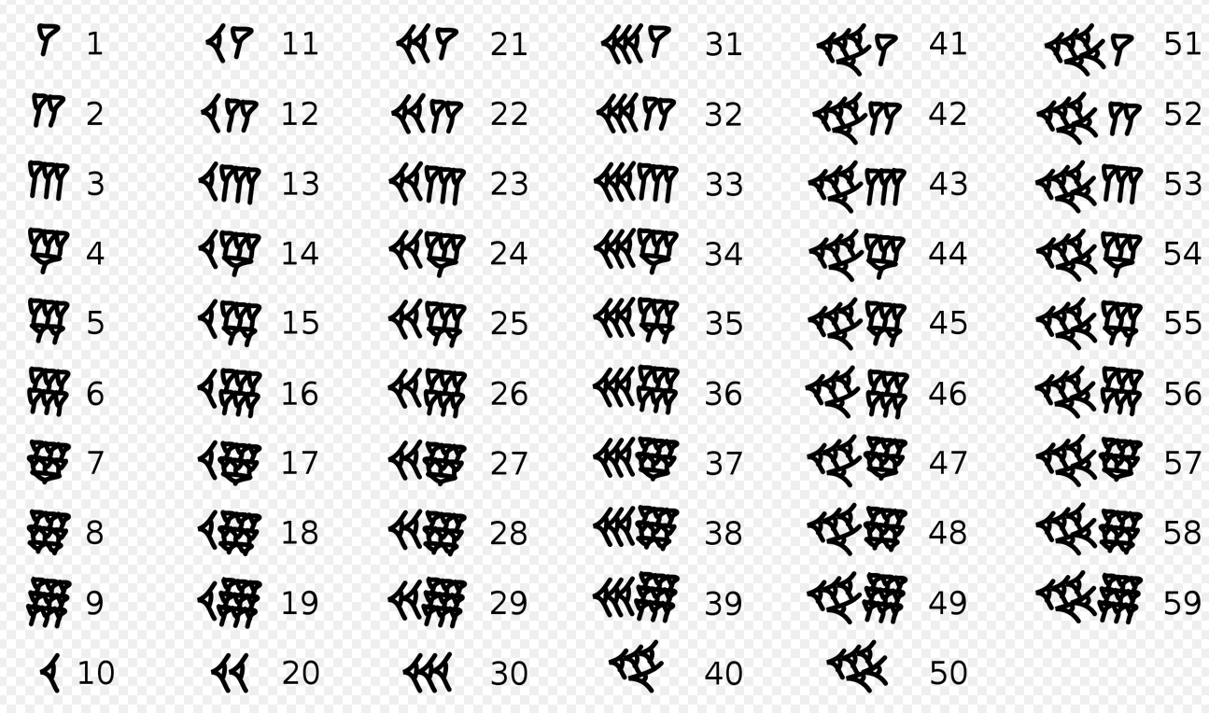

Here is 1,57,46,40 in Babylonian numerals

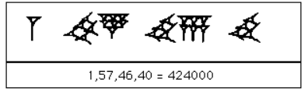

##### METHODS OF COMPUTATION,

GOTO KATZ p.12,

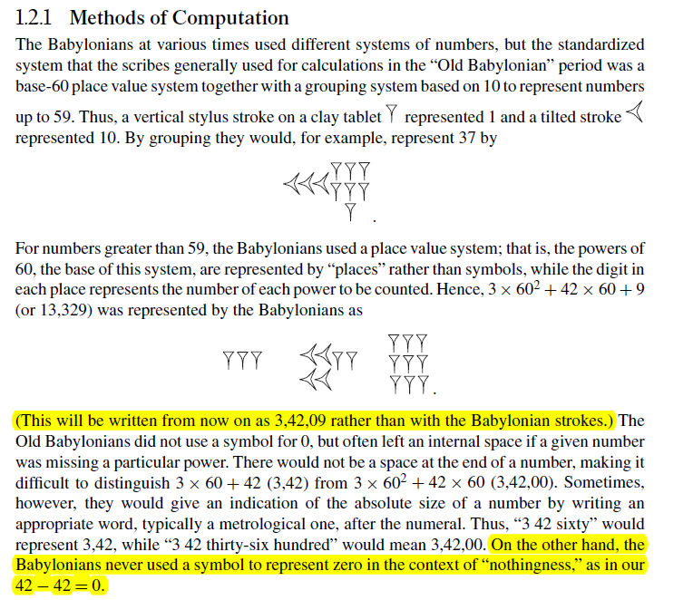

Ηταν PLACE VALUE SYSTEM. THERE was n0 ZERO,

Tilted, move or cause to move into a sloping position.

Katz p. 12,

number system was a **place value system**, the actual algorithms for addition and subtraction, including carrying and borrowing, **may well have been similar to modern ones.** For example, to add 23,37 (= 1417) to 41,32 (= 2492), one first adds 37 and 32 to get 1,09 (= 69). One writes down 09 and carries 1 to the next column. Then 23+ 41+ 1= 1, 05 (= 65), and the final result is 1,05,09 (= 3909).

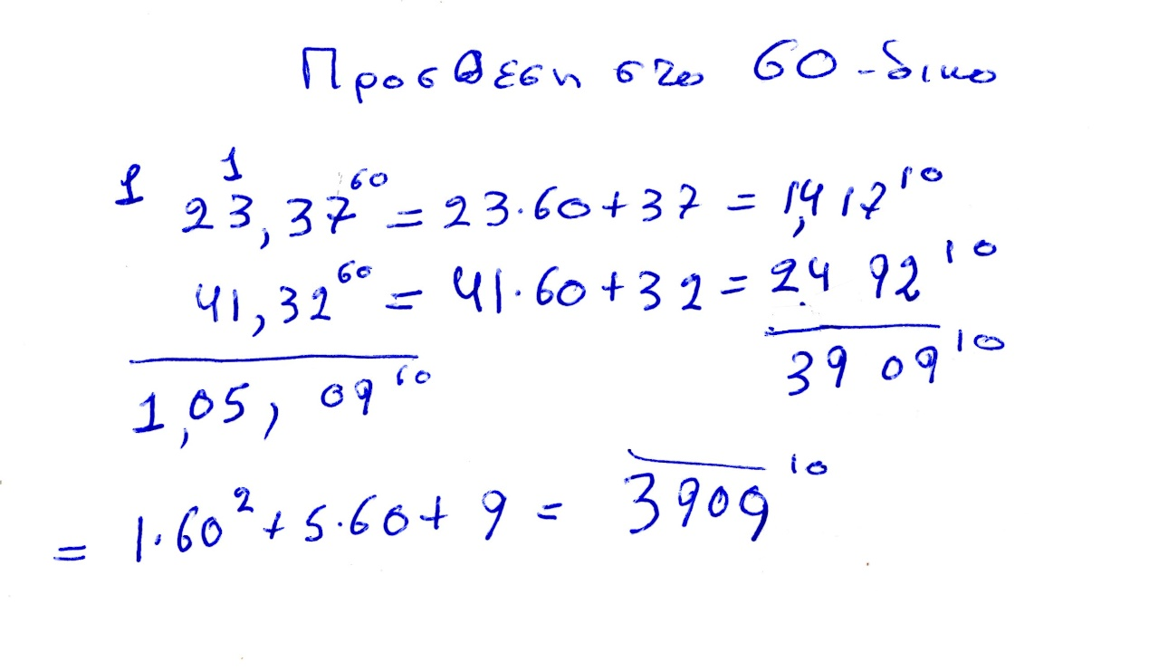

## ΑΙΓΥΠΤΟΣ,

### ΓΕΝΙΚΟΤΗΤΕΣ

Hecataeus and Herodotus on "A Gift of the River"

Author(s): J. Gwyn Griffiths

Source: Journal of Near Eastern Studies, Vol. 25, No. 1 (Jan., 1966), pp. 57-61

Published by: University of Chicago Press

Stable URL: http://www.jstor.org/stable/543141

Accessed: 27-11-2015 08:57 UTCHECATAEUS AND HERODOTUS ON "A GIFT OF THE RIVER"1

**IT may be questioned whether a geography lesson on Egypt is ever given anywhere**

**without including the statement that "Egypt is the gift of the Nile."** The earliest

recorded verbal form of this statement appears in Herodotus, 2. 5:

HEEODOTUS, WITH AN ENGLISH TRANSLATION BY

A. GODLKY, HON. FELLOW OF MAGDALEN COLLEGE, OXFORD

IN FOUR VOLUMES

Vol1, BOOKS I AKP II,

p. 279-282,

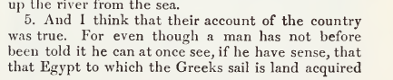

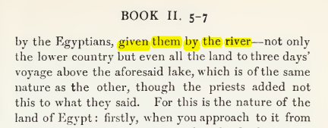

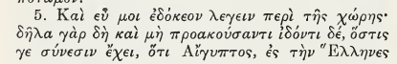

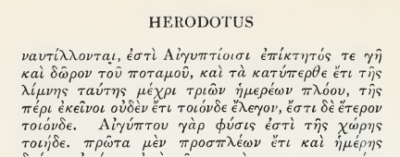

ΣΓΠ. O ΗΡΟΔΟΤΟΣ βλεπει την ΑΙΓΥΠΤΟ με σεβασμο, αλλα την θεωρει κουρασμενο πολιτισμο.

Map of ancient Egypt, showing major cities and sites of the Dynastic period (c. 3150 BC to 30 BC)

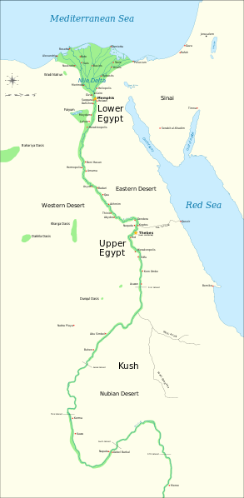

<https://en.wikipedia.org/wiki/File:Ancient_Egypt_map-en.svg>,

<https://en.wikipedia.org/wiki/Cradle_of_civilization#/media/File:Ancient_Egypt_map-en.svg>,

#### GOTO Katz, Victor J. A history of mathematics 3rd ed. p. 2

**Agriculture emerged in the Nile Valley in Egypt close to 7000 years ago**,

but the first dynasty to rule both Upper Egypt (the river valley) and Lower Egypt (the delta) dates from about 3100 bce. The legacy of the first pharaohs included an elite of officials and priests, a luxurious court, and for the kings themselves, a role as intermediary between mortals and gods. This role fostered the development of Egypt’s monumental architecture, including the pyramids, built as royal tombs, and the great temples at Luxor and Karnak. Writing began in Egypt at about this time, and much of the earliest writing concerned accounting, primarily of various types of goods. There were several different systems of measuring, depending on the particular goods being measured. But since there were only a limited number of signs, the same signs meant different things in connection with different measuring systems. From the beginning of Egyptian writing, there were two styles, the hieroglyphic writing for monumental inscriptions and the hieratic, or cursive, writing, done with a brush and ink on papyrus.

Greek domination of Egypt in the centuries surrounding the beginning of our era was responsible for the disappearance of both of these native Egyptian writing forms. Fortunately**, Jean Champollion (1790–1832)** was able to begin the process of understanding Egyptian writing early in the nineteenth century through the help of a multilingual inscription—the Rosetta stone—**in hieroglyphics** and **Greek** as well as the later **demotic writing**, a form of the hieratic writing of the papyri (Fig. 1.1).

It was the scribes who fostered the development of the mathematical techniques. These government officials were crucial to ensuring the collection and distribution of goods, thus helping to provide the material basis for the pharaohs’ rule (Fig. 1.2).

Thus, evidence for the techniques comes from the education and daily work of the scribes, particularly as related in two papyri containing collections of mathematical problems with their solutions, the *Rhind Mathematical Papyrus*, named for the Scotsman A. H. Rhind (1833–1863) who purchased it at Luxor in 1858,

(Rhind Mathematical Papyrus. The British Museum, where the majority of the papyrus is now kept, acquired it in 1865 along with the Egyptian Mathematical Leather Roll, also owned by Henry Rhind.[2])

and the *Moscow Mathematical Papyrus*, purchased in 1893 by V. S. Golenishchev (d. 1947) who later sold it to the Moscow Museum of Fine Arts.

**The former papyrus (RHIND) was copied about 1650 bce** by the scribe A’h-mose from an original about 200 years older and is approximately 18 feet long and 13 inches high.

**The latter papyrus (MOSCOW) dates** from roughly the same period and is over 15 feet long, but only some 3 inches high. Unfortunately, although a good many papyri have survived the ages due to the generally dry Egyptian climate, it is the case that papyrus is very fragile. Thus, besides the two papyri mentioned, only a few short fragments of other original Egyptian mathematical papyri are still extant. These two mathematical texts inform us first of all about the types of problems that needed to be solved. **The majority of problems were concerned with topics involving the administration of the state**. That scribes were occupied with such tasks is shown by illustrations found on the walls of private tombs. Very often, in tombs of high officials, scribes are depicted working together, probably in accounting for cattle or produce. Similarly, there exist three dimensional models representing such scenes as the filling of granaries, and these scenes always include a scribe to record quantities. Thus, it is clear that Egyptian mathematics was developed and practiced in this practical context. One other area in which mathematics played an important rolewas architecture. Numerous remains of buildings demonstrate that mathematical techniques were used both in their design and construction. Unfortunately, there are few detailed accounts of exactly how the mathematics was used in building, so we can only speculate about many of the details. We deal with a few of these ideas below.

#### Rosetta Stone

<https://en.wikipedia.org/wiki/Rosetta_Stone>,

The Rosetta Stone is a stele of granodiorite inscribed with three versions of a decree issued in 196 BC during the Ptolemaic dynasty of Egypt, on behalf of King Ptolemy V Epiphanes. The top and middle texts are in Ancient Egyptian **using hieroglyphic** and **Demotic** scripts, respectively, while the bottom is in Ancient Greek. The decree has only minor differences across the three versions, making the Rosetta Stone key to deciphering the Egyptian scripts.

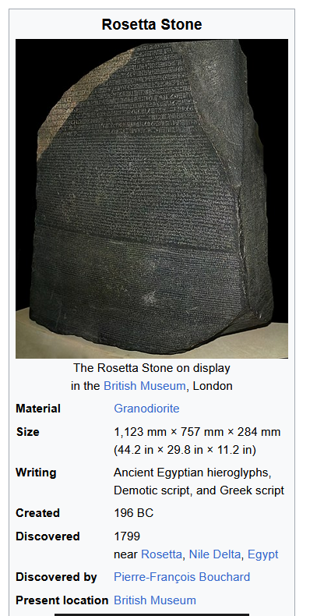

### ΣΧΕΣΗΣ ΕΛΛΗΝΙΚΩΝ ΚΑΙ ΑΙΓΥΠΤΙΑΚΩΝ ΜΑΘΗΜΑΤΙΚΩΝ,

#### COOKE ROGER. The history of mathematics : a brief course, 3rd edition. Wiley 2013,

**7.2. GEOMETRY**

The most fascinating aspect of Egyptian mathematics is the application of these computational techniques to geometry. In Section 109 of Book 2 of his *History*, **the Greek historian Herodotus writes that King Sesostris1 dug a multitude of canals to carry water to the arid parts of Egypt. He goes on to connect this Egyptian engineering with Greek geometry:**

SGP. “brackish (brackish /ˈbrakɪʃ/ adjective: brackish,

(of water) slightly salty, water from wells.)

109. For this cause Egypt was intersected. This king moreover (so they said) divided the country among all the Egyptians by giving each an equal square parcel of land, and made this his source of revenue, appointing the payment of a yearly tax.

And any man who was robbed by the river of a part of his land would come to Sesostris and declare what had befallen him ; then the king would send

men to look into it and measure the space by which the land was diminished, so that thereafter it should pay in proportion to the tax originally imposed. **From this, to my thinking, the Greeks learnt the art of measuring land ; the sunclock and the sundial, and the twelve divisions of the day, came to Hellas not from Egypt but from Babylonia.”**

**Sunclock**

**Sunclock**

[**https://sunclock.ch**](https://sunclock.ch)**,**

**Astronomical clock for sunrise, sunset, moon, temporal hours and daily and yearly rhythms.**

SUNDIAL, Wikipedia,

an instrument showing the time by the shadow of a pointer cast by the sun on to a plate marked with the hours of the day.

<https://en.wikipedia.org/wiki/File:Melbourne_sundial_at_Flagstaff_Gardens.JPG>,

Melbourne_sundial_at_Flagstaff_Gardens.JPG.

#### ARISTOTLE,

##### ARISTOTLE, KATZ p. 35

Fortunately for us, most of the early Greek mathematics we will discuss involves little calculation. As Aristotle wrote in his *Metaphysics*, At first, he who invented any art whatever that went beyond the common perceptions of man was naturally admired by men, not only because there was something useful in the inventions, but because he was thought wise and superior to the rest. But as more arts were invented, and some were directed to the necessities of life, **others to recreation**, the inventors of the latter were naturally always regarded as wiser than the inventors of the former, because their branches of knowledge did not aim at utility. Hence when all such inventions were already established, the sciences which do not aim at giving pleasure or at the necessities of life were discovered, and first in the places where men first began to have leisure. This is why the mathematical arts were founded in Egypt; for there the priestly caste was allowed to be at leisure.4

Although Aristotle referred only to Egypt, he certainly believed that in Greece as well

mathematics was the province of a leisured class, people who did not deal with such mundane matters as measurement or accountancy problems. Thus, in Greece as in Egypt and Mesopotamia, mathematics of the type we will discuss in this chapter and the next was the province of a very limited group of people, virtually all of whom were part of the **ruling groups**. As we will see, this theoretical mathematics was to be a central part of the education

of the rulers of the state.

##### AristotleMetaphysicsRossWilliamDavid, p 3-4

English translation

Again, we do not regard any of the senses as Wisdom; yet surely these give the most authoritative knowledge of particulars. But they do not tell us the 'why' of anything-e.g. why fire is hot; they only say that it is hot.

At first he who invented any art whatever that went beyond the common perceptions of man was naturally admired by men, not only because there was something useful in the inventions, but because he was thought wise and superior to the rest. But as more arts were invented, and some were directed to the necessities of life, others to recreation, **the inventors of the latter were naturally always regarded as wiser than the inventors of the former,** because their branches of knowledge did not aim at utility. Hence when all such inventions were already established, the sciences which do not aim at giving pleasure or at the necessities of life were discovered, and first in the places where men first began to have leisure**. This is why the mathematical arts were founded in Egypt; for there the priestly caste was** allowed to be at leisure.

Greek original, Bekker page 981a, line 25

… ἔτι δὲ τῶν αἰσθήσεων οὐδεμίαν ἡγούμεθα εἶναι σοφίαν·

καίτοι κυριώταταί γ' εἰσὶν αὗται τῶν καθ' ἕκαστα γνώσεις· ἀλλ'

οὐ λέγουσι τὸ διὰ τί περὶ οὐδενός, οἷον διὰ τί θερμὸν τὸ πῦρ,

ὁποιανοῦν εὑρόντα τέχνην παρὰ τὰς κοινὰς αἰσθήσεις θαυ-

μάζεσθαι ὑπὸ τῶν ἀνθρώπων μὴ μόνον διὰ τὸ χρήσιμον

εἶναί τι τῶν εὑρεθέντων ἀλλ' ὡς σοφὸν καὶ διαφέροντα τῶν

ἄλλων· πλειόνων δ' εὑρισκομένων τεχνῶν καὶ τῶν μὲν

πρὸς τἀναγκαῖα τῶν δὲ πρὸς διαγωγὴν οὐσῶν, ἀεὶ σοφωτέ-

ρους τοὺς τοιούτους ἐκείνων ὑπολαμβάνεσθαι διὰ τὸ μὴ πρὸς

χρῆσιν εἶναι τὰς ἐπιστήμας αὐτῶν. ὅθεν ἤδη πάντων τῶν

τοιούτων κατεσκευασμένων αἱ μὴ πρὸς ἡδονὴν μηδὲ πρὸς

τἀναγκαῖα τῶν ἐπιστημῶν εὑρέθησαν, καὶ πρῶτον ἐν τούτοις

τοῖς τόποις οὗ πρῶτον **ἐσχόλασαν**· **διὸ περὶ Αἴγυπτον αἱ μαθη-**

**ματικαὶ πρῶτον τέχναι συνέστησαν**, ἐκεῖ γὰρ ἀφείθη **σχο-**

**λάζειν τὸ τῶν ἱερέων ἔθνος**.

σχολάζειν τὸ τῶν ἱερέων ἔθνος.

##### THALES, KATZ, p.32

**Thales was the first to go to Egypt and bring**

**back to Greece this study [geometry]**; he

himself discovered many propositions, and

disclosed the underlying principles of many

others to his successors, in some cases his

method being more general, in others more

empirical.

—Proclus’s Summary (c. 450 ce) of

Eudemus’s History (c. 320 bce)1

### ΙΕΡΟΓΛΥΦΙΚΟ ΣΥΣΤΗΜΑ,

Katz p.3,

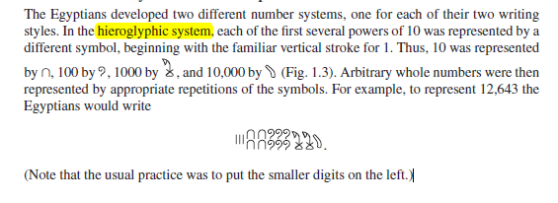

#### ΠΡΟΣΘΕΣΙΣ ΙΕΡΟΓΛΥΦΙΚΩΝ,

Katz p. 3,

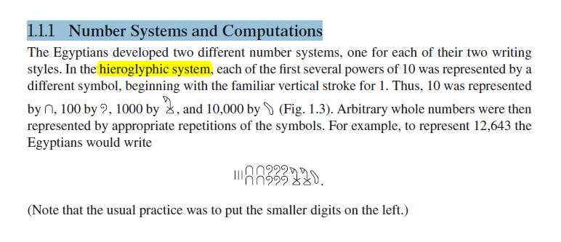

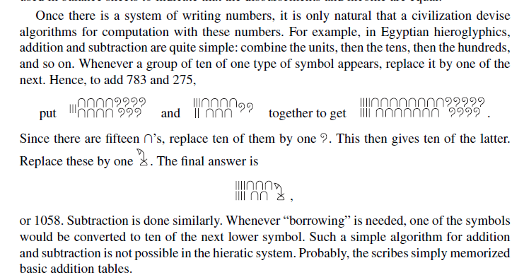

## GREECE, [ΕΛΛΑΣ

WESTERN CIVILIZATION

ΕΒΡΑΙΚΗ ΒΙΒΛΟΣ,

ΑΡΧΑΙΑ ΕΛΛΑΔΑ,

ΡΩΜΗ,

### ΣΧΟΛΙΑΣΜΟΣ ΤΩΝ ΕΛΛΗΝΙΚΩΝ ΜΑΘΗΜΑΤΙΚΩΝ,

ΑΠΟΔΕΙΞΗ και ΑΞΙΩΜΑΤΑ

ΔΗΜΟΚΡΑΤΙΑ,

#### KATZ p. 33, greek mathematics,

As the quotation and the (probably) fictional account indicate, a new attitude toward mathematics appeared in Greece sometime before the fourth century bce. It was no longer sufficient merely to calculate numerical answers to problems. One now had to prove that the results were correct. To double a cube, that is, to find a new cube whose volume was twice that of the original one, is equivalent to determining the cube root of 2, and that was not a difficult problem numerically. The oracle, however, was not concerned with numerical calculation, but with geometric construction. That in turn depended on geometric proof by some logical argument, the earliest manifestation of such in Greece being attributed to Thales.

This change in the nature of mathematics, beginning around 600 bce, was related to the great differences between the emerging Greek civilization and those of Egypt and Babylonia, from whom the Greeks learned. The physical nature of Greece with its many mountains and islands is such that large-scale agriculture was not possible. Perhaps because of this, Greece did not develop a central government. The basic political organization was the polis, or city-state. The governments of the city-state were of every possible variety but in general controlled populations of only a few thousand. Whether the governments were democratic or monarchical, (ΣΓΠ, or ARISTOCRATIC), they were not arbitrary. Each government was ruled by law and therefore encouraged its citizens to be able to argue and debate. It was perhaps out of this characteristic that there developed the necessity for proof in mathematics, that is, for argument aimed at convincing others of a particular truth.

ΠΑΠ. ΠΝΥΚΑ, ΔΙΚΑΣΤΗΡΙΑ, ΔΙΑΛΟΓΟΙ ΣΩΚΡΑΤΟΥΣ STON DROMO, , . ΣΗΜΕΡΑ ΤΙ ΓΙΝΕΤΑΙ ?,

Because virtually every city-state had access to the sea, there was constant trade, both in Greece itself and with other civilizations. As a result, the Greeks were exposed to many different peoples and, in fact, themselves settled in areas all around the eastern Mediterranean. In addition, a rising standard of living helped to attract able people from other parts of the world. Hence, the Greeks were able to study differing answers to fundamental questions about the world. They began to create their own answers. In many areas of thought, they learned not to accept what had been handed down from ancient times. Instead, they began to ask, and to try to answer, “Why?” Greek thinkers eventually came to the realization that the world around them was knowable, that they could discover its characteristics by rational inquiry. Hence, they were anxious to discover and expound theories in such fields as mathematics, physics, biology, medicine, and politics. And althoughWestern civilization owes a great debt to Greek society in literature, art, and architecture, it is to Greek mathematics that we owe the idea of mathematical proof, an idea at the basis of modern mathematics and, by extension, at the foundation of our modern technological civilization.

#### KATZ, p. 35. ARISTOTLE,

Fortunately for us, most of the early Greek mathematics we will discuss involves little calculation.

As Aristotle wrote in his *Metaphysics*, At first, he who invented any art whatever that went beyond the common perceptions of man was naturally admired by men, not only because there was something useful in the inventions, but because he was thought wise and superior to the rest. But as more arts were invented, and some were directed to the necessities of life, others to recreation, the inventors of the latter were naturally always regarded as wiser than the inventors of the former, because their branches of knowledge did not aim at utility. Hence when all such inventions were already established, the sciences which do not aim at giving pleasure or at the necessities of life were discovered, and first in the places where men first began to have leisure. This is why the mathematical arts were founded in Egypt; for there the priestly caste was allowed to be at leisure

Although Aristotle referred only to Egypt, he certainly believed that in Greece as well mathematics was the province of a leisured class, people who did not deal with such mundane (χωρις ενδιαφερον), matters as measurement or accountancy problems. Thus, in Greece as in Egypt and Mesopotamia, mathematics of the type we will discuss in this chapter and the next was the province of a very limited group of people, virtually all of whom were part of the ruling groups. As we will see, this theoretical mathematics was to be a central part of the education of the rulers of the state.

## GREECE, [ΕΛΛΑΣ

WESTERN CIVILIZATION

ΕΒΡΑΙΚΗ ΒΙΒΛΟΣ,

ΑΡΧΑΙΑ ΕΛΛΑΔΑ,

ΡΩΜΗ,

### ΣΧΟΛΙΑΣΜΟΣ ΤΩΝ ΕΛΛΗΝΙΚΩΝ ΜΑΘΗΜΑΤΙΚΩΝ,

ΑΠΟΔΕΙΞΗ και ΑΞΙΩΜΑΤΑ

ΔΗΜΟΚΡΑΤΙΑ,

#### KATZ p. 33, greek mathematics,

As the quotation and the (probably) fictional account indicate, a new attitude toward mathematics appeared in Greece sometime before the fourth century bce. It was no longer sufficient merely to calculate numerical answers to problems. One now had to prove that the results were correct. To double a cube, that is, to find a new cube whose volume was twice that of the original one, is equivalent to determining the cube root of 2, and that was not a difficult problem numerically. The oracle, however, was not concerned with numerical calculation, but with geometric construction. That in turn depended on geometric proof by some logical argument, the earliest manifestation of such in Greece being attributed to Thales.

This change in the nature of mathematics, beginning around 600 bce, was related to the great differences between the emerging Greek civilization and those of Egypt and Babylonia, from whom the Greeks learned. The physical nature of Greece with its many mountains and islands is such that large-scale agriculture was not possible. Perhaps because of this, Greece did not develop a central government. The basic political organization was the polis, or city-state. The governments of the city-state were of every possible variety but in general controlled populations of only a few thousand. Whether the governments were democratic or monarchical, (ΣΓΠ, or ARISTOCRATIC), they were not arbitrary. Each government was ruled by law and therefore encouraged its citizens to be able to argue and debate. It was perhaps out of this characteristic that there developed the necessity for proof in mathematics, that is, for argument aimed at convincing others of a particular truth.

ΠΑΠ. ΠΝΥΚΑ, ΔΙΚΑΣΤΗΡΙΑ, ΔΙΑΛΟΓΟΙ ΣΩΚΡΑΤΟΥΣ STON DROMO, , . ΣΗΜΕΡΑ ΤΙ ΓΙΝΕΤΑΙ ?,

Because virtually every city-state had access to the sea, there was constant trade, both in Greece itself and with other civilizations. As a result, the Greeks were exposed to many different peoples and, in fact, themselves settled in areas all around the eastern Mediterranean. In addition, a rising standard of living helped to attract able people from other parts of the world. Hence, the Greeks were able to study differing answers to fundamental questions about the world. They began to create their own answers. In many areas of thought, they learned not to accept what had been handed down from ancient times. Instead, they began to ask, and to try to answer, “Why?” Greek thinkers eventually came to the realization that the world around them was knowable, that they could discover its characteristics by rational inquiry. Hence, they were anxious to discover and expound theories in such fields as mathematics, physics, biology, medicine, and politics. And althoughWestern civilization owes a great debt to Greek society in literature, art, and architecture, it is to Greek mathematics that we owe the idea of mathematical proof, an idea at the basis of modern mathematics and, by extension, at the foundation of our modern technological civilization.

#### KATZ, p. 35. ARISTOTLE,

Fortunately for us, most of the early Greek mathematics we will discuss involves little calculation.

As Aristotle wrote in his *Metaphysics*, At first, he who invented any art whatever that went beyond the common perceptions of man was naturally admired by men, not only because there was something useful in the inventions, but because he was thought wise and superior to the rest. But as more arts were invented, and some were directed to the necessities of life, others to recreation, the inventors of the latter were naturally always regarded as wiser than the inventors of the former, because their branches of knowledge did not aim at utility. Hence when all such inventions were already established, the sciences which do not aim at giving pleasure or at the necessities of life were discovered, and first in the places where men first began to have leisure. This is why the mathematical arts were founded in Egypt; for there the priestly caste was allowed to be at leisure

Although Aristotle referred only to Egypt, he certainly believed that in Greece as well mathematics was the province of a leisured class, people who did not deal with such mundane (χωρις ενδιαφερον), matters as measurement or accountancy problems. Thus, in Greece as in Egypt and Mesopotamia, mathematics of the type we will discuss in this chapter and the next was the province of a very limited group of people, virtually all of whom were part of the ruling groups. As we will see, this theoretical mathematics was to be a central part of the education of the rulers of the state.