12 ΔΙΑΛΕΞΗ,

ΤΕΤΑΡΤΗ, 03-04-2024,

Webex meeting recording: 12 INM 2024 tetarth, 11.00-15.00-20240403 0816-1

Password: 7dMHDxYB

Recording link: <https://uoa.webex.com/uoa/ldr.php?RCID=3eb7ab4b1b81852f34f70f077cae6087>,

**ΠΡΟΚΑΤΑΡΚΤΙΚΑ,**

ΑΠΑΝΤΗΣΗ στις 3001,

Πληροφοριες για ΕΡΓΑΣΙΑ 6001,

### ΓΕΝΙΚΕΣ ΕΚΤΙΜΗΣΕΙΣ ΓΙΑ ΤΗΝ ΕΛΛΗΝΙΚΗ ΔΙΑΝΟΗΣΗ,

#### ColeSymes p. 107

And yet the profound significance of Greek experiments

with new forms of governance and new ideas about

the world is undeniable. This can be seen with particular

clarity if we compare the Greek poleis with the empires and

kingdoms of the Bronze Age. The typical political regime of

the ancient Near Eastern world was, as we have seen, that

of a monarch supported by a powerful priesthood. In this

context, cultural achievements were mainly instruments to

enhance the prestige of rulers, and economic life was controlled

by palaces and temples. By contrast, the core values

of the Greeks were the primacy of the human male and

the principles of competition, individual achievement, and

human freedom and responsibility. (The very word for freedom—

eleutheria—**cannot be translated into any ancient**

**Near Eastern language, not even Hebrew**.) In his history,

Herodotus records a conversation between a Greek (in

this case a Spartan) and a Persian, who expresses surprise

that the Greeks should raise spears against the supposedly

benign rule of his emperor. The Spartan retorts, “You understand

how to be a slave, but you know nothing of freedom.

Had you tasted it, you would advise us to fight not only

with spears but with axes**.” How the Greeks came to turn**

**those spears on one another within a few generations of**

**their united victory is a story worthy of one of their own tragedies.**

Another way of appreciating the enduring importance

of Greek civilization is to recall the essential vocabulary we

have inherited from it: not only the word *democracy* but *politics*,

*philosophy*, *theater*, *history*. How would we think without

these concepts? The very notion of humanity comes to us

from the Greeks. For them, the fullest development of one’s

potential should be the aim of existence: every free man

is the sculptor of his own monument. This work of growing

from childishness to personhood is what the Greeks

called *paideia,* from which our term *pedagogy* is derived;

the Romans called it *humanitas*. How this and other ideas

came to be disseminated beyond Greece, to be adopted by

the peoples and places of a much wider world, is the subject

of Chapter 4.

#### KittoGreeks1957.pdf. p. 176-177

Now we must turn to another feature of the Greek mind, its

firm belief in Reason. There is a pleasing, though possibly

libellous, story of a Chinese philosopher who was asked what

the Earth rested on. *A tortoise', said the philosopher. 'And

what does the tortoise rest on?' *A table.' 'And what does the

table rest on?' 'An elephant'. 'And what does the elephant rest

on?' 'Don't be inquisitive.' **Whether Chinese or not, this is**

**emphatically not Hellenic**. The Greek never doubted for a

moment that the universe is not capricious : **it obeys Law and**

**is therefore capable of explanation.** Even in pre-philosophical

Homer we find this idea, for behind the gods (though sometimes

identified with them) is a shadowy power that Homer

calls **Ananke,** Necessity, an Order of things which even the

gods cannot infringe. Greek Tragedy is built on the faith that

in human affairs it is Law that reigns, not chance.

### GREEK NUMBERS,

KATZ p. 34,

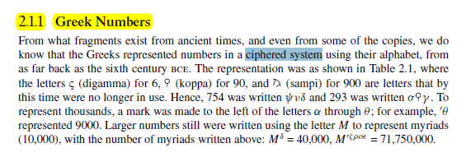

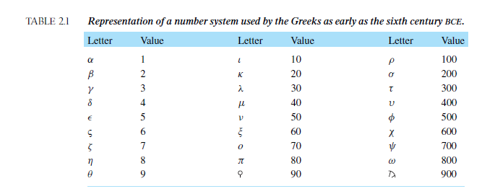

SGP. Πολύ μεγαλοι αριθμοι ΔΕΝ εκφραζονται.

p.35

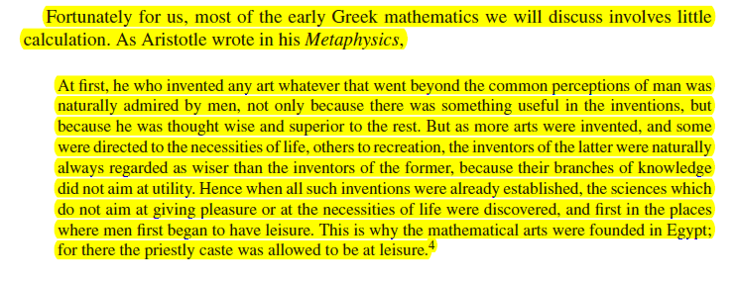

p. 49.

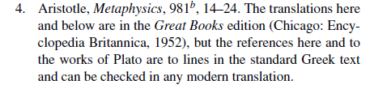

p. 36, αποψη katz

Although Aristotle referred only to Egypt, he certainly believed that in Greece as well

mathematics was the province of a leisured class, people who did not deal with such mundane matters as measurement or accountancy problems. Thus, in Greece as in Egypt and Mesopotamia, mathematics of the type we will discuss in this chapter and the next was the province of a very limited group of people, virtually all of whom were part of the ruling groups. **As we will see, this theoretical mathematics was to be a central part of the education of the rulers of the state**.

? τα σκεφτηκε αυτά ο ΑΡΙΣΤΟΤΕΛΗΣ,

<https://www.britannica.com/science/numeral/Numeral-systems#ref797067>,

Numeral systems

The Greeks, who entered the field much later and were influenced in their alphabet by the Phoenicians, based their first elaborate system chiefly on the initial letters of the numeral names. This was a natural thing for all early civilizations, since the custom of writing out the names for large numbers was at first quite general, and the use of an initial by way of abbreviation of a word is universal. The Greek system of abbreviations, known today as Attic numerals, appears in the records of the 5th century bce but was probably used much earlier.

?ΣΓΠ. Τα σκεφτηκε αυτά ο ΑΡΙΣΤΟΤΕΛΗΣ ?

## ROME,

### SOME REMARKS

#### KATZ 157,

Κατά το 1ο αι[ωνα π.Χ. , the entire eastern Mediterranean—and much else besides—was part of the Roman Empire. The administrative center of the empire was, of course, in Rome, and the official language was Latin. Nevertheless, in much of the empire there were local rulers, and the Romans left the local language and culture intact. In particular, in the eastern Mediterranean, including what is now Egypt, Israel, Syria, mainland Greece, and Turkey, **the prevalent “international” language remained Greek** (από την κατάκτηση του μ. Αλεξάνδρου, τα ελλήνικα ήσαν η γλώσσα της οικονομικής δραστηριότητας). And Alexandria itself remained an intellectual center, where Ptolemy (ο αστρονόμος), among others, found it conducive to work.

ΚΑΤΖ π. 170, Cicero, Tusculan Disputations (Cambridge: Harvard University Press, 1927), I, p. 2.

#### Katz p. 157,

5.3.1 **Roman Mathematics**

Was there “Roman mathematics,” or was all the mathematics accomplished under the aegis of the Roman Empire part of “Greek mathematics”? **The great orator Cicero admitted that the Romans were not interested in mathematics:** “The Greeks held the geometer in the highest honor; accordingly, nothing made more brilliant progress among them than mathematics. But we have established as the limit of this art its usefulness in measuring and counting.”**13** But Cicero himself, as a magistrate and landowner, was certainly numerate enough to understand accounts and detect frauds. So, although it is certainly true that there was no Roman Euclid or Archimedes, in fact the Romans did have somewhat more to do with mathematics than “measuring and counting.”

One person whose writings (in Latin) display a solid knowledge of mathematics is **Vitruvius (first century bce). In his famous work, *On Architecture***, he wrote that architects needed to have a comprehensive liberal education, including topics from draftsmanship to astronomy. In particular, he noted: “Geometry, in turn, offers many aids to architecture, and first among them, it hands down the technique of compass and rule, which enables the onsite layout of the plan as well as the placement of set-squares, levels, and lines. Likewise, through knowledge of optics, windows are properly designed so as to face particular regions of heaven. Through arithmetic the expenses of buildings are totaled up, and the principles of measurement are developed, the difficult issues of symmetry are resolved by geometric principles and methods.”14 But although Vitruvius recommended such knowledge for architects, *On Architecture* itself contains only a little mathematics.

Μηπως δεν εχου βρεθει ?

14. Vitruvius, Ten Books on Architecture, Ingrid Rowland and Thomas Howe, eds. (Cambridge: Cambridge University Press, 1999), p. 22.

#### ΣΧΕΣΕΙΣ ΡΩΜΗΣ και ΕΛΛΑΔΟΣ,

##### The Punic Wars,

<https://en.wikipedia.org/wiki/Punic_Wars>,

The Punic Wars were a series of wars between 264 and 146 BC fought between the Roman Republic and Ancient Carthage. Three wars took place, on both land and sea, across the western Mediterranean region and involved a total of forty-three years of warfare.

##### ΘΑΝΑΤΟΣ ΑΡΧΙΜΗΔΗ και ΑΠΟΛΛΩΝΙΟΥ,

###### Β ΚΑΡΧΗΔΟΝΙΑΚΟΣ ΠΟΛΕΜΟΣ, 218 π.Χ. έως το 202 π.Χ.,

ΘΑΝΑΤΟΣ ΑΡΧΙΜΗΔΗ, 212 πολιορκια συρακουσων,

Adrian Goldsworthy, *The Punic Wars, 2000,* Cassell Military Paperbacks*, p. 266,*

*Anafores,* 26 Livy 25. 27. 6–7, 28. 1–31. 11, Plutarch Marcellus 19–20.

Titus Livius (Latin: [ˈtɪtʊs ˈliːwiʊs]; 59 BC – AD 17),

###### The Battle of Magnesia took place in either December 190 or January 189 BC. I

Περι το 190 π.Χ. πεθαινει ο ΑΠΟΛΛΩΝΙΟΣ της ΠΕΡΓΑΜΟΥ,

##### ΟΡΑΤΙΟΣ, ΒΙΡΓΙΛΙΟΣ, ΚΙΚΕΡΩΝ,

###### Graecia capta ferum victorem cepit et artes intulit agresti Latio.

Horace, Epistles 2.1.156, in Horace : Satires, Epistles, and Ars Poetica (1929) edited and translated by H. R. Fairclough, p. 408

Μτφ. Greece, the captive, made her savage victor captive, and brought the arts into rustic Latium.

**Quintus Horatius Flaccus** ([Classical Latin](https://en.wikipedia.org/wiki/Classical_Latin): [[ˈkᶣiːn̪t̪ʊs̠ (h)ɔˈraːt̪iʊs̠ ˈfɫ̪akːʊs̠]](https://en.wikipedia.org/wiki/Help:IPA/Latin); 8 December 65[[1]](https://en.wikipedia.org/wiki/Horace#cite_note-1) – 27 November 8 BC), known in the English-speaking world as **Horace** ([/ˈhɒrɪs/](https://en.wikipedia.org/wiki/Help:IPA/English)), was the leading Roman [lyric poet](https://en.wikipedia.org/wiki/Lyric_poetry) during the time of [Augustus](https://en.wikipedia.org/wiki/Augustus) (also known as Octavian). The rhetorician [Quintilian](https://en.wikipedia.org/wiki/Quintilian) regarded his [*Odes*](https://en.wikipedia.org/wiki/Odes_(Horace)) as just about the only Latin lyrics worth reading: "He can be lofty sometimes, yet he is also full of charm and grace, versatile in his figures, and felicitously daring in his choice of words."[[nb 1]](https://en.wikipedia.org/wiki/Horace#cite_note-2)

HAROLD McMILLAN, WWII

GREEKS/ROMANS and BRITISH/USA,

##### VIRGIL, AINIAD, … “MEMENTO ROMANO”,

###### MEMENTO ROMANO,

<http://classicalanthology.theclassicslibrary.com/2012/08/07/aeneid-6-847-853/>.

Aeneid

<https://en.wikipedia.org/wiki/Aeneid>,

The Aeneid (/ɪˈniːɪd/ ih-NEE-id; Latin: Aenē̆is [ae̯ˈneːɪs] or [ˈae̯neɪs]) is a Latin epic poem that tells the legendary story of Aeneas, a Trojan who fled the fall of Troy and travelled to Italy, where he became the ancestor of the Romans. Written by the Roman poet Virgil between 29 and 19 BC, the Aeneid comprises 9,896 lines in dactylic hexameter.[1] The first six of the poem's twelve books tell the story of Aeneas' wanderings from Troy to Italy, and the poem's second half tells of the Trojans' ultimately victorious war upon the Latins, under whose name Aeneas and his Trojan followers are destined to be subsumed.

**Aeneid 6.847-853** – Virgil’s vision of Roman greatness

Virgil’s vision of Roman greatness put into the mouth of Anchises, the dead father of Aeneas whom Aeneas travels to find in the Underworld in this book – the turning point of the poem.

Anchises points out the future heroes of Rome yet to be born, a long catalogue that is patriotic and visionary but also cautionary and sad. It culminates in this grand passage which, **although outwardly imperialistic**, also warns of the great responsibilities and dangers that go with power.

Jane Mason

Excudent alii spirantia mollius aera,

credo equidem, vivos ducent de marmore voltus,

orabunt causas melius, caelique meatus

describent radio, et surgentia sidera dicent: 850

tu regere imperio populos, **Romane, memento**;

hae tibi erunt artes; pacisque imponere morem,

parcere subiectis, et debellare superbos.”

Others will forge breathing bronzes more smoothly

(I believe it at any rate), and draw forth living features from marble.

They will plead law-suits better

and trace the movements Of the sky with a rod and describe the rising stars.

You, **O Roman, govern the nations with your power- remember this!**

**These will be your arts – to impose the ways of peace**,

To show mercy to the conquered and to subdue the proud.

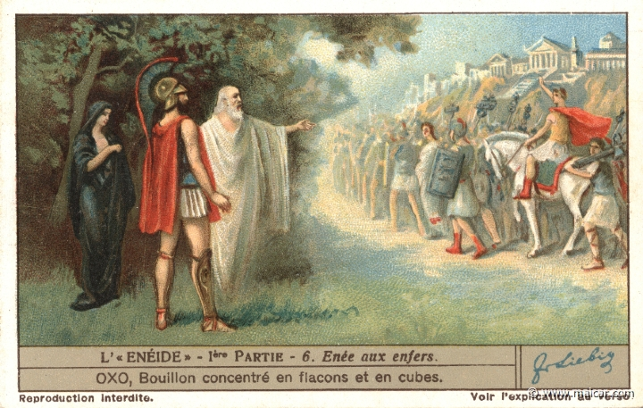

<https://classicalanthology.theclassicslibrary.com/2012/08/07/aeneid-6-847-853/>,

Picture from Carlos Parada, Greek Mythology Link, www.maicar.com – ~~click here~~ for more about Aeneas’ journey to the Underworld including an excellent map.

The above text is provided by the Perseus Digital Library and the translation is by Jane Mason.

Enfer=κολασισ

##### Graeculi

Νικήτας Δημήτριος,

<https://www.lit.auth.gr/node/17>,

Ο Δημήτριος Νικήτας είναι Ομότιμος Καθηγητής Λατινικής Φιλολογίας της Φιλοσοφικής Σχολής του Αριστοτελείου Πανεπιστημίου Θεσσαλονίκης.

<https://pheidias.antibaro.gr/Hellas_names/graeculi-Nikitas.html>,

Ο ελληνικός χαρακτηρισμός «Γραικύλος» είναι απόδοση του λατινικού χαρακτηρισμού Graeculus, ο οποίος με τη σειρά του είναι υποκοριστικό του εθνικού ονόματος Graecus που χρησιμοποιούσαν οι Ρωμαίοι για τους Ελληνες. Το λατινικό υποκοριστικό μαρτυρείται σε πενήντα περίπου χωρία λατίνων συγγραφέων, από τα χρόνια του Κικέρωνα μέχρι σχεδόν τον 4ο αιώνα μ.Χ. Το ελληνικό υποκοριστικό με εξαίρεση μια μαρτυρία του Δίωνος Κασσίου (46, 18, 1, βλ. παρακάτω), δεν εντοπίζεται στην αρχαία ελληνική και στη βυζαντινή γραμματεία ως τον 10ο αιώνα.

Αξίζει επίσης να σημειωθεί ότι το όνομα Graeculus είναι, μαζί με το όνομα Poenulus (= «Καρχηδονίσκος»), τα μόνα υποκοριστικά εθνικών χαρακτηρισμών που περιέχει η λατινική γλώσσα. Δεν είναι φυσικά τυχαίο το γεγονός ότι τα δύο αυτά υποκοριστικά αφορούν τους δύο μεγαλύτερους αντιπάλους της Ρώμης, τους οποίους υπέταξε η ρωμαϊκή λόγχη με πολύ μόχθο και αίμα.

Οπως ορθά σημειώνεται στο «βέβηλο» γράμμα που παραθέτει ο Μάριος Πλωρίτης στο «Βήμα» της Κυριακής, 7 Ιουνίου 1998, «"πατέρας" αυτού του επιθέτου (Graeculus) ήταν ο Κικέρων». Αυτό αληθεύει υπό την έννοια ότι ο διάσημος αυτός ρωμαίος πολιτικός και ρήτορας πρέπει να θωρηθεί πιθανότατα ο «ευρετής» αυτού του υποκοριστικού, το οποίο επανέρχεται στο έργο του επανειλημμένα (16 φορές!).

###### Cicero and the Greeks

<https://www.worldhistory.biz/sundries/31218-4-cicero-and-the-greeks.html>,

… Admiration for the cultural achievements of classical Greece was one side of this ambivalent attitude. The other was a feeling of superiority towards their Greek contemporaries who were, after all, their provincial subjects and whom they often regarded with contempt. …

**Cicero often expresses a Roman sense of superiority over the Greeks**. In a letter to his brother Quintus he warns him to be careful in his choice of Greek friends; …

###### GuiteHaroldCicerosAttitudeToTheGreeks,

Paper,

Pont du Gard,

<https://en.wikipedia.org/wiki/Pont_du_Gard>,

The Pont du Gard is an ancient Roman aqueduct bridge built in the first century AD to carry water over **50 km** (31 mi) to the Roman colony of Nemausus (Nîmes).[3] It crosses the river Gardon near the town of Vers-Pont-du-Gard in southern France. The Pont du Gard is one of the best preserved Roman aqueduct bridges. It was added to UNESCO's list of World Heritage sites in 1985 because of its exceptional preservation, historical importance, and architectural ingenuity.[4]…

…In one section, the winding route between the Pont du Gard and St Bonnet required an extraordinary degree of accuracy from the Roman engineers, **who had to allow for a fall of only 7 millimetres (0.28 in) per 100 metres** (330 ft) of the conduit.[10] …

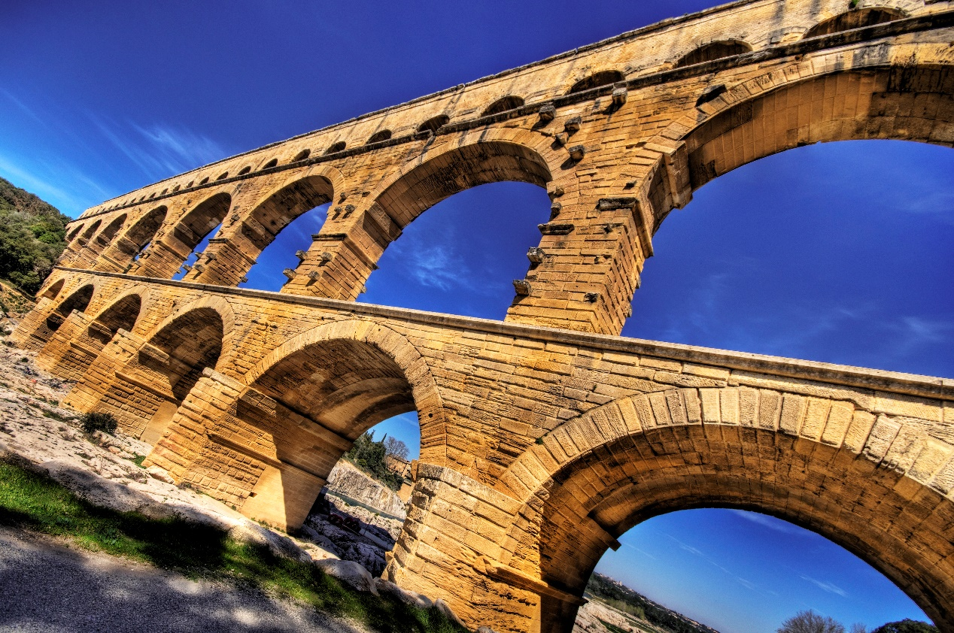

Pont du Gard's stone blocks, some of which weigh up to six tons, were precisely cut to fit together without the need for mortar.

#### Roman law,

<https://en.wikipedia.org/wiki/Roman_law>,

Roman law is the legal system of ancient Rome, including the legal developments spanning over a thousand years of jurisprudence, from the Twelve Tables (c. 449 BC), to the Corpus Juris Civilis (AD 529) ordered by Eastern Roman emperor Justinian I. Roman law forms the basic framework for civil law, the most widely used legal system today, and the terms are sometimes used synonymously. The historical importance of Roman law is reflected by the continued use of Latin legal terminology in many legal systems influenced by it, including common law.

After the dissolution of the Western Roman Empire, the Roman law remained in effect in the Eastern Roman Empire. From the 7th century onward, the legal language in the East was Greek.

1964, ΕΙΣΑΓΩΓΙΚΕΣ ΕΞΕΤΑΣΕΙΣ, λατινικα,

### ROMAN MATHEMATICS,

#### GENERALITIES,

KATZ, p. 157,

PRACTICAL MATHEMATICS

By’s time, the entire eastern Mediterranean—and much else besides—was part of the Roman Empire. The administrative center of the empire was, of course, in Rome, and the official language was Latin. Nevertheless, in much of the empire there were local rulers, and the **Romans left the local language and culture intact.** In particular, in the eastern Mediterranean, including what is now Egypt, Israel, Syria, mainland Greece, and Turkey, the prevalent “international” language remained Greek. And Alexandria itself remained an intellectual center, where Ptolemy, among others, found it conducive to work.

5.3.1 Roman Mathematics

Was there “Roman mathematics,” or was all the mathematics accomplished under the aegis of the Roman Empire part of “Greek mathematics”? **The great orator Cicero admitted that the Romans were not interested in mathematics:** “The Greeks held the geometer in the highest honor; accordingly, nothing made more brilliant progress among them than mathematics. But we have established as the limit of this art its usefulness in measuring and counting.”**13** But Cicero himself, as a magistrate and landowner, was certainly numerate enough to understand accounts and detect frauds. So, although it is certainly true that there was no Roman Euclid or Archimedes, in fact the Romans did have somewhat more to do with mathematics than “measuring and counting.” One person whose writings (in Latin) display a solid knowledge of mathematics is Vitruvius (first century bce). In his famous work, On Architecture, he wrote that architects needed to have a comprehensive liberal education, including topics from draftsmanship to astronomy. In particular, he noted: “Geometry, in turn, offers many aids to architecture, and first among them, it hands down the technique of compass and rule, which enables the onsite layout of the plan as well as the placement of set-squares, levels, and lines. Likewise, through knowledge of optics, windows are properly designed so as to face particular regions of heaven. Through arithmetic the expenses of buildings are totaled up, and the principles of measurement are developed, the difficult issues of symmetry are resolved by geometric principles and methods.”14 But although Vitruvius recommended such knowledge for architects, On Architecture itself contains only a little mathematics.

The Roman Empire was famous for its surveyors. **They laid out roads and aqueducts** throughout a huge territory, many of which still survive. But an inspection of the extant surveying manuals shows that the Roman surveyors used only very elementary mathematics.

… This is obviously quite an elementary method, but the records do not show the use of more sophisticated mathematics in surveying.

This is particularly surprising, since Greek mathematicians had developed better methods of indirect measurement. As we have seen, Hipparchus’s and Ptolemy’s trigonometry enabled the Greeks to “measure” triangles in the heavens as well as those on the earth related to occurrences in the heavens. And it would appear that these same methods would enable one to solve ordinary triangles on earth in order to make indirect measurements of distance and height. It would seem natural that, at least after the time of Hipparchus, the Greeks and Romans would use trigonometrical methods, that is, methods involving the table of chords. But the available historical evidence gives us no reason to believe that they did so.

13. Cicero, Tusculan Disputations (Cambridge: Harvard University

Press, 1927), I, p. 2.

14. Vitruvius, Ten Books on Architecture, Ingrid Rowland and

Thomas Howe, eds. (Cambridge: Cambridge University

Press, 1999), p. 22.