13 ΔΙΑΛΕΞΗ,

06-04-2024, ΣΑΒΒΑΤΟ, 12.00-02.00,

Webex meeting recording: 13 dialeksis INM 2024, SATURDAY 12.00-14.00-20240406 0930-1

Password: bUp7hQZf

Recording link: <https://uoa.webex.com/uoa/ldr.php?RCID=d2f3810c0448fb8b5b6119e865672d44>,

**ΠΡΟΚΑΤΑΡΚΤΙΚΑ, ,**

ΑΠΑΝΤΗΣΗ στις 3002 ?, δεν εγινε

#### ROMAN NUMERALS, περιληψη

ΑΡΙΘΜΟΙ 1-10,

I, II, III, IV, V, VI, VII, VIII, IX, X.

ΒΑΣΙΚΑ ΣΥΜΒΟΛΑ για αριθμους 1-3999,

I V X L C D M

1 5 10 50 100 500 1000

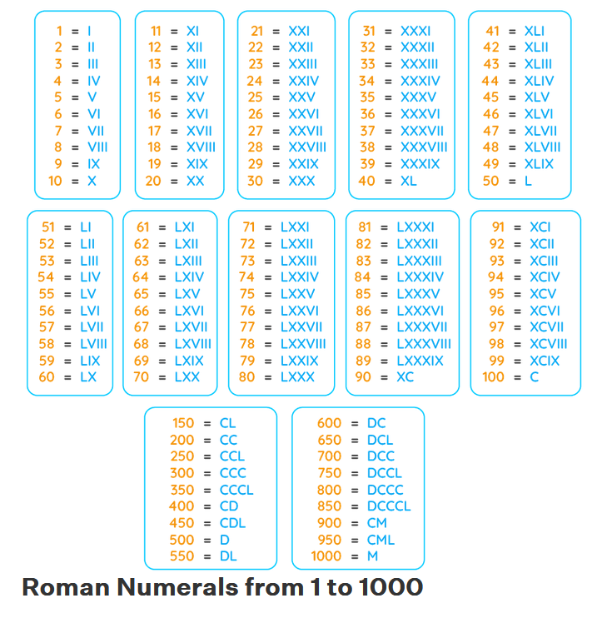

##### ΑΝΙΣΟΤΗΤΑ, ΠΡΟΣΘΕΣΙΣ,

CCM,L,V= 855,

DCCC, L, III=853,

855+853=1708,

CCM, L, V

DCCC, L, III

--------------------

MDCC, , VIII

1

###### **superiority of its numeral system !!!**

Roman numerals

<https://www.britannica.com/science/numeral/Numeral-systems#ref797067>,

The direct influence of Rome for such a long period, the **superiority of its numeral system** (**ti leei ?),** over any other simple one that had been known in Europe before about the 10th century, and the **compelling force of tradition** explain the strong position that the system maintained for nearly 2,000 years in commerce, in scientific and theological literature, and in belles lettres. It had the great advantage that, for the mass of users, memorizing the values of only four letters was necessary—V, X, L, and C. **Moreover, it was easier to see three in III than in 3 and to see nine in VIIII than in 9**, and it was correspondingly easier to add numbers—**the most basic arithmetic operation.**

###### Addition of Two Roman Numerals

<https://medium.com/@jsrcoder/addition-of-two-roman-numerals-9823de610cb5>,

εχει προγραμμα