14 ΔΙΑΛΕΞΙΣ,

10-04-2024, τεταρτη.

Webex meeting recording: 14 dialeksis INM 2024 tetarth, 11.00-14.00-20240410 0819-1

Password: UcFSksJ4

Recording link: https://uoa.webex.com/uoa/ldr.php?RCID=4078ac3e76d3da5591558c2f3898a260,

**ΠΡΟΚΑΤΑΡΚΤΙΚΑ,**

**ΕΠΑΝΑΛΗΨΕΙΣ,**

## ΕΠΑΝΑΛ. ΙΝΔΙΚΟ-ΑΡΑΒΙΚΟ ΑΡΙΘΜΗΤΙΚΟ ΣΥΣΤΗΜΑ, ΠΕΡΙΛΗΨΙΣ,

### Hindu–Arabic numeral system,

<https://en.wikipedia.org/wiki/Hindu%E2%80%93Arabic_numeral_system#Glyph_comparison>,

“The Hindu–Arabic numeral system or Indo-Arabic numeral system[1] (also called the Hindu numeral system or Arabic numeral system)[2][note 1] is a positional (place value), decimal numeral system, and is the most common system for the symbolic representation of numbers in the world.

**It was invented between the 1st and 4th centuries by Indian mathematicians**. The system was adopted **in Arabic mathematics by the 9th century**. It became more widely known through the writings of the Persian mathematician Al-Khwārizmī[3], (Ο ΧΟΡΑΣΜΙΟΣ, 9th century), ), . (On the Calculation with Hindu Numerals, c. 825) and Arab mathematician Al-Kindi (On the Use of the Hindu Numerals, c. 830). The system had spread to medieval Europe by the High Middle Ages.

#### Adoption in Europe

Main article: Arabic numerals

“The Arabic numeral system first appeared in Europe in the Spanish Codex Vigilanus, year 976.

In Christian Europe, the first mention and representation of Hindu–Arabic numerals (from one to nine, without zero), is in the Codex Vigilanus (aka Albeldensis), an illuminated compilation of various historical documents from the Visigothic period in Spain, written in the year 976 by three monks of the Riojan monastery of San Martín de Albelda. Between 967 and 969, **Gerbert de Aurillac (946 – 12 May 1003)** discovered and studied Arab science in the Catalan abbeys. Later he obtained from these places the book De multiplicatione et divisione (On multiplication and division). After becoming **Pope Sylvester II in the year 999,** he introduced a new model of abacus, the so-called Abacus of Gerbert, by adopting tokens representing Hindu–Arabic numerals, from one to nine.

ΣΓΠ, **Sylvester or Silvester** is a name derived from the Latin adjective silvestris meaning "wooded" or "wild", which derives from the noun silva meaning **"woodland**". Classical Latin spells this with i. In Classical Latin, y represented a separate sound distinct from i, not a native Latin sound but one used in transcriptions of foreign words. After the Classical period y was pronounced as i. Spellings with Sylv- in place of Silv- date from after the Classical period.

**Fibonacci**,

<https://en.wikipedia.org/wiki/Fibonacci>,

Fibonacci (/ˌfɪbəˈnɑːtʃi/;[3] also US: /ˌfiːb-/,[4][5] Italian: [fiboˈnattʃi]; c. 1170 – c. 1240–50),[6] also known as **Leonardo Bonacci**, **Leonardo of Pisa**, or **Leonardo Bigollo Pisano** ('Leonardo the Traveller from Pisa'[7]), was an Italian mathematician from the **Republic** of Pisa, considered to be "the most talented Western mathematician of the Middle Ages".[8] ???? Eves, Howard. An Introduction to the History of Mathematics. Brooks Cole, 1990: ISBN 0-03-029558-0 (6th ed.), p. 261,

**Leonardo Fibonacci (c. 1170 – c. 1240–50),**

brought this system to Europe. His book Liber Abaci introduced Modus Indorum (the method of the Indians), today known as Hindu–Arabic numeral system or base-10 positional notation, the use of zero, and the decimal place system to the Latin world. The numeral system came to be called "Arabic" by the Europeans. **It was used in European mathematics from the 12th century, and entered common use from the 15th century to replace Roman numerals.[15][16]”**

**Liber Abaci**

Liber Abaci (also spelled as Liber Abbaci;[1] "The Book of Calculation") is a **historic 1202** Latin manuscript on arithmetic by Leonardo of Pisa, posthumously known as Fibonacci.

*Liber Abaci* was among the first Western books to describe the [Hindu–Arabic numeral system](https://en.wikipedia.org/wiki/Hindu%E2%80%93Arabic_numeral_system) and to use symbols resembling modern "[Arabic numerals](https://en.wikipedia.org/wiki/Arabic_numerals)". By addressing the applications of both commercial tradesmen and mathematicians, it promoted the superiority of the system, and the use of these glyphs.[[2]](https://en.wikipedia.org/wiki/Liber_Abaci#cite_note-2)

Although the book's title is sometimes translated as "**The Book of the Abacus", Sigler (2002) notes that it is an error to read this as referring to calculating devices called "abacu**s". Rather, the word "abacus" was used at the time to refer to calculation in any form; the spelling "abbacus" with two "b"s (which is how Leonardo spelled it in the original Latin manuscript) was, and still is in Italy, used to refer to calculation using Hindu-Arabic numerals, which can avoid confusion. The book describes methods of doing calculations without aid of an abacus, and as Ore (1948) confirms, for centuries after its publication the algorismists (followers of the style of calculation demonstrated in Liber Abaci) remained in conflict with the abacists (traditionalists who continued to use the abacus in conjunction with Roman numerals). The historian of mathematics Carl Boyer emphasizes in his History of Mathematics that although "Liber abaci...is not on the abacus" per se, nevertheless "...it is a very thorough treatise on algebraic methods and problems in which the use of the Hindu-Arabic numerals is strongly advocated."[3]

**In 1240, the Republic of Pisa honored Fibonacci (referred to as Leonardo Bigollo)[20] by granting him a salary in a decree that recognized him for the services that he had given to the city as an advisor on matters of accounting and instruction to citizens.[21][22]**

Fibonacci is thought to have died between 1240[23] and 1250,[24] in Pisa.

[21], Keith Devlin (7 November 2002). *["A man to count on"](https://www.theguardian.com/education/2002/nov/07/research.science)*. The Guardian. [*Archived*](https://web.archive.org/web/20160917004540/https:/www.theguardian.com/education/2002/nov/07/research.science) from the original on 17 September 2016*. Retrieved 7 June 2016*.

<https://www.theguardian.com/education/2002/nov/07/research.science>,

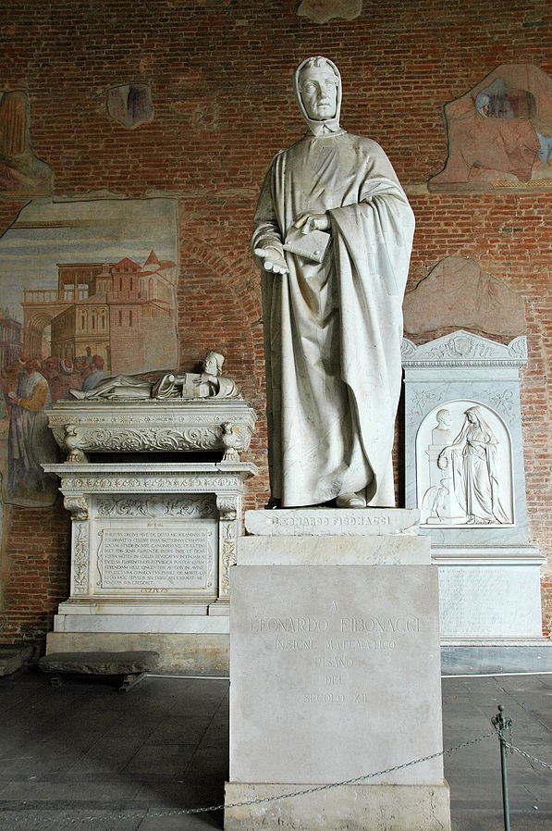

<https://en.wikipedia.org/wiki/Fibonacci>,

Statue of Fibonacci (1863) by Giovanni Paganucci in the [Camposanto di Pisa](https://en.wikipedia.org/wiki/Camposanto_di_Pisa)[[a]](https://en.wikipedia.org/wiki/Fibonacci#cite_note-2)

### ΣΧΟΛΙΑΣΜΟΣ ΑΡΙΘΜΗΤΙΚΩΝ ΣΥΣΤΗΜΑΤΩΝ ΑΙΓΥΠΤΙΩΝ, ΒΑΒΥΛΩΝΙΩΝ, ΕΛΛΗΝΩΝ ΡΩΜΑΙΩΝ, ΙΝΔΩΝ-ΑΡΑΒΩΝ,

#### ΚΥΡΙΑ ΣΗΜΕΙΑ

ΚΟΙΝΩΝΙΚΗ ΑΔΡΑΝΕΙΑ,

ΣΧΕΣΗ με την ΟΙΚΟΝΟΜΙΑ, κλπ

ΑΝΑΓΚΗ ΣΥΜΦΕΡΟΝΤΩΝ υπερ του νέο ΣΥΣΤΗΜΑ,

ΠΡΟΣΩΠΙΚΟΙ ΠΑΡΑΓΟΝΤΕΣ

Leonardo Fibonacci, Παπας GERBERT d AURILAC,

ΤΙ ΠΡΕΠΕΙ ΝΑ ΚΑΝΟΥΜΕ ?,

ΕΝΕΡΓΗ ΓΝΩΡΙΜΙΑ με αλλους λαους,

Πειραματισμος σε νεες ιδεες,

«ΔΗΜΟΚΡΑΤΙΑ»,

## ΕΠΑΝΑΛ, ΤΑ ΣΤΟΙΧΕΙΑ,

### ΚΕΝΤΡΙΚΑ ΖΗΤΗΜΑΤΑ,

ΛΟΓΙΚΗ,

ΑΞΙΩΜΑΤΙΚΗ ΘΕΩΡΗΣΗ,

ΜΕΘΟΔΟΣ ΤΗΣ ΕΞΑΝΤΛΗΣΗΣ, (METHOD OF EXAUSTION),

?? ΡΟΛΟΣ ΤΗΣ ΔΗΜΟΚΡΑΤΙΑΣ,

# ΕΞΙΣΩΣΕΙΣ 2ου ΒΑΘΜΟΥ, ΠΕΡΙΛΗΨΗΣ,

## BABYLONIAN CUT and PASTE,

### x+y=b, xy=c

GO KATZ p. 23 and 24,

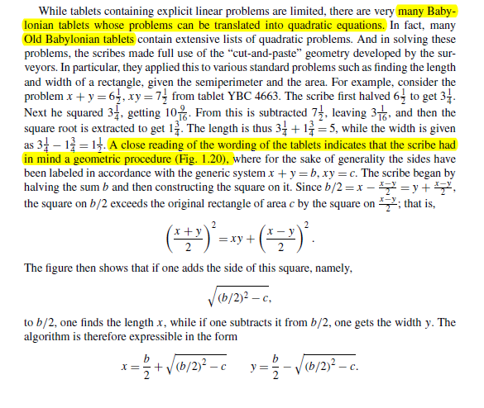

Kata go p. 24,

Σκοπος να αποδειχθη ότι αν x>y

((x+y)/2)2 =xy+ ((x-y)/2))2

Πιθανη ιδεα των Βαβυλωνιων ένα γεωμετρικο σχημα.

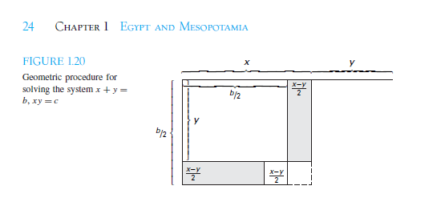

Γο KATZ p.23

Η παραπανω περιγραφη, αντιστοιχει στην σειρα ενεργειων για την εκτελεση των πραξεων, β, β/2, (β/2)2

(β/2)2 –c, ( (β/2)2 –c)1/2 . (μεθοδος ευρεσης τετραγωνικης ριζας)

ΤΟ ΜΗΚΟΣ είναι , β/2 + ( (β/2)2 –c)1/2

ΤΟ ΠΛΑΤΟΣ είναι β/2 - ( (β/2)2 –c)1/2

Κατωτερω αναλυουμε «καπως καλλιτερα», την αποδειξη του

((x+y)/2)2 =xy+ ((x-y)/2))2

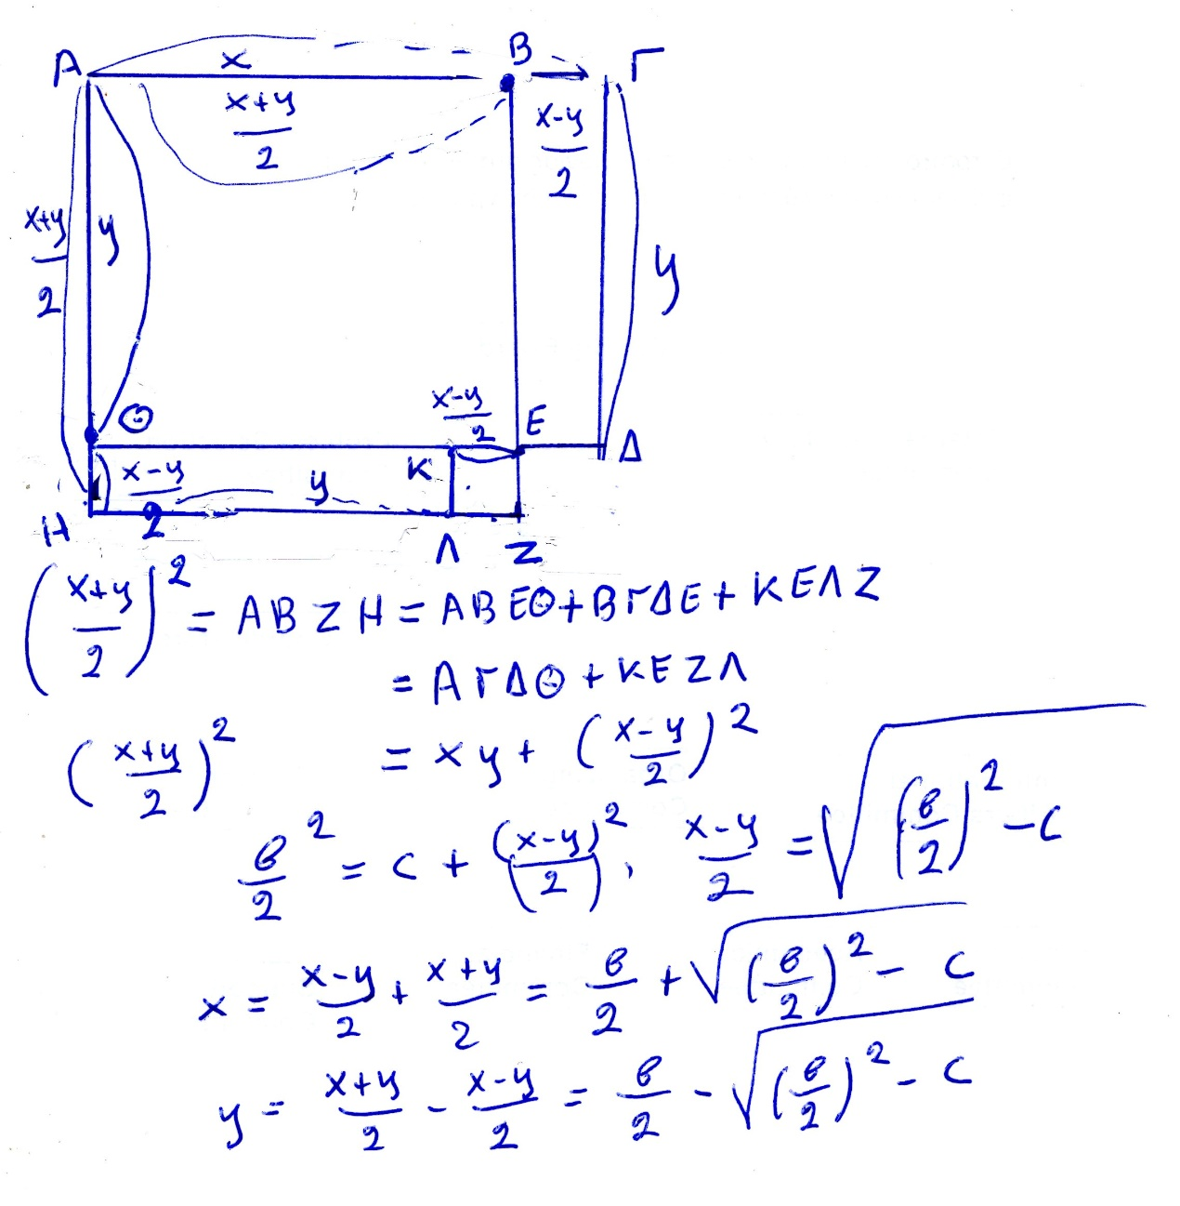

### ΕΞΙΣΩΣΗΣ x2 +bx=c,

KATZ p.24, 25

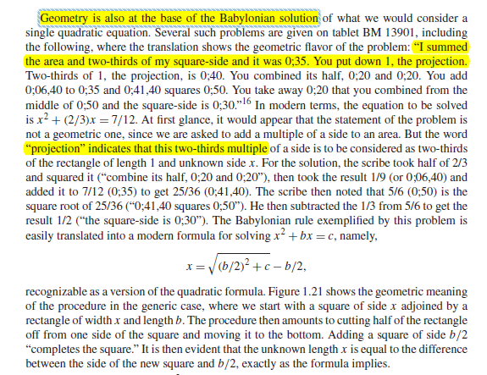

Ας δουμαι πως τα παραπανω εξηγουνται γεωμετρικα.

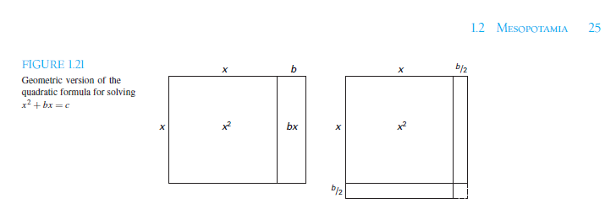

**ΕΞΙΣΩΣΗ x2 +bx=c,**

Τα κατωτερω είναι καπως πιο απλοποιητικα.

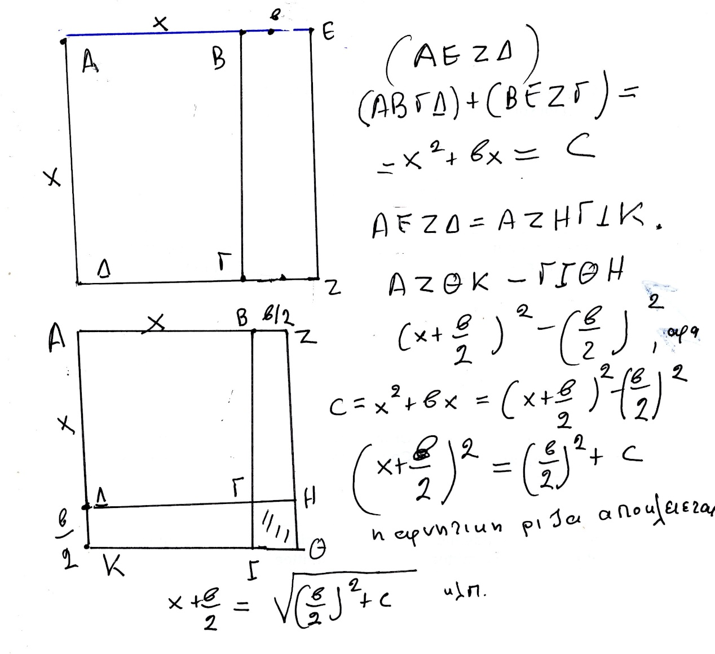

### x2 –bx=c

katz p. 25

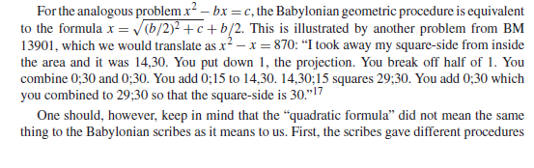

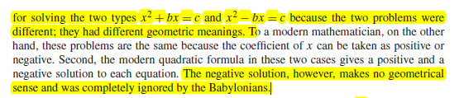

Κατωτερω δινουμε μια αποδειξη, με γεωμετρικο τροπο, CUT-PASTE, basizomenh στην γνωση των εμβαδων ορθογωνιων παραλληλογραμμων. Φαινεται ότι καπως ετσι τα εκαναν και οι ΒΑΒΥΛΩΝΙΟΙ.

**ΕΞΙΣΩΣΗ, x2 –bx=c**

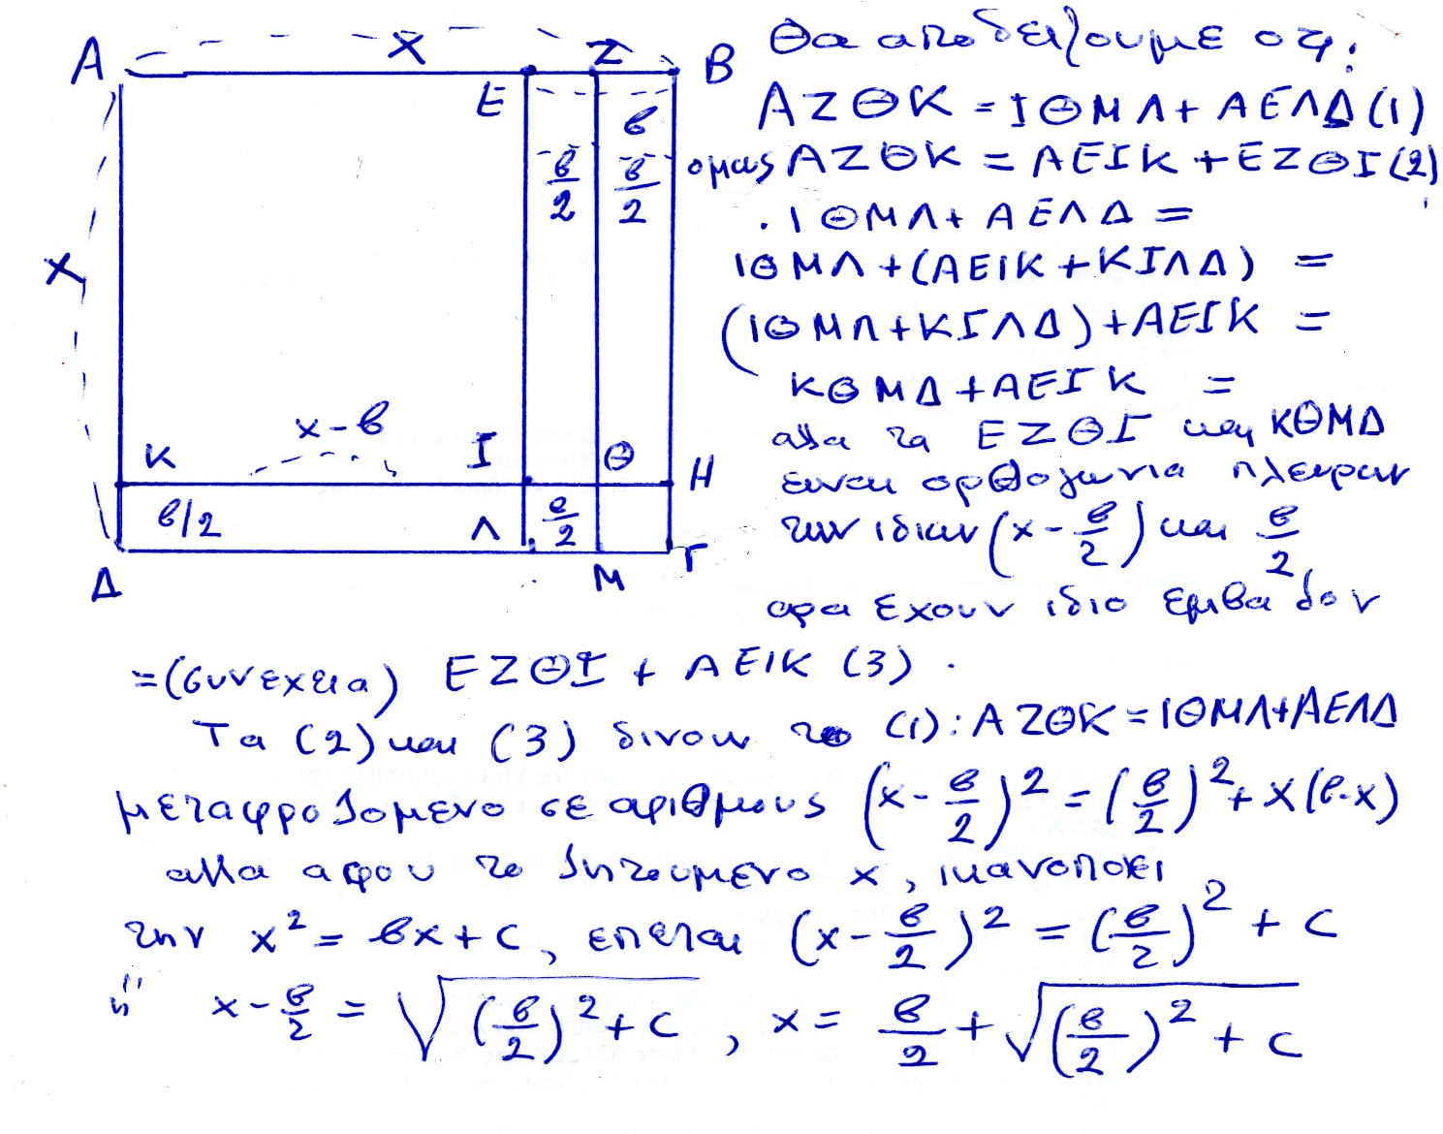

### SCALING,

Katz p.25

### x2 –y2 = (x+y).(x-y),

Να αποδειχθει γεωμετρικα, katz p.26,

### CONCLUSION for BABYLONIAN MATHEMATICS,

GO KATZ p. 27, είναι μια αποψη ενδιαφερουσα,

The extant papyri and tablets containing Egyptian and Babylonian mathematics were **generally teaching documents,** used to transmit knowledge from one scribe to another. Their function was to provide trainee scribes with a set of example-types, problems whose solutions could be applied in other situations. Learning mathematics for these trainees was learning how to select and perhaps modify an appropriate algorithm, and then mastering the arithmetic techniques necessary to carry out the algorithm to solve a new problem. **The reasoning behind the algorithms was evidently transmitted orally, so that mathematicians today are forced to speculate as to the origins.** We note that although the long lists of quadratic problems on some of the Babylonian tablets were given as “real-world” problems, the problems are in fact just as contrived as the ones found in most current algebra texts. That the authors knew they were contrived is shown by the fact that, typically, **all problems of a given set have the same answer.** But since often the problems grew in complexity, it appears that the tablets were used to develop techniques of solution. **One can speculate, therefore, that the study of mathematical problem solving, especially problems involving quadratic equations, was a method for training the minds of future leaders of the country.** In otherwords, it was not really that important to solve quadratic equations—there were few real situations that required them. What was important was for the students to develop skills in solving problems in general, skills that could be used in **dealing with the everyday problems that a nation’s leaders need to solve.** These skills included not only following well-established procedures—algorithms—but also knowing how and when to modify the methods and how to reduce more complicated problems to ones already solved. **Today’s students are often told that mathematics is studied to “train the mind.” It seems that teachers have been telling their students the same thing for the past 4000 years.**

SGP. TA της ΜΕΣΟΠΟΤΑΜΙΑΣ, MAΘHMATIKA eginan kyrios gia efarmoges. Piθanh εξαιρεση η εξισωση β βαθμου.

ΕΛΛΕΙΨΗ «ΑΛΓΕΒΡΑΣ»

## ΕΥΚΛΕΙΔΕΙΑ ΛΥΣΗ Β/θμιας ΕΞΙΣΩΣΗΣ

Γενικη εξισωση β βαθμου κατά την σημερινη αντιληψη:

ax2 +bx+c=0,

where a, b, c are real numbers, a not 0.

Εξισωσεις β βαθμου κατά την ΕΥΚΛΕΙΔΕΙΑΝ ΑΝΤΙΛΗΨΗ

**x2 +ax=c, x2 =ax+c, x2 +c= ax, me a line segment, c area, both positive**

ΣΗΜΕΡΑ,

Η εξισωση ax2 +bx+c=0

Εχει 2 ριζες, τις (-b ± (b2 – 4ac)1/2 )/(2a), στο μιγαδικο πεδιο

An b=2β, οι ριζες είναι, (-β ± (β2 – 4ac)1/2 )/a,

Με οσα ειπαμε, είναι ολες κατασκευασιμες.

### ΔΙΑΙΡΕΣΙΣ ΧΡΥΣΗΣ ΤΟΜΗΣ,

ΣΤΟΙΧΕΙΑ ΕΥΚΛΕΙΔΗ ΙΙ 11,

«λυση» της εξισωσης a(a-x)=x2 ,

See <https://mathcs.clarku.edu/~djoyce/java/elements/bookII/propII11.html>,

EUCLID S ELEMENTS

