15 ΔΙΑΛΕΞΙΣ,

ΤΕΤΑΡΤΗ, 17-04-2024, 11-02μμ,

Webex meeting recording: 15 dialeksis INM 2024 tetarth, 11.00-14.00-20240417 0816-1

Password: 23cEeD55

Recording link: <https://uoa.webex.com/uoa/ldr.php?RCID=ebe5ed43eba045a508ebbd07a8a21b59>,

ΠΡΟΚΑΤΑΡΚΤΙΚΑ

ΑΠΟΥΣΙΕΣ,

Σαββατο 20-04-2024 εχουμε διωρο,

Τι κανουμε τα επομενα σαββατα, ?

ΣΧΟΛΙΑ περι την ΕΡΓΑΣΙΑ 6001,

Εστω τριγωνo με πλευρες a, b, c. Εστωσαν τρια χαρακτηριστικα μεγεθη του τριγωνου x, y, z, . Ζητειται να ερευνηθη αν δοθεντων των x, y, z, κατασκευαζεται το τριγωνον.

α ) εκφραζουμε τα x, y, z, ωs synarthseis των a, b, c, (αν γινεται),

x=f (a, b, c), y=g(a, b, c), z=t(a, b, c)

β ) Λυνουμε το συστημα

x=f (a, b, c), y=g(a, b, c), z=t(a, b, c),

με «γνωστα» τα x, y, z, kαι αγνωστους τα a, b, c, δηλ θα βρουμε τυπους π.χ.

a= F(x, y, z), b=G(x, y, z), c=T(x, y, z), klp

Πρεπει τα F, G, T να είναι κατασκευασιμα. κλπ κλπ

## ΔΙΟΦΑΝΤΟΣ, Diophantus,

#### Diophantus, Wikipedia,

<https://en.wikipedia.org/wiki/Diophantus>,

For the general, see Diophantus (general). For the sophist, see Diophantus the Arab.

**Diophantus of Alexandria[1] (born c. AD 200 – c. 214; died c. AD 284 – c. 298)** was a Greek mathematician, who was the author of a series of books called Arithmetica, many of which deal with solving algebraic equations.[2]

Diophantus is considered "the father of algebra"[3] by many mathematicians because of his contributions to number theory, mathematical equations, and the earliest known **use of algebraic notation and symbolism in his works**.[4][5]

**ΣΓΠ, ΚΕΝΤΡΙΚΑ ΣΗΜΕΙΑ,**

(α) syncopated

(β) Επεξετεινε την συζητηση στον κοσμο των ΡΗΤΩΝ,

It should be mentioned here that Diophantus never used general methods in his solutions. **Hermann Hankel**, renowned German mathematician made the following remark regarding Diophantus.

"Our author (Diophantos) not the **slightest** trace of a general, comprehensive method is discernible; each problem calls for some special method which refuses to work even for the most closely related problems.

Discernible,

able to be perceived by a sense (such as sight or smell) or by the mind

For this reason it is difficult for the modern scholar to solve the 101st problem even after having studied 100 of Diophantos's solutions".[14]

Hankel H., “Geschichte der mathematic im altertum und mittelalter, Leipzig, 1874. (translated to English by Ulrich Lirecht in Chinese Mathematics in the thirteenth century, Dover publications, New York, 1973.

TRANSLATE, Geschichte der mathematic im altertum und mittelalter, History of mathematics in antiquity and the Middle Ages

**In modern use, Diophantine equations are algebraic equations with integer coefficients, for which integer solutions are sought.**Diophantine equations, Diophantine geometry, and Diophantine approximations are subareas of number theory that are named after him. Diophantus coined the term παρισότης (parisotes) to refer to an approximate equality.[6] This term was rendered as adaequalitas in Latin, and became the technique of adequality developed by Pierre de Fermat to find maxima for functions and tangent lines to curves. Diophantus was the first Greek mathematician who recognized positive rational numbers as numbers, by allowing fractions for coefficients and solutions.

#### DIOPHANTUS AND GREEK ALGEBRA, KATZ, p. 176

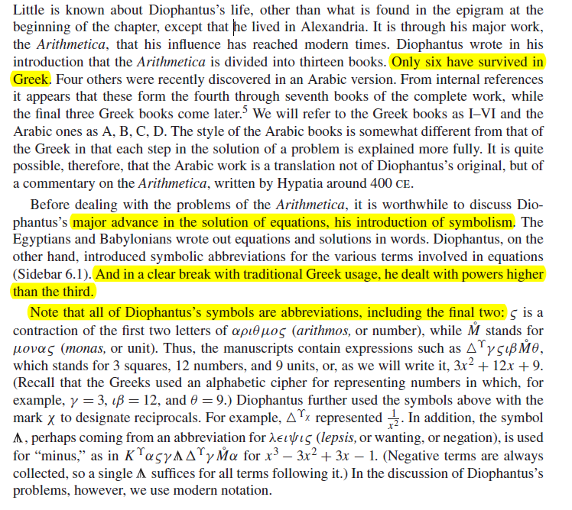

KATZ p. 177.

### ΑΠΟΨΕΙΣ,

History, wiki

Like many other Greek mathematical treatises, Diophantus was forgotten in Western Europe during the Dark Ages, since the study of ancient Greek, and literacy in general, had greatly declined. The portion of the Greek Arithmetica that survived, however, was, like all ancient Greek texts transmitted to the early modern world, copied by, and thus known to, medieval Byzantine scholars. Scholia on Diophantus by the Byzantine Greek scholar John Chortasmenos (1370–1437) are preserved together with a comprehensive commentary written by the earlier Greek scholar Maximos Planudes (1260 – 1305), who produced an edition of Diophantus within the library of the Chora Monastery in Byzantine Constantinople.[15] In addition, some portion of the Arithmetica probably survived in the Arab tradition (see above).

In 1463 **German mathematician Regiomontanus** wrote:

"No one has yet translated from the Greek into Latin the thirteen books of Diophantus, in which the very flower of the whole of arithmetic lies hidden . . . ."

Arithmetica was first translated from Greek into Latin by Bombelli in 1570, but the translation was never published. However, Bombelli borrowed many of the problems for his own book Algebra. The editio princeps of Arithmetica was published in 1575 by Xylander. The Latin translation of Arithmetica by Bachet in 1621 became the first Latin edition that was widely available. Pierre de Fermat owned a copy, studied it and made notes in the margins. A later 1895 Latin translation by Paul Tannery was said to be an improvement by Thomas L. Heath, who used it in the 1910 second edition of his English translation.

Influence

Diophantus' work has had a large influence in history. Editions of Arithmetica exerted a profound influence on the development of algebra in Europe in the late sixteenth and through the 17th and 18th centuries. Diophantus and his works also influenced Arab mathematics and were of great fame among Arab mathematicians. Diophantus' work created a foundation for work on algebra and in fact much of advanced mathematics is based on algebra.[19] How much he affected India is a matter of debate.

Diophantus has been considered **"the father of algebra**" because of his contributions to number theory, mathematical notations and the earliest known use of syncopated notation in his book series Arithmetica.[20] However this is usually debated, because **Al-Khwarizmi** was also given the title as "the father of algebra", nevertheless both mathematicians were responsible for paving the way for algebra today.

**ΣΓΠ, ΚΕΝΤΡΙΚΑ ΣΗΜΕΙΑ,**

(α) syncopated

(β) Επεξετεινε την συζητηση στον κοσμο των ΡΗΤΩΝ,

### ΑΡΙΘΜΗΤΙΚΑ, ΣΓΠ

#### SIR THOMAS L. HEATH,

DIOPHANTUS OF ALEXANDRIA, A STUDY IN THE HISTORY OF GREEK ALGEBRA

##### ΣΥΓΚΕΚΟΜΜΕΝΟΣ ΣΥΜΒΟΛΙΣΜΟΣ

p. 129, Book I,

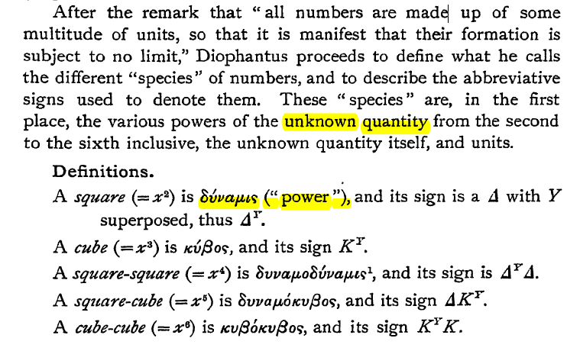

p.130, Book I,

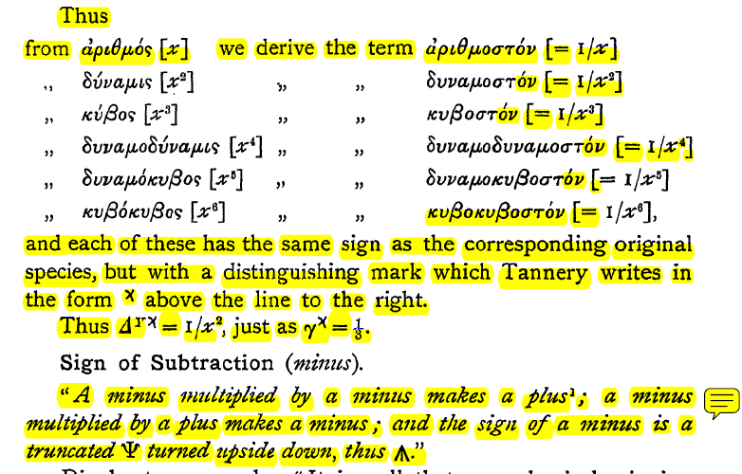

<https://en.wikipedia.org/wiki/Isabella_Bashmakova>,

Isabella Grigoryevna Bashmakova (Russian: Изабелла Григорьевна Башмакова, **1921–2005**) was a Russian historian of mathematics. In 2001, she was a recipient of the **Alexander Koyré́** Medal of the International Academy of the History of Science.

ΦΙΛΗ ΧΡΙΣΤΙΝΑ,

Demetrios Christodoulou Switzerland (2011), Chryssa Kouveliotou United States (2021),

##### ΚΟΣΜΟΣ ΤΩΝ ΡΗΤΩΝ,

p. 131, book I.

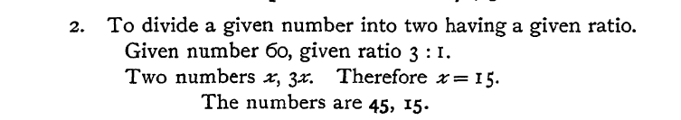

p. 133, book I,

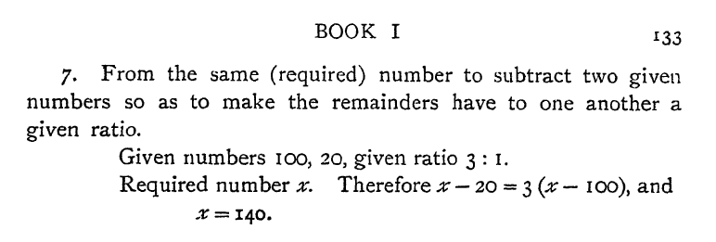

##### ΔΙΑΦΟΡΑ,

###### NEGATIVE NUMBERS,

p. 52

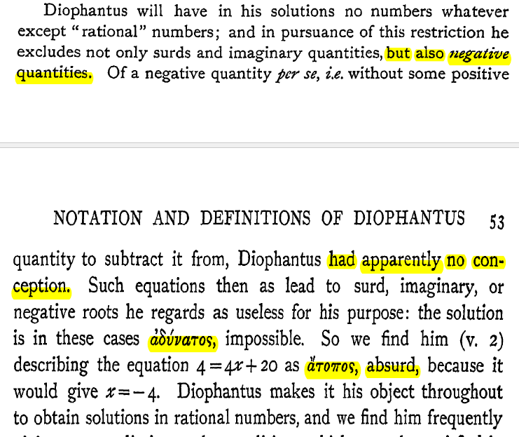

p. 200, book V,

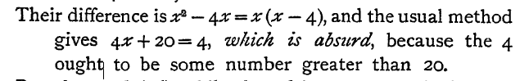

Negative number,

<https://en.wikipedia.org/wiki/Negative_number>,

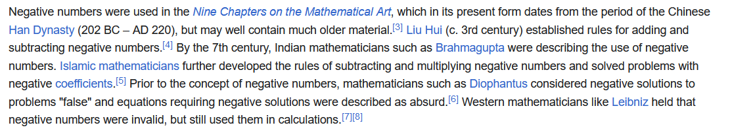

###### THE MARGIN, ΠΕΡΙΘΩΡΙΟ,

Arithmetica, Wikipedia,

Arithmetica is the major work of Diophantus and the most prominent work on algebra in Greek mathematics. It is a collection of problems giving numerical solutions of both determinate and indeterminate equations. **Of the original thirteen books of which Arithmetica consisted only six have survived,** though there are some who believe that four Arabic books discovered in 1968 are also by Diophantus.[13] Some Diophantine problems from Arithmetica have been found in Arabic sources.

**The 1621 edition of Arithmetica by Bachet gained fame after Pierre de Fermat wrote his famous "Last Theorem" in the margins of his copy:**

"If an integer n is greater than 2, then an + bn = cn has no solutions in non-zero integers a, b, and c. I have a truly marvelous proof of this proposition which this margin is too narrow to contain."

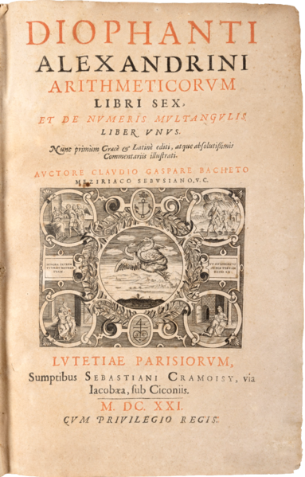

Title page of the original 1621 edition of the Latin translation by [Claude Gaspard Bachet de Méziriac](https://en.wikipedia.org/wiki/Claude_Gaspard_Bachet_de_M%C3%A9ziriac) of Diophantus' *Arithmetica,* [*https://en.wikipedia.org/wiki/Diophantus*](https://en.wikipedia.org/wiki/Diophantus)*,*

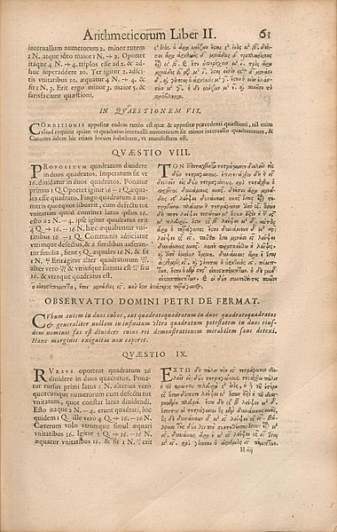

Problem II.8 in the *Arithmetica* (edition of 1670), annotated with Fermat's comment which became [Fermat's Last Theorem](https://en.wikipedia.org/wiki/Fermat%27s_Last_Theorem).,

HEATH, p. 144, book II,

**8. To divide a given square number into two squares**

3 It is to this proposition that Fermat appended his famous note in which he

enunciates what is known as the " great theorem " of Fermat.

The text of the note is as follows :

"On the other hand it is impossible to separate a cube into two cubes, or a

biquadrate into two bi quadrates, or generally any power except a square into two powers with the same exponent. I have discovered a truly marvellous proof of this, which however the margin is not large enough to contain."

Fermat was not the first mathematician so moved to write in his own marginal notes to Diophantus; the Byzantine scholar [John Chortasmenos](https://en.wikipedia.org/wiki/John_Chortasmenos) (1370–1437) had written **"Thy soul, Diophantus, be with Satan because of the difficulty of your other theorems and particularly of the present theorem" next to the same problem**.[[14]](https://en.wikipedia.org/wiki/Diophantus#cite_note-:0-15)

?? Maximus Planudes (c. 1260 – c. 1305, ),

Βλ. Authority across the Byzantine Empire, Judith Herrin, σελ. .322

Και Acerbi, Fabio (2013). "Why did Chortasmenos sent Diphantus to the Devil?". Greek, Roman and Byzantine Studies. 53: 379–389. ISSN 0017-3916 – via library.duke.edu.

## THE ARABS 8-13th century

### History of the Arabs,

<https://en.wikipedia.org/wiki/History_of_the_Arabs>,

The recorded history of the Arabs begins in the mid-ninth century BC, which is the earliest known attestation of the Old Arabic language. **Tradition holds that Arabs descend from Ishmael, the son of Abraham.[1**] The Syrian Desert is the home of the first attested "Arab" groups,[2][3] as well other Arab groups that spread in the land and existed for millennia.[4]

ΙΣΜΑΗΛ, ΑΓΑΡ,

#### Map of expansion of Caliphate.

[https://en.wikipedia.org/wiki/History_of_the_Arabs#](https://en.wikipedia.org/wiki/History_of_the_Arabs),

<https://en.wikipedia.org/wiki/History_of_the_Arabs#/media/File:Map_of_expansion_of_Caliphate.svg>,

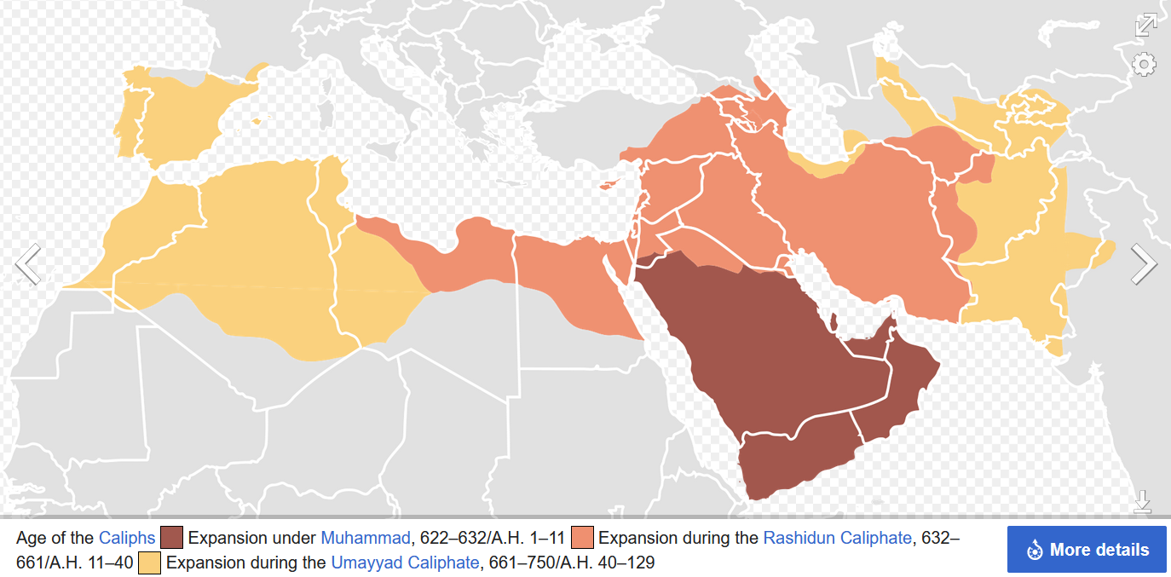

**The Rashidun Caliphate** (Arabic: ٱلْخِلَافَةُ ٱلرَّاشِدَةُ, romanized: al-Khilāfah ar-Rāšidah) was the first caliphate to succeed the Islamic prophet Muhammad. It was ruled by the first four successive caliphs of Muhammad after his death in 632 CE (11 AH). During its existence, the empire was the most powerful economic, cultural, and military force in West Asia and Northeast Africa.

Etymology **The Arabic word rāshidūn (singular: rāshid) means** **"rightly-guided"**. The reign of these four caliphs is considered in Sunni Islam to have been 'rightly-guided', meaning that it constitutes a model (sunna) to be followed and emulated from a religious point of view.[6] This term is not used by Shia Muslims, who reject the rule of the first three caliphs as illegitimate.[7]

#### GIBRALTAR,

<https://en.wikipedia.org/wiki/Gibraltar>,

The name is derived from Arabic: جبل طارق, romanized: **Jabal Ṭāriq, lit. 'Mount of Tariq'** (named after the 8th-century Moorish military leader **Tariq ibn Ziyad).**[20] That continues to be its name in Arabic. It has also been suggested that the name is a contraction of the Arabic: جبل على الطريق jabal ʽalā aṭ-ṭarīq ('mountain on the way').,

Following **a raid in 710,** a predominantly Berber army under the command of Tariq ibn Ziyad crossed from North Africa in April 711 and landed somewhere in the vicinity of Gibraltar (though most likely not in the bay or at the Rock itself).[30][31]

#### Islamic Golden Age

<https://en.wikipedia.org/wiki/Islamic_Golden_Age>,

The Islamic Golden Age was a period of scientific, economic and cultural flourishing in the history of Islam, traditionally dated from the 8th century to the 13th century.[1][2][3]

This period is traditionally understood to have begun during the reign of the **Abbasid caliph Harun al-Rashid (786 to 809) with the inauguration of the House of Wisdom,** which saw scholars from all over the Muslim world flock to Baghdad, the world's largest city by then, to translate the known world's classical knowledge into Arabic and Persian.[4] The period is traditionally said to have ended with the collapse of the Abbasid caliphate due to Mongol invasions and the **Siege of Baghdad in 1258.[5]**

There are a few alternative timelines. Some scholars extend the end date of the golden age to around 1350, including the Timurid Renaissance within it,[6][7] while others place the end of the Islamic Golden Age as late as the end of 15th to 16th centuries, including the rise of the Islamic gunpowder empires.[1][2][3]

##### The House of Wisdom

(Arabic: بيت الحكمة, romanized: Bayt al-Ḥikmah), also known as the Grand Library of Baghdad, was a major Abbasid public academy and intellectual center in Baghdad and one of the world's largest public libraries during the Islamic Golden Age.[1][2][3] The House of Wisdom was founded either as a library for the collections of **the Caliph Harun al-Rashid (763 or 766 – 809), in the late 8th century or was a private collection created by al-Mansur (r. 754–775)** to house rare books and collections of poetry in Arabic. During the reign of the **Caliph al-Ma'mun ( 786 –833**), it was turned into a public academy and a library, τοτε ηκμασε ο Khwarizmi .[1][4]

The House of Wisdom and its contents were destroyed in the Siege of Baghdad in 1258,

### ARABIC ALGEBRA,

Katz p.271,

The most important contributions of the Islamic mathematicians lie in the area of algebra. **They took the material already developed by the Babylonians, combined it with the classical Greek heritage of geometry,** and produced a new algebra, which they proceeded to extend. By the end of the ninth century, the chief Greek mathematical classics were well known in the Islamic world. Islamic scholars studied them and wrote commentaries on them.

The most important idea they learned from their study of these **Greek works was the notion of proof. (SGP and axioms, poy den akoloythhsan !)**, They absorbed the idea that one could not consider a mathematical problem solved unless one could demonstrate that the solution was valid. How does one demonstrate this, particularly for an algebra problem? The answer seemed clear. The only real proofs were geometric.

After all, it was geometry that was found in Greek texts, not algebra. Hence, Islamic scholars generally set themselves the tasks of justifying algebraic rules, either the ancient Babylonian ones or new ones they themselves discovered, and justifying them through geometry.

#### Muḥammad ibn Musa al-Khwarizmi (c. 780–850),

GOOGLE: Khwarizmi,

##### WIKIPEDIA Muḥammad ibn Mūsā

Muḥammad ibn Mūsā al-Khwārizmī[note 1] (Arabic: محمد بن موسى الخوارزمي; c. 780 – c. 850), or al-Khwarizmi η al-Khwarizmi, was a polymath from **Khwarazm**, who produced vastly influential works in mathematics, astronomy, and geography. Around 820 CE, he was appointed as the astronomer and head of the library of the House of Wisdom in Baghdad.[6]: 14

GOGLE: Khwarizmi,

FULL NAME,   **Abu Abdallah Muḥammad ibn Mūsā al-Jwārizmī**.

o ΜΩΑΜΕΘ, Ο πατερας του ΑΜΠΝΤΑΛΑΧ (Δουλου του ΘΕΟΥ), υιος του ΜΩΗΣΗ, από την ΧΟΡΑΣΜΙΑ (ο ΧΟΡΑΣΜΙΟΣ), .

Few details of al-Khwārizmī's life are known with certainty. Ibn al-Nadim gives his birthplace as Khwarazm, and he is generally thought to have come from this region.[26][27][28] Of Persian stock,[29][26][30][31][32] **his name means 'the native of Khwarazm' (Chorasmia), a region that was part of Greater Iran,[33] and is now part of Turkmenistan, and Uzbekistan.**[34]

(Está en una estampilla conmemorativa de la **Unión Sovietica**, emitida el 6 de Septiembre del 1983. La estampilla dice su nombre y "1200 años", referente al aniversario aproximado de su nacimiento). Approximate birth 783.

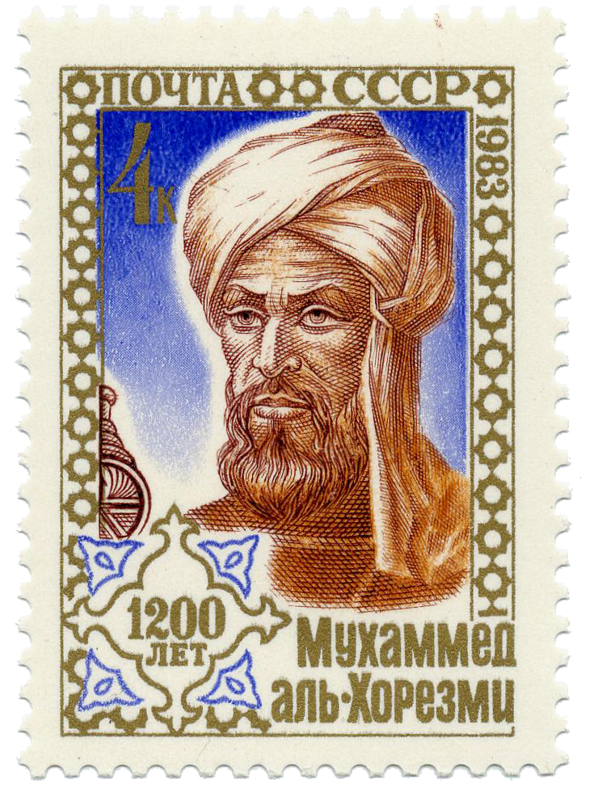

A Soviet postage stamp (issued 6 September 1983) commemorating al-Khwārizmī's (approximate) 1200th birthday.

<https://en.wikipedia.org/wiki/Al-Khwarizmi>,

##### VARIOUS,

CARDANO, ARS MAGNA, trnl WITMER, p. 7

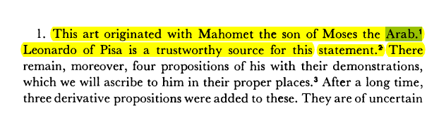

##### Khwarazm

has been known also as Chorasmia, Khaurism,[3] Khwarezm, Khwarezmia, Khwarizm, Khwarazm, Khorezm,[4] Khoresm, Khorasam, Kharazm, Harezm, Horezm, and Chorezm.[5]

In Avestan the name is Xvairizem; in Old Persian 𐎢𐎺𐎠𐎼𐏀𐎷𐎡𐏁 u-v-a-r-z-mi-i-š or 𐎢𐎺𐎠𐎼𐏀𐎷𐎡𐎹 u-v-a-r-z-mi-i-y (/hUvārazmī-/); in Modern Persian: خوارزم Xārazm; in Arabic: خَـوَارِزْم Khawārizm; in Old Chinese *qʰaljɯʔmriɡ (呼似密); in Modern Chinese Huālázǐmó (花剌子模 / Xiao'erjing: خُوَلاذِمُوْ); in Tajik: Хоразм, Xorazm, خوارَزم; in Kazakh: Хорезм (Xorezm), حورەزم; in Uzbek: Xorazm, Хоразм, خورەزم; in Turkmen: Horezm, Хорезм, خوْرِزم; in Azerbaijani: Xarəzm, Харәзм; in Turkish: Harezm**; in Greek language Χορασμία (Chorasmía) and Χορασίμα (Chorasíma) by Herodotus**.

###### Map of the Central Asian Republics

(Kazakhstan, Uzbekistan ...Map of the Central Asian Republics (Kazakhstan, Uzbekistan ...

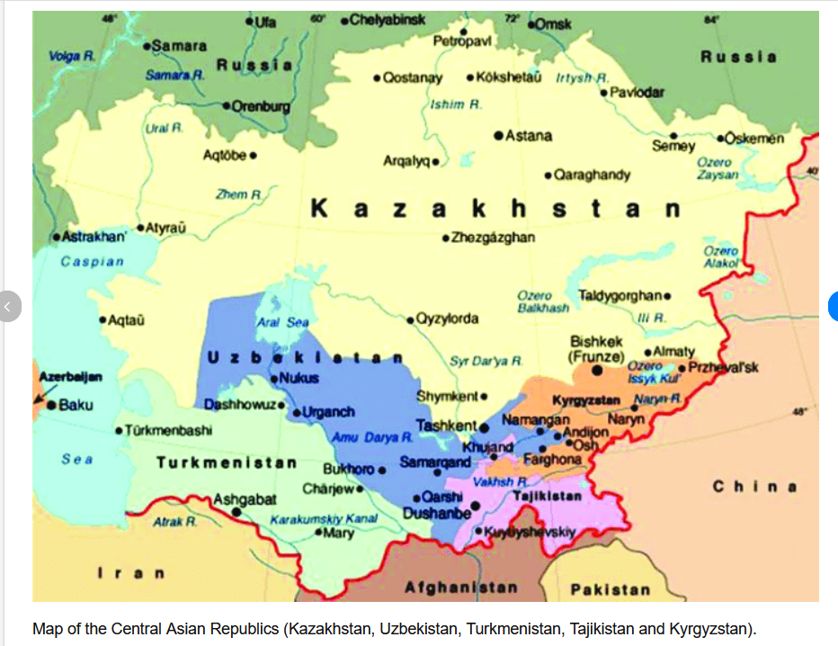

<https://www.google.com/search?client=firefox-b-d&q=Turkmenistan%E2%80%93Uzbekistan++map#vhid=-_7uuRteYhptAM&vssid=l>,

<https://www.researchgate.net/figure/Map-of-the-Central-Asian-Republics-Kazakhstan-Uzbekistan-Turkmenistan-Tajikistan-and_fig1_341538060>,

#### The Compendious Book on Calculation by Completion and Balancing,

“Al-kitāb al-mukhtaṣar fī ḥisāb al-ğabr wa’l-muqābala”[

Katz p. 272

GOOGLE: Al-Jabr, Al jabr, ισως AlJabr.

<https://mathshistory.st-andrews.ac.uk/Biographies/Al-Khwarizmi/quotations/>,

The Arabs contributed nothing new to the theory, but al-Khowirizmi (c. 825) states the usual rules, and the same is true of his successors.

David Eugene Smith. History of Mathematics (1923)

##### st-andrews, Abu Ja'far Muhammad ibn Musa Al-Khwarizmi,

Ο ΜΩΑΜΕΘ, πατερας του Ζαφαρ, υιος του ΜΩΗΣΗ, από την ΧΟΡΑΣΜΙΑ,

<https://mathshistory.st-andrews.ac.uk/Biographies/Al-Khwarizmi/>,

**Al-Khwarizmi also wrote a treatise on Hindu-Arabic numerals.** The Arabic text is lost but a Latin translation, Algoritmi de numero Indorum in English Al-Khwarizmi on the Hindu Art of Reckoning gave rise to the word algorithm deriving from his name in the title. Unfortunately the Latin translation (translated into English in [19]) is known to be much changed from al-Khwarizmi's original text (of which even the title is unknown). The work describes the Hindu place-value system of numerals based on 1, 2, 3, 4, 5, 6, 7, 8, 9, and 0. **The first use of zero as a place holder** in positional base notation was probably due to al-Khwarizmi in this work. Methods for arithmetical calculation are given, and a method to find square roots is known to have been in the Arabic original although it is missing from the Latin version. Toomer writes [1]:-

... the decimal place-value system was a fairly recent arrival from India and ... al-Khwarizmi's work was the first to expound it systematically. Thus, although elementary, it was of seminal importance.

**Akolouthei kalo paradeidma**,

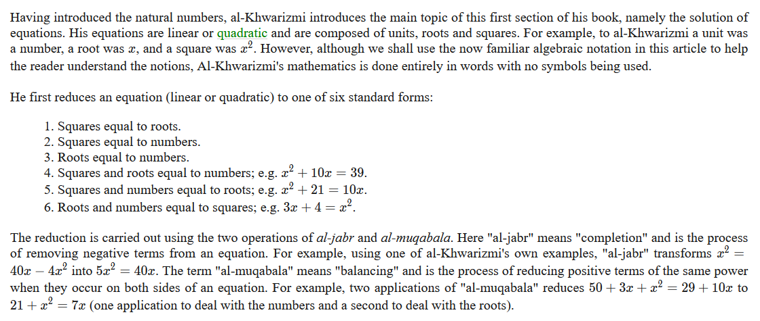

ΠΑΡΑΔΕΙΓΜΑ, «εξισοροπισης» και «αποκαταστασης»

Να βρεθει x ώστε x2 +8x=9

**An** υπαρχει x που να ικανοποιει την ως ανω τοτε

x2 +8x+16=9+16 muqābala,

(x+4)2 =9+16 =25, al-ğabr, klp

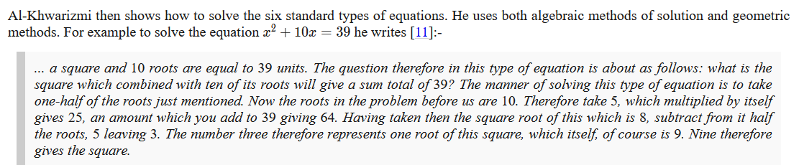

x2 +10x=39

x2 +10x+25=39+25 , muqābala

(x+5)2 =64, aljabr, etc

x+5= 8,

x=8-5=3

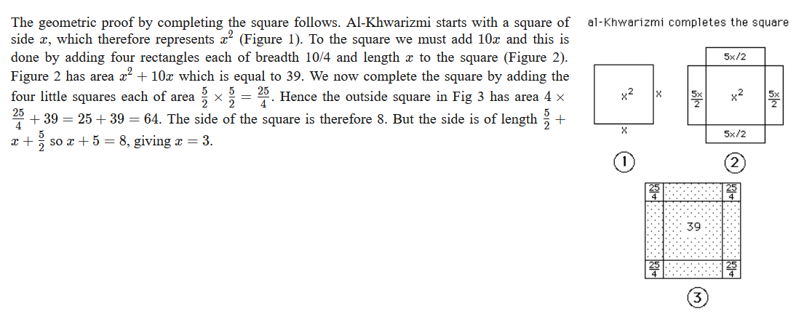

##### LEGACY,

**CARDANO, ARS MAGNA, trnl WITMER, p. 7**



[**https://en.wikipedia.org/wiki/Al-Jabr**](https://en.wikipedia.org/wiki/Al-Jabr)**,**

In the 12th century, Latin translations of his textbook on arithmetic (Algorithmo de Numero Indorum) which codified the various Indian numerals, introduced the decimal positional number system to the Western world.[23] The Compendious Book on Calculation by **Completion and Balancing, translated into Latin by Robert of Chester in 1145, was used until the sixteenth century as the principal mathematical text-book of European universities.[24][25][26][27]**

**R. Rashed and Angela Armstrong write:**

Al-Khwarizmi's text can be seen to be distinct not only from the Babylonian tablets, but also from the Diophantus' Arithmetica. It no longer concerns a series of problems to be resolved, but an exposition which starts with primitive terms in which the **combinations must give all possible prototypes for equations**, which henceforward explicitly constitute the **true object of study**. On the other hand, the idea of an equation for its own sake appears from the beginning and, one could say, in a generic manner, insofar as it does not simply emerge in the course of solving a problem, but is specifically called on to define an infinite class of problems.[8]

**J. J. O'Connor and E. F. Robertson wrote in the MacTutor History of Mathematics archive:**

Perhaps one of the most significant advances made by Arabic mathematics began at this time with the work of al-Khwarizmi, namely the beginnings of algebra. It is important to understand just how significant this new idea was. It was a revolutionary move away from the **Greek concept of mathematics which was essentially geometry.** Algebra was a unifying theory which allowed **rational numbers, irrational numbers, geometrical magnitudes, etc., to all be treated as "algebraic objects**". It gave mathematics a whole new development path so much broader in concept to that which had existed before, and provided a vehicle for future development of the subject. Another important aspect of the introduction of algebraic ideas was that it allowed mathematics to be applied to itself in a way which had not happened before.