16 ΔΙΑΛΕΞΗ,

Webex meeting recording: 16 Dialekisis INM 2024, SATURDAY 12.00-14.00-20240420 0916-1

Password: mJZDHXM7

Recording link: https://uoa.webex.com/uoa/ldr.php?RCID=3de4668c2f2a1b2c50fd7ebc85975587

ΠΡΟΚΑΤΑΡΚΤΙΚΑ,

Σαβατο του ΛΑΖΑΡΟΥ, 27-04-2024, να μετακινηθει το

Σαβαττο 18-05-2024 (το πρωτο μετα της διακοπες του ΠΑΣΧΑ, που θα γινει 2ωρο,

Θα το ρυθμισουμε αργοτερα, . Το 18-05-2024, ενεδιν , όχι μαθημα

ΕΤΣΙ καταλληγουμε σε ΧΡΕΟΣ 3 ημερων που πρεπει να καλυφθη

ERGASIA 2002 καλλιτερο συστημα,

1004 hliokentriko να σθμπληροτηει η λυση,

# [ΟΛΟΚΛΗΡΩΜΑ, [ΠΑΡΑΓΩΓΟΙ,

## ΑΡΧΙΜΗΔΗΣ, Archimedes,

### HISTORY,

#### <https://en.wikipedia.org/wiki/Archimedes#cite_note-23>,

**Archimedes of Syracuse** ([/ˌɑːrkɪˈmiːdiːz/](https://en.wikipedia.org/wiki/Help:IPA/English), [*ARK-ihm-EE-deez*](https://en.wikipedia.org/wiki/Help:Pronunciation_respelling_key);[[2]](https://en.wikipedia.org/wiki/Archimedes#cite_note-Collins-2)[[a]](https://en.wikipedia.org/wiki/Archimedes#cite_note-3) c. 287 – c. 212 BC) was an [Ancient Greek](https://en.wikipedia.org/wiki/Ancient_Greece) [mathematician](https://en.wikipedia.org/wiki/Greek_mathematics), [physicist](https://en.wikipedia.org/wiki/Physicist), [engineer](https://en.wikipedia.org/wiki/Engineer), [astronomer](https://en.wikipedia.org/wiki/Astronomer), and [inventor](https://en.wikipedia.org/wiki/Invention) from the ancient city of [Syracuse](https://en.wikipedia.org/wiki/Syracuse,_Sicily) in [Sicily](https://en.wikipedia.org/wiki/History_of_Greek_and_Hellenistic_Sicily).[[3]](https://en.wikipedia.org/wiki/Archimedes#cite_note-4) Although few details of his life are known, he is regarded as one of **the leading scientists in** [**classical antiquity**](https://en.wikipedia.org/wiki/Classical_antiquity)**.** **Considered the greatest mathematician of** [**ancient history**](https://en.wikipedia.org/wiki/Ancient_history)**, and one of the greatest of all time,**[**[4]**](https://en.wikipedia.org/wiki/Archimedes#cite_note-LitList-5)

**ΣΓΠ. ΑΡΧΙΜΗΔΗΣ η ΣΤΟΙΧΕΙΑ ?**

Archimedes anticipated modern [calculus](https://en.wikipedia.org/wiki/Calculus) and [analysis](https://en.wikipedia.org/wiki/Mathematical_analysis) by applying the concept of the [infinitely small](https://en.wikipedia.org/wiki/Cavalieri%27s_principle) and the [method of exhaustion](https://en.wikipedia.org/wiki/Method_of_exhaustion) to derive and rigorously prove a range of [geometrical](https://en.wikipedia.org/wiki/Geometry) [theorems](https://en.wikipedia.org/wiki/Theorem).[[5]](https://en.wikipedia.org/wiki/Archimedes#cite_note-:2-6)[[6]](https://en.wikipedia.org/wiki/Archimedes#cite_note-:9-7) These include the [area of a circle](https://en.wikipedia.org/wiki/Area_of_a_circle), the [surface area](https://en.wikipedia.org/wiki/Surface_area) and [volume](https://en.wikipedia.org/wiki/Volume) of a [sphere](https://en.wikipedia.org/wiki/Sphere), the area of an [ellipse](https://en.wikipedia.org/wiki/Ellipse), the area under a [parabola](https://en.wikipedia.org/wiki/Parabola), the volume of a segment of a [paraboloid of revolution](https://en.wikipedia.org/wiki/Paraboloid_of_revolution), the volume of a segment of a [hyperboloid of revolution](https://en.wikipedia.org/wiki/Hyperboloid_of_revolution), and the area of a [spiral](https://en.wikipedia.org/wiki/Spiral).[[7]](https://en.wikipedia.org/wiki/Archimedes#cite_note-8)[[8]](https://en.wikipedia.org/wiki/Archimedes#cite_note-:0-9)

ΣΓΠ εννοια οριου,

#### Magna Graecia, Magna Grecia, Μεγαλη Ελλας,

ιταλικά: Grande Ellade,

<https://en.wikipedia.org/wiki/Magna_Graecia>,

Magna Graecia[a] was the name given by the Romans to the Greek-speaking coastal areas of Southern Italy in the present-day Italian regions of Calabria, Apulia, Basilicata, Campania and Sicily; these regions were extensively populated by Greek settlers **starting from the 8th century BC.[2]**

The settlements in this region, founded initially by their metropoleis (mother cities), eventually evolved into strong Greek city-states (poleis), functioning independently. The settlers brought with them their Hellenic civilization, and developed their own civilisation of the highest level,[3] due to the distance from the motherland and the influence of the indigenous peoples of southern Italy[3] which left a lasting imprint on Italy (such as in the culture of ancient Rome). They also influenced the native peoples, such as the Sicels and the Oenotrians, who became hellenised after they adopted the Greek culture as their own. **In some fields such as architecture and urban planning, they sometimes surpassed the mother country**.[4] The ancient inhabitants of Magna Graecia are called Italiotes and Siceliotes.

Remains of some of these Greek cities can be seen today, such as Neapolis ("New City", now Naples), Syrakousai (Syracuse), Akragas (Agrigento), Taras (Taranto), Rhegion (Reggio Calabria), and Kroton (Crotone). **The most populous city of Magna Graecia was Sybaris (now Sibari) with an estimated population, from 600 BC to 510 BC, between 300,000 and 500,000**.[1]

Bl. Kai Μεγάλη Ελλάδα, <https://el.wikipedia.org/wiki/%CE%9C%CE%B5%CE%B3%CE%AC%CE%BB%CE%B7_%CE%95%CE%BB%CE%BB%CE%AC%CE%B4%CE%B1>,

The government of city-states was usually an aristocracy[5] **and the cities were often at war with each other.[6]**

The Second Punic War put an end to the independence of the cities of Magna Graecia, which were annexed to the Roman Republic in 205 BC.[7],

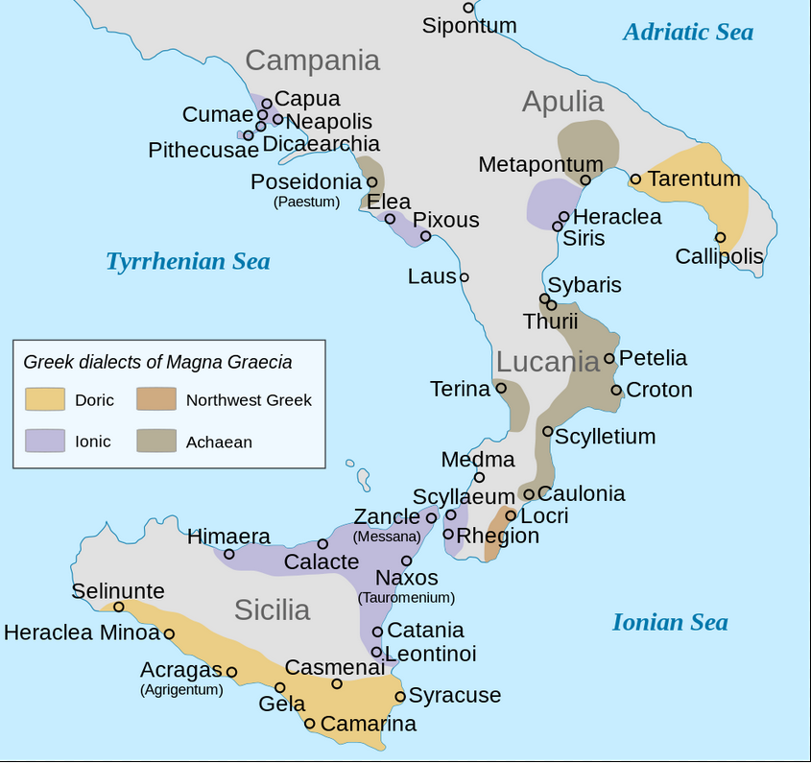

#### EDWARDS,

c. H. Edwards, Jr., The Historical Development of the Calculus

1979 by Springer-Verlag New York, Inc.,

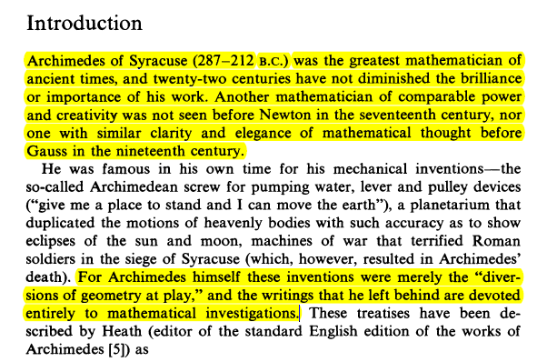

#### T. L. HEATH, Sc.D., THE WORKS OF ARCHIMEDES, CAMBRIDGE: AT THE UNIVERSITY PRESS. 1897

p. xvi,

After his return to Syracuse he lived a life entirely devoted

to mathematical research. Incidentally he made himself famous

by a variety **of ingenious mechanical inventions**. These things

were however merely the "**diversions of geometry at play**," and

he attached no importance to them. In the words of Plutarch, " he

possessed so high a spirit, so profound a soul, and such treasures

of scientific knowledge that, though these inventions had obtained

for him the renown of. more than human sagacity, he yet would

not deign to leave behind him any written work on such subjects,

but, regarding as ignoble and sordid the business of mechanics

and every sort of art which is directed to use and profit, he placed

his whole ambition in those speculations in whose beauty and

subtlety there is no admixture of the common needs of life J." In

fact he wrote only one such mechanical book, On Sphere-making^,

to which allusion will be made later.

Plutarch, Marcellus, 14.

### AREA OF PARABOLA, ARCHIMEDES, ΕΜΒΑΔΟΝ ΠΑΡΑΒΟΛΗΣ, ΑΡΧΙΜΗΔΗΣ,

#### Area and the Method of Exhaustion, ΜΕΘΟΔΟΣ ΤΗΣ ΕΞΑΝΤΛΗΣΗΣ,

c. H. Edwards, Jr., The Historical Development of the Calculus

1979 by Springer-Verlag New York, Inc.,

See p. 16

COMMENT. Όταν εχουν κοινο «συνορον», τι γινεται ?

COMMENTS. a) "horror of ? the infinite" ? What is this ?

b) “limit” ? it is complex notion.

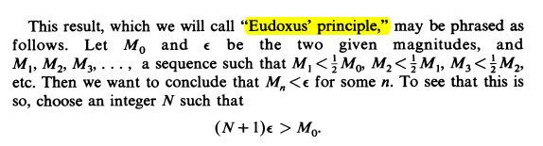

Στην σημερινη ορολογια αυτό σημαινει ότι η ακολουθια Μn teinei στο 0.

Πρωτα αποδεικνυουμε επαγωγικα ότι Μn < (1/2)n Μ0 , kai en synexeia oti η (1/2)n  τεινει στο 0 (σημερινη ορολογια).

#### Quadrature of the Parabola

<https://en.wikipedia.org/wiki/Quadrature_of_the_Parabola>,

Quadrature of the Parabola (Greek: **Τετραγωνισμὸς παραβολῆς**) is a treatise on geometry, written by Archimedes in **the 3rd century BC** and addressed to his Alexandrian acquaintance Dositheus. It contains 24 propositions regarding parabolas, culminating in two proofs showing that the area of a parabolic segment (the region enclosed by a parabola and a line) is 4 3 {\displaystyle {\tfrac {4}{3}}} that of a certain inscribed triangle.

Heath Thomas L. Ed. The Works of Archimedes. Cambridge University Press 2010.

Το κειμενο εισ τα αγγλικα υπαρχει p.233.

##### The Quadrature of the Parabola,

Edwards p. 35

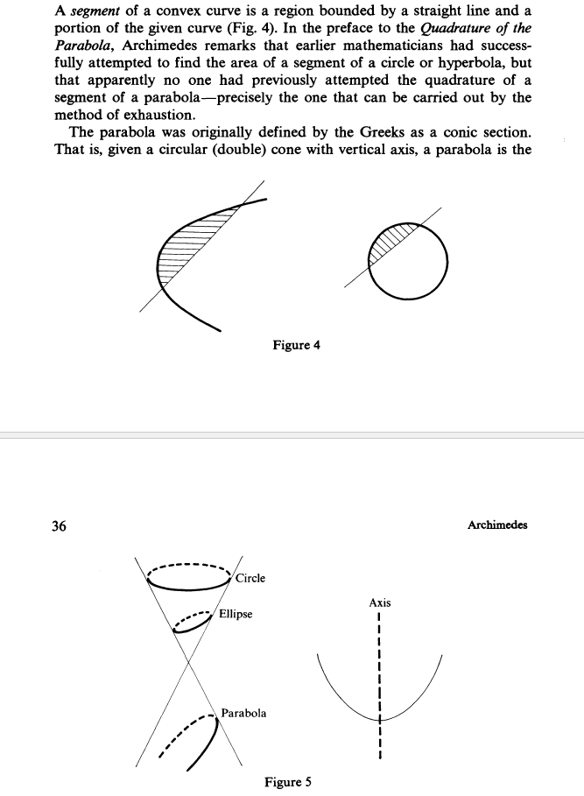

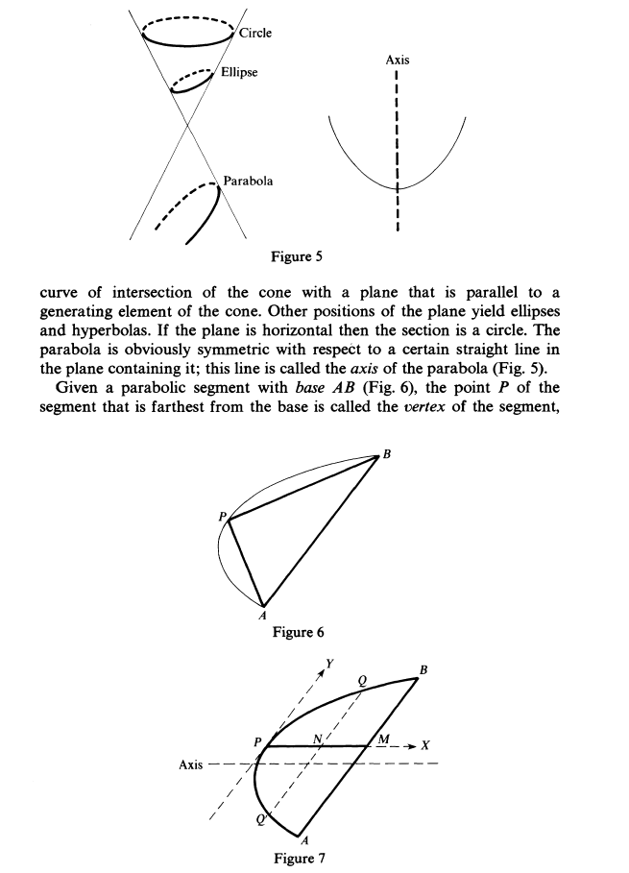

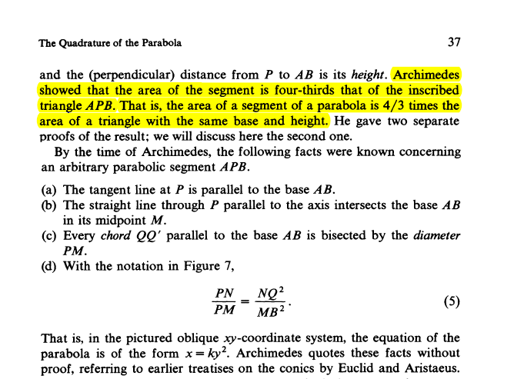

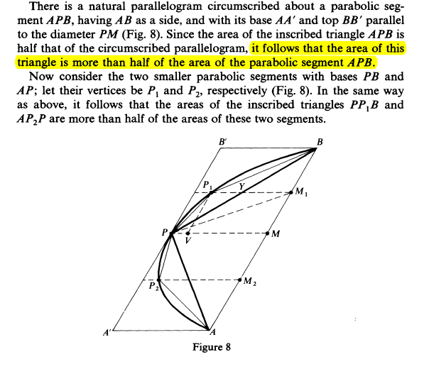

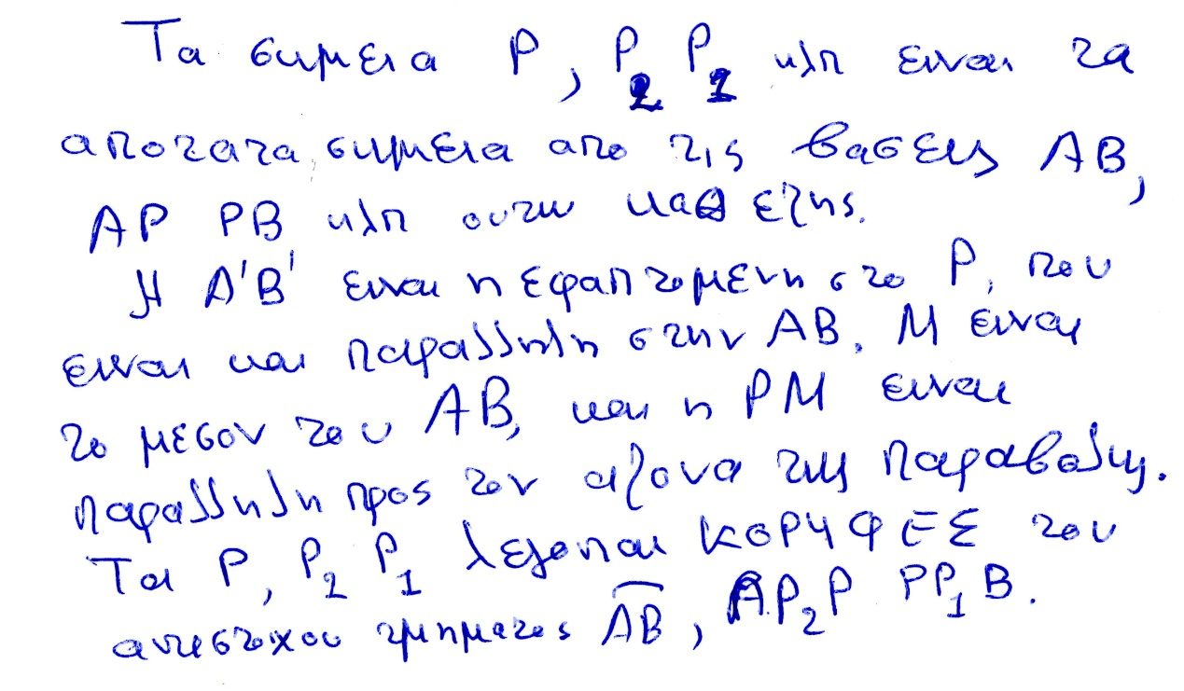

Να β;αλοθεμε το τοξο από επανω οποως στο ΑΒ, .



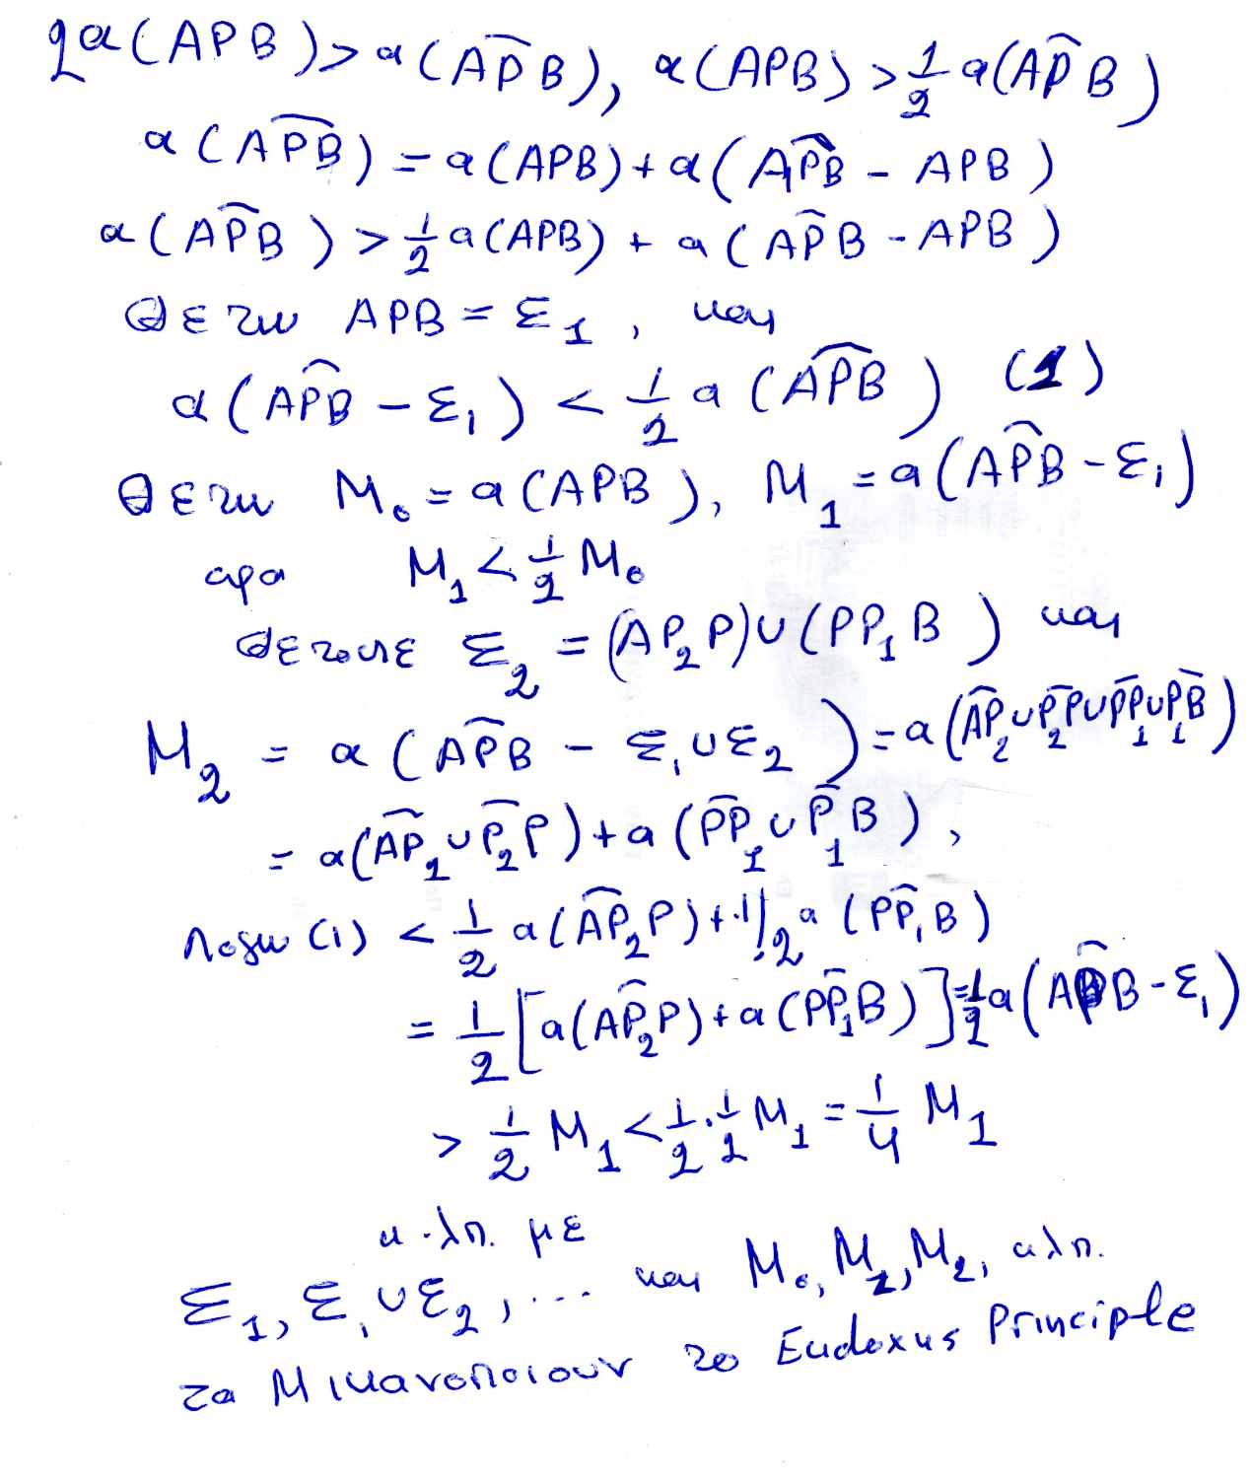

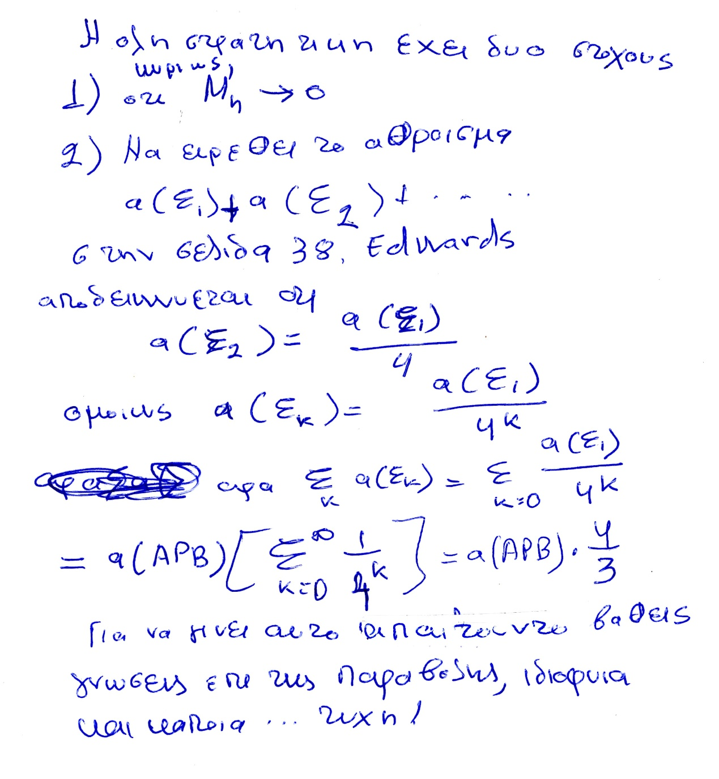

Το ανωτερω 4k , να γινει 4(k-1),

### Η ΙΔΕΑ ΤΟΥ ΟΛΟΚΛΗΡΩΜΑΤΟΣ,

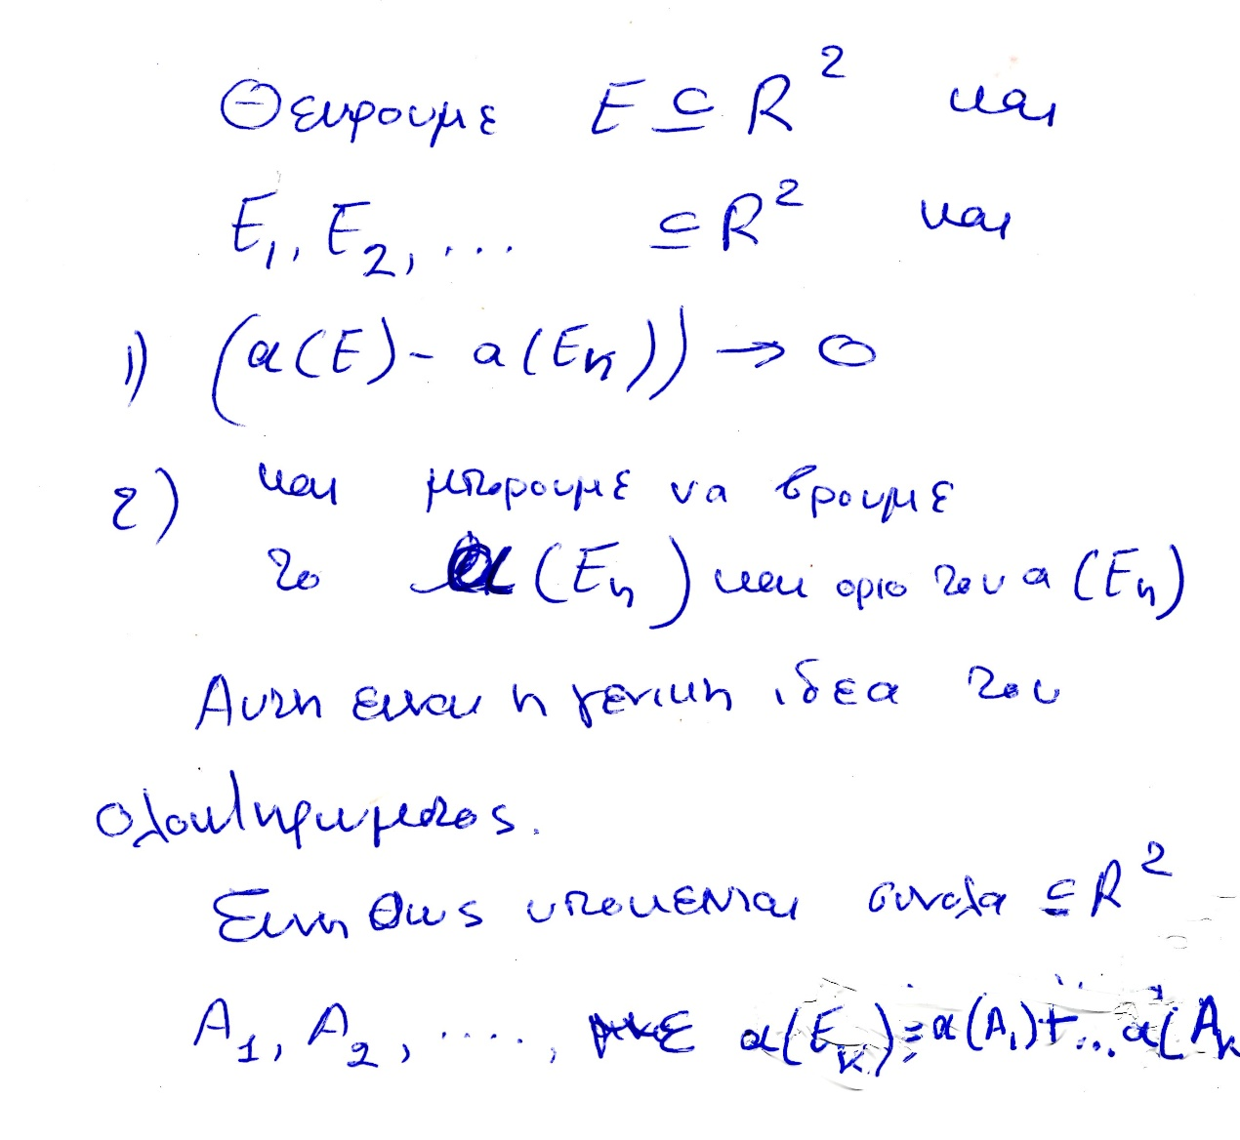

#### Η γραμμη του ΑΡΧΙΜΗΔΗ,

ΣΥΓΚΕΚΡΙΜΕΝΑ, η γραμμη του ΑΡΧΙΜΗΔΗ, σε συγχρονη ορολογια, εχει τα παρακατω κεντρικα στοιχεια, (κατω από αρκετα γενικες συνθηκες).

Υπο αρκετα γενικες υποθεσεις, Εστω Ε υποσυνολον του επιπεδου του οποιου ζητειται το εμβαδον .

Εστω Ε1, Ε2, … ακολουθια υποσυνολων του Ε, τα οποια ανα δυο τεμνονται σε συνολα εμβαδου 0. Τα Ε1, Ε2, … εχουν γνωστον εμβαδον,

Προαπαιτειται

α ) lim (a(E)-( a(Ε1 )+ a( Ε2 )+ … a(Ek ) +…+ ) ) είναι 0

β) Μπορουμε να βρουμε το limk ( a(Ε1 )+ a( Ε2 )+ … a(Ek ) +…+ ) )

τοτε συναγομεν οτι a(E)= limk ( a(Ε1 )+ a( Ε2 )+ … a(Ek ) +…+ ) )