18 ΔΙΑΛΕΞΙΣ,
Τεταρτη, 15-05-2024, 11.00-14.00,
Webex meeting recording: 18 INM 2024 tetarth, 11.00-14.00-20240515 0831-1
Password: zMRJMZd4
Recording link: https://uoa.webex.com/uoa/ldr.php?RCID=8ea24607ed397baaa851702fd301c2a2,

ΠΡΟΚΑΤΑΡΚΤΙΚΑ,
Εχουμε ηδη διαπραγματευθη
6002, 6003,
ΕΡΓΑΣΙΕΣ προς διαπραγμετευσιν,
1004 ηλιοκεντρικο, 5001 (4001) κυβικες ριζες του 1, 8001 δευτερος ορος,

ΚΕΝΤΡΙΚΗ ΙΔΕΑ ΤΗΣ ΛΥΣΗΣ 3βαθμιας εξισωσησ,
Το ολον ζητημα ευρισκεται στο πλασιο των «πραγματικων», (όχι των γεωμετρικων μεγεθων).
Περαιτερω τα κεντρικα σημεια ειναι

Απόδειξη μέσω στερεομετρίας, του
(s+t)³ -3st(s+t) –(s³ +t³) =0

. ΓΕΩΜΕΤΡΙΚΗ ΑΠΟΔΕΙΞΗ, Αραβικη επιρροη.
Εγνωριζε τον ΕΥΚΛΕΙΔΗ, ΔΕΝ εγnωριζε τον ΔΙΟΦΑΝΤΟ.
GEOMETRIC PROOF,
https://www.pinterest.com/pin/299489443969463718/,

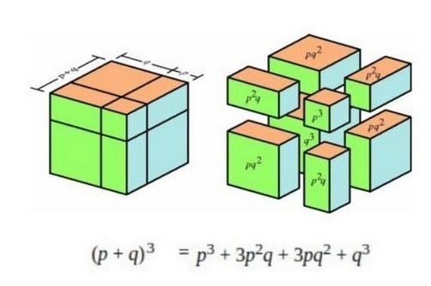
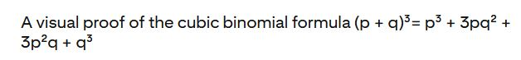

ΣΧΟΛΙΟΝ. Βλ. και, Cubic equation, https://en.wikipedia.org/wiki/Cubic_equation,

αναγωγη σε δευτεροβαθμια εξισωση
Εξισωση x³ +px +q =0
Ταυτοτητα (s+t)³ -3st(s+t) –(s³ +t³) =0

Αν βρω s, t τετοια ωστε
-3st=p και –(s³ +t³)=q,
tote EXΩ την λυση x=s+t !!!

ΟΜΩΣ, τοτε τα s, t, ικανοποιουν
st=-p/3 και s³ +t³ =-q, η
s³t³=-(p/3)³ και s³ +t³ =-q,
δηλ. για τα s³ , t³, ξερω αθροισμα και γινομενον είναι λυσεις 2-βαθμιου εξισωσεως (!) που ξερω πώς να την λυσω.
Είναι η y² +qy-(p/3)³ =0
Αφου βρω τα s³ , t³, θα εξαγαγω τις κυβικες ριζες, οποτε βρισκω τα s, t και το (s+t) είναι η ζητουμενη ριζα ! (Αυτό ΔΕΝ «γινεται» «γεωμετρικα»).

Βλ. κατωτερω,

ΣΧΟΛΙΑ,
ΓΕΩΜΕΤΡΙΚΗ ΘΕΩΡΗΣΙΣ
Εστω x, s, t, μηκη, p εμβαδον, q ογκος.
s³t³=-(p/3)³ δεν εχει αμεσον γεωμετρικον νοημα,

ΠΝΕΥΜΑ ΑΝΤΙΛΟΓΙΑΣ: Μια στιγμη. Αν η ως ανω 2-βαθμια εξισωση ΔΕΝ εχει (πραγματικες) ριζες, τοτε «τινος» «θα εξαγαγω τις κυβικες ριζες» ?
ΠΝΕΥΜΑ ΑΙΣΙΟΔΟΞΙΑΣ: Ελα μωρε τωρα, λεπτομερια, κατι θα βρεθει !.

ΠΑΡΑΔΕΙΓΜΑ, Βλ. Ars Magna p. 99,
(x-2)(x² +2x+10) =(x³ + 6x-20),
Opote oi rizes einai 2, 1+i3^{1/2} , 1-i3^{1/2} ,
Η εξισωση αυτή εχει την πραγματικη ριζα 2
Σελ. 99
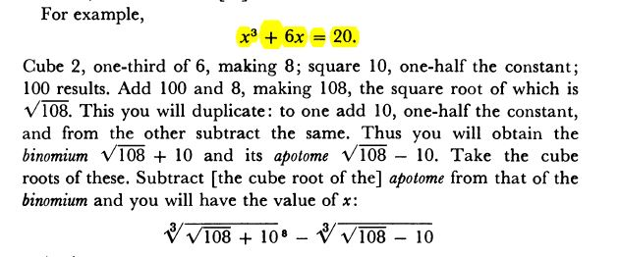,

ΑΝΑΛΥΣΗ,

Srinivasa Ramanujan, Srinivasa Ramanujan,
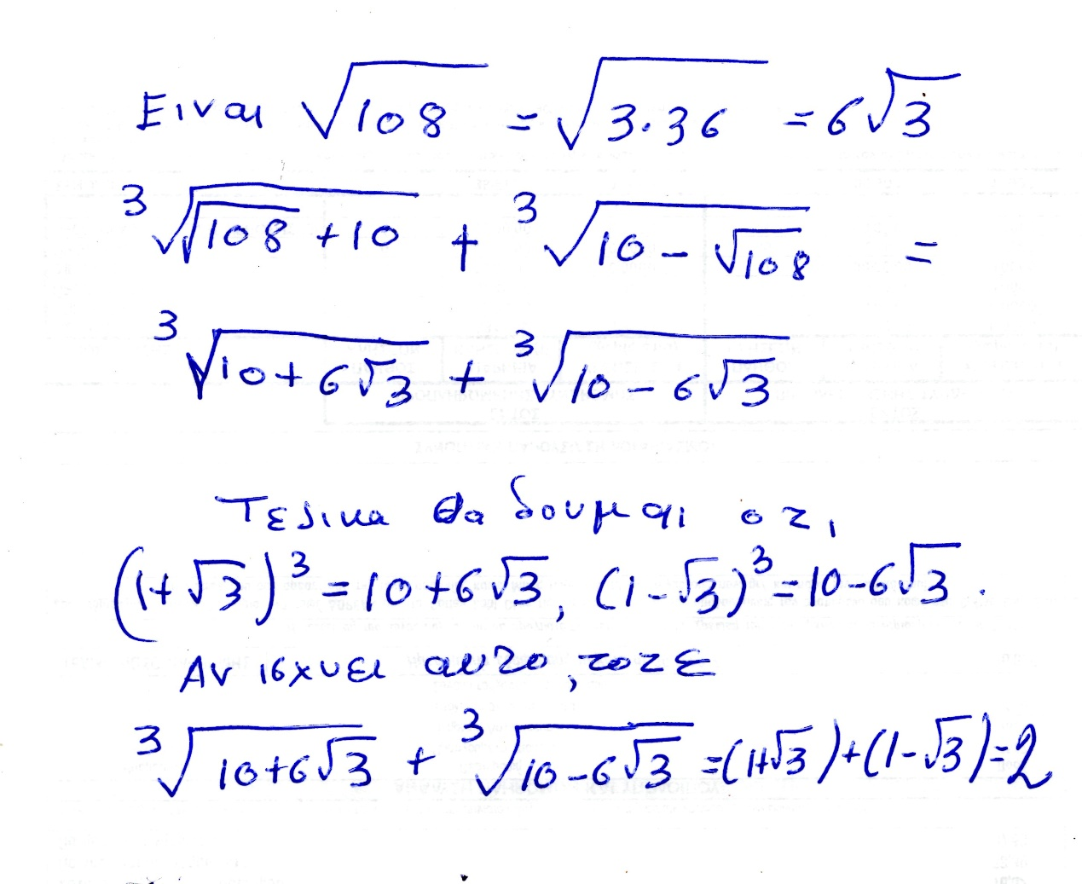
Fysika h isothyta ayth apodeiknyetai mesω πραξεων. Υπαρχει θεμα του «πως μας ηρθε», το οποιον θα συζητησουμε καπως και κατωτερω.

Ώστε εδώ απεδειχθη ότι αυτό του βρισκει και o CARDANO, einai ontωs h riza 2, που το ξεραμε από την αρχη.
Όμως …

«ΜΙΚΡΗ ΑΝΑΛΥΣΗ»

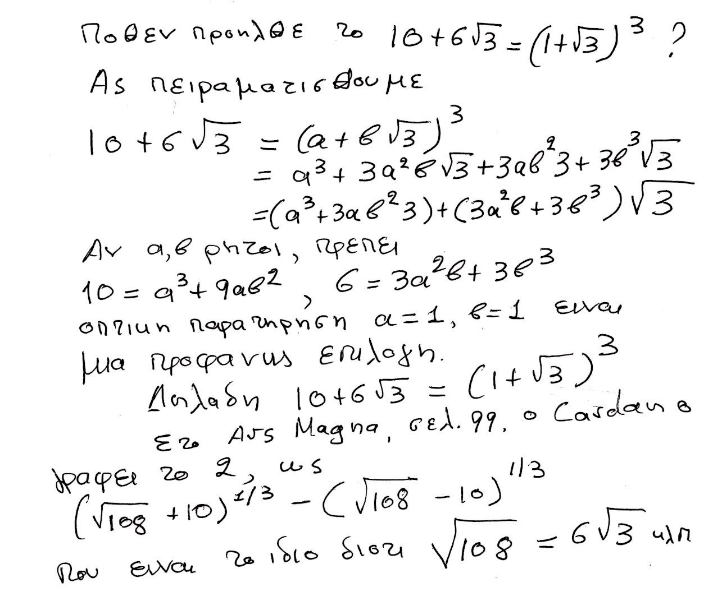

ΣΓΠ, ΛΥΣΗ ΕΞΙΣΩΣΕΩΝ ΒΑΘΜΟΥ 3,
Συστηματικα, με την σημερινη οπτικη,

ΠΡΟΚΑΤΑΡΚΤΙΚΑ,

Στα κατωτερω τυπικα θεωρουμε εξισωση
x³ + px+q=0,
Με p, q είναι πραγματικοι, .

Κατωτερω Επιλεγουμε ω=(-1 ± (3^{1/2} )i )/2

Υπαρξη κυβικης ριζας μιγαδικου

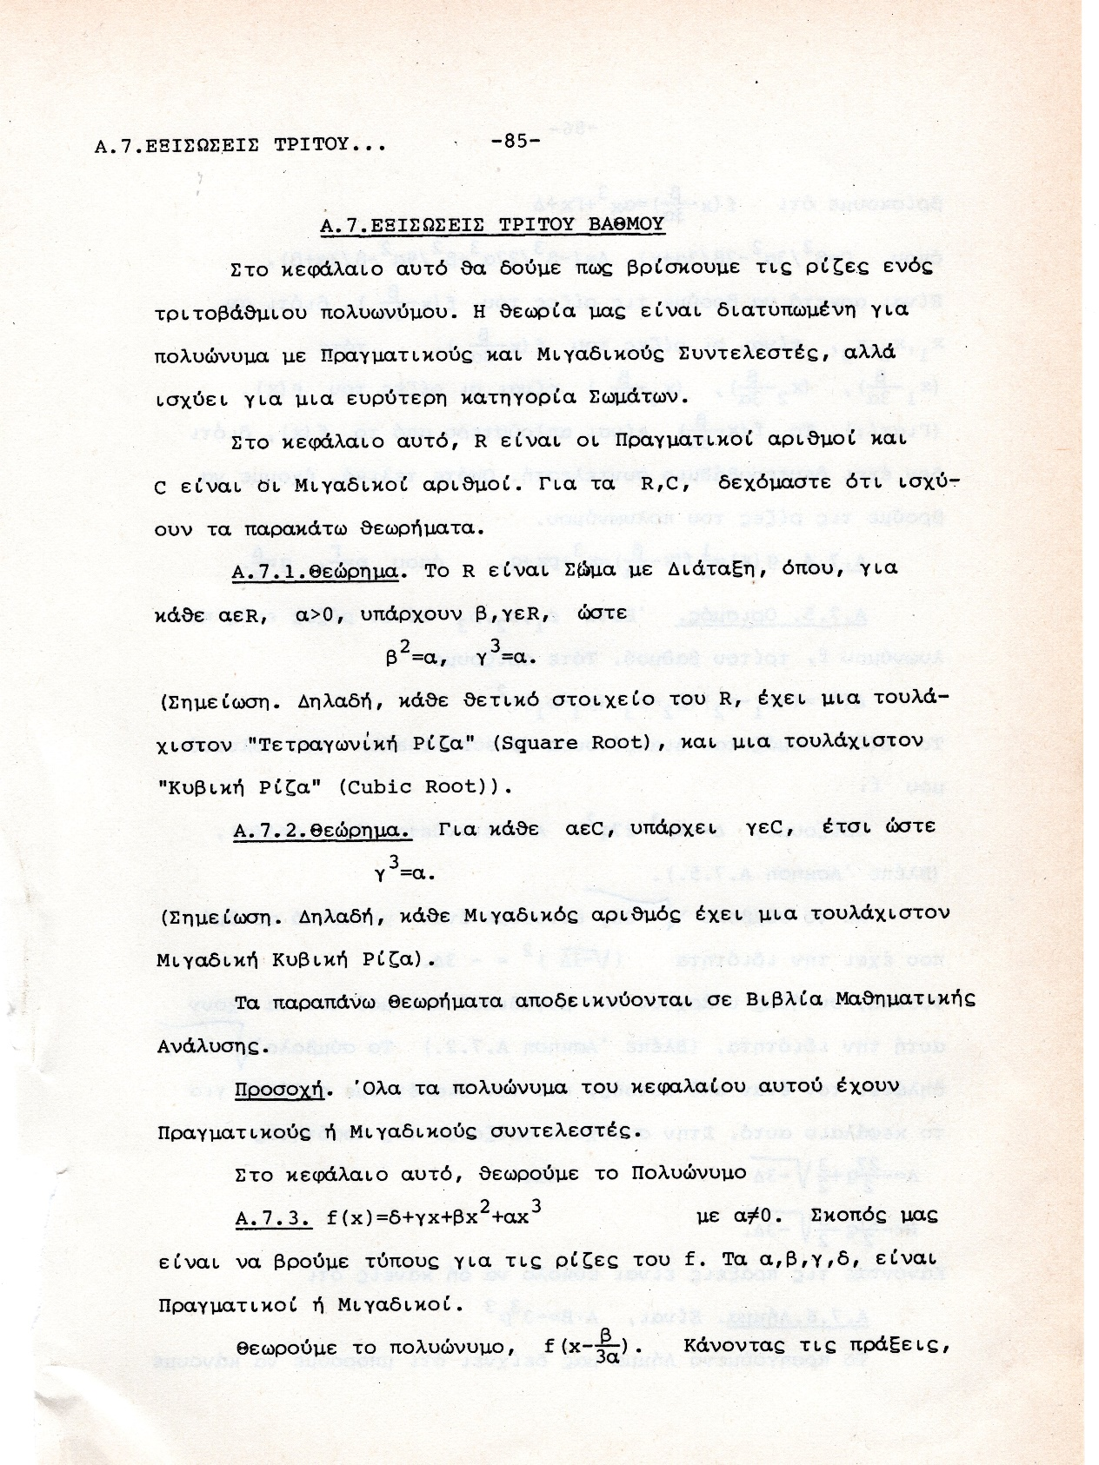

r(cosθ+isinθ),
( r^{1/3}(cos(θ/3)+isin(θ/3) ) )³ = r(cosθ+isinθ),
de MOIVRE formula.

ΤΥΠΟΙ CARDANO,

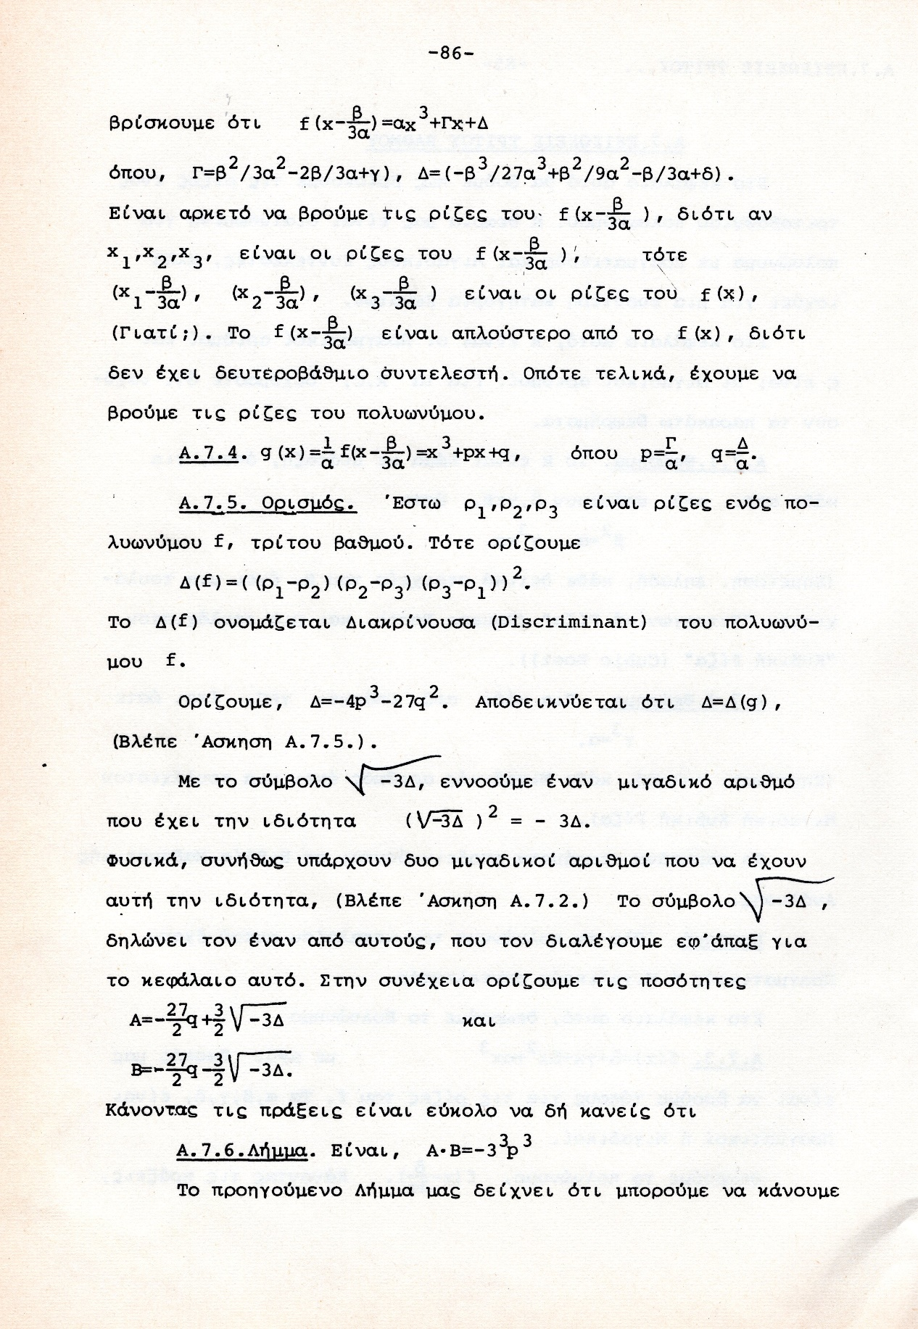

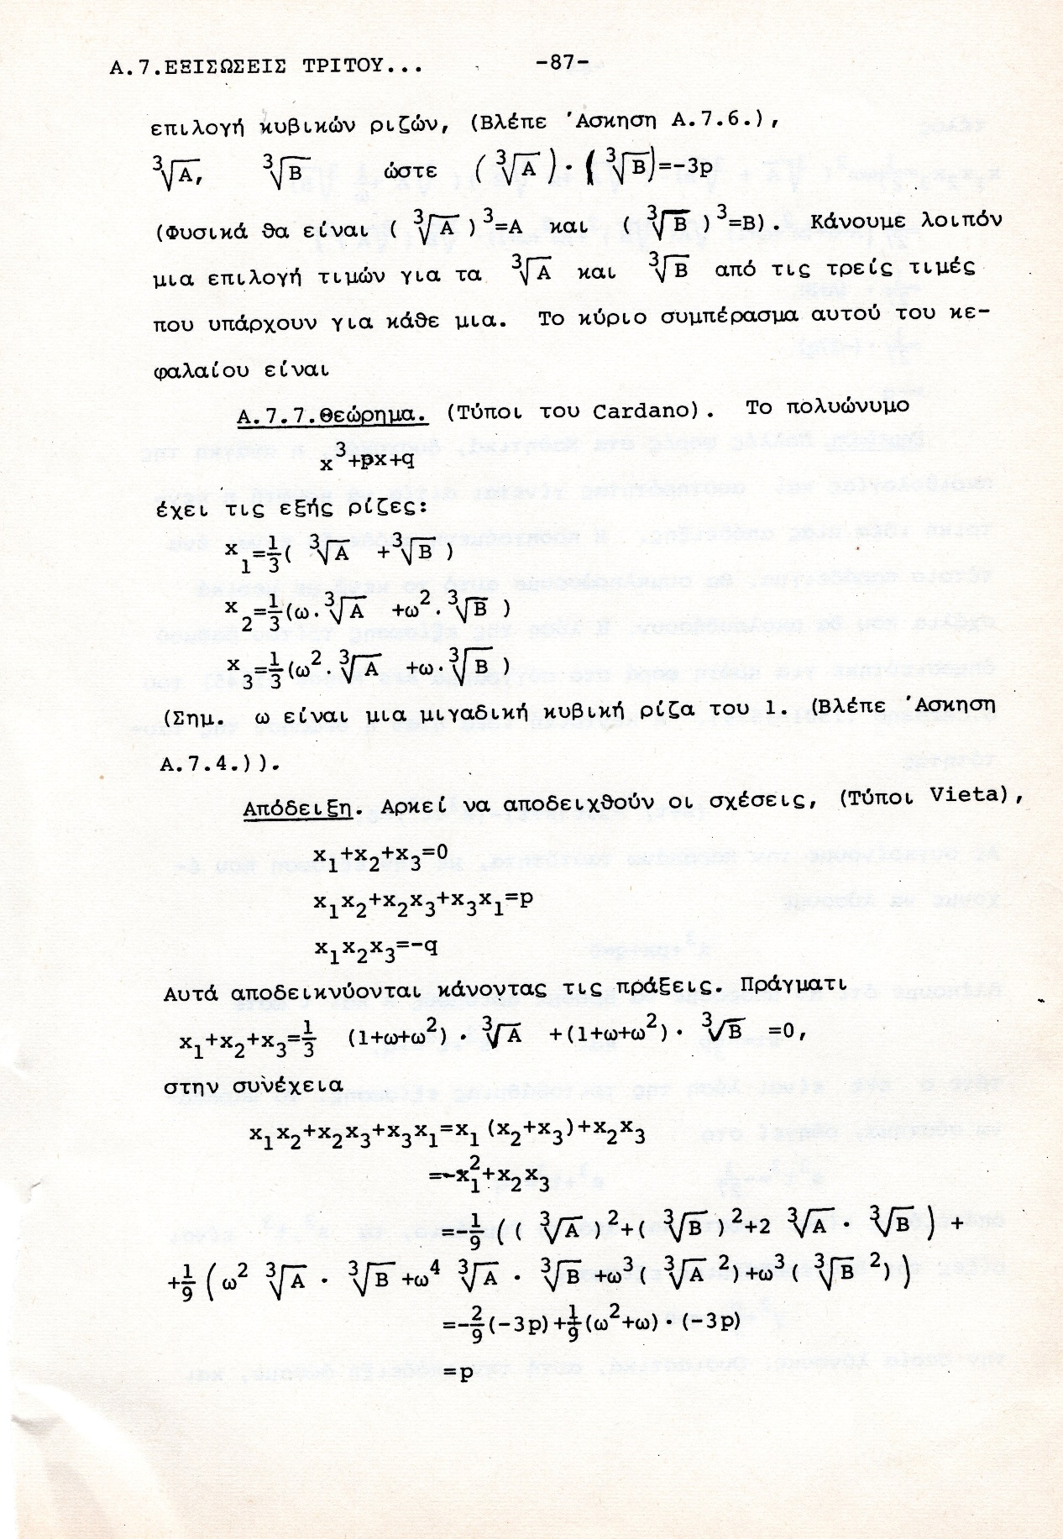

ΣΧΟΛΙΟ ΤΗΣ ΑΠΟΔΕΙΞΗΣ,

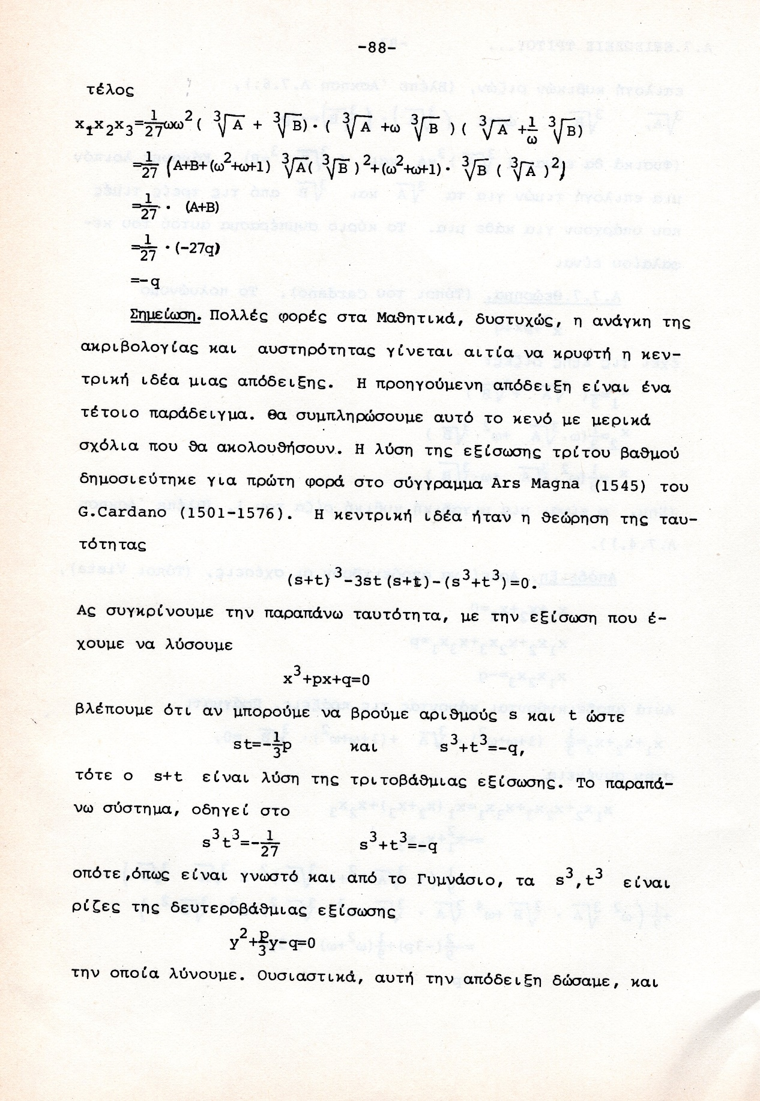

ΡΟΛΟΣ ΔΙΑΚΡΙΝΟΥΣΑΣ,
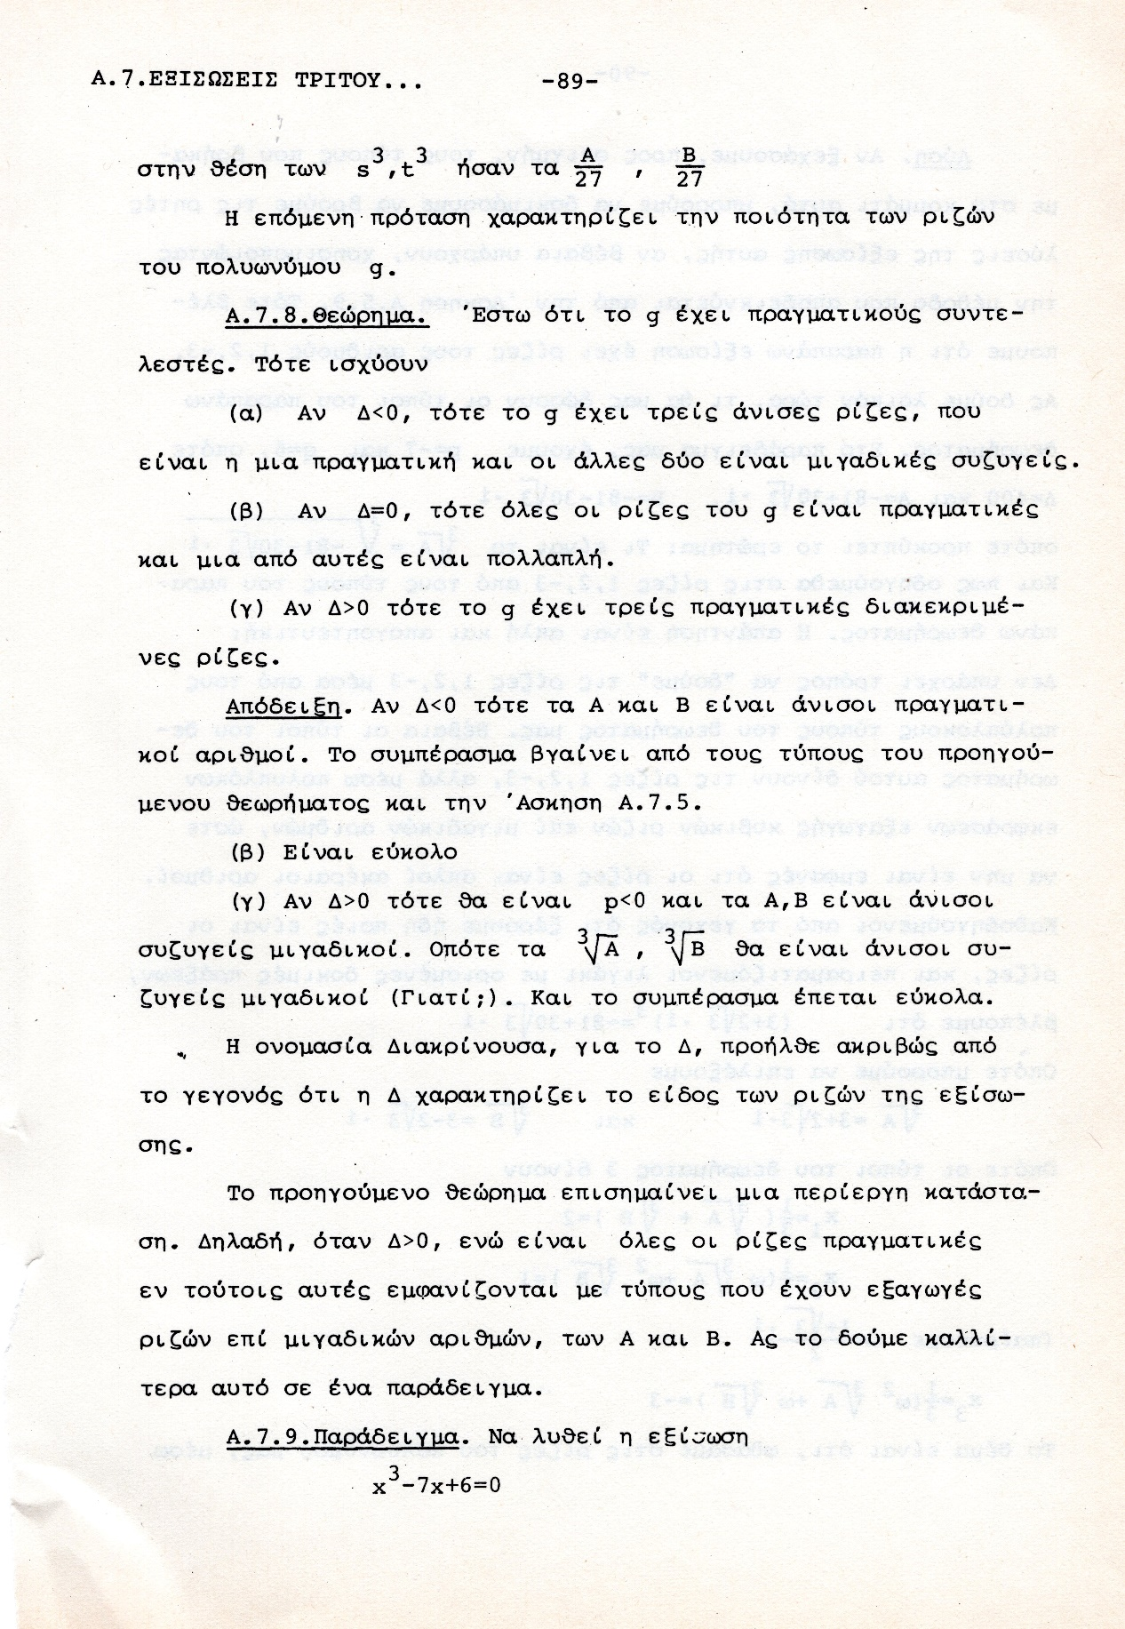

ΠΟΙΟΤΙΚΗ ΔΙΑΦΟΡΑ ΜΕΤΑΞΥ β/θμιων και τριτο/βαθμιων Εξισωσεων
Η αναγκη υπαρξης ευρυτερου «κοσμου», για τις τριτο/βαθμιεσ Εξισωσεισ

Αναγκη εκφρασης Πραγματικων ριζων, μεσω πραξεων επι μιγαδικων.

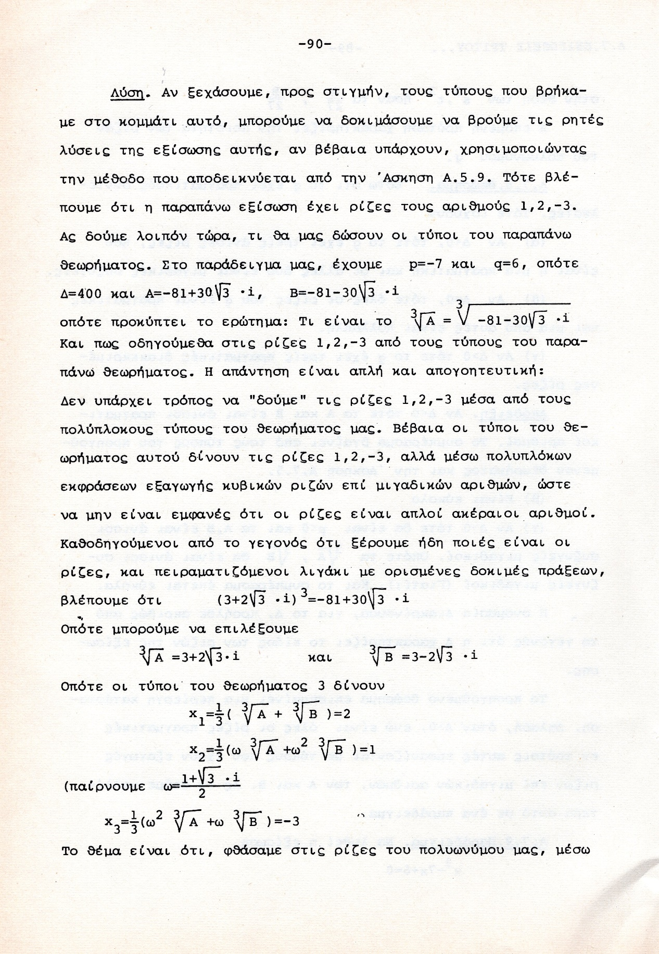

Προβληματα στην εξαγωγη κυβικης ριζας μιγαδικων,

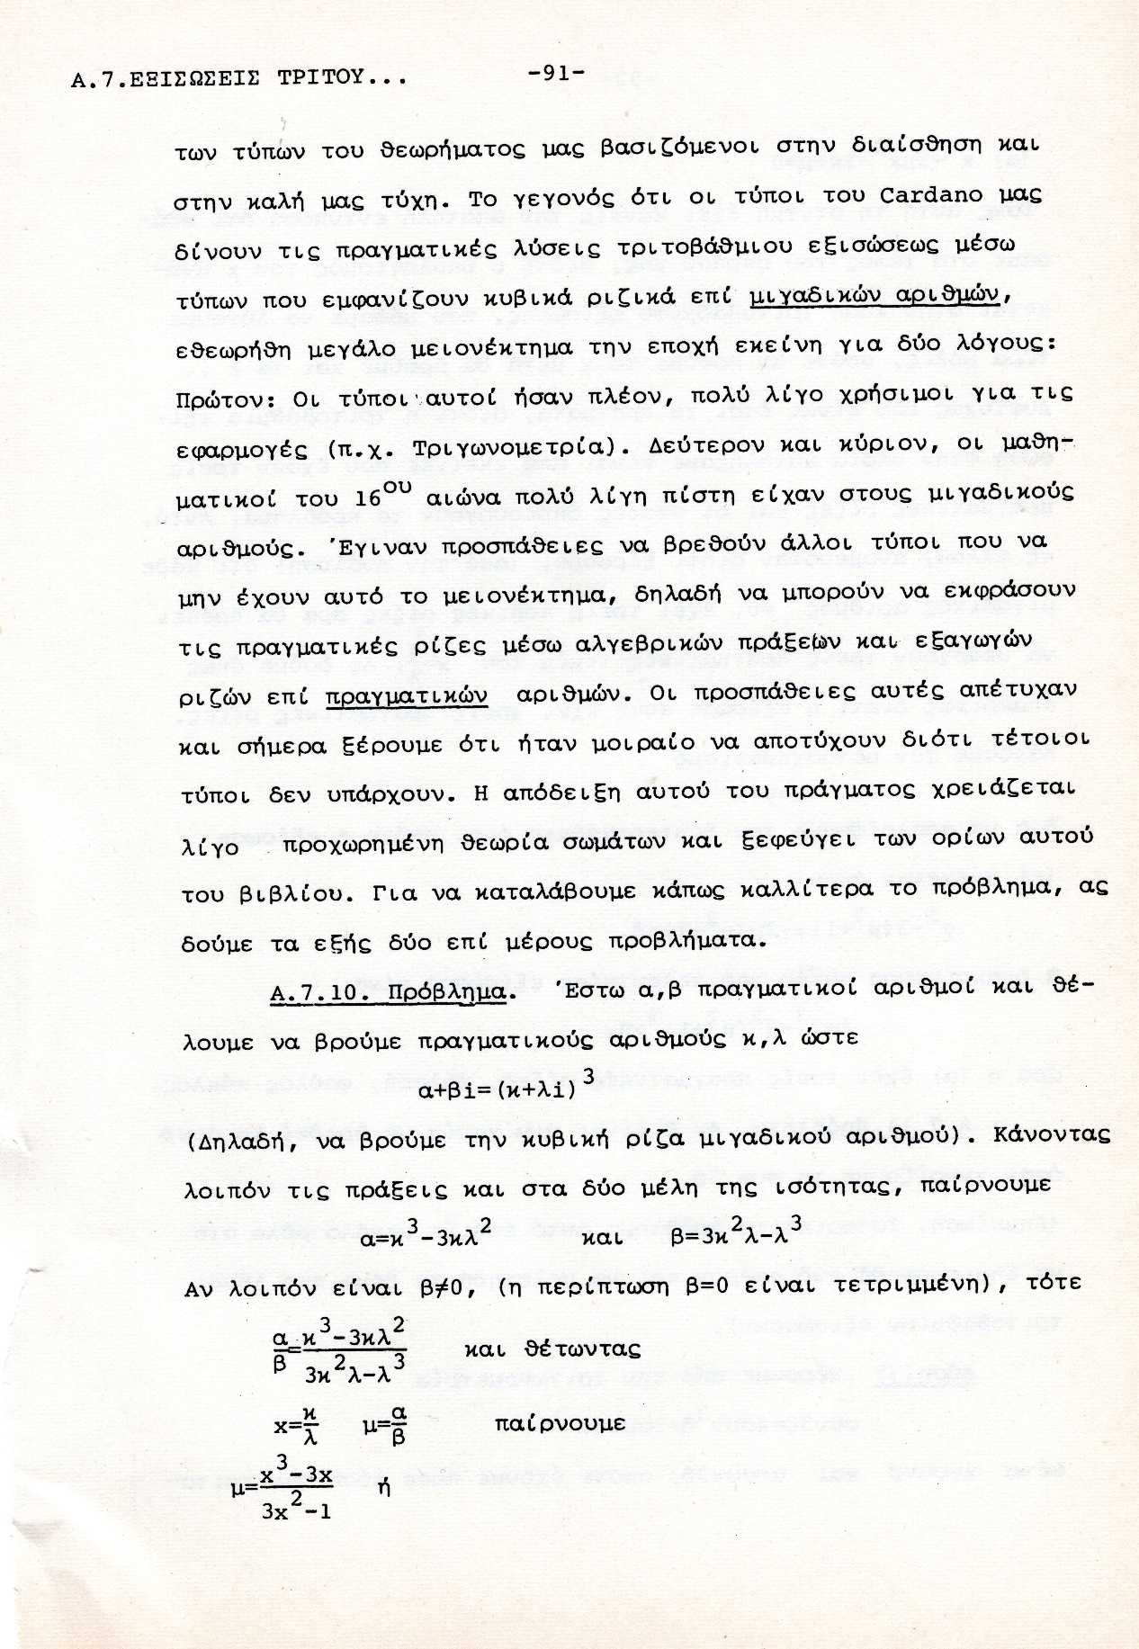

Προβληματα στον υπολογισμο του συνθ, γνωστου οντως του συν3θ,

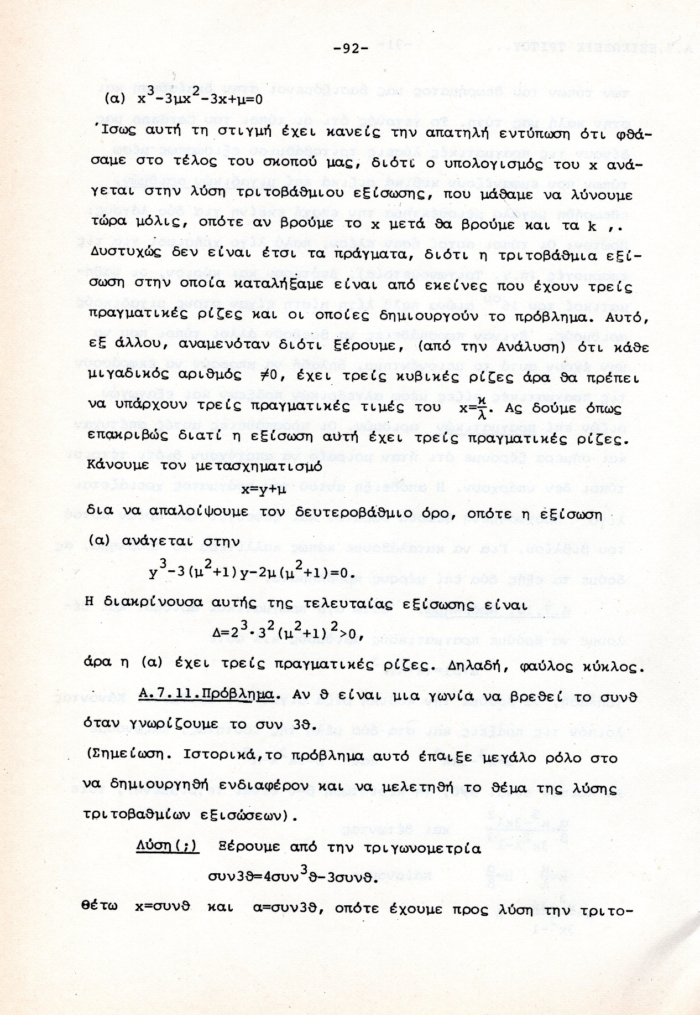

Παραδειγμα πληρους εξισωσης,

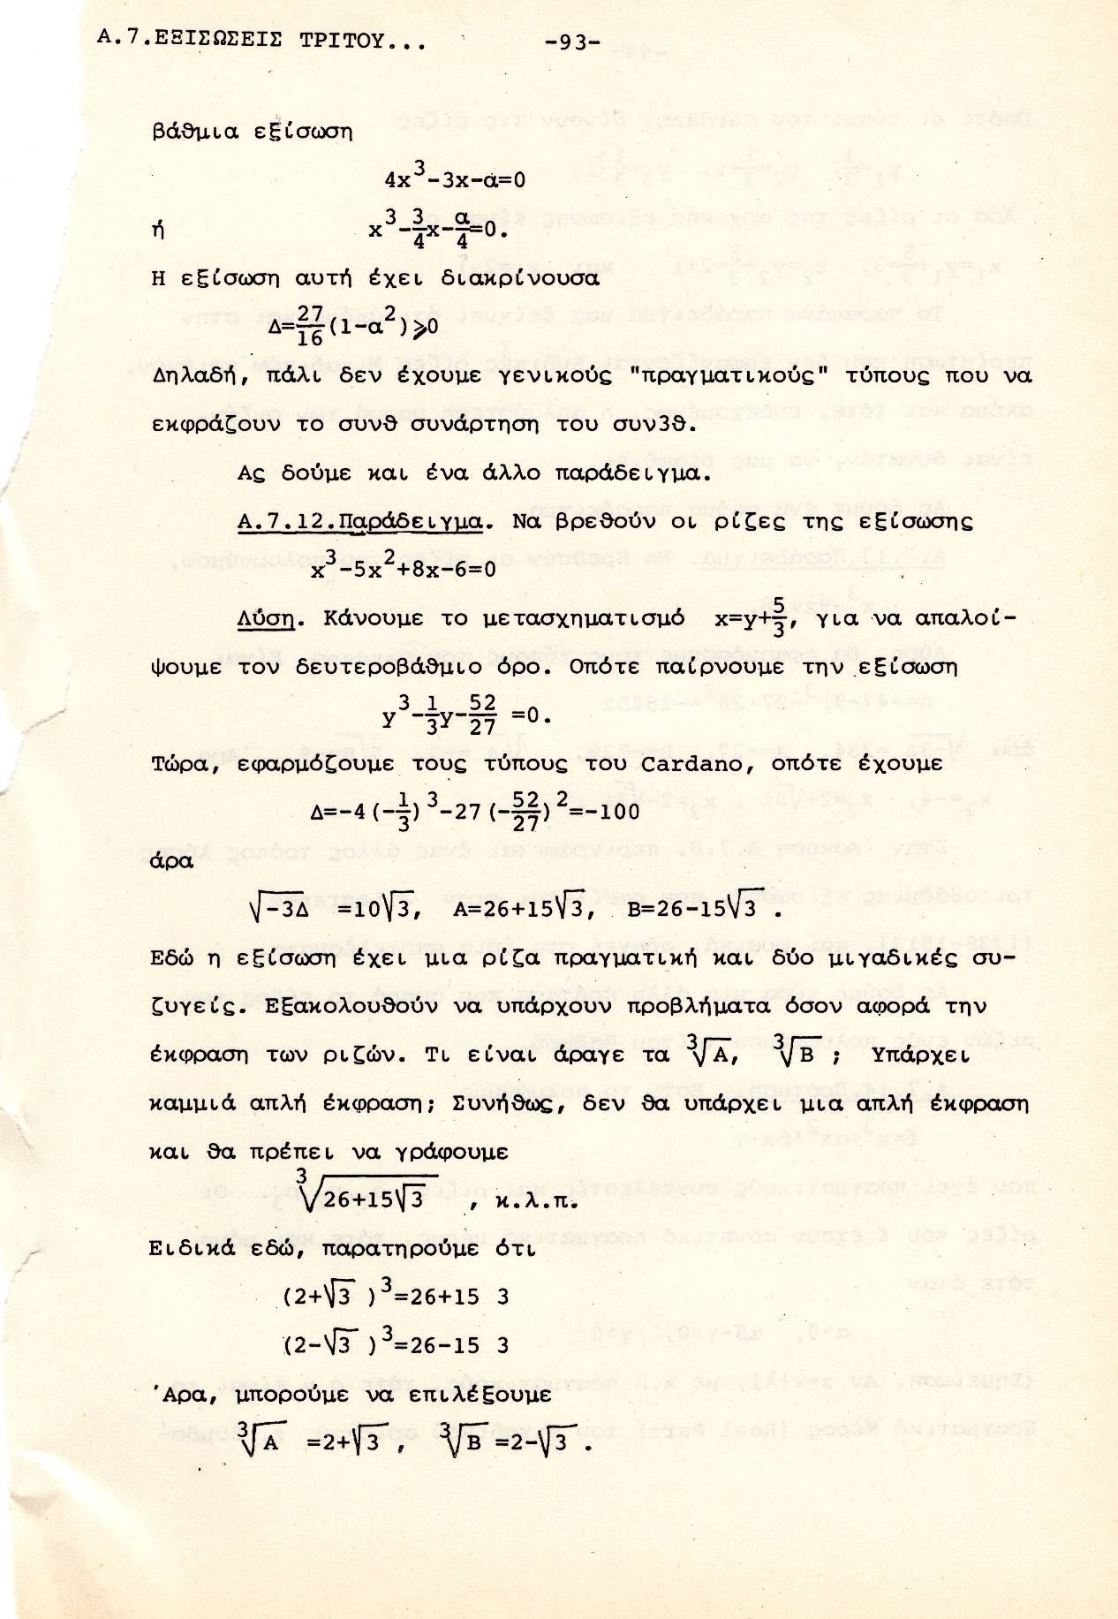
ΣΧΟΛΙΟ. Τα δυο 3, που είναι ξεχωρα στο δεξιο ακρο να γινουν 3^{1/2} ,

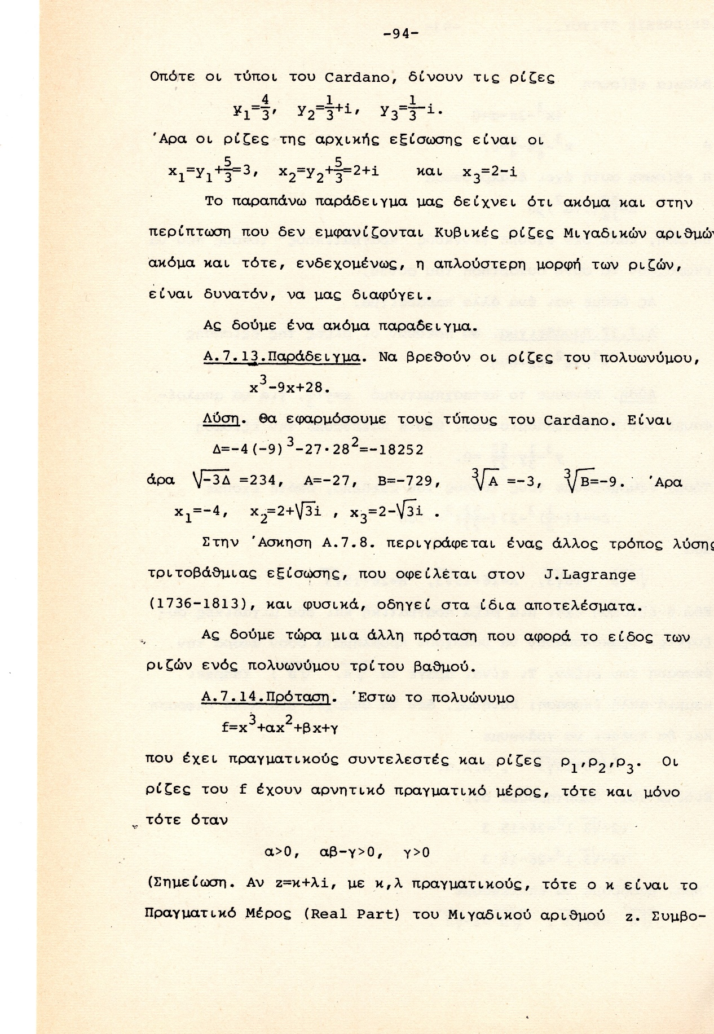

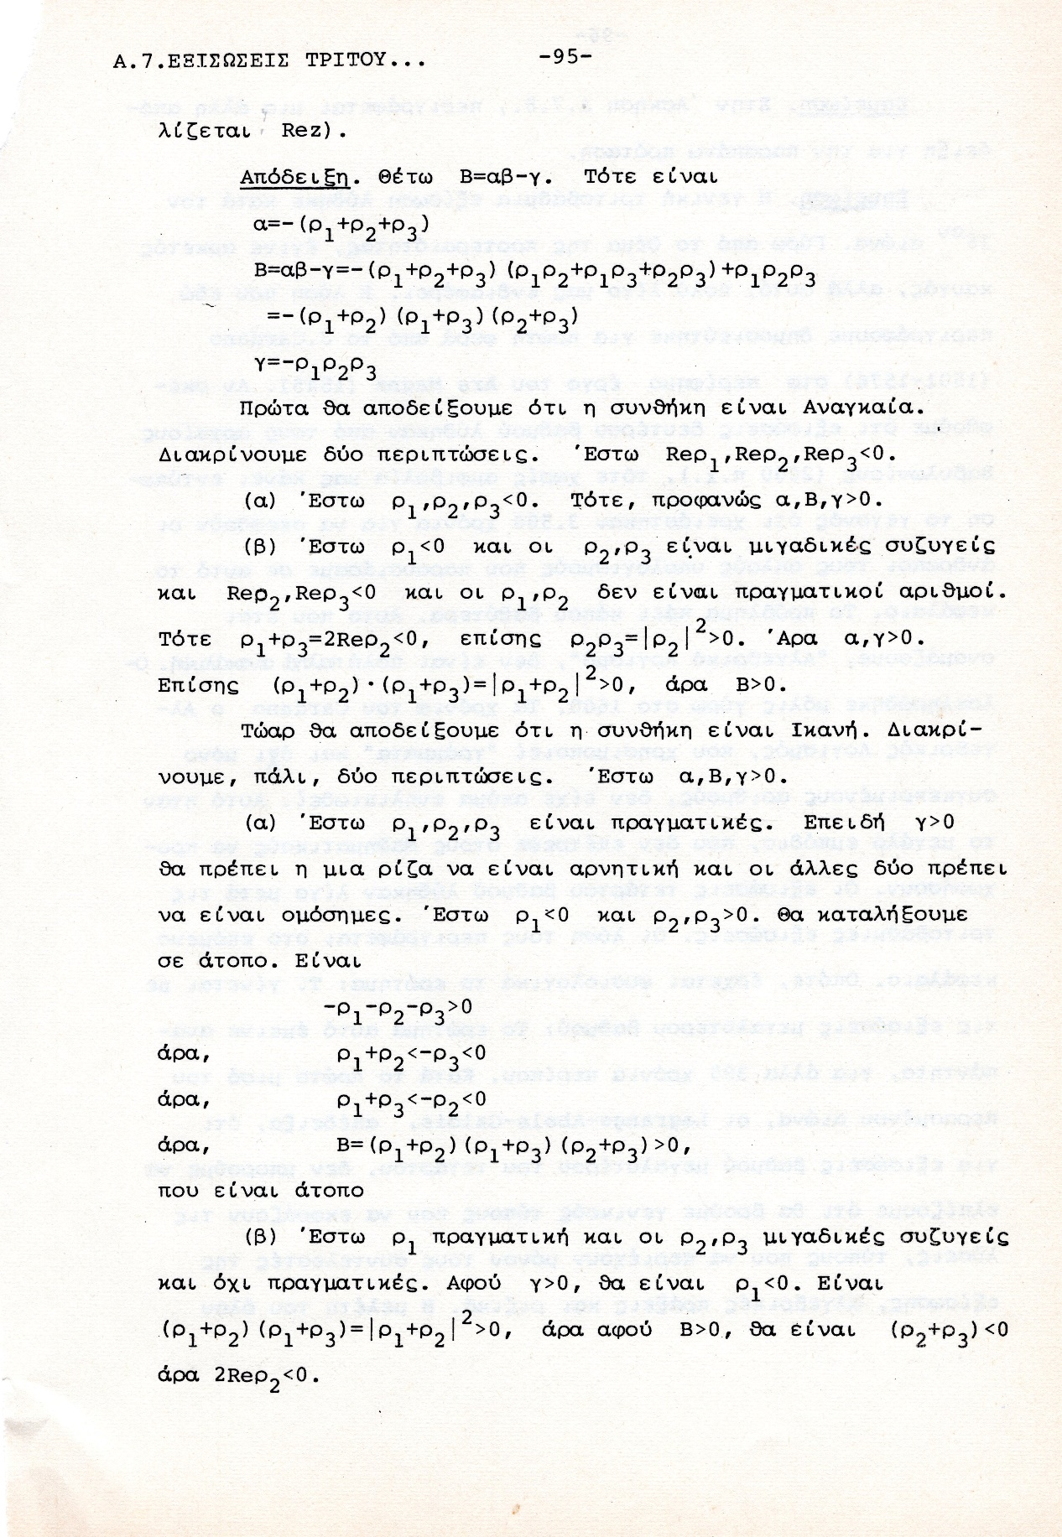

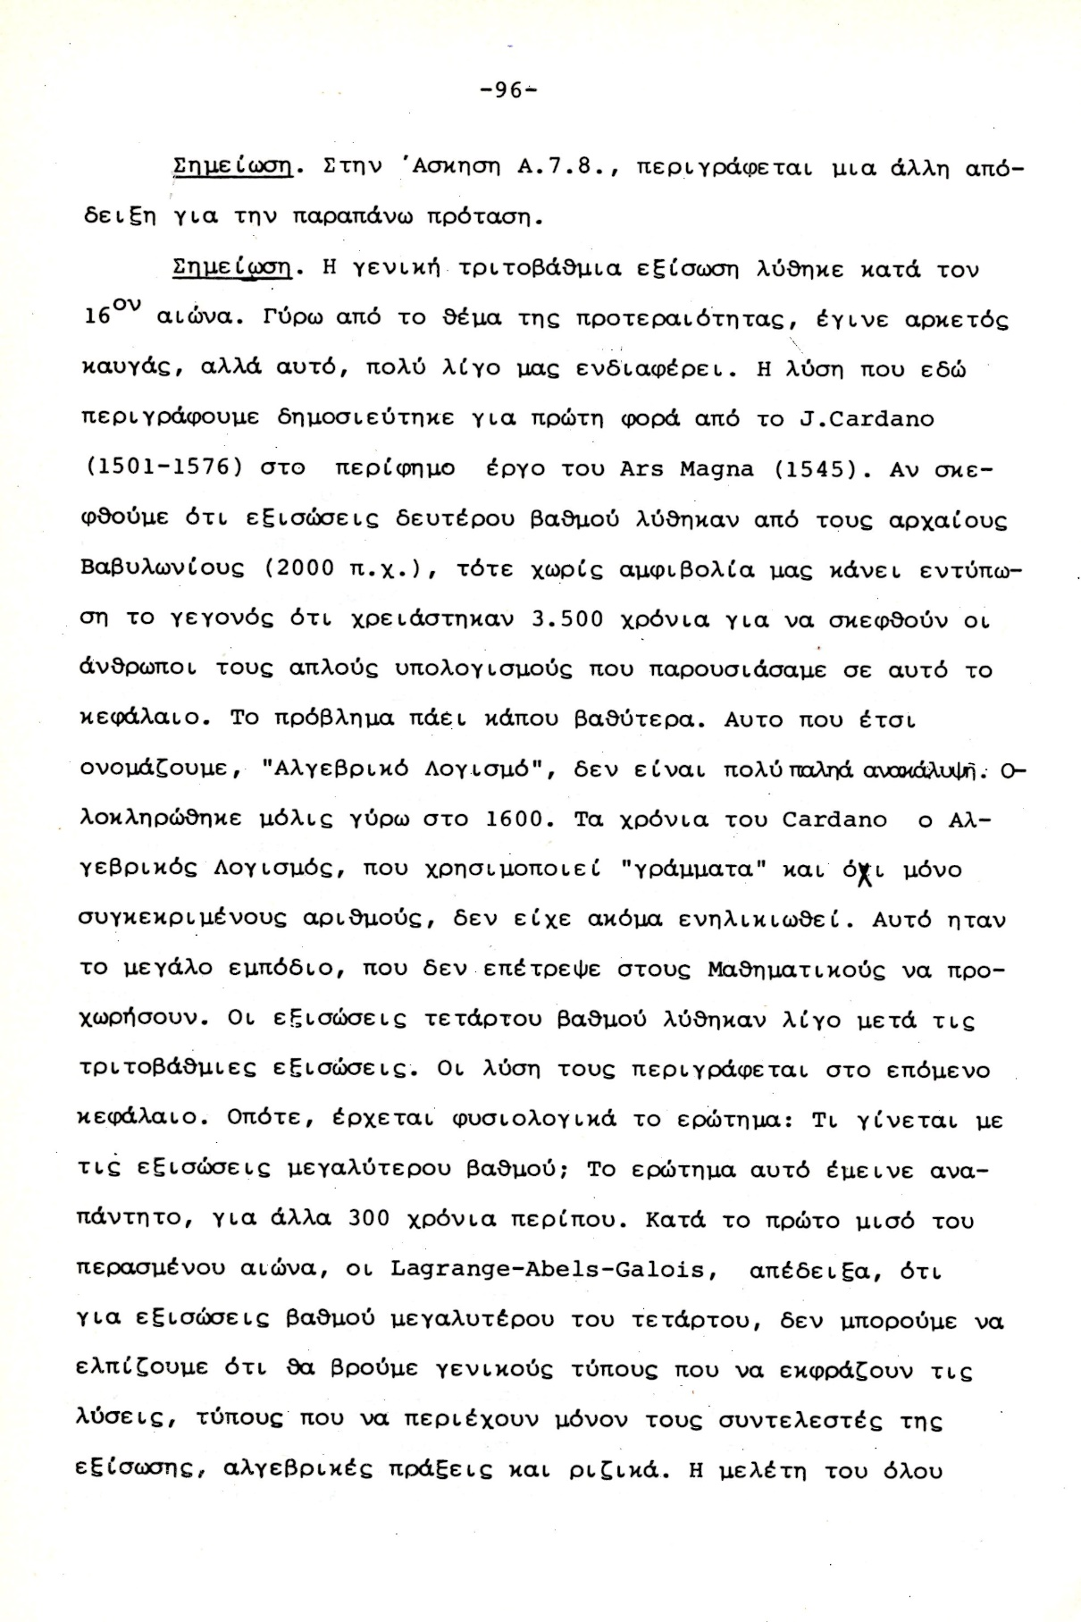

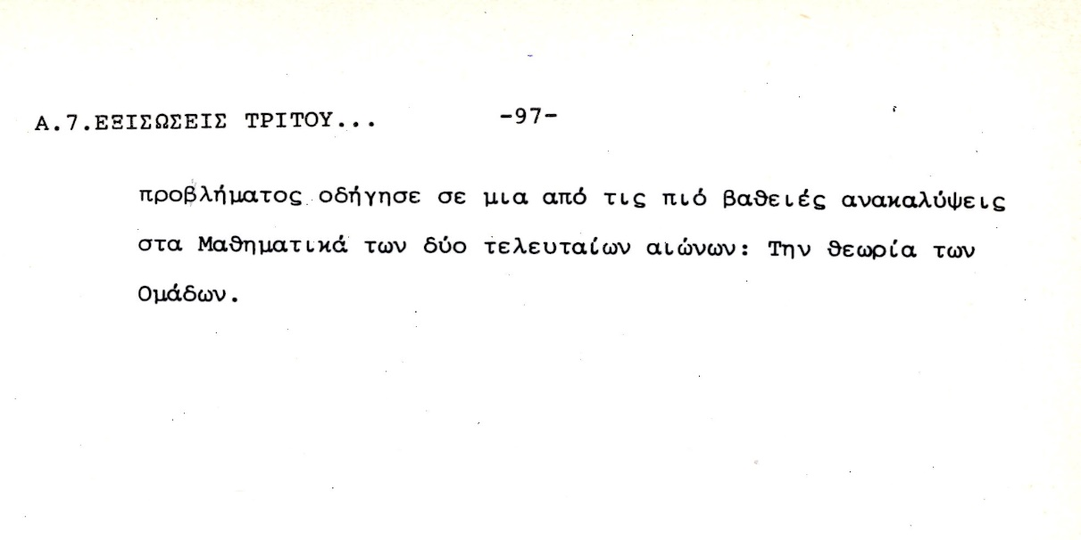

ΑΣΚΗΣΕΙΣ,
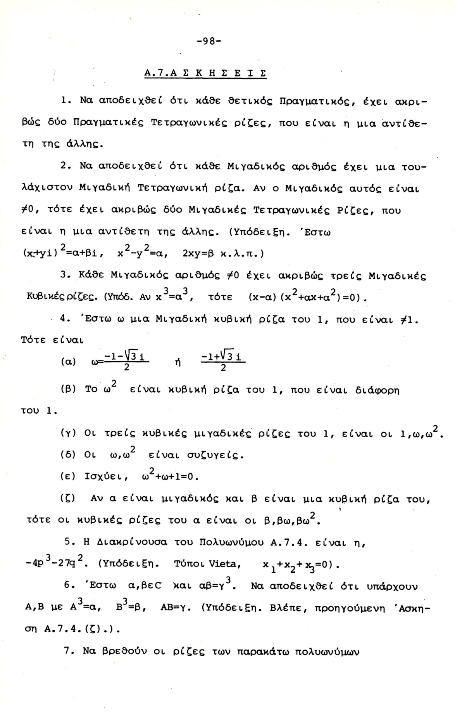

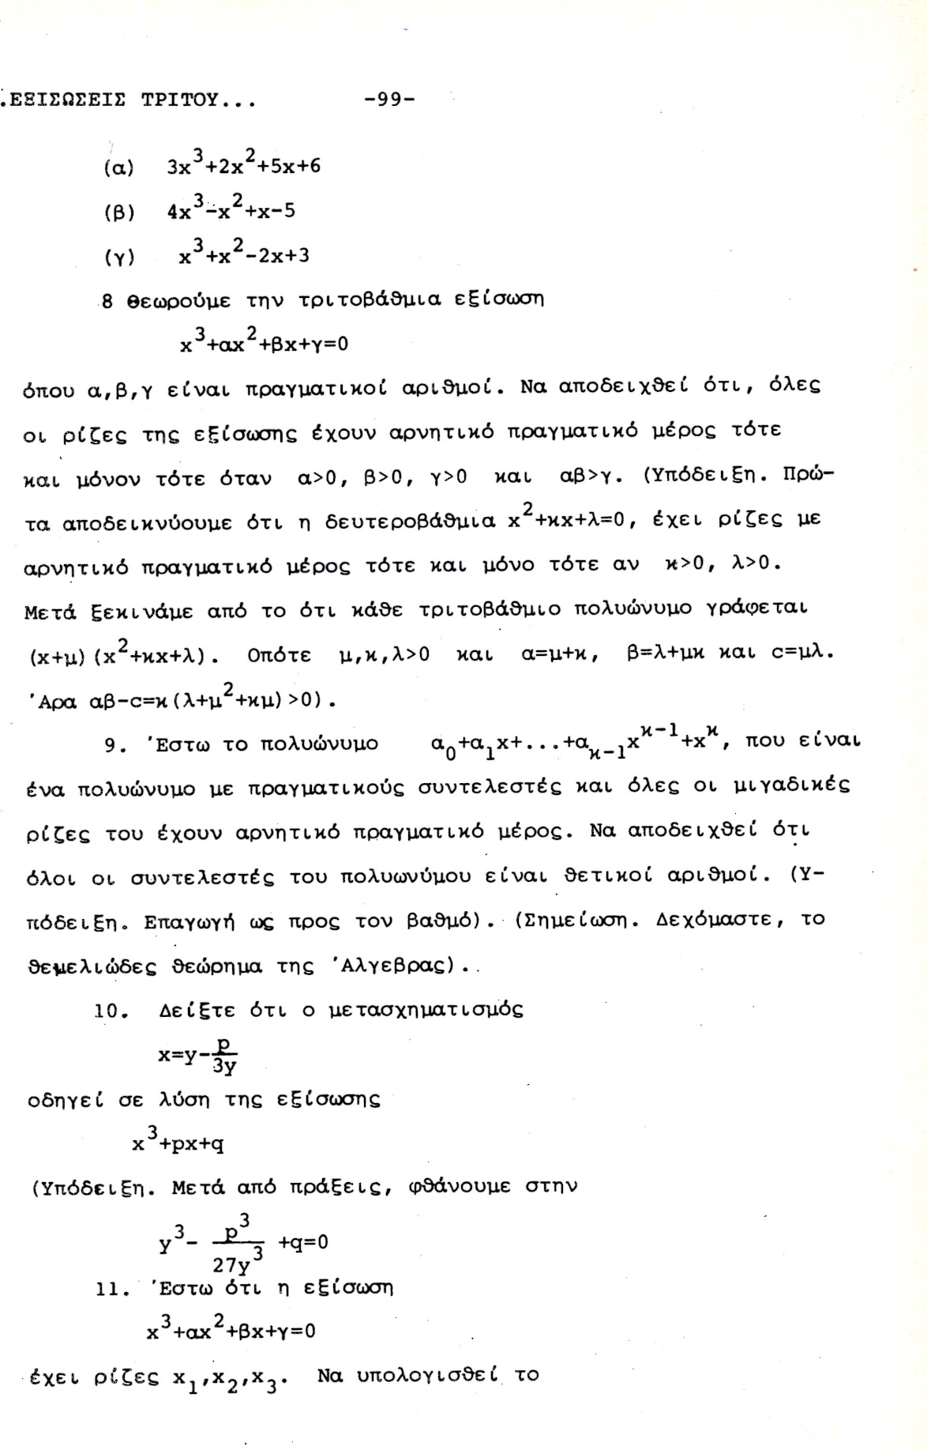

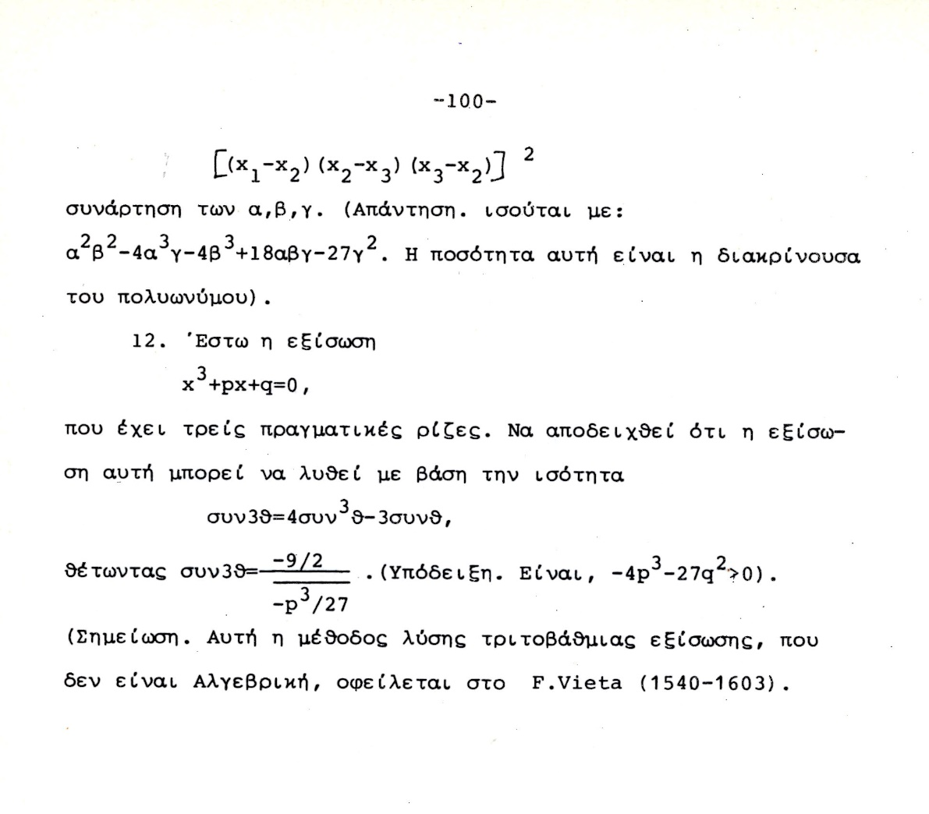

ΣΥΓΚΕΚΡΙΜΕΝΑ ΠΑΡΑΔΕΙΓΜΑΤΑ,

x³ + 6x=20,
Βλ. Ars Magna p. 99,
Η εξισωση αυτή εχει την πραγματικη ριζα 2
(x-2)(x² +2x+10),
Opote oi rizes einai 2, 1+i3^{1/2} , 1-i3^{1/2} ,
Ο ΙΕΡΩΝΥΜΟΣ, γραφει

Ας δουμαι τι δινουν οι τυποι του CARDANO.

ΣΓΠSrinivasa Ramanujan, Srinivasa Ramanujan,

Συνεχιζουμε το παραπανω
Ώστε εδώ απεδειχθη ότι αυτό του βρισκει και o CARDANO, einai ontωs h riza 2, που το ξεραμε από την αρχη.
Όμως …

Παρακατω το αποδεικνυουμε στην μορφη ΣΓΠ
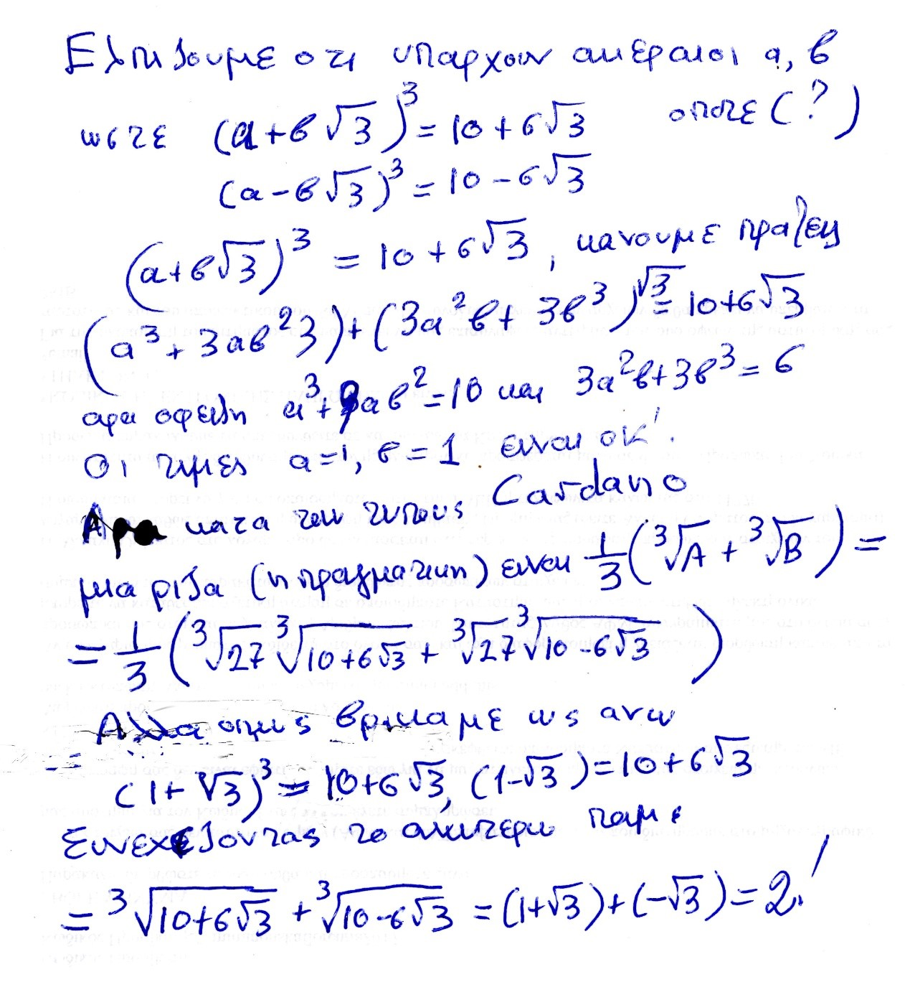
ΟΥΦ !, στην τελευταια γραμμη ξεχασα το 1 στο (1-3^{1/2} ₎
Επισης ξεχασα τον εκθετη 3 στο, (1-3^{1/2} )
_{ΣΧΟΛΙΟ ΣΓΠ, .}
Οι τυποι του ΙΕΡΩΝΥΜΟΥ, ενιοτε δινουν πραγματικες ριζες σε ΠΟΛΥΠΛΟΚΗ ΜΟΡΦΗ,

x³ -7x+6=0

Θεωρουμε την ως ανω εξισωση. Την φτιαξαμε από το γινομενο
(x-1)(x-2)(x+3)= x³ -7x+6, ριζες 1, 2, -3.
Κατά την ως ανω μεθοδο του CARDANO, οι ριζες περιγραφονται ως κατωτερω.
Κανοντας τις πραξεισ
Α=-81+30(3^{1/2} )i, Β==-81-30(3^{1/2} )i,
ΘΕΤΟΝΤΑΣ ω=(1+(3^{1/2} )i)/2.
H πορεια του CARDANO (με μεταγενεστερες βελτιωσεις), δινει τις τρεις ριζες
ρ₁ =(1/3)(Α^{1/3} +Β^{1/3} )
ρ₂ =(1/3)(ωΑ^{1/3} +ω²Β^{1/3} )
ρ₃ =(1/3)( ω²Α^{1/3} +ωΒ^{1/3} )
Κανοντας απλα τις πραξεις, όπως καταλαβαινουμε τους μιγαδικους σημερα, διαπιστωνουμε τις ισοτητες
((3+ 2(3^{1/2})i)³ =A kai ((3- 2(3^{1/2})i)³ =B
οποτε
ρ₁ = (1/3) ((3+ 2(3 ^{1/2})i+ ((3- 2(3 ^{1/2})i ) )=2
ρ₂ =(1/3)(ωΑ^{1/3} +ω²Β^{1/3} )=1
ρ₃ =(1/3)( ω²Α^{1/3} +ωΒ^{1/3} )=-3
Η ΑΠΟΔΕΙΞΗ ΤΕΛΕΙΩΣΕ,

πως όμως «μαντεψαμε» το ((3+ 2(3^{1/2})i) και
(3- 2(3^{1/2})i) είναι οι κυβικες ριζες των Α και Β, ?

Ας δουμε πως βρισκουμε την «κυβικη» ριζα του Α=-81+30(3^{1/2} )i,
Ξεκιναμε με την ελπιδα; Ότι υπαρχουν ακεραιοι α, β, ώστε
(α + β3^{1/2}i )³ =-81+30(3^{1/2} )i,
Μετα από καποια αναζητηση, διαπιστωνουμε ότι τα α=3 και β=2, είναι λυσεις, και προχωρουμε με αυτές.
Τα παραπανω λιγο-πολύ με poly δισταγμο ηταν το στυλ του BOMBELLI (όχι του CARDANO)
Παρεμφερει υπολογισμους κανει και ο ΚΑΤΖ p. 406.

ΣΧΟΛΙΟΝ ΣΓΠ. Ενιοτε οι τυποι του ΙΕΡΩΝΥΜΟΥ δινουν πραγματικες ριζες με πραξεις μεσω ΜΙΓΑΔΙΚΩΝ.
Εδώ εμφανιζεται συγκεκριμενα η ΠΟΙΟΤΙΚΗ ΔΙΑΦΟΡΑ μεταξυ β/βαθμιων και τριτοβαθμιων εξισωσεων
Συγκρισης με δευτεροβαθμια εξισωση,
ΜΕΤΑΞΥ β/θμιων και τριτο/βαθμιων Εξισωσεων
Η αναγκη υπαρξης ευρυτερου «κοσμου», για τις τριτο/βαθμιεσ Εξισωσεισ

ΠΑΡΑΤΗΡΗΣΕΙΣ ΕΠΙ ΤΟΥ ARS MAGNA,

p. vii,
FOREWORD by Oystein Ore
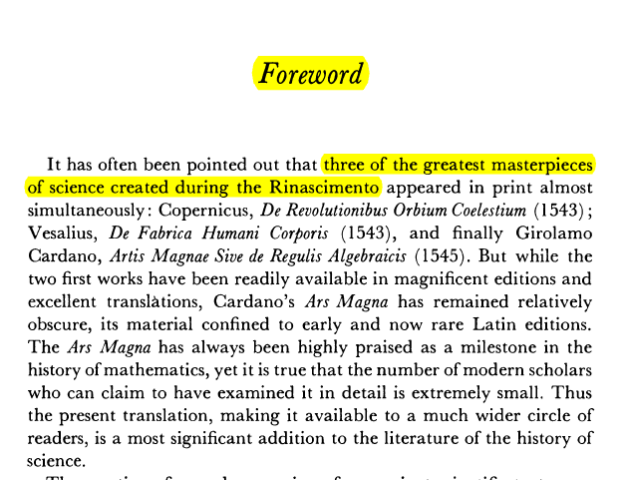

p. xiii
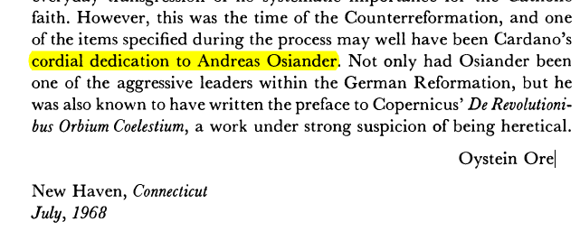

DEDICATION to ANDREAS OSIANDER,
p. 2

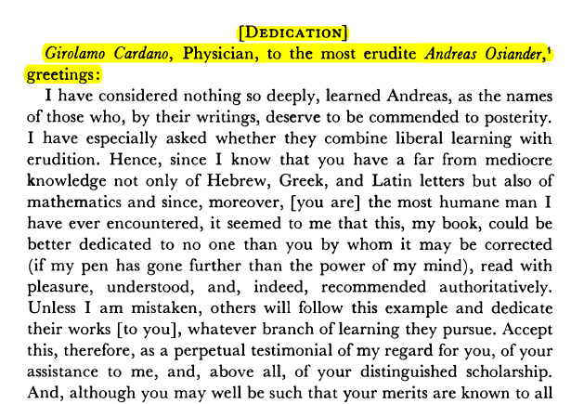

THE ARAB,
p. 7

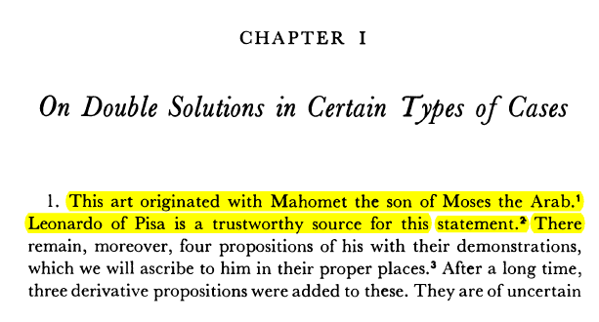

Αναγνωριση πρωταιρεοτητων
p. 8,
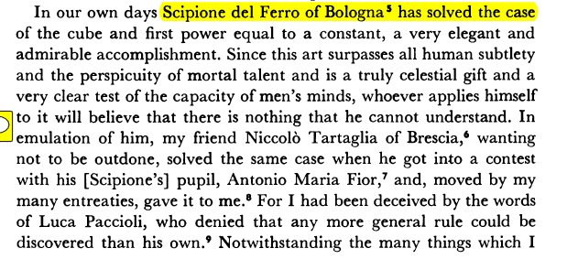
ΣΧΟΛΙΟΝ. Αναγνωριση πρωταιρεοτητων.

ΑΡΝΗΤΙΚΟΙ ΑΡΙΘΜΟΙ,
p. 10
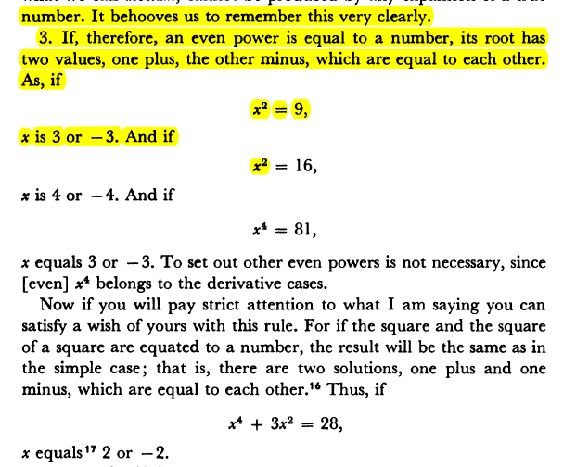

ΜΙΓΑΔΙΚΟΙ ΑΡΙΘΜΟΙ,
p. 219,
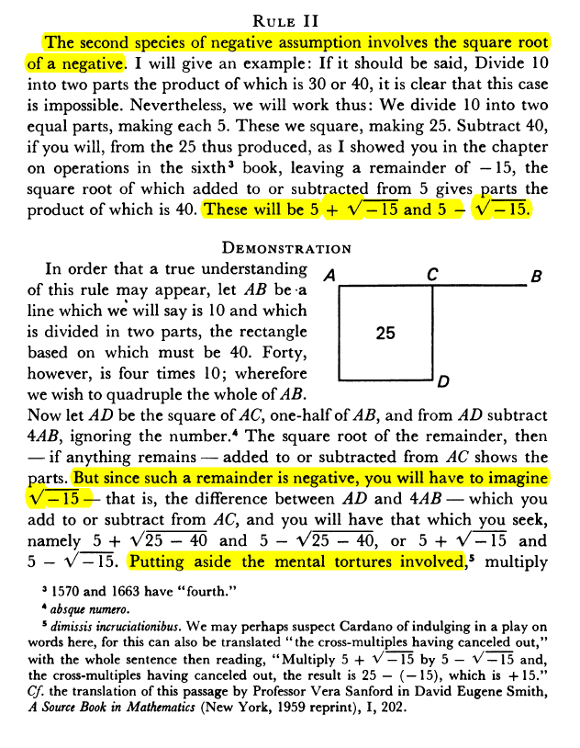
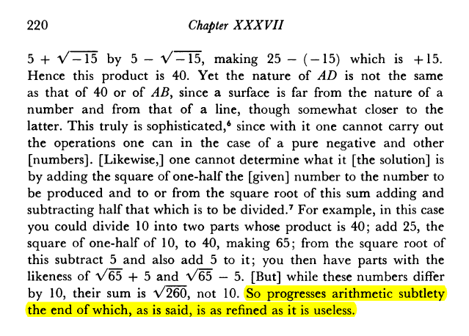
INFO,
subtlety λεπτότητα, επιδεξιότητα
refined, εκλεπτυσμένος, εξευγενισμένος

casus irreducibilis,
ΕΡΩΤΗΜΑ.
Αν εξισωση 3^{ου} βαθμου εχει 3 ριζες πραγματικες, είναι δυνατον να υπαρξουν τυποι που να δινουν τις 3 ριζες με πραξεις που εχουν ΜΟΝΟΝ τα συμβολα +, επι, δια, ριζικα. ?

https://en.wikipedia.org/wiki/Pierre_Wantzel,
Wantzel was also the first person who proved, in 1843,[6] that when a cubic polynomial with rational coefficients has three real roots but it is irreducible in Q[x] (the so-called casus (περιπτωση) irreducibilis), then the roots cannot be expressed from the coefficients using real radicals alone (ΣΓΠ. i.e. radicals Επι πραγματικων αριθμων), that is, complex non-real numbers must be involved if one expresses the roots from the coefficients using radicals. This theorem would be rediscovered decades later by (and sometimes attributed to) Vincenzo Mollame and Otto Hölder.

ΣΥΓΚΡΙΣΗ με δευτεροβαθμιες.
Για να βρουμε τις 3 πραγματικες ριζες, εχουμε αναγκη την υπαρξη ενοσ ευρυτερου σωματος περαν των πραγματικων.

ΤΙ ΕΚΑΝΕ ΤΗΝ ΔΙΑΦΟΡΑ,
«περισσοτερη «αλγεβρικοτης»»
ΔΕΝ υπηρχε καποιο νέο εργαλειο. Πιο επιδεξια χρηση των παλαιων.

CARDAN BIO,

WIKIPEDIA,
https://en.wikipedia.org/wiki/Gerolamo_Cardano,

Gerolamo Cardano (Italian: [dʒeˈrɔːlamo karˈdaːno]; also Girolamo[3] or Geronimo;[4] French: Jérôme Cardan; Latin: Hieronymus Cardanus; 24 September 1501– 21 September 1576) was an Italian polymath, whose interests and proficiencies ranged through those of mathematician, physician, biologist, physicist, chemist, astrologer, astronomer, philosopher, writer, and gambler.[5] He was one of the most influential mathematicians of the Renaissance, and was one of the key figures in the foundation of probability and the earliest introducer of the binomial coefficients and the binomial theorem in the Western world. He wrote more than 200 works on science.[6]

Cardano partially invented and described several mechanical devices including the combination lock, the gimbal consisting of three concentric rings allowing a supported compass or gyroscope to rotate freely, and the Cardan shaft with universal joints, which allows the transmission of rotary motion at various angles and is used in vehicles to this day. He made significant contributions to hypocycloids, published in De proportionibus, in 1570. The generating circles of these hypocycloids were later named Cardano circles or cardanic circles and were used for the construction of the first high-speed printing presses.[7]

Today, he is well known for his achievements in algebra. In his 1545 book Ars Magna, he made the first systematic use of negative numbers in Europe, published with attribution the solutions of other mathematicians for the cubic and quartic equations, and acknowledged the existence of imaginary numbers.
SGP. Ta anωterω einai yperbolika,
SGP. ΣΧΟΛΙΑ. “first systematic use of negative numbers in Europe”.
FibonacciSiglerLiberAbaciS.pdf, p. 320. On a Purse Found by Five Men. Einai kapos asafes. To ekshgei kallitera o KATZ, p. 345.
ΣΧΟΛΙΑ. «acknowledged the existence of imaginary numbers»
See CardanoArsMagnaTranWitmerS.pdf, p. pdf 243-244.

So progresses arithmetic subtlety (εκλεπτισμενοσ), the end of which, as is said, is as refined (εξευγενισμενοσ), as it is useless.

Early life and education

Cardano was born on 24 September 1501[8] in Pavia, Lombardy, the illegitimate child of Fazio Cardano, a mathematically gifted jurist, lawyer, and close friend of Leonardo da Vinci. In his autobiography (De propria vita, 1821), Cardano wrote that his mother, Chiara Micheri, had taken "various abortive medicines" (p. 4) to terminate the pregnancy; he said: "I was taken by violent means from my mother; I was almost dead." She was in labour ? for three days.[9] Shortly before his birth, his mother had to move from Milan to Pavia to escape the Plague; her three other children died from the disease.
From CardanoGirolamoBookΟfMyLifeDeVitaPropriaLiber]
After a depressing childhood, with frequent illnesses, and the rough upbringing by his overbearing father, in 1520, Cardano entered the University of Pavia against the wish of his father, who wanted his son to undertake studies of law, but Girolamo felt more attracted to philosophy and science. During the Italian War of 1521–1526, however, the authorities in Pavia were forced to close the university in 1524.[10] Cardano resumed his studies at the University of Padua, where he graduated with a doctorate in medicine in 1525.[11] His eccentric and confrontational style did not earn him many friends and he had a difficult time finding work after his studies had ended. In 1525, Cardano repeatedly applied to the College of Physicians in Milan, but was not admitted owing to his combative reputation and illegitimate birth. However, he was consulted by many members of the College of Physicians, because of his irrefutable intelligence.[12]

Early career as a physician

Cardano wanted to practice medicine in a large, rich city like Milan, but he was denied a license to practice, so he settled for the town of Piove di Sacco, where he practiced without a license. There, he married Lucia Banderini in 1531. Before her death in 1546, they had three children, Giovanni Battista (1534), Chiara (1537) and Aldo Urbano (1543).[9] Cardano later wrote that those were the happiest days of his life.

With the help of a few noblemen, Cardano obtained a teaching position in mathematics in Milan. Having finally received his medical license, he practiced mathematics and medicine simultaneously, treating a few influential patients in the process. Because of this, he became one of the most sought-after doctors in Milan. In fact, by 1536, he was able to quit his teaching position, although he was still interested in mathematics. His notability in the medical field was such that the aristocracy tried to lure him out of Milan. Cardano later wrote that he turned down offers from the kings of Denmark and France, and the Queen of Scotland.[13]

Mathematics
Portrait of Cardano on display at the School of Mathematics and Statistics, University of St Andrews

Gerolamo Cardano was the first European mathematician to make systematic use of negative numbers.[14] He published with attribution the solution of Scipione del Ferro to the cubic equation and the solution of Cardano's student Lodovico Ferrari to the quartic equation in his 1545 book Ars Magna, an influential work on algebra. The solution to one particular case of the cubic equation a x 3 + b x + c = 0 ax^3+bx+c=0[15] (in modern notation) had been communicated to him in 1539 by Niccolò Fontana Tartaglia (who later claimed that Cardano had sworn not to reveal it, and engaged Cardano in a decade-long dispute) in the form of a poem,[16] but del Ferro's solution predated Tartaglia's.[13] In his exposition, he acknowledged the existence of what are now called imaginary numbers, although he did not understand their properties, described for the first time by his Italian contemporary Rafael Bombelli. In Opus novum de proportionibus he introduced the binomial coefficients and the binomial theorem.
ARS MAGNA p. 8.

Cardano was notoriously short of money and kept himself solvent by being an accomplished gambler and chess player. His book about games of chance, Liber de ludo aleae ("Book on Games of Chance"), written around 1564,[17] but not published until 1663, contains the first systematic treatment of probability,[18] as well as a section on effective cheating methods. He used the game of throwing dice to understand the basic concepts of probability. He demonstrated the efficacy of defining odds as the ratio of favourable to unfavourable outcomes (which implies that the probability of an event is given by the ratio of favourable outcomes to the total number of possible outcomes).[19] He was also aware of the multiplication rule for independent events but was not certain about what values should be multiplied.[20]

Cardano was notoriously short of money and kept himself solvent by being an accomplished gambler and chess player. His book about games of chance, Liber de ludo aleae ("Book on Games of Chance"), written around 1564,[17] but not published until 1663, contains the first systematic treatment of probability,[18] as well as a section on effective cheating methods. He used the game of throwing dice to understand the basic concepts of probability. He demonstrated the efficacy of defining odds as the ratio of favourable to unfavourable outcomes (which implies that the probability of an event is given by the ratio of favourable outcomes to the total number of possible outcomes).[19] He was also aware of the multiplication rule for independent events but was not certain about what values should be multiplied.[20]

Later years and death

In 1553 Cardano traveled to Scotland to treat the Archbishop of St Andrews who suffered of a disease that had left him speechless and was thought incurable. The treatment was a success and the diplomat Thomas Randolph recorded that "merry tales" about Cardano's methods were still current in Edinburgh in 1562.[24] Cardano wrote that the Archbishop had been short of breath for ten years, and after the cure was effected by his assistant, he was paid 1,400 gold crowns.[25]
INFO. GOOGLE What is a Scottish church called?
Church of Scotland, national church in Scotland, which accepted the Presbyterian faith during the 16th-century Reformation. John Knox. Areas Of Involvement: Reformed and Presbyterian churches Related People: John Knox Alexander Henderson.

Medallion portrait of Cardano aged 49 by Leone Leoni (1509–1590)

Two of Cardano's children — Giovanni Battista and Aldo Urbano — came to ignoble ends. Giovanni Battista, Cardano's eldest and favorite son was arrested in 1560 for having poisoned his wife,[13] after he had discovered that their three children were not his. Giovanni was put to trial and, when Cardano could not pay the restitution demanded by the victim's family, was sentenced to death and beheaded. Cardano's other son Aldo Urbano was a gambler, who stole money from his father, and so Gerolamo disinherited him in 1569.

Cardano moved from Pavia to Bologna, in part because he believed that the decision to execute his son was influenced by Gerolamo's battles with the academic establishment in Pavia, and his colleagues' jealousy at his scientific achievements, and also because he was beset with allegations of sexual impropriety with his students.[9] He obtained a position as professor of medicine at the University of Bologna.

Cardano was arrested by the Inquisition in 1570
after an accusation of heresy by the Inquisitor of Como, who targeted Cardano's De rerum varietate (1557) (ΔΙΑΦΟΡΑ ΠΡΑΓΜΑΤΑ) .[26] The inquisitors complained about Cardano's writings on astrology, especially his claim that self-harming religiously motivated actions of martyrs and heretics were caused by the stars.[27] In his 1543 book De Supplemento Almanach, a commentary on the astrological work Tetrabiblos by Ptolemy, Cardano had also published a horoscope of Jesus. Cardano was imprisoned for several months and lost his professorship in Bologna. He abjured (απεποιηθην), and was freed, probably with help from powerful churchmen in Rome.[27] All his non-medical works were prohibited and placed on the Index.[27]
[27] RegierJonathanReadingCardanoWithTheRomanInquisition,

ΣΥΜΠΛΗΡΟΜΑΤΙΚΑ,

Κατωτερω παραθετουμε, ποιοι είναι οι τυποι του CARDANO, poy briskontai kai parapano.
Βλ. SGP3kai4bathm σελ. 85, στον ΥΠΟΦΑΚΕΛΟ ΒΙΒΛΙΟΓΡΑΦΙΑ του φακελου ΕΓΓΡΑΦΑ. Εκει υπαρχουν ολες οι αποδειξεις.
H arxikh ejisvsh einai
x³ +px + q=0
Κατωτερω καταγραφουμε τα αποτελεσματα.

Το Δ λεγεται ΔΙΑΚΡΙΝΟΥΣΑ (DISCRIMINANT), .

ΠΡΟΤΑΣΗ.
Α) αν Δ>0, τοτε οι τρεις ως ανω ριζες είναι ΠΡΑΓΜΑΤΙΚΕΣ !
Β) αν Δ<0, τοτε οι τρεις ως ριζες είναι ΜΙΑ ΠΡΑΓΜΑΤΙΚΗ και οι δυο ΜΙΓΑΔΙΚΕΣ συζυγεις,

ΜΑΘΗΜΑΤΙΚΑ Γ΄ Τάξης Γενικού Λυκείου
Ομάδας Προσανατολισμού Θετικών Σπουδών
και Σπουδών Οικονομίας & Πληροφορικής
Β´ ΜΈΡΟΣ

