19 ΔΙΑΛΕΞΙΣ,

Τεταρτη 22-05-2024,

19 ΔΙΑΛΕΞΙΣ Α,

Webex meeting recording: 19 A Dialexis ths 22-05-2024 Tetarth-20240523 1325-1

Password: Trdj2WjD

Recording link: <https://uoa.webex.com/uoa/ldr.php?RCID=047ca09d18862e00fb904dad1a1c6a29>,

19 ΔΙΑΛΕΞΙΣ Β, Webex meeting recording: 19 B INM 2024 tetarth, 11.00-14.00-20240522 0926-1

Password: VnJ6y9Ww

Recording link: <https://uoa.webex.com/uoa/ldr.php?RCID=2522fa49c3d9f7a2904c64976ea0ced7>,

**ΠΡΟΚΑΤΑΡΚΤΙΚΑ,**

Εχουμε ηδη διαπραγματευθη

6002, 6003,

ΕΡΓΑΣΙΕΣ προς διαπραγμετευσιν,

1004 ηλιοκεντρικο, 5001 (4001) κυβικες ριζες του 1, 8001 δευτερος ορος,

ΠΕΡΙΛΗΨΙΣ ΙΕΡΩΝΥΜΟΣ ΚΑΡΔΑΝΟΣ,

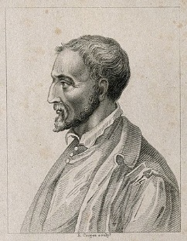

17th-century portrait [engraving](https://en.wikipedia.org/wiki/Engraving) of Cardano (1501-1576)

Artis Magnae, Sive de Regulis Algebraicis Liber Unus

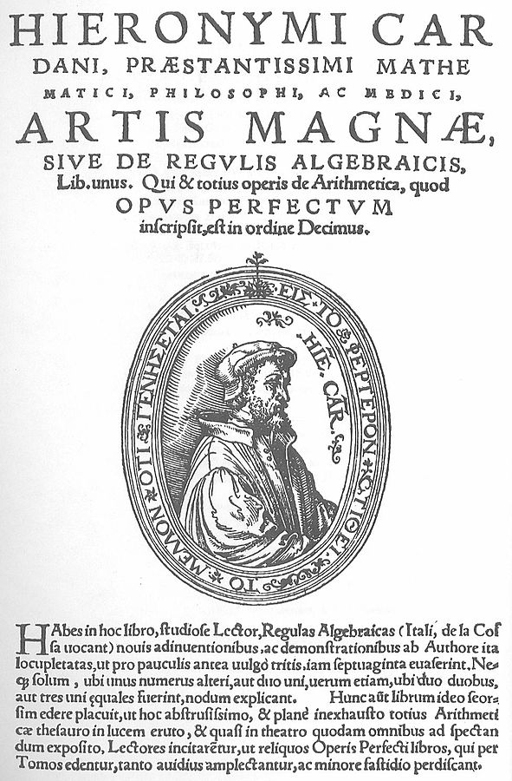

The title page of the Ars Magna

Author Girolamo Cardano

Language Latin

Subject Mathematics

Publication date 1545

ΣΧΟΛΙΑ,

Praestantissimus,

From praestans (“standing ahead of others, excelling”) + -issimus (“-est, most”).

# ΟΙ ΜΙΓΑΔΙΚΟΙ, 2024,

## ΜΙΓΑΔΙΚΟΙ (σημερα),

### ΟΡΙΣΜΟΙ,

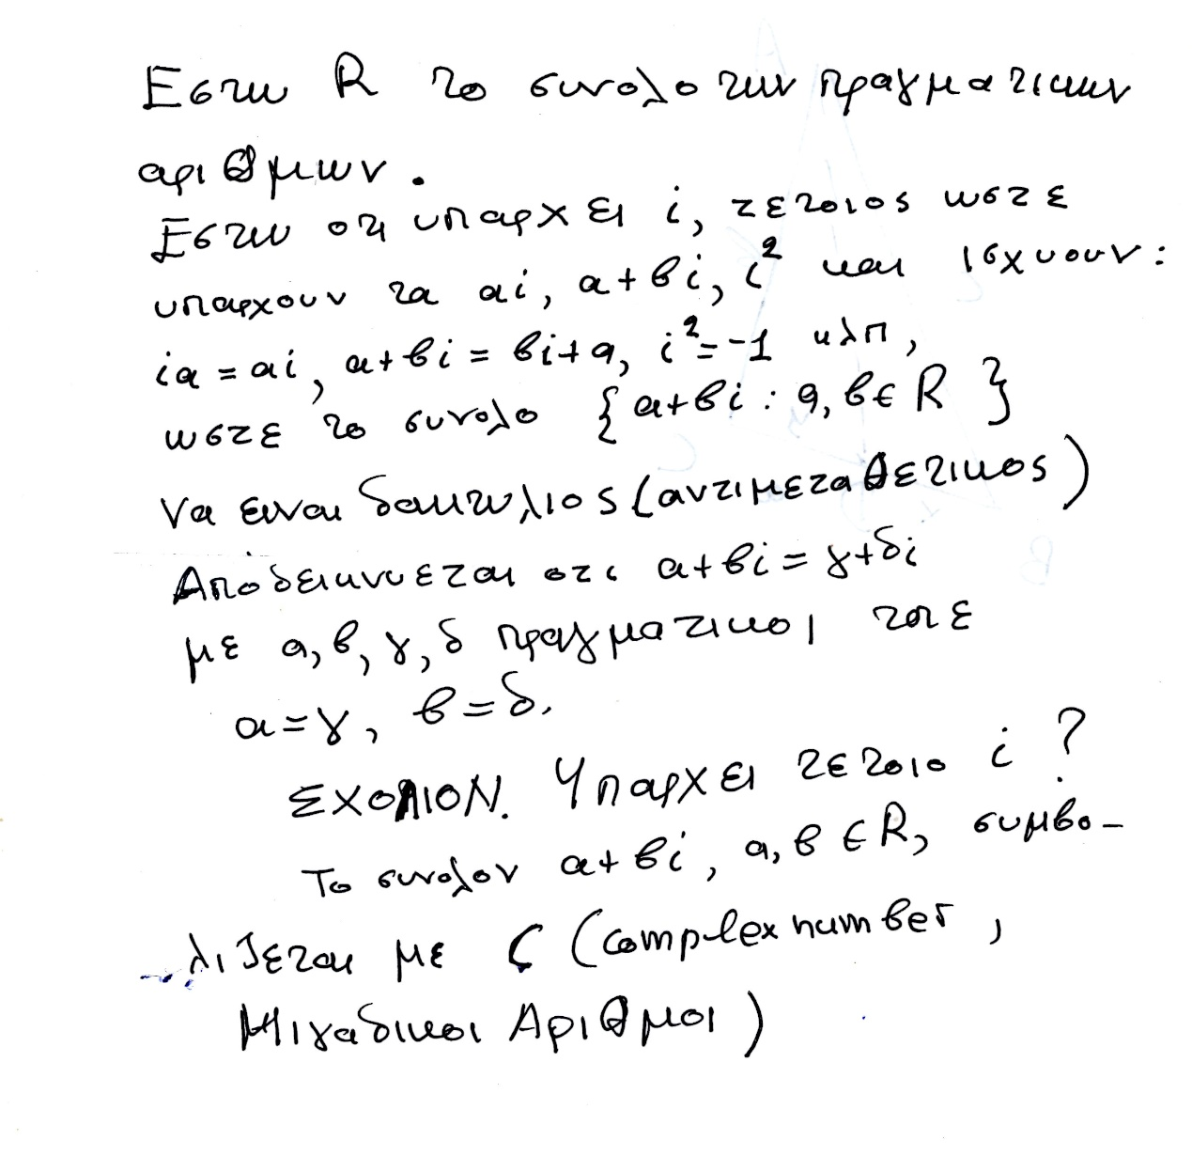

### ΡΙΖΙΚΑ,

Εστω α πραγματικος θετικος η 0, τοτε α1/2 είναι ο θετικος η 0 β, που β2 =α.

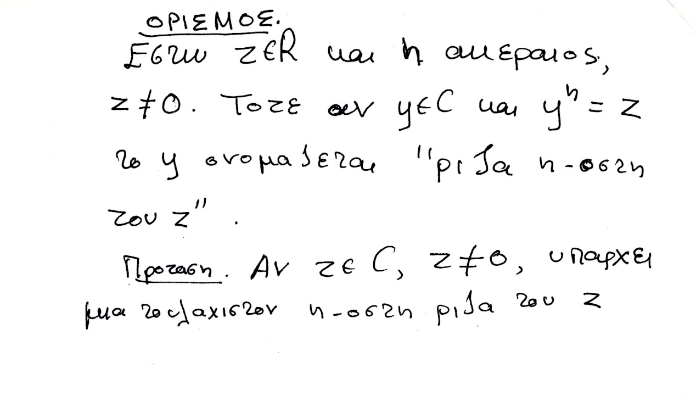

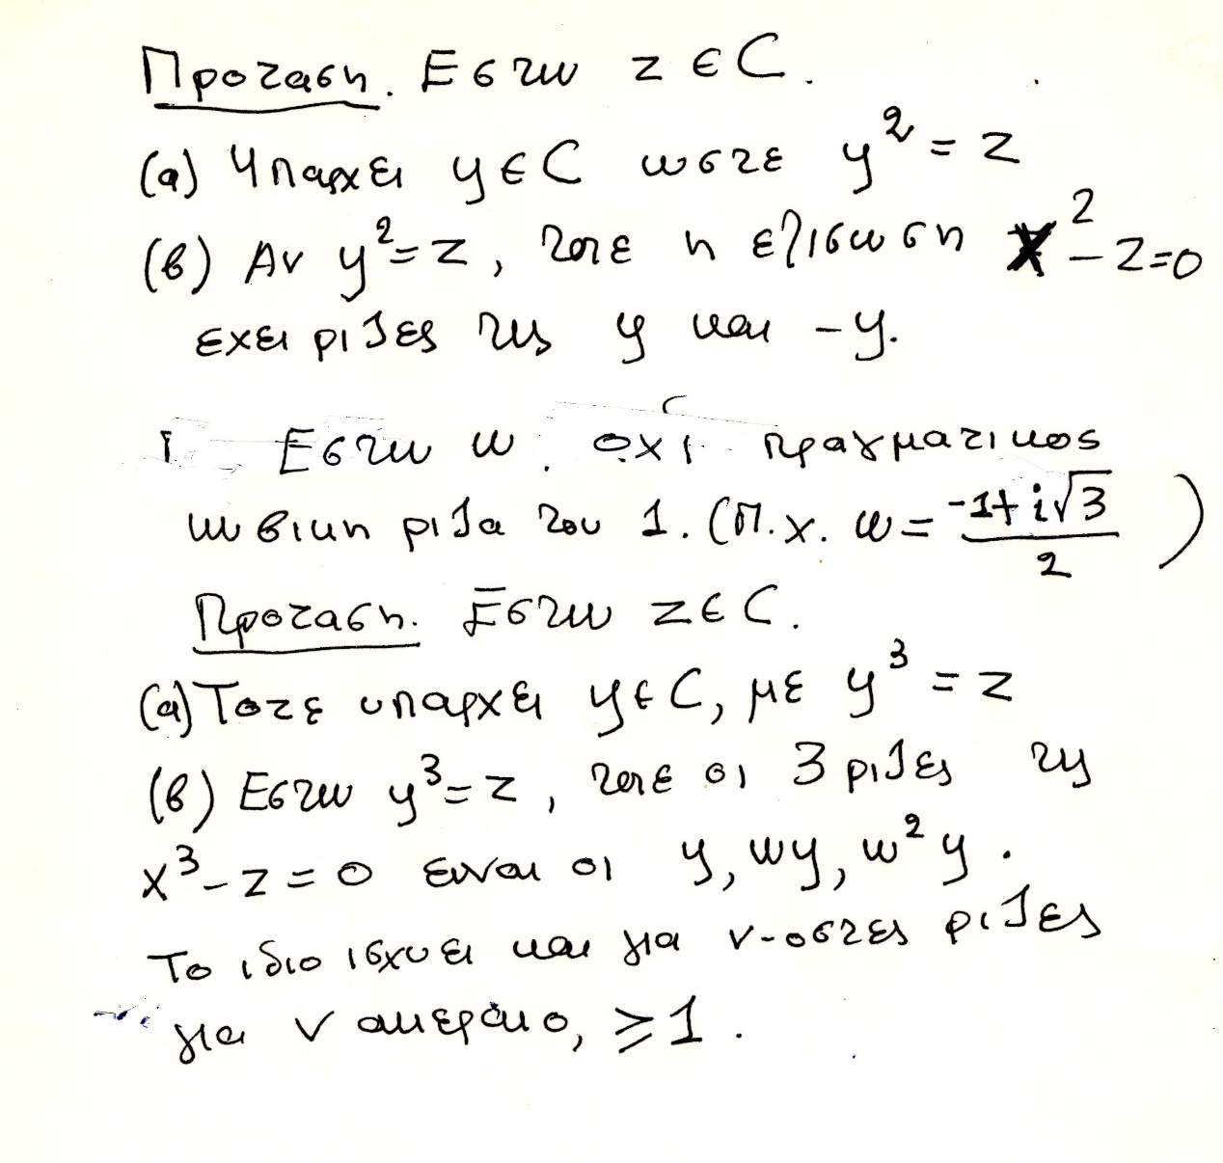

### ΔΙΑΦΩΤΙΣΜΟΣ επι του υπο υπο υπο κεφαλαιου, ΣΓΠ, ΛΥΣΗ ΕΞΙΣΩΣΕΩΝ ΒΑΘΜΟΥ 3,

#### Υπαρξη κυβικης ριζας μιγαδικου

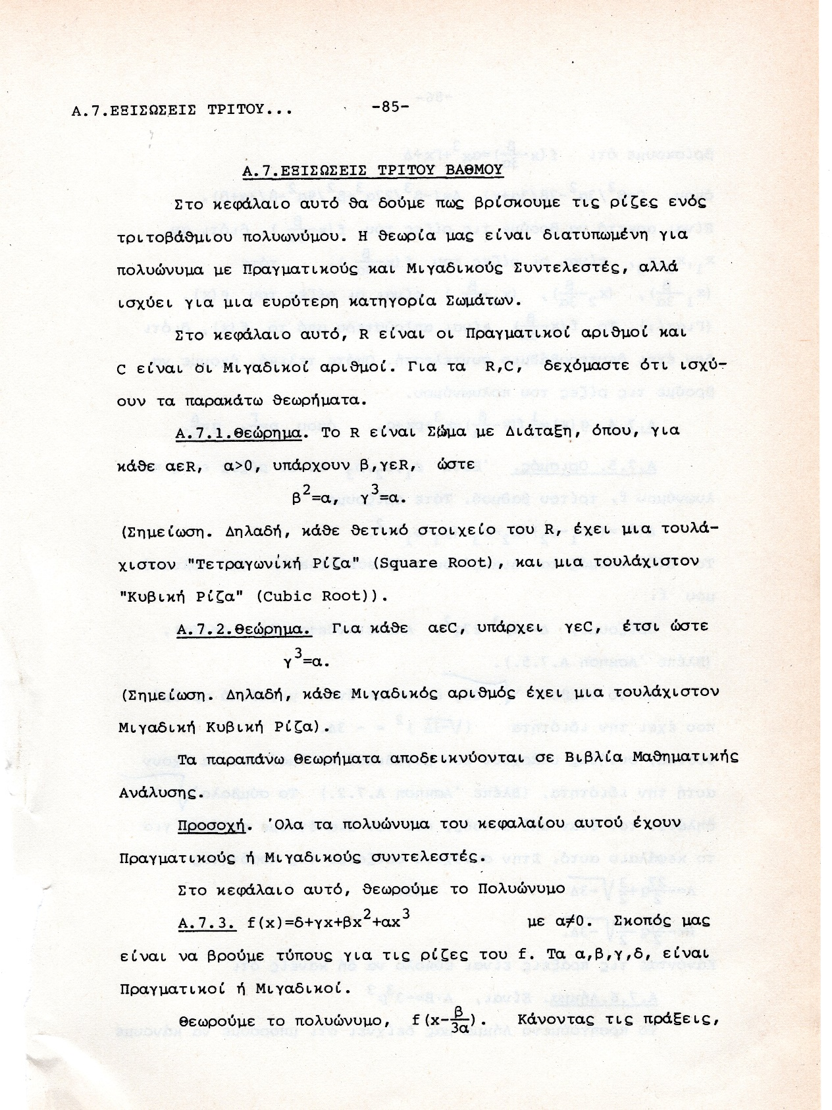

r(cosθ+isinθ),

( r1/3(cos(θ/3)+isin(θ/3) ) )3 = r(cosθ+isinθ),

de MOIVRE formula. Συνδεση μιγαδικων και τριγωνομετριας, .

#### ΤΥΠΟΙ CARDANO,

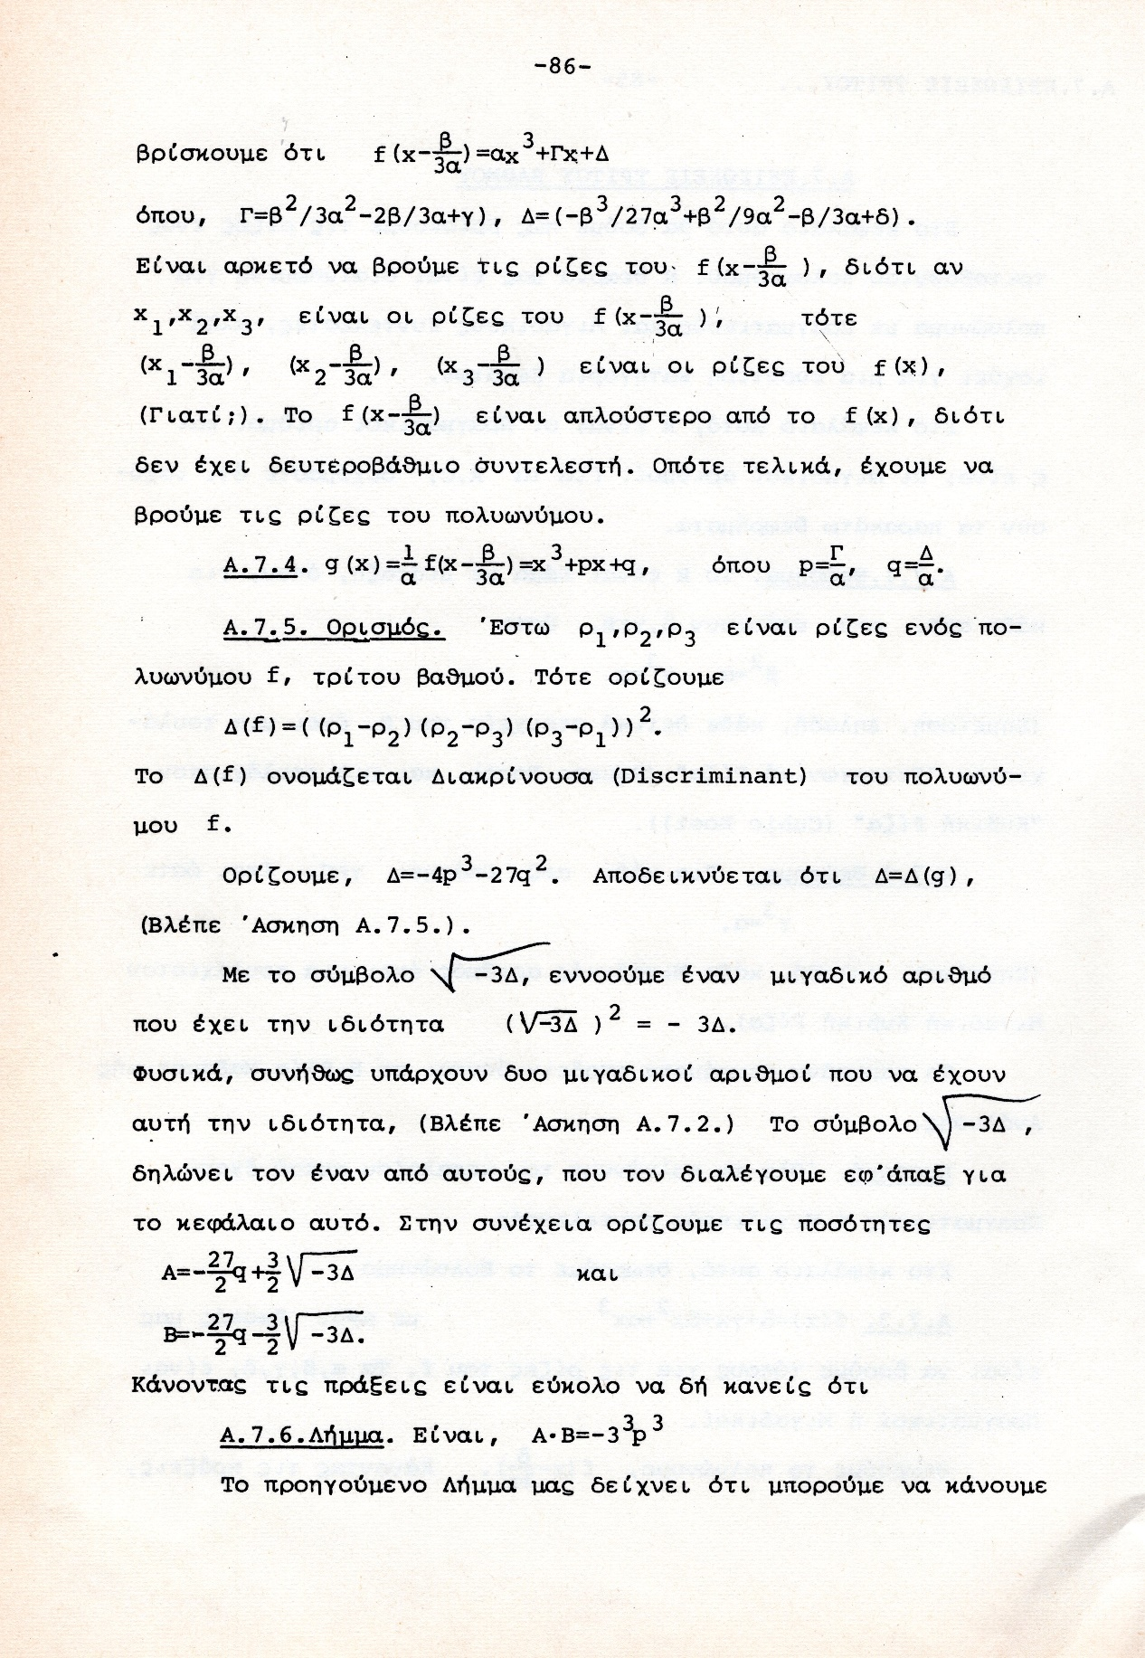

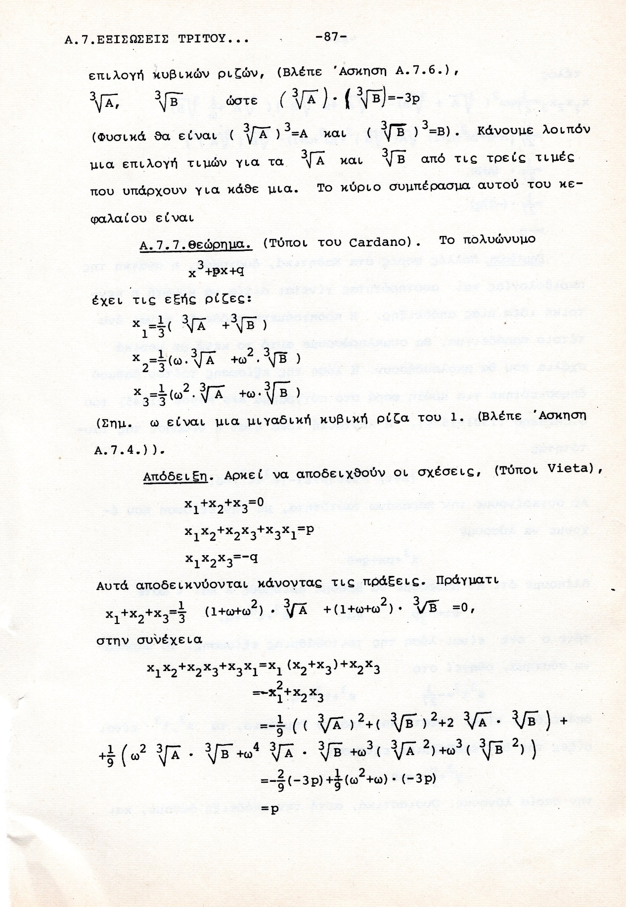

## Rafael Bombelli,

### BOMBELLI BIO,

#### <https://en.wikipedia.org/wiki/Rafael_Bombelli#cite_note-Stedall-5>,

**Rafael Bombelli (baptised on 20 January 1526; died 1572)[**a][1][2] was an Italian mathematician. Born in Bologna, he is the author of a treatise on algebra and is a central figure in the understanding of imaginary numbers.

He was the one who finally **managed to address the problem with imaginary numbers.** In his **1572 book, L'Algebra**, Bombelli solved equations using the method of del Ferro/Tartaglia. He introduced the **rhetoric** that preceded the representative symbols +i and -i and described how they both worked.

Rafael Bombelli was baptised on 20 January 1526[3] in Bologna, Papal States. He was born to Antonio Mazzoli, a wool merchant, and Diamante Scudieri, a tailor's daughter. The Mazzoli family was once quite powerful in Bologna. When Pope Julius II came to power, in 1506, he exiled the ruling family, the Bentivoglios. The Bentivoglio family attempted to retake Bologna in 1508, but failed. Rafael's grandfather participated in the coup attempt, and was captured and executed. Later, Antonio was able to return to Bologna, **having changed his surname to Bombelli** to escape the reputation of the Mazzoli family. Rafael was the oldest of six children. Rafael received no college education, **but was instead taught by an engineer-architect** by the name of **Pier Francesco Clementi**.

Bombelli felt that none of the works on algebra by the leading mathematicians of his day provided a careful and thorough exposition of the subject. Instead of another convoluted treatise that only mathematicians could comprehend, Rafael decided to write a book on algebra that could be understood by anyone. His text would be self-contained and easily read by those without higher education.

Bombelli died in 1572 in Rome.

#### <https://mathshistory.st-andrews.ac.uk/Biographies/Bombelli/>,

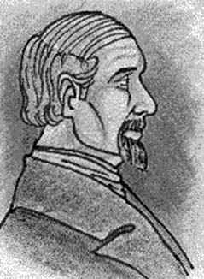

It was in 1549 that **Alessandro Rufini, Bombelli's patron,** acquired the rights to reclaim that part of the marshes of the **Val di Chiana** which belonged to the Papal States. The Val di Chiana is a fairly central region in the Tuscan Apennines which was not well drained either by the Arno river which runs north west going through Florence and Pisa to the sea, or by the Tiber which runs south through Rome. By 1551 Bombelli was in the Val di Chiana recording the boundaries to the land that was to be reclaimed. He worked on this project until 1555 when there was an interruption to the reclamation work.

**While Bombelli was waiting for the Val di Chiana project to recommence, he decided to write an algebra book.** He had felt that the reason for the many arguments between leading mathematicians was the lack of a careful exposition of the subject. Only Cardan had, in Bombelli's opinion, explored the topic in depth and his great masterpiece was not accessible to people without a thorough grasp of mathematics. Bombelli felt that a self-contained text which could be read by those without a high level of mathematical training would be beneficial. He wrote in the preface of his book [2] (see also [3]):-

On one of Bombelli's visits to Rome he made an exciting mathematical discovery. **Antonio Maria Pazzi, who taught mathematics at the University of Rome,** showed Bombelli a **manuscript of Diophantus's** Arithmetica and, after Bombelli had examined it, the two men decided to make a translation. Bombelli wrote in [2] (see also [3]):-

... [we], in order to enrich the world with a work so finely made, decided to translate it and we have translated five of the books (there being seven in all); the remainder we were not able to finish because of pressure of work on one or other.

Despite never completing the task, Bombelli began to revise his algebra text in the light of what he had discovered in Diophantus. In particular, 143 of the 272 problems which Bombelli gives in Book III are taken from Diophantus. Bombelli does not identify which problems are his own and which are due to Diophantus, but he does give full credit to Diophantus acknowledging that he has borrowed many of the problems given in his text from the Arithmetica.

### ΜΙΓΑΔΙΚΟΙ (κατά ΜΠΟΜΠΕΛΛΙ),

#### ΠΡΑΓΜΑΤΙΚΟΙ ΑΡΙΘΜΟΙ,

##### https://en.wikipedia.org/wiki/Rafael_Bombelli#cite_note-Stedall-5

In the book that was published in 1572, entitled Algebra, Bombelli gave a comprehensive account of the algebra known at the time. **He was the first European to write down the way** of performing computations with negative numbers. The following is an excerpt from the text:

"Plus times plus makes plus

**Minus times minus makes plus**

Plus times minus makes minus

Minus times plus makes minus

Plus 8 times plus 8 makes plus 64

Minus 5 times minus 6 makes plus 30

Minus 4 times plus 5 makes minus 20

Plus 5 times minus 4 makes minus 20"

As was intended, Bombelli used simple language as can be seen above so that anybody could understand it. But at the same time, he was thorough.

##### Brahmagupta

Brahmagupta's Brahmasphuṭasiddhānta (628 a.d.), is the first book that provides rules for arithmetic manipulations that apply to zero and to negative numbers.[27] The Brāhmasphuṭasiddhānta is the earliest known text to treat zero as a number in its own right, rather than as simply a placeholder digit in representing another number as was done by the Babylonians or as a symbol for lack of quantity as was done by Ptolemy and the Romans. In chapter eighteen of his Brāhmasphuṭasiddhānta, Brahmagupta describes operations on negative numbers. He first describes addition and subtraction,

He goes on to describe multiplication,

18.33. The product of a negative and a positive is negative, **of two negatives positive,** and of positives positive; the product of zero and a negative, of zero and a positive, or of two zeros is zero.[20]

#### ΜΙΓΑΔΙΚΟΙ,

##### https://mathshistory.st-andrews.ac.uk/Biographies/Bombelli/,

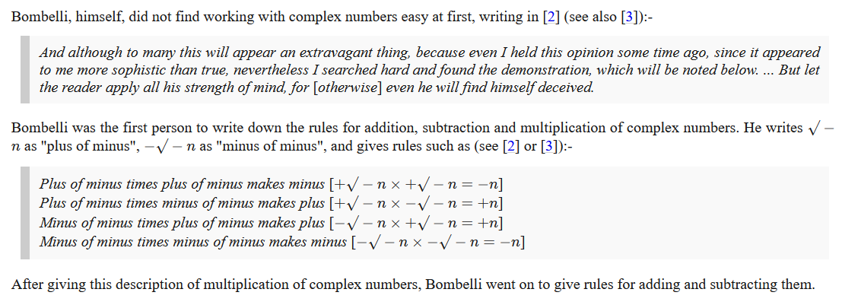

Se sygxrono symbolismo, π.χ.

(2i)(3i)=-6, (2i)(-3i)=6, (-2i)(3i)=1, (-2i)(-3i)=-1, .

Plus di minus einai i, minus di minus is -i,

Bombelli avoided confusion by giving a special name to square roots of negative numbers, instead of just trying to deal with them as regular radicals like other mathematicians did. This made it clear that these numbers were neither positive nor negative. This kind of system avoids the confusion that Euler encountered. **Bombelli called the imaginary number i "plus of minus" and used "minus of minus" for -i**.

(a+bi)(c+di)=ac +a(di)+(bi)c+(bi)((di)= ac+(ad)i +(bc)i +(bd**)(ii)** =

= ac + (ad+bc)i + (bd)(-1) = (ac –bd) + (ad+bc)i

ΣΧΟΛΙΟ

Όμως

((-1)1/2 )((-1)1/2 ) =( (-1)(-1) )1/2 =1 η ii=(-1) ?

##### ΕΦΑΡΜΟΓΗ στις 3βαθμιες εξισωσεις,

x3 -7x+6=0

Θεωρουμε την ως ανω εξισωση. Την φτιαξαμε από το γινομενο

(x-1)(x-2)(x+3)= x3 -7x+6, ριζες 1, 2, -3.

Κατά την ως ανω μεθοδο του CARDANO, οι ριζες περιγραφονται ως κατωτερω.

Κανοντας τις πραξεισ

Α=-81+30(31/2 )i, Β==-81-30(31/2 )i,

ΘΕΤΟΝΤΑΣ ω=(1+(31/2 )i)/2.

H πορεια του CARDANO (με μεταγενεστερες βελτιωσεις), δινει τις τρεις ριζες

ρ1 =(1/3)(Α1/3 +Β1/3 )

ρ2 =(1/3)(ωΑ1/3 +ω2Β1/3 )

ρ3 =(1/3)( ω2Α1/3 +ωΒ1/3 )

Κανοντας απλα τις πραξεις, όπως καταλαβαινουμε τους μιγαδικους σημερα, διαπιστωνουμε τις ισοτητες

((3+ 2(31/2)i)3 =A kai ((3- 2(31/2)i)3 =B

οποτε

ρ1 = (1/3) ((3+ 2(3 1/2)i+ ((3- 2(3 1/2)i ) )=2

ρ2 =(1/3)(ωΑ1/3 +ω2Β1/3 )=1

ρ3 =(1/3)( ω2Α1/3 +ωΒ1/3 )=-3

Η ΑΠΟΔΕΙΞΗ ΤΕΛΕΙΩΣΕ,

πως όμως «μαντεψαμε» το ((3+ 2(31/2)i) και

(3- 2(31/2)i) είναι οι κυβικες ριζες των Α και Β, ?

Ας δουμε πως βρισκουμε την «κυβικη» ριζα του Α=-81+30(31/2 )i,

Ξεκιναμε με την ελπιδα; Ότι υπαρχουν ακεραιοι α, β, ώστε

(α + β31/2i)3 =-81+30(31/2 )i,

Μετα από καποια αναζητηση, διαπιστωνουμε ότι τα α=3 και β=2, είναι λυσεις, και προχωρουμε με αυτές.

Τα παραπανω λιγο-πολύ με poly δισταγμο ηταν το στυλ του BOMBELLI (όχι του CARDANO)

Παρεμφερει υπολογισμους κανει και ο ΚΑΤΖ p. 406.

ΣΧΟΛΙΟΝ ΣΓΠ. Ενιοτε οι τυποι του ΙΕΡΩΝΥΜΟΥ δινουν πραγματικες ριζες με πραξεις μεσω ΜΙΓΑΔΙΚΩΝ.

Εδώ εμφανιζεται συγκεκριμενα η ΠΟΙΟΤΙΚΗ ΔΙΑΦΟΡΑ μεταξυ β/βαθμιων και τριτοβαθμιων εξισωσεων

Συγκρισης με δευτεροβαθμια εξισωση,

ΜΕΤΑΞΥ β/θμιων και τριτο/βαθμιων Εξισωσεων

Η αναγκη υπαρξης ευρυτερου «κοσμου», για τις τριτο/βαθμιεσ Εξισωσεισ

ΕΔΩ σταματαει η βιντεοσκοπιση του 19 διαλεξις Α, κα συνεχιζει η 19 διαλεξις Β,

### ΣΥΜΒΟΛΙΣΜΟΙ,

#### ΠΑΛΑΙΟΤΕΡΗ ΓΡΑΦΗ ΔΥΝΑΜΕΩΝ,

KatzHistoryOfMathematics3rdS, 12.1.1. p.386

Algebraic Symbolism and Techniques (ΑΝΑΓΕΝΝHΣΗ),

**Algebraic Symbolism and Techniques**

Recall that Islamic algebra was entirely rhetorical. There were no symbols for the unknown or

its powers nor for the operations performed on these quantities. **Everything was written out in words**.

The same was generally true in the works of the early abacists and in the earlier Italian work of **Leonardo of Pisa (Fibonacci**).

Επισης η γραφη του ΙΕΡΩΝΥΜΟΥ ηταν «ρητορικη», (Rhetoric)

(SGP, Syncopated (Συγκεκομμενος)),

Early in the fifteenth century, however, some of the abacists (Arabic numerals), began to substitute abbreviations for unknowns. For example, in place of the standard words ***cosa* (thing, x),** *censo* (square, απογραφη), *cubo* (cube), and *radice* (root), some authors used the abbreviations *c*, *ce*, *cu*, and *R*. Combinations of these abbreviations were used for higher powers.

Thus,

***ce di ce* or *ce ce* stood for *censo di censo* or fourth power (*x*2*x*2);**

***ce cu* or *cu ce***, designating ***censo di cubo* and *cubo di censo*,** respectively**, ce di cu stood for fifth power (*x*2*x*3);** And

***cu cu*, designating *cubo di cubo*, stood for sixth power (*x*3*x*3**).

**Η επαναληψη δηλωνε γινομενο**.

Syncopated Algebra 275 – 1600

<https://jwilson.coe.uga.edu/emt668/emt668.student.folders/Hix/EMT635/Alg.sync.timeline.html>,

ΔΙΟΦΑΝΤΟΣ,

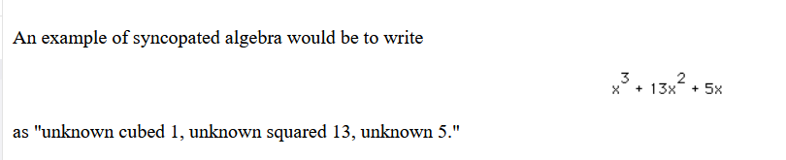

#### Here are some examples of Bombelli's notation.

<https://mathshistory.st-andrews.ac.uk/Biographies/Bombelli/>,

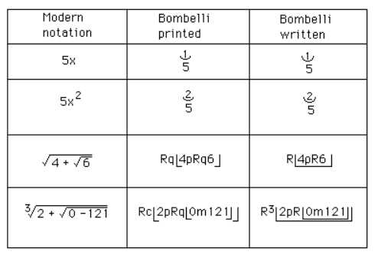

He then showed that, using his calculus of complex numbers, correct real solutions could be obtained **from the Cardan-Tartaglia formula for the solution to a cubic even when the formula gave an expression involving the square roots of negative numbers**.

Finally we should make some comments on Bombelli's notation. Although authors such as [Pacioli](https://mathshistory.st-andrews.ac.uk/Biographies/Pacioli/) had made limited use of notation, others such as [Cardan](https://mathshistory.st-andrews.ac.uk/Biographies/Cardan/) had used no symbols at all. Bombelli, however, used quite sophisticated notation. It is worth remarking that the printed version of his book uses a slightly different notation from his manuscript, and this is not really surprising for there were problems printing mathematical notation which to some extent limited the type of notation which could be used in print.

ΣΧΟΛΙΟΝ.

xkxm =xk+n ,

# ΝΕΑ ALGEBRA του 16ου αιωνα, 2024,

## Η ΑΛΓΕΒΡΑ ΤΟΥ ΓΥΜΝΑΣΙΟΥ σημερα,

Κάθε ΜΕΓΕΘΟΣ μπορει να χαρακτηρισθει με συμβολα x, y, a, b, c, …που δηλωνουν (πραγματικους) αριθμους

Μπορουμε να γραφουμε ΕΚΦΡΑΣΕΙΣ a+x, ax, xa, a(b+c), (ab)c, a(bc), klp . **ΔΕΝ δινουμε αναγκαστικα ερμηνεια.**

ΙΣΧΥΕΙ ax=xa, a(b+c)=ab+ac, (ab)c= a(bc), κλπ,

(δηλαδη ισχυουν τα αξιωματα του ΔΑΚΤΥΛΙΟΥ, η μπορουμε τα πουμε ισχυουν οι «νομοι» των πραξεων). (Σημερα κωδικοποιουνται με τα αξιωματα ΔΑΚΤΥΛΙΟΥ).

Εχουμε πολλες ΜΕΤΑΒΛΗΤΕΣ και ΠΑΡΑΜΕΤΡΟΥΣ,

VIETE,

Ο VIETE απαιτουσε ΟΜΟΙΟΓΕΝΙΑ,

Interestingly, although the ‘=’ sign first appeared in 1557, Viète didn’t ever use it and expressed that relationship verbally (aequetur, make equal to something else).

Kata ayton x 2 kai x5 DEN ΠΡΟΣΤΙΘΕΝΤΑΙ

Ο Descartes ston επομενο αιωνα εδειξε

111x2 =x2 , ara afoy εχει νοημα to (111x2 +x5 ), ara kai το ισον του (x2 +x5 ),

KATZ, p. 407

Vi`ete, Algebraic Symbolism, and Analysis .

*The Analytic Art,* KATZ, p. 408, 12.4.1 Fran¸cois Vi`ete and The Analytic Art

Endiaferoyses parathrhseis

### ΕΥΚΛΕΙΔΕΙΑ ΓΕΩΜΕΤΡΙΑ Α και Β ΛΥΚΕΙΟΥ,

ΕΥΚΛΕΙΔΕΙΑ ΓΕΩΜΕΤΡΙΑ, Τεύχος Α΄, Κωδικός βιβλίου: 0-22-0236, ISBN 978-960-06-5177-5

ΕΥΚΛΕΙΔΕΙΑ ΓΕΩΜΕΤΡΙΑ, Τεύχος B΄, Κωδικός βιβλίου: 0-22-0239, ISBN 978-960-06-5317-5,

#### ΜΗΚΟΣ ΕΥΘΥΓΡΑΜΜΟΥ ΤΜΗΜΑΤΟΣ,

##### ΕΥΚΛΕΙΔΕΙΑ ΓΕΩΜΕΤΡΙΑ, Τεύχος Α΄, Σελ. 20

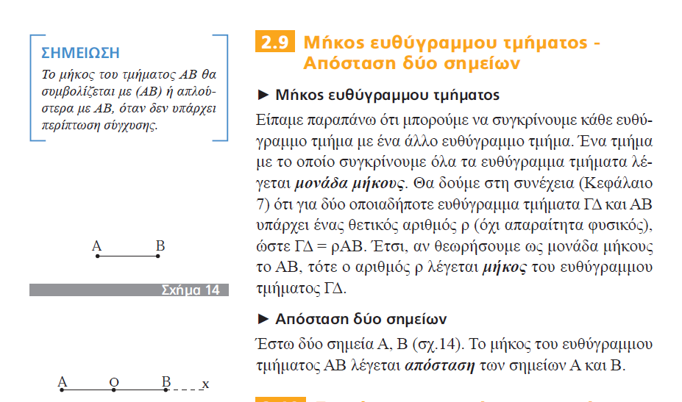

##### ΕΥΚΛΕΙΔΕΙΑ ΓΕΩΜΕΤΡΙΑ, Τεύχος Β΄, Σελ. 9

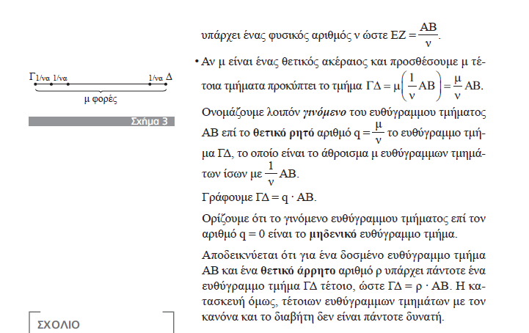

ΟΥΤΕ ΕΔΩ ΤΟ ΑΠΟΔΕΙΚΝΥΕΙ, DEN TO ORIZEI kan,

#### ΥΨΟΣ ΕΚ ΤΩΝ ΠΛΕΥΡΩΝ,

##### ΕΥΚΛΕΙΔΕΙΑ ΓΕΩΜΕΤΡΙΑ, Τεύχος B΄,

σελ. 53

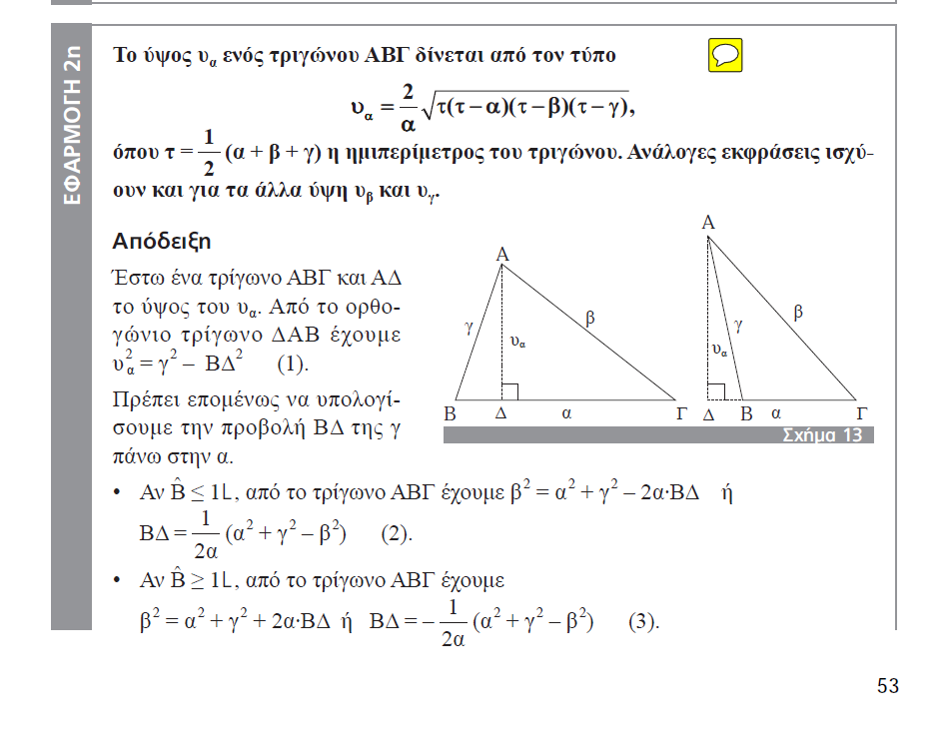

Σελ. 54,

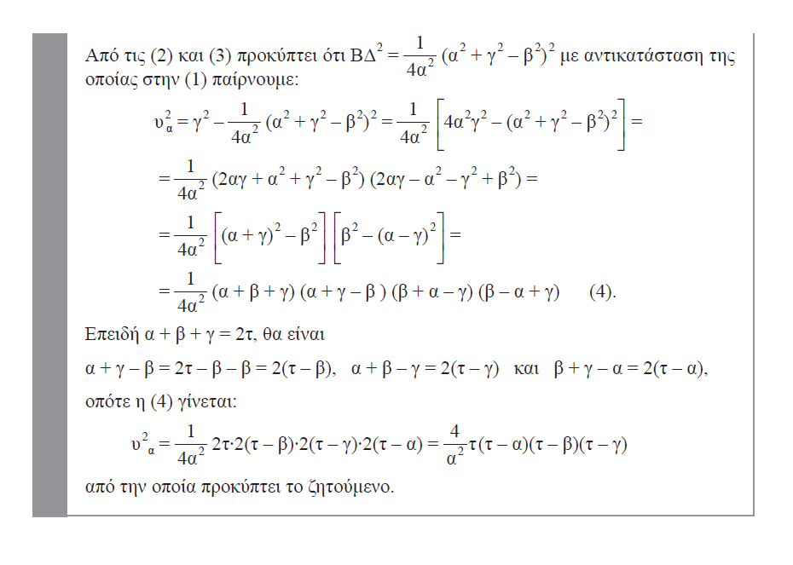

### ΕΡΓΑΣΙΑ 6001, τριγωνο εκ των υψων,

#### ΕΡΓΑΣΙΑ,

Ας υποθεσουμε ότι εχουμε τριγωνο ΑΒΓ, του οποιου ξέρουμε τα τρία ΥΨΗ, (δηλ. τα μηκη τους), υα , υβ , υγ , . Να κατασκευασθεί με ΚΑΝΟΝΑ και ΔΙΑΒΗΤΗ (Κ&Δ), το τριγωνο ΑΒΓ.

(μπορείτε να χρησιμοποιήσετε ΑΛΓΕΒΡΑ, οση θελετε).

ΣΥΜΒΟΥΛΗ.

Να μην φοβηθείτε !.

Να βρειτε σε βιβλια κλπ τους τυπους που το εμβαδον τριγωνου εκ των πλευρων του τριγωνου.

##### ΑΝΑΛΥΣΗ,

Για το τριγωνο ΑΒΓ, ισχύει

2(εμβ ΑΒΓ)=αυα = βυβ = γυγ

Με τον τυπο του ΗΡΩΝΑ (να τον βρειτε !), εχουμε υπολογισει το εμβαδο εκ των πλευρων,

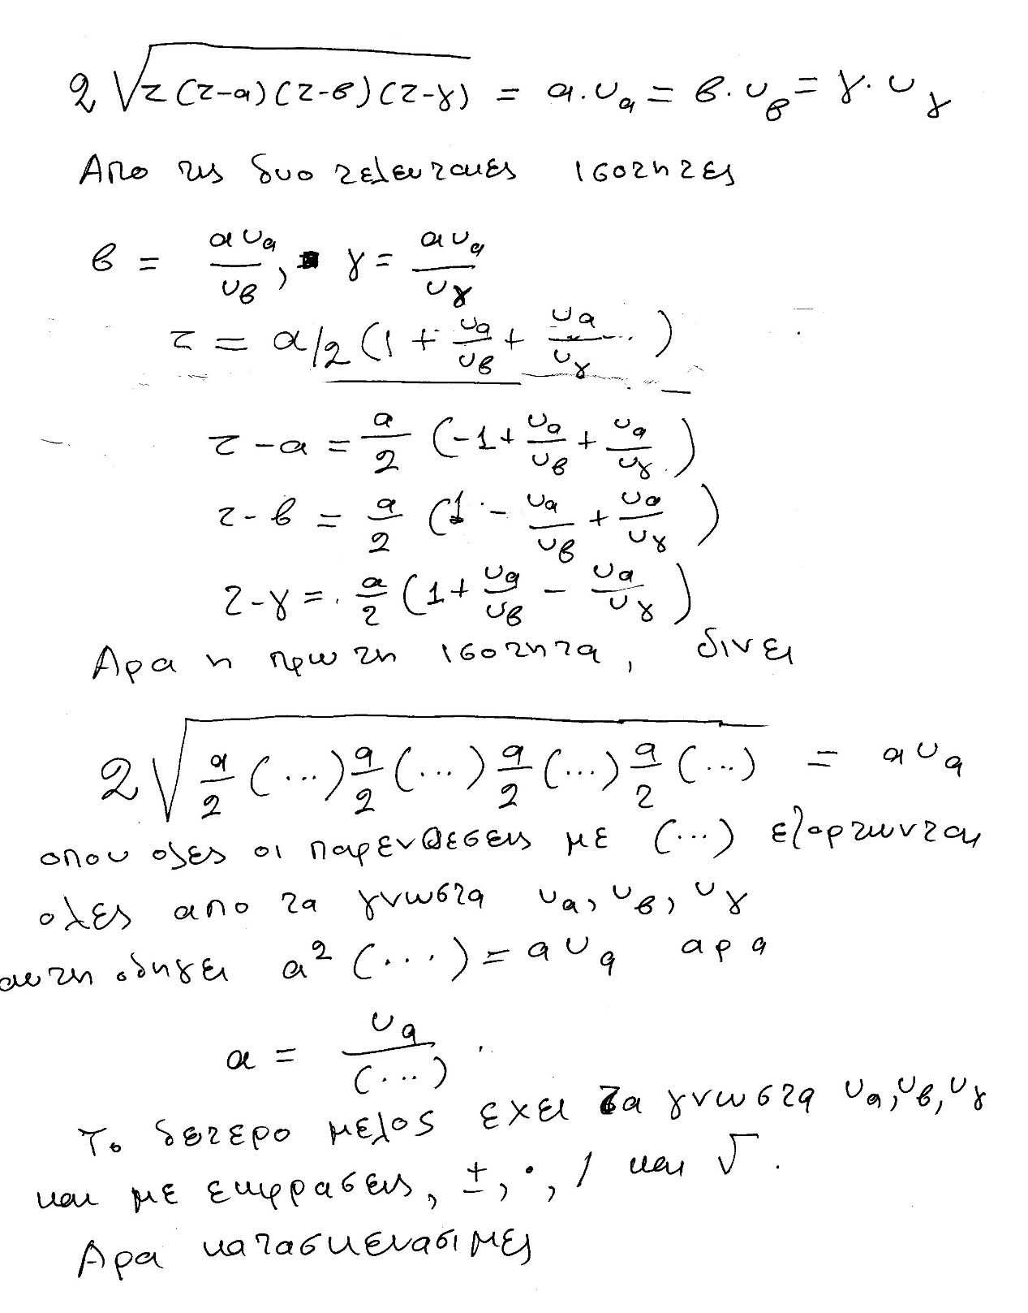

ΔΙΟΡΘΩΣΙΣ, είναι 2αυα

#### ΑΠΑΝΤΗΣΙΣ,

Έστω τρίγωνο ΑΒΓ με γνωστά ύψη υα, υβ, υγ. Από τον τύπο του Ήρωνα έχουμε ότι (ΑΒΓ) = , με s = . Σε αυτό το τρίγωνο έχουμε ότι (ΑΒΓ) =  ==. Επομένως,  =  =  =  ⇒

⇒ 2= αυα = βυβ = γυγ. Επιπλέον, έχουμε ότι:  . Τότε s =  και άρα:

s – α = 

s – β = 

s – γ = 

Άρα η σχέση = αυα = βυβ = γυγ γίνεται:

= αυα ⇒

⇒ = αυα ⇒

⇒ α = το οποίο είναι κατασκευάσιμο γιατί, όπως δείξαμε σε προηγούμενη εργασία, τα ύψη υα, υβ, υγ είναι γνωστά και κατασκευάσιμα, επομένως, αφού το δεύτερο μέλος περιέχει πράξεις πρόσθεσης, πολλαπλασιασμού, αφαίρεσης, διαίρεσης και ριζών τετραγωνικων, τότε και το α είναι κατασκευάσιμο. Συνεπώς και τα β, γ είναι κατασκευάσιμα ως συνδυασμός πολλαπλασιασμού και διαίρεσης των α, υβ, υγ. kai τετραγωνικης ριζας.

#### ΓΕΩΜΕΤΡΙΚΗ ΑΠΑΝΤΙΣΙΣ,

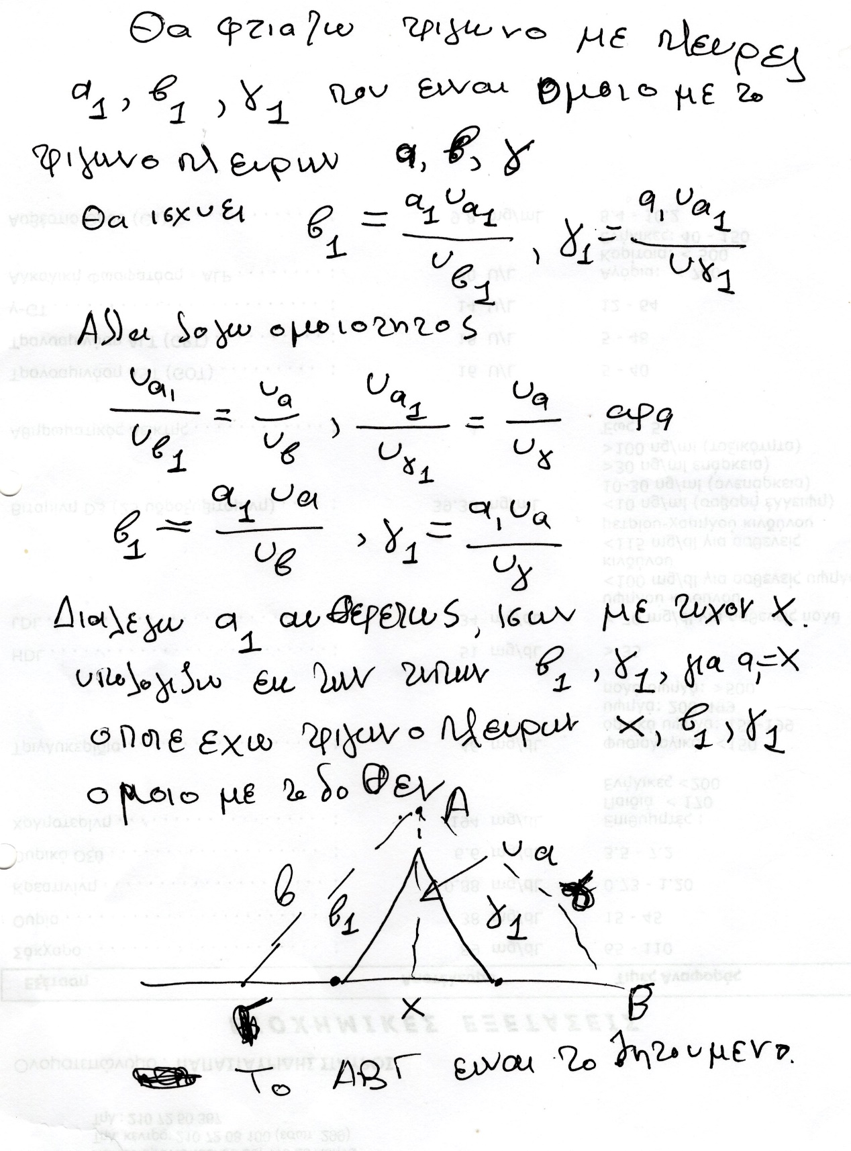

### COMPUTE BISECTOR FROM THE SIDES of a TRIANGLE,

### ΕΡΓΑΣΙΑ 6004 (2024)

Διδεται τριγωνον ABC kai AD, η ΔΙΧΟΤΟΜΟΣ,

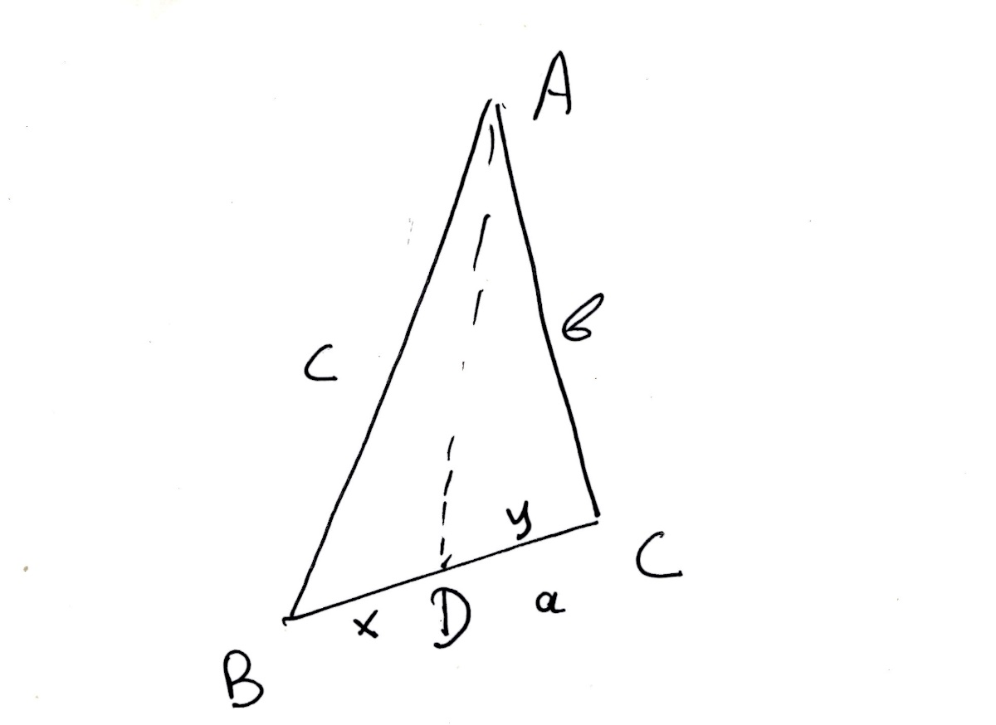

a) Να ευρεθει το x= BD συναρτησει των a, b, c, .

b) Να ευρεθει το d= AD συναρτησει των a, b, c, .

#### ΣΥΜΒΟΥΛΕΣ.

Από το βιβλιο της ΕΥΚΛΕΙΔΙΑΣ ΓΕΩΜΕΤΡΙΑΣ Β τομος του ΛΥΚΕΙΟΥ, να χρησιμοποιηθει το

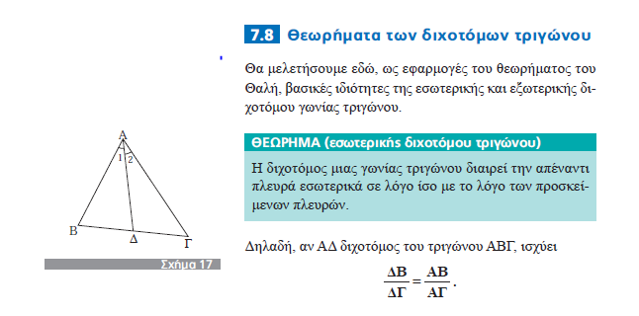

Να χρησιμοποιηθη το ΘΕΩΡΗΜΑ του ΣΥΝΙΜΗΤΟΝΟΥ, από την ΤΡΟΓΩΝΟΜΕΤΡΙΑ,

### ΑΠΑΝΤΗΣΙΣ,

a)

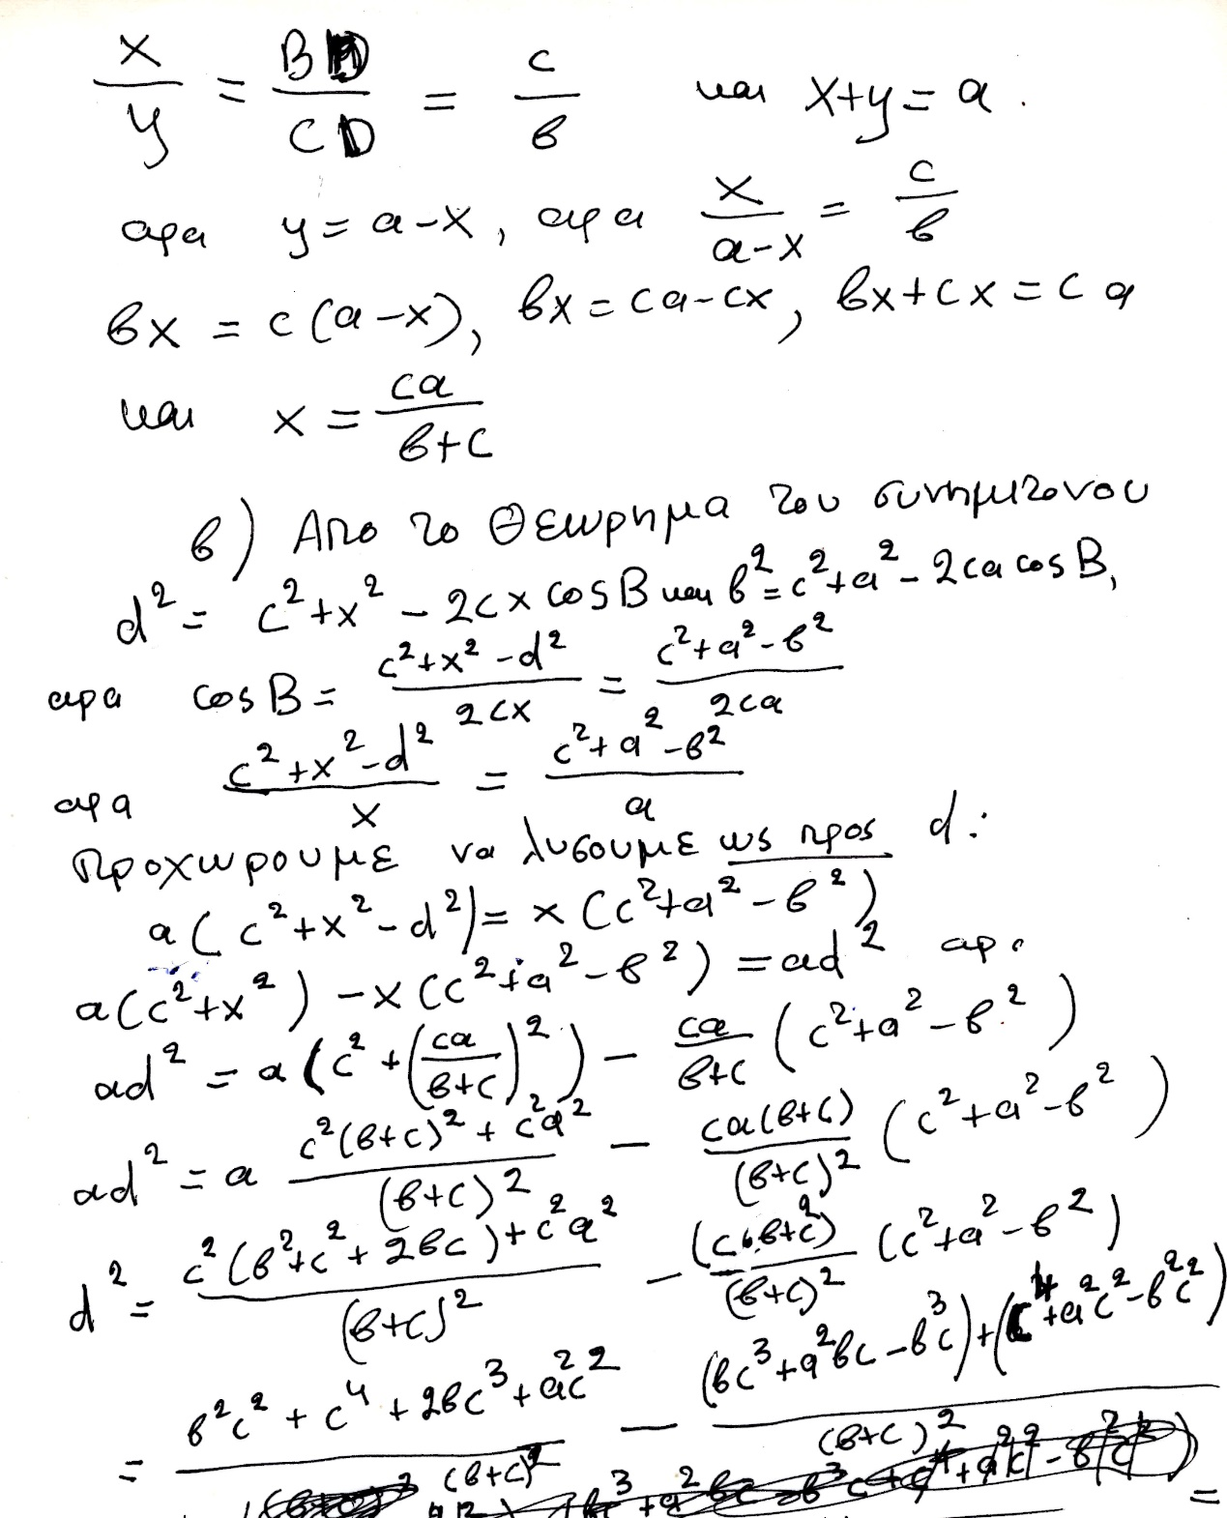

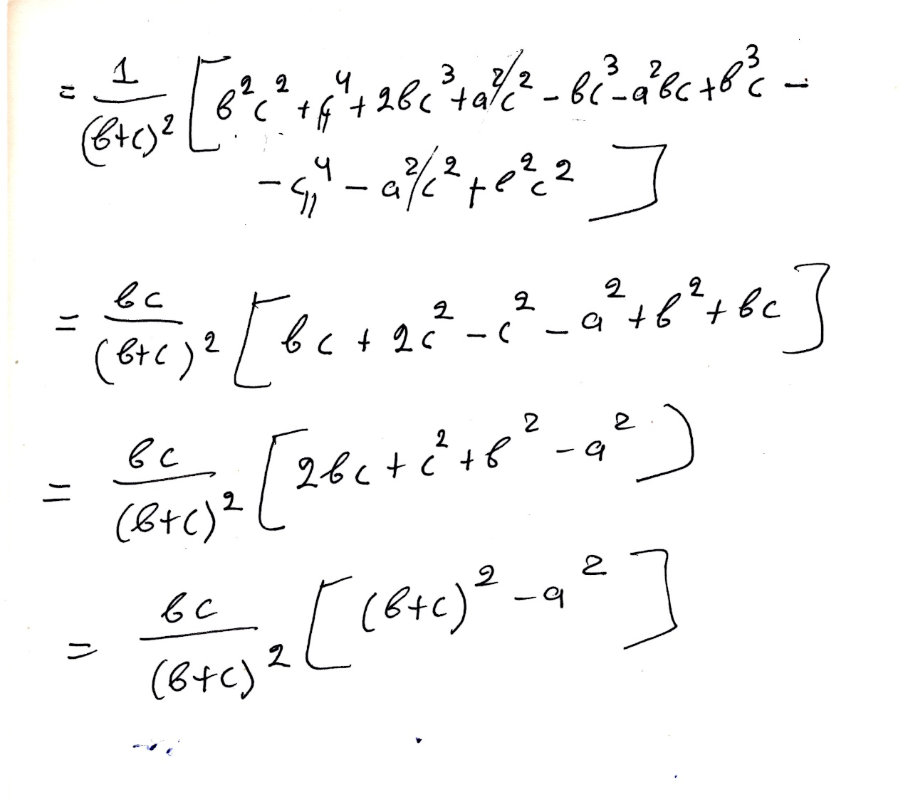

#### ΓΕΩΜΕΤΡΙΚΗ ΛΥΣΗΣ,

Length of Angle Bisector

<https://proofwiki.org/wiki/Length_of_Angle_Bisector>,

#### CONSTRUCTING TRIANGLE from the BISECTORS,

#### Imposibility of the construction

<https://www.cut-the-knot.org/triangle/TriangleFromBisectors.shtml>,

It is impossible to construct an isosceles triangle given the lengths of its 2 different bisectors (again, apart from the equilateral triangle). It is sufficient to prove this and it follows that the general triangle is also impossible to construct.

<https://www.quora.com/How-do-I-construct-a-triangle-with-3-given-angle-bisectors>, ???????

## FRANCOIS VIETE, François Viète, BIO,

### WIKIPEDIA

<https://en.wikipedia.org/wiki/Fran%C3%A7ois_Vi%C3%A8te>,

François Viète

François Viète, Seigneur (αφέντης ουσ αρσ, άρχοντας ουσ αρσ), de la Bigotière (Latin: Franciscus Vieta;

**1540 – 23 February 1603),** commonly known by his mononym, Vieta, was a French mathematician whose work on new algebra was **an important step towards modern algebra**, due to its **innovative use of letters as parameters in equations**. He was a lawyer by trade, and served as a **privy councillor** to both Henry III and Henry IV of France.

Biography

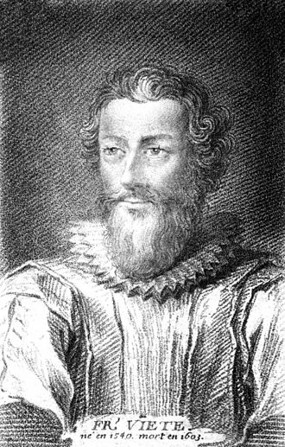

#### Early life and education

Viète was born at Fontenay-le-Comte in present-day Vendée. His grandfather was a merchant from La Rochelle.

His father, Etienne Viète, **was an attorney in Fontenay-le-Comte and a notary in Le Busseau**. His mother was the aunt of Barnabé Brisson, a magistrate and the first president of parliament during the ascendancy of the **Catholic League of France**.

**Viète went to a Franciscan school and in 1558 studied law at Poitiers, graduating as a Bachelor of Laws in 1559.** A year later, he began his career as an attorney in his native town.[3] From the outset, he was entrusted with some major cases, including the settlement of rent in Poitou for the widow of King Francis I of France and looking after the interests of Mary, Queen of Scots.

#### Serving Parthenay

In 1564, Viète **entered the service** of Antoinette d’Aubeterre, Lady Soubise, wife of **Jean V de Parthenay-Soubise**, one of the **main Huguenot military leaders** and accompanied him to Lyon to collect documents about his heroic defence of that city against the troops of Jacques of Savoy, 2nd Duke of Nemours just the year before.

The same year, at Parc-Soubise, in the commune of Mouchamps in present-day Vendée, Viète became the tutor of **Catherine de Parthenay,** Soubise's twelve-year-old daughter. He taught her science and mathematics and wrote for her numerous treatises on astronomy and trigonometry, some of which have survived. In these treatises, **Viète used decimal numbers (twenty years before Stevin's paper) and he also noted the elliptic orbit of the planets,[4] forty years before Kepler and twenty years before Giordano Bruno's death**.

John V de Parthenay presented him to King Charles IX of France. Viète wrote a genealogy of the Parthenay family and following the death of Jean V de Parthenay-Soubise in 1566 his biography.

In 1568, Antoinette, Lady Soubise, married her daughter Catherine to **Baron Charles de Quellenec** and Viète went with Lady Soubise to La Rochelle, where he mixed with the highest Calvinist aristocracy, leaders like Coligny and Condé and Queen Jeanne d’Albret of Navarre and her son, Henry of Navarre, the future Henry IV of France.

In 1570, he refused to represent the Soubise ladies in their infamous lawsuit against **the Baron De Quellenec, where they claimed the Baron was unable (or unwilling) to provide** an heir.

#### First steps in Paris

In 1571, he enrolled as an attorney in Paris, and continued to **visit his student Catherine**. He regularly lived in Fontenay-le-Comte, where he took on some municipal functions. He began publishing his Universalium inspectionum ad Canonem mathematicum liber singularis and **wrote new mathematical research by night or during periods of leisure**. He was known to dwell on any one question for up to three days, his elbow on the desk, feeding himself without changing position (according to his friend, Jacques de Thou).[5]

**In 1572, Viète was in Paris during the St. Bartholomew's Day** massacre. That night, Baron De Quellenec was killed after having tried to save Admiral Coligny the previous night. The same year, Viète met Françoise de Rohan, Lady of Garnache, **and became her adviser against Jacques, Duke of Nemours**.

In 1573, he became a councillor of the Parliament of Brittany, at Rennes, and two years later, he obtained the agreement of Antoinette d'Aubeterre for **the marriage of Catherine of Parthenay to Duke René de Rohan, Françoise's brother**.

In 1576, **Henri, duc de Rohan** took him under his special protection, recommending him in 1580 as "maître des requêtes" (ΕΦΕΤΕΙΟΝ). . In 1579, Viète finished the printing of his Universalium inspectionum (Mettayer publisher), published as an appendix to a book of two trigonometric tables (Canon mathematicus, seu ad triangula, the "canon" referred to by the title of his Universalium inspectionum, and Canonion triangulorum laterum rationalium). A year later, he was appointed maître des requêtes to the parliament of Paris, committed to serving the king. **That same year, his success in the trial between the Duke of Nemours and Françoise de Rohan, to the benefit of the latter, earned him the resentment of the tenacious Catholic League.**

**Catholic League**

ΓΟΟΓΛΕ. Holy League, French **La Sainte Ligue**, association of Roman Catholics during the French Wars of Religion of the late 16th century; it was first organized in 1576 under the leadership of Henri I de Lorraine, 3e duc de Guise, to oppose concessions granted to the Protestants (Huguenots) by King Henry III.

#### Exile in Fontenay

**Between 1583 and 1585, the League persuaded Henry III to release Viète, Viète having been accused of sympathy with the Protestant cause.** Henry of Navarre, at Rohan's instigation, addressed two letters to King Henry III of France on March 3 and April 26, 1585, in an attempt to obtain Viète's restoration to his former office, but he failed.[3]

Viète retired to Fontenay and Beauvoir-sur-Mer, with François de Rohan. **He spent four years devoted to mathematics, writing his New Algebra (1591**).

#### Code-breaker to two kings,

In 1589, Henry III took refuge in Blois. He commanded the royal officials to be at Tours before 15 April 1589. Viète was one of the first who came back to Tours. He **deciphered the secret letters of the Catholic League and other enemies of the king.** Later, he had arguments with the classical scholar [Joseph Juste Scaliger](https://en.wikipedia.org/wiki/Joseph_Juste_Scaliger). Viète triumphed against him in 1590.

After the death of Henry III, Viète became a privy councillor to Henry of Navarre, now Henry IV.[[6]](https://en.wikipedia.org/wiki/Fran%C3%A7ois_Vi%C3%A8te#cite_note-6): 75–77 He was appreciated by the king, who admired his mathematical talents. Viète was given the position of councillor of the *parlement* at [Tours](https://en.wikipedia.org/wiki/Tours). In 1590, Viète discovered the key to a [Spanish](https://en.wikipedia.org/wiki/Spanish_language) [cipher](https://en.wikipedia.org/wiki/Cipher), consisting of more than 500 characters, and this meant that all dispatches in that language which fell into the hands of the French could be easily read.[[7]](https://en.wikipedia.org/wiki/Fran%C3%A7ois_Vi%C3%A8te#cite_note-FOOTNOTECantor191158-7)

Henry IV published a letter from Commander Moreo to the King of Spain. The contents of this letter, read by Viète, revealed that the head of the League in France, [Charles, Duke of Mayenne](https://en.wikipedia.org/wiki/Charles,_Duke_of_Mayenne), planned to become king in place of Henry IV. This publication led to the settlement of the [Wars of Religion](https://en.wikipedia.org/wiki/French_Wars_of_Religion). **The King of Spain accused Viète of having used magical powers.** In 1593, Viète published his arguments against Scaliger. **Beginning in 1594, he was appointed exclusively deciphering the enemy's secret codes**.

#### Work and thought

Ενδιαφερον κειμενο, όχι πολλεσ αναφορεσ,

<https://mathshistory.st-andrews.ac.uk/Biographies/Viete/>,

H L L Busard, Biography in Dictionary of Scientific Biography (New York 1970-1990).

<https://www.encyclopedia.com/people/science-and-technology/mathematics-biographies/francois-viete>,

Viète himself, published his answer to Roomen's problem in 1595, stating in the introduction [1]:-

I, who do not profess to be a mathematician, but who, **whenever there is leisure, delight in mathematical studies** ...

###### Viète's symbolic algebra

Firstly, Viète gave algebra a foundation as strong as that of geometry. He then ended the **algebra of procedures** (al-Jabr and al-Muqabala), creating the **first symbolic algebra,** and claiming that with it, all problems could be solved (nullum non problema solvere).[12][13]

In his dedication of the Isagoge to Catherine de Parthenay, Viète wrote:

"These things which are new are wont in the beginning to be set forth rudely and formlessly and must then be polished and perfected in succeeding centuries. Behold, the art which I present is new, but in truth so old, so spoiled and defiled by the **barbarians**, that I considered it necessary, in order to introduce an entirely new form into it, to think out and publish a new vocabulary, having gotten rid of all its pseudo-technical terms..."[14]

#### Adriaan van Roomen's problem

xxxxxxxx

#### Religious and political beliefs

Viète was accused of Protestantism by the Catholic League, but he was not a Huguenot**. His father was,** according **to Dhombres.[**19] Indifferent in religious matters, he did not adopt the Calvinist faith of Parthenay, nor that of his other protectors, the Rohan family. His call to the parliament of Rennes proved the opposite. **At the reception as a member of the court of Brittany, on 6 April 1574, he read in public a statement of Catholic faith**.[19]

Nevertheless, **Viète defended and protected Protestants his whole life**, and suffered, in turn, the wrath of the League. It seems that for him**, the stability of the state was to be preserved** and that under this requirement, the King's religion did not matter. At that time, such people were called "Politicals."

**Furthermore, at his death, he did not want to confess his sins**. A friend had to convince him that **his own daughter would not find a husband,** were he to refuse the sacraments of the Catholic Church. Whether Viète was an atheist or not is a matter of debate.[19]