20 ΔΙΑΛΕΞΗ,

Webex meeting recording: 20 INM 2024, SATURDAY 12.00-14.00-20240525 0916-1

Password: kPMtq6EJ

Recording link: <https://uoa.webex.com/uoa/ldr.php?RCID=a673e021519d9beea73307dc6eb99891>,

**ΠΡΟΚΑΤΑΡΚΤΙΚΑ,**

Εχουμε ηδη διαπραγματευθη

6002, 6003,

ΕΡΓΑΣΙΕΣ προς διαπραγμετευσιν,

1004 ηλιοκεντρικο, 5001 (4001) κυβικες ριζες του 1, 8001 δευτερος ορος,

Η ΕΡΓΑΣΙΑ 6004 (2024) ελυθη στην ταξη, αλλα δεν εχω διορθωσει τα γραπτα,

# ΑΝΑΛΥΤΙΚΗ ΓΕΩΜΕΤΡΙΑ, ANALYTIC GEOMETRY, 2024,

## Pierre de Fermat, BIO

### <https://en.wikipedia.org/wiki/Pierre_de_Fermat>,

Pierre de Fermat (French: [pjɛʁ də fɛʁma];

**between 31 October and 6 December 1607[a] – 12 January 1665)** was a French mathematician who is given credit for early developments that led to infinitesimal calculus, including his technique of adequality. In particular, he is recognized for his discovery of an original method of finding **the greatest and the smallest ordinates** of curved lines, which is analogous to that of differential calculus, then unknown, and his research into number theory. **He made notable contributions to analytic geometry**, probability, and optics.

COMMENT. Unappropriate, very weak, .

He is best known for his Fermat's principle for light propagation and his Fermat's Last Theorem in number theory, which he described in a note at the margin of a copy of Diophantus' Arithmetica. He was also a lawyer[3], (judge) at the Parlement (courts), of Toulouse, France.

ΣΓΠ. ΜΑΖΥ με τον ΚΑΡΤΕΣΙΟ, είναι οι κυριοι θεμελιωτες της ΑΝΑΛΥΤΙΚΗΣ ΓΕΩΜΕΤΡΙΑΣ.

#### Biography

Fermat was born in 1607 in **Beaumont-de-Lomagne**, France—the late 15th-century mansion where Fermat was born is now a museum. He was from Gascony, where his father, Dominique Fermat, **was a wealthy leather merchant** and served three one-year terms as one of the four consuls of Beaumont-de-Lomagne. His mother was Claire de Long.[2] Pierre had one brother and two sisters and was almost certainly brought up in the town of his birth.[citation needed]

He attended the **University of Orléans from 1623** and received **a bachelor in civil law in 1626**, before moving to Bordeaux. In Bordeaux, he began his first serious mathematical researches, and in 1629 he gave a copy of his restoration of **Apollonius's De Locis Planis** to one of the mathematicians there. Certainly, in Bordeaux he was in contact with Beaugrand and during this time he produced important work on maxima and minima which he gave to Étienne d'Espagnet who clearly shared mathematical interests with Fermat. **There he became much influenced by the work of François Viète**.[4]

In 1630, **he bought the office of** a councilor at the **Parlement de Toulouse**, one of the High Courts of Judicature in France, and was sworn in by the Grand Chambre in May 1631. **He held this office for the rest of his life.** Fermat thereby became entitled to change his name from **Pierre Fermat to Pierre de Fermat**. On 1 June 1631, Fermat married Louise de Long, a fourth cousin of his mother Claire de Fermat (née de Long). The Fermats had eight children, five of whom survived to adulthood: Clément-Samuel, Jean, Claire, Catherine, and Louise.[5][6][7]

SGP**. COLBERT**,

ΣΓΠ. **Τοπος γεννησης Beaumont-de-Lomagne**

Fluent in six languages (**French, Latin, Occitan, classical Greek, Italian and Spanish**), Fermat was praised for his written verse in several languages and his **advice was eagerly sought regarding the emendation** ((editorial change, correction),**), of Greek texts**. He communicated most of his work in letters to friends, often with little or no proof of his theorems. In some of these letters to his friends, he explored many of the fundamental ideas of calculus before Newton or Leibniz. Fermat was a trained lawyer **making mathematics more of a hobby than a profession.** Nevertheless, he made important contributions to analytical geometry, probability, number theory and calculus.[8] Secrecy was common in European mathematical circles at the time. This naturally led to priority disputes with contemporaries such as Descartes and Wallis.[9]

COMMENTS on “hobby”,

Anders Hald writes that, **"The basis of Fermat's mathematics was the classical Greek treatises combined with Vieta's new algebraic methods**."[10]

#### FERMAT the “AMATEUR”,

Who was Fermat?

<https://simonsingh.net/books/fermats-last-theorem/who-was-fermat/>,

Pierre de Fermat is one of the top ten greatest mathematicians in history. Alongside Blaise Pascal, he established the foundations of probability theory, which is the mathematics of gambling, risk and change. Also, when Newton was asked where he got the idea of calculus from, he credited “Monsieur Fermat’s method of drawing tangents”. Already it is clear that Fermat has changed the world we live in, because everybody from insurance companies to stock markets use probability theory and everybody from architects to NASA use calculus.

But Fermat’s greatest ideas are in the area of number theory, a subject which has virtually no practical applications. Number theory is the purest form of mathematics, concerned with the study of whole numbers, the relationships between them, and the patterns they form.

By the way, Fermat lived in the 17th century near Toulouse in southwest France, and his day job was as a judge dealing with some of the nastiest cases imaginable, **including the condemnation of priests to be burned at the stake.** **Judges were generally discouraged from socialising** within the community in order to avoid a conflict of interests, so Fermat would spend his evenings hidden in his study, pursuing his mathematical interests. He was a truly amateur academic **and E.T. Bell called him the Prince of Amateurs.** However, **when Julian Coolidge wrote Mathematics of Great Amateurs, he excluded Fermat on the grounds that he was ‘so really great that he should count as a professiona**l.’

**SGP, η αλλοι αραγε τι ησαν, ??**

#### Work Pierre de Fermat

The 1670 edition of Diophantus's Arithmetica includes Fermat's commentary, referred to as his "Last Theorem" (Observatio Domini Petri de Fermat), posthumously published by his son

**Fermat's pioneering work in analytic geometry (Methodus ad disquirendam maximam et minimam et de tangentibus linearum curvarum) was circulated in manuscript form in 1636** (based on results achieved in 1629),[11] **predating the publication of Descartes' famous La géométrie (1637), which exploited the work.[**12] This manuscript was published posthumously in 1679 in Varia opera mathematica, as **Ad Locos Planos et Solidos Isagoge** (Introduction to Plane and Solid Loci).[13]

In Methodus ad disquirendam maximam et minimam and in De tangentibus linearum curvarum, Fermat developed a method (adequality) for determining maxima, minima, and tangents to various curves that was equivalent to differential calculus.[14][15] In these works, Fermat obtained a technique for finding the centers of gravity of various plane and solid figures, which led to his further work in quadrature.

**Fermat was the first person known to have evaluated the integral of general power functions.** With his method, he was able to reduce this evaluation to the sum of geometric series (ΣΓΠ ε όχι και ΓΕΩΜΕΤΡΙΚΕΣ!). .[16] **The resulting formula was helpful to Newton, and then Leibniz,** when they independently developed the fundamental theorem of calculus.[citation needed]

In number theory, Fermat studied Pell's equation, perfect numbers, amicable numbers and what would later become Fermat numbers. It was while researching perfect numbers that he discovered Fermat's little theorem. He invented a factorization method—Fermat's factorization method—and popularized the proof by infinite descent, which he used to prove Fermat's right triangle theorem which includes as a corollary Fermat's Last Theorem for the case n = 4. Fermat developed the two-square theorem, and the polygonal number theorem, which states that each number is a sum of three triangular numbers, four square numbers, five pentagonal numbers, and so on.

Although Fermat claimed to have proven all his arithmetic theorems, few records of his proofs have survived. Many mathematicians, including Gauss, doubted several of his claims, especially given the difficulty of some of the problems and the limited mathematical methods available to Fermat. **His famous Last Theorem was first discovered by his son in the margin in his father's copy of an edition of Diophantus,** and included the statement that the margin was too small to include the proof. It seems that he had not written to Marin Mersenne about it**. It was first proven in 1994, by Sir Andrew Wiles, using techniques unavailable to Fermat**.[citation needed]

## RENE DESCARTES, DESCARTES RENE,

### <https://en.wikipedia.org/wiki/Ren%C3%A9_Descartes>,

**René Descartes** ([/deɪˈkɑːrt/](https://en.wikipedia.org/wiki/Help:IPA/English) or [UK](https://en.wikipedia.org/wiki/British_English): [/ˈdeɪkɑːrt/](https://en.wikipedia.org/wiki/Help:IPA/English); French: [[ʁəne dekaʁt]](https://en.wikipedia.org/wiki/Help:IPA/French) ([listen](https://upload.wikimedia.org/wikipedia/commons/a/ac/LL-Q150_%28fra%29-GrandCelinien-Descartes.wav)); [Latinized](https://en.wikipedia.org/wiki/Latinisation_of_names): **Renatus Cartesius**;[[note 3]](https://en.wikipedia.org/wiki/Ren%C3%A9_Descartes#cite_note-19)[[17]](https://en.wikipedia.org/wiki/Ren%C3%A9_Descartes#cite_note-longman-20) 31 March 1596 – 11 February 1650)[[18]](https://en.wikipedia.org/wiki/Ren%C3%A9_Descartes#cite_note-21)[[19]](https://en.wikipedia.org/wiki/Ren%C3%A9_Descartes#cite_note-22)[[20]](https://en.wikipedia.org/wiki/Ren%C3%A9_Descartes#cite_note-23): 58 was a [French philosopher](https://en.wikipedia.org/wiki/French_philosophy), [scientist](https://en.wikipedia.org/wiki/Scientist), and [mathematician](https://en.wikipedia.org/wiki/Mathematician), widely considered a seminal figure in the emergence of [modern philosophy](https://en.wikipedia.org/wiki/Modern_philosophy) and [science](https://en.wikipedia.org/wiki/Modern_science). Mathematics was central to his method of inquiry, and he connected the previously separate fields of [geometry](https://en.wikipedia.org/wiki/Geometry) and [algebra](https://en.wikipedia.org/wiki/Algebra) into [analytic geometry](https://en.wikipedia.org/wiki/Analytic_geometry). Descartes spent much of his working life in the [Dutch Republic](https://en.wikipedia.org/wiki/Dutch_Republic), initially serving the [Dutch States Army](https://en.wikipedia.org/wiki/Dutch_States_Army), later becoming a central intellectual of the [Dutch Golden Age](https://en.wikipedia.org/wiki/Dutch_Golden_Age).[[21]](https://en.wikipedia.org/wiki/Ren%C3%A9_Descartes#cite_note-24) Although he served a [Protestant state](https://en.wikipedia.org/wiki/Dutch_Reformed_Church) and was later counted as a [Deist](https://en.wikipedia.org/wiki/Deism) by critics, Descartes was [Roman Catholic](https://en.wikipedia.org/wiki/Roman_Catholicism).[[22]](https://en.wikipedia.org/wiki/Ren%C3%A9_Descartes#cite_note-25)[[23]](https://en.wikipedia.org/wiki/Ren%C3%A9_Descartes#cite_note-26)

### Early life

The house where Descartes was born in [La Haye en Touraine](https://en.wikipedia.org/wiki/Descartes,_Indre-et-Loire)

René Descartes was born in [La Haye en Touraine](https://en.wikipedia.org/wiki/Descartes,_Indre-et-Loire), [Province of Touraine](https://en.wikipedia.org/wiki/Touraine) (now [Descartes](https://en.wikipedia.org/wiki/Descartes,_Indre-et-Loire), [Indre-et-Loire](https://en.wikipedia.org/wiki/Indre-et-Loire)), France, on 31 March 1596.[[28]](https://en.wikipedia.org/wiki/Ren%C3%A9_Descartes#cite_note-:2-33) René Descartes was conceived about halfway through August 1595. His mother, Jeanne Brochard, died a few days after giving birth to a still-born child in May 1597.[[29]](https://en.wikipedia.org/wiki/Ren%C3%A9_Descartes#cite_note-34)[[28]](https://en.wikipedia.org/wiki/Ren%C3%A9_Descartes#cite_note-:2-33) **Descartes' father, Joachim, was a member of the** [**Parlement of Brittany**](https://en.wikipedia.org/wiki/Parlement_of_Brittany) **at** [**Rennes**](https://en.wikipedia.org/wiki/Rennes)**.**[**[30]**](https://en.wikipedia.org/wiki/Ren%C3%A9_Descartes#cite_note-35): 22 René lived with his grandmother and with his great-uncle. **Although the Descartes family was Roman Catholic, the** [**Poitou**](https://en.wikipedia.org/wiki/Poitou) **region was controlled by the Protestant** [**Huguenots**](https://en.wikipedia.org/wiki/Huguenots).[[31]](https://en.wikipedia.org/wiki/Ren%C3%A9_Descartes#cite_note-36) In **1607, late because of his fragile health, he entered the** [**Jesuit**](https://en.wikipedia.org/wiki/Jesuit)[**Collège Royal Henry-Le-Grand**](https://en.wikipedia.org/wiki/Coll%C3%A8ge_Royal_Henry-Le-Grand) **at** [**La Flèche**](https://en.wikipedia.org/wiki/La_Fl%C3%A8che)**,**[**[32]**](https://en.wikipedia.org/wiki/Ren%C3%A9_Descartes#cite_note-37)[**[33]**](https://en.wikipedia.org/wiki/Ren%C3%A9_Descartes#cite_note-38) **where he was introduced to mathematics and physics, including** [**Galileo**](https://en.wikipedia.org/wiki/Galileo)**'s work.**[**[34]**](https://en.wikipedia.org/wiki/Ren%C3%A9_Descartes#cite_note-:3-39)[**[35]**](https://en.wikipedia.org/wiki/Ren%C3%A9_Descartes#cite_note-40)While there, Descartes first encountered hermetic mysticism. After graduation in 1614, he studied for two years (1615–16) at **the** [**University of Poitiers**](https://en.wikipedia.org/wiki/University_of_Poitiers)**, earning a** [***Baccalauréat***](https://en.wikipedia.org/wiki/Baccalaur%C3%A9at) **and** [***Licence***](https://en.wikipedia.org/wiki/Licentiate_(degree)) **in** [**canon**](https://en.wikipedia.org/wiki/Canon_law) **and** [**civil law**](https://en.wikipedia.org/wiki/Civil_law_(legal_system)) **in 1616,**[**[34]**](https://en.wikipedia.org/wiki/Ren%C3%A9_Descartes#cite_note-:3-39) **in accordance with his father's wishes that he should become a lawyer.**[**[36]**](https://en.wikipedia.org/wiki/Ren%C3%A9_Descartes#cite_note-41) **From there, he moved to Paris.**

In [*Discourse on the Method*](https://en.wikipedia.org/wiki/Discourse_on_the_Method), Descartes recalls:[[37]](https://en.wikipedia.org/wiki/Ren%C3%A9_Descartes#cite_note-42): 20–21

In accordance with his ambition to become a professional military officer in 1618, Descartes joined**, as a** [**mercenary**](https://en.wikipedia.org/wiki/Mercenary)**, (μισθοφορος), the** [**Protestant**](https://en.wikipedia.org/wiki/Protestant)[**Dutch States Army**](https://en.wikipedia.org/wiki/Dutch_States_Army) in [Breda](https://en.wikipedia.org/wiki/Breda) under the command of [Maurice of Nassau](https://en.wikipedia.org/wiki/Maurice_of_Nassau),[[34]](https://en.wikipedia.org/wiki/Ren%C3%A9_Descartes#cite_note-:3-39) and undertook a formal study of [military engineering](https://en.wikipedia.org/wiki/Military_engineering), as established by [Simon Stevin](https://en.wikipedia.org/wiki/Simon_Stevin).[[38]](https://en.wikipedia.org/wiki/Ren%C3%A9_Descartes#cite_note-:7-43): 66 Descartes, therefore, received much encouragement in Breda to advance his knowledge of mathematics.[[34]](https://en.wikipedia.org/wiki/Ren%C3%A9_Descartes#cite_note-:3-39)

**While in the service of the** [**Catholic**](https://en.wikipedia.org/wiki/Catholic) **Duke** [**Maximilian of Bavaria**](https://en.wikipedia.org/wiki/Maximilian_I,_Elector_of_Bavaria) **from 1619,**[**[41]**](https://en.wikipedia.org/wiki/Ren%C3%A9_Descartes#cite_note-46) Descartes was present at the [Battle of the White Mountain](https://en.wikipedia.org/wiki/Battle_of_the_White_Mountain) near [Prague](https://en.wikipedia.org/wiki/Prague), in November 1620.[[42]](https://en.wikipedia.org/wiki/Ren%C3%A9_Descartes#cite_note-47)[[43]](https://en.wikipedia.org/wiki/Ren%C3%A9_Descartes#cite_note-48)

### France

In 1620, Descartes left the army. He visited Basilica della Santa Casa in Loreto, then visited various countries before returning to France, and during the next few years, he spent time in Paris. It was there that he composed his first essay on method**: Regulae ad Directionem Ingenii (Rules for the Direction of the Mind)**.[40] He arrived in La Haye in 1623, **selling all of his property to invest in bonds, which provided a comfortable income for the rest of his life**.[38]: 132 [49]: 94  Descartes was present at **the siege of La Rochelle by Cardinal Richelieu in 1627**.[49]:

SGP. FERMAT, d ARTANIAN.

### Death

**Descartes arranged to give lessons to Queen Christina after her birthday**, three times a week at 5 am, in her cold and draughty castle. However, by 15 January 1650 the Queen actually met with Descartes only four or five times.[[72]](https://en.wikipedia.org/wiki/Ren%C3%A9_Descartes#cite_note-Åkerman_1991-79) It soon became clear they did not like each other; she did not care for his [mechanical philosophy](https://en.wikipedia.org/wiki/Mechanical_philosophy#Descartes_and_the_mechanical_philosophy), nor did he share her interest in [Ancient Greek language](https://en.wikipedia.org/wiki/Ancient_Greek_language) and [literature](https://en.wikipedia.org/wiki/Ancient_Greek_literature).[[72]](https://en.wikipedia.org/wiki/Ren%C3%A9_Descartes#cite_note-Åkerman_1991-79) On 1 February 1650, he contracted [pneumonia](https://en.wikipedia.org/wiki/Pneumonia) and died on 11 February at Chanut.[[76]](https://en.wikipedia.org/wiki/Ren%C3%A9_Descartes#cite_note-83)

As a Catholic[[84]](https://en.wikipedia.org/wiki/Ren%C3%A9_Descartes#cite_note-books.google.be-91)[[85]](https://en.wikipedia.org/wiki/Ren%C3%A9_Descartes#cite_note-KrR-5EKLSQMC_p._207-92)[[86]](https://en.wikipedia.org/wiki/Ren%C3%A9_Descartes#cite_note-Gh_BAAAQBAJ_p._107-93) in a Protestant nation, he was interred in a graveyard used mainly for orphans in [Adolf Fredriks kyrka](https://en.wikipedia.org/wiki/Adolf_Fredrik_Church) in Stockholm. His manuscripts came into the possession of [Claude Clerselier](https://en.wikipedia.org/wiki/Claude_Clerselier), Chanut's brother-in-law, and "a devout Catholic who has begun the process of turning Descartes into a saint by cutting, adding and publishing his letters selectively."[[87]](https://en.wikipedia.org/wiki/Ren%C3%A9_Descartes#cite_note-94)[[88]](https://en.wikipedia.org/wiki/Ren%C3%A9_Descartes#cite_note-95): 137–154 **In 1663, the** [**Pope**](https://en.wikipedia.org/wiki/Pope_Alexander_VII) **placed Descartes' works on the** [***Index of Prohibited Books***](https://en.wikipedia.org/wiki/Index_Librorum_Prohibitorum)**. I**n 1666, sixteen years after his death, his remains were taken to France and buried in [Saint-Étienne-du-Mont](https://en.wikipedia.org/wiki/Saint-%C3%89tienne-du-Mont). **In 1671,** [**Louis XIV**](https://en.wikipedia.org/wiki/Louis_XIV) **prohibited all lectures in** [**Cartesianism**](https://en.wikipedia.org/wiki/Cartesianism)**.** Although the [National Convention](https://en.wikipedia.org/wiki/National_Convention) in 1792 had planned to transfer his remains to the [Panthéon](https://en.wikipedia.org/wiki/Panth%C3%A9on), he was reburied in the [Abbey of Saint-Germain-des-Prés](https://en.wikipedia.org/wiki/Abbey_of_Saint-Germain-des-Pr%C3%A9s) in 1819, missing a finger and the skull.[[note 8]](https://en.wikipedia.org/wiki/Ren%C3%A9_Descartes#cite_note-96) His skull is on display in the [Musée de l'Homme](https://en.wikipedia.org/wiki/Mus%C3%A9e_de_l%27Homme) in Paris.[[89]](https://en.wikipedia.org/wiki/Ren%C3%A9_Descartes#cite_note-97)

## ΑΝΑΛΥΤΙΚΗ ΓΕΩΜΕΤΡΙΑ,

### ΜΑΘΗΜΑΤΙΚΑ Β΄ ΤΑΞΗ ΓΕΝΙΚΟΥ ΛΥΚΕΙΟΥ Ομάδα Προσανατολισμού Θετικών Σπουδών

Κωδικός Βιβλίου: 0-22-0168, ISBN 978-960-06-2423-6

Αρχειο MathBLykeiouBMAnalytGeom.pdf,

Σελ 30,

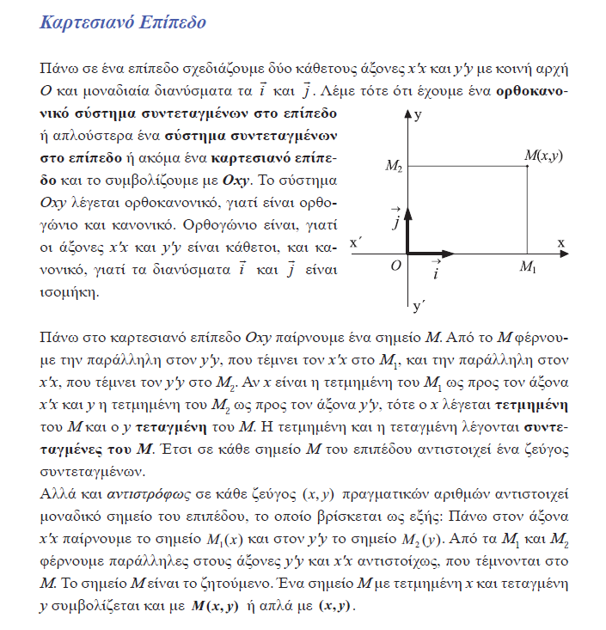

Σελ. 33

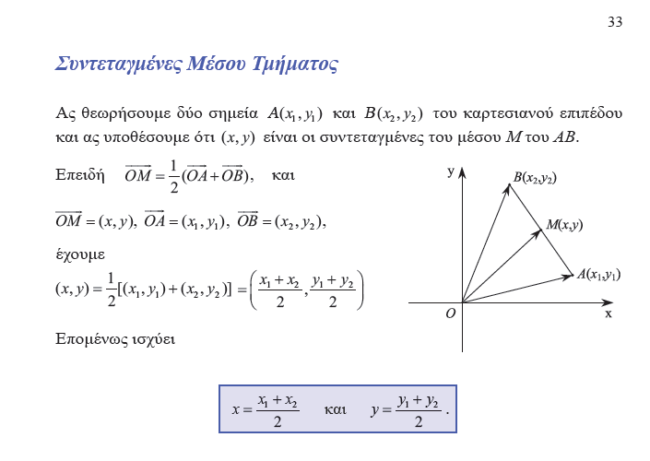

Σελ. 35,

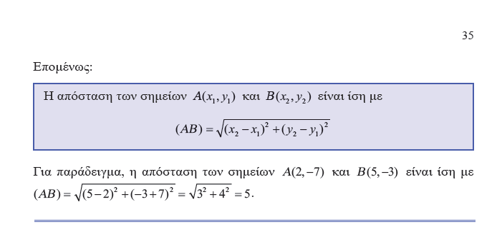

σελ. 66

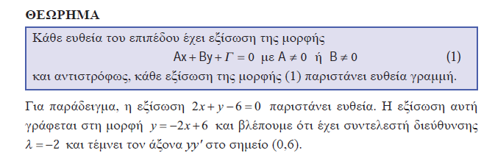

Σελ. 70

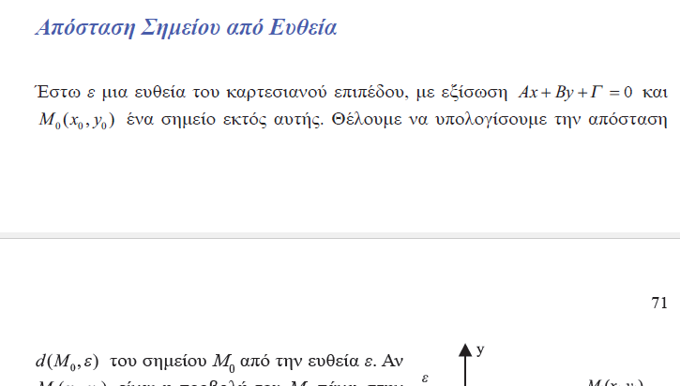

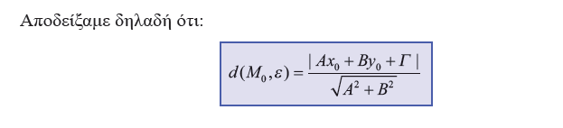

Σελ. 85

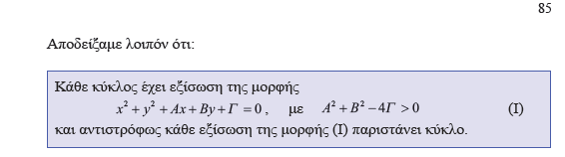

Συγκεκεριμενα

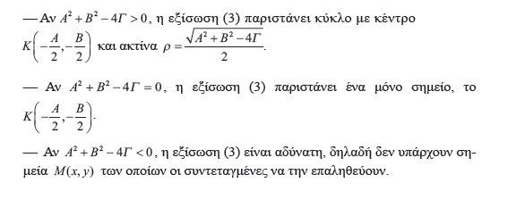

### ΕΞΙΣΩΣΗ β ΒΑΘΜΟΥ, ΕΞΙΣΩΣΙΣ ΚΩΝΙΚΩΝ ΤΟΜΩΝ,

#### SIMMONS , CALCULUS WITH ANALYTIC GEOMETRY,

SECOND EDITION GEORGE F. SIMMONS

Colorado College, Colorado Springs

THE McGRAW-HILL COMPANIES, INC.

New York St. Louis San Francisco Auckland Bogota Caracas Lisbon London

Ekei υπαρχει και η αποδειξη

p. 552

The general equation of the second degree in x and *y* is

*Ax2 + Bxy + Cy2 + Dx + Ey + F =* 0, (1)

where at least one of the coefficients *A, B, C* is different from zero. The latter requirement, of course, guarantees that the degree of the equation really is 2, rather than 1 or 0.

p. 553

***The graph of every second-degree equation*** *of the form* (1) *is a circle, a parabola, an ellipse, a hyperbola,*

*a point, the empty set, a single line, or a pair of lines.*

Επισης βλεπε Conic section

<https://en.wikipedia.org/wiki/Conic_section#CITEREFProtterMorrey1970>,

### Το ΘΕΩΡΗΜΑ του ΑΠΟΛΛΩΝΙΟΥ, ΘΕΩΡΗΜΑ ΤΩΝ ΔΙΑΜΕΣΩΝ,

KATZ p. 457

#### Apollonius's theorem,

<https://en.wikipedia.org/wiki/Apollonius%27s_theorem>,

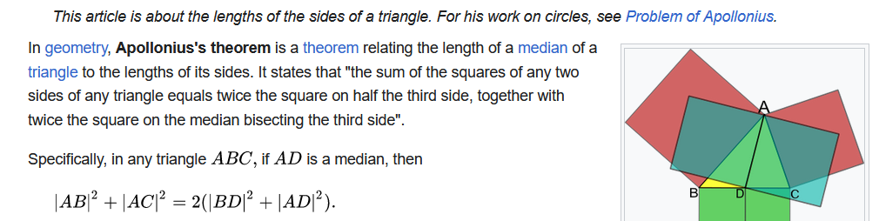

ΣΓΠ. Εμφαση σε αθροισμα τετραγωνων.

#### ΓΕΝΙΚΕΥΣΗ ΑΠΟΛΛΩΝΙΟΥ ΘΕΩΡΗΜΑΤΟΣ,

##### ΕΡΓΑΣΙΑ 11001,

**ΘΕΜΑ**

Έστωσαν Α1 , Α2,….ΑΚ σημεία του επιπέδου και β,α1,α2,…,ακ>0 πραγματικοί αριθμοί

Να βρεθεί ο γ.τ των σημείων Μ ώστε α1(ΜΑ1)2+…..+ακ(ΜΑΚ)2=β

**ΑΠΑΝΤΗΣΗ**

Ας θεωρήσουμε τα σημεία Α1(x1,y1) , Α2(x2,y2),….,ΑΚ(xκ,yκ) του επιπέδου και β,α1,α2,…,ακ>0 πραγματικοί αριθμοί

Αν Μ(x,y) τυχαίο σημείο του επιπέδου ώστε να ισχύει

α1(ΜΑ1)2+…..+ακ(ΜΑΚ)2=β τότε

α1((x-x1)2+(y-y1)2)+ α2((x-x2)2+(y-y2)2)+….+ ακ((x-xκ)2+(y-yκ)2)=β⇔

α1(x2-2xx1+x12)+ α1(y2-2yy1+y12)+………+ αk(x2-2xxk+xk2)+ αk(y2-2yyk+yk2)-β=0⇔

(α1+….ακ)x2+((α1+….ακ)y2-2(α1x1+…+ακxκ)x-2(α1y1+…+ακyκ)y+(α1x12+…+ακxκ2+α1y12+…+ακyκ2-β)=0

Διαιρώντας με το α1+….ακ≠0(α1,α2,…,ακ>0) προκύπτει

x2+y2-2 = 0 (1)

Αν θεωρήσουμε Α= $-2\frac{α_{1}x_{1}+…{+a}_{κ}x_{κ}}{α_{1}+….α_{κ}}$, Β= $-2\frac{α_{1}y_{1}+…{+a}_{κ}y_{κ}}{α_{1}+….α_{κ}}$, Γ= $\frac{α_{1}{x_{1}}^{2}+…{+a}_{κ}{x_{κ}}^{2}-β}{α_{1}+….α_{κ}}$

Τότε η (1) γίνεται x2+y2+Ax+By+Γ=0, η οποία αποτελεί εξίσωση κύκλου μόνο αν ικανοποιείται η συνθήκη Α2+Β2-4Γ>0

Επομένως :

* Αν Α2+Β2-4Γ>0 με Α= $-2\frac{α_{1}x_{1}+…{+a}_{κ}x_{κ}}{α_{1}+….α_{κ}}$, Β= $-2\frac{α_{1}y_{1}+…{+a}_{κ}y_{κ}}{α_{1}+….α_{κ}}$, Γ= $\frac{α_{1}{x_{1}}^{2}+…+a_{κ}{x_{κ}}^{2}-β}{α_{1}+….α_{κ}}$

τότε ο γεωμετρικός τόπος των σημείων Μ είναι κύκλος με κέντρο Κ $(-\frac{Α}{2},-\frac{Β}{2})$ και ακτίνα ρ= $\frac{\sqrt{Α^{2}+Β^{2}-4Γ}}{2}$

COMMENT. To kentro toy kykloy αναξαρτητο του β, .

* Αν Α2+Β2-4Γ=0 με Α= $-2\frac{α_{1}x_{1}+…a_{κ}x_{κ}}{α_{1}+….α_{κ}}$, Β= $-2\frac{α_{1}y_{1}+…a_{κ}y_{κ}}{α_{1}+….α_{κ}}$, Γ= $\frac{α_{1}{x_{1}}^{2}+…a_{κ}{x_{κ}}^{2}-β}{α_{1}+….α_{κ}}$ τότε ρ=0

τότε ο γεωμετρικός τόπος των σημείων Μ είναι το σημείο $(-\frac{Α}{2},-\frac{Β}{2})$ (δηλ. ο κύκλος εκφυλίζεται σε σημείο )

* Αν Α2+Β2-4Γ<0 τότε η (1) είναι αδύνατη στους πραγματικούς αριθμούς

#### ΠΑΡΑΛΛΑΓΗ 4ων ΔΥΝΑΜΕΩΝ,

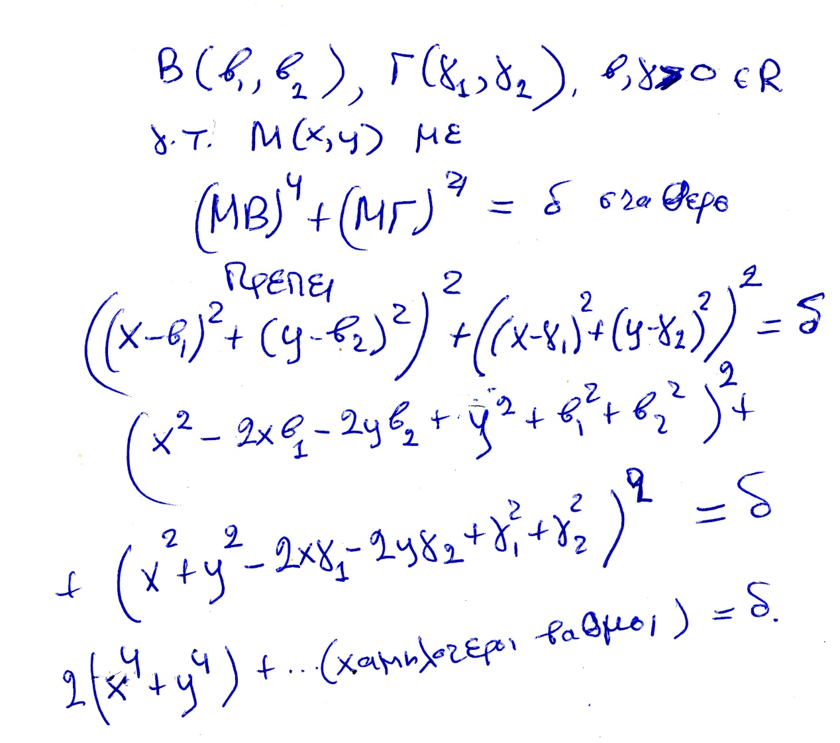

# ΔΙΑΦΟΡΙΚΟΣ ΛΟΓΙΣΜΟΣ, DIFFERENTIAL CALCULUS,

p. 122,

Ακολουθουμε κυριως τον EDWARDS, ch. 5 Early Tangent Constructions, p. 122, .

Introduction

In modem calculus courses the treatment of differentiation and the construction

of tangent lines to curves usually precede the treatment of

integration and the calculation of areas under curves. This is a reversal of

the historical sequence of discovery; as we have seen in the preceding

chapters, the calculation of curvilinear areas dates back to ancient times.

However, apart from simple constructions of tangent lines to conic sections

(with the static Greek view of a tangent line as a line touching the

curve in only one point), and the isolated example of Archimedes' construction

of the tangent to his spiral, tangent lines were not studied until

the middle decades of the seventeenth century.

Then, beginning about 1635, a number of different methods for the

construction of tangent lines to general curves were rapidly discovered and

investigated. It was the combination of these new tangent methods with

area problems and techniques, during the last third of the seventeenth

century, that produced the calculus as a new unified method of mathematical

analysis.

## Fermat's Pseudo-equality Methods,

p. 122,

### Adequality

<https://en.wikipedia.org/wiki/Adequality#cite_note-Katz_Schaps_20213-3>,

Adequality is a technique developed by Pierre de Fermat in his treatise Methodus ad disquirendam maximam et minimam[1] (a Latin treatise circulated in France c. 1636 ) to calculate maxima and minima of functions, tangents to curves, area, center of mass, least action, and other problems in calculus. **According to André Weil, Fermat "introduces the technical term adaequalitas, adaequare, etc., which he says he has borrowed from Diophantus.** As Diophantus V.11 shows, **it means an approximate equality,** and this is indeed how Fermat explains the word in one of his later writings." (Weil 1973).[2] Diophantus coined the word **παρισοτης** (parisotēs) to refer to an approximate equality.[3] Claude Gaspard Bachet de Méziriac translated Diophantus's Greek word into Latin as adaequalitas.[citation needed] Paul Tannery's French translation of Fermat’s Latin treatises on maxima and minima used the words adéquation and adégaler.[citation needed]

### maxima-minima,

Edwards p.122,

Fermat was the first to solve maximum-minimum problems by somehow

taking into account the characteristic behavior of a function near its

extreme values. For example, in order to determine how to subdivide a

segment of length b into two segments x and b - x whose product



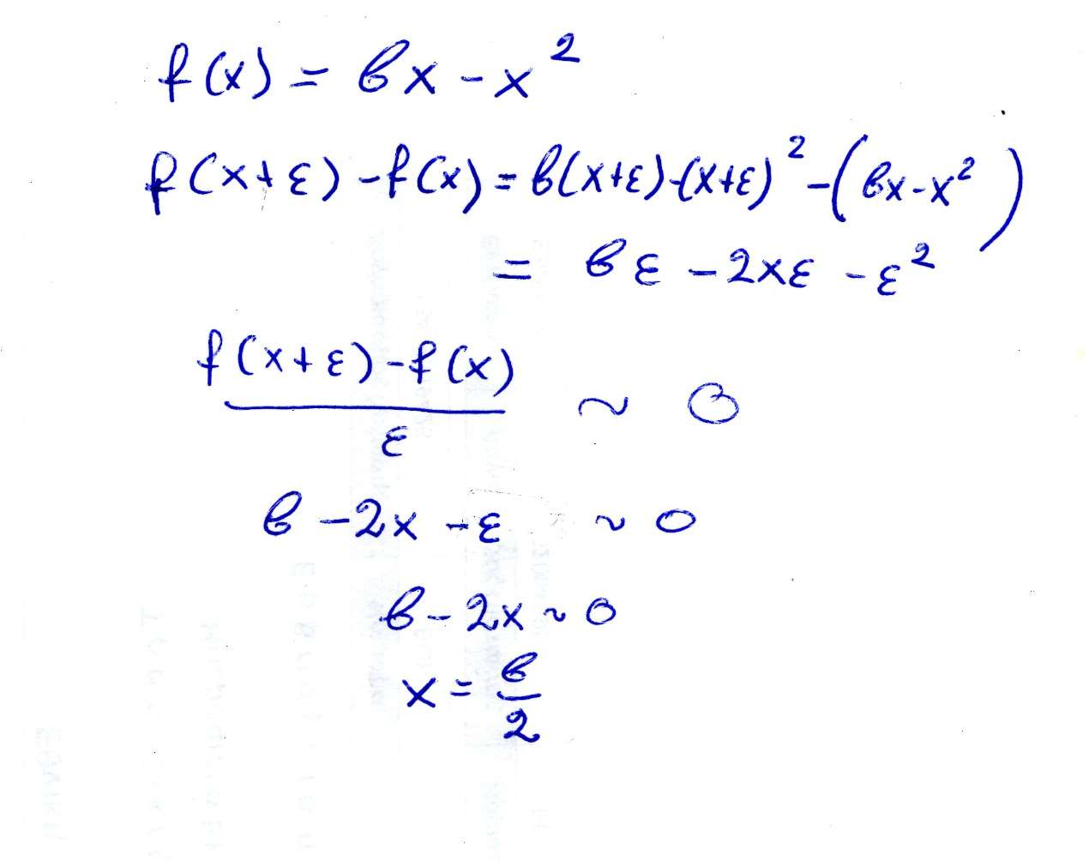

### Tangents and Pseudo Equality,

Edwards 123,

Katz, p. 507

All other properties of curves [besides those

concerning quadrature] depend only on

the angles that these curves make with

other lines. But the angle formed by two

intersecting curves can be as easily measured

as the angle between two straight lines,

provided that a straight line can be drawn

making right angles with one of these curves

at its point of intersection with the other.

This is my reason for believing that I shall

have given here a sufficient introduction to

the study of curves when I have given a

general method of drawing a straight line

making right angles with a curve at an

arbitrarily chosen point upon it. And I dare

say that this is not only the most useful and

most general problem in geometry that I

know, but even that I have ever desired to

know.

—From Descartes’ Geometry1

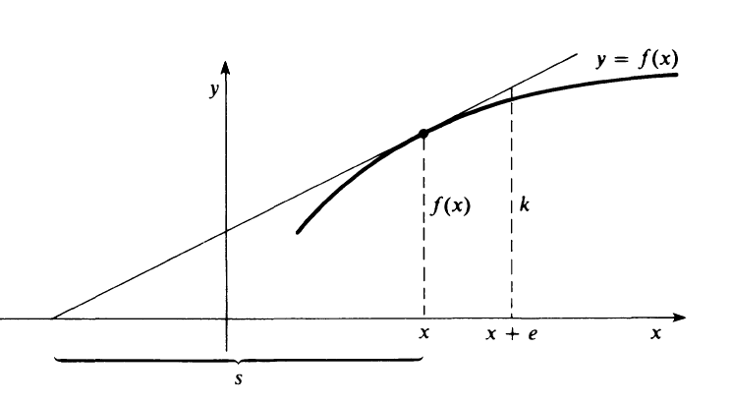

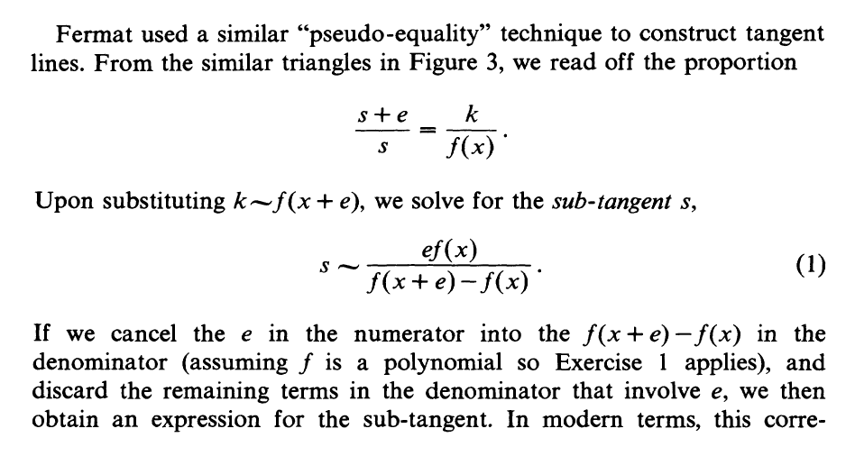

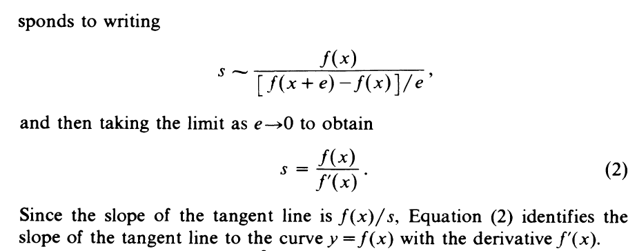

Αυτο φαινεται καλλιτερα αν γραψουμε την τελευταια ως, f’(x)=f(x)/s.

##### ΠΑΡΑΔΕΙΓΜΑ η ΠΑΡΑΓΩΓΟΣ της xn,

Εστω f(x)=xn , cosn, sinx,

f’ (x) = nxn-1 , -sinx, cosx,

