04 ΔΙΑΛΕΞΗΣ,

ΣΑΒΑΤΟ 08-03-2025, 3μμ

LINK, parakoloyuhshs,

[**https://uoa.webex.com/uoa/j.php?MTID=m7b498d2f2d351207db8ece8bc3cc22f8**](https://uoa.webex.com/uoa/j.php?MTID=m7b498d2f2d351207db8ece8bc3cc22f8)**,**

**LINK του ΒΙΝΤΕΟ**

Webex meeting recording: 04 INM SABBATO 2025-20250308 1439-1

Password: uDK2PtWq

Recording link: <https://uoa.webex.com/uoa/ldr.php?RCID=d9874b3469cc164ccc0e80d5285bb220>,

ΠΡΟΚΑΤΑΡΚΤΙΚΑ,

ΒΙΝΤΕΟΣΚΟΠΙΣΗΣ

ΕΠΑΝΑΛΗΨΙΣ ΠΡΟΗΓΟΥΜΕΝΩΝ, από ΓΙΑΤΙ ΕΙΝΑΙ ΣΠΟΥΔΑΙΟΣ ΠΙΝΑΚΑΣ ?,

# ΠΟΛΙΤΙΣΜΟΣ, CIVILIZATION,

## ΠΑΡΑΤΗΡΗΣΕΙΣ ΤΙΝΕΣ,

### ΓΛΩΣΣΙΚΑ,

CIVILIZATION (USA), CIVILISATION (british), =ΠΟΛΙΤΙΣΜΟΣ.

Σχετιζαται με το ΠΟΛΙΣ.

CULTURE, ΚΟΥΛΤΟΥΡΑ,

**Is it civilization or civilisation,**

[**https://sapling.ai/usage/civilized-vs-civilised**](https://sapling.ai/usage/civilized-vs-civilised)**,**

Civilized and civilised are both English terms. **Civilized** is predominantly used in 🇺🇸 American (US) English while C**ivilised** is predominantly used in 🇬🇧 British English (used in UK/AU/NZ) ( en-GB ).

SGP. Συγκριση μεταξυ CIVILISATION, ΠΟΛΙΤΙΣΜΟΣ (ελλ).

Υπουργειο Πολιτισμου, Ministry of Culture,

<https://en.wikipedia.org/wiki/Civilization>,

The **English word civilization** comes from the 16th-century French civilisé ("civilized"), from **Latin civilis ("civil")**, related to civis ("citizen") and civitas ("The social body of the citizens united by law").

Latin word for "city" was **urbs**.[12]

CIVILIS. civic, civil (of or pertaining to citizens)

public, political (of or pertaining to public or political life)

### TAXONOMY, ΤΑΞΙΝΟΜΙΣΗ ΖΩΩΝ,

#### Taxonomy (biology)

<https://en.wikipedia.org/wiki/Taxonomy_(biology)>,

In biology**, taxonomy (from Ancient Greek τάξις (taxis) 'arrangement', and -νομία (-nomia) 'method'**) is the scientific study of naming, defining (circumscribing) and classifying groups of biological organisms based on **shared characteristics.** Organisms are grouped into taxa (singular: taxon) and these groups are given a taxonomic rank; groups of a given rank can be aggregated to form a more inclusive group of higher rank, thus creating a taxonomic hierarchy. The principal ranks in modern use are **domain, kingdom, phylum (phylum = φύλο, δηλαδή φυλή), class, order, family, genus, and species**.

The Swedish botanist Carl Linnaeus is regarded as the founder of the current system of taxonomy, as he developed a ranked system known as Linnaean taxonomy for categorizing organisms and **binomial nomenclature for naming organisms**.

BINOMIAL. Binomial expressions are common English phrases that include a pair of words usually joined by “and” or “or” (e.g. black and white, plain and simple, more or less). The order of the words is usually fixed, and they are a single chunk of English vocabulary

Λευτερια η θανατος, όλα η τιποτα, again and again, tried and tested, back and forth, bit by bit,

#### ΣΥΜΠΛΗΡΩΜΑΤΑ,

###### Carl Linnaeus,

Carl Linnaeus (/lɪˈniːəs, lɪˈneɪəs/;[1][2] 23 May[note 1**] 1707 – 10 January 1778),** also known after his ennoblement in 1761 as **Carl von Linné**[3] (Swedish pronunciation: [ˈkɑːɭ fɔn lɪˈneː] (listen)), was a Swedish botanist, zoologist, taxonomist, and physician who formalised **binomial nomenclature**, the modern system of naming organisms. He is known as the "father of modern taxonomy".[4] Many of his writings were in Latin; his name is rendered in Latin as **Carolus Linnæus** and, after his 1761 ennoblement, as **Carolus a Linné**.

**binomial nomenclature**

Διωνυμική ονοματολογία (Binomial nomenclature)

Στη βιολογία, η διωνυμική ονοματολογία είναι η επίσημη μέθοδος ονοματοδοσίας των ειδών. Αφού προτάθηκε η λογική του «διώνυμου», οι επιστημονικές ονομασίες των ειδών σχηματίζονται από το συνδυασμό δύο όρων: **το όνομα του γένους και το όνομα του είδους.** Βικιπαίδεια

#### SPECIES, ΕΙΔΟΣ, .

<https://www.nature.com/scitable/definition/species-312/>,

A biological **species** is a group of organisms that **can reproduce with one another in nature and produce fertile offspring.**

SUBSPECIES

#### Canine Family, ΟΙΚΟΓΕΝΙΑ ΚΥΝΕΙΔΕΣ,

Etymology. From Latin canīnus (“of dogs, dog-like”), from canis (“dog”). Compare French canin.

ΚΥΩΝ, παρεμφερες του CANIS

κληρονομημένο από την πρωτοϊνδοευρωπαϊκή *ḱwṓ. Συγγενή: σανσκριτική श्वन् (śván), λατινική canis (> γαλλική chien), αγγλοσαξονική hund, αγγλική hound

ΔΕΝ σχετιζεται με τα ΛΥΚΟΦΩΣ η ΛΥΚΑΥΓΕΣ,

File:Twilight description full day.svg

<https://commons.wikimedia.org/wiki/File:Twilight_description_full_day.svg>,

ΠΟΥ ΑΝΗΚΟΥΝ ΟΙ ΣΚΥΛΟΙ,

**ORDER (ΤΑΞΙΣ),** Carnivora

**Family (ΟΙΚΟΓΕΝΙΑ),** Canine (ΚΑΝΙΔΕΣ η ΚΥΝΙΔΕΣ),

**Genus (ΓΕΝΟΣ),** Canis, **(ΚΥΩΝ),** (π.χ. λύκους, τα κογιότ, τα τσακάλια, τα ντίνγκο τους σκύλους κλπ).

**Species (ΕΙΔΟΣ), Canis lupus** (The wolf (Canis lupus;[b] pl.: wolves), also known as the gray wolf or grey wolf,)

Lupus latin for eng. wolf,

**ΔΕΝ σχετιζεται με τα ΛΥΚΟΦΩΣ η ΛΥΚΑΥΓΕΣ,**

**File:Twilight description full day.svg**

[**https://commons.wikimedia.org/wiki/File:Twilight_description_full_day.svg**](https://commons.wikimedia.org/wiki/File:Twilight_description_full_day.svg)**,**

**SubSpecies (Υπο-ΕΙΔΟΣ), Canis lupus familiaris (οικογενια)** (τα συνηθη σκυλια),

CYNIC, ΚΥΝΙΚΟΣ, . contemptuously distrustful of human nature and motives .

e.g. Franklin D. Roosevelt. Those cynical men who say that democracy cannot be honest and efficient.

##### ΣΥΜΠΛΗΡΩΜΑΤΑ,

###### ΚΙΝΑΙΔΟΣ,

###### ΔΕΝ σχετιζεται με τα ΛΥΚΟΦΩΣ η ΛΥΚΑΥΓΕΣ,

File:Twilight description full day.svg

<https://commons.wikimedia.org/wiki/File:Twilight_description_full_day.svg>,

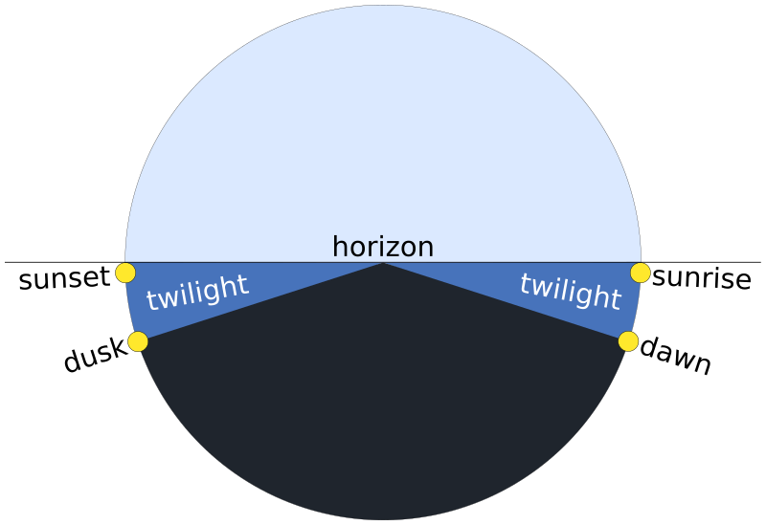

###### Subspecies of Canis lupus,

<https://en.wikipedia.org/wiki/Subspecies_of_Canis_lupus>,

π.χ. λυκος, ντινγκο

###### VARIOUS,

(REMARK. Dogs & the Canine Family, <https://www.britannica.com/browse/Dogs>,

Dog είναι υποειδοσ το **Canis lupus familiaris**, domestic mammal of the genus **CANIS**, ανηκει **Canidae family**,και στην **order Carnivora.** Dogs, It is a **subspecies** of the **gray wolf** (**species Canis lupus**) and is related to foxes and jackals (τσακαλι), . The dog is one of the two most ubiquitous and most popular domestic animals in the world (the cat is the other). For more than 12,000 years it has lived with humans as a hunting companion, protector, object of scorn or adoration, and friend. :

### ΗΟΜΟ (ΑΝΘΡΩΠΟΣ),

**Homo is a Latin word that means man, or human**. When it is used as a prefix, as in "homosexual," it comes from the Greek word homos, meaning the same. It is from the word "homosexual" that the noun homo is shortened and takes its second meaning — a derogatory term for a homosexual or gay man.

Family (ΟΙΚΟΓΕΝΕΙΑ), Hominidae (ΑΝΘΡΩΠΙΔΑΙ η ΜΕΓΑΛΟΙ ΠΙΘΗΚΟΙ)

Π.χ. άνθρωπο, χιμπατζίδες, γορίλες και ουρακοτάγκους.

ΣΧΟΛΙΟΝ, Βασιλισα ΒΙΚΤΩΡΙΑ,

GENUS(ΓΕΝΟΣ), HOMO (ΑΝΘΡΩΠΟΣ

(SPECIES) ΕΙΔΗ του GENUS(ΓΕΝΟΣ), HOMO (ΑΝΘΡΩΠΟΣ

**Homo Sapiens (ανθρωπος ο σοφος η ο εμφρων)**

**Ιt is likely that Homo sapiens (anatomically modern humans) has been the only extant species of genus Homo.**

**Αλλα ειδη του genus homo:**

†Homo habilis (Άνθρωπος ο επιδέξιος)

mainly used tools in butchering

†Homo erectus (ΑΝΘΡΩΠΟΣ Ο ΟΡΘΙΟΣ)

†Homo antecessor (ΑΝΘΡΩΠΟΣ Ο ΠΡΟΔΡΟΜΟΣ)

Populations of this species may have been present elsewhere in Western Europe, and were among the first to colonise that region of the world, hence the name.

†Homo ergaster (ΑΝΘΡΩΠΟΣ ΕΡΓΑΤΗΣ),

reference to the more advanced tools used by the species in comparison to those of their ancestors.

†Homo heidelbergensis

†Homo floresiensis

that inhabited the island of Flores Indonesia, until the arrival of modern humans about 50,000 years ago.

REMARK. To **GENUS einai HOMO** (ΑΝΘΡΩΠΟΣ).

To Homo Sapiens einai specie. Οι **Homo Sapiens (ανθρωπος ο σοφος η ο εμφρων)** είναι SPECIES (ΕΙΔΟΣ), toy GENUS HOMO, sto opoio ypagometha kai emeis, .

Einai anoikto thema an oi Homo periexoyn kai deytero **species**, (p.x. tous NEADERTHAL), .

**Εάν εμεις και οι NEADERTHAL ανηκουν στι ιδιο ειδος**, τοτε αυτό το ειδος θα λεγεται **Homo Sapiens, και εμεις θα ειμαστε το ΥΠΟΕΙΔΟΣ (subspecies), Homo Sapiens Sapiens, ενώ οι NEADERTHAL θa einai to υποειδοσ , Homo Sapiens neanderthalensis.**

**Εάν εμεις και οι NEADERTHAL ΔΕΝ ανηκουν στι ιδιο ειδος, τοτε μιλαμε για δυο ειδη του genus Homo, το homo Sapiens εμεισ και το ειδος NEADERTHAL. Αμφοτερα θα ανηκουν στο genus Homo.**

#### ΔΙΑΦΟΡΑ,

**ΚΥΝΟΔΟΝΤΕΣ,**

ΚΥΝΟΔΟΝΤΕΣ ΑΝΘΡΩΠΟΥ, 13, 23, 33, 43,

O HOMO kai οι ΠΙΘΗΚΟΙ εχουν κοινο προγονο.

#### †Homo neanderthalensis

**Ανοικτο ερωτημα :** αν Homo neanderthalensis και Homo sapiens, einai ΔΙΑΦΟΡΕΤΙΚΑ ΕΙΔΗ.

#### ΣΥΜΠΛΗΡΩΣΕΙΣ, REMARKS, .

##### HUMAN.

<https://en.wikipedia.org/wiki/Human>,

All modern humans are classified into the [species](https://en.wikipedia.org/wiki/Species) *Homo sapiens*, coined by [Carl Linnaeus](https://en.wikipedia.org/wiki/Carl_Linnaeus) in his 1735 work [*Systema Naturae*](https://en.wikipedia.org/wiki/Systema_Naturae).[[2]](https://en.wikipedia.org/wiki/Human#cite_note-2) The [generic name](https://en.wikipedia.org/wiki/Name_of_a_biological_genus) "[*Homo*](https://en.wikipedia.org/wiki/Homo)" is a learned 18th-century derivation from Latin *homō*, which refers to humans of either sex.[[3]](https://en.wikipedia.org/wiki/Human#cite_note-3) The word *human* can refer to all members of the *Homo* **genus**,[[4]](https://en.wikipedia.org/wiki/Human#cite_note-auto-4) although in common usage it generally just refers to *Homo sapiens,* the only extant **species**.[[5]](https://en.wikipedia.org/wiki/Human#cite_note-5) The name "*Homo* *sapiens*" means 'wise man' or 'knowledgeable man'.[[6]](https://en.wikipedia.org/wiki/Human#cite_note-6) There is disagreement if certain extinct members of the genus, namely [Neanderthals](https://en.wikipedia.org/wiki/Neanderthal), should be included as a separate species of humans or as a [subspecies](https://en.wikipedia.org/wiki/Subspecies) of *H. sapiens*.[[4]](https://en.wikipedia.org/wiki/Human#cite_note-auto-4) )

##### Subspecies,

<https://en.wikipedia.org/wiki/Subspecies>,

In biological classification, subspecies is a rank below species, used for populations that live **in different areas and vary in size, shape, or other physical characteristics (morphology), but that can successfully interbreed**.[2][3] Not all species have subspecies, but for those that do there must be at least two. Subspecies is abbreviated subsp. or ssp. and the singular and plural forms are the same ("the subspecies is" or "the subspecies are"). )

<https://en.wikipedia.org/wiki/Homo>,

**Homo (from Latin homō 'man') is the genus that encompasses the extant species Homo sapiens (modern humans),** plus several extinct species classified as either ancestral to or closely related to modern humans (depending on the species), most notably H. erectus and H. neanderthalensis. **The genus emerged with the appearance of H. habilis just over 2 million years ago.**[a] Homo, together with the genus Paranthropus, is probably sister to Australopithecus africanus, which itself had previously split from the lineage of Pan, the chimpanzees.[b][4][5]

**Homo erectus appeared about 2 million years ago and**, in several early migrations, spread throughout Africa (where it is dubbed H. ergaster) and Eurasia. It was likely that the first human species lived in a hunter-gatherer society and was able to control fire. An adaptive and successful species, H. erectus persisted for more than a million years and gradually diverged into new species by around 500,000 years ago.[c][6]

### «African origin" recent model,

ΔΙΑΡΚΕΙΑ ΥΠΑΡΞΗΣ ΣΥΜΠΑΝΤΟΣ

Age of the universe

<https://en.wikipedia.org/wiki/Age_of_the_universe>,

In physical cosmology, the age of the universe is the time elapsed since the Big Bang. Astronomers have derived two different measurements of the age of the universe:[1] a measurement based on direct observations of an early state of the universe, which indicate an age **of 13.787±0.020 billion years** (c. 14billions) as interpreted with the Lambda-CDM concordance model as of 2021;[2] and a measurement based on the observations of the local, modern universe, which suggest a younger age.[3][4][5]

ΔΙΑΡΚΕΙΑ ΥΠΑΡΞΗΣ ΓΗΣ

<https://en.wikipedia.org/wiki/Age_of_Earth>,

Age of Earth

The age of Earth is estimated to be **4.54 ± 0.05 billion years** (4.54 × 109 years ± 1%).[1][2][3][4] (c. 4.5 billion) This age may represent the age of Earth's accretion, or core formation, or of the material from which Earth formed.[2] This dating is based on evidence from radiometric age-dating of meteorite[5] material and is consistent with the radiometric ages of the oldest-known terrestrial material[6] and lunar samples.[7]

ΕΜΦΑΝΙΣΗ ΖΩΗΣ,

Earliest known life forms,

<https://en.wikipedia.org/wiki/Earliest_known_life_forms>,

The earliest known life forms on Earth may be as old **as 4.1 billion years old** (or Ga) (c. 4 billions) according to biologically fractionated graphite inside a single zircon grain in the Jack Hills range of Australia.[2]

<https://en.wikipedia.org/wiki/Recent_African_origin_of_modern_humans>,

The history of civilization is a short one. Within the study of humanity, which reaches back to **the genus Homo (ΑΝΘΡΩΠΟΣ), in Africa, some 1.7 million years** ago, it is merely a blip on the radar screen.

**H. sapiens,** οσον αφορα **σωματικα χαρακτηριστικα,**  **most likely** developed in the Horn of Africa **between 300,000 and 200,000 years ago,.** Εχει τα δικα μας σωματικα χαρακτηριστικα**.**

<https://en.wikipedia.org/wiki/Horn_of_Africa>,

<https://en.wikipedia.org/wiki/File:Horn_of_Africa_(orthographic_projection).svg>,

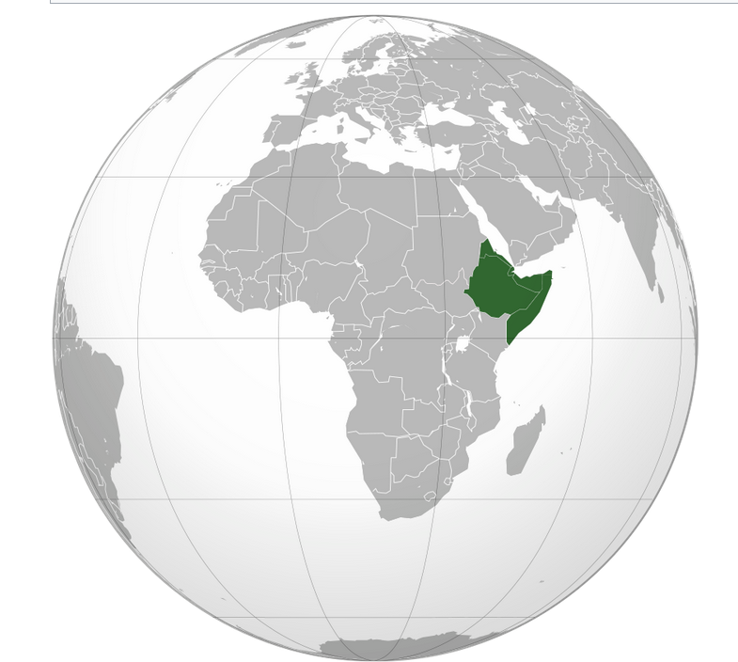

The "recent African origin" model proposes that **all modern non-African populations** are **substantially descended** from populations of H. sapiens that left Africa after that time.

H. sapiens dispersed from Africa in several waves, from possibly as early as **250,000 years ago,** and certainly by **130,000** years ago,.

**Behavioral modernity**, involving the development of **language, figurative art (describes artwork particularly paintings and sculptures that is clearly derived from real object), and early forms of religion (etc.)** is taken to have arisen **before 40,000 years ago**,

SGP. Υπαρξη Αριθμισης, 30000π.Χ.

Behavioral modernity,

<https://en.wikipedia.org/wiki/Behavioral_modernity>,

Behavioral modernity is a suite of **behavioral and cognitive traits** that distinguishes **current Homo sapiens from other anatomically modern humans**, hominins, and primates.[1] Most scholars agree that modern human behavior can be characterized by **abstract thinking**, **planning depth**, **symbolic behavior** (e.g., art, ornamentation), **music and dance**, **exploitation of large game**, and **blade technology**, among others.[2][3] Underlying these behaviors and technological innovations are cognitive and cultural foundations that have been documented experimentally and ethnographically by evolutionary and cultural anthropologists. These human universal patterns include cumulative cultural adaptation, social norms, language, and extensive help and cooperation beyond close kin.[4][5].

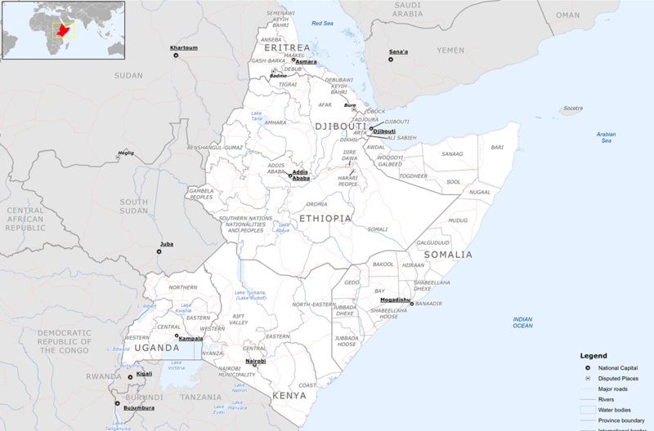

The Greater Horn of Africa consists of more than the typical four countries, including also **Kenya, Uganda, Sudan and South Sudan**.[23][24]

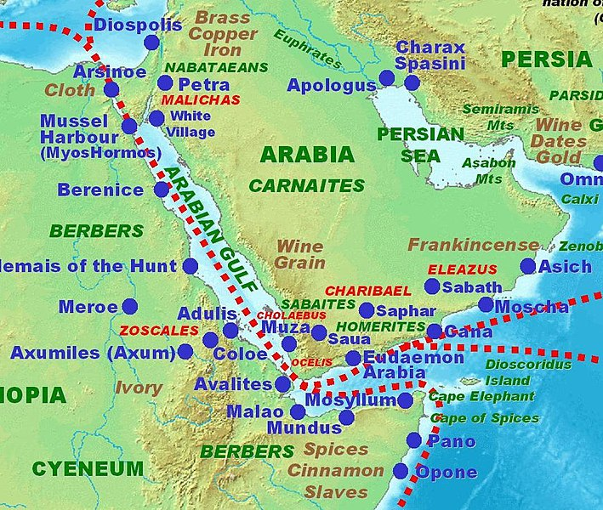

Ancient trading centers in the Horn of Africa and the Arabian peninsula according to the Periplus of the Erythraean Sea

ΕΡΥΘΡΑ ΘΑΛΑΣΣΑ, είναι ΕΡΥΘΡΩΠΗ λογω πλαγκτον κλπ

### ΠΕΡΙΛΗΨΗΣ,

Family (ΟΙΚΟΓΕΝΕΙΑ), Hominidae (ΑΝΘΡΩΠΙΔΑΙ η ΜΕΓΑΛΟΙ ΠΙΘΗΚΟΙ)

Π.χ. άνθρωπο, χιμπατζίδες, γορίλες και ουρακοτάγκους.

GENUS(ΓΕΝΟΣ), HOMO (ΑΝΘΡΩΠΟΣ

(SPECIES) ΕΙΔΗ

Homo Sapiens (ανθρωπος ο σοφος η ο εμφρων)

Ιt is likely that Homo sapiens (anatomically modern humans) has been the only extant species of genus Homo.

ΧΡΟΝΙΚΗ ΕΞΕΛΙΞΗ,

Αρχη του ΣΥΜΠΑΝΤΟΣ.

Προ c. 14 δισ. ετη.

Δημιουργια ΓΗΣ.

c. 4.5 billions ετη.

Εμφανισης ΖΩΗΣ στην ΓΗ

Προ c. 4 δις. ετη.

ΓΕΝΟΣ ΑΝΘΡΩΠΟΣ,

Προ 1.7 millions ετη, στην ΑΦΡΙΚΗ.

HOMO SAPIENS,

**Homo sapiens,** οσον αφορα **σωματικα χαρακτηριστικα,**  **most likely** developed in the HORN of Africa **between 300,000 and 200,000** years ago,.

HOMO SAPIENS, **Behavioral modernity**,

**Behavioral modernity**, involving the development of **language, figurative art** (describes artwork particularly paintings and sculptures that is clearly derived from real object**), and early forms of religion (etc.)** is taken to have arisen **before 40,000 years ago**,