07 ΔΙΑΛΕΞΙΣ,

ΣΑΒΒΑΤΟ 22-03-2023,

Webex meeting recording: 07 INM-20250322 sabaton

Password: eHvAyhM6

Recording link: <https://uoa.webex.com/uoa/ldr.php?RCID=9e54d7831e581a4f90e1f46bc6aea63e>,

**ΠΡΟΚΑΤΑΡΚΤΙΚΑ,**

Σημερα συζηταμε τις 1001, 1006, 1007,

Το ερχομενο σ/κ, θα συζητησουμε τις εργασιες ~~2004~~, 1005, 1003, 3001,

# ΔΥΤΙΚΟΣ ΠΟΛΙΤΙΣΜΟΣ ([WESTERN CIVILIZATION)

## the Fertile Crescent

<https://en.wikipedia.org/wiki/Fertile_Crescent>,

the Fertile Crescent (ΗΜΙΣΕΛΙΝΟΣ), is most famous for its sites related to the origins of agriculture. The western zone around the Jordan and upper Euphrates rivers gave rise to the first known Neolithic farming settlements (referred to as Pre-Pottery Neolithic A (PPNA)), which date to around **9,000 BCE** and includes very ancient sites such as Göbekli Tepe (ΤΟΥΡΚΙΑ), Chogha Golan (ΙΡΑΝ), and **Jericho** (aka Tell es-Sultan), (State of Palestine).

The term "Fertile Crescent" was popularized **by archaeologist James Henry Breasted, in** Outlines of European History (1914)and Ancient Times, A History of the Early World (1916).[4][5][6][7][8][9] He wrote:[4]

“ It lies like an army facing south, with one wing stretching along the eastern shore of the Mediterranean and the other reaching out to the Persian Gulf, while the center has its back against the northern mountains. The end of the western wing is Palestine; Assyria makes up a large part of the center; while the end of the eastern wing is Babylonia. [...] This great semicircle, for lack of a name, may be called the Fertile Crescent..”

### CRESCENT, Maps

<https://en.wikipedia.org/wiki/Fertile_Crescent>,

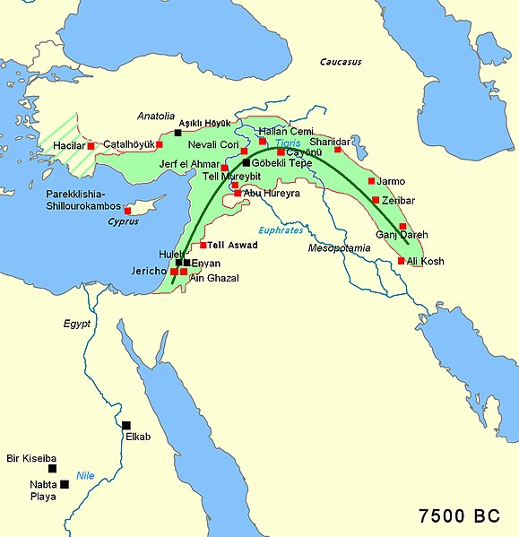

**Map of the Fertile Crescent**

Area of the fertile crescent, circa 7500 BCE, with main sites **of the Pre-Pottery** Neolithic period. The area of Mesopotamia proper was not yet settled by humans. Includes Göbekli Tepe, a site in modern-day Turkey that is dated circa 9000 BCE.

Fertile crescent Neolithic B circa 7500 BC; **black squares indicate pre-agricultural sites**

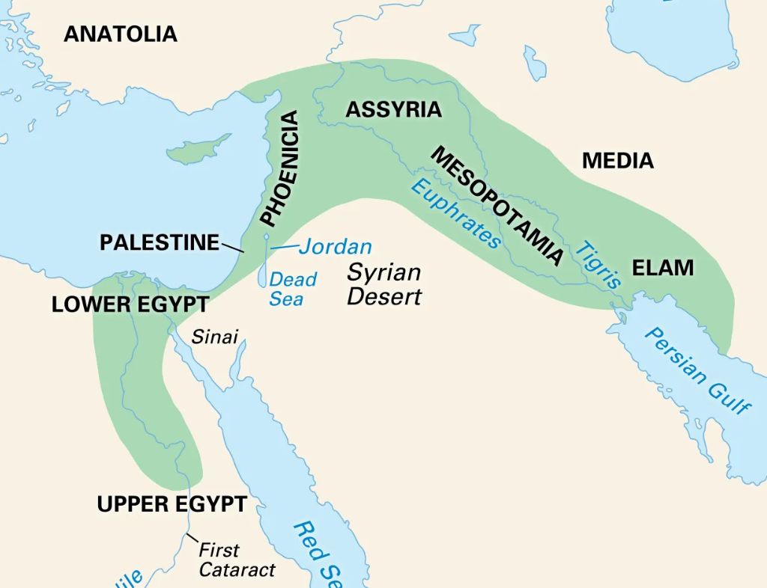

<https://www.britannica.com/place/Fertile-Crescent>,

περιεχει εδώ και αιγυπτο,

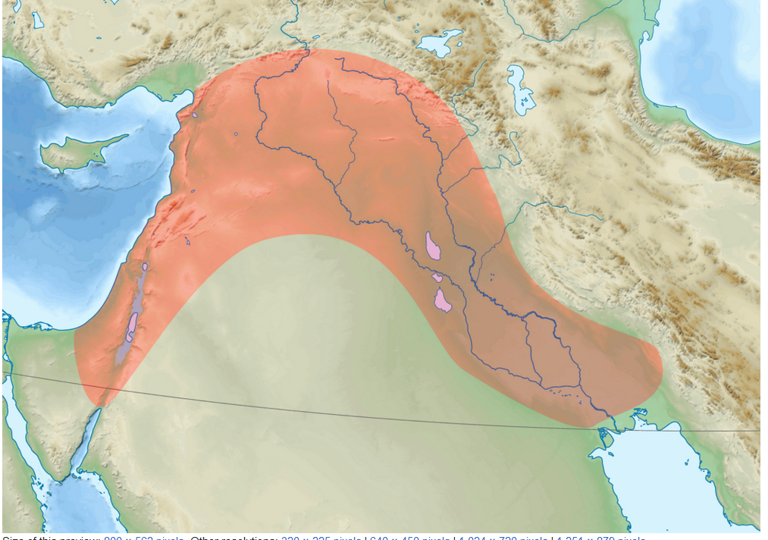

<https://en.wikipedia.org/wiki/Fertile_Crescent>,

Map showing the generally defined area of the Fertile Crescent in red

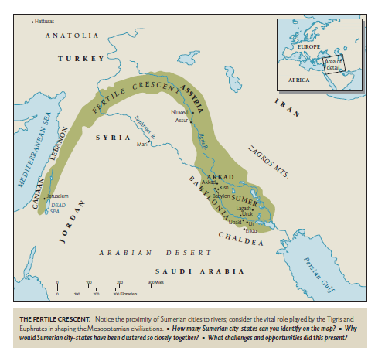

ColeSymes p. 11.

#### The Symbol Crescent, ,

##### CRESCENT, BYZANTIUM, Philip II of Macedon

?? αβεβαιον,

Cresento, croissant,

Crescent,

<https://en.wikipedia.org/wiki/Byzantium>,

Crescent,

<https://en.wikipedia.org/wiki/Crescent>,

The word crescent is derived etymologically from the present participle of the Latin verb **crescere** "to grow", technically denoting the waxing moon (luna crescens).

##### The Battle of Vienna[a] Wikipedia, οχι 2025

took place at Kahlenberg Mountain near Vienna on 12 September 1683[3] after the city had been besieged by the Ottoman Empire for two months. The battle was fought by the Holy Roman Empire (led by the Habsburg monarchy) and the Polish–Lithuanian Commonwealth, both under the command of King John III Sobieski, against the Ottomans and their vassal and tributary states. The battle marked the first time the Commonwealth and the Holy Roman Empire had cooperated militarily against the Ottomans. The defeat is often seen as a turning point for Ottoman expansion into Europe, after which they would gain no further ground.[22][Note 3] In the ensuing war that lasted until 1699, the Ottomans would cede most of Ottoman Hungary to Leopold I, Holy Roman Emperor.[22]

Fertile Cresent, ευφορος ημισελινοσ

Crescent, croissant,

Kipferl. The origin of the croissant can actually be traced back to 13th century Austria, where it was called the **kipferl**, the German word for crescent. However it was an Austrian artillery officer August Zang who founded a **Viennese bakery** at 1692, rue du richelieu in Paris.

## SUMER, ΣΟΥΜΕΡΙΑ, : η «έναρξη» του ΔΥΤΙΚΟΥ ΠΟΛΙΤΙΣΜΟΥ,

### SUMER, 2025,

Sumer, (c. 5500 – c. 1800 BC)

<https://en.wikipedia.org/wiki/Sumer>,

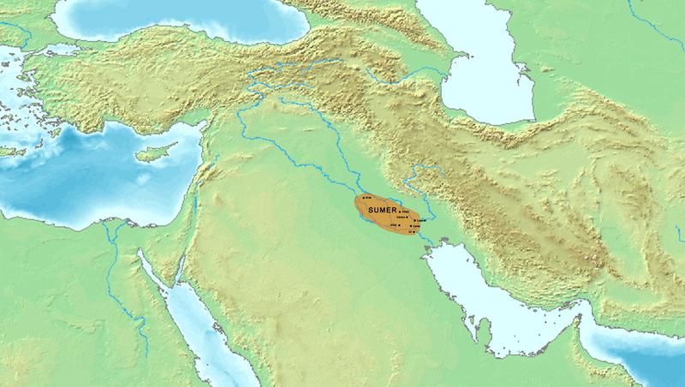

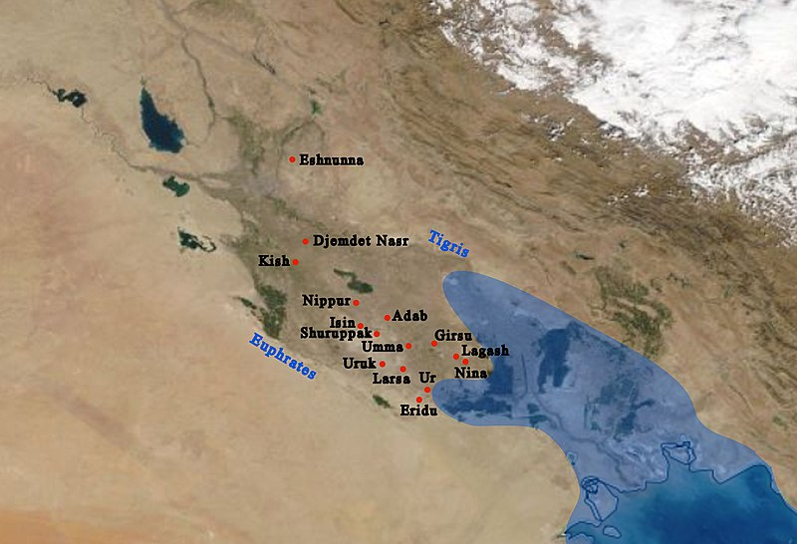

The general location on a modern map, and main cities of Sumer with ancient coastline. **The coastline nearly reached Ur in ancient times**.

UR, URUK, ,

<https://en.wikipedia.org/wiki/Sumer>.

Sumer (/ˈsuːmər/)[note 1] is the earliest known civilization in the historical region of southern Mesopotamia, modern-day southern Iraq, during the Chalcolithic and Early Bronze ages, **and arguably the first civilization in the world with Ancient Egypt and the Indus Valley.**[1] Living along the valleys of the Tigris and Euphrates, Sumerian farmers were able to grow an abundance of grain and other crops, the surplus of which enabled them to settle in one place**. Proto-writing in the prehistory dates back to c. 3000 BC**. The earliest texts come from the cities of Uruk and Jemdet Nasr and date back to 3300 BC; early cuneiform script writing emerged in 3000 BC.[2]

**Modern historians have suggested that Sumer was first permanently settled between c. 5500 and 4000 BC** by a West Asian people who spoke the Sumerian language (pointing to the names of cities, rivers, basic occupations, etc., as evidence)

AkkadMap.jpg, UR, URUK,

<http://www.crystalinks.com/uruk.html>,

### Gilgamesh, οχι 2025

<https://en.wikipedia.org/wiki/Gilgamesh>,

Gilgamesh[a] was a historical king of the Sumerian city-state of Uruk, a major hero in ancient Mesopotamian mythology, and the protagonist of the Epic of Gilgamesh, an epic poem written in Akkadian during the late second millennium BC. He probably ruled sometime between **2800 and 2500 BC** and was posthumously deified.

He became a major figure in Sumerian legends during the Third Dynasty of Ur

(c. 2112 – c. 2004 BC).

Tales of Gilgamesh's legendary exploits are narrated in five surviving Sumerian poems. The earliest of these is probably **Gilgamesh**, Enkidu, and the Netherworld, in which Gilgamesh comes to the aid of the goddess Inanna and drives away the creatures infesting her huluppu tree. She gives him two unknown objects called a mikku and a pikku, which he loses. After Enkidu's death, his shade tells Gilgamesh about the bleak conditions in the Underworld. The poem Gilgamesh and Agga describes Gilgamesh's revolt against his overlord King Agga. Other Sumerian poems relate Gilgamesh's defeat of the ogre (αγριάνθρωπος ) Huwawa and the Bull of Heaven and a fifth, poorly preserved one apparently describes his death and funeral.

In later Babylonian times, these stories began to be woven into a connected narrative. The standard Akkadian Epic of Gilgamesh was composed by a scribe named

Sîn-lēqi-unninni, probably during the

Middle Babylonian Period (c. **1600 – c. 1155 BC**), based on much older source material. In the epic, Gilgamesh is a demigod of superhuman strength who befriends the wildman Enkidu. Together, they go on adventures, defeating Humbaba (the East Semitic name for Huwawa) and the Bull of Heaven, who, in the epic, is sent to attack them by Ishtar (the East Semitic equivalent of Inanna) after Gilgamesh rejects her offer for him to become her consort. **After Enkidu dies of a disease sent as punishment from the gods, Gilgamesh becomes afraid of his own death**, and visits the sage Utnapishtim, the survivor of the Great Flood, hoping to find immortality. Gilgamesh repeatedly fails the trials set before him and returns home to Uruk, **realizing that immortality is beyond his reach. (ΣΓΠ. Μετεπειτα αναζητει δοξαν).**

Most classical historians agree that the Epic of Gilgamesh exerted substantial influence on both the Iliad and the Odyssey, **two epic poems written in ancient Greek during the eighth century BC**. The story of Gilgamesh's birth is described in a second-century AD anecdote from On the Nature of Animals by the Greek writer Aelian. Aelian relates that Gilgamesh's grandfather kept his mother under guard to prevent her from becoming pregnant, because he had been told by an oracle that his grandson would overthrow him. She became pregnant and the guards threw the child off a tower, but an eagle rescued him mid-fall and delivered him safely to an orchard, where he was raised by the gardener. The Epic of Gilgamesh was **rediscovered in the Library of Ashurbanipal in 1849.** After being translated in the early 1870s, it caused widespread controversy due to similarities between portions of it and the Hebrew Bible. Gilgamesh remained mostly obscure until the mid-twentieth century, but, since the late twentieth-century, he has become an increasingly prominent figure in modern culture.

COMMENT. Ashurbanipal. Ashurbanipal was the king of the Neo-Assyrian Empire from 669 BC to his death in 631. He is generally remembered as the last great king of Assyria. Είναι γνωστός για τη δημιουργία σημαντικής συλλογής εγγράφων σφηνοειδούς γραφής στο βασιλικό παλάτι στη Νινευή.

#### Discovery

About 15,000 fragments of Assyrian cuneiform tablets were discovered in the Library of Ashurbanipal in Nineveh by Austen Henry Layard, his assistant Hormuzd Rassam, and W. K. Loftus in the early 1850s.[9] Late in the following decade, the British Museum hired **George Smith to study these**; in 1872, Smith read translated fragments before the Society of Biblical Archaeology,[10] and in **1875 and 1876 he published fuller translations,[**11] the latter of which was published as The Chaldaean Account of Genesis.

#### Relationship to the Bible

Various themes, plot elements, and characters in the Hebrew Bible correlate with the Epic of Gilgamesh – notably, the accounts of the **Garden of Eden**, the advice from **Ecclesiastes** (Greek word Ἐκκλησιαστής), and **the Genesis flood narrative**.

#### Influence on Homer οχι 2025

Numerous scholars have drawn attention to various themes, episodes, and verses, indicating that the Epic of Gilgamesh had a substantial influence on both of the epic poems ascribed to Homer. These influences are detailed by Martin Litchfield West in The East Face of Helicon: West Asiatic Elements in Greek Poetry and Myth.[75] According to Tzvi Abusch of Brandeis University, the poem "**combines the power and tragedy of the Iliad with the wanderings and marvels of the Odyssey. It is a work of adventure, but is no less a meditation on some fundamental issues of human existence."**[76] Martin West, in "The East face of Helicon", speculates that the memory of Gilgamesh would have reached the Greeks through a lost poem about Heracles.[37]

## ΒΑΣΙΚΕΣ ΠΑΡΑΤΗΡΗΣΕΙΣ για τον ΔΥΤΙΚΟ ΠΟΛΙΤΙΣΜΟ,

#### ΟΙ ΒΑΣΕΙΣ ΤΟΥ ΔΥΤΙΚΟΥ ΠΟΛΙΤΙΣΜΟΥ, 2025,

<https://en.wikipedia.org/wiki/History_of_Western_civilization_before_AD_500#cite_note-Cambridge_University_Historical_Series-3>,

The civilizations **of Classical Greece (Hellenic)[1] and Roman Empire (Latin)[2] as well as Ancient Israel (Hebraism, ΕΒΡΑΙΣΜΟΣ,** )[3] and early Christendom are considered seminal periods in Western history;.[4][5][6]

From **Ancient Greece sprang belief in democracy, and the pursuit of intellectual inquiry into such subjects as truth** and **beauty**;

**from Rome** came lessons **in government administration**, martial organization, engineering **and law;**

and from **Ancient Israel sprang Christianity with its ideals of the brotherhood of humanity.**

Strong cultural contributions also emerged from the pagan **Germanic, Celtic, Wendic, Finnic, Baltic and Nordic peoples of pre-Christian Europe.** Following **the 5th-century "Fall of Rome", Europe entered the Middle Ages**, during which period the Catholic Church filled the power vacuum left in the West by the fallen Roman Empire, while the Eastern Roman Empire (Byzantine Empire) endured for centuries.

###### ΒΙΒΛΙΟΓΡΑΦΙΑ,

Library Journal. Vol. 97. Bowker. April 1972. p. 1588. "Ancient Greece: Cradle of Western Culture (Series), disc. 6 strips with 3 discs, range: 44–60 fr., 17–18 min"

Jacob Dorsey Forrest (1906). The development of western civilization: a study in ethical, economic and political evolution. The University of Chicago Press.

Cambridge University Historical Series, An Essay on Western Civilization in Its Economic Aspects, p.40: Hebraism, like Hellenism, has been an all-important factor in the development of Western Civilization; Judaism, as the precursor of Christianity, has indirectly had had much to do with shaping the ideals and morality of western nations since the Christian era.

##### Βασεις του Δυτικου Πολιτισμου. symplhromatiko

<https://en.wikipedia.org/wiki/Cradle_of_civilization>,

There is academic consensus that **Classical Greece was the seminal culture** that provided the foundation of modern Western culture, democracy, art, theatre, philosophy, and science. For this reason it is known as the cradle of Western Civilization.[a] Along with Greece, **Rome has sometimes been described as a birthplace or as the cradle of Western Civilization because of the role the city had in politics, republicanism, law, architecture, warfare and Western Christianity**.[b]

ΠΟΛΛΟΙ αναφερουν την HEBREW BIBLE-CHRISTIANITY,

Τονιζει την ΒΟΗΘΕΙΑ στους ΑΔΥΝΑΤΟΥΣ.

ΣΓΠ. ΕΒΡΑΙΚΗ ΒΙΒΛΟΣ-ΕΛΛΗΝΙΚΗ ΦΙΛΟΣΟΦΙΑ, ΕΠΙΣΤΗΜΗ, ΤΕΧΝΗ, ΔΗΜΟΚΡΑΤΙΑ κλπ- ΡΩΜΑΙΚΗ ΔΙΟΙΚΗΣΗ.

CRADLE, κρεβατάκι μωρού

Cradle, verb to place or keep in or as if in a cradle

Seminal, adj (influential)

Semen, n (ejaculate, sperm)

#### Abrahamic religions,

<https://en.wikipedia.org/wiki/Abrahamic_religions>,

Demographics

Worldwide percentage of adherents by Abrahamic religion, as of 2015[155]

**Christianity (31.2%)**

**Islam (24.1%)**

**Judaism (0.18%)**

Baháʼí Faith (0.07%)

Other (non-Abrahamic) (45.45%)

**Christianity** is the largest Abrahamic religion with **about 2.3 billion adherents**, constituting about 31.1% of the world's population**.[156] Islam is the second largest Abrahamic religion, as well as the fastest-growing** Abrahamic religion in recent decades.[156][157] **It has about 1.9 billion adherents**, called Muslims, which constitute about 24.1% of the world's population. The third largest Abrahamic religion is Judaism with about 14.1 million adherents, called Jews.[156]

#### Deuteronomy 24:17-22, στηρηξισ αδυνατων, 2025,

<https://www.bible.com/bible/compare/DEU.24.17-22>,

**Make sure foreigners and orphans get their just rights. Don’t take the cloak (μανδύας )of a widow as security for a loan.** Don’t ever forget that you were once slaves in Egypt and GOD, your God, got you out of there. I command you: Do what I’m telling you. When you harvest your grain and forget a sheaf back in the field, don’t go back and get it; leave it for the foreigner, the orphan, and the widow so that GOD, your God, will bless you in all your work. When you shake the olives off your trees, don’t go back over the branches and strip them bare—what’s left is for the foreigner, the orphan, and the widow. And when you cut the grapes in your vineyard, don’t take every last grape—leave a few for the foreigner, the orphan, and the widow. Don’t ever forget that you were a slave in Egypt. I command you: Do what I’m telling you.

#### Corpus Juris Civilis,

<https://en.wikipedia.org/wiki/Corpus_Juris_Civilis>,

The ***Corpus Juris*** (or ***Iuris***) ***Civilis*** ("Body of Civil Law", ΑΣΤΙΚΟΣ ΚΩΔΙΚΑΣ) is the modern name[[1]](https://en.wikipedia.org/wiki/Corpus_Juris_Civilis#cite_note-1) for a collection of fundamental works in [jurisprudence](https://en.wikipedia.org/wiki/Jurisprudence), issued[[*vague*](https://en.wikipedia.org/wiki/Wikipedia:Vagueness)] from 529 to 534 by order of [Byzantine Emperor](https://en.wikipedia.org/wiki/Byzantine_Emperor) [Justinian I](https://en.wikipedia.org/wiki/Justinian_I).

…The **Corpus Juris Civilis was revised into Greek**, when that became the predominant language of the Eastern Roman Empire, and continued to form the basis of the empire's laws, the Basilika (Greek: τὰ βασιλικά, 'imperial laws'), through the 15th century. …

## ΓΕΝΙΚΑ ΣΥΜΠΕΡΑΣΜΑΤΑ για τον ΔΥΤΙΚΟ ΠΟΛΙΤΙΣΜΟ,

2021,

#### Eν περιληψει ΧΡΟΝΟΛΟΓΙΕΣ του ΔΥΤΙΚΟΥ ΠΟΛΙΤΙΣΜΟΥ, από την ΟΠΤΙΚΗ της ΙΝΜ,

ΜΕΧΡΙ 500μ.Χ.

ΜΕΣΟΠΟΤΑΜΙΑ, ΒΑΒΥΛΩΝ, ΑΙΓΥΠΤΟΣ, ΙΣΡΑΗΛ, ΕΛΛΑΣ, ΡΩΜΗ

Μετα το 500μ.Χ.

ΠΤΩΣΗΣ ΡΩΜΑΙΚΗΣ ΑΥΤΟΚΡΑΤΟΡΙΑΣ

**In 476, the Germanic barbarian king Odoacer** deposed the last emperor of the Western Roman Empire in Italy, **Romulus Augustus (nicknamed Augustulus)**, and

he Senate sent the imperial insignia to the **Eastern Roman Emperor** Zeno.

King Arthur, Βaσιλιαs ΑΡΘΟΥΡΟΣ 6ος αιων

ΔΥΤΙΚΗ ΕΥΡΩΠΗ, ΒΥΖΑΝΤΙΟΝ, ΑΡΑΒΕΣ,

1000μΧ, η ΕΥΡΩΠΗ αντεπιτιθεται,

ΑΝΑΓΕΝΝΗΣΗ ΕΥΡΩΠΗΣ 1350-1700,

ΕΠΙΣΤΗΜΟΝΙΚΗ ΕΠΑΝΑΣΤΑΣΗ 1500-1700.

ΔΙΑΦΩΤΙΣΜΟΣ 1700-1800,

ΓΑΛΛΙΚΗ ΕΠΑΝΑΣΤΑΣΗ, 1789,

Allon j enfant dela patrie,

### ΓΙΑΤΙ Η ΜΕΣΟ ΠΟΤΑΜΙΑ ?, 2025

#### **Jared Diamond** Guns, Germs, and Steel: The Fates of Human Societies

(subtitled A Short History of Everybody for the Last 13,000 Years in Britain)

**Jared Diamond postulates** that the reason the Fertile Crescent was the earliest civilization was that large-seeded**, easily domesticable plants (wheat and barley, among others) and large domesticable animals (**cattle, pigs, sheep, horses**) were native to the region.**

ΣΓΠ. ΕΥΚΡΑΤΟΝ ΚΛΙΜΑ, TEMPERATE CLIMATE,

By contrast, it took **thousands of years of selective breeding in Mesoamerica for maize** to become productive enough to be **a staple crop**.

**Mesoamerica also lacked large domesticable animals**. Llamas (προβατοκaμηλοs), were the only large, domesticable animal in the Andes of South America. Llamas are large enough to be **pack animals but not large enough to be ridden or used as draft animals**.

**Australia** lacked both easily domesticable plants and large animals.[12][13]

#### GLOSSARY,

**TEMPERATE,**

relating to or denoting a region or climate characterized by mild temperatures.

Also showing moderation or self-restraint.

**large-seeded,**

It is generally believed that, when competing for the same resources, large plant seeds beat out small seeds regardless of the growing conditions.

**pack animals,**

A pack animal, also known as a sumpter animal or **beast of burden**, is an individual or type of working animal used by humans as means of transporting materials by attaching them so their weight bears on the animal's back, in contrast to draft animals which pull loads but do not carry them.

Traditional pack animals are diverse including **camels, goats, yaks, reindeer, water buffaloes, and llamas** as well as the more familiar pack animals like dogs, horses, donkeys, and mules.

**A draft animal is a** domesticated animal that pulls a load, or cart, of materials, but does not carry the load on its back.

**staple crop** The term means the common basis of the everyday diet in a place. Potatoes and rice are the most usual examples, but bread is not a staple food because it is a manufactured food which cannot be stored. Of course, it can always be made, since wheat is a staple food.

Rice, maize and wheat make up two-thirds of this already small group of foods.

**What does staple mean?**

a main or important part of something: Once a staple of men's business wardrobes, the suit is becoming more rare.

**Llama,**

The llama (/ˈlɑːmə/; Spanish pronunciation: [ˈʎama] or [ˈʝama]) (Lama glama) is a **domesticated** South American camelid, widely used **as a meat and pack animal** by Andean cultures since the pre-Columbian era.

Llamas are social animals and live with others as a herd. Their wool is soft and contains only a small amount of lanolin.[2] Llamas can learn simple tasks after a few repetitions. When using a pack, they can carry about 25 to 30% of their body weight **for 8 to 13 km (5–8 miles).[**3] The name llama (in the past also spelled "lama" or "glama") was adopted by European settlers from native Peruvians.[4**],**

# ΓΕΝΙΚΑ ΣΥΜΠΕΡΑΣΜΑΤΑ περι πολιτισμων,

### ΚΟΙΝΕΣ ΙΔΙΟΤHΤΕΣ ΠΟΛΙΤΙΣΜΩΝ,

Συνηθως ενας μεγαλος ποταμος,

STAPLE FOOD, φυτικον,

ΕΡΩΤΗΜΑ: γιατι ανεπτυχθησαν οπου ανεπτυχθησαν ?,

### ΑΝΩΤΕΡΟΙ και ΚΑΤΩΤΕΡΟΙ ΠΟΛΙΤΙΣΜΟΙ, 2025,

**ΔΕΝ υπαρχουν ΑΝΩΤΕΡΟΙ και ΚΑΤΩΤΕΡΟΙ ΛΑΟΙ**,

ΔΥΤΙΚΟΣ ΠΟΛΙΤΙΣΜΟΣ, **ΚΙΝΕΖΙΚΟΣ ΠΟΛΙΤΙΣΜΟΣ**

Ο κυριος αντιπαλος του ΔΥΤΙΚΟΥ ΠΟΛΙΤΙΣΜΟΥ.

ΜΑΡΚΟ ΠΟΛΟ,

JD Vance, «πολος δυναμης»,