08 ΔΙΑΛΕΞΙΣ, 23-03-2025,

Webex meeting recording: 08 INM-20250323 kyriakh

Password: eKE8qbqt

Recording link: <https://uoa.webex.com/uoa/ldr.php?RCID=7e1bc50f2b83b9d67d6c5cb91739ff45>,

**ΠΡΟΚΑΤΑΡΚΤΙΚΑ,**

Na melετηθουν από το βιβλιο του Α ΓΙΑΝΝΟΠΟΥΛΟΥ, ΑΠΕΙΡΟΣΤΙΚΟΣ ΛΟΓΙΣΜΟΣ τομος Α.

# ΓΕΝΙΚΑ ΣΥΜΠΕΡΑΣΜΑΤΑ περι πολιτισμων,

### ΚΟΙΝΕΣ ΙΔΙΟΤHΤΕΣ ΠΟΛΙΤΙΣΜΩΝ,

Συνηθως ενας μεγαλος ποταμος,

STAPLE FOOD, φυτικον,

ΕΡΩΤΗΜΑ: γιατι ανεπτυχθησαν οπου ανεπτυχθησαν ?,

### ΑΝΩΤΕΡΟΙ και ΚΑΤΩΤΕΡΟΙ ΠΟΛΙΤΙΣΜΟΙ, 2025,

**ΔΕΝ υπαρχουν ΑΝΩΤΕΡΟΙ και ΚΑΤΩΤΕΡΟΙ ΛΑΟΙ**,

ΔΥΤΙΚΟΣ ΠΟΛΙΤΙΣΜΟΣ, **ΚΙΝΕΖΙΚΟΣ ΠΟΛΙΤΙΣΜΟΣ**

Ο κυριος αντιπαλος του ΔΥΤΙΚΟΥ ΠΟΛΙΤΙΣΜΟΥ.

ΜΑΡΚΟ ΠΟΛΟ,

JD Vance, «πολος δυναμης»,

### Διατι περι πολιτισμων στο μαθημα ΙΝΜ, ?

OI μαθηματικoi προιον ενός πολιτισμου

#### UNIVERSAL LAWS,

ΥΠΑΡΧΟΥΝ ΝΟΜΟΙ ΣΤΗΝ ΙΣΤΟΡΙΑ ?

ColeSymes, p. 18

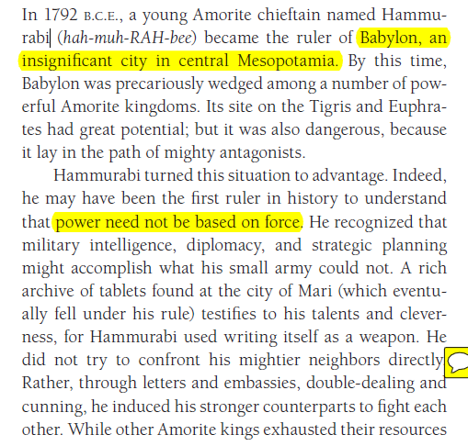

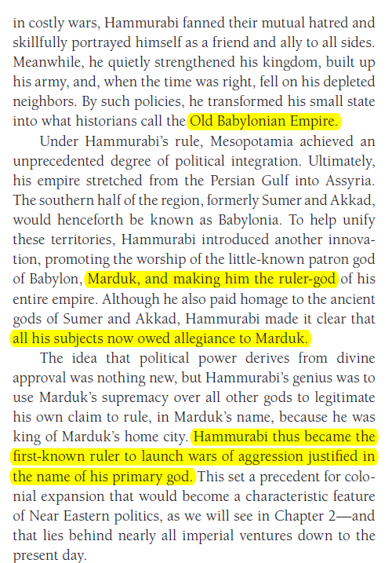

#### CONCLUSIONS Cole-Symes p. 36 ch1

CONCLUSION

While the story of Babel records the legendary loss of a shared

language, this chapter shows that people of the distant past

can still communicate with us. The marks they have left on

the landscape, the remains of their daily lives, their written

records, and their very bodies make it possible for historians

to piece together evidence and to make sense of it. And every

year new sources come to light, meaning that we have to

be ready to **revise—constantly—our understanding of what**

**happened in the past**.

Although this chapter has emphasized the differences

between the early civilizations of Mesopotamia and

Egypt, it is worth noting some significant similarities.

Both developed **the fundamental technologies of writing**

**at about the same time, and this facilitated political alliances,**

**long-distance trade, and the transmission of vital**

**information to ??? posterity.** **During the third millennium,**

both underwent a process of political consolidation, an

elaboration of religious ritual, and a melding of spiritual

and political leadership. Both engaged in massive building

and irrigation projects, and both commanded material

and human resources on an enormous scale. At the

same time, each of these civilizations cultivated an inward

focus. Although they had some contact with each other,

and some transfers of information and technology probably

took place, there were few significant political or cultural

interactions. For the most part, they inhabited separate

worlds. This relative isolation was about to change, however.

**The next millennium (3000-2000) would see the emergence of**

large-scale, land-based empires in the Near East that would

transform life in Mesopotamia, Egypt, and the lands that

lay between them. These are the developments we examine

in Chapter 2.

#### ΕΡΩΤΗΣΗ για λιγους ?

ΣΑΡΚΟΒΟΡΑ ΒΡΩΣΙΜΑ υπαρχουν ?

## GLOSSARY,

Transliterated, to represent or spell in the characters of another alphabet

Arguably=a statement is very possibly true even if it is not certainly true, πιθανοτατα,

Fertile Cresent, ευφορος ημισελινοσ

Crescent, croissant,

# Τα Μαθηματικα των ΑΡΙΘΜΗΤΙΚΩΝ ΣΥΣΤΗΜΑΤΩΝ,

,

## ΓΕΝΙΚΟΤΗΤΕΣ,

Τα παρακατω είναι από το βιβλιο του Α ΓΙΑΝΝΟΠΟΥΛΟΥ, ΑΠΕΙΡΟΣΤΙΚΟΣ ΛΟΓΙΣΜΟΣ τομος Α.

Giannop p. 2

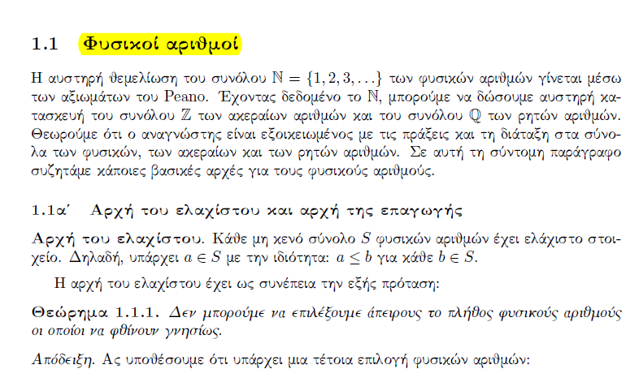

ΟΡΙΣΜΟΣ. Ζ+ είναι NU{0},

Giannop p. 2

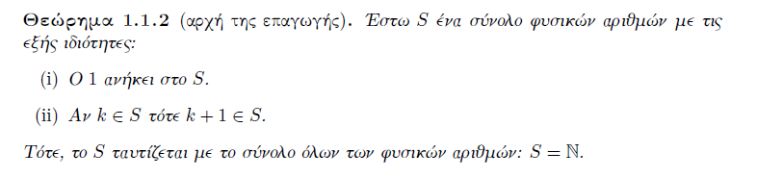

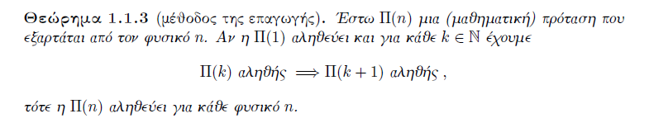

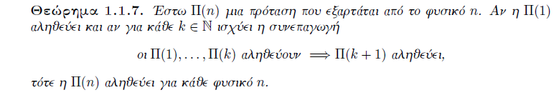

To παραπανω θεώρημα το ονομαζουμε «ΕΠΑΓΩΓΗ του ΕΛΑΧΙΣΤΟΥ»,

## ΤΑΥΤΟΤΗΤΑ ΤΗΣ ΔΙΑΙΡΕΣΗΣ, ΤΑΥΤΟΤΗΤΑ του ΕΥΚΛΕΙΔΗ,

GIANOP p. 5

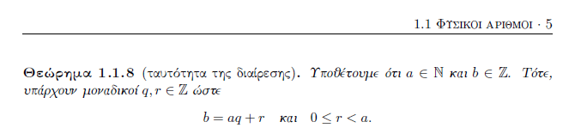

ΑΠΟΔΕΙΞΙΣ ΥΠΑΡΞΗΣ.

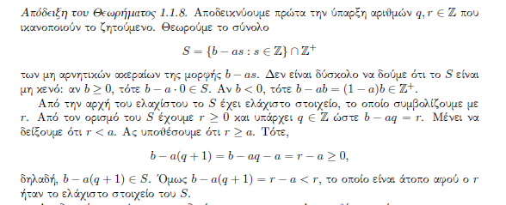

ΑΠΟΔΕΙΞΙΣ ΜΟΝΟΣΗΜΑΝΤΟΥ,

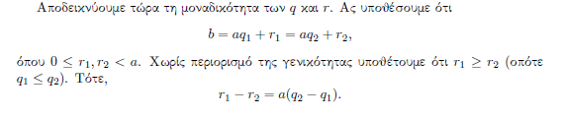

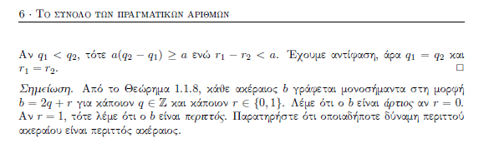

Τα παραπανω ΔΕΝ ευρισκουν τα q, r, **απλως αποδεικνουν ότι υπαρχουν**.