11 ΔΙΑΛΕΞΗΣ,

Σαββατον 05-04-2025

Webex meeting recording: 10 INM-20250405 sabbaton

Password: Er6va3uy

Recording link: <https://uoa.webex.com/uoa/ldr.php?RCID=04674f45977d6c072eb22120e83873db>,

**ΕΝΗΜΕΡΩΣΙΣ,**

Ξεκιναμε με εργασιες 1006babel, 1007schoolathenssexism

Προετοιμασια για τα ΜΙΓΑΔΙΚΑ. 4001, 5001, erxomewno sabbato

# ΑΡΙΘΜΗΤΙΚΑ ΣΥΣΤΗΜΑΤΑ ΠΟΛΙΤΙΣΜΩΝ,

## ΜΕΣΟΠΟΤΑΜΙΑ,

### ΓΕΝΙΚΗ ΘΕΩΡΗΣΗ τησ ΜΕΣΟΠΟΤΑΜΙΑΣ,

GOTO KATZ p.10,

The Mesopotamian civilization is perhaps a bit older than the Egyptian, having developed in the Tigris and Euphrates River **valley beginning sometime in the fifth millennium bce.** Many different governments ruled this region over the centuries.

Initially, there were many small city-states, but then the area was unified under a **dynasty from Akkad**, which lasted from approximately 2350 to 2150 bce. Shortly thereafter, the Third Dynasty of Ur rapidly expanded until it controlled most of southern Mesopotamia. This dynasty produced a very centralized bureaucratic state. In particular, it created a large system of scribal schools to train members of the bureaucracy. Although the Ur Dynasty collapsed around 2000 bce, the small city-states that succeeded it still demanded numerate scribes.

By 1750 bce, (περιπου 1800π.Χ), Hammurabi, the ruler of (old) Babylon, one of these city-states, had expanded his rule to much of Mesopotamia and instituted a legal system to help regulate his empire (Fig. 1.6).

### Hammurabi, ΧΑΜΟΥΡΑΜΠΙ, ΝΟΜΟΘΕΤΗΣ, ΠΟΛΙΤΙΚΟΣ,

Κκ ΧΑΜΜΟΥΡΑΜΠΙ,

**Hammurabi also spelled Hammurapi,** was the sixth Amorite king of the Old Babylonian Empire, **reigning from c. 1792 to c. 1750 BC.**

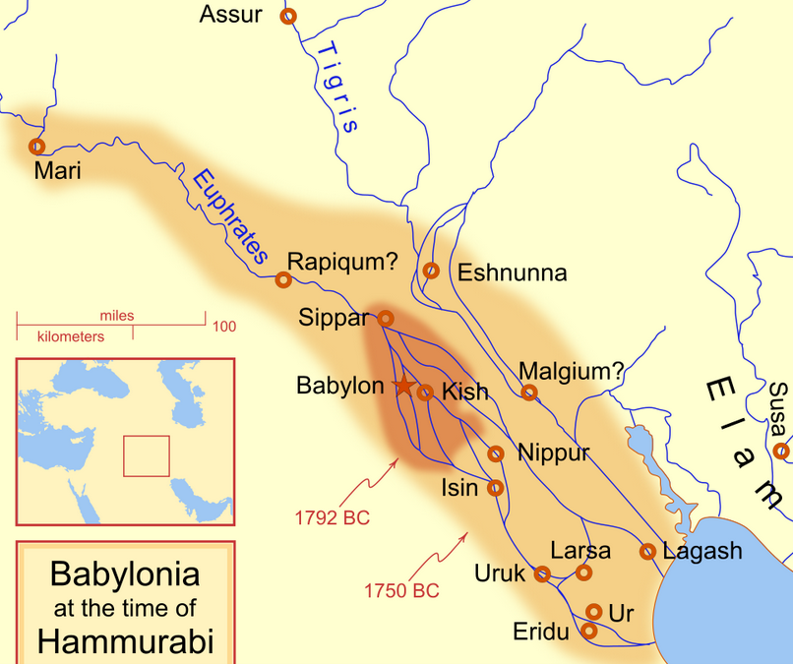

Map showing the Babylonian territory upon Hammurabi's ascension in c. 1792 BC and upon his death in c. 1750 BC. <https://en.wikipedia.org/wiki/Hammurabi>,

PERSIAN GULF,

Strait (πορθμος) of Hormuz. STRAIT, a narrow passage of water connecting two seas or two other large areas of water.

Ο πορθμός είναι ναυτικός γεωγραφικός όρος, με τον οποίο χαρακτηρίζεται η φυσική στενή λωρίδα θάλασσας που χωρίζοντας δύο στεριές ενώνει δύο μεγαλύτερες θάλασσες. Είναι ιδιαίτερος όρος του αμφίγειου. Οι πορθμοί άλλοτε είναι πολύ μακρείς και άλλοτε δαιδαλώδεις. <https://el.wikipedia.org/wiki/%CE%A0%CE%BF%CF%81%CE%B8%CE%BC%CF%8C%CF%82>,

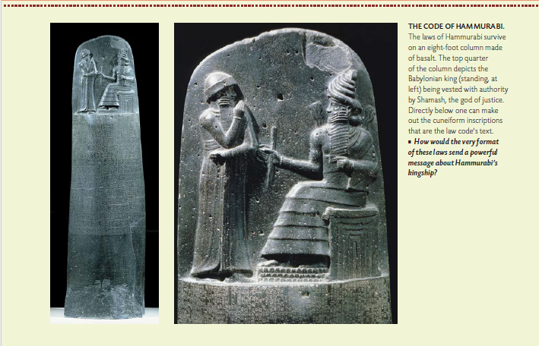

ColeSymes, p 18,

Hammurabi (standing) receiving his royal insignia from Shamash θεος δικαιοσυνης (or possibly Marduk, ο μειζων θεοσ)

Code of Hammurabi, king of Babylon; front, bas-relief.

Bas-relief. Relief sculpture—sculpture that projects in varying degrees from a two-dimensional background—has a distinguished history dating back over 20,000 years in Eastern and Western cultures. Alto-relievo (high relief) approaches three dimensions while bas-relief (low relief) at times is more akin to two-dimensional drawing.

The term relief is from the Latin **verb relevare,** to raise (lit. to lift back). To create a sculpture in relief is to give the impression that the sculpted material has been raised above the background plane.

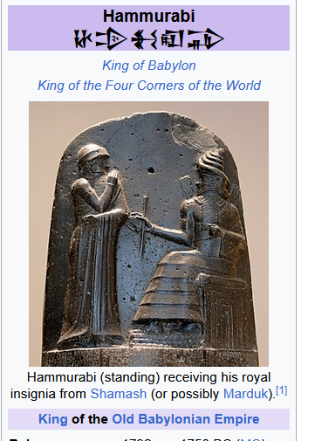

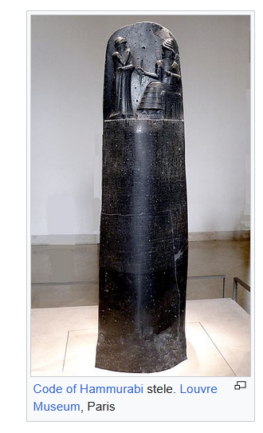

<https://en.wikipedia.org/wiki/Hammurabi>,

Code of Hammurabi stele. Louvre Museum, Paris. <https://en.wikipedia.org/wiki/Hammurabi>,

Because of Hammurabi's reputation as a lawgiver, his depiction can be found in law buildings throughout the world. Hammurabi is one of the **23 lawgivers depicted in marble bas-reliefs in the chamber of the U.S. House of Representatives** in the United States Capitol.[34] A frieze by Adolph Weinman depicting the "great lawgivers of history", including Hammurabi, is on the south wall of the U.S. Supreme Court building.[35][36]. <https://en.wikipedia.org/wiki/Hammurabi>,

#### 23 lawgivers depicted in marble bas-reliefs in the chamber of the U.S. House of Representatives in the United States Capitol,

<https://www.aoc.gov/explore-capitol-campus/art/relief-portrait-plaques-lawgivers>,

The 23 marble relief portraits over the gallery doors of the House Chamber in the U.S. Capitol depict historical figures noted for their work in establishing the principles that underlie American law. They were installed when the chamber was remodeled in 1949-1950. Created in bas relief of white Vermont marble by seven different sculptors, the plaques each measure 28 inches in diameter.

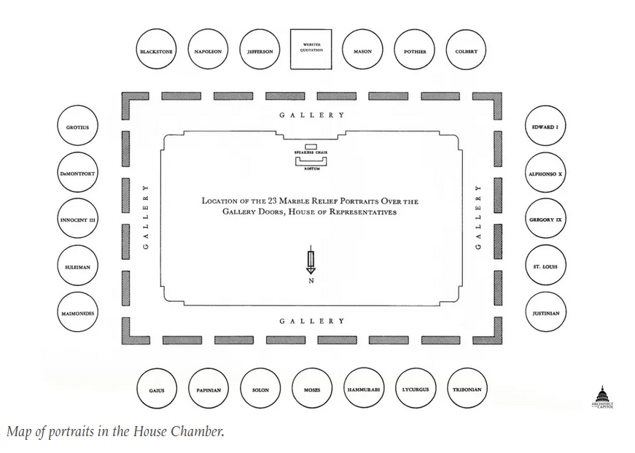

The 11 profiles in the eastern half of the chamber face left and the 11 in the western half face right, so that all look towards the **full-face relief of Moses** in the center of the north wall.

The subjects of the reliefs were chosen by scholars from the University of Pennsylvania and the Columbia Historical Society of Washington, D.C., in consultation with authoritative staff members of the Library of Congress. The selection was approved by a special committee of five Members of the House of Representatives and the Architect of the Capitol.

The plaster models for these reliefs are on display on the walls in the Rayburn House Office Building subway terminal.

LIST OF THE 23,

Alfonso X

Edward I

Gaius

George Mason

Gregory IX

**Hammurabi**

Hugo Grotius

Innocent III

Jean Baptiste Colbert

Justinian I

**Lycurgus**

Maimonides

Moses

**Napoleon I**

Papinian

Robert Joseph Pothier

Saint Louis

Simon de Montfort

**Solon**

**Suleiman**

Thomas Jefferson. All men were created equal !

<https://en.wikipedia.org/wiki/All_men_are_created_equal>,

Thomas Jefferson during the beginning of the Revolutionary War in 1776.[1] It reads:

"We hold these truths to be self-evident, that all men are created equal, that they are endowed by their Creator with certain unalienable Rights, that among these are Life, Liberty and the pursuit of Happiness."

Tribonian

Sir William Blackstone

#### HAMMURABI ΠΟΛΙΤΙΚΟΣ,

ColeSymes, p. 18

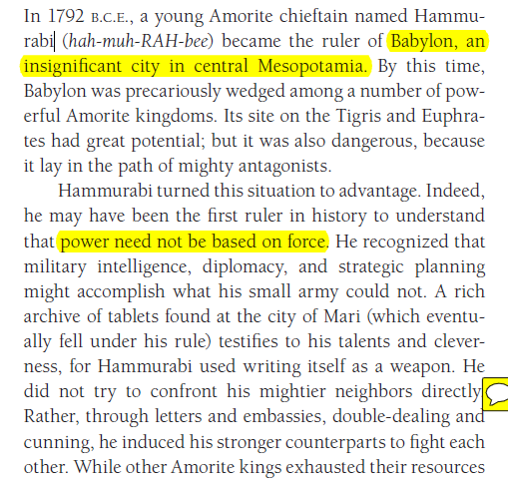

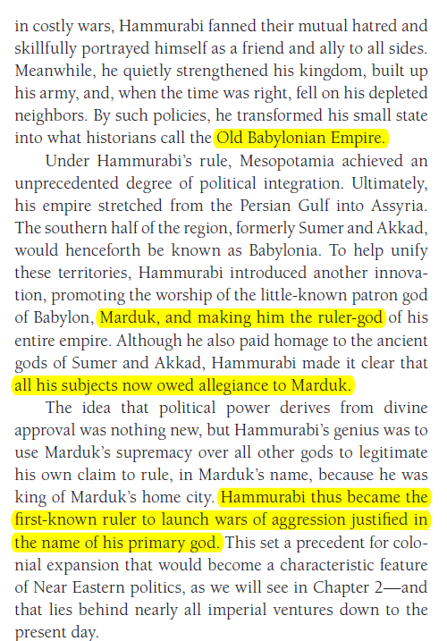

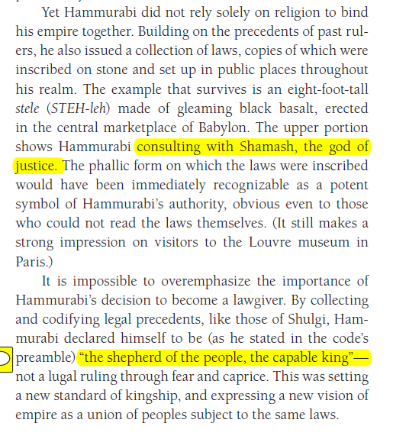

#### CODE OF HAMMURABI

<https://en.wikipedia.org/wiki/Code_of_Hammurabi>,

The Code of Hammurabi is a well-preserved Babylonian code of law of ancient Mesopotamia, dated back to about 1754 BCE (Middle Chronology). It is one of the oldest deciphered writings of significant length in the world. The sixth Babylonian king, Hammurabi, enacted the code. A partial copy exists on a 2.25 metre (7.5 ft) stone stele. It consists of 282 laws, with scaled punishments, adjusting "**an eye for an eye, a tooth for a tooth**" (lex talionis)[1] (talionis, retaliation ), as graded depending on social status, of slave versus free, man or woman.[2]

<https://en.wikipedia.org/wiki/Hammurabi>,

Hammurabi is best known for having issued the Code of Hammurabi, which he claimed to have received **from Shamash, the Babylonian god of justice**. Unlike earlier Sumerian law codes, such as the Code of Ur-Nammu, which had focused on compensating the victim of the crime, (είναι δικαιοτερο ?)the Law of Hammurabi was one of the first law codes **to place greater emphasis on the physical punishment of the perpetrator.** It prescribed specific penalties for each crime **and is among the first codes to establish the presumption of innocence.** They were intended to limit what a wronged person was permitted to do in retribution. **The Code of Hammurabi and the Law of Moses in the Torah contain numerous similarities**.

#### A Mathematician’s Apology, G. H. Hardy, : Hammurabi has perished ?

**p. 11,**

If intellectual curiosity, professional pride, and ambition are the dominant incentives **to research**, then assuredly no one has a fairer chance of satisfying them than a mathematician. His subject is the most curious of all—there is none in which **truth plays such odd pranks**. It has the most elaborate and the most fascinating technique, and gives unrivalled openings for the display of sheer professional skill. Finally, as history proves abundantly, mathematical achievement, **whatever its intrinsic worth**, **is the most enduring** of all. We can see this even in semi-historic civilizations. The Babylonian and Assyrian civilizations have perished; Hammurabi, Sargon, and Nebuchadnezzar are empty names; yet Babylonian mathematics is still interesting, and the Babylonian scale of 60 is still used in astronomy. But of course the crucial case is that of the Greeks.

The Greeks were the first mathematicians who are still ‘real’ to us to-day. Oriental mathematics may be an interesting curiosity, but Greek mathematics is the real thing. The Greeks first spoke a language which modern mathematicians can understand: as Littlewood said to me once, they are not clever schoolboys or ‘scholarship candidates’, but ‘Fellows of another college’. So Greek mathematics is ‘permanent’, more permanent even than Greek literature. **Archimedes** will be remembered when **Aeschylus** is forgotten, because languages die and mathematical ideas do not. ‘Immortality’ may be a silly word, but probably a mathematician

has the best chance of whatever it may mean.

##### ΣΧΟΛΙΑ,

«3 best british mathematicians, HARDY, LITTLEWOOD and HARDY, LITTLEWOOD»,

### ΑΣΤΡΟΝΟΜΙΑ ΒΑΒΥΛΩΝΙΩΝ

ΜΟΙΡΕΣ, ΛΕΠΤΑ, ΔΕΥΤΕΡΟΛΕΠΤΑ, κλπ

??? ΠΡΟΒΛΕΨΕΙΣ ΕΚΛΗΨΕΩΝ ΣΕΛΗΝΗΣ,

Journal for the History of Astronomy

Lunar Eclipse Times Predicted by the Babylonians

J. M. Steele, F. R. Stephenson

First Published May 1, 1997 Research Article

<https://en.wikipedia.org/wiki/History_of_astronomy#cite_ref-dp1998_17-0>, History of astronomy

Astronomy is the oldest of the natural sciences, dating back to antiquity, **with its origins in the religious, mythological, cosmological, calendrical, and astrological beliefs and practices of prehistory**: vestiges of these are still found in astrology, a discipline long interwoven with public and governmental astronomy, and not completely disentangled from **it until a few centuries ago in the Western World** (see astrology and astronomy). In some cultures, astronomical data was used for astrological prognostication.

**Ancient astronomers were able to differentiate between stars and planets, as stars remain relatively fixed over the centuries while planets will move an appreciable amount during a comparatively short time**.

**The origins of Western astronomy can be found in Mesopotamia, the "land between the rivers" Tigris and Euphrates, where the ancient kingdoms of Sumer, Assyria, and Babylonia were located.**

**A form of writing known as cuneiform (ΣΦΗΝΟΕΙΔΗΣ), emerged among the Sumerians around 3500–3000 BC**. Our knowledge of Sumerian astronomy is indirect, via the earliest Babylonian star catalogues dating from about 1200 BC. The fact that many star names appear in Sumerian suggests a continuity reaching into the Early Bronze Age. Astral theology, which gave planetary gods an important role in Mesopotamian mythology and religion, began with the Sumerians. **They also used a sexagesimal (base 60) place-value number system,** which simplified the task of recording very large and very small numbers. **The modern practice of dividing a circle into 360 degrees, of 60 minutes each, began with the Sumerians**. For more information, see the articles on Babylonian numerals and mathematics.

**Babylonian astronomy was the basis for much of what was done in Greek and Hellenistic astronomy, in classical Indian astronomy, in Sassanian Iran, in Byzantium, in Syria, in Islamic astronomy, in Central Asia, and in Western Europe**.( Pingree, David (1998), "Legacies in Astronomy and Celestial Omens", in Dalley, Stephanie, The Legacy of Mesopotamia, Oxford University Press, pp. 125–137, ISBN 0-19-814946-8.)