12 ΔΙΑΛΕΞΙΣ,

Kyriakh 06-04-2025,

Webex meeting recording: 12 INM-20250406 kyriakh

Password: pPENXcQ6

Recording link: <https://uoa.webex.com/uoa/ldr.php?RCID=03ea39b972a6cc7d3f968a04e2460309>,

**ΕΝΗΜΕΡΩΣΙΣ,**

Το ερχομενο σαββατο θα συζητηθουν

ΜΙΓΑΔΙΚΑ. 4001, 5001, δηλωθηκε στο προηγουμενο μαθημα

, erxomewno sabbato 3001 κατασκ σομα, 3002 ριζες, 3003 π,

### ΑΡΙΘΜΟΙ,

#### INFO

**Cuneus (ΣΦΗΝΑ),** comprises the Latin root of cuneiform, which means wedge (ΣΦΗΝΑ, **ΣΦΗΝΟΕΙΔΗΣ ΓΡΑΦΗ**), ). A triangular reed (ΚΑΛΑΜΟΣ) or stylus was used to form cuneiform signs in wet clay. Clay tablets (πλακιδιον η πινακιδα, από πηλο), were then dried in the sun to permanently fix the writing (Fairbank, 1970). **Sumerian cuneiform existed as the first written language.**

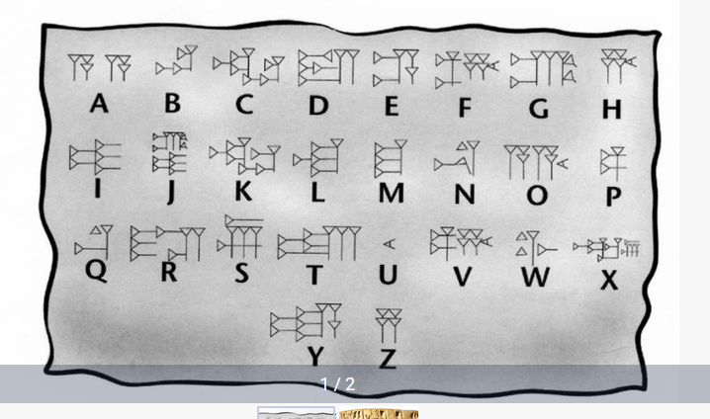

Cuneiform script - world’s first ever writing system,

<https://azertag.az/en/xeber/Cuneiform_script___worlds_first_ever_writing_system-2106473>,

#### Cuneiform script,

Go BURTON p. 20

BURTON, p. 24,

#### ΒΑΒΥΛΩΝΙΑΚΟΙ ΑΡΙΘΜΟΙ,

##### Babylonian numerals

<https://mathshistory.st-andrews.ac.uk/HistTopics/Babylonian_numerals/>,

The Babylonian civilisation in Mesopotamia replaced the Sumerian civilisation and the Akkadian civilisation. We give a little historical background to these events in our article Babylonian mathematics. Certainly in terms of their number system the Babylonians inherited ideas from the Sumerians and from the Akkadians. From the number systems of these earlier peoples came the base of 60, that is the sexagesimal system. Yet neither the Sumerian nor the Akkadian system was a **positional system** and this advance by the Babylonians was undoubtedly their greatest achievement in terms of developing the number system. **Some would argue that it was their biggest achievement in mathematics**.

Often when told that the Babylonian number system was base 60 people's first reaction is: what a lot of special number symbols they must have had to learn. Now of course this comment is based on knowledge of our own decimal system which is a positional system with nine special symbols and a zero symbol to denote an empty place. However, rather than have to learn 10 symbols as we do to use our decimal numbers**, the Babylonians only had to learn two symbols** to produce their base 60 positional system.

Now although the Babylonian system was a positional base 60 system, it had some vestiges of a base 10 system within it. This is because the 59 numbers, which go into one of the places of the system, were **built from a 'unit' symbol and a 'ten' symbol**.

Here are the 59 symbols built from these two symbols

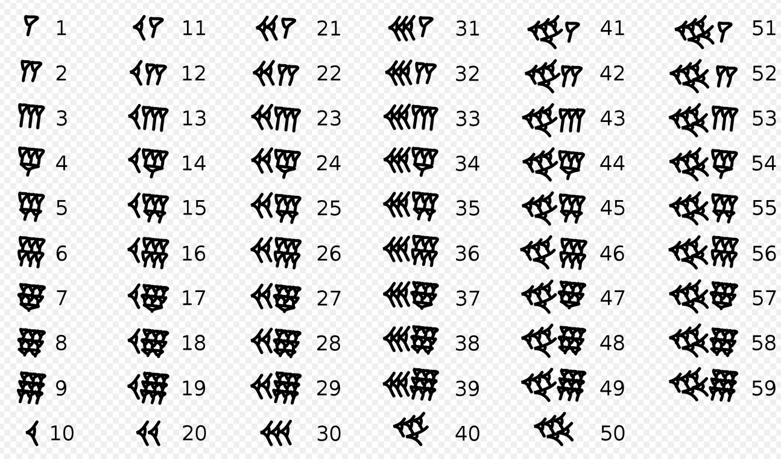

Here is 1,57,46,40 in Babylonian numerals

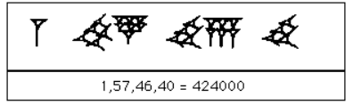

##### METHODS OF COMPUTATION,

GOTO KATZ p.12,

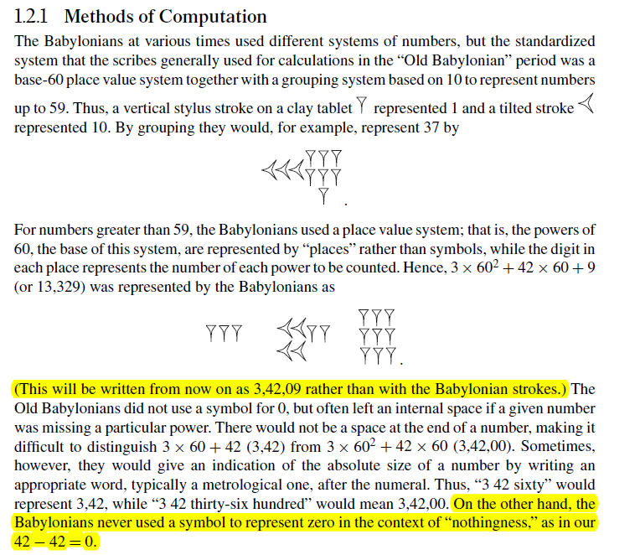

Ηταν PLACE VALUE SYSTEM. THERE was nο ZERO,

Tilted, move or cause to move into a sloping position.

Katz p. 12,

number system was a **place value system**, the actual algorithms for addition and subtraction, including carrying and borrowing, **may well have been similar to modern ones.** For example, to add 23,37 (= 1417) to 41,32 (= 2492), one first adds 37 and 32 to get 1,09 (= 69). One writes down 09 and carries 1 to the next column. Then 23+ 41+ 1= 1, 05 (= 65), and the final result is 1,05,09 (= 3909).

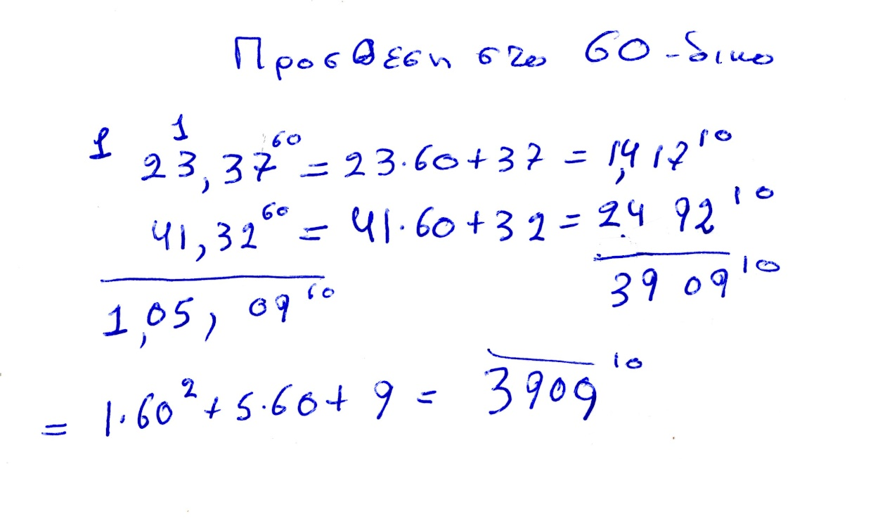

### ΣΥΜΠΛΗΡΩΜΑΤΑ,

#### **Lycurgus, Solon,**

**Lycurgus,**

Lycurgus (/laɪˈkɜːrɡəs/; ‹See Tfd›Greek: Λυκοῦργος Lykourgos) was the legendary lawgiver of Sparta, credited with the formation of its eunomia ('good order'),[1] involving political, economic, and social reforms to produce a military-oriented Spartan society in accordance with the Delphic oracle. The Spartans in the historical period honoured him as god.[2]

As a historical figure, almost nothing is known for certain about him, including when he lived and what he did in life. The stories of him place him at multiple times. Nor is it clear when the political reforms attributed to him, called the Great Rhetra, occurred. Ancient dates range from – putting aside the implausibly early Xenophonic 11th century BC – **the early ninth century (c. 885 BC) to as late as early eighth century (c. 776 BC).** There remains no consensus as to when he lived; some modern scholars deny that he existed at all.

**Solon (‹See Tfd›Greek: Σόλων; c. 630 – c. 560 BC)[1]**

was an archaic Athenian statesman, lawmaker, political philosopher, and poet. He is one of the Seven Sages of Greece and credited with laying the foundations for Athenian democracy.[2][3][4] Solon's efforts to legislate against political, economic and moral decline[5] resulted in his constitutional reform overturning most of Draco's laws.

Solon's reforms included debt relief later known and celebrated among Athenians as the seisachtheia (shaking off of burdens). He is described by Aristotle in the Athenian Constitution as "the first people's champion". Demosthenes credited Solon's reforms with starting a golden age.

Modern knowledge of Solon is limited by the fact that his works only survive in fragments and appear to feature interpolations by later authors. It is further limited by the general paucity of documentary and archaeological evidence covering Athens in the early 6th century BC.[6]

#### <https://en.wikipedia.org/wiki/Eleanor_Robson>,

συσταση δ. λαππα, .

**Eleanor Robson**, FBA (born 1969) is a British Assyriologist and academic. She is Professor of Ancient Middle Eastern History at University College London. She is a former chair of the British Institute for the Study of Iraq and a Quondam fellow of All Souls College, Oxford.[1] She is a Fellow of the British Academy.[2]

##### <https://motivate.maths.org/content/BabylonianMaths/>,

Babylonian Maths

4000 years ago, children in school were learning maths just as they do now. But what maths did they learn and how did they learn it? In this resource pack, Dr Eleanor Robson, shows us how we can find out about an ancient civilisation through the objects they left behind.

#### ΠΟΛΛΑΠΛΑΣΙΑΣΜΟΣ

Goto katz p. 13,

Because the place value system was based on 60, the multiplication tables were extensive. Any given one listed the multiples of a particular number, say, 9, from 1× 9 to 20 × 9 and then gave 30 × 9, 40 × 9, and 50 × 9 (Fig. 1.9). If one needed the product 34 × 9, one simply added the two results 30 × 9 = 4, 30 (= 270) and 4 × 9 = 36 to get 5,06 (= 306). For multiplication of two- or three-digit sexagesimal numbers, one needed to use several such tables. The exact algorithm the Babylonians used for such multiplications—where the partial products are written and how the final result is obtained—is not known, but it may well have been similar to our own.

One might think that for a complete system of tables, the Babylonians would have one for each integer from 2 to 59. Such was not the case, however. In fact, although there are no tables for 11, 13, 17, for example, there are tables for 1,15, 3,45, and 44,26,40. We do not know precisely why the Babylonians made these choices;

## ΑΙΓΥΠΤΟΣ,

### ΓΕΝΙΚΟΤΗΤΕΣ

Hecataeus and Herodotus on "A Gift of the River"

Author(s): J. Gwyn Griffiths

Source: Journal of Near Eastern Studies, Vol. 25, No. 1 (Jan., 1966), pp. 57-61

Published by: University of Chicago Press

Stable URL: http://www.jstor.org/stable/543141

Accessed: 27-11-2015 08:57 UTCHECATAEUS AND HERODOTUS ON "A GIFT OF THE RIVER"1

**IT may be questioned whether a geography lesson on Egypt is ever given anywhere without including the statement that "Egypt is the gift of the Nile."** The earliest recorded verbal form of this statement appears in Herodotus, 2. 5:

HEEODOTUS, WITH AN ENGLISH TRANSLATION BY

A. GODLKY, HON. FELLOW OF MAGDALEN COLLEGE, OXFORD

IN FOUR VOLUMES

Vol1, BOOKS I AKP II,

p. 279-282,

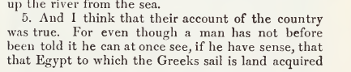

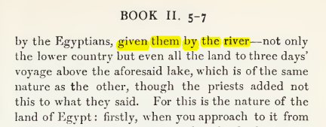

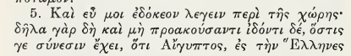

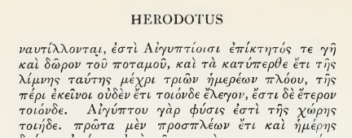

ΣΓΠ. O ΗΡΟΔΟΤΟΣ βλεπει την ΑΙΓΥΠΤΟ με σεβασμο, αλλα την θεωρει κουρασμενο πολιτισμο.

Map of ancient Egypt, showing major cities and sites of the Dynastic period (c. 3150 BC to 30 BC)

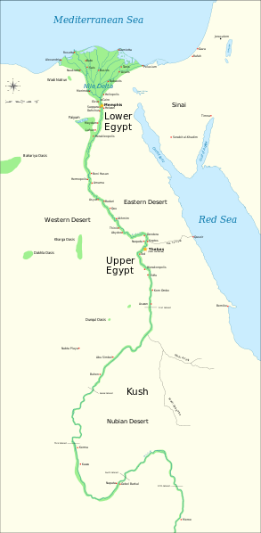

<https://en.wikipedia.org/wiki/File:Ancient_Egypt_map-en.svg>,

<https://en.wikipedia.org/wiki/Cradle_of_civilization#/media/File:Ancient_Egypt_map-en.svg>,

#### GOTO Katz, Victor J. A history of mathematics 3rd ed. p. 2

**Agriculture emerged in the Nile Valley in Egypt close to 7000 years ago**,

but the first dynasty to rule both Upper Egypt (the river valley) and Lower Egypt (the delta) dates from about 3100 bce (c 3000). The legacy of the first pharaohs included an elite of officials and priests, a luxurious court, and for the kings themselves, a role as intermediary between mortals and gods. This role fostered the development of Egypt’s monumental architecture, including the pyramids, built as royal tombs, and the great temples at Luxor and Karnak. Writing began in Egypt at about this time, and much of the earliest writing concerned accounting, primarily of various types of goods. There were several different systems of measuring, depending on the particular goods being measured. But since there were only a limited number of signs, the same signs meant different things in connection with different measuring systems. From the beginning of Egyptian writing, there were two styles, the hieroglyphic writing for monumental inscriptions and the hieratic, or cursive, writing, done with a brush and ink on papyrus.

(REMARK. First coined 1726, from French hiéroglyphique, from Latin hieroglyphicus, from Ancient Greek ἱερογλυφικός (hierogluphikós), from ἱερογλυφέω (hierogluphéō, “to represent hieroglyphically”), from ἱερός (hierós, “sacred, holy”) + γλύφω (glúphō, “to carve (κοβω), to engrave (χαραζω) , to cut out”). By surface analysis, hiero- +‎ glyphic.

Greek domination of Egypt in the centuries surrounding the beginning of our era was responsible for the disappearance of both of these native Egyptian writing forms. Fortunately**, Jean Champollion (1790–1832)** was able to begin the process of understanding Egyptian writing early in the nineteenth century through the help of a multilingual inscription—the Rosetta stone—**in hieroglyphics** and **Greek** as well as the later **demotic writing**, a form of the hieratic writing of the papyri (Fig. 1.1).

**It was the scribes who fostered the development of the mathematical techniques. These government officials were crucial to ensuring the collection and distribution of goods, thus helping to provide the material basis for the pharaohs’ rule** (Fig. 1.2).

Thus, evidence for the techniques comes from the education and daily work of the scribes, particularly as related in two papyri containing collections of mathematical problems with their solutions, the *Rhind Mathematical Papyrus*, named for the Scotsman A. H. Rhind (1833–1863) who purchased it at Luxor in 1858,

(Rhind Mathematical Papyrus. The British Museum, where the majority of the papyrus is now kept, acquired it in 1865 along with the Egyptian Mathematical Leather Roll, also owned by Henry Rhind.[2])

and the *Moscow Mathematical Papyrus*, purchased in 1893 by V. S. Golenishchev (d. 1947) who later sold it to the Moscow Museum of Fine Arts.

**The former papyrus (RHIND) was copied about 1650 bce** by the scribe A’h-mose from an original about 200 years older and is approximately 18 feet long and 13 inches high.

**The latter papyrus (MOSCOW) dates** from roughly the same period and is over 15 feet long, but only some 3 inches high. Unfortunately, although a good many papyri have survived the ages due to the generally dry Egyptian climate, it is the case that papyrus is very fragile. Thus, besides the two papyri mentioned, only a few short fragments of other original Egyptian mathematical papyri are still extant. These two mathematical texts inform us first of all about the types of problems that needed to be solved. **The majority of problems were concerned with topics involving the administration of the state**. That scribes were occupied with such tasks is shown by illustrations found on the walls of private tombs. Very often, in tombs of high officials, scribes are depicted working together, probably in accounting for cattle or produce. Similarly, there exist three dimensional models representing such scenes as the filling of granaries, and these scenes always include a scribe to record quantities. Thus, it is clear that Egyptian mathematics was developed and practiced in this practical context. One other area in which mathematics played an important rolewas architecture. Numerous remains of buildings demonstrate that mathematical techniques were used both in their design and construction. Unfortunately, there are few detailed accounts of exactly how the mathematics was used in building, so we can only speculate about many of the details. We deal with a few of these ideas below.

### ΣΧΕΣΗΣ ΕΛΛΗΝΙΚΩΝ ΚΑΙ ΑΙΓΥΠΤΙΑΚΩΝ ΜΑΘΗΜΑΤΙΚΩΝ,

#### COOKE ROGER. The history of mathematics : a brief course, 3rd edition. Wiley 2013,

**7.2. GEOMETRY**

The most fascinating aspect of Egyptian mathematics is the application of these computational techniques to geometry. In Section 109 of Book 2 of his *History*, **the Greek historian Herodotus writes that King Sesostris1 dug a multitude of canals to carry water to the arid parts of Egypt. He goes on to connect this Egyptian engineering with Greek geometry:**

SGP. “brackish (brackish /ˈbrakɪʃ/ adjective: brackish,

(of water) slightly salty, water from wells.)

109. For this cause Egypt was intersected. This king moreover (so they said) divided the country among all the Egyptians by giving each an equal square parcel of land, and made this his source of revenue, appointing the payment of a yearly tax.

And any man who was robbed by the river of a part of his land would come to Sesostris and declare what had befallen him ; then the king would send

men to look into it and measure the space by which the land was diminished, so that thereafter it should pay in proportion to the tax originally imposed. **From this, to my thinking, the Greeks learnt the art of measuring land ; the sunclock and the sundial, and the twelve divisions of the day, came to Hellas not from Egypt but from Babylonia.”**

**Sunclock**

**Sunclock**

[**https://sunclock.ch**](https://sunclock.ch)**,**

**Astronomical clock for sunrise, sunset, moon, temporal hours and daily and yearly rhythms.**

SUNDIAL, Wikipedia,

an instrument showing the time by the shadow of a pointer cast by the sun on to a plate marked with the hours of the day.

<https://en.wikipedia.org/wiki/File:Melbourne_sundial_at_Flagstaff_Gardens.JPG>,

Melbourne_sundial_at_Flagstaff_Gardens.JPG.

#### ARISTOTLE,

##### ARISTOTLE, KATZ p. 35

Fortunately for us, most of the early Greek mathematics we will discuss involves little calculation. As Aristotle wrote in his *Metaphysics*, At first, he who invented any art whatever that went beyond the common perceptions of man was naturally admired by men, not only because there was something useful in the inventions, but because he was thought wise and superior to the rest. But as more arts were invented, and some were directed to the necessities of life, **others to recreation**, the inventors of the latter were naturally always regarded as wiser than the inventors of the former, because their branches of knowledge did not aim at utility. Hence when all such inventions were already established, the sciences which do not aim at giving pleasure or at the necessities of life were discovered, and first in the places where men first began to have leisure. This is why the mathematical arts were founded in Egypt; for there the priestly caste was allowed to be at leisure.4. ?? Είναι ετσι ?

Although Aristotle referred only to Egypt, he certainly believed that in Greece as well

mathematics was the province of a leisured class, people who did not deal with such mundane matters as measurement or accountancy problems. Thus, in Greece as in Egypt and Mesopotamia, mathematics of the type we will discuss in this chapter and the next was the province of a very limited group of people, virtually all of whom were part of the **ruling groups**. As we will see, this theoretical mathematics was to be a central part of the education

of the rulers of the state.