13 ΔΙΑΛΕΞΙΣ,

ΣΑΒΒΑΤΟΝ 12-04-2025,

Webex meeting recording: 13 INM-20250412 sabato lazarou

Recording link: https://uoa.webex.com/uoa/ldr.php?RCID=9522c7c4dfc5ba654e58e62d79b44b69

Password: PyPJm7Cu,

**ΠΡΟΚΑΤΑΡΚΤΙΚΑ,**

Ξεκιναμε με επαναληψη του 12 διαλεξις,

ΕΡΓΑΣΙΕΣ ξεκιναμε 3001-3, τελικα αναβληθησασ

**ΕΠΑΝΑΛΗΨΙΣ 12 διαλεξης κλπ**

11 διαλεξις, HAMMURABI ΠΟΛΙΤΙΚΟΣ

12 διαλεξις, ΑΡΙΘΜΟΙ βαβυλωνιων, ΣΧΕΣΗΣ ΕΛΛΗΝΙΚΩΝ ΚΑΙ ΑΙΓΥΠΤΙΑΚΩΝ ΜΑΘΗΜΑΤΙΚΩΝ,

##### AristotleMetaphysicsRossWilliamDavid, p 3-4

English translation

Again, we do not regard any of the senses as Wisdom; yet surely these give the most authoritative knowledge of particulars. But they do not tell us the 'why' of anything-e.g. why fire is hot; they only say that it is hot.

At first he who invented any art whatever that went beyond the common perceptions of man was naturally admired by men, not only because there was something useful in the inventions, but because he was thought wise and superior to the rest. But as more arts were invented, and some were directed to the necessities of life, others to recreation, **the inventors of the latter were naturally always regarded as wiser than the inventors of the former,** because their branches of knowledge did not aim at utility. Hence when all such inventions were already established, the sciences which do not aim at giving pleasure or at the necessities of life were discovered, and first in the places where men first began to have leisure**. This is why the mathematical arts were founded in Egypt; for there the priestly caste was** allowed to be at leisure.

Greek original, Bekker page 981a, line 25

… ἔτι δὲ τῶν αἰσθήσεων οὐδεμίαν ἡγούμεθα εἶναι σοφίαν·

καίτοι κυριώταταί γ' εἰσὶν αὗται τῶν καθ' ἕκαστα γνώσεις· ἀλλ'

οὐ λέγουσι τὸ διὰ τί περὶ οὐδενός, οἷον διὰ τί θερμὸν τὸ πῦρ,

ὁποιανοῦν εὑρόντα τέχνην παρὰ τὰς κοινὰς αἰσθήσεις θαυ-

μάζεσθαι ὑπὸ τῶν ἀνθρώπων μὴ μόνον διὰ τὸ χρήσιμον

εἶναί τι τῶν εὑρεθέντων ἀλλ' ὡς σοφὸν καὶ διαφέροντα τῶν

ἄλλων· πλειόνων δ' εὑρισκομένων τεχνῶν καὶ τῶν μὲν

πρὸς τἀναγκαῖα τῶν δὲ πρὸς διαγωγὴν οὐσῶν, ἀεὶ σοφωτέ-

ρους τοὺς τοιούτους ἐκείνων ὑπολαμβάνεσθαι διὰ τὸ μὴ πρὸς

χρῆσιν εἶναι τὰς ἐπιστήμας αὐτῶν. ὅθεν ἤδη πάντων τῶν

τοιούτων κατεσκευασμένων αἱ μὴ πρὸς ἡδονὴν μηδὲ πρὸς

τἀναγκαῖα τῶν ἐπιστημῶν εὑρέθησαν, καὶ πρῶτον ἐν τούτοις

τοῖς τόποις οὗ πρῶτον **ἐσχόλασαν**· **διὸ περὶ Αἴγυπτον αἱ μαθη-**

**ματικαὶ πρῶτον τέχναι συνέστησαν**, ἐκεῖ γὰρ ἀφείθη **σχο-**

**λάζειν τὸ τῶν ἱερέων ἔθνος**.

**σχολάζειν τὸ τῶν ἱερέων ἔθνος.**

##### THALES, KATZ, p.32

**Thales was the first to go to Egypt and bring**

**back to Greece this study [geometry]**; he

himself discovered many propositions, and

disclosed the underlying principles of many

others to his successors, in some cases his

method being more general, in others more

empirical.

—Proclus’s Summary (c. 450 ce) of

Eudemus’s History (c. 320 bce)1

### ΙΕΡΟΓΛΥΦΙΚΟ ΣΥΣΤΗΜΑ,

Katz p.3,

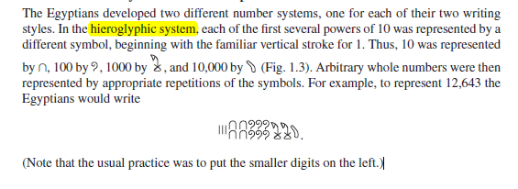

#### ΠΡΟΣΘΕΣΙΣ ΙΕΡΟΓΛΥΦΙΚΩΝ,

Katz p. 3,

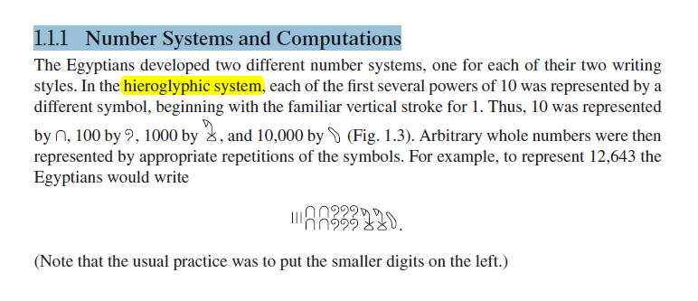

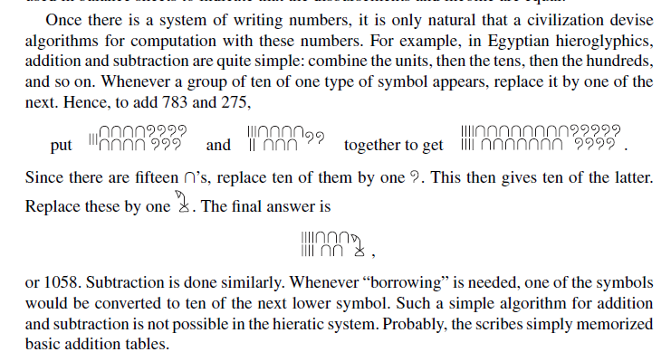

## GREECE, [ΕΛΛΑΣ

ΟΙ ΤΡΕΙΣ ΒΑΣΕΙΣ του WESTERN CIVILIZATION

ΕΒΡΑΙΚΗ ΒΙΒΛΟΣ,

ΑΡΧΑΙΑ ΕΛΛΑΔΑ,

ΡΩΜΗ,

### ΣΧΟΛΙΑΣΜΟΣ ΤΩΝ ΕΛΛΗΝΙΚΩΝ ΜΑΘΗΜΑΤΙΚΩΝ,

ΑΠΟΔΕΙΞΗ και ΑΞΙΩΜΑΤΑ

ΠΡΟΕΛΕΥΣΙΣ : ΔΗΜΟΚΡΑΤΙΑ,

#### KATZ p. 33, greek mathematics,

As the quotation and the (probably) fictional account indicate, a new attitude toward mathematics appeared in Greece sometime before the fourth century bce. It was no longer sufficient merely to calculate numerical answers to problems. One now had to prove that the results were correct. To double a cube, that is, to find a new cube whose volume was twice that of the original one, is equivalent to determining the cube root of 2, and that was not a difficult problem numerically. The oracle, however, was not concerned with numerical calculation, but with geometric construction. That in turn depended on geometric proof by some logical argument, the earliest manifestation of such in Greece being attributed to Thales.

This change in the nature of mathematics, beginning around 600 bce, was related to the great differences between the emerging Greek civilization and those of Egypt and Babylonia, **from whom the Greeks learned**. The physical nature of Greece with its many mountains and islands is such that large-scale agriculture was not possible. Perhaps because of this, Greece did not develop a central government. The basic political organization was the polis, or city-state. The governments of the city-state were of every possible variety but in general controlled populations of only a few thousand. Whether the governments were democratic or monarchical, (ΣΓΠ, or ARISTOCRATIC), they were not arbitrary. Each government was ruled by law and therefore encouraged its citizens to be able to argue and debate. It was perhaps out of this characteristic that there developed the necessity for proof in mathematics, that is, for argument aimed at convincing others of a particular truth.

ΠΑΠ.

ΠΝΥΚΑ, 483 ψηφισμα ΘΕΜΙΣΤΟΚΛΗ

ΔΙΚΑΣΤΗΡΙΑ, Τοποθετησεις στο ΔΙΚΑΣΤΗΡΙΟ,

ΔΙΑΛΟΓΟΙ ΣΩΚΡΑΤΟΥΣ STON DROMO, .

ΣΗΜΕΡΑ ΤΙ ΓΙΝΕΤΑΙ ?,

Because virtually every city-state had access to the sea, there was constant trade, both in Greece itself and with other civilizations. As a result, the Greeks were exposed to many different peoples and, in fact, themselves settled in areas all around the eastern Mediterranean. In addition, a rising standard of living helped to attract able people from other parts of the world. Hence, the Greeks were able to study differing answers to fundamental questions about the world. They began to create their own answers. In many areas of thought, they learned not to accept what had been handed down from ancient times. Instead, they began to ask, and to try to answer, “Why?” Greek thinkers eventually came to the realization that the world around them was knowable, that they could discover its characteristics by rational inquiry. Hence, they were anxious to discover and expound theories in such fields as mathematics, physics, biology, medicine, and politics. And althoughWestern civilization owes a great debt to Greek society in literature, art, and architecture, it is to Greek mathematics that we owe the idea of mathematical proof, an idea at the basis of modern mathematics and, by extension, at the foundation of our modern technological civilization.

#### KATZ, p. 35. ARISTOTLE,

Fortunately for us, most of the early Greek mathematics we will discuss involves little calculation.

As Aristotle wrote in his *Metaphysics*, At first, he who invented any art whatever that went beyond the common perceptions of man was naturally admired by men, not only because there was something useful in the inventions, but because he was thought wise and superior to the rest. But as more arts were invented, and some were directed to the necessities of life, others to recreation, the inventors of the latter were naturally always regarded as wiser than the inventors of the former, because their branches of knowledge did not aim at utility. Hence when all such inventions were already established, the sciences which do not aim at giving pleasure or at the necessities of life were discovered, and first in the places where men first began to have leisure. This is why the mathematical arts were founded in Egypt; for there the priestly caste was allowed to be at leisure

Although Aristotle referred only to Egypt, he certainly believed that in Greece as well mathematics was the province of a leisured class, people who did not deal with such mundane (χωρις ενδιαφερον), matters as measurement or accountancy problems. Thus, in Greece as in Egypt and Mesopotamia, mathematics of the type we will discuss in this chapter and the next was the province of a very limited group of people, virtually all of whom were part of the ruling groups. As we will see, this theoretical mathematics was to be a central part of the education of the rulers of the state.

#### A Mathematician’s Apology, G. H. Hardy,

**p. 11,**

If intellectual curiosity, professional pride, and ambition are the dominant incentives to research, then assuredly no one has a fairer chance of satisfying them than a mathematician. His subject is the most curious of all—there is none in which truth plays such odd pranks. It has the most elaborate and the most fascinating technique, and gives unrivalled openings for the display of sheer professional skill. Finally, as history proves abundantly, mathematical achievement, whatever its intrinsic worth, is the most enduring of all. We can see this even in semi-historic civilizations. The Babylonian and Assyrian civilizations have perished; Hammurabi, Sargon, and Nebuchadnezzar are empty names; yet Babylonian mathematics is still interesting, and the Babylonian scale of 60 is still used in astronomy. But of course the crucial case is that of the Greeks.

( COMMENTS SGP

“yet Babylonian mathematics is still interesting, and the Babylonian scale of 60 is still used in astronomy” )

The Greeks were the first mathematicians who are still ‘real’ to us to-day. Oriental mathematics may be an interesting curiosity, but Greek mathematics is the real thing. The Greeks first spoke a language which modern mathematicians can understand: as Littlewood said to me once, they are not clever schoolboys or ‘scholarship candidates’, but ‘Fellows of another college’. So Greek mathematics is ‘permanent’, more permanent even than Greek literature.

( COMMENTS SGP

“So Greek mathematics is ‘permanent’,”)

**Archimedes** will be remembered when **Aeschylus** is forgotten, because languages die and mathematical ideas do not. ‘Immortality’ may be a silly word, but probably a mathematician

has the best chance of whatever it may mean.

NATIONAL THEATER OLIVIER, ORESTEIA,

#### NETZ,

NetzRevielNewHistoryOfGreekMathematics2022, p. 12,

Slabs, thick flat object, πλακα,

Limestone, Ασβεστόλιθος

Na do epishs 26-30, exei kai Pythagorean theorem,

GO NETZ, NetzRevielNewHistoryOfGreekMathematics2022, p. 12,

O netz axizei na to do, exei polla