16 ΔΙΑΛΕΞΙΣ, 2025

10-05-2025, ΣΑΒΒΑΤΟ,

Ακολουθουν 2 βιντεο,

Webex meeting recording: 16a INM-20250510 1920-2

Recording link: https://uoa.webex.com/uoa/ldr.php?RCID=4b1d1c3f027a63ac0ef1313776c3f882

Password: Gps5zNYb

Webex meeting recording: 16b INM-20250510 1920-1

Recording link: https://uoa.webex.com/uoa/ldr.php?RCID=16d25d9eb8ef5434bd305526ef5ec54f

Password: cZuR5knm

**ΠΡΟΚΑΤΑΡΚΤΙΚΑ,**

Σχεδιαζουμε να κανουμε τις εργασιες,

1005, 2002, 2004, 3002, 3003,

Υπενθυμισις, την πεμπτη οφειλονται οι

8001, 8041, 6002, 6003, 6004,

## ΕΠΑΝΑΛΗΨΙΣ. ΙΝΔΙΚΟ-ΑΡΑΒΙΚΟ ΑΡΙΘΜΗΤΙΚΟ ΣΥΣΤΗΜΑ, ΠΕΡΙΛΗΨΙΣ, ναι 2025

### Hindu–Arabic numeral system,

<https://en.wikipedia.org/wiki/Hindu%E2%80%93Arabic_numeral_system#Glyph_comparison>,

“The Hindu–Arabic numeral system or Indo-Arabic numeral system[1] (also called the Hindu numeral system or Arabic numeral system)[2][note 1] is a positional (place value), decimal numeral system, and is the most common system for the symbolic representation of numbers in the world.

**It was invented between the 1st and 4th centuries by Indian mathematicians**. The system was adopted **in Arabic mathematics by the 9th century**. It became more widely known through the writings of the Persian mathematician Al-Khwārizmī[3], (Ο ΧΟΡΑΣΜΙΟΣ, 9th century), ), . (On the Calculation with Hindu Numerals, c. 825) and Arab mathematician Al-Kindi (On the Use of the Hindu Numerals, c. 830). The system had spread to medieval Europe by the **High Middle Ages (1300-1500)**.

ψηφια 1, …9,

#### Adoption in Europe

Main article: Arabic numerals

“The Arabic numeral system first appeared in Europe in the Spanish Codex Vigilanus, year 976.

In Christian Europe, the first mention and representation of Hindu–Arabic numerals (from one to nine, without zero), is in the Codex Vigilanus (aka Albeldensis), an illuminated compilation of various historical documents from the Visigothic period in Spain, written in the year 976 by three monks of the Riojan monastery of San Martín de Albelda. Between 967 and 969, **Gerbert de Aurillac (946 – 12 May 1003)** discovered and studied Arab science in the Catalan abbeys. Later he obtained from these places the book De multiplicatione et divisione (On multiplication and division). After becoming **Pope Sylvester II in the year 999,** he introduced a new model of abacus, the so-called Abacus of Gerbert, by adopting tokens representing Hindu–Arabic numerals, from **one to nine**.

ΣΓΠ, **Sylvester or Silvester** is a name derived from the Latin adjective silvestris meaning "wooded" or "wild", which derives from the noun silva meaning **"woodland**". Classical Latin spells this with i. In Classical Latin, y represented a separate sound distinct from i, not a native Latin sound but one used in transcriptions of foreign words. After the Classical period y was pronounced as i. Spellings with Sylv- in place of Silv- date from after the Classical period.

Ο **Pope Sylvester II, δεν καταφερε να το προωθησει, .**

**Fibonacci**,

<https://en.wikipedia.org/wiki/Fibonacci>,

Fibonacci (/ˌfɪbəˈnɑːtʃi/;[3] also US: /ˌfiːb-/,[4][5] Italian: [fiboˈnattʃi]; c. 1170 – c. 1240–50),[6] also known as **Leonardo Bonacci**, **Leonardo of Pisa**, or **Leonardo Bigollo Pisano** ('Leonardo the Traveller from Pisa'[7]), was an Italian mathematician from the **Republic** of Pisa,

considered to be "the most talented Western mathematician of the Middle Ages".[8] ???? Eves, Howard. An Introduction to the History of Mathematics. Brooks Cole, 1990: ISBN 0-03-029558-0 (6th ed.), p. 261,

**Leonardo Fibonacci (c. 1170 – c. 1240–50),**

brought this system to Europe. His book Liber Abaci introduced Modus Indorum (the method of the Indians), today known as Hindu–Arabic numeral system or base-10 positional notation, the **use of zero**, and the decimal place system to the Latin world. The numeral system came to be called "Arabic" by the Europeans. **It was used in European mathematics from the 12th century, and entered common use from the 15th century to replace Roman numerals.[15][16]”**

**Liber Abaci**

Liber Abaci (also spelled as Liber Abbaci;[1] ( καλλιτεη αποδοσις "The Book of Calculation") is a **historic 1202** Latin manuscript on arithmetic by Leonardo of Pisa, posthumously known as Fibonacci.

*Liber Abaci* was among the first Western books to describe the [Hindu–Arabic numeral system](https://en.wikipedia.org/wiki/Hindu%E2%80%93Arabic_numeral_system) and to use symbols resembling modern "[Arabic numerals](https://en.wikipedia.org/wiki/Arabic_numerals)". By addressing the applications of both commercial tradesmen and mathematicians, it promoted the superiority of the system, and the use of these glyphs.[[2]](https://en.wikipedia.org/wiki/Liber_Abaci#cite_note-2)

Although the book's title is sometimes translated as "**The Book of the Abacus", Sigler (2002) notes that it is an error to read this as referring to calculating devices called "abacu**s". Rather, the word "abacus" was used at the time to refer to calculation in any form; the spelling "abbacus" with two "b"s (which is how Leonardo spelled it in the original Latin manuscript) was, and still is in Italy, used to refer to calculation using Hindu-Arabic numerals, which can avoid confusion. The book describes methods of doing calculations without aid of an abacus, and as Ore (1948) confirms, for centuries after its publication the algorismists (followers of the style of calculation demonstrated in Liber Abaci) remained in conflict with the abacists (traditionalists who continued to use the abacus in conjunction with Roman numerals). The historian of mathematics Carl Boyer emphasizes in his History of Mathematics that although "**Liber abaci...is not on the abacus**" per se, nevertheless "...it is a very thorough treatise on algebraic methods and problems in which the use of the Hindu-Arabic numerals is strongly advocated."[3]

ΣΧΟΛΙΟΝ. abacus(n.)

late 14c., "sand table for drawing, calculating, etc.," also "art of calculating with an abacus," from Latin abacus, from Greek abax (genitive abakos) "counting table, board for drawing," a word of uncertain etymology.

It is said to be from a Semitic source, such as Phoenician or Hebrew abaq "sand strewn on a surface for writing," literally "dust," from the Semitic root a-b-q "to fly off," but Beekes and others find this "semantically weak."

**In 1240, the Republic of Pisa honored Fibonacci (referred to as Leonardo Bigollo)[20] by granting him a salary in a decree that recognized him for the services that he had given to the city as an advisor on matters of accounting and instruction to citizens.[21][22]**

Fibonacci is thought to have died between 1240[23] and 1250,[24] in Pisa.

[21], Keith Devlin (7 November 2002). *["A man to count on"](https://www.theguardian.com/education/2002/nov/07/research.science)*. The Guardian. [*Archived*](https://web.archive.org/web/20160917004540/https:/www.theguardian.com/education/2002/nov/07/research.science) from the original on 17 September 2016*. Retrieved 7 June 2016*.

<https://www.theguardian.com/education/2002/nov/07/research.science>,

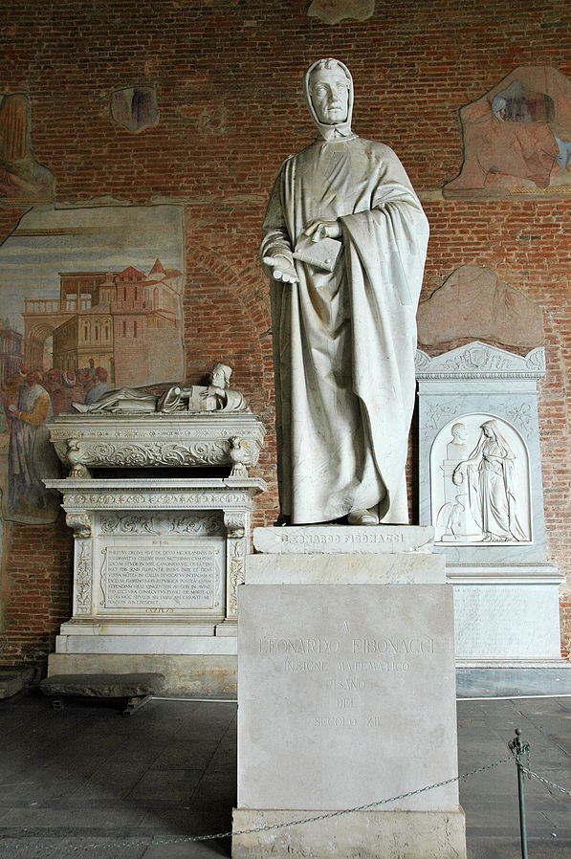

<https://en.wikipedia.org/wiki/Fibonacci>,

Statue of Fibonacci (1863) by Giovanni Paganucci in the [Camposanto di Pisa](https://en.wikipedia.org/wiki/Camposanto_di_Pisa)[[a]](https://en.wikipedia.org/wiki/Fibonacci#cite_note-2)

### ΣΧΟΛΙΑΣΜΟΣ ΑΡΙΘΜΗΤΙΚΩΝ ΣΥΣΤΗΜΑΤΩΝ ΑΙΓΥΠΤΙΩΝ, ΒΑΒΥΛΩΝΙΩΝ, ΕΛΛΗΝΩΝ ΡΩΜΑΙΩΝ, ΙΝΔΩΝ-ΑΡΑΒΩΝ,

#### ΚΥΡΙΑ ΣΗΜΕΙΑ

Μικρη μεταδοσις

ΣΧΕΣΗ με την ΟΙΚΟΝΟΜΙΑ, κλπ

ΚΟΙΝΩΝΙΚΗ ΑΔΡΑΝΕΙΑ,

Κάθε ΠΟΛΙΤΙΣΜΟΣ παραγει τα μαθηματικα του (η ΔΕΝ παραγει),

Επαφες με αλλους λαουσ

ΠΡΟΣΩΠΙΚΟΙ ΠΑΡΑΓΟΝΤΕΣ

Leonardo Fibonacci, Παπας GERBERT d AURILAC,

ΑΡΧΑΙΑ ΕΛΛΑΔΑ,

ΔΗΜΟΚΡΑΤΙΑ,

ΑΡΙΣΤΕΙΑ,

Ολυμπιακοι αγωνες,

ΟΜΗΡΟΣ, ΙΛΙΑΔΑ,

GOOGLE classical greece aristeia

In ordinary life, aristeia was a Greek term for unusually valiant behaviour in battle, heroism, valour, derring-do, and rare proof of courage. From this ideal, other ideals were derived, especially aristeíon (heroism) and also honour, reward, and the victorious prize for the greatest valour in battle).

WIKIPEDIA, <https://en.wikipedia.org/wiki/Aristeia>,

<https://www.phil.muni.cz/en/research/publishing-and-editorial-activities-of-the-faculty/overview-of-publishing-and-scientific-activities/1686858>,

Aristeia: A Philosophical Ideal as the Basic of Ancient Greek Physical Preparation and Valiant Behaviour on the Battlefields,

ΤΙ ΠΡΕΠΕΙ ΝΑ ΚΑΝΟΥΜΕ ?,

ΕΝΕΡΓΗ ΓΝΩΡΙΜΙΑ με αλλους λαους,

Ανοικτοτησ σε νεες ιδεες,

Χρηματοδοτησης,

ΚΑΝΑΜΕ τις ΕΡΓΑΣΙΕΣ 2004, 1005, 2002, 3003, 3002,

Από εδώ και περα, το μαθημα συνεχιζει στο

11.4, THE ARABS 8-13th century,

Συνεχεια της 16 διαλεξησ,

## THE ARABS 8-13th century

### History of the Arabs,

<https://en.wikipedia.org/wiki/History_of_the_Arabs>,

The recorded history of the Arabs begins in the mid-ninth century BC, which is the earliest known attestation of the Old Arabic language. **Tradition holds that Arabs descend from Ishmael, the son of Abraham.[1**]

The Syrian Desert is the home of the first attested "Arab" groups,[2][3] as well other Arab groups that spread in the land and existed for millennia.[4]

ΙΣΜΑΗΛ, ΑΓΑΡ,

#### Map of expansion of Caliphate.

[https://en.wikipedia.org/wiki/History_of_the_Arabs#](https://en.wikipedia.org/wiki/History_of_the_Arabs),

<https://en.wikipedia.org/wiki/History_of_the_Arabs#/media/File:Map_of_expansion_of_Caliphate.svg>,

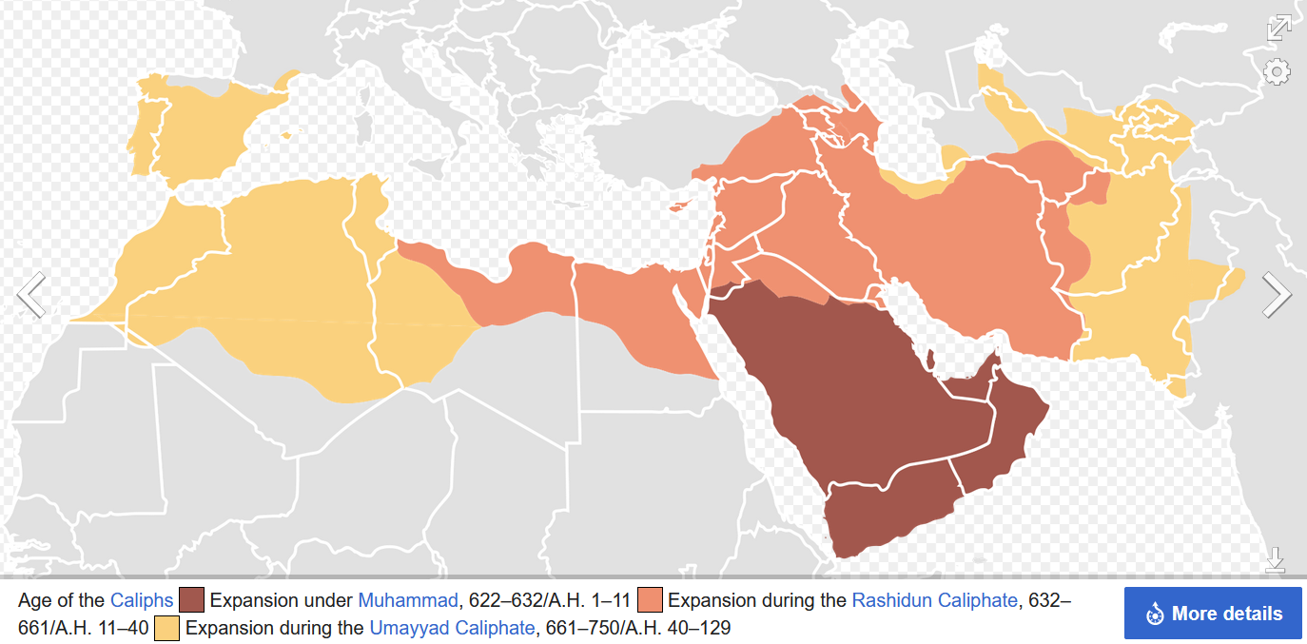

**The Rashidun Caliphate** (Arabic: ٱلْخِلَافَةُ ٱلرَّاشِدَةُ, romanized: al-Khilāfah ar-Rāšidah) was the first caliphate to succeed the Islamic prophet Muhammad. It was ruled by the first four successive caliphs of Muhammad after his death in 632 CE (11 AH). During its existence, the empire was the most powerful economic, cultural, and military force in West Asia and Northeast Africa.

Etymology **The Arabic word rāshidūn (singular: rāshid) means** **"rightly-guided"**. The reign of these four caliphs is considered in Sunni Islam to have been 'rightly-guided', meaning that it constitutes a model (sunna) to be followed and emulated from a religious point of view.[6] This term is not used by Shia Muslims, who reject the rule of the first three caliphs as illegitimate.[7]

**Abbasid Caliphate, ( 750–1258, 1261–1517**)

<https://en.wikipedia.org/wiki/Abbasid_Caliphate>,

The Abbasid Caliphate first centered its government in Kufa, modern-day Iraq, but in 762 the caliph al-Mansur founded the city of **Baghdad** as the new capital. Baghdad became the center of science, culture, arts, and invention in what became known as the Golden Age of Islam.

The Islamic Golden Age was a period of scientific, economic and cultural flourishing in the history of Islam, traditionally **dated from the 8th century to the 13th century**.[

#### GIBRALTAR,

<https://en.wikipedia.org/wiki/Gibraltar>,

The name is derived from Arabic: جبل طارق, romanized: **Jabal Ṭāriq, lit. 'Mount of Tariq'** (named after the 8th-century Moorish military leader **Tariq ibn Ziyad).**[20] That continues to be its name in Arabic. It has also been suggested that the name is a contraction of the Arabic: جبل على الطريق jabal ʽalā aṭ-ṭarīq ('mountain on the way').,

Following **a raid in 710,** a predominantly Berber army under the command of Tariq ibn Ziyad crossed from North Africa in April 711 and landed somewhere in the vicinity of Gibraltar (though most likely not in the bay or at the Rock itself).[30][31]

### ARABIC ALGEBRA,

Katz p.271,

The most important contributions of the Islamic mathematicians lie in the area of algebra. **They took the material already developed by the Babylonians, combined it with the classical Greek heritage of geometry,** and produced a new algebra, which they proceeded to extend. By the end of the ninth century, the chief Greek mathematical classics were well known in the Islamic world. Islamic scholars studied them and wrote commentaries on them.

The most important idea they learned from their study of these **Greek works was the notion of proof. (SGP and axioms, poy den akoloythhsan !)**, They absorbed the idea that one could not consider a mathematical problem solved unless one could demonstrate that the solution was valid. How does one demonstrate this, particularly for an algebra problem? The answer seemed clear. The only real proofs were geometric.

After all, it was geometry that was found in Greek texts, not algebra. Hence, Islamic scholars generally set themselves the tasks of justifying algebraic rules, either the ancient Babylonian ones or new ones they themselves discovered, and justifying them through geometry.

#### Muḥammad ibn Musa al-Khwarizmi (c. 780–850),

GOOGLE: Khwarizmi,

##### WIKIPEDIA Muḥammad ibn Mūsā

Muḥammad ibn Mūsā al-Khwārizmī[note 1] (Arabic: محمد بن موسى الخوارزمي; c. 780 – c. 850), or al-Khwarizmi η al-Khwarizmi, was a polymath from **Khwarazm**, who produced vastly influential works in mathematics, astronomy, and geography. Around 820 CE, he was appointed as the astronomer and head of the library of the House of Wisdom in Baghdad.[6]: 14

GOGLE: Khwarizmi,

FULL NAME,   **Abu Abdallah Muḥammad ibn Mūsā al-Jwārizmī**.

o ΜΩΑΜΕΘ, Ο πατερας του ΑΜΠΝΤΑΛΑΧ (Δουλου του ΘΕΟΥ), υιος του ΜΩΗΣΗ, από την ΧΟΡΑΣΜΙΑ (ο ΧΟΡΑΣΜΙΟΣ), .

SGP, ABU=father of,

e.g. Ahmed Hussein al-Sharaa[d] (born 29 October 1982) also known by his nom de guerre[e] Abu Mohammad al-Julani,

al JULANI,

SGP. Εντοπισμος με το FIND, Muqabala, The Condensed Book on the Calculation

Few details of al-Khwārizmī's life are known with certainty. Ibn al-Nadim gives his birthplace as Khwarazm, and he is generally thought to have come from this region.[26][27][28] Of Persian stock,[29][26][30][31][32] **his name means 'the native of Khwarazm' (Chorasmia), a region that was part of Greater Iran,[33] and is now part of Turkmenistan, and Uzbekistan.**[34]

###### Map of the Central Asian Republics

(Kazakhstan, Uzbekistan ...Map of the Central Asian Republics (Kazakhstan, Uzbekistan ...

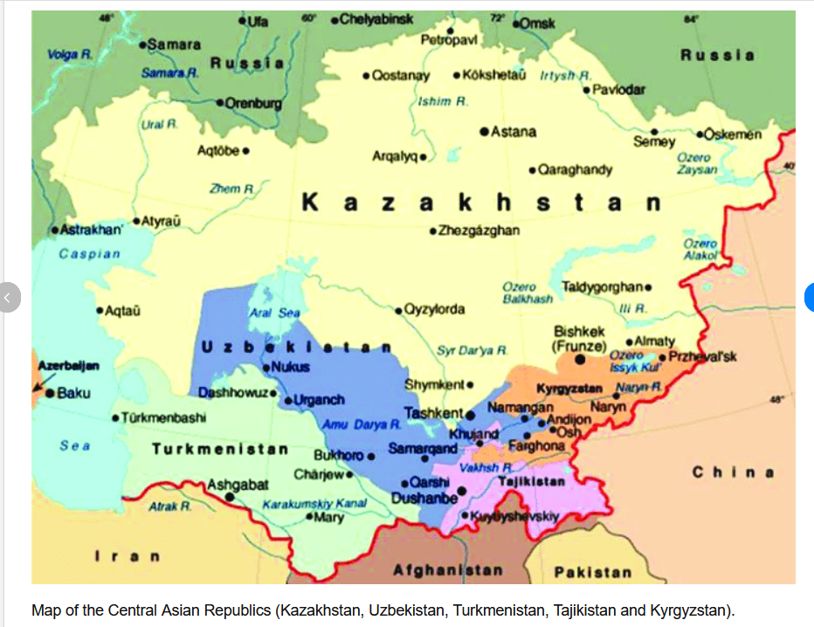

<https://www.google.com/search?client=firefox-b-d&q=Turkmenistan%E2%80%93Uzbekistan++map#vhid=-_7uuRteYhptAM&vssid=l>,

<https://www.researchgate.net/figure/Map-of-the-Central-Asian-Republics-Kazakhstan-Uzbekistan-Turkmenistan-Tajikistan-and_fig1_341538060>,

(Está en una estampilla conmemorativa de la **Unión Sovietica**, emitida el 6 de Septiembre del 1983. La estampilla dice su nombre y "1200 años", referente al aniversario aproximado de su nacimiento). Approximate birth 783.

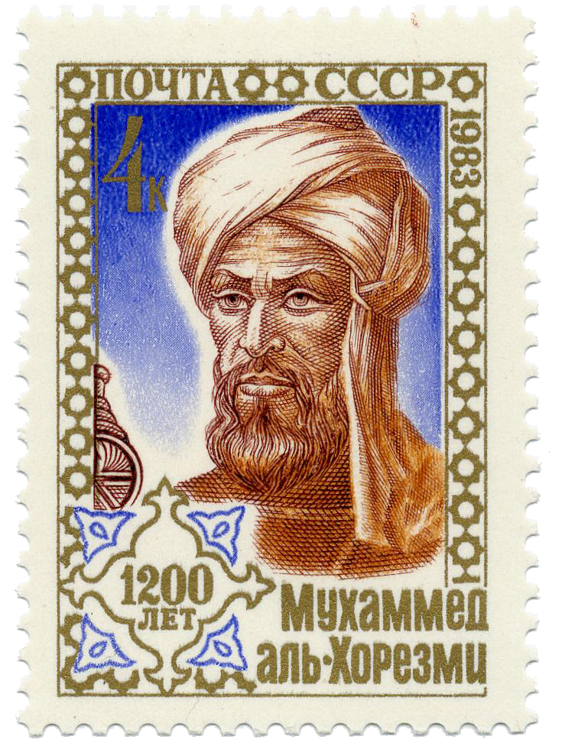

A Soviet postage stamp (issued 6 September 1983) commemorating al-Khwārizmī's (approximate) 1200th birthday.

<https://en.wikipedia.org/wiki/Al-Khwarizmi>,

#### The Compendious Book on Calculation by **Completion and Balancing**,

“**Al-kitāb al-mukhtaṣar fī ḥisāb al-ğabr wa’l-muqābala**”

Katz p. 272

GOOGLE: Al-Jabr, Al jabr, ισως AlJabr.

SGP,

Al-kitāb= the book, . χειροπρακτορ

al-mukhtaṣar =a concise handbook of legal treatises,

ḥisāb= reckoning,

**Al jabr= restoring, η τακτοποιησις.** Algebrista=Χειροπρακτης, .

**Muqābala=εξισσοροπισης**,

Compendious=Συνοπτικος,

**Δηλ. Το βιβλιο που μελεταει υπολογισμους, μεσω τακτοποιησης και εξισοροπισης,**

##### st-andrews, Abu Ja'far Muhammad ibn Musa Al-Khwarizmi,

Ο ΜΩΑΜΕΘ, πατερας του Ζαφαρ, υιος του ΜΩΗΣΗ, από την ΧΟΡΑΣΜΙΑ,

<https://mathshistory.st-andrews.ac.uk/Biographies/Al-Khwarizmi/>,

**Al-Khwarizmi also wrote a treatise on Hindu-Arabic numerals.** The Arabic text is lost but a Latin translation, Algoritmi de numero Indorum in English Al-Khwarizmi on the Hindu Art of Reckoning gave rise to the word algorithm deriving from his name in the title. Unfortunately the Latin translation (translated into English in [19]) is known to be much changed from al-Khwarizmi's original text (of which even the title is unknown). The work describes the Hindu place-value system of numerals based on 1, 2, 3, 4, 5, 6, 7, 8, 9, and 0. **The first use of zero as a place holder** in positional base notation was probably due to al-Khwarizmi in this work. Methods for arithmetical calculation are given, and a method to find square roots is known to have been in the Arabic original although it is missing from the Latin version. Toomer writes [1]:-

... the decimal place-value system was a fairly recent arrival from India and ... al-Khwarizmi's work was the first to expound it systematically. Thus, although elementary, it was of seminal importance.

##### Akolouthei kalo paradeidma,

<https://mathshistory.st-andrews.ac.uk/Biographies/Al-Khwarizmi/>,

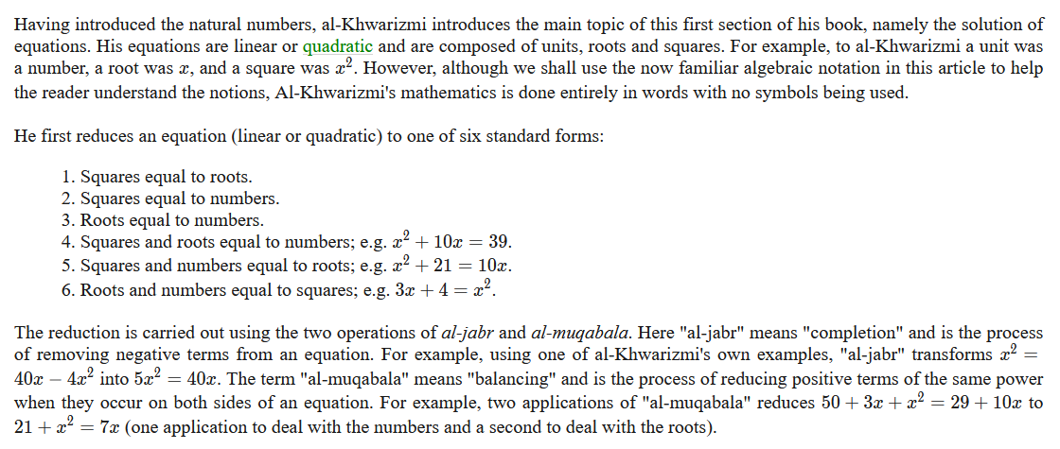

ΣΤΑ ΑΝΩΤΕΡΩ

Οι τρεις πρωτες περιπτωσεις, είναι ως κατωτερω

1 SQUARES equal ROOTS, e.g. 5x2 =2x

2 SQUARES equal NUMBERS, e.g. 7x2 =2

3 ROOT equal NUMBERS, e.g. 7x= 2

Οι συντελεστες είναι ΘΕΤΙΚΟΙ, εξ ου και η κατηγοριοποιησης.

Σημερα στο ΓΥΜΝΑΣΙΟ-ΛΥΚΕΙΟ γραφουμε

ax2 +bx+c=0

kai h gnvsth lysh einai

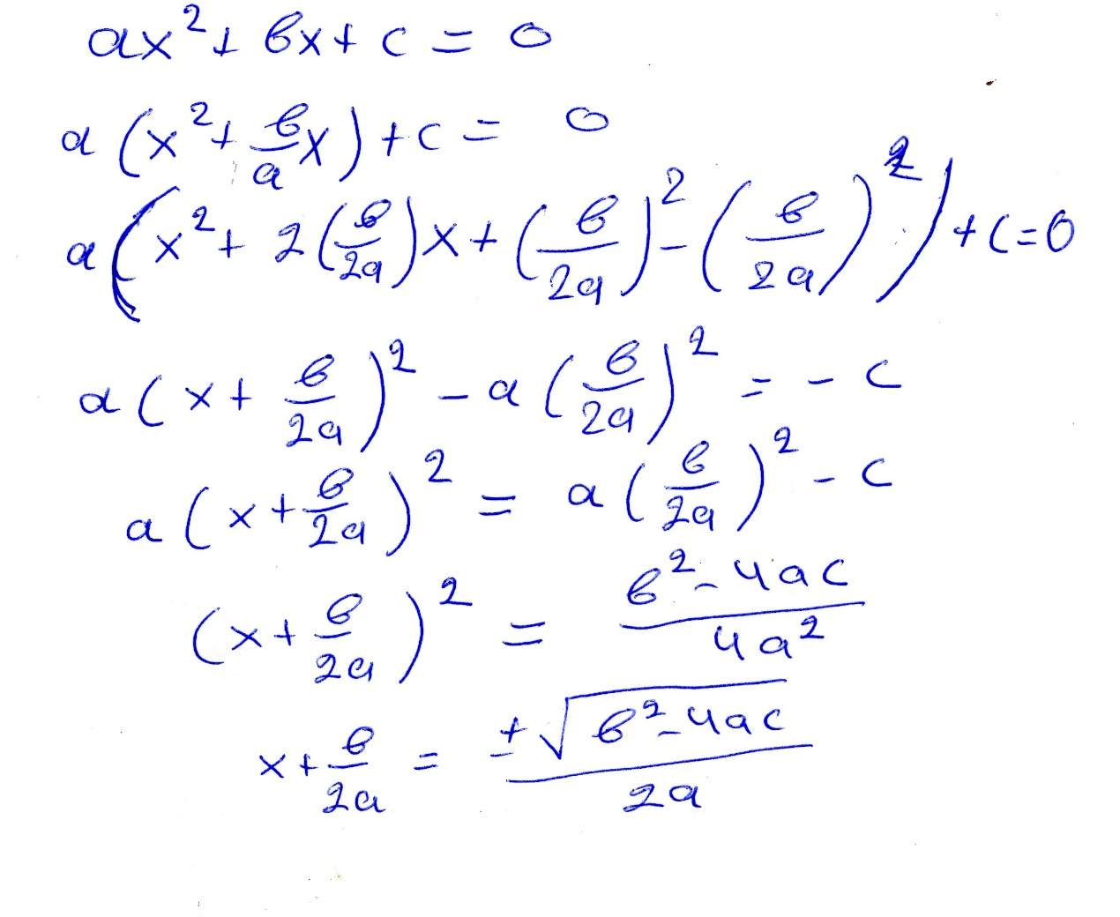

ΠΑΡΑΔΕΙΓΜΑ, «εξισοροπισης» και «αποκαταστασης»

Να βρεθει x ώστε x2 +8x=9

**An** υπαρχει x που να ικανοποιει την ως ανω τοτε

x2 +8x+16=9+16 muqābala,

(x+4)2 =9+16 =25, al-ğabr, klp

Καπως ως ανωτερω λυνουμε στο ΛΥΚΕΙΟ, εξισωσεις βαθμου 2,

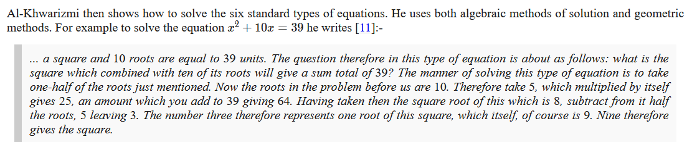

x2 +10x=39

x2 +10x+25=39+25 , muqābala

(x+5)2 =64, aljabr, etc

x+5= 8,

x=8-5=3

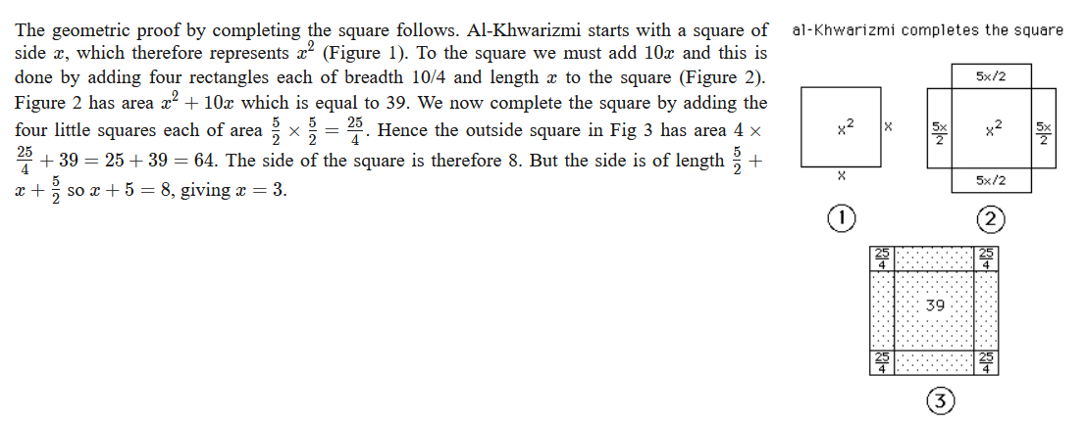

To παραπανω κατωτερω γραφεται καπως καλλιτερα

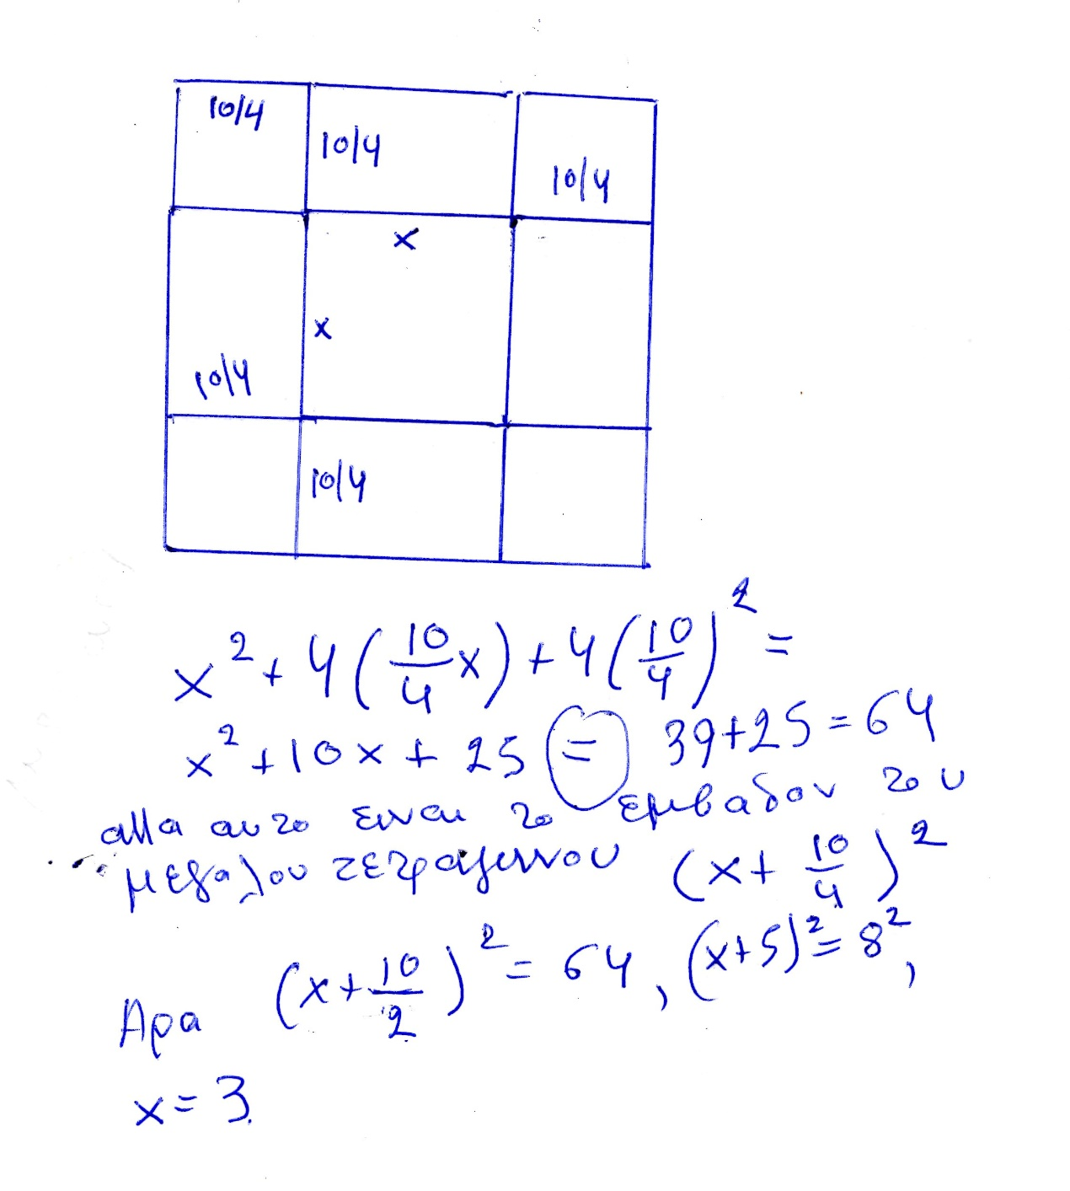

Cool! Ε!

These geometrical proofs are a matter of disagreement between experts. The question, which seems not to have an easy answer, is whether al-Khwarizmi was familiar with [Euclid](https://mathshistory.st-andrews.ac.uk/Biographies/Euclid/)'s Elements. We know that he could have been, perhaps it is even fair to say "should have been", familiar with [Euclid](https://mathshistory.st-andrews.ac.uk/Biographies/Euclid/)'s work. In al-Rashid's reign, while al-Khwarizmi was still young, al-Hajjaj had translated [Euclid](https://mathshistory.st-andrews.ac.uk/Biographies/Euclid/)'s Elements into Arabic and al-Hajjaj was one of al-Khwarizmi's colleagues in the House of Wisdom. This would support Toomer's comments in [[1](https://mathshistory.st-andrews.ac.uk/Biographies/Al-Khwarizmi/#reference-1)]:-

... in his introductory section al-Khwarizmi uses geometrical figures to explain equations, which surely argues for a familiarity with Book II of [Euclid](https://mathshistory.st-andrews.ac.uk/Biographies/Euclid/)'s "Elements".

Rashed [[9](https://mathshistory.st-andrews.ac.uk/Biographies/Al-Khwarizmi/#reference-9)] writes that al-Khwarizmi's:-

... treatment was very probably inspired by recent knowledge of the "Elements".

However, Gandz in [[6](https://mathshistory.st-andrews.ac.uk/Biographies/Al-Khwarizmi/#reference-6)] (see also [[23](https://mathshistory.st-andrews.ac.uk/Biographies/Al-Khwarizmi/#reference-23)]), argues for a very different view:-

[Euclid](https://mathshistory.st-andrews.ac.uk/Biographies/Euclid/)'s "Elements" in their spirit and letter are entirely unknown to [al-Khwarizmi]. **Al-Khwarizmi has neither definitions, nor axioms, nor postulates, nor any demonstration of the Euclidean kind.**

I [EFR] think that it is clear that whether or not al-Khwarizmi had studied [Euclid](https://mathshistory.st-andrews.ac.uk/Biographies/Euclid/)'s Elements, he was influenced by other geometrical works. As Parshall writes in [[35](https://mathshistory.st-andrews.ac.uk/Biographies/Al-Khwarizmi/#reference-35)]:-

... because his treatment of practical geometry so closely followed that of the Hebrew text, Mishnat ha Middot, which dated from around 150 AD, the evidence of Semitic ancestry exists.

Al-Khwarizmi continues his study of algebra in Hisab al-jabr w'al-muqabala by examining how the laws of arithmetic extend to an arithmetic for his algebraic objects. For example he shows how to multiply out expressions such as

**(a+bx)(c+dx)(a+bx)(c+dx)**

although again we should emphasise that al-Khwarizmi uses only words to describe his expressions, and no symbols are used. Rashed [[9](https://mathshistory.st-andrews.ac.uk/Biographies/Al-Khwarizmi/#reference-9)] sees a remarkable depth and novelty in these calculations by al-Khwarizmi which appear to us, when examined from a modern perspective, as relatively elementary. He writes [[9](https://mathshistory.st-andrews.ac.uk/Biographies/Al-Khwarizmi/#reference-9)]:-

Al-Khwarizmi's concept of algebra can now be grasped with greater precision: it concerns the theory of linear and quadratic equations with a single unknown, and the elementary arithmetic of relative binomials and trinomials. ... The solution had to be general and calculable at the same time and in a mathematical fashion, that is, geometrically founded. ... The restriction of degree, as well as that of the number of unsophisticated terms, is instantly explained. From its true emergence, algebra can be seen as a theory of equations solved by means of [radicals](https://mathshistory.st-andrews.ac.uk/Glossary/#radical), and of algebraic calculations on related expressions...

If this interpretation is correct, then al-Khwarizmi was as Sarton writes:-

... the greatest mathematician of the time, and if one takes all the circumstances into account, one of the greatest of all time....

In a similar vein Rashed writes [[9](https://mathshistory.st-andrews.ac.uk/Biographies/Al-Khwarizmi/#reference-9)]:-

It is impossible to overstress the originality of the conception and style of al-Khwarizmi's algebra...

but a different view is taken by Crossley who writes [[4](https://mathshistory.st-andrews.ac.uk/Biographies/Al-Khwarizmi/#reference-4)]:-

[Al-Khwarizmi] may not have been very original...

and Toomer who writes in [[1](https://mathshistory.st-andrews.ac.uk/Biographies/Al-Khwarizmi/#reference-1)]:-

... Al-Khwarizmi's scientific achievements were at best mediocre.

In [[23](https://mathshistory.st-andrews.ac.uk/Biographies/Al-Khwarizmi/#reference-23)] Gandz gives this opinion of al-Khwarizmi's algebra:-

Al-Khwarizmi's algebra is regarded as the foundation and cornerstone of the sciences. In a sense, al-Khwarizmi is more entitled to be called "the father of algebra" than [Diophantus](https://mathshistory.st-andrews.ac.uk/Biographies/Diophantus/) because al-Khwarizmi is the first to teach algebra in an elementary form and for its own sake, [Diophantus](https://mathshistory.st-andrews.ac.uk/Biographies/Diophantus/) is primarily concerned with the theory of numbers.

The next part of al-Khwarizmi's Algebra consists of applications and worked examples. He then goes on to look at rules for finding the area of figures such as the circle and also finding the volume of solids such as the sphere, cone, and pyramid. This section on mensuration certainly has more in common with Hindu and Hebrew texts than it does with any Greek work. The final part of the book deals with the complicated Islamic rules for inheritance but require little from the earlier algebra beyond solving linear equations.

Al-Khwarizmi also wrote a treatise on Hindu-Arabic numerals. The Arabic text is lost but a Latin translation, Algoritmi de numero Indorum in English Al-Khwarizmi on the Hindu Art of Reckoning gave rise to the word algorithm deriving from his name in the title. Unfortunately the Latin translation (translated into English in [[19](https://mathshistory.st-andrews.ac.uk/Biographies/Al-Khwarizmi/#reference-19)]) is known to be much changed from al-Khwarizmi's original text (of which even the title is unknown). The work describes the Hindu place-value system of numerals based on 1, 2, 3, 4, 5, 6, 7, 8, 9, and 0. **The first use of zero as a place holder in positional base notation was probably due to al-Khwarizmi in this work**. Methods for arithmetical calculation are given, and a method to find square roots is known to have been in the Arabic original although it is missing from the Latin version. Toomer writes [[1](https://mathshistory.st-andrews.ac.uk/Biographies/Al-Khwarizmi/#reference-1)]:-

... the decimal place-value system was a fairly recent arrival from India and ... al-Khwarizmi's work was the first to expound it systematically. Thus, although elementary, it was of seminal importance.