19 ΔΙΑΛΕΞΙΣ,

18-05-2025, κυριακη,

Webex meeting recording: 19 INM-20250518 1605-1

Recording link: https://uoa.webex.com/uoa/ldr.php?RCID=bb40a7addf300bd025cfa247fa2deeae

Password: vEsWY3PQ

**ΠΡΟΚΑΤΑΡΚΤΙΚΑ,**

ΠΡΟΘΕΣΙΣ να γινουν οι ΕΡΓΑΣΙΕΣ

3002, kybikh riza toy 2,

8001 apaloifh deyteroy oroy, 8041 kybos divnymoy,

Karaueodvrh αγγλικη αναφορα,

6002 typos hrona, 6004 lenghth bisector,

2004, anisothta b-adikon

1005 diderot, συζητηθηκε στο 18 διαλεξις,

Di gave a similar rule for solving special quartic equations, while Piero

# ΕΞΙΣΩΣΕΙΣ ΤΡΙΤΟΥ ΒΑΘΜΟΥ, 2024, 2025,

See KATZ, p. 383,

**But of number, cosa [unknown], and**

**cubo [cube of the unknown], however**

**they are compounded . . . , nobody until**

**now has formed general rules,** because they

are not ?? proportional among them. . . . And

therefore, until now, for their equations,

one cannot give general rules except that,

sometimes, by trial, . . . in some particular

cases. And therefore when in your equations

you find terms with different intervals

without proportion, you shall say that the

art, until now, **has not given the solution to**

**this case, . . . even if the case may be possible**.

—From the **Summa de arithmetica**,

geometrica, proportioni et proportionalita

of **Luca Pacioli, 1494**

### ΣΥΜΠΛΗΡΩΜΑΤΑ,

**Fra. Luca Bartolomeo de Pacioli (sometimes Paccioli or Paciolo; c. 1447 – 19 June 1517)[3]**

was an Italian mathematician, Franciscan friar, collaborator with Leonardo da Vinci, and an early contributor to the field now known as accounting. He is referred to as the father of accounting and bookkeeping and he was the first person to publish a work on the **double-entry system** of book-keeping on the continent.[4][a] He was also called Luca di Borgo after his birthplace, Borgo Sansepolcro, Tuscany.

Several of his works were plagiarised from Piero della Francesca, in what has been called "probably the first full-blown case of plagiarism in the history of mathematics".[6]

### ΤΙ ΑΛΓΕΒΡΑ ΗΞΕΡΕ Ο ΚΑΡΔΑΝΟΣ

#### Elimination of second term,

Katz p. 388, 12.1.2 Higher-Degree Equations,

Η γενικη εξισωση τριτου βαθμου είναι η

ax3 +bx2 +cx +d=0, a not 0,

panta αναγεται στην μορφη

Εξισωση x3 +px +q =0

### Algebraic Symbolism and Techniques,

#### DIOPHANTOS, ARITHMETICA, HEATH, p.9

Antiθetωs O ΔΙΟΦΑΝΤΟΣ εως καποιο βαθμο ειχα συμβολισμους,

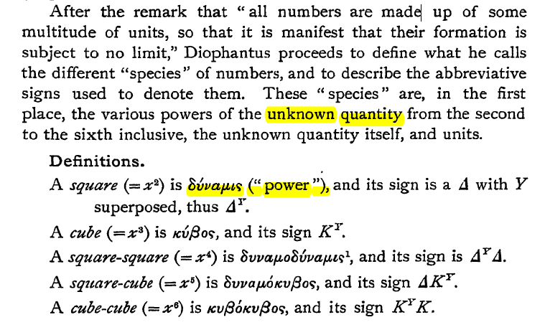

#### ISLAMIC ALGEBRA,

12.1.1 **Algebraic Symbolism and Techniques** (ΑΝΑΓΕΝΝHΣΗ),

KatzHistoryOfMathematics3rdS, 12.1.1. p.386

**Recall that Islamic algebra was entirely rhetorical**. There were no symbols for the unknown or its powers nor for the operations performed on these quantities. **Everything was written out in words**.

The same was generally true in the works of the early abacists and in the earlier Italian work of **Leonardo of Pisa (Fibonacci**)..

ΣΓΠ, **Αυτό αφορα και τον ΧΟΡΑΣΜΙΟ**,

#### Early in the fifteenth century, ABBREVIATIONS,

KATZ, p. 386

Early in the fifteenth century, however, some of the abacists (Arabic numerals), began to substitute abbreviations for unknowns. For example, in place of the standard words ***cosa* (thing),** ***censo***(square, απογραφη), **cubo**(cube), and ***radice*** (root), some authors used the abbreviations *c*, *ce*, *cu*, and *R*. Combinations of these abbreviations were used for higher powers.

Thus,

***ce di ce* or *ce ce* stood for *censo di censo* or fourth power (*x*2*x*2);**

***ce cu* or *cu ce*,** designating ***censo di cubo* and *cubo di censo (x3 x2)*, respectively, ce di cu stood for fifth power (*x*2*x*3);**

And

***cu cu*, designating *cubo di cubo*, stood for sixth power (*x*3*x*3**).

**Η επαναληψη δηλωνε γινομενο**.

By the **end of the fifteenth century, however**, the naming scheme for higher powers had changed, and authors used

*ce cu* or ***censo di cubo* to designate the sixth power (*(x*3*)*2)** and *cu cu* or *cubo di cubo* to represent the ninth power (*(x*3*)*3).

**Η επαναληψη δηλωνε «δυναμη εις την δυναμη»**.

The fifth power was then designated as *p.r.* or *primo relato* and the seventh power as *s.r.* or *secondo relato*..

RELATO, σχετιζομενος, συγγενης,

***Coss*** was simply the German form of

the Italian **cosa,** or thing, the name usually given to the unknown in an algebraic equation.

Two of the most important **Cossists** in the first half of the sixteenth century were Christoff Rudolff (sixteenth century)

and Michael Stifel (1487–1567).

**Piu, πλεον,**

The most important (and obvious) meaning of più is as an adjective meaning “more”

**Più bella cosa**, (πιο όμορφο πράγμα), Eros Ramazzotti

“to pio ομορφο plasma”

<https://lyricstranslate.com/el/piu-bella-cosa-pio-omorfo-pragma.html>,

**Meno, less,**

SGP, δυσχερια στην μεταδοσι, koinonikh adraneia,

#### ΑΛΓΕΒΡΙΚΟΣ ΛΟΓΙΣΜΟΣ του ARS MAGNA,

Ston CARDANO **Everything was written out in words**.

Αυτό που λεμε x to oνομαζε «COSA, =ΤΗING”

E.G. “On the Cube Equal to the Thing and Number,” “that is, *x*3 = *cx* + *d*,”

Οι συντελεστες και το x ησαν ΑΡΙΘΜΟΙ, γενικως (ασχετα με το τι μετρανε).

ΠΡΟΣΟΧΗ. Πλην του x, (ηταν συνηθως ο «αγνωστος»), οι λοιποι αριθμοι ησαν «συγκεκριμενοι» (όχι παραμετροι).

Ισχυαν οι γνωστοι νομοι των πραξεων

Π.χ. τα αβ υπαρχει, ισως δεν ξερουμε τι είναι, όμως «θεωρουμε» ότι αβ=βα,

“ΗΞΕΡΕ” τους αρνητικουσ αριθμουσ, αλλα δεν εκανε πληρη χρηση

Ολες οι ριζες παραδειγματων είναι μη-αρνητικοι.

Οι εξισωσεις του εχουν ΠΑΝΤΑ θετικους συντελεστες (η 0).

Π.χ. x2 +5x=3 kai h x2 +3=5x,

Ewxoyn allh antimetωpisin ενώ εμεις

Αντιμετωπιζουμε εννοιαια την

ax2 +bx+γ=0

ΔΕΝ υπηρχαν γραμματα για παραμετρους.

Το “x” (ROOT), το ειχε από τον «ΑΡΑΒΑ» (ΧΟΡΑΣΜΙΟ), όπως λεει, . Δεν ηξερε τον ΔΙΟΦΑΝΤΟ.

##### “Υστερησις” του ARS MAGNA εναντι του σημερινου ΓΥΜΝΑΣΙΟΥ-ΛΥΚΕΙΟΥ,

Μεταβλητες, καθ υμας, υπαρχει μονον μια, ο x.

ΔΕΝ υπηρχαν παραμετροι.

Στην θεση τους υπηρχαν συγκεκριμενοι αριθμοι.

ΔΕΝ υπαρχουν ΣΥΜΒΟΛΑ

#### Αθροισμα και γινομενο ριζων β-θμιας εξισωσης,

Το παρακατω είναι βοηθητικη προτασισ

Εστω κ, λ μιγαδικοι με κ+λ=α και κλ=β.

Τοτε τα κ, λ είναι οι ριζες της

χ 2 –αχ +β=0

Επισης κ, λ= ( α ± (α2 – 4β )1/2 )/2

~~18 ΔΙΑΛΕΞΙΣ, 2024~~

~~Τεταρτη, 15-05-2024, 11.00-14.00,~~

### ΚΕΝΤΡΙΚΗ ΙΔΕΑ ΤΗΣ ΛΥΣΗΣ 3βαθμιας εξισωσησ,

Το ολον ζητημα ευρισκεται στο πλασιο των «πραγματικων», (όχι των γεωμετρικων μεγεθων).

Περαιτερω τα κεντρικα σημεια ειναι

#### Απόδειξη μέσω στερεομετρίας, του

(s+t)3 -3st(s+t) –(s3 +t3) =0,

. ΓΕΩΜΕΤΡΙΚΗ ΑΠΟΔΕΙΞΗ, Αραβικη επιρροη.

Εγνωριζε τον ΕΥΚΛΕΙΔΗ, ΔΕΝ εγnωριζε τον ΔΙΟΦΑΝΤΟ.

GEOMETRIC PROOF,

<https://www.pinterest.com/pin/299489443969463718/>,

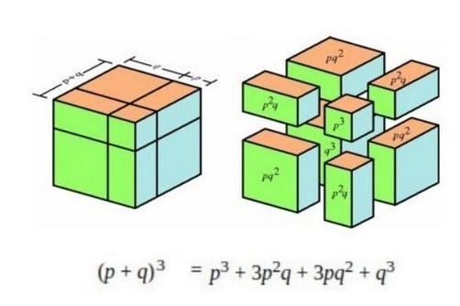

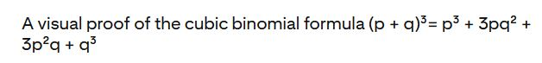

ΣΧΟΛΙΟΝ. Βλ. και, Cubic equation, <https://en.wikipedia.org/wiki/Cubic_equation>,

#### αναγωγη σε δευτεροβαθμια εξισωση

Εξισωση x3 +px +q =0

Ταυτοτητα (s+t)3 -3st(s+t) –(s3 +t3) =0

Αν βρω s, t τετοια ωστε

-3st=p και –(s3 +t3)=q,

tote EXΩ την λυση x=s+t !!!

ΟΜΩΣ, τοτε τα s, t, ικανοποιουν

st=-p/3 και s3 +t3 =-q, η

s3t3=-(p/3)3 και s3 +t3 =-q,

δηλ. για τα s3 , t3,ξερω αθροισμα και γινομενονείναι λυσεις 2-βαθμιου εξισωσεως (!) που ξερω πώς να την λυσω.

Είναι η y2 +qy-(p/3)3 =0,

Αφου βρω τα s3 , t3,θα εξαγαγω τις κυβικες ριζες, οποτε βρισκω τα s, t και το (s+t) είναι η ζητουμενη ριζα ! (Αυτό ΔΕΝ «γινεται» «γεωμετρικα»).

##### ΠΡΟΤΑΣΙΣ. Ν-οστη ριζα μιγαδικου

Estω ν θετικος ακεραιος, και z mhgadikos όχι 0.

Τοτε υπαρχει μια τουλαχιστον ν-οστη ριζα του z (δηλ. υπαρχει τουλαδιστον ενας μιγαδικος w, ωste wν =ζ.

Αποδ. Ο z γραφεται ως γνωστον

z=r(cosθ+isinθ),

Είναι η τριγωνομετρικη μορφη του z.

Εστω w= r(cos(θ/ν)+isin(θ/ν))

Kata ton τυπο de MOIVRE formula, (βλ. wikipedia https://en.wikipedia.org/wiki/De_Moivre%27s_formula, ), ισχυει

w ν =( r(cos(θ/ν)+isin(θ/ν) )ν = r(cosθ+isinθ),

Αρα το συγκεκριμενο w, είναι μια ν-οστη ριζα του z.

###### ΣΧΟΛΙΑ,

ΓΕΩΜΕΤΡΙΚΗ ΘΕΩΡΗΣΙΣ

Εστω x, s, t, μηκη, p εμβαδον, q ογκος.

s3t3=-(p/3)3 **δεν εχει αμεσον γεωμετρικον νοημα**,

ΠΝΕΥΜΑ ΑΝΤΙΛΟΓΙΑΣ: Μια στιγμη. Αν η ως ανω 2-βαθμια εξισωση ΔΕΝ εχει (πραγματικες) ριζες, τοτε «τινος» «θα εξαγαγω τις κυβικες ριζες» ?

ΠΝΕΥΜΑ ΑΙΣΙΟΔΟΞΙΑΣ: Ελα μωρε τωρα, λεπτομεριεσ, κατι θα βρεθει !.

#### ΠΑΡΑΔΕΙΓΜΑ, 2 και μιγαδικοι, Βλ. Ars Magna p. 99,

(x-2)(x2 +2x+10) =(x3 + 6x-20),

Opote oi rizes einai 2, -1+i31/2 , -1-i31/2 ,

Η εξισωση αυτή εχει την πραγματικη ριζα 2

Σελ. 99

Genikotera η ως ανω «λυσις»,

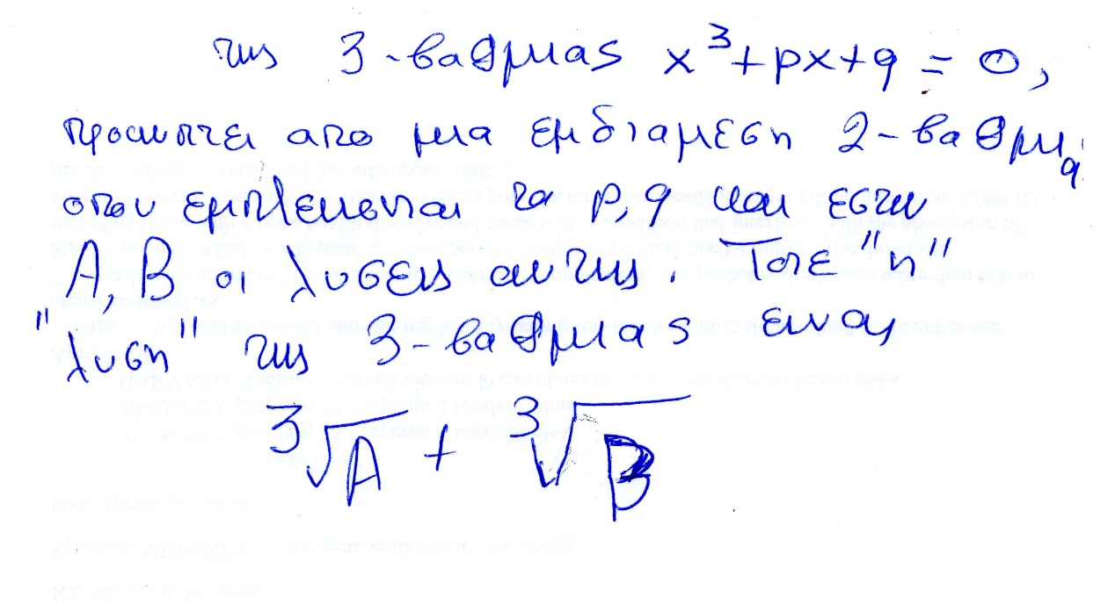

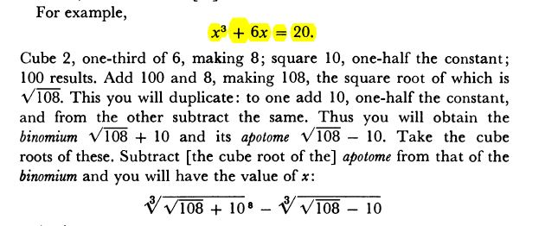,

ΠΟΥ ΕΙΝΑΙ Η ΛΥΣΗ 2?

ΓΕΝΙΚΟΤΕΡΑ,αν 3-βαθμια, εχει 1 πραγματικη και δυο μιγαδικες, ΤΟΤΕ ΚΑΤΙ ΓΙΝΕΤΑΙ, ΑΛΛΟΙΩΣ τι?

##### ΑΝΑΛΥΣΙΣ,

????? Srinivasa Ramanujan, Srinivasa Ramanujan,

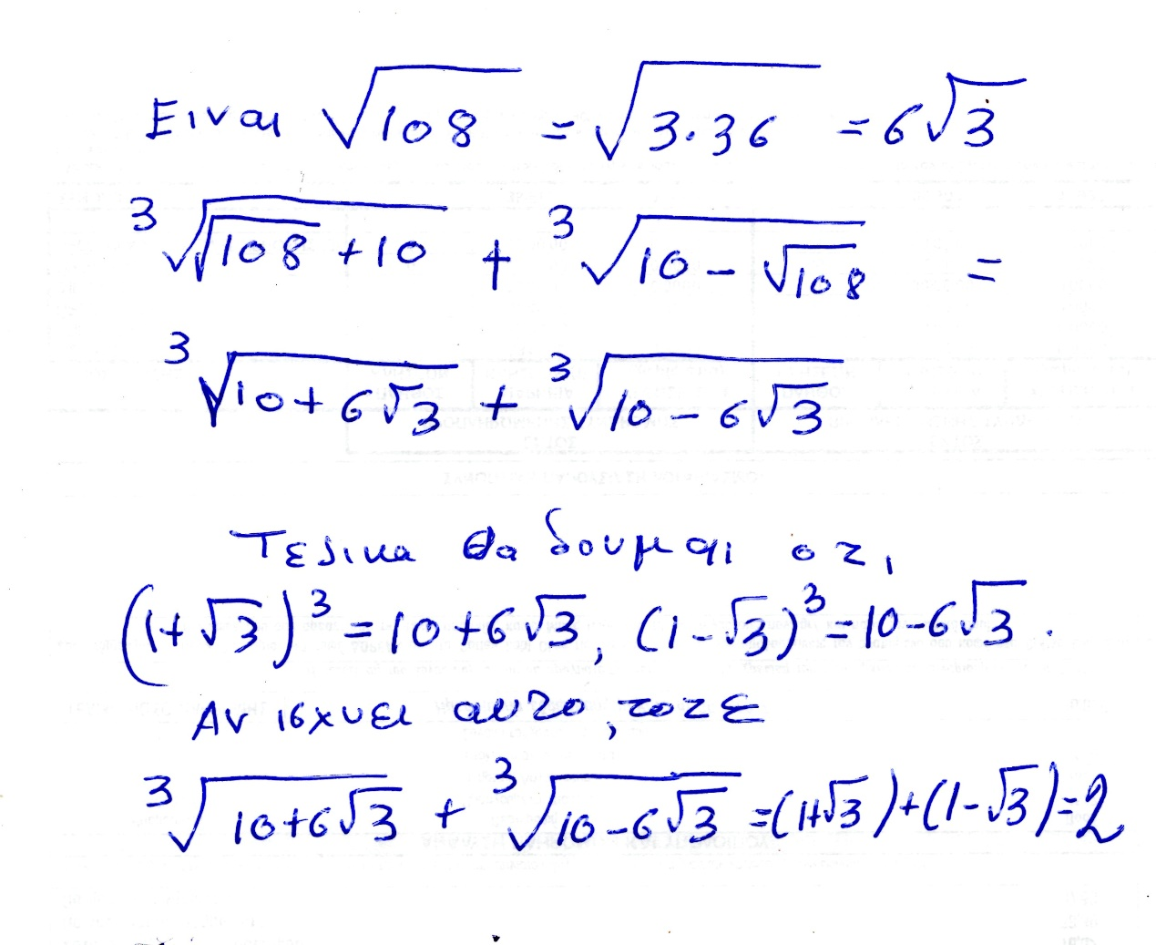

Fysika h isothyta ayth apodeiknyetai mesω πραξεων. Υπαρχει θεμα του «πως μας ηρθε», το οποιον θα συζητησουμε καπως και κατωτερω.

Ώστε εδώ απεδειχθη ότι αυτό του βρισκει και o CARDANO, einai ontωs h riza 2, που το ξεραμε από την αρχη.

Όμως …

«ΜΙΚΡΗ ΑΝΑΛΥΣΗ» όχι 2025,

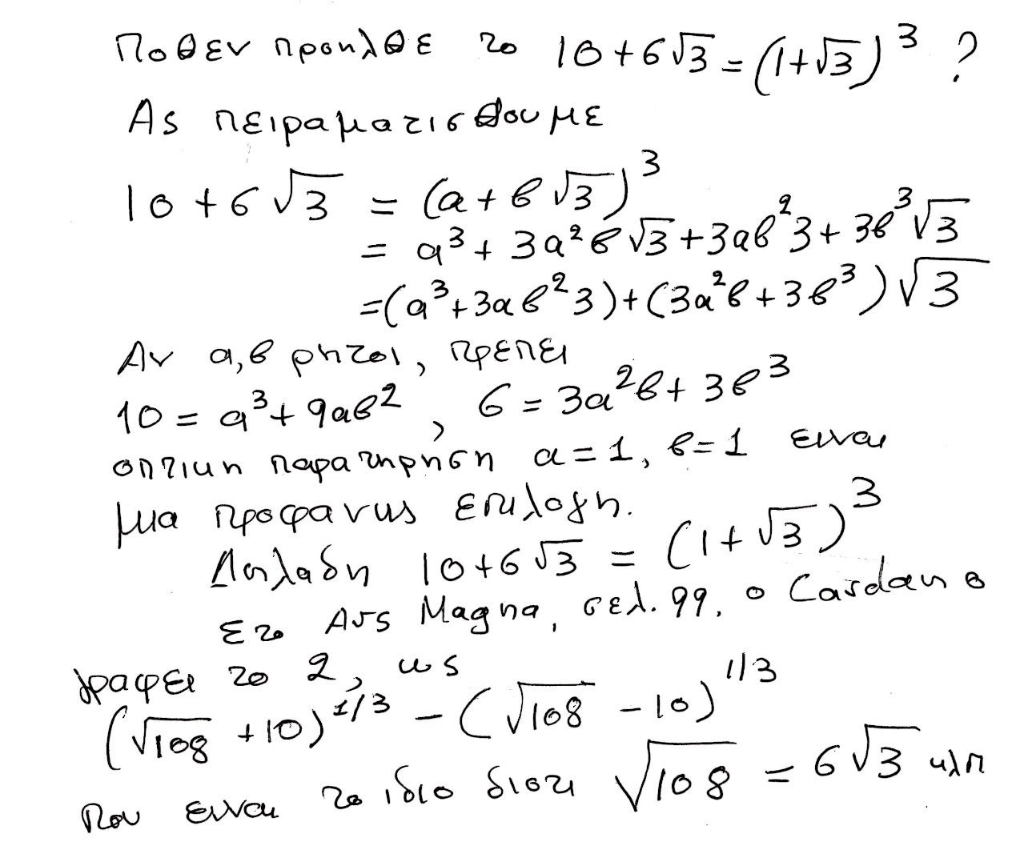

### ΣΥΓΚΕΚΡΙΜΕΝΑ ΠΑΡΑΔΕΙΓΜΑΤΑ,

#### 2 και μιγαδικοι, x3 + 6x=20, einai πιο παννω,

Βλ. Ars Magna p. 99,

Η εξισωση αυτή εχει την πραγματικη ριζα 2

(x-2)(x2 +2x+10),

Opote oi rizes einai 2, 1+i31/2 , 1-i31/2 ,

Ο ΙΕΡΩΝΥΜΟΣ, γραφει



Ας δουμαι τι δινουν οι τυποι του CARDANO.

ΣΓΠSrinivasa Ramanujan, Srinivasa Ramanujan,

Συνεχιζουμε το παραπανω



Ώστε εδώ απεδειχθη ότι αυτό του βρισκει και o CARDANO, einai ontωs h riza 2, που το ξεραμε από την αρχη.

Όμως …

Παρακατω το αποδεικνυουμε στην μορφη ΣΓΠ

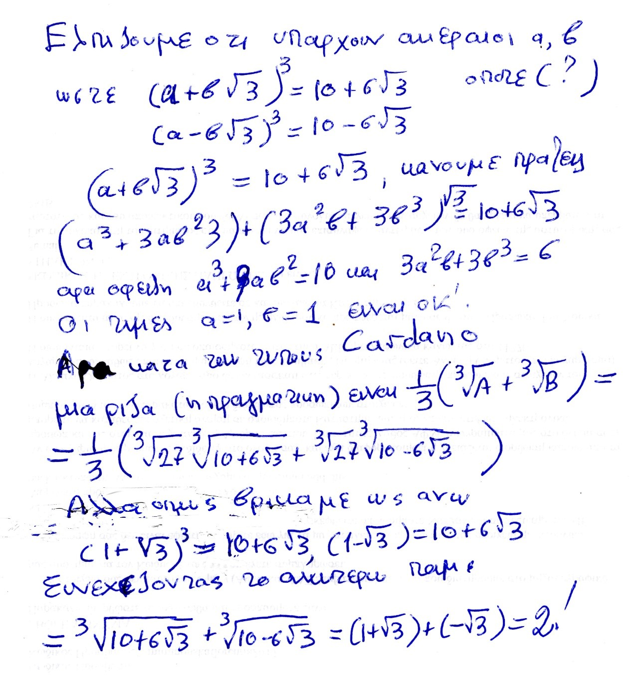

ΟΥΦ !, στην τελευταια γραμμη ξεχασα το 1 στο (1-31/2 )

Επισης ξεχασα τον εκθετη 3 στο, (1-31/2 )

ΣΧΟΛΙΟ ΣΓΠ, .

Οι τυποι του ΙΕΡΩΝΥΜΟΥ, ενιοτε δινουν πραγματικες ριζες σε ΠΟΛΥΠΛΟΚΗ ΜΟΡΦΗ,

#### Ριζες 1, 2, -3, x3 -7x+6=0

Θεωρουμε την ως ανω εξισωση. Την φτιαξαμε από το γινομενο

(x-1)(x-2)(x+3)= x3 -7x+6, ριζες 1, 2, -3.

Κατά την ως ανω μεθοδο του CARDANO, οι ριζες περιγραφονται ως κατωτερω.

Κανοντας τις πραξεισ

Α=-81+30(31/2 )i, Β==-81-30(31/2 )i,

ΘΕΤΟΝΤΑΣ ω=(1+(31/2 )i)/2.

H πορεια του CARDANO (με μεταγενεστερες βελτιωσεις), δινει τις τρεις ριζες

ρ1 =(1/3)(Α1/3 +Β1/3 )

ρ2 =(1/3)(ωΑ1/3 +ω2Β1/3 )

ρ3 =(1/3)( ω2Α1/3 +ωΒ1/3 )

Κανοντας απλα τις πραξεις, όπως καταλαβαινουμε τους μιγαδικους σημερα, διαπιστωνουμε τις ισοτητες

((3+ 2(31/2)i)3 =A kai ((3- 2(31/2)i)3 =B

οποτε

ρ1 = (1/3) ((3+ 2(3 1/2)i+ ((3- 2(3 1/2)i ) )=2

ρ2 =(1/3)(ωΑ1/3 +ω2Β1/3 )=1

ρ3 =(1/3)( ω2Α1/3 +ωΒ1/3 )=-3

Η ΑΠΟΔΕΙΞΗ ΤΕΛΕΙΩΣΕ,

#### πως όμως «μαντεψαμε»,

πως όμως «μαντεψαμε» το ((3+ 2(31/2)i) και

(3- 2(31/2)i) είναι οι κυβικες ριζες των Α και Β, ?

Ας δουμε πως βρισκουμε την «κυβικη» ριζα του Α=-81+30(31/2 )i,

Ξεκιναμε με την ελπιδα; Ότι υπαρχουν ακεραιοι α, β, ώστε

(α + β31/2i)3 =-81+30(31/2 )i,

Μετα από καποια αναζητηση, διαπιστωνουμε ότι τα α=3 και β=2, είναι λυσεις, και προχωρουμε με αυτές.

Τα παραπανω λιγο-πολύ με poly δισταγμο ηταν το στυλ του BOMBELLI (όχι του CARDANO)

Παρεμφερει υπολογισμους κανει και ο ΚΑΤΖ p. 406.

#### ΣΧΟΛΙΟΝ ΣΓΠ.

Ενιοτε οι τυποι του ΙΕΡΩΝΥΜΟΥ δινουν πραγματικες ριζες με πραξεις μεσω ΜΙΓΑΔΙΚΩΝ.

Εδώ εμφανιζεται συγκεκριμενα η ΠΟΙΟΤΙΚΗ ΔΙΑΦΟΡΑ μεταξυ β/βαθμιων και τριτοβαθμιων εξισωσεων

Συγκρισης με δευτεροβαθμια εξισωση,

ΜΕΤΑΞΥ β/θμιων και τριτο/βαθμιων Εξισωσεων

Η αναγκη υπαρξης ευρυτερου «κοσμου», για τις τριτο/βαθμιεσ Εξισωσεις. Τετοιος είναι οι ΜΙΓΑΔΙΚΟΙ

ΒΑΒΥΛΩΝΙΟΙ. Πραγματικοι ΘΕΤΙΚΟΙ

ΕΥΚΛΕΙΔΗΣ. ΓΕΩΜΕΤΡΙΚΑ ΜΕΓΕΘΗ, Κατασκευες ΚΑΝΟΝΑΣ-ΔΙΑΒΗΤΗΣ

ΔΙΟΦΑΝΤΟΣ, ΡΗΤΟΙ-ΘΕΤΙΚΟΙ

ΧΟΡΑΣΜΙΟΣ, Πραγματικοι ΘΕΤΙΚΟΙ

ΙΕΡΩΝΥΜΟΣ-ΜΠΟΜΠΕΛΙ, ΜΙΓΑΔΙΚΟΙ

### ΠΑΡΑΤΗΡΗΣΕΙΣ ΕΠΙ ΤΟΥ ARS MAGNA,

p. vii,

FOREWORD by Oystein Ore

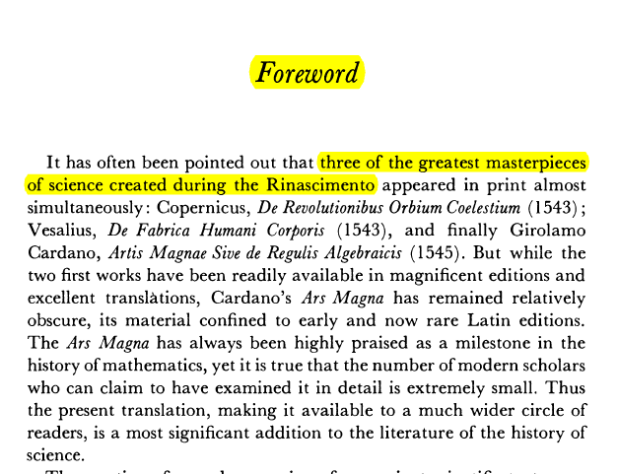

p. xiii

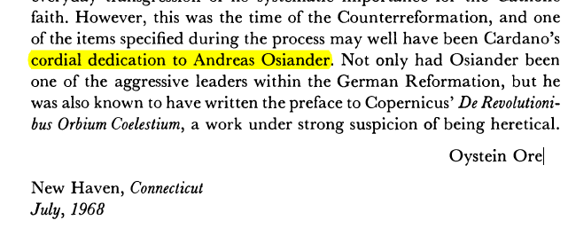

#### DEDICATION to ANDREAS OSIANDER,

p. 2

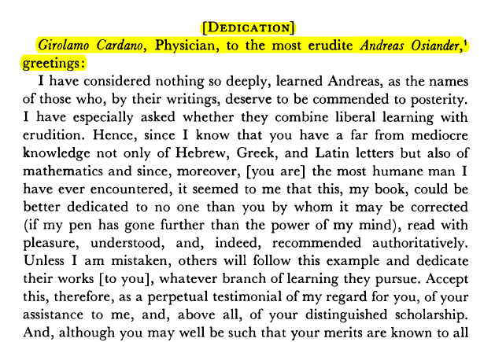

#### THE ARAB,

p. 7

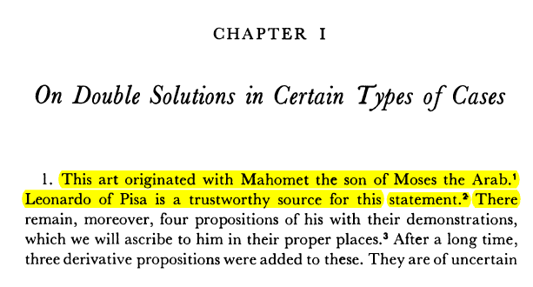

#### ΜΙΓΑΔΙΚΟΙ ΑΡΙΘΜΟΙ,

p. 219,

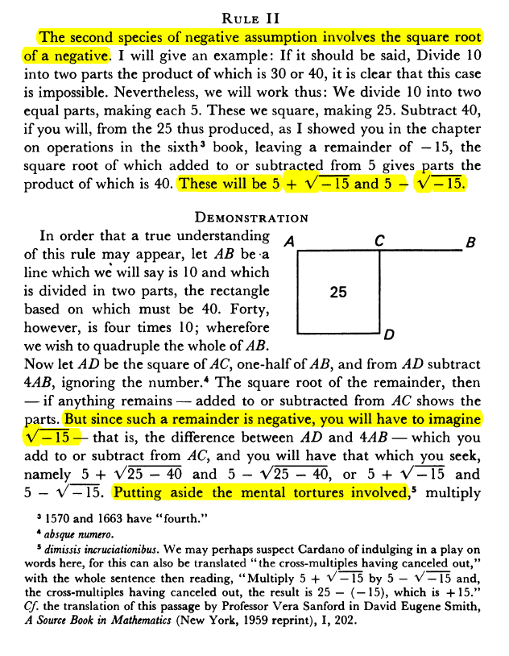

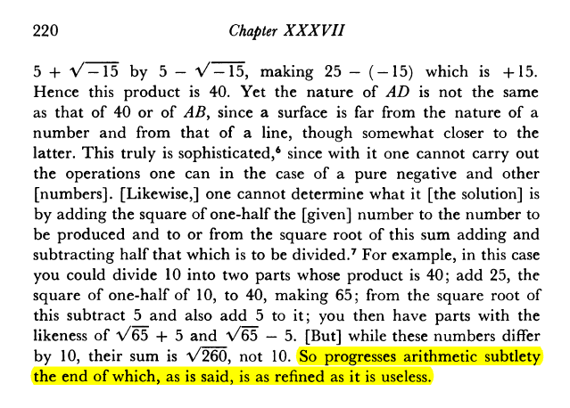

INFO,

subtlety λεπτότητα, επιδεξιότητα

refined, εκλεπτυσμένος, εξευγενισμένος

#### ΣΥΓΚΡΙΣΗ με δευτεροβαθμιες.

Για να βρουμε τις 3 πραγματικες ριζες, εχουμε αναγκη την **υπαρξη ενοσ ευρυτερου σωματος περαν των πραγματικων.**

#### ΤΙ ΕΚΑΝΕ ΤΗΝ ΔΙΑΦΟΡΑ,

«περισσοτερη «αλγεβρικοτης»»

ΔΕΝ υπηρχε καποιο νέο εργαλειο. Πιο επιδεξια χρηση των παλαιων.

### CARDAN BIO, WIKIPEDIA,

<https://en.wikipedia.org/wiki/Gerolamo_Cardano>,

Gerolamo Cardano (Italian: [dʒeˈrɔːlamo karˈdaːno]; also Girolamo[3] or Geronimo;[4] French: Jérôme Cardan; Latin: Hieronymus Cardanus; 24 September 1501– 21 September 1576) was an Italian polymath, whose interests and proficiencies ranged through those **of mathematician, physician, biologist, physicist, chemist, astrologer, astronomer, philosopher, writer, and gambler**.[5] He was one of the most **influential mathematicians of the Renaissance**, and was one of the key figures in the foundation of probability and the earliest introducer of the binomial coefficients and the binomial theorem in the Western world. He wrote more than 200 works on science.[6]

Cardano partially invented and described several mechanical devices including the combination lock, the gimbal consisting of three concentric rings allowing a supported compass or gyroscope to rotate freely, and the Cardan shaft with universal joints, which allows the transmission of rotary motion at various angles and is used in vehicles to this day. He made significant contributions to hypocycloids, published in De proportionibus, in 1570. The generating circles of these hypocycloids were later named Cardano circles or cardanic circles and were used for the construction of the first high-speed printing presses.[7]

Today, he is well known for his achievements in algebra. In his 1545 book Ars Magna, he made the first systematic use of negative numbers in Europe, published with attribution the solutions of other mathematicians for the cubic and quartic equations, and **acknowledged the existence** of imaginary numbers.

SGP. Ta anωterω einai yperbolika,

SGP. ΣΧΟΛΙΑ. “first systematic use of negative numbers in Europe”.

FibonacciSiglerLiberAbaciS.pdf, p. 320. *On a Purse Found by Five Men.* Einai kapos asafes. To ekshgei kallitera o KATZ, p. 345.

ΣΧΟΛΙΑ. «acknowledged the existence of imaginary numbers»

See CardanoArsMagnaTranWitmerS.pdf, p. pdf 243-244.

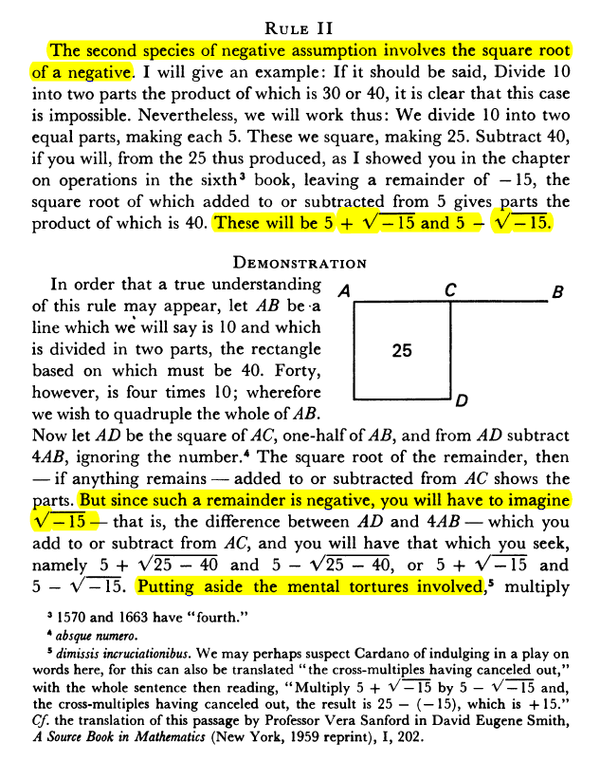

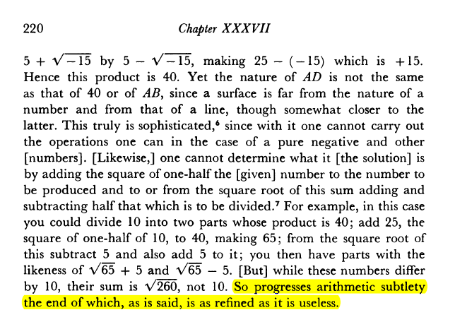

So progresses arithmetic subtlety (εκλεπτισμενοσ), the end of which, as is said, is as refined (εξευγενισμενοσ), as it is useless.

#### Early life and education

Cardano was born on 24 September 1501[8] in Pavia, Lombardy, the illegitimate child of Fazio Cardano, a **mathematically gifted jurist, lawyer, and close friend of Leonardo da Vinci.** **In his autobiography (De propria vita, 1821), Cardano wrote that his mother, Chiara Micheri, had taken "various abortive medicines**" (p. 4) to terminate the pregnancy; he said: "I was taken by violent means from my mother; I was almost dead." She was in labour ? for three days.[9] Shortly before his birth, his mother had to move from Milan to Pavia to escape the Plague; her three other children died from the disease.

From CardanoGirolamoBookΟfMyLifeDeVitaPropriaLiber]

After a depressing childhood, with frequent illnesses, and the rough upbringing by his overbearing father, in 1520, Cardano entered the **University of Pavia** against the wish of his father, who wanted his son to undertake studies of law, but Girolamo felt more attracted to philosophy and science. During the Italian War of 1521–1526, however, the authorities in Pavia were forced to close the university in 1524.[10] Cardano **resumed his studies at the University of Padua**, where he graduated with a doctorate in medicine in 1525.[11] His eccentric and confrontational style did not earn him many friends and he had a difficult time finding work after his studies had ended. In 1525, Cardano **repeatedly applied to the College of Physicians in Milan, but was not admitted owing to his combative reputation and illegitimate birth**. However, he was consulted by many members of the College of Physicians, because of his irrefutable intelligence.[12]

#### Early career as a physician

Cardano wanted to practice medicine in a large, rich city like Milan, but he was **denied a license to practice, so he settled for the town of Piove di Sacco**, where he practiced without a license. There, he married Lucia Banderini in 1531. Before her death in 1546, they had three children, Giovanni Battista (1534), Chiara (1537) and Aldo Urbano (1543).[9] Cardano later wrote that those were the happiest days of his life.

With the help of a few noblemen, Cardano obtained a teaching position in mathematics in Milan. **Having finally received his medical license, he practiced mathematics and medicine simultaneously, treating a few influential patients in the** process. Because of this, he became one of the most sought-after doctors in Milan. In fact, by 1536, he was able to quit his teaching position, although he was still interested in mathematics. His notability in the medical field was such that the aristocracy tried to lure him out of Milan. Cardano later wrote that he turned down offers from the kings of Denmark and France, and the Queen of Scotland.[13]

#### Mathematics

Portrait of Cardano on display at the School of Mathematics and Statistics, University of St Andrews

Gerolamo Cardano was the first European mathematician to make systematic use of negative numbers.[14] He published with attribution the solution of Scipione del Ferro to the cubic equation and the solution of Cardano's student Lodovico Ferrari to the quartic equation in his 1545 book Ars Magna, an influential work on algebra. The solution to one particular case of the cubic equation a x 3 + b x + c = 0 ax^3+bx+c=0[15] (in modern notation) had been communicated to him in 1539 by **Niccolò Fontana Tartaglia** (who later claimed that Cardano had sworn not to reveal it, and engaged Cardano in a decade-long dispute) in the form of a poem,[16] but del Ferro's solution predated Tartaglia's.[13] In his exposition, he acknowledged the existence of what are now called imaginary numbers, although he did not understand their properties, described for the first time by his Italian contemporary Rafael Bombelli. In Opus novum de proportionibus he introduced the binomial coefficients and the binomial theorem.

ARS MAGNA p. 8.

**Cardano was notoriously short of money and kept himself solvent by being an accomplished gambler and chess player**. His book about games of chance, Liber de ludo aleae ("Book on Games of Chance"), written around 1564,[17] but not published until 1663, contains the first systematic treatment of probability,[18**] as well as a section on effective cheating methods.** He used the game of throwing dice to understand the basic concepts of probability. He demonstrated the efficacy of defining odds as the ratio of favourable to unfavourable outcomes (which implies that the probability of an event is given by the ratio of favourable outcomes to the total number of possible outcomes).[19] He was also aware of the multiplication rule for independent events but was not certain about what values should be multiplied.[20]

Cardano was notoriously short of money and kept himself solvent by being an accomplished gambler and chess player. His book about games of chance, Liber de ludo aleae ("Book on Games of Chance"), written around 1564,[17] but not published until 1663, contains the first systematic treatment of probability,[18] as well as a section on effective cheating methods. He used the game of throwing dice to understand the basic concepts of probability. He demonstrated the efficacy of defining odds as the ratio of favourable to unfavourable outcomes (which implies that the probability of an event is given by the ratio of favourable outcomes to the total number of possible outcomes).[19] He was also aware of the multiplication rule for independent events but was not certain about what values should be multiplied.[20]

#### Later years and death

**In 1553 Cardano traveled to Scotland to treat the Archbishop of St Andrews who suffered of a disease that had left him speechless and was thought incurable. The treatment was a success and the diplomat Thomas Randolph recorded that "merry tales" about Cardano's methods were still current in Edinburgh in** 1562.[24] Cardano wrote that the Archbishop had been short of breath for ten years, and after the cure was effected by his assistant, he was paid 1,400 gold crowns.[25]

INFO. GOOGLE What is a Scottish church called?

Church of Scotland, **national church in Scotland,** which accepted the Presbyterian faith during the 16th-century Reformation. John Knox. Areas Of Involvement: Reformed and Presbyterian churches Related People: John Knox Alexander Henderson.

Medallion portrait of Cardano aged 49 by Leone Leoni (1509–1590)

**Two of Cardano's children — Giovanni Battista and Aldo Urbano — came to ignoble ends.** Giovanni Battista, Cardano's eldest and favorite son was arrested in 1560 for having poisoned his wife,[13] after he had discovered that their three children were not his. Giovanni was put to trial and, when Cardano could not pay the restitution demanded by the victim's family, was sentenced to death and beheaded. Cardano's other son Aldo Urbano was a gambler, who stole money from his father, and so Gerolamo disinherited him in 1569.

Cardano moved from Pavia to Bologna, in part because he believed that the decision to execute his son was influenced by Gerolamo's battles with the academic establishment in Pavia, and his colleagues' jealousy at his scientific achievements, and also because he was beset with allegations of sexual impropriety with his students.[9] He obtained a position as professor of medicine at the University of Bologna.

##### Cardano was arrested by the Inquisition in 1570

**after an accusation of heresy by the Inquisitor of Como, who targeted Cardano's De rerum varietate (1557) (ΔΙΑΦΟΡΑ ΠΡΑΓΜΑΤΑ) .**[26] The inquisitors complained about Cardano's writings on astrology, especially his claim that self-**harming religiously motivated actions of martyrs and heretics were caused by the stars.[27**] In his 1543 book De Supplemento Almanach, a commentary on the astrological work Tetrabiblos by Ptolemy, Cardano had also published a horoscope of Jesus. Cardano was imprisoned for several months and lost his professorship in Bologna. He abjured (απεποιηθην), and was freed, probably with help from powerful churchmen in Rome.[27**] All his non-medical works were prohibited and placed on the Index.[27]**

**[27] RegierJonathanReadingCardanoWithTheRomanInquisition,**

# [ΜΙΓΑΔΙΚΟΙ, [COMPLEX NUMBERS, ΝΑΙ 2025, 2024,

## ΜΙΓΑΔΙΚΟΙ (σημερα),

### ΟΡΙΣΜΟΙ,

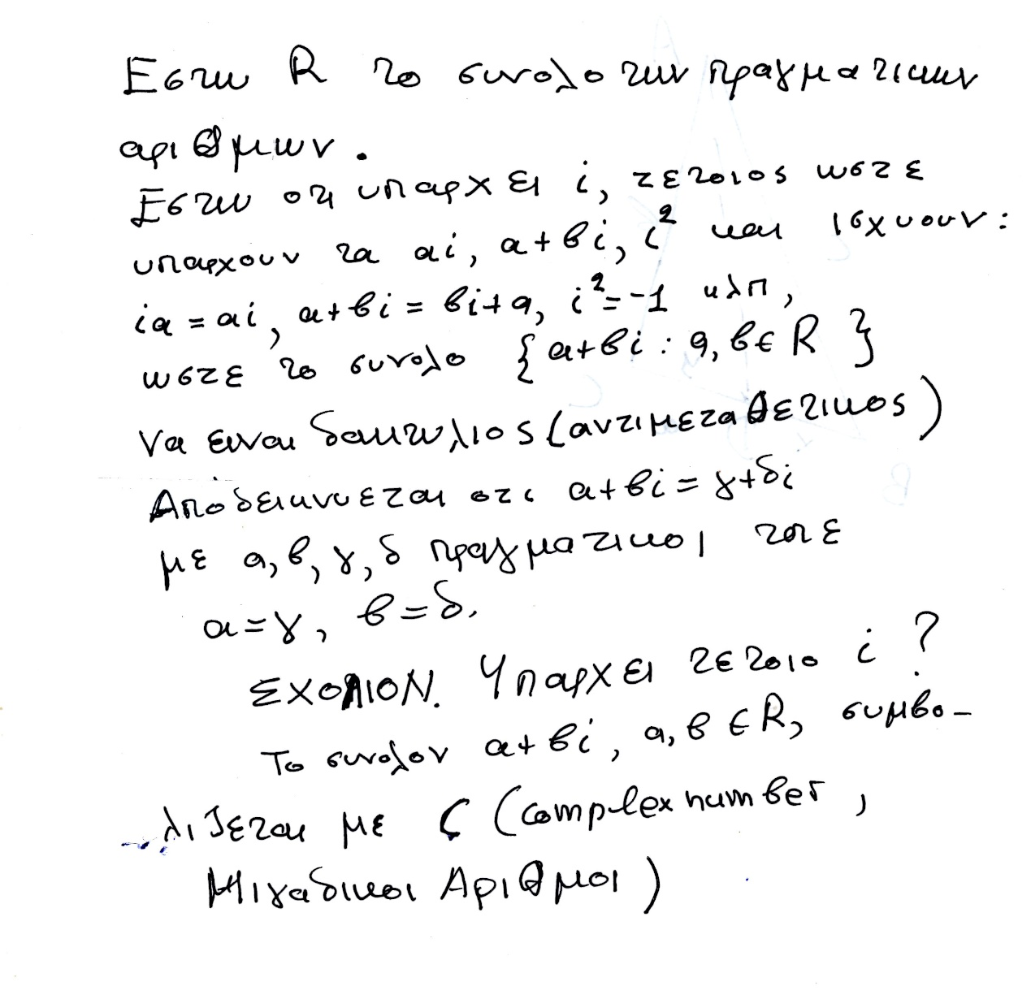

### ΡΙΖΙΚΑ,

Εστω α πραγματικος θετικος η 0, τοτε α1/2 είναι ο θετικος η 0 β, που β2 =α.

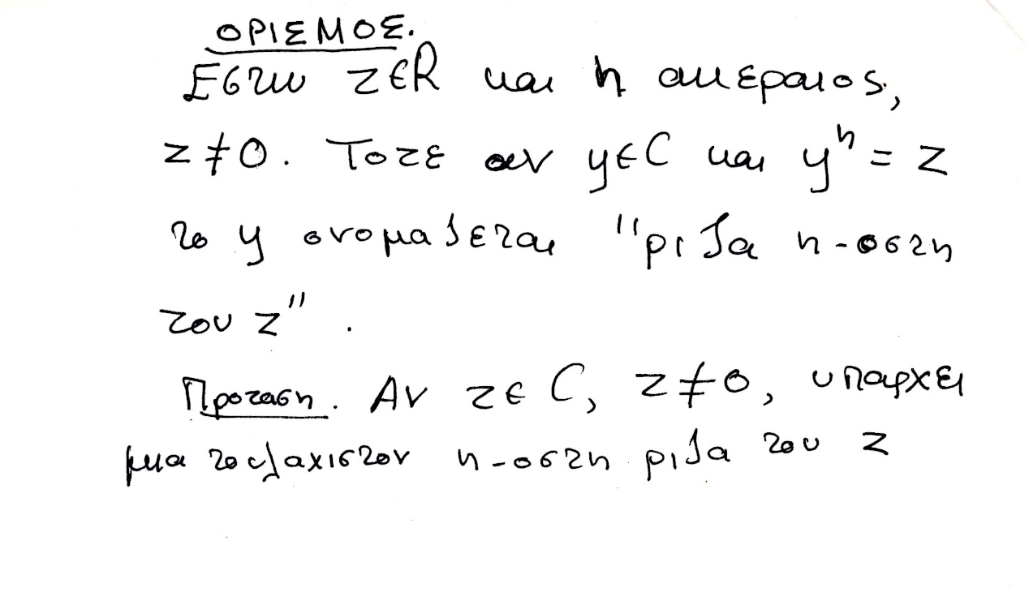

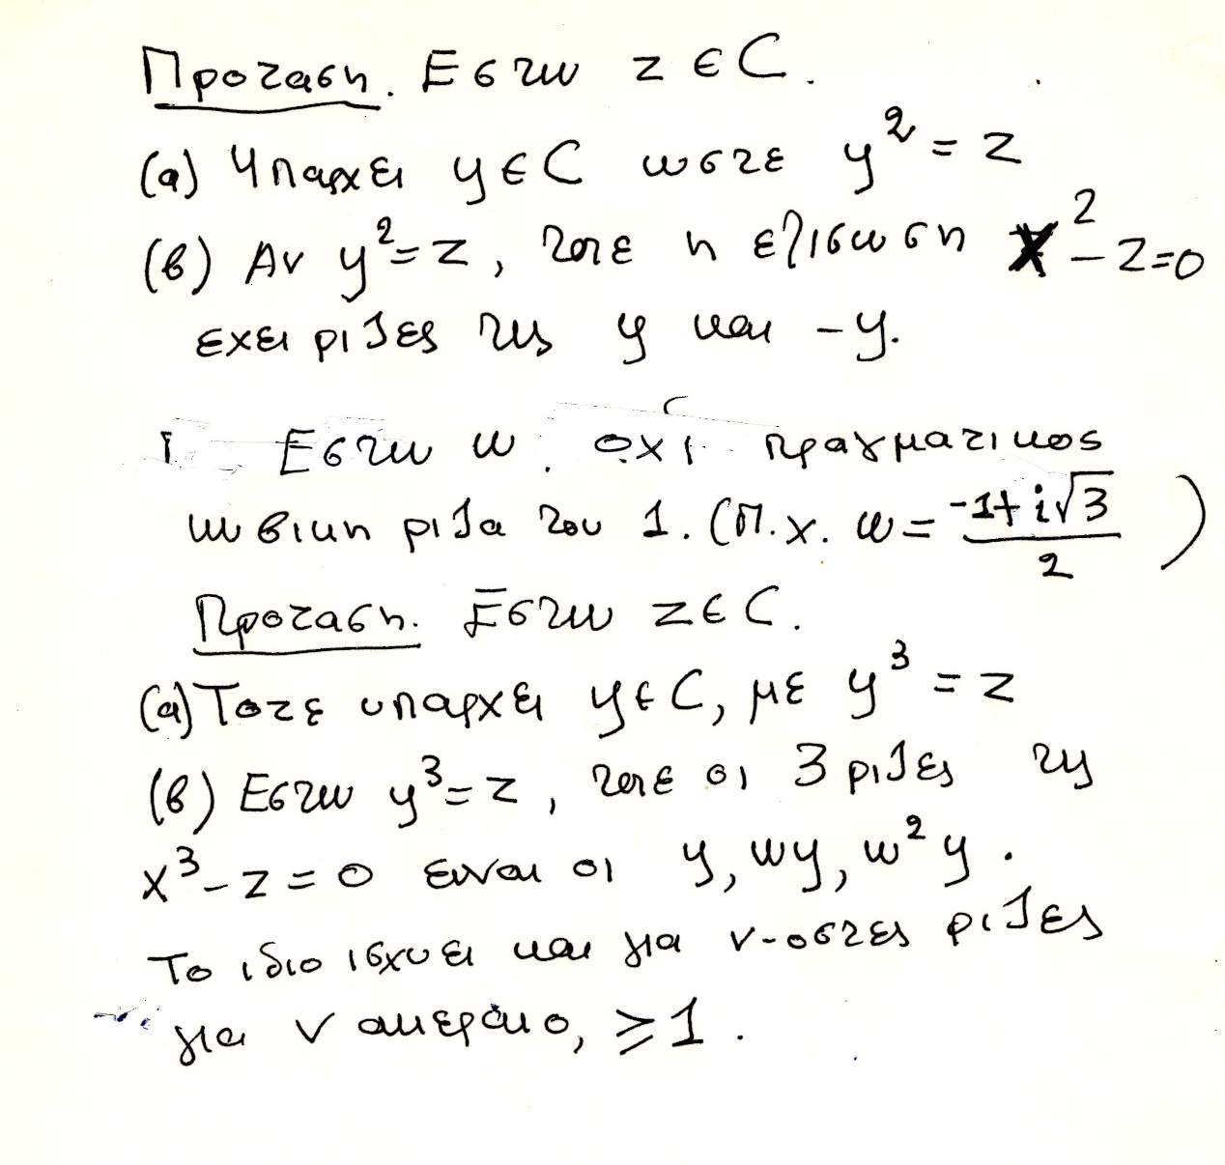

## ΜΙΓΑΔΙΚΟΙ κλπ (κατά ΜΠΟΜΠΕΛΛΙ),

#### ΠΡΑΓΜΑΤΙΚΟΙ ΑΡΙΘΜΟΙ,

##### https://en.wikipedia.org/wiki/Rafael_Bombelli#cite_note-Stedall-5

In the book that was published in 1572, entitled Algebra, Bombelli gave a comprehensive account of the algebra known at the time. **He was the first European to write down the way** of performing computations with negative numbers. The following is an excerpt from the text:

"Plus times plus makes plus

**Minus times minus makes plus**

Plus times minus makes minus

Minus times plus makes minus

Plus 8 times plus 8 makes plus 64

Minus 5 times minus 6 makes plus 30

Minus 4 times plus 5 makes minus 20

Plus 5 times minus 4 makes minus 20"

As was intended, Bombelli used simple language as can be seen above so that anybody could understand it. But at the same time, he was thorough.

##### Brahmagupta

**Brahmagupta's Brahmasphuṭasiddhānta (628 a.d.)**, is the first book that provides rules for arithmetic manipulations that apply to zero and to negative numbers.[27] The Brāhmasphuṭasiddhānta is the earliest known text to treat zero as a number in its own right, rather than as simply a placeholder digit in representing another number as was done by the Babylonians or as a symbol for lack of quantity as was done by Ptolemy and the Romans. In chapter eighteen of his Brāhmasphuṭasiddhānta, Brahmagupta describes operations on negative numbers. He first describes addition and subtraction,

He goes on to describe multiplication,

18.33. The product of a negative and a positive is negative, **of two negatives positive,** and of positives positive; the product of zero and a negative, of zero and a positive, or of two zeros is zero.[20]

#### ΜΙΓΑΔΙΚΟΙ,

##### https://mathshistory.st-andrews.ac.uk/Biographies/Bombelli/,

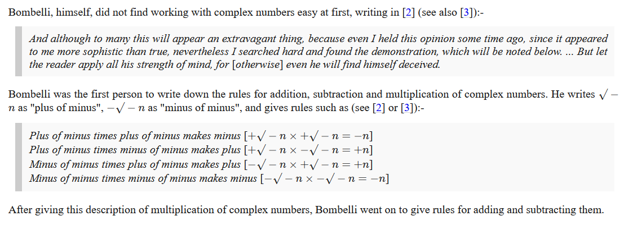

**Bombelli called the imaginary number i "plus of minus" and used "minus of minus" for -i**.

Se sygxrono symbolismo, π.χ.

(2i)(3i)=-6, (2i)(-3i)=6, (-2i)(3i)=6, (-2i)(-3i)=-6, .

**Plus di minus einai i, minus di minus is -i,**

Bombelli avoided confusion by giving a special name to square roots of negative numbers, instead of just trying to deal with them as regular radicals like other mathematicians did. This made it clear that these numbers were neither positive nor negative. This kind of system avoids the confusion that Euler encountered. **Bombelli called the imaginary number i "plus of minus" and used "minus of minus" for -i**.

(a+bi)(c+di)=ac +a(di)+(bi)c+(bi)((di)= ac+(ad)i +(bc)i +(bd**)(ii)** =

= ac + (ad+bc)i + (bd)(-1) = (ac –bd) + (ad+bc)i

**ΣΧΟΛΙΟ. Κατο περιεργο**

Όμως

((-1)1/2 )((-1)1/2 ) =( (-1)(-1) )1/2 =1 η ii=(-1) ?

Το z1/2  den orizetai

### ΣΥΜΒΟΛΙΣΜΟΙ,

#### ΠΑΛΑΙΟΤΕΡΗ ΓΡΑΦΗ ΔΥΝΑΜΕΩΝ,

KatzHistoryOfMathematics3rdS, 12.1.1. p.386

Algebraic Symbolism and Techniques (ΑΝΑΓΕΝΝHΣΗ),

**Algebraic Symbolism and Techniques**

Recall that Islamic algebra was entirely rhetorical. There were no symbols for the unknown or

its powers nor for the operations performed on these quantities. **Everything was written out in words**.

The same was generally true in the works of the early abacists and in the earlier Italian work of **Leonardo of Pisa (Fibonacci**).

Επισης η γραφη του ΙΕΡΩΝΥΜΟΥ ηταν «ρητορικη», (Rhetoric)

(SGP, Syncopated (Συγκεκομμενος)),

Early in the fifteenth century, however, some of the abacists (Arabic numerals), began to substitute abbreviations for unknowns. For example, in place of the standard words ***cosa* (thing, x),** *censo* (square, απογραφη), *cubo* (cube), and *radice* (root), some authors used the abbreviations *c*, *ce*, *cu*, and *R*. Combinations of these abbreviations were used for higher powers.

Thus,

***ce di ce* or *ce ce* stood for *censo di censo* or fourth power (*x*2*x*2);**

***ce cu* or *cu ce***, designating ***censo di cubo* and *cubo di censo*,** respectively**, ce di cu stood for fifth power (*x*2*x*3);** And

***cu cu*, designating *cubo di cubo*, stood for sixth power (*x*3*x*3**).

**Η επαναληψη δηλωνε γινομενο**.

Syncopated Algebra 275 – 1600

<https://jwilson.coe.uga.edu/emt668/emt668.student.folders/Hix/EMT635/Alg.sync.timeline.html>,

ΔΙΟΦΑΝΤΟΣ,

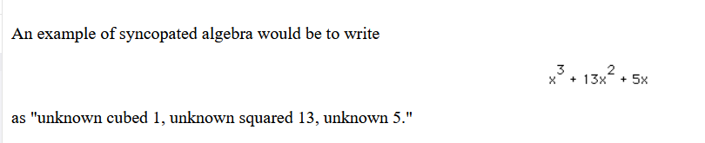

#### Here are some examples of Bombelli's notation.

<https://mathshistory.st-andrews.ac.uk/Biographies/Bombelli/>,

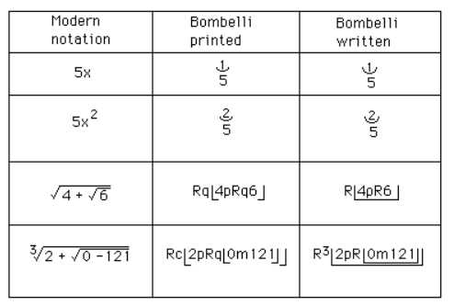

He then showed that, using his calculus of complex numbers, correct real solutions could be obtained **from the Cardan-Tartaglia formula for the solution to a cubic even when the formula gave an expression involving the square roots of negative numbers**.

Finally we should make some comments on Bombelli's notation. Although authors such as [Pacioli](https://mathshistory.st-andrews.ac.uk/Biographies/Pacioli/) had made limited use of notation, others such as [Cardan](https://mathshistory.st-andrews.ac.uk/Biographies/Cardan/) had used no symbols at all. Bombelli, however, used quite sophisticated notation. It is worth remarking that the printed version of his book uses a slightly different notation from his manuscript, and this is not really surprising for there were problems printing mathematical notation which to some extent limited the type of notation which could be used in print.

ΣΧΟΛΙΟΝ. Που πλεονεκτei ο BOMBELLI ?

xkxm =xk+n ,