20 ΔΙΑΛΕΞΙΣ,

ΣΑΒΒΑΤΟΝ, 24-05-2025,

**ΠΡΟΚΑΤΑΡΚΤΙΚΑ,**

Να λυσουμε τις ΕΡΓΑΣΙΕΣ,

6001LyshTrigonoEkTonYpsonAlgebr, 6002LyshTyposToyHrona, 6004LyshLengthOfBisector, 6003LyshEmbadoTetrapleurou, 8001LYSEISApaloifhDeuterouOrou,

Εγιναν 6001, 6002, 6003,

## BOMBELLI RAFAEL, RAFAEL BOMBELLI BIO,

### Rafael Bombelli,

<https://mathshistory.st-andrews.ac.uk/Biographies/Bombelli/>,

MacTutor logo MacTutor

Rafael Bombelli

Born January 1526, Bologna, Papal States (now Italy)

Died 1572, (probably) Rome, Papal States (now Italy)

Summary

Rafael Bombelli was an Italian mathematician who wrote an influential algebra text and made free use of both negative numbers and complex numbers.

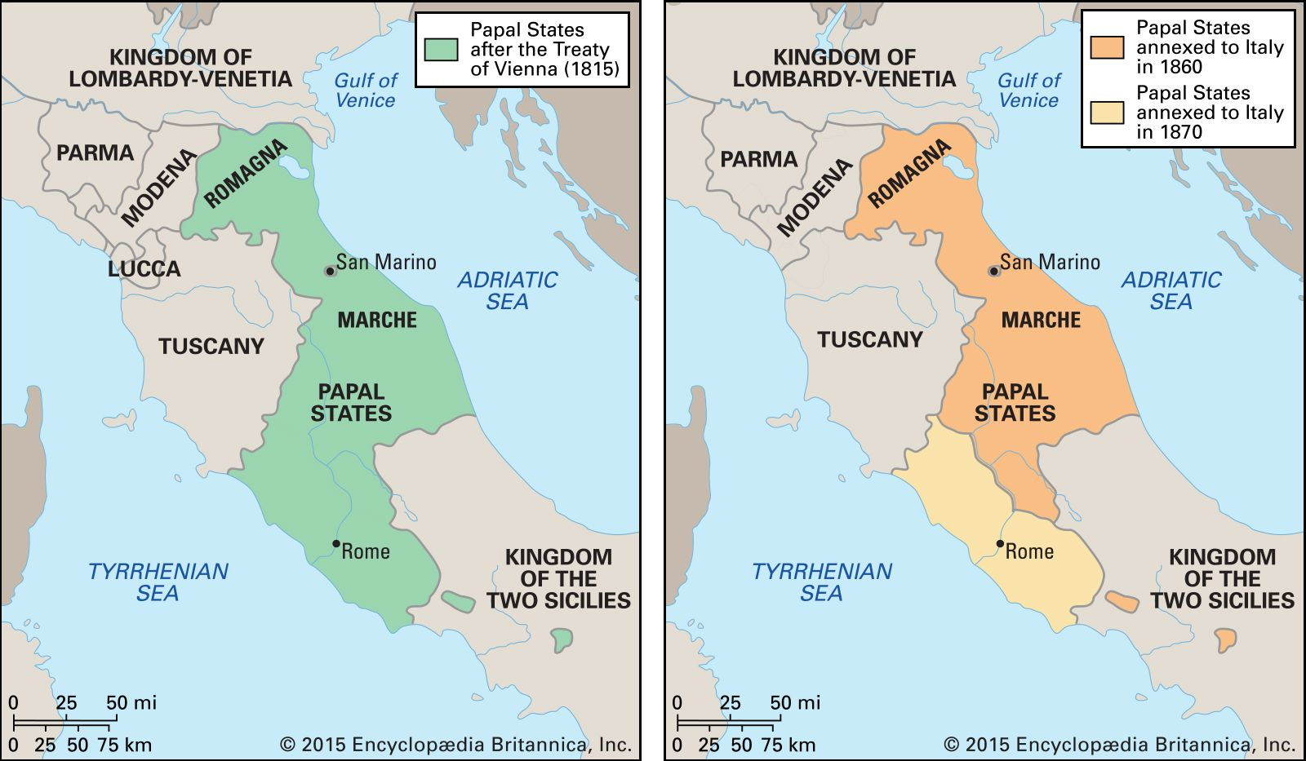

<https://www.google.com/search?client=firefox-b-d&sca_esv=373b249675fd824a&q=papal+state&tbm=isch&source=lnms&sa=X&ved=2ahUKEwjkk_2rxeKEAxWGRPEDHWUEBf8Q0pQJegQIDBAB&biw=1156&bih=502&dpr=1.25>,

Biography

**Rafael Bombelli**'s father was **Antonio Mazzoli** but he changed his name from **Mazzoli to Bombelli**. It is perhaps worth giving a little family background. The Bentivoglio family ruled over Bologna from 1443. **Sante Bentivoglio** was "signore" (meaning lord) of Bologna from 1443 and he was succeeded by Giovanni II Bentivoglio who improved the city of Bologna, in particular developing its waterways. **The Mazzoli family were supporters of the Bentivoglio family but their fortunes changed when Pope Julius II took control of Bologna in 1506, driving the Bentivoglio family into exile**. An attempt to regain control in 1508 was defeated and Antonio Mazzoli's grandfather, like several other supporters of the failed Bentivoglio coup, were executed. The Mazzoli family suffered for many years by having their property confiscated, but the property was returned to Antonio Mazzoli, Rafael Bombelli's father. **Antonio Mazzoli was able to return to live in Bologna**. There he carried on his trade as **a wool merchant and married Diamante Scudieri, a tailor's daughter.** Rafael Bombelli was their eldest son, and he was one of a family of six children. Rafael **received no university education**. He was taught by an engineer- architect **Pier Francesco Clementi** so it is perhaps not too surprising that Bombelli himself should turn to that occupation. **Bombelli found himself a patron in Alessandro Rufini who was a Roman noble**, later to become the Bishop of Melfi.

It is unclear exactly how Bombelli learnt of the leading mathematical works of the day, but of course he lived in the right part of Italy to be involved in the major events surrounding the solution of [cubic](https://mathshistory.st-andrews.ac.uk/Glossary/#cubic_equation) and [quartic equations](https://mathshistory.st-andrews.ac.uk/Glossary/#quartic_equation). [Scipione del Ferro](https://mathshistory.st-andrews.ac.uk/Biographies/Ferro/), the first to solve the cubic equation was the professor at Bologna, Bombelli's home town, but del [Ferro](https://mathshistory.st-andrews.ac.uk/Biographies/Ferro/) died the year that Bombelli was born. The contest between Fior and [Tartaglia](https://mathshistory.st-andrews.ac.uk/Biographies/Tartaglia/) (see [Tartaglia](https://mathshistory.st-andrews.ac.uk/Biographies/Tartaglia/)'s biography) took place in 1535 when Bombelli was nine years old, and [Cardan](https://mathshistory.st-andrews.ac.uk/Biographies/Cardan/)'s major work on the topic *Ars Magna* Ⓣ was published in 1545. **Clearly Bombelli had studied** [**Cardan**](https://mathshistory.st-andrews.ac.uk/Biographies/Cardan/)**'s work and he** also followed closely the very public arguments between [Cardan](https://mathshistory.st-andrews.ac.uk/Biographies/Cardan/), [Ferrari](https://mathshistory.st-andrews.ac.uk/Biographies/Ferrari/) and [Tartaglia](https://mathshistory.st-andrews.ac.uk/Biographies/Tartaglia/) which culminated in the contest between [Ferrari](https://mathshistory.st-andrews.ac.uk/Biographies/Ferrari/) and [Tartaglia](https://mathshistory.st-andrews.ac.uk/Biographies/Tartaglia/) in Milan in 1548 (see [Ferrari](https://mathshistory.st-andrews.ac.uk/Biographies/Ferrari/)'s biography for details).

From about 1548 Pier Francesco Clementi, Bombelli's teacher, worked for the Apostolic Camera, a specialised department of the papacy in Rome set up to deal with legal and financial matters. The Apostolic Camera employed Clementi to reclaim marshes near Foligno on the Topino River, southeast of Perugia in central Italy. This region had became part of the Papal States in 1439. It is probable that Bombelli assisted his **teacher Clementi** with this project, but we have no direct evidence that this was the case. We certainly know that around 1549 Bombelli became interested in another reclamation project in a neighbouring region.

It was in 1549 that Alessandro Rufini, Bombelli's patron, acquired the rights to reclaim that part of the marshes of the

**Val di Chiana** which belonged to the Papal States. The Val di Chiana is a fairly central region in the Tuscan Apennines which was not well drained either by the Arno river which runs north west going through Florence and Pisa to the sea, or by the Tiber which runs south through Rome. By 1551 Bombelli was in the Val di Chiana recording the boundaries to the land that was to be reclaimed. **He worked on this project until 1555 when there was an interruption to the reclamation work.**

**While Bombelli was waiting for the Val di Chiana project to recommence, he decided to write an algebra book**.

He had felt that the reason for the many arguments between leading mathematicians was the **lack of a careful exposition of the subject.** Only [Cardan](https://mathshistory.st-andrews.ac.uk/Biographies/Cardan/) had, in Bombelli's opinion, explored the topic in depth and his great masterpiece was not accessible to people without a thorough grasp of mathematics. Bombelli felt that a self-contained text which could be read by those without a high level of mathematical training would be beneficial. He wrote in the preface of his book [[2](https://mathshistory.st-andrews.ac.uk/Biographies/Bombelli/#reference-2)] (see also [[3](https://mathshistory.st-andrews.ac.uk/Biographies/Bombelli/#reference-3)]):-

**I began by reviewing the majority of those authors who have written on [algebra] up to the present, in order to be able to serve instead of them on the matter, since there are a great many of them.**

By 1557, the work at Val di Chiana still being suspended, Bombelli had begun writing his algebra text. We will study in detail the contents of the work below. Suffice to say for the **moment that, in 1560 when work at Val di Chiana recommenced, Bombelli had not completed his algebra book**.

Work at the Val di Chiana marshes could not have been far from completion when it had been suspended, for it was completed before the end of 1560. The scheme was a great success and through the project Bombelli gained a high reputation as an hydraulic engineer. In 1561 Bombelli went to Rome but **failed in an attempt to repair the Santa Maria bridge** over the Tiber. However, with reputation still high, Bombelli was taken on as a consultant for a project to drain the Pontine Marshes. These marshes in the Lazio region of south-central Italy had been an area where malaria had been a health hazard since the period of the Roman Republic. Several emperors and popes made unsuccessful attempts to reclaim the area but all, including the one which Bombelli acted as consultant on for Pope Pius IV, came to nothing. [It was not until 1928 that the Pontine Marshes were finally drained.]

On one of Bombelli's visits to Rome he made an exciting mathematical discovery. Antonio Maria Pazzi, who taught mathematics at the University of Rome, showed Bombelli a manuscript of [Diophantus](https://mathshistory.st-andrews.ac.uk/Biographies/Diophantus/)'s *Arithmetica* and, after Bombelli had examined it, the two men decided to make a translation. Bombelli wrote in [[2](https://mathshistory.st-andrews.ac.uk/Biographies/Bombelli/#reference-2)] (see also [[3](https://mathshistory.st-andrews.ac.uk/Biographies/Bombelli/#reference-3)]):-

... [we], **in order to enrich the world with a work so finely made, decided to translate it and we have translated five of the books (there being seven in all); the remainder we were not able to finish because of pressure of work on one or other.**

Despite never completing the task, Bombelli began to revise his algebra text in the light of what he had discovered in [Diophantus](https://mathshistory.st-andrews.ac.uk/Biographies/Diophantus/). In particular, 143 of the 272 problems which Bombelli gives in Book III are taken from [Diophantus](https://mathshistory.st-andrews.ac.uk/Biographies/Diophantus/). Bombelli does not identify which problems are his own and which are due to [Diophantus](https://mathshistory.st-andrews.ac.uk/Biographies/Diophantus/), but he does give full credit to [Diophantus](https://mathshistory.st-andrews.ac.uk/Biographies/Diophantus/) acknowledging that he has borrowed many of the problems given in his text from the *Arithmetica*.

Bombelli's *Algebra* was intended to be in five books. The first three were published in 1572 and at the end of the third book he wrote that [[1](https://mathshistory.st-andrews.ac.uk/Biographies/Bombelli/#reference-1)]:-

... the geometrical part, **Books IV and V**, is not yet ready for the publisher, but its publication will follow shortly.

Unfortunately Bombelli **was never able to complete these last two volumes for he died shortly after the publication of the first three volumes.** In 1923, however, Bombelli's manuscript was discovered in a library in Bologna by Bortolotti. As well as a manuscript version of the three published books, there was the unfinished manuscript of the other two books. Bortolotti published the incomplete geometrical part of Bombelli's work in 1929. Some results from Bombelli's incomplete Book IV are also described in [[17](https://mathshistory.st-andrews.ac.uk/Biographies/Bombelli/#reference-17)] where author remarks that Bombelli's methods are related to the geometrical procedures of [Omar Khayyam](https://mathshistory.st-andrews.ac.uk/Biographies/Khayyam/).

TI KAINOYΡΓIO EΦEΡE O ΒΟΜΠΕΛΙ,

ΜΙΓΑΔΙΚΟΙ ΣΥΜΒΟΛΙΣΜΟΙ

Πηγαινουμε ανωτερω στο

In the book that was published in 1572, entitled Algebra

Recall that Islamic algebra was entirely rhetorical

methods are related to the geometrical procedures

#### ΜΙΓΑΔΙΚΟΙ,

##### https://mathshistory.st-andrews.ac.uk/Biographies/Bombelli/,

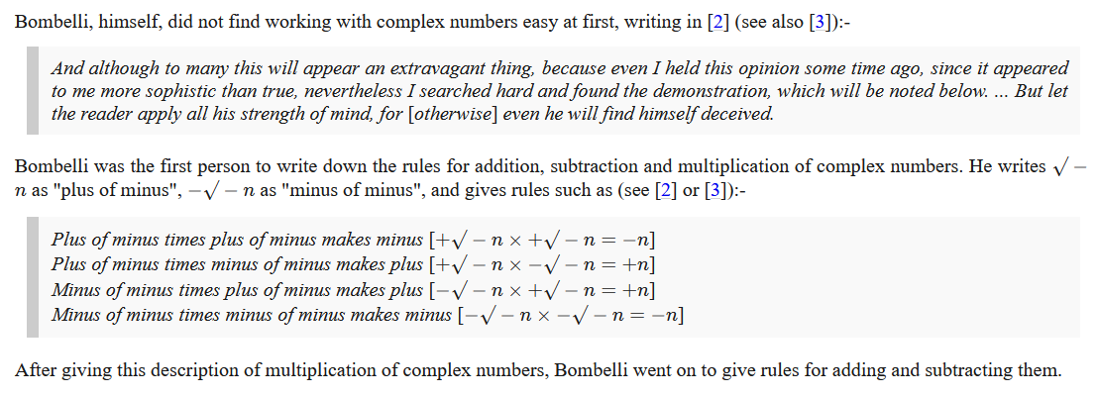

**Bombelli called the imaginary number i "plus of minus" and used "minus of minus" for -i**.

Se sygxrono symbolismo, π.χ.

(2i)(3i)=-6, (2i)(-3i)=6, (-2i)(3i)=6, (-2i)(-3i)=-6, .

**Plus di minus einai i, minus di minus is -i,**

Bombelli avoided confusion by giving a special name to square roots of negative numbers, instead of just trying to deal with them as regular radicals like other mathematicians did. This made it clear that these numbers were neither positive nor negative. This kind of system avoids the confusion that Euler encountered. **Bombelli called the imaginary number i "plus of minus" and used "minus of minus" for -i**.

(a+bi)(c+di)=ac +a(di)+(bi)c+(bi)((di)= ac+(ad)i +(bc)i +(bd**)(ii)** =

= ac + (ad+bc)i + (bd)(-1) = (ac –bd) + (ad+bc)i

**ΣΧΟΛΙΟ. Κατο περιεργο**

Όμως

((-1)1/2 )((-1)1/2 ) =( (-1)(-1) )1/2 =1 η ii=(-1) ?

Το z1/2  den orizetai

### ΣΥΜΒΟΛΙΣΜΟΙ,

#### ΠΑΛΑΙΟΤΕΡΗ ΓΡΑΦΗ ΔΥΝΑΜΕΩΝ,

KatzHistoryOfMathematics3rdS, 12.1.1. p.386

Algebraic Symbolism and Techniques (ΑΝΑΓΕΝΝHΣΗ),

**Algebraic Symbolism and Techniques**

Recall that Islamic algebra was entirely rhetorical. There were no symbols for the unknown or

its powers nor for the operations performed on these quantities. **Everything was written out in words**.

The same was generally true in the works of the early abacists and in the earlier Italian work of **Leonardo of Pisa (Fibonacci**).

Επισης η γραφη του ΙΕΡΩΝΥΜΟΥ ηταν «ρητορικη», (Rhetoric)

(SGP, Syncopated (Συγκεκομμενος)),

Early in the fifteenth century, however, some of the abacists (Arabic numerals), began to substitute abbreviations for unknowns. For example, in place of the standard words ***cosa* (thing, x),** *censo* (square, απογραφη), *cubo* (cube), and *radice* (root), some authors used the abbreviations *c*, *ce*, *cu*, and *R*. Combinations of these abbreviations were used for higher powers.

Thus,

***ce di ce* or *ce ce* stood for *censo di censo* or fourth power (*x*2*x*2);**

***ce cu* or *cu ce***, designating ***censo di cubo* and *cubo di censo*,** respectively**, ce di cu stood for fifth power (*x*2*x*3);** And

***cu cu*, designating *cubo di cubo*, stood for sixth power (*x*3*x*3**).

**Η επαναληψη δηλωνε γινομενο**.

Syncopated Algebra 275 – 1600

<https://jwilson.coe.uga.edu/emt668/emt668.student.folders/Hix/EMT635/Alg.sync.timeline.html>,

ΔΙΟΦΑΝΤΟΣ,

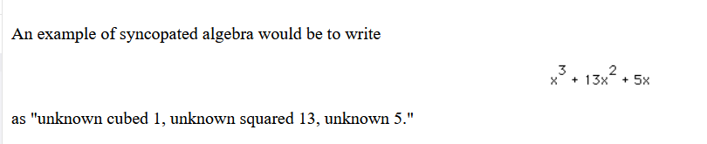

#### Here are some examples of Bombelli's notation.

<https://mathshistory.st-andrews.ac.uk/Biographies/Bombelli/>,

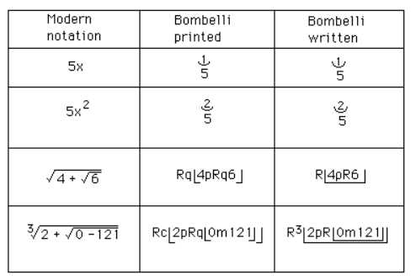

He then showed that, using his calculus of complex numbers, correct real solutions could be obtained **from the Cardan-Tartaglia formula for the solution to a cubic even when the formula gave an expression involving the square roots of negative numbers**.

Finally we should make some comments on Bombelli's notation. Although authors such as [Pacioli](https://mathshistory.st-andrews.ac.uk/Biographies/Pacioli/) had made limited use of notation, others such as [Cardan](https://mathshistory.st-andrews.ac.uk/Biographies/Cardan/) had used no symbols at all. Bombelli, however, used quite sophisticated notation. It is worth remarking that the printed version of his book uses a slightly different notation from his manuscript, and this is not really surprising for there were problems printing mathematical notation which to some extent limited the type of notation which could be used in print.

ΣΧΟΛΙΟΝ. Που πλεονεκτei ο BOMBELLI ?

xkxm =xk+n ,

# ΝΕΑ ALGEBRA του 16ου αιωνα,

## Η ΑΛΓΕΒΡΑ ΤΟΥ ΓΥΜΝΑΣΙΟΥ σημερα,

Κάθε ΜΕΓΕΘΟΣ μπορει να χαρακτηρισθει με συμβολα x, y, a, b, c, …που δηλωνουν (πραγματικους) αριθμους

Μπορουμε να γραφουμε ΕΚΦΡΑΣΕΙΣ a+x, ax, xa, a(b+c), (ab)c, a(bc), klp . **ΔΕΝ δινουμε αναγκαστικα ερμηνεια.**

ΙΣΧΥΕΙ ax=xa, a(b+c)=ab+ac, (ab)c= a(bc), κλπ,

(δηλαδη ισχυουν τα αξιωματα του ΔΑΚΤΥΛΙΟΥ, η μπορουμε τα πουμε ισχυουν οι «νομοι» των πραξεων). (Σημερα κωδικοποιουνται με τα αξιωματα ΔΑΚΤΥΛΙΟΥ).

Εχουμε πολλες ΜΕΤΑΒΛΗΤΕΣ και ΠΑΡΑΜΕΤΡΟΥΣ,

VIETE,

Ο VIETE απαιτουσε ΟΜΟΙΟΓΕΝΙΑ,

Interestingly, although the ‘=’ sign first appeared in 1557, Viète didn’t ever use it and expressed that relationship verbally (aequetur, make equal to something else).

Kata ayton x 2 kai x5 DEN ΠΡΟΣΤΙΘΕΝΤΑΙ

Ο Descartes ston επομενο αιωνα εδειξε

111x2 =x2 , ara afoy εχει νοημα to (111x2 +x5 ), ara kai το ισον του (x2 +x5 ),

KATZ, p. 407,

Vi`ete, Algebraic Symbolism, and Analysis .

*The Analytic Art,* KATZ, p. 408, 12.4.1 Fran¸cois Vi`ete and The Analytic Art

Endiaferoyses parathrhseis

### ΕΥΚΛΕΙΔΕΙΑ ΓΕΩΜΕΤΡΙΑ Α και Β ΛΥΚΕΙΟΥ,

ΕΥΚΛΕΙΔΕΙΑ ΓΕΩΜΕΤΡΙΑ, Τεύχος Α΄, Κωδικός βιβλίου: 0-22-0236, ISBN 978-960-06-5177-5

ΕΥΚΛΕΙΔΕΙΑ ΓΕΩΜΕΤΡΙΑ, Τεύχος B΄, Κωδικός βιβλίου: 0-22-0239, ISBN 978-960-06-5317-5,

#### ΜΗΚΟΣ ΕΥΘΥΓΡΑΜΜΟΥ ΤΜΗΜΑΤΟΣ,

##### ΕΥΚΛΕΙΔΕΙΑ ΓΕΩΜΕΤΡΙΑ, Τεύχος Α΄, Σελ. 20

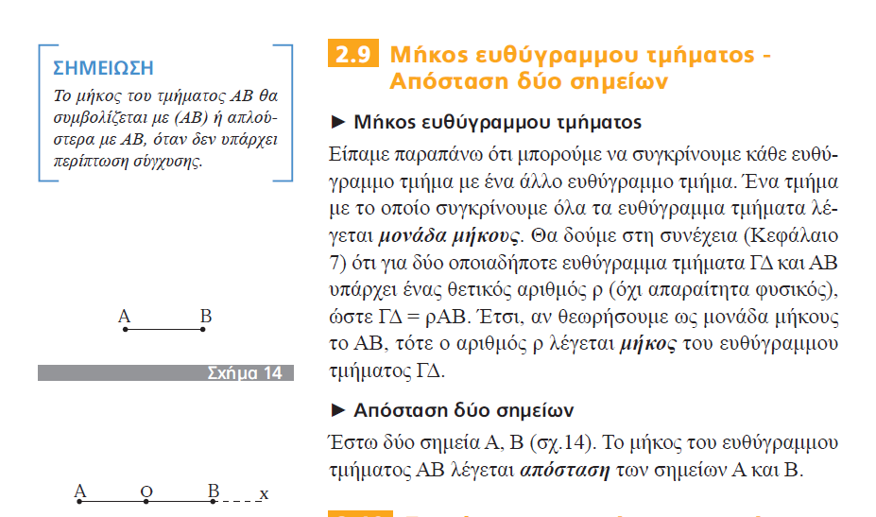

##### ΕΥΚΛΕΙΔΕΙΑ ΓΕΩΜΕΤΡΙΑ, Τεύχος Β΄, Σελ. 9

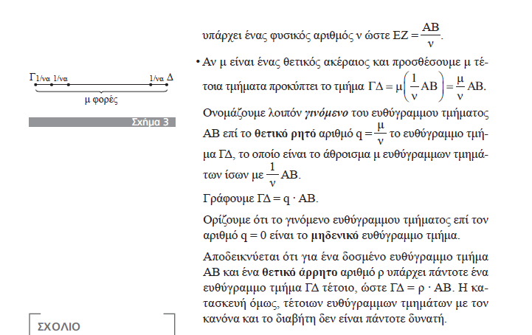

ΟΥΤΕ ΕΔΩ ΤΟ ΑΠΟΔΕΙΚΝΥΕΙ, DEN TO ORIZEI kan,

## FRANCOIS VIETE, François Viète, BIO,

### WIKIPEDIA

<https://en.wikipedia.org/wiki/Fran%C3%A7ois_Vi%C3%A8te>,

François Viète

François Viète, Seigneur (αφέντης ουσ αρσ, άρχοντας ουσ αρσ), de la Bigotière (Latin: Franciscus Vieta;

**1540 – 23 February 1603),** commonly known by his mononym, Vieta, was a French mathematician whose work on new algebra was **an important step towards modern algebra**, due to its **innovative use of letters as parameters in equations**. He was a lawyer by trade, and served as a **privy councillor** to both Henry III and Henry IV of France.

Biography

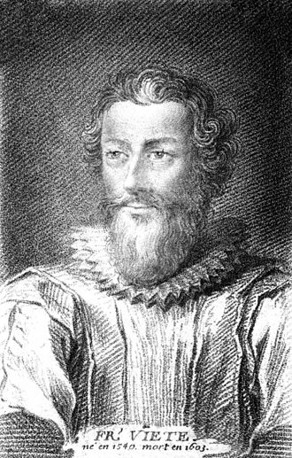

#### Early life and education

Viète was born at Fontenay-le-Comte in present-day Vendée. His grandfather was a merchant from La Rochelle.

His father, Etienne Viète, **was an attorney in Fontenay-le-Comte and a notary in Le Busseau**. His mother was the aunt of Barnabé Brisson, a magistrate and the first president of parliament during the ascendancy of the **Catholic League of France**.

**Viète went to a Franciscan school and in 1558 studied law at Poitiers, graduating as a Bachelor of Laws in 1559.** A year later, he began his career as an attorney in his native town.[3] From the outset, he was entrusted with some major cases, including the settlement of rent in Poitou for the widow of King Francis I of France and looking after the interests of Mary, Queen of Scots.

#### Serving Parthenay

In 1564, Viète **entered the service** of Antoinette d’Aubeterre, Lady Soubise, wife of **Jean V de Parthenay-Soubise**, one of the **main Huguenot military leaders** and accompanied him to Lyon to collect documents about his heroic defence of that city against the troops of Jacques of Savoy, 2nd Duke of Nemours just the year before.

The same year, at Parc-Soubise, in the commune of Mouchamps in present-day Vendée, Viète became the tutor of **Catherine de Parthenay,** Soubise's twelve-year-old daughter. He taught her science and mathematics and wrote for her numerous treatises on astronomy and trigonometry, some of which have survived. In these treatises, **Viète used decimal numbers (twenty years before Stevin's paper) and he also noted the elliptic orbit of the planets,[4] forty years before Kepler and twenty years before Giordano Bruno's death**.

John V de Parthenay presented him to King Charles IX of France. Viète wrote a genealogy of the Parthenay family and following the death of Jean V de Parthenay-Soubise in 1566 his biography.

In 1568, Antoinette, Lady Soubise, married her daughter Catherine to **Baron Charles de Quellenec** and Viète went with Lady Soubise to La Rochelle, where he mixed with the highest Calvinist aristocracy, leaders like Coligny and Condé and Queen Jeanne d’Albret of Navarre and her son, Henry of Navarre, the future Henry IV of France.

In 1570, he refused to represent the Soubise ladies in their infamous lawsuit against **the Baron De Quellenec, where they claimed the Baron was unable (or unwilling) to provide** an heir.

#### First steps in Paris

In 1571, he enrolled as an attorney in Paris, and continued to **visit his student Catherine**. He regularly lived in Fontenay-le-Comte, where he took on some municipal functions. He began publishing his Universalium inspectionum ad Canonem mathematicum liber singularis and **wrote new mathematical research by night or during periods of leisure**. He was known to dwell on any one question for up to three days, his elbow on the desk, feeding himself without changing position (according to his friend, Jacques de Thou).[5]

**In 1572, Viète was in Paris during the St. Bartholomew's Day** massacre. That night, Baron De Quellenec was killed after having tried to save Admiral Coligny the previous night. The same year, Viète met Françoise de Rohan, Lady of Garnache, **and became her adviser against Jacques, Duke of Nemours**.

In 1573, he became a councillor of the Parliament of Brittany, at Rennes, and two years later, he obtained the agreement of Antoinette d'Aubeterre for **the marriage of Catherine of Parthenay to Duke René de Rohan, Françoise's brother**.

In 1576, **Henri, duc de Rohan** took him under his special protection, recommending him in 1580 as "maître des requêtes" (ΕΦΕΤΕΙΟΝ). . In 1579, Viète finished the printing of his Universalium inspectionum (Mettayer publisher), published as an appendix to a book of two trigonometric tables (Canon mathematicus, seu ad triangula, the "canon" referred to by the title of his Universalium inspectionum, and Canonion triangulorum laterum rationalium). A year later, he was appointed maître des requêtes to the parliament of Paris, committed to serving the king. **That same year, his success in the trial between the Duke of Nemours and Françoise de Rohan, to the benefit of the latter, earned him the resentment of the tenacious Catholic League.**

**Catholic League**

ΓΟΟΓΛΕ. Holy League, French **La Sainte Ligue**, association of Roman Catholics during the French Wars of Religion of the late 16th century; it was first organized in 1576 under the leadership of Henri I de Lorraine, 3e duc de Guise, to oppose concessions granted to the Protestants (Huguenots) by King Henry III.

#### Exile in Fontenay

**Between 1583 and 1585, the League persuaded Henry III to release Viète, Viète having been accused of sympathy with the Protestant cause.** Henry of Navarre, at Rohan's instigation, addressed two letters to King Henry III of France on March 3 and April 26, 1585, in an attempt to obtain Viète's restoration to his former office, but he failed.[3]

Viète retired to Fontenay and Beauvoir-sur-Mer, with François de Rohan. **He spent four years devoted to mathematics, writing his New Algebra (1591**).