22 ΔΙΑΛΕΞΙΣ,

31 ΜΑΙΟΥ 2025, ΣΑΒΒΑΤΟΝ,

Webex meeting recording: 22 INM-20250531 1906-1

Recording link: https://uoa.webex.com/uoa/ldr.php?RCID=e27fbde719106d2f09bb55cd788f2479

Password: YvwBfe9E,

**ΥΠ ΟΨΙΝ,**

6002 hronas, 2004 anisothra baseon,

? 11003, 11071, 11072,

EJETASEIS. ΤΡΙΤΗ, 24-06-2025, 1μμ-4μμ., .

# [ΔΙΑΦΟΡΙΚΟΣ ΛΟΓΙΣΜΟΣ, [DIFFERENTIAL CALCULUS,

p. 122,

EDWARDS The Historical Development of the Calculus

Ακολουθουμε κυριως τον EDWARDS, ch. 5 Early Tangent Constructions, p. 122, .

Introduction

In modem calculus courses the treatment of differentiation and the construction

of tangent lines to curves usually precede the treatment of

integration and the calculation of areas under curves. This is a reversal of

the historical sequence of discovery; as we have seen in the preceding

chapters, the calculation of curvilinear areas dates back to ancient times.

However, apart from simple constructions of tangent lines to conic sections

(with the static Greek view of a tangent line as a line touching the

curve in only one point), and the isolated example of Archimedes' construction

of the tangent to his spiral, tangent lines were not studied until

the middle decades of the seventeenth century.

Then, beginning about 1635, a number of different methods for the

construction of tangent lines to general curves were rapidly discovered and

investigated. It was the combination of these new tangent methods with

area problems and techniques, during the last third of the seventeenth

century, that produced the calculus as a new unified method of mathematical

analysis.

## Fermat's Pseudo-equality Methods,

p. 122,

### Adequality

<https://en.wikipedia.org/wiki/Adequality#cite_note-Katz_Schaps_20213-3>,

Adequality is a technique developed by Pierre de Fermat in his treatise Methodus ad disquirendam maximam et minimam[1] (a Latin treatise circulated in France c. 1636 ) to calculate maxima and minima of functions, tangents to curves, area, center of mass, least action, and other problems in calculus. **According to André Weil, Fermat "introduces the technical term adaequalitas, adaequare, etc., which he says he has borrowed from Diophantus.** As Diophantus V.11 shows, **it means an approximate equality,** and this is indeed how Fermat explains the word in one of his later writings." (Weil 1973).[2] Diophantus coined the word **παρισοτης** (parisotēs) to refer to an approximate equality.[3] Claude Gaspard Bachet de Méziriac translated Diophantus's Greek word into Latin as adaequalitas.[citation needed] Paul Tannery's French translation of Fermat’s Latin treatises on maxima and minima used the words adéquation and adégaler.[citation needed]

### maxima-minima,

Edwards p.122,

Fermat was the first to solve maximum-minimum problems by somehow

taking into account the characteristic behavior of a function near its

extreme values. For example, in order to determine how to subdivide a

segment of length b into two segments x and b - x whose product



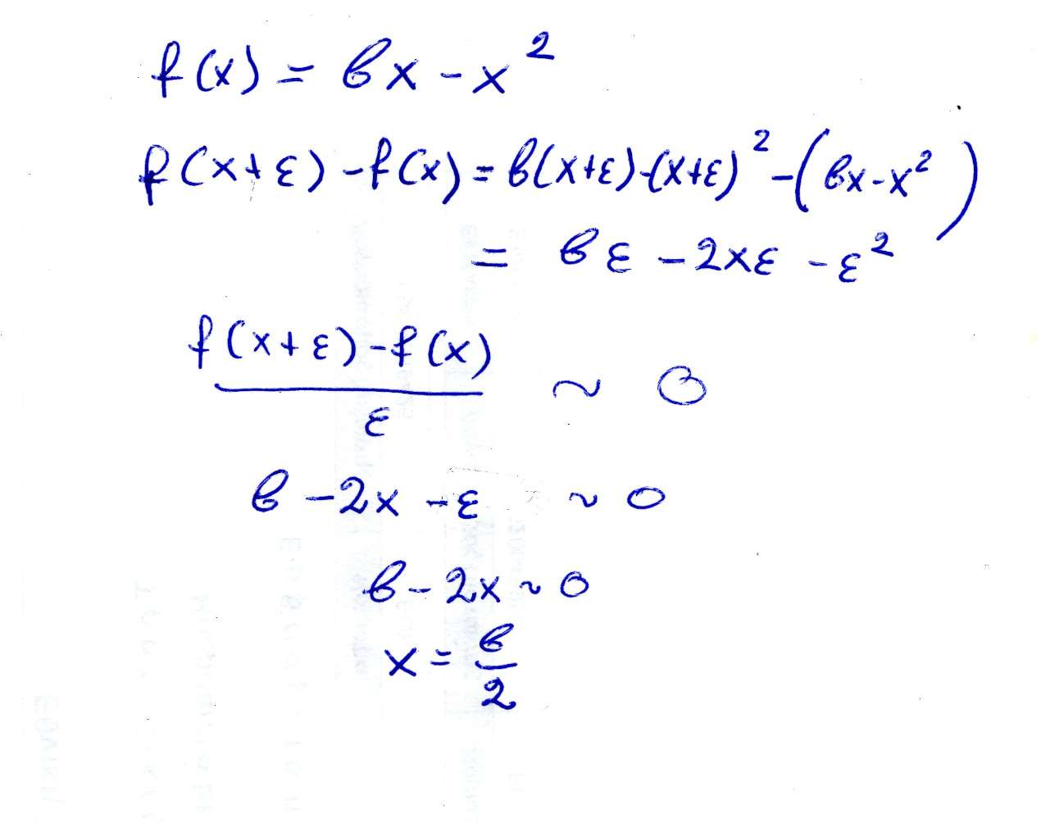

### Tangents and Pseudo Equality,

Edwards 123,

Katz, p. 507

All other properties of curves [besides those

concerning quadrature] depend only on

the angles that these curves make with

other lines. But the angle formed by two

intersecting curves can be as easily measured

as the angle between two straight lines,

provided that a straight line can be drawn

making right angles with one of these curves

at its point of intersection with the other.

This is my reason for believing that I shall

have given here a sufficient introduction to

the study of curves when I have given a

general method of drawing a straight line

making right angles with a curve at an

arbitrarily chosen point upon it. And I dare

say that this is not only the most useful and

most general problem in geometry that I

know, but even that I have ever desired to

know.

—From Descartes’ Geometry1

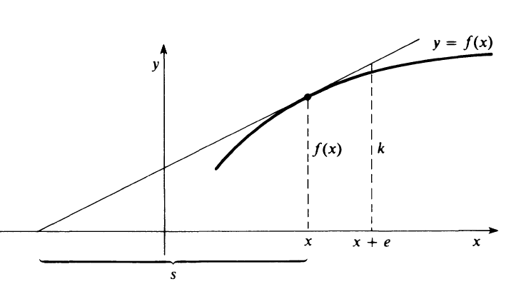

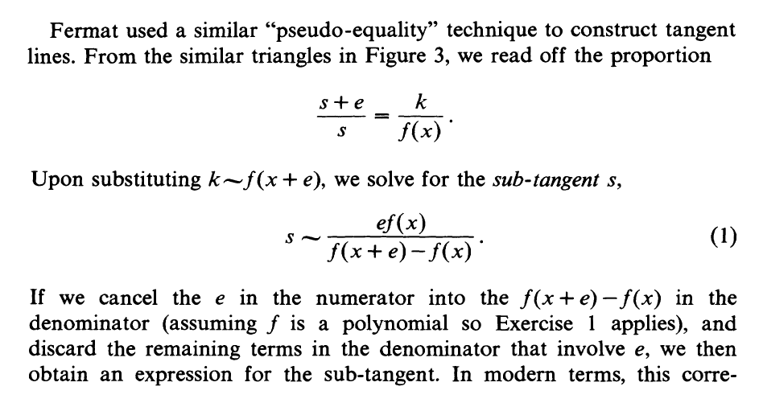

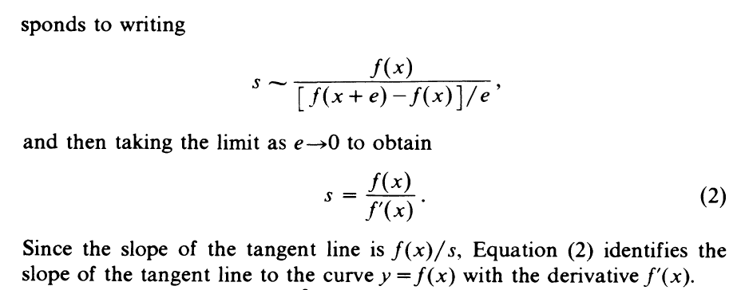

Αυτο φαινεται καλλιτερα αν γραψουμε την τελευταια ως, f’(x)=f(x)/s.

##### ΠΑΡΑΔΕΙΓΜΑ η ΠΑΡΑΓΩΓΟΣ της xn,

Εστω f(x)=xn , cosn, sinx,

f’ (x) = nxn-1 , -sinx, cosx,

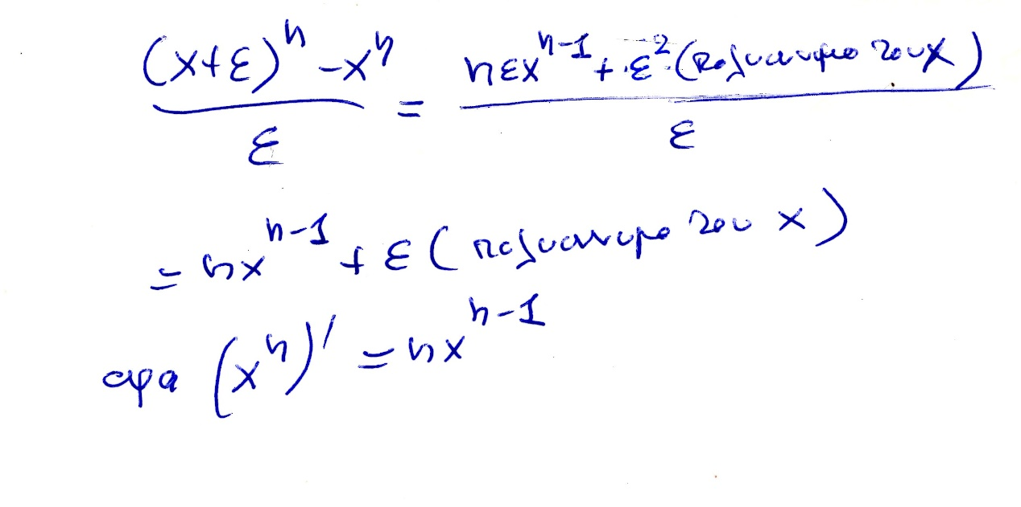

### Όχι 2025, Descartes' Circle Method,

~~21 ΔΙΑΛΕΞΗ,~~

~~Τεταρτη, 29-05-2024, 11-2μμ,~~

Aneblhthh iatrikoi logoi,

~~21 ΔΙΑΛΕΞΗ,~~

ΤΕΤΑΡΤΗ, 05-06-2024, 11.00-14.00,

Webex meeting recording: 21 dialeksis INM 2024 tetarth, 11.00-14.00-20240605 0821-1

Password: 3bRktakj

Recording link: <https://uoa.webex.com/uoa/ldr.php?RCID=86851fc85ca2998bb34b19047882b3b0>,

# [INTEGRAL CALCULUS, [ΟΛΟΚΛΗΡΩΤΙΚΟΣ ΛΟΓΙΣΜΟΣ,

## [INTEGRATION RIENMANN RIENMANN,

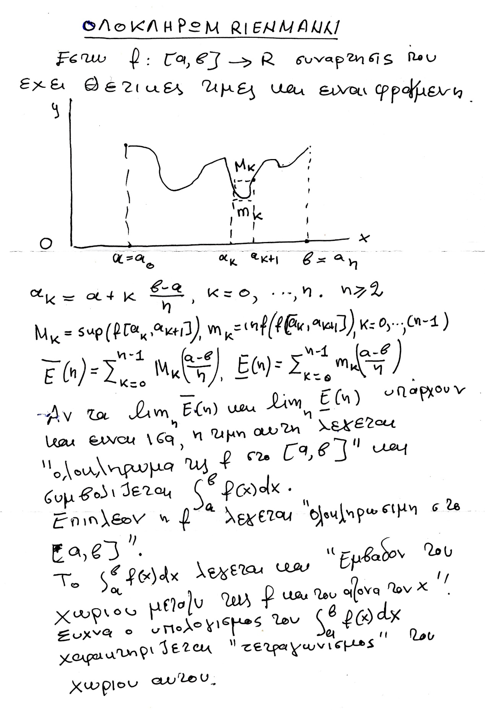

Αναλογα οριζεται και για συναρτησεις όχι αναγκαστικα θετικεσ παντου

OI συνεχεις συναρτησεις είναι ολοκληρωσιμες,

Ένα βασικο ΘΕΩΡΗΜΑ είναι

α)Αν η f είναι συνεχης τοτε είναι ολοκληρωσιμη.

β) Αν οι f, g είναι ολοκληρωσιμες στο [α, β] και ζ η είναι πραγματικοι, τοτε

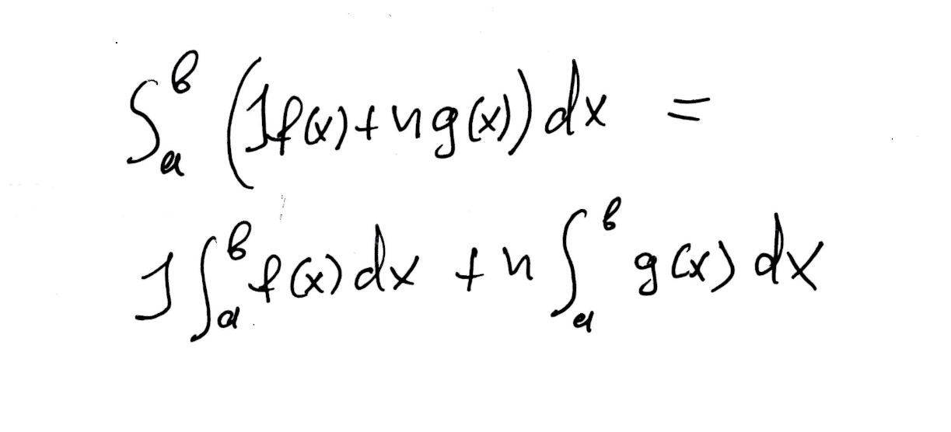

γ ) Αν οι f, είναι ολοκληρωσιμη αντιστοιχως στο [α, γ], και β μεταξυ α και γ, τοτε]

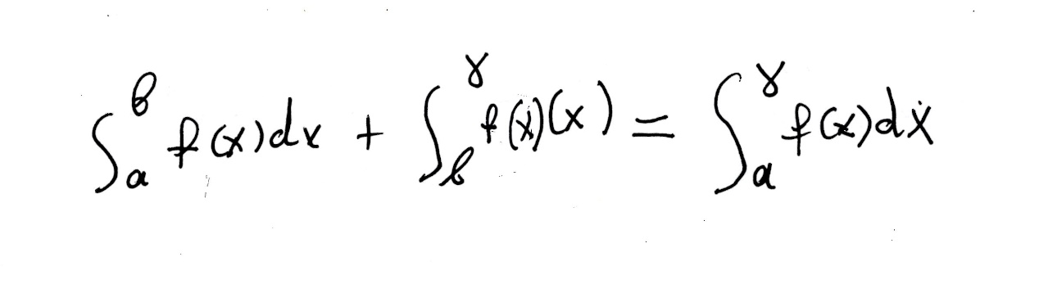

## [INTEGRATION FERMAT,

Εχω παρει στοιχεια, EDWARDS, The Historical Development of the Calculus. Ιδιαιτερα π.98 Early Indivisibles and Infinitesimal Techniques 98, καιArithmetical Quadratures p.109,

Κατωτερω αναγγελεται μια ανακαλυψη

Βλ. Katz p. 507

To indicate the extent of his research in finding areas, **Fermat**

**wrote to Roberval on September 22, 1636**: “I have **squared**

infinitely many figures composed of curved lines; as, for

example, if you would imagine a figure like the parabola but such

that **the cubes of the ordinates are proportional to the abscissas.** This

figure approaches the parabola and differs only in that, whereas in

the parabola one takes the ratios of the squares, I take in this figure

that of the cubes; it is for that reason that M. de Beaugrand, to whom

I showed the proposition, calls it a ‘solid parabola.’ . . **. I have had to**

**follow a path other than that of Archimedes in the quadrature of the**

**parabola and that I would never have solved it by the latter means.”2**

Ο Fermat ασχοληθηκε κατ αρχας με τα μονονυμα xk για θετικο κ, .

Βλ. EDWARDS, p. 110

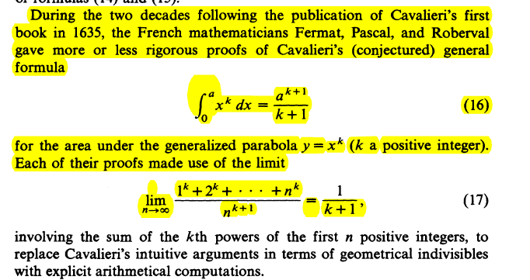

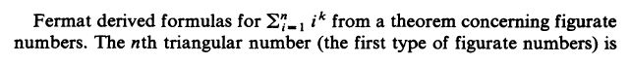

Η περιπτωση των μονονυμων είναι καπως απλουστερη από την γενικην διοτι εχουμε αυξουσες συναρτησεις, και τα sup και inf του RΙΕΝΜΑΝΝ, αντικαθιστανται από το ΜΕΓΙΣΤΟΝ και ΕΛΑΧΙΣΤΟΝ,

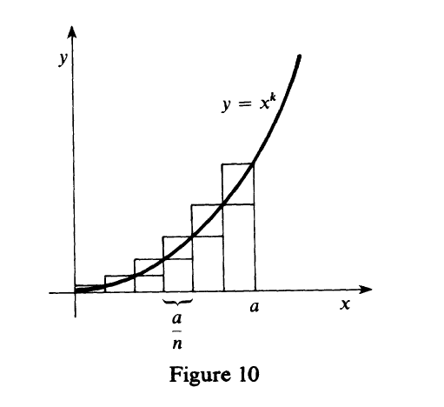

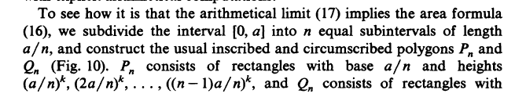

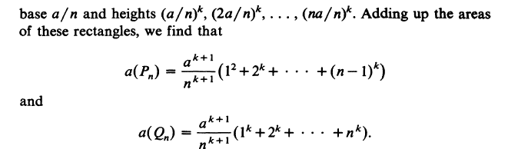

Γραφω καπως αναλυτικοτερα τα ανωτερω



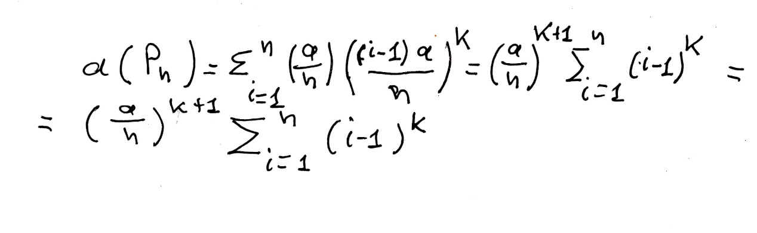

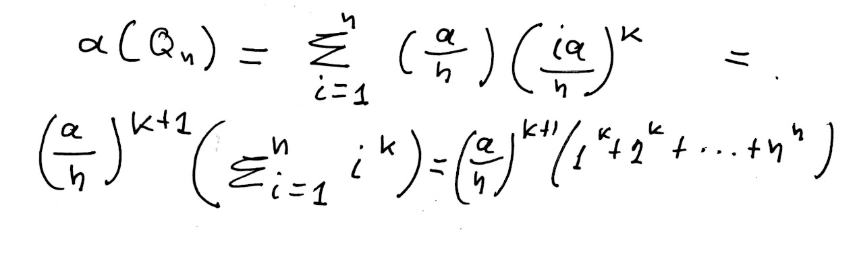

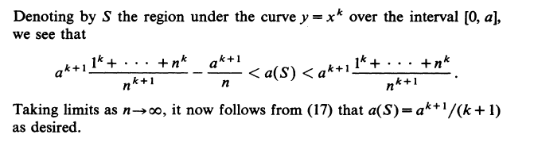



Με συμβολα αυτό γραφεται

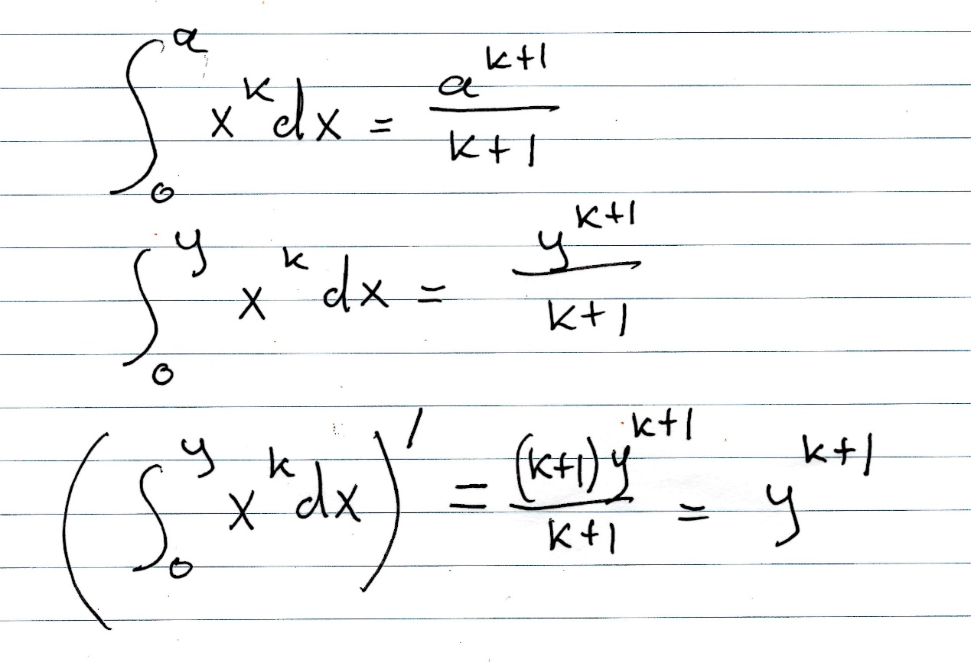, Η τελευταια παραγτωγιση είναι ως προς y.

O Fermat απεδειξε την σχεση αυτή για κάθε k ρητον, (πλην k=-1).

ΛΑΘΟΣ μου ! To « k+1» ως εκθετης σthn teleytaia grammh , NA GINEI «k» !

Ti ennooyse o ΦΕΡΜΑΤ με το

«. **. I have had to follow a path other than that of Archimedes in the quadrature of the parabola and that I would never have solved it by the latter means» ?**

**Στο πανεπιστημιο πως τω καναμε ?**

### ΑΘΡΟΙΣΜΑ ΔΥΝΑΜΕΩΝ, Summation of Powers,

<https://en.wikipedia.org/wiki/Faulhaber%27s_formula>,

<https://en.wikipedia.org/wiki/Sums_of_powers>,

Sums of consecutive powers,

<https://www.johndcook.com/blog/2016/12/31/sums-of-consecutive-powers/>,

