23 ΔΙΑΛΕΞΙΣ,

KYRIAKH, 01-06-2025,

Webex meeting recording: 23 INM-20250601 1507-1

Recording link: https://uoa.webex.com/uoa/ldr.php?RCID=4249648afeca1113845cc997523e55ac

Password: dCN4H2ii

**ΠΛΗΡΟΦΟΡΗΣΙΣ**

ΠΕΡΙΛΗΨΙΣ 22 ΔΙΑΛΕΞΙΣ,

~~6002 hronas~~, 2004 anisothra baseon, 2002 συγριση βασεων,

? 11003, 11071, 11072,

## [FUNDAMENTAL THEOREM OF CALCULUS, [FTC, ΘΘΑ,

Με συμβολα αυτό γραφεται

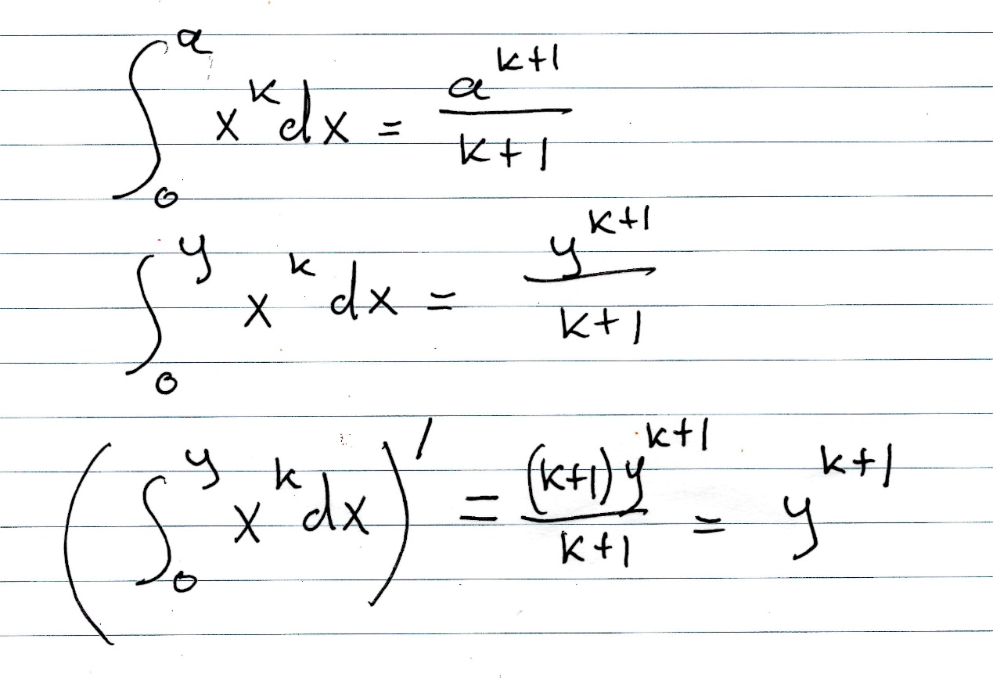, Η τελευταια παραγτωγιση είναι ως προς y.

O Fermat απεδειξε την σχεση αυτή για κάθε k ρητον, (πλην k=-1).

ΛΑΘΟΣ μου ! To « k+1» ως εκθετης σthn teleytaia grammh , NA GINEI «k» !

Ti ennooyse o ΦΕΡΜΑΤ με το

«. **. I have had to follow a path other than that of Archimedes in the quadrature of the parabola and that I would never have solved it by the latter means» ?**

**Στο πανεπιστημιο πως τω καναμε ?**

### PROF by NEWTON,

ΘΕΩΡΗΜΑ ΘΘΑ, Εστω f συναρτησις που ολοκληρωνεται. Υπο πολύ γενικές συνθήκες ισχύει

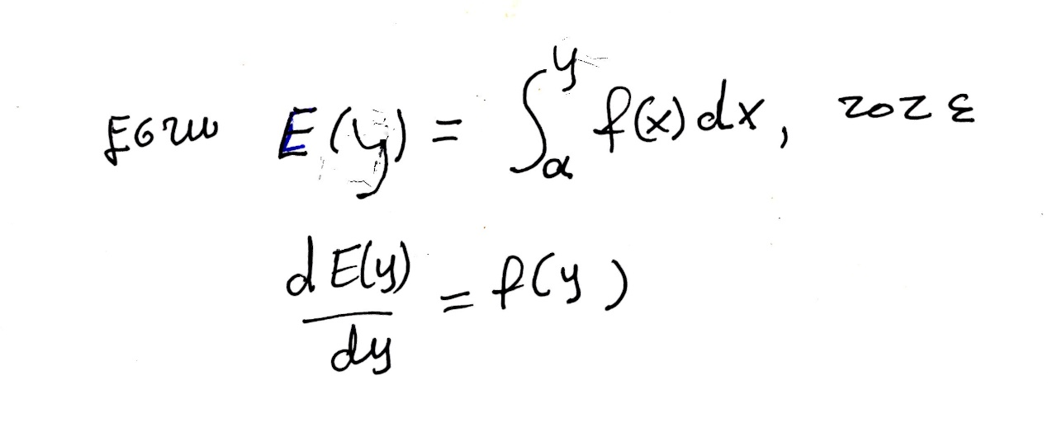

Ασφαλως ισχυει για συνεχεις συναρτησεις σε κλειστο διαστημα.

Ο ΝΕΥΤΩΝ αλλα και οι λοιποι δεν θεωρουσαν την ακριβη διατυπωσιν πολύ αναγκαια.

~~Νευτων, λαιμπνιτζ~~

ΑΠΟΔΕΙΞΙΣ.

Κατωτερω περιγραφουμε την αποδειξιν του ΝΕΥΤΩΝΟΣ, .

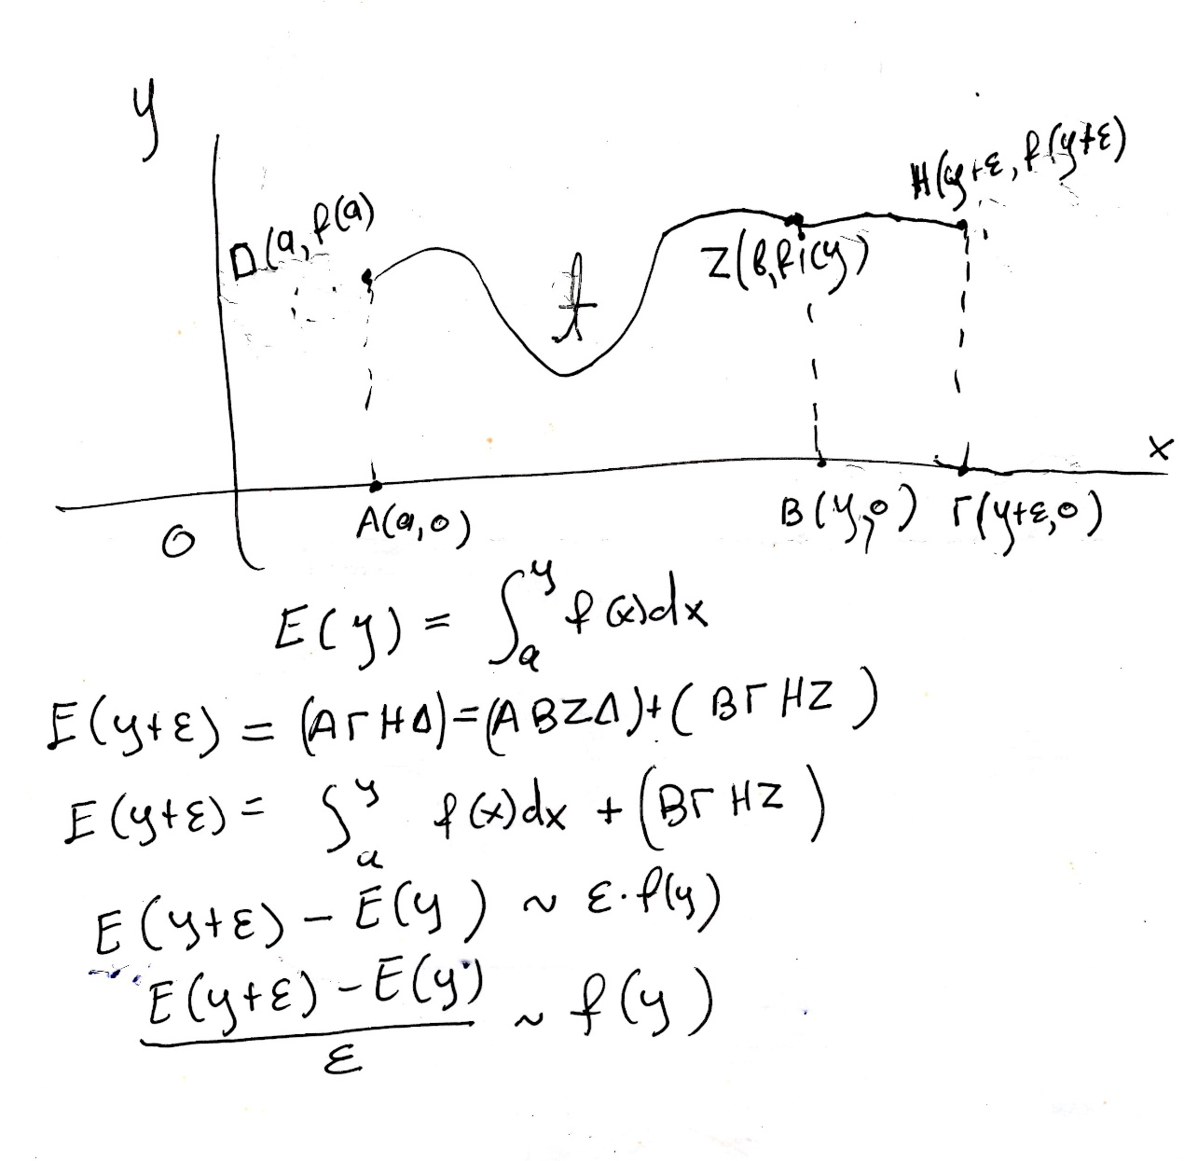

ΛΑΘΟΣ. Το z (b, f(y)), einai z(y, f(y), .

Ας ρηξουμε μια ακομα ματια στο παρακατω

Με συμβολα αυτό γραφεται

, Η τελευταια παραγτωγιση είναι ως προς y.

O Fermat απεδειξε την σχεση αυτή για κάθε k ρητον, (πλην k=-1).

ΛΑΘΟΣ μου ! To « k+1» ως εκθετης σthn teleytaia grammh , NA GINEI «k» !

### Isaac Newton, Newton Isaak, bio

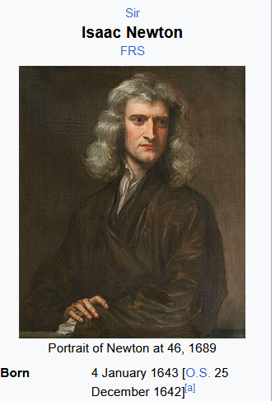

#### ΚΑΤΖ p. 545,

Newton was born on December 25, 1642, at Woolsthorpe,

near Grantham, some 100 miles north of London, to a

mother already widowed in October. When he was three years

old, **his mother remarried and left young Isaac in the care of his**

**grandmother** until she returned to Woolsthorpe in 1653 upon

the death of her second husband. In 1655, Newton was sent

**to Grantham to attend the local grammar school. It was here**

**that he mastered Latin, the mainstay of the classical school**

**curriculum, and also was introduced to the study of mathematics**

**by the somewhat unusual schoolmaster Henry Stokes.** Not

only did Newton learn basic arithmetic, he also studied such

**advanced topics as plane trigonometry and geometric constructions**,

thus putting him far ahead of his fellow students on his

matriculation at Trinity College, Cambridge, in 1661.

**Mathematics, however, was not generally part of the course**

**of study at Cambridge**, even after the appointment of Barrow

**as Lucasian Professor of Mathematics in 1663**. In fact, the university

had few requirements at all**. If one stayed in residence**

**for four years and paid one’s fees, one received a bachelor’s**

**degree**. On the other hand, because in 1663 Newton started to

explore on his own the mathematics he had been introduced to

at school, it was to his advantage that the university did not particularly

care what he studied. **He mastered Euclid so that he**

**could understand trigonometry**, then the Clavis mathematicae

(Key to Mathematics) ofWilliam Oughtred (1574–1660), then

Descartes’ Geometry in van Schooten’s Latin edition along

with the hundreds of pages of commentary, Vi`ete’s collected

works, and finally Wallis’s Arithmetica infinitorum. Because

Isaac Barrow was giving his first series of Lucasian lectures

on the foundations of mathematics in 1664, in all probability

the older mathematician encouraged the younger, perhaps

even lending him books from his own mathematics collection.

To devote himself fully to research, however, Newton needed

the security of university financial support. This was assured

through a scholarship in 1664, a fellowship in 1667, and the appointment

as Lucasian professor in 1669, all probably through

the influence of Barrow.

Apparently, one of the central reasons for Newton’s success

in his development not only of the calculus but also of the basic

principles of optics and mechanics was his intense facility for

concentration. As John Maynard Keynes wrote, “I believe that

the clue to his mind is to be found in his unusual powers of

continuous concentrated introspection. . . . His peculiar gift

was the power of holding in his mind a purely mental problem

until he had seen straight through it. . . . I believe that Newton

could hold a problem in his mind for hours and days and weeks

until it surrendered to him its secret.”4 Newton’s powers of

concentration are exemplified by many stories told of him,

similar to stories about Archimedes. For example, “when he

had friends to entertain at his chamber, if he stept into his study

for a bottle of wine, and a thought came into his head, he would

sit down to paper and forget his friends.”5 In fact, “thinking all

hours lost, that were not spent in his studies, . . . heseldom left

his chamber, unless at Term Time, when he read in the schools,

as being Lucasian professor.” But when he lectured, “so few

went to hear him, and fewer that understood him, that ofttimes

he did in a manner, for want of hearers, read to the walls.”6

**Perhaps Newton was not a success as a professor, but as the**

**central figure in the Scientific Revolution, his works continue**

**to exert their influence on our lives** (Fig. 16.1).

KATZ 544,

oxi 2024, 2025,

### Gottfried Wilhelm Leibniz, bio,

#### <https://en.wikipedia.org/wiki/Gottfried_Wilhelm_Leibniz>,

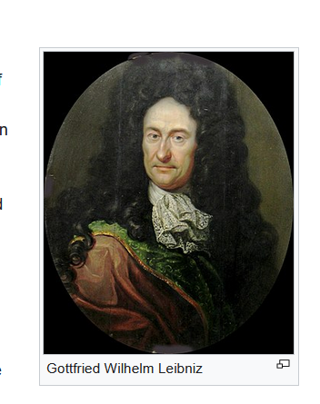

#### Katz P. 666,

The second inventor of the calculus, Gottfried Wilhelm

Leibniz, was born in Leipzig to the third wife of the vice

**chairman of the faculty of philosophy at the University of**

**Leipzig**. **Although his father died when he was only six**, the

young Leibniz had already been inculcated with a desire to

read and study. **During his youth, he taught himself Latin** and

plowed through the Latin classics as well as the philosophical

and theological works in his father’s extensive library. In

1661, he entered the University of Leipzig where he spent **most**

**of his time studying philosophy.** He did attend introductory

lectures on Euclid, but commented in later life about the low

level of mathematics teaching at Leipzig. Leibniz received his

bachelor’s degree in 1663 and his master’s degree in 1664, but

although he prepared a dissertation for the **degree of Doctor**

**of Law,** the university refused to award it to him, probably because

of some political problems in the faculty. Leibniz thus

left Leipzig and received his degree in 1667 from the University

of Altdorf in Nuremberg.

Meanwhile, Leibniz had been introduced to advanced mathematics

during a brief stay at the University of Jena in 1663 and

began to work out the details of what he hoped would be his

most original contribution to philosophy, the development of

an alphabet of human thought, a way of representing all fundamental

concepts symbolically and a method of combining

these symbols to represent more complex thoughts. Although

Leibniz never completed this project, his initial ideas are contained

in his Dissertatio de arte combinatoria (Dissertation on

the Combinatorial Art) of 1666, in which he worked out for

himself Pascal’s arithmetic triangle as well as the various relations

among the quantities included. This interest in finding

appropriate symbols to represent thoughts and ways of combining

these, however, ultimately led him to the invention of

the symbols for calculus we use today.

Soon after Leibniz finished his university studies, he entered

**upon a career first in diplomacy for the Elector of Mainz and**

**during much of his later life as a counselor to the Duke of**

**Hanover.** Although there were various periods of his life when

his job kept him extremely busy, **he was nevertheless able to**

**find time to pursue his ideas on mathematics** and to carry on a

lively correspondence on the subject with colleagues all over

Europe (Fig. 16.12).

**LEIBNIZ,**

**https://en.wikipedia.org/wiki/Gottfried_Wilhelm_Leibniz, 24-05-2024,**

FTC,

Leibniz is credited, along with [Isaac Newton](https://en.wikipedia.org/wiki/Isaac_Newton), with the discovery of [calculus](https://en.wikipedia.org/wiki/Calculus) (differential and integral calculus). According to Leibniz's notebooks, a critical breakthrough occurred on 11 November 1675, when he employed integral calculus for the first time to find the area under the graph of a function y = f(x).[[119]](https://en.wikipedia.org/wiki/Gottfried_Wilhelm_Leibniz#cite_note-Leibniz1920-121) He introduced several notations used to this day, for instance the [integral sign](https://en.wikipedia.org/wiki/Integral_sign) ∫ ( ∫ f ( x ) d x ), representing an elongated S, from the Latin word *summa*, and the d used for [differentials](https://en.wikipedia.org/wiki/Differential_(infinitesimal)) ( d y d x ), from the Latin word *differentia*. Leibniz did not publish anything about his calculus until 1684.[[120]](https://en.wikipedia.org/wiki/Gottfried_Wilhelm_Leibniz#cite_note-122) Leibniz expressed the inverse relation of integration and differentiation, later called the [fundamental theorem of calculus](https://en.wikipedia.org/wiki/Fundamental_theorem_of_calculus), by means of a figure[[121]](https://en.wikipedia.org/wiki/Gottfried_Wilhelm_Leibniz#cite_note-123) in his **1693 paper *Supplementum geometriae dimensoriae****...*.[[122]](https://en.wikipedia.org/wiki/Gottfried_Wilhelm_Leibniz#cite_note-124) However, [James Gregory](https://en.wikipedia.org/wiki/James_Gregory_(mathematician)) is credited for the theorem's discovery in geometric form, [Isaac Barrow](https://en.wikipedia.org/wiki/Isaac_Barrow) proved a more generalized geometric version, and [Newton](https://en.wikipedia.org/wiki/Isaac_Newton) developed supporting theory. The concept became more transparent as developed through Leibniz's formalism and new notation.[[123]](https://en.wikipedia.org/wiki/Gottfried_Wilhelm_Leibniz#cite_note-125) The [product rule](https://en.wikipedia.org/wiki/Product_rule) of [differential calculus](https://en.wikipedia.org/wiki/Differential_calculus) is still called "Leibniz's law". In addition, the theorem that tells how and when to differentiate under the integral sign is called the [Leibniz integral rule](https://en.wikipedia.org/wiki/Leibniz_integral_rule).

SGP comment. Favors LEIBNITZ,

### [WHO PROVED FIRST THE FUNDAMENTAL THEOREM OF CALCULUS, WHO PROVED FIRST FTC,

#### WIKIPEDIA POINT OF VIEW,

<https://en.wikipedia.org/wiki/Fundamental_theorem_of_calculus>,

Geometric meaning/Proof

From the conjecture and the proof of the fundamental theorem of calculus, calculus as a unified theory of integration and differentiation is started. **The first published statement and proof of a rudimentary form of the fundamental theorem, strongly geometric in character,[2] was by James Gregory (1638–1675).[**3][4] Isaac Barrow (1630–1677) proved a more generalized version of the theorem,[5] while his student Isaac Newton (1642–1727) completed the development of the surrounding mathematical theory. Gottfried Leibniz (1646–1716) systematized the knowledge into a calculus for infinitesimal quantities and introduced the notation used today.

ΑΣΑΦΕΣ

#### James Gregory,

James Gregory (mathematician)

<https://en.wikipedia.org/wiki/James_Gregory_(mathematician)#Mathematics>,

James Gregory FRS (November 1638 – October 1675) was a Scottish mathematician and astronomer. His surname is sometimes spelled as Gregorie, the original Scottish spelling. He described an early practical design for the reflecting telescope – the Gregorian telescope – and made advances in trigonometry, discovering infinite series representations for several trigonometric functions.

In his book Geometriae Pars Universalis (1668)[1] (βλ. KATZ p. 534, ),

Gregory gave both the first published statement and proof of the fundamental theorem of the calculus (stated from a geometric point of view, and only for a special class of the curves considered by later versions of the theorem), for which he was acknowledged by Isaac Barrow

… Gregory was born in 1638. His mother Janet was the daughter of Jean and David Anderson and **his father was John Gregory**,[9] an Episcopalian Church of Scotland minister, …

… He was successively professor at the University of St Andrews and the University of Edinburgh.

#### ISAAK BARROW,

Isaac Barrow

<https://en.wikipedia.org/wiki/Isaac_Barrow>,

Isaac Barrow (October 1630 – 4 May 1677) was an English Christian theologian and mathematician who is generally given credit for his early role in the development of infinitesimal calculus; in particular, for the discovery of the fundamental theorem of calculus. His work centered on the properties of the tangent; Barrow was the first to calculate the tangents of the kappa curve. He is also notable for being the inaugural holder of the prestigious Lucasian Professorship of Mathematics (CAMBRIDGE), , a post later held by his student, Isaac Newton.

… Isaac went to school first at Charterhouse (where he was so turbulent and pugnacious (**eager or quick to argue, quarrel, or fight**.), that his father was heard to pray that if it pleased God to take any of his children he could best spare Isaac), and subsequently to Felsted School, where he settled and learned under the brilliant puritan Headmaster Martin Holbeach who ten years previously had educated John Wallis.[5] Having learnt Greek, Hebrew, Latin and logic at Felsted, in preparation for university studies,[6] he continued his education at Trinity College, Cambridge; he enrolled there because of an offer of support from an unspecified member of the Walpole family, "an offer that was perhaps prompted by the Walpoles' sympathy for Barrow's adherence to the Royalist cause."[7] His uncle and namesake Isaac Barrow, afterwards Bishop of St Asaph, was a Fellow of, …

… Career

On the Restoration in 1660, he was ordained and appointed to the Regius Professorship of Greek at Cambridge. In 1662 he was made professor of geometry at Gresham College, and in 1663 was selected as the first occupier of the Lucasian chair at Cambridge. During his tenure of this chair he published two mathematical works of great learning and elegance, the first on geometry and the second on optics. In 1669 he resigned his professorship in favour of Isaac Newton.[11] …

Απεδειξε το ΘΘΑ

*Lectiones geometricae* (*Geometrical Lectures*) (1670) of Barrow (βλ. KATZ p. 536),

ISAAK BARROW,

<https://mathshistory.st-andrews.ac.uk/Biographies/Barrow/>,

… In 1669 Barrow resigned from the Lucasian Chair and did no further mathematical work. This allowed Newton to take over. Barrow was appointed as Royal Chaplain to Charles II at Salisbury in 1670, then, in February 1673, Charles II awarded Barrow the Mastership of Trinity declaring him to be the best scholar in England.

##### Gregory, Barrow,

ΒΛΕΠΕ KATZ p. 534-536,

15.3.2 Gregory and the Fundamental Theorem

James Gregory (1638–1675), both of whom decided to organize

the material relating to tangents, areas, and rectification gathered in their travels through

France, Italy, and the Netherlands and to present it systematically. Not surprisingly, then, the

*Lectiones geometricae* (*Geometrical Lectures*) (1670) of Barrow and the

*Geometriae pars universalis* (*Universal Part of Geometry*) (1668) of Gregory contained much of the same

material presented in similar ways.

**In effect, both of these works were treatises on material today identified as calculus, but with presentations in the geometrical style each author had learned in his university study.**

**Neither was able to translate the material into a method of computation useful for solving problems.**

#### LEIBNIZ,

**WIKIPEDIA LEIBNIZ,**

Calculus

Leibniz is credited, along with Sir Isaac Newton, with the discovery of calculus (differential and integral calculus). According to Leibniz's notebooks, a critical breakthrough occurred on 11 November 1675, when he employed integral calculus for the first time to find the area under the graph of a function y = f(x).[111] He introduced several notations used to this day, for instance the integral sign ∫, representing an elongated S, from the Latin word summa, and the d used for differentials, from the Latin word differentia. Leibniz did not publish anything about his calculus until 1684.[112] Leibniz expressed the inverse relation of integration and differentiation, later called the fundamental theorem of calculus, by means of a figure[113]

**Οχι 2025, STRUIK, SOURCE BOOK, p. 281,**

2 LEIBNIZ. THE FIRST PUBLICATION OF HIS INTEGRAL CALCULUS

Two years after Leibniz had published his first account of the differential calculus, he published

a paper on the inverse tangent problem in which the symbol J appears. This was done

in a rather casual way, since the paper was a review of a book by the Scottish pupil of

Newton, John Craig. Leibniz used the occasion to illustrate two fundamental points at the

same time: (a) the power of the integration symbol in combination with that of differentiation

(if ρ dy = χ dx, then J ρ dy = J χ dx, and conversely, which is the expression of the

inverse character of the differential and the integral calculus), and (6) the power of the method

to represent that still poorly explored type of relation, the "transcendental" quantities.

Leibniz's paper "De geometria recondita et analysi indivisibilium atque infinitorum"

(On a deeply hidden geometry and the analysis of indivisibles and infinities) appeared in the

Acta Eruditorum 5 (1686) and was reprinted in Leibniz, Mathematische Schriften, Abth. 2,

Band III, 226-235. A German translation by G. Kowalewski can be found in Ostwald's

Klassiker, No. 162 (Engelmann, Leipzig, 1908). Here follows a translation of that part of the

paper dealing with the introduction of the integral calculus.

#### NEWTON,

<https://en.wikipedia.org/wiki/Leibniz%E2%80%93Newton_calculus_controversy>,

did not explain his eventual [fluxional](https://en.wikipedia.org/wiki/Fluxion_(mathematics)) [notation for the calculus](https://en.wikipedia.org/wiki/Newton%27s_notation)[[3]](https://en.wikipedia.org/wiki/Leibniz%E2%80%93Newton_calculus_controversy#cite_note-1696posn-3) in print until 1693 (in part) and 1704 (in full).

#### Did Barrow Invent the Calculus?, katz p. 539,

Given that Barrow knew the algebraic procedures for calculating

tangents and areas and was also aware of the fundamental

theorem, should he be considered one of the inventors of

the calculus? The answer must be no. Barrow presented all of

his work in a classic geometric form. It does not appear that

he was aware of the fundamental nature of the two theorems

presented in the text. Barrow did not mention that they are particularly

important; he just presented them as two among many

geometrical results dealing with tangents and areas. And Barrow

never used them to calculate areas. (SGP, or differential equations)

Perhaps if Newton had not come along, Barrow would have seen the uses to which these theorems could be put. **But because he realized that Newton’s**

**abilities outshone his own** ???, and because he was more

concerned with **pursuing theological interests**, Barrow abandoned

the study of mathematics to his younger colleague and

left to him the invention of the calculus.

#### Leibniz–Newton calculus controversy,

<https://en.wikipedia.org/wiki/Leibniz%E2%80%93Newton_calculus_controversy>,

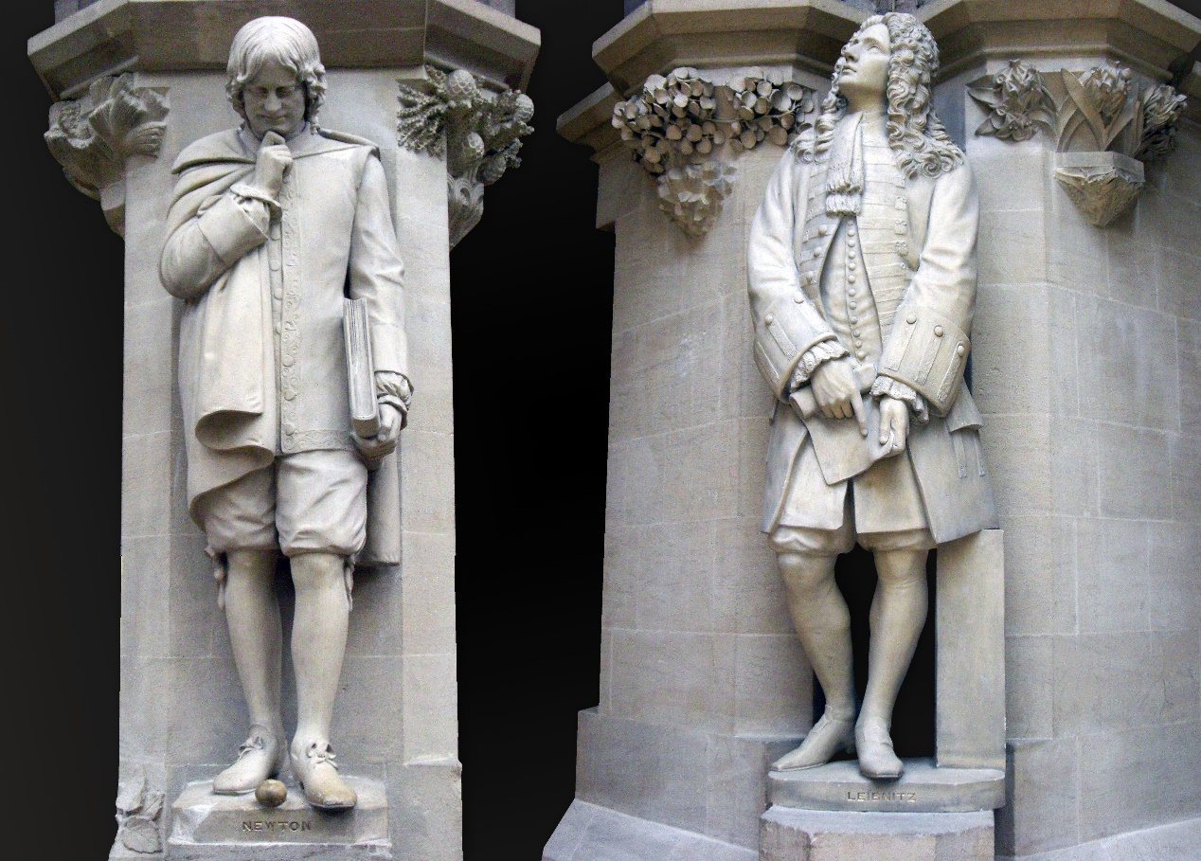

Statues of Isaac Newton and Gottfried Wilhelm Leibniz in the courtyard of the [Oxford University Museum of Natural History](https://en.wikipedia.org/wiki/Oxford_University_Museum_of_Natural_History),

**THEY proved FTC independentry of each other.**

**Newton discovered first, Leibniz published first,**

## ΜΑΘΗΜΑΤΙΚΗ ΑΥΣΤΗΡΟΤΗΤΑ, RIGOR,

### H. Edwards, Jr. The Historical Development of the Calculus. 1979.

p. 98.

During the late middle ages Euclid's *Elements* and the works of Archimedes had been extant, but not always generally accessible and never fully mastered. **The sixteenth century saw, finally, the wide dissemination and serious study of these Greek mathematical masterworks. (ΣΓΠ. ΤΥΠΟΓΡΑΦΙΑ),**  By the latter part of the century, the understanding of Archimedes' work had reached the point that further progress along the lines of classical Greek mathematics was possible. During the century preceding Newton and Leibniz the method of exhaustion was refined and applied by numerous mathematicians to a wide variety of new quadrature, cubature, and rectification problems (see the reviews of this work by Baron [2], Chapter 3, and Whiteside [12], pp. 331-348). Although Archimedes' accomplishments provided the chief inspiration for the resumption of mathematical progress, the time was ripe for the development of simpler new methods, ones that could be applied to the investigation of area and volume problems with greater ease than could the method of exhaustion with its tedious double *reductio ad absurdum* proofs. While continuing to regard Archimedean proofs as the ultimate models of rigor and precision, the Renaissance mathematical mind **was more interested in quick new results and methods of rapid discovery than in the stringent requirements of rigorous proof**. The common view of the period **was expressed in 1657 by Huygens as follows:**

«In order to achieve the confidence of the experts **it is not of great interest whether we give an absolute demonstration or such a foundation of it** that after having seen it they do not doubt that a perfect demonstration can be given. I am willing to concede that it should appear in a clear, elegant, and ingenious form, as in all works of Archimedes. But the first and most important thing is the mode of discovery itself, which men of learning delight in knowing. Hence it seems that we must above all follow that method by which this can be understood and presented most concisely and clearly. We then **save ourselves the labor of writing, and others that of reading**-those others who have no time to take notice of the enormous quantity of geometrical inventions which increase from day to day and in this learned century seem to grow beyond bounds if they must use the **prolix** and perfect method of the Ancients.»

(Struik [II], p. 189, D. J. Struik, A Source Book in Mathematics, 1200-1800. Cambridge, MA:

Harvard University Press, 1969.).

prolix ; Κύριες μεταφράσεις ; Αγγλικά, Ελληνικά ; prolix adj, (overly wordy), μακροσκελής επίθ ; σχοινοτενής επίθ ; φλύαρος επίθ.