02B MATHHMA
Webex meeting recording: 02 B MATHMA INM 2026-20260221 1452-1
Recording link: https://uoa.webex.com/uoa/ldr.php?RCID=753227655a7eda737311a77f53f9a884,
Password: PgZuZJK6

ΕΛΛΗΝΙΚΟΣ ΠΟΛΙΤΙΣΜΟΣ, GREEK CIVILIZATION, (c. 1200 BC) to the death of Alexander the Great (323 BC),

ΕΚΣΤΡΑΤΙΑ ΜΕΓΑΛΟΥ ΑΛΕΞΑΝΔΡΟΥ, map
https://www.shutterstock.com/image-vector/empire-alexander-great-on-his-conquest-2463195941?trackingId=b126fc84-bfeb-4d12-9a07-7a7f2b05c4d4&listId=searchResults,
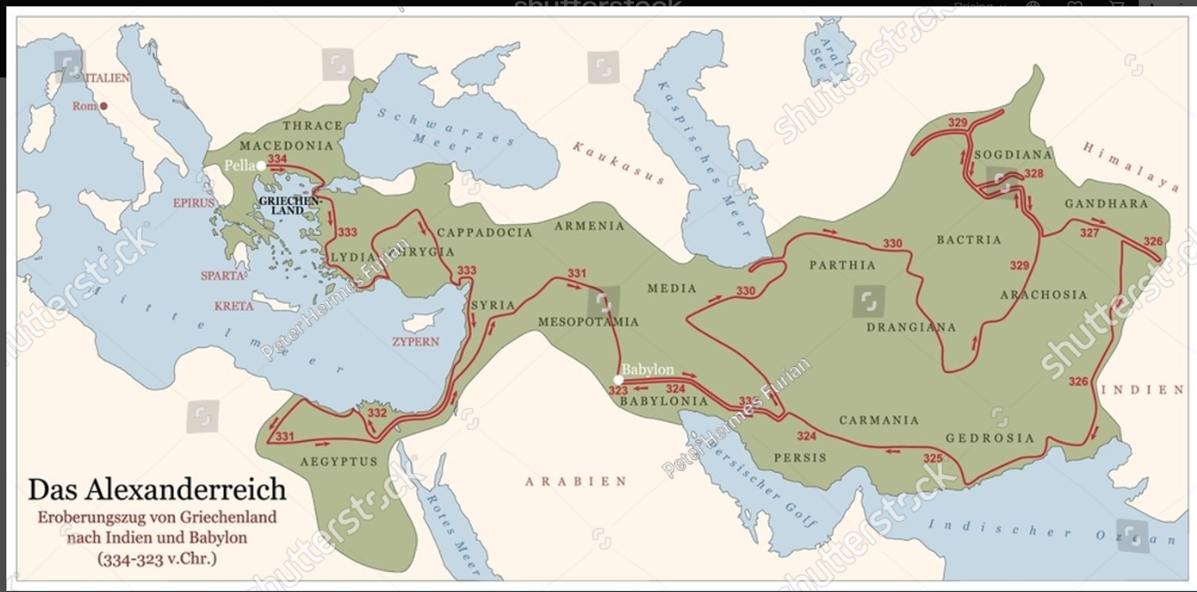

GOOGLE, greek people
AI
Origins: Proto-Greeks arrived in the southern Balkan peninsula around 2200–1900 BC. Genetic studies indicate a direct continuity between ancient and modern Greeks.
Ancient Greek civilization was a foundational culture in the Mediterranean, lasting roughly from the end of the Mycenaean period (c. 1200 BC) to the death of Alexander the Great (323 BC), with its influence continuing through the Hellenistic and Roman eras. Renowned for its immense contributions to politics, philosophy, science, and art, it is widely considered the cradle (κρεβατακι μωρου), of Western civilization
COMMENT SGP. Democracy,

ΜΑΘΗΜΑΤΙΚΑ.
ΛΟΓΙΚΗ, ΑΞΙΩΜΑΤΑ, First discussion about INTEGRAL,

ΣΧΟΛΙΟΝ, A Mathematician’s Apology, G. H. Hardy, sel. 11
The Greeks were the first mathematicians who are still ‘real’ to us to-day. Oriental mathematics may be an interesting curiosity, but Greek mathematics is the real thing. The Greeks first spoke a language which modern mathematicians can understand: as Littlewood said to me once, they are not clever schoolboys or ‘scholarship candidates’, but ‘Fellows of another college’. So Greek mathematics is ‘permanent’, more permanent even than Greek literature.

ROMAN EMPIRE, 27 BC-476 AD,

GOOGLE roman empire

Map of the Ancient Roman Empire at Its Peak (117 CE), provided by TheCollector.com,
https://www.thecollector.com/maps-resources/map-roman-empire-peak/,
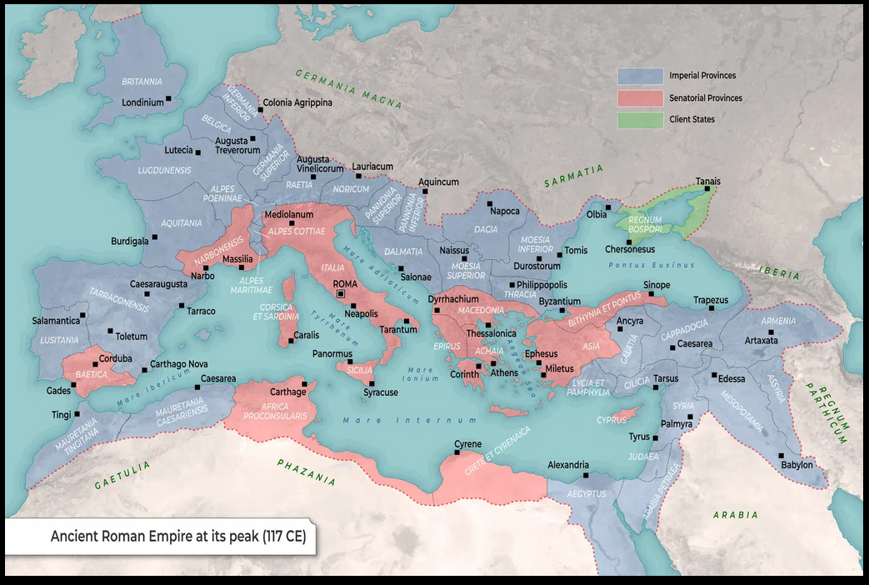

IMPERIAL PROVINCES, An Imperial Province was a Roman province whose governor was appointed directly and solely by the emperor. These provinces were generally located on the borders of the empire, were strategically and militarily important for security, or were socially unstable (at war or prone to rebel against the empire).
SENATORIAL PROVINCES, Senatorial provinces were stable, largely pacified Roman regions managed by the Senate rather than the Emperor, typically governed by proconsuls or propraetors without major military presence. Established by Augustus in 27 BCE, key examples included Asia, Africa, Achaea, Baetica, and Narbonensis, focused on tax collection and administration.

AI Overview
The Roman Empire was
one of the most dominant and influential civilizations in history, transitioning from a republic to an autocratic empire in 27 BC and lasting for centuries. At its height, it spanned three continents—Europe, Asia Minor, and North Africa—circling the Mediterranean Sea (marem nostrum).
COMMENT SGP. Administration,

ΜΑΘΗΜΑΤΙΚΑ.
ΟΧΙ ΚΑΤΙ ΠΡΩΤΗΣ ΓΡΑΜΜΗΣ,

Byzantine Empire, 330 AD-1453 AD,

https://en.wikipedia.org/wiki/Byzantine_Empire, map,
The empire in 555 under Justinian I, its greatest extent since the fall of the Western Roman Empire, vassals shaded in pink
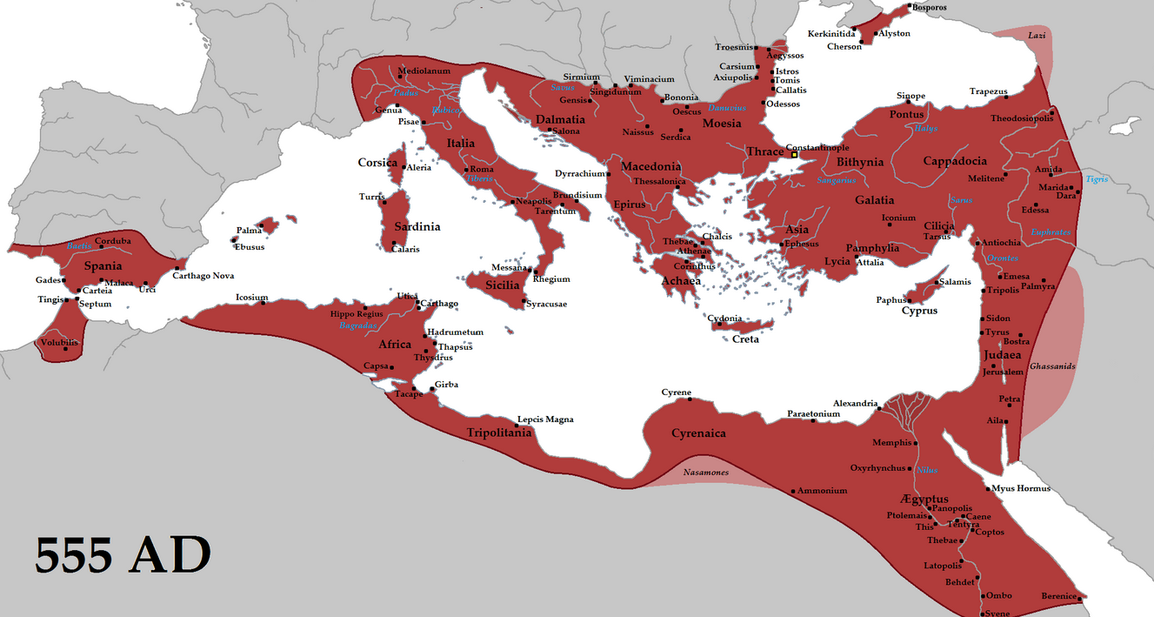

ΜΑΘΗΜΑΤΙΚΑ.
ΟΧΙ ΚΑΤΙ ΠΡΩΤΗΣ ΓΡΑΜΜΗΣ,

